**Activity 2 Documentation**

*Figure 1. Forked the existing repository.*

*Figure 2. Initialized the repository and checked the status; no commits yet.*

*Figure 3. Staged changes for commit.*

*Figure 4. Checked the status again after staging.*

*Figure 5. Attempted to commit but encountered an issue.*

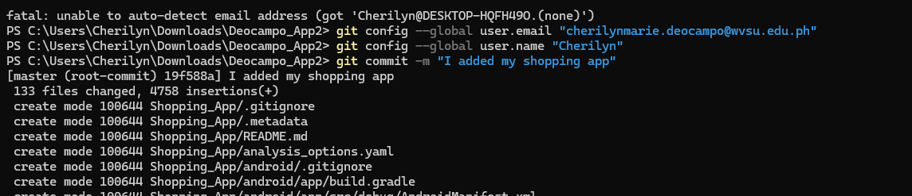

*Figure 6. Configured my accounts settings.*

*Figure 7. Added a remote repository and pushed changes.*

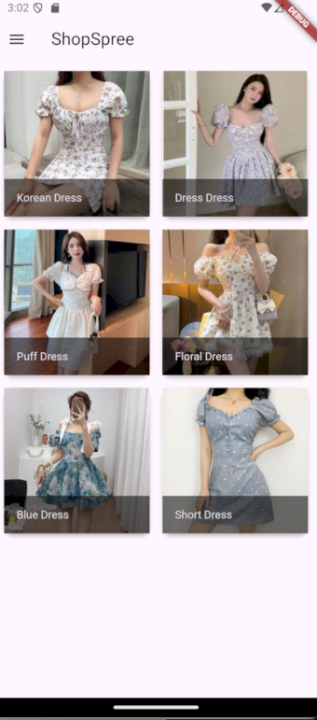*

*Figure 8. Output of my Shopping App.*