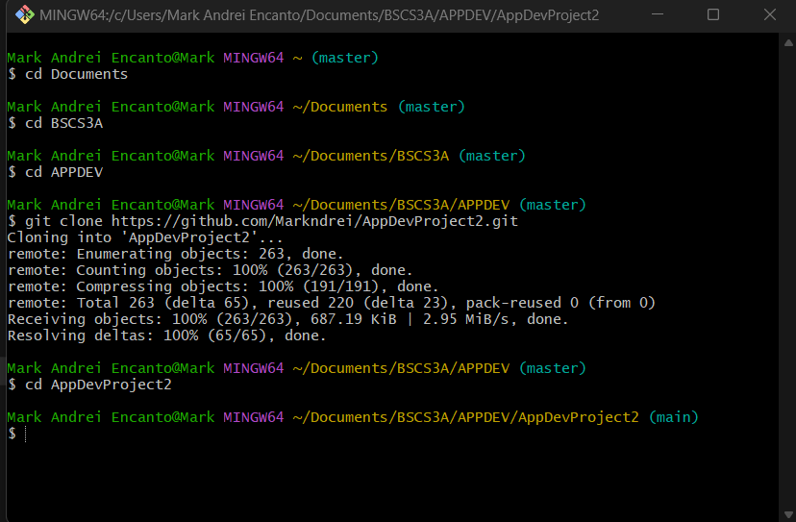

**FIGURE 1. CLONING OF REPOSITORY**

**Commands used:**

**Cd**  to open and locate folders for the cloning.

**git clone <link>** to clone repository locally.

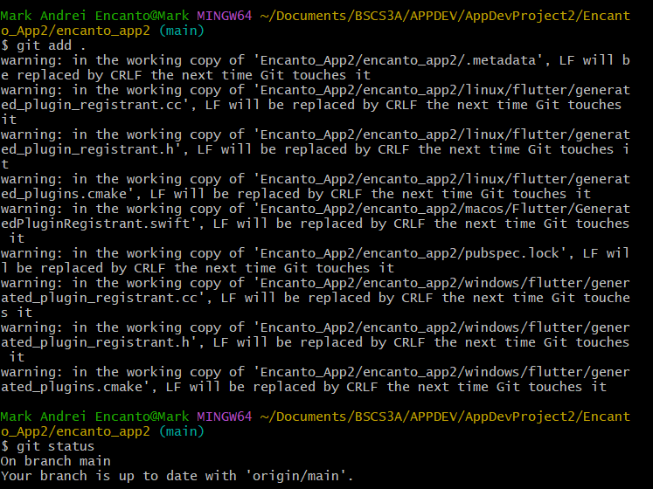

**Figure 2. Adding of Changes**

**git add .** to update and validate the the current changes.

**git status** to check if the branch is up to date.

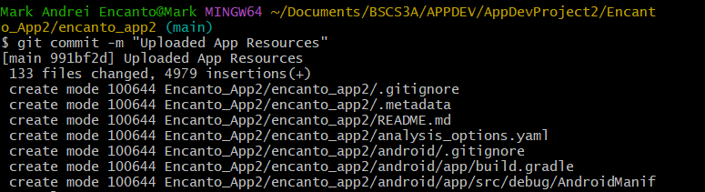

**Figure 3. Committing Changes.**

**Git commit -m** to commit all the changes to the repository.