Name: **Chariz Dianne D. Falco**  
Section: **BSCS 3A – AI**

Date/Deadline: **September 13, 2024**

1. **Forking the repository.**

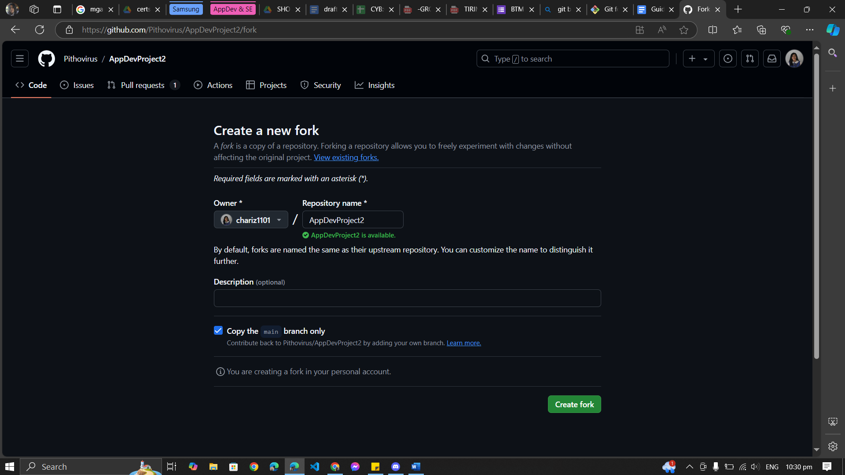

1. **Cloning the repository using the command “git clone <URL>”**A computer screen shot of a black screen

   Description automatically generatedA screenshot of a computer

   Description automatically generated
2. Making a new folder for my file and pasting my application inside.

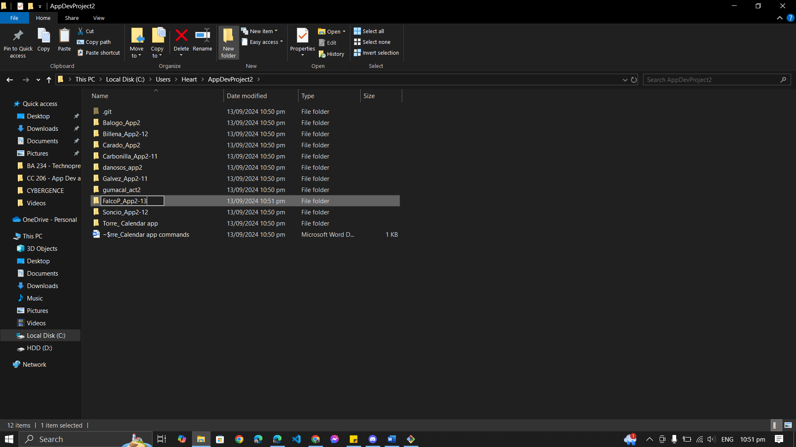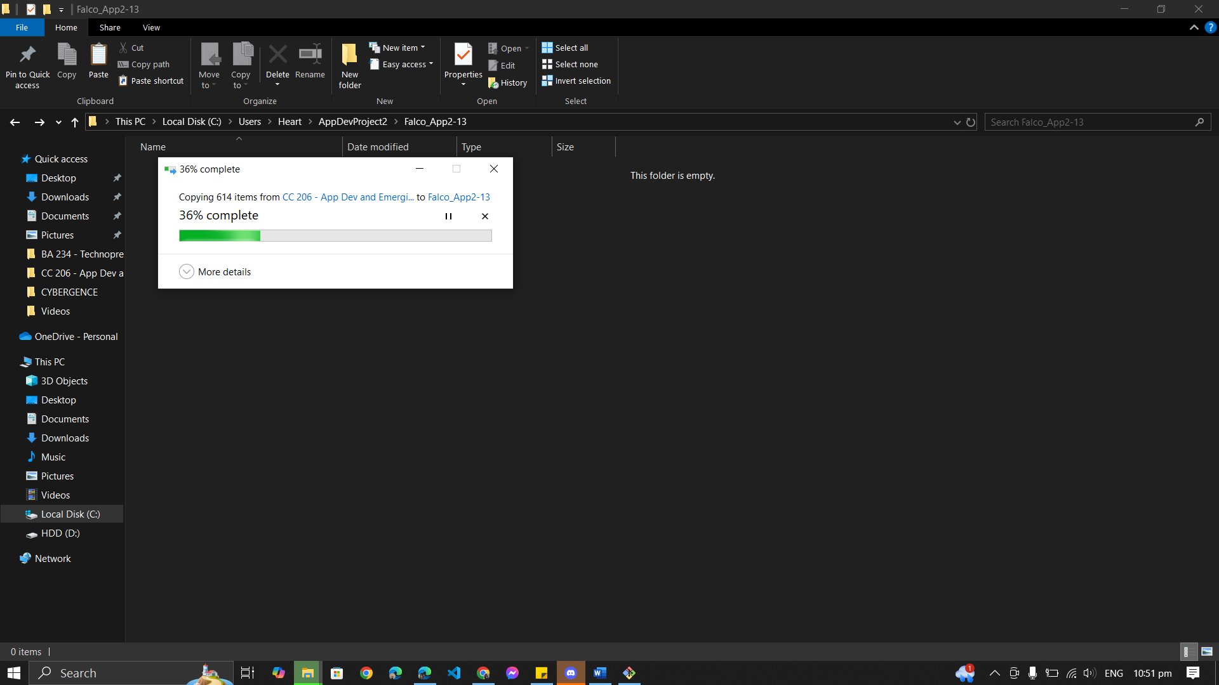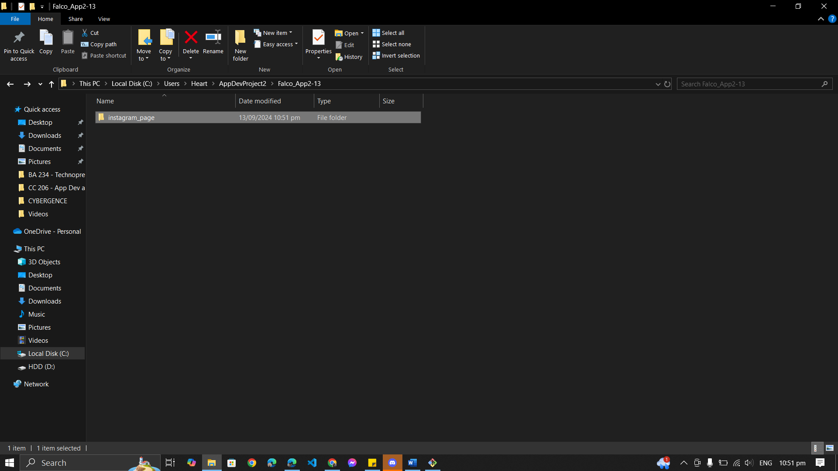

1. **Checking the status of my cloned repository with the code “git status”** A computer screen shot of a black rectangle with colorful text

   Description automatically generated
2. **Adding all the changes I have made with the code “git add .”** A screenshot of a computer

   Description automatically generated
3. **Committing my changes to the repository with the code “git commit -m “<message>””**A screenshot of a computer

   Description automatically generated
4. **Pushing my changes to the repository with the code “git push”** A screenshot of a computer

   Description automatically generatedA screenshot of a computer

   Description automatically generated
5. Making a pull request to the original repository so the changes can be accepted.

