**Tacuel, Allan Andrews**

**BSCS 3-A**

**Appdev2 Act2**

**Commands used to copy the repository**

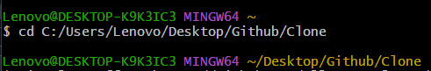

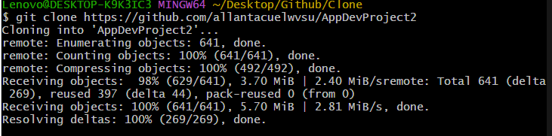

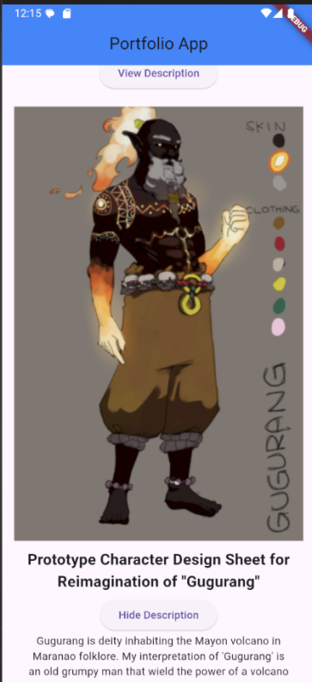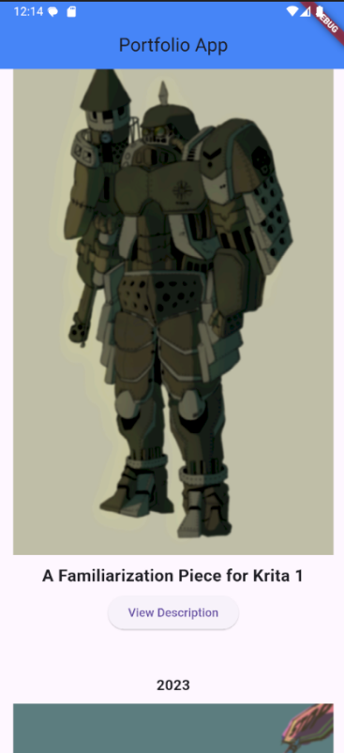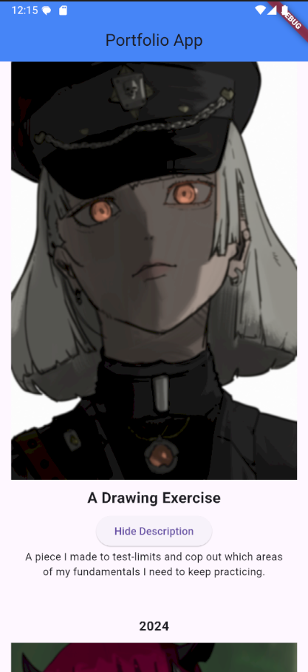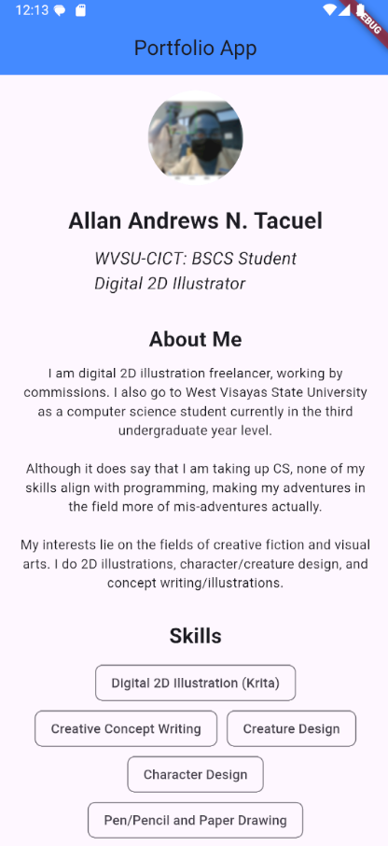**App Screenshots**