Name: Michael Rey T. Tuando

Section: BSCS 3-A AI

Date/Deadline: September 15, 2024

**AppDev2 Activity**

Travel App Snippets:

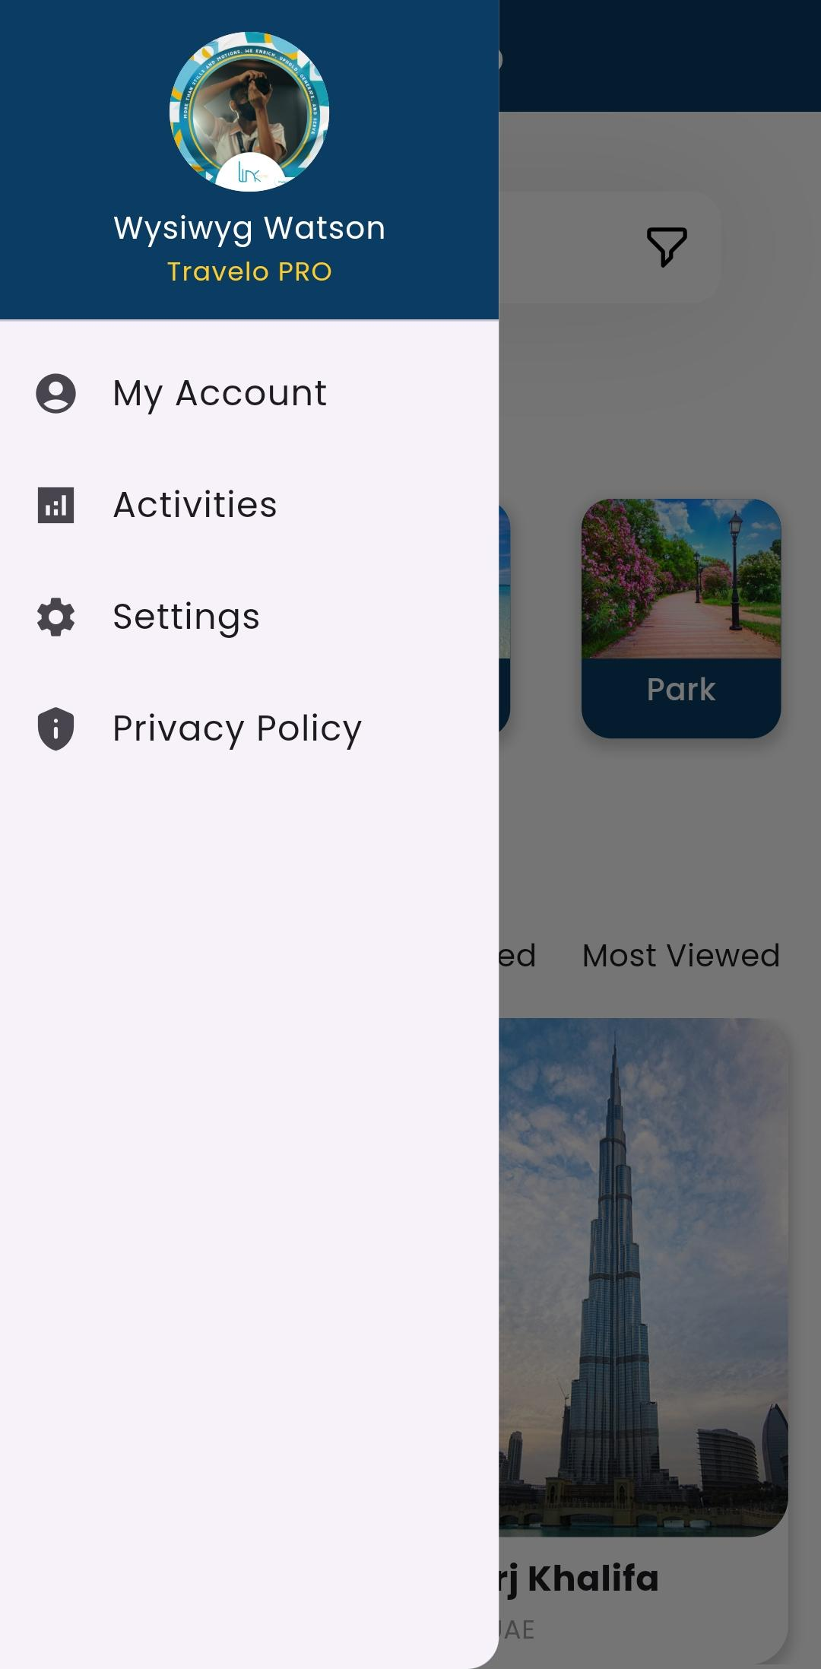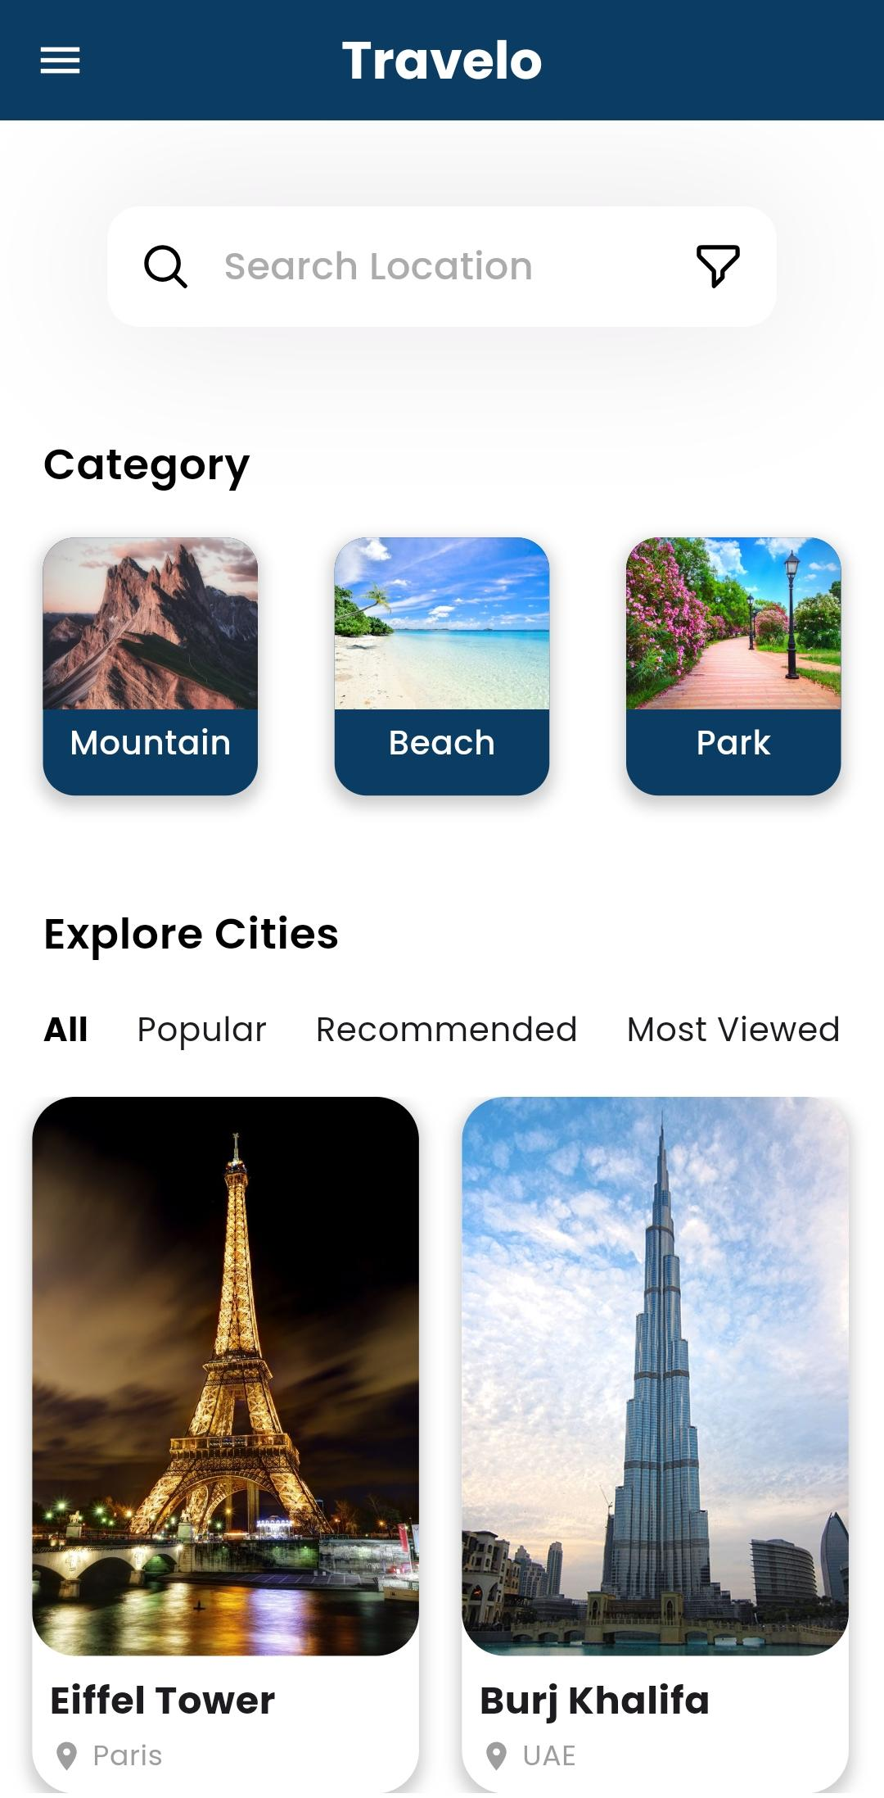

Screenshots of git commands and other processes:

Forked the original repository.

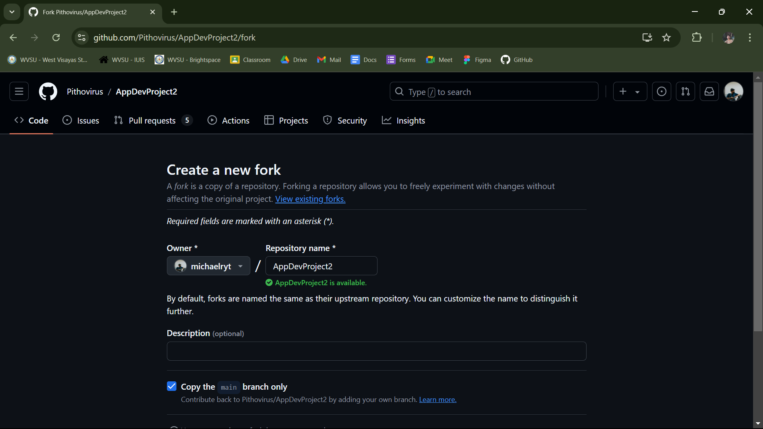

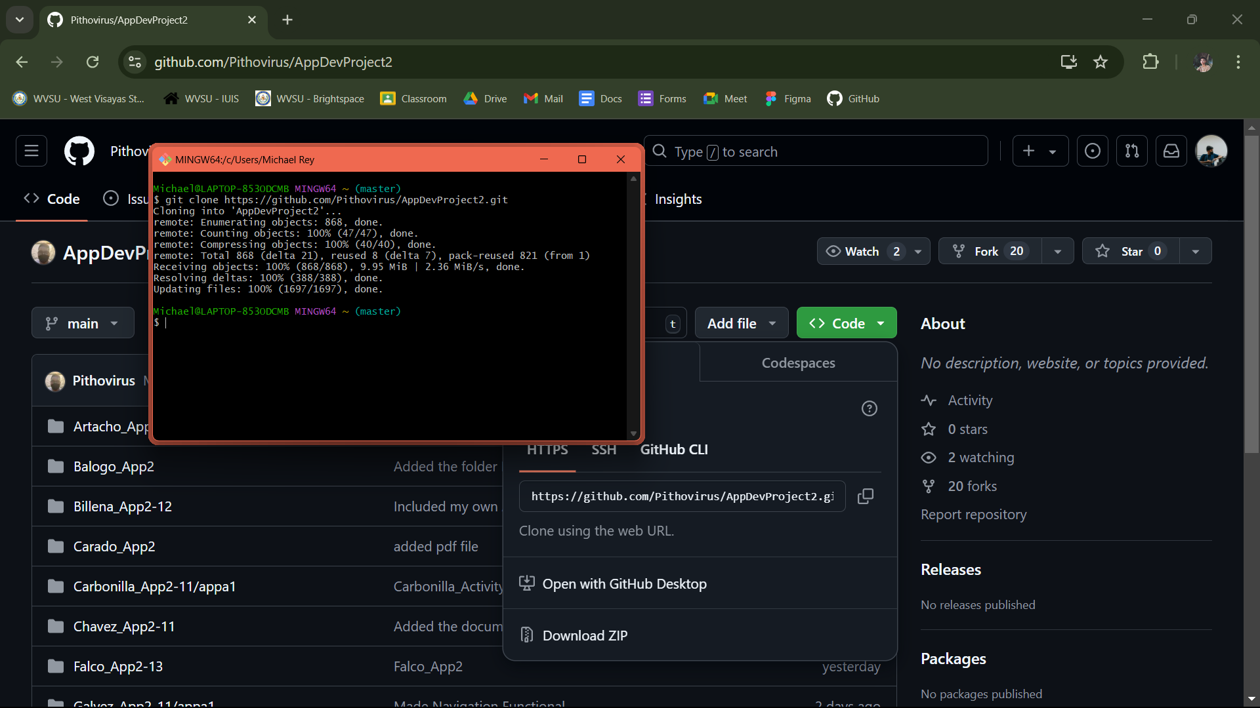Cloned the repository using url using the command ‘git clone’.

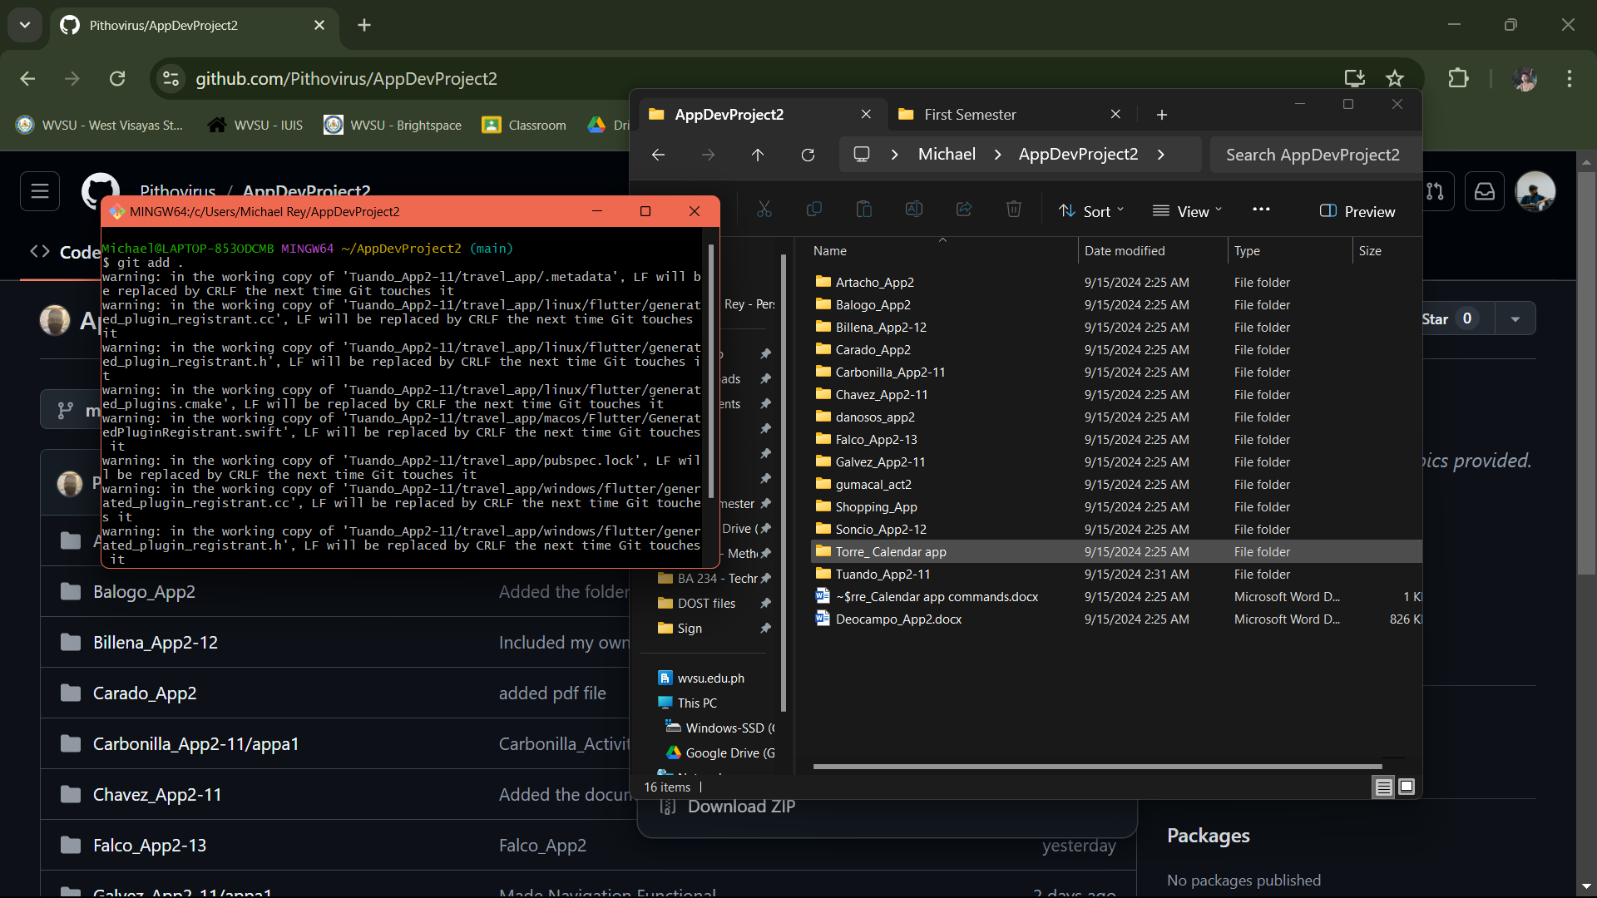Used ‘git add .’ to add my all my files.

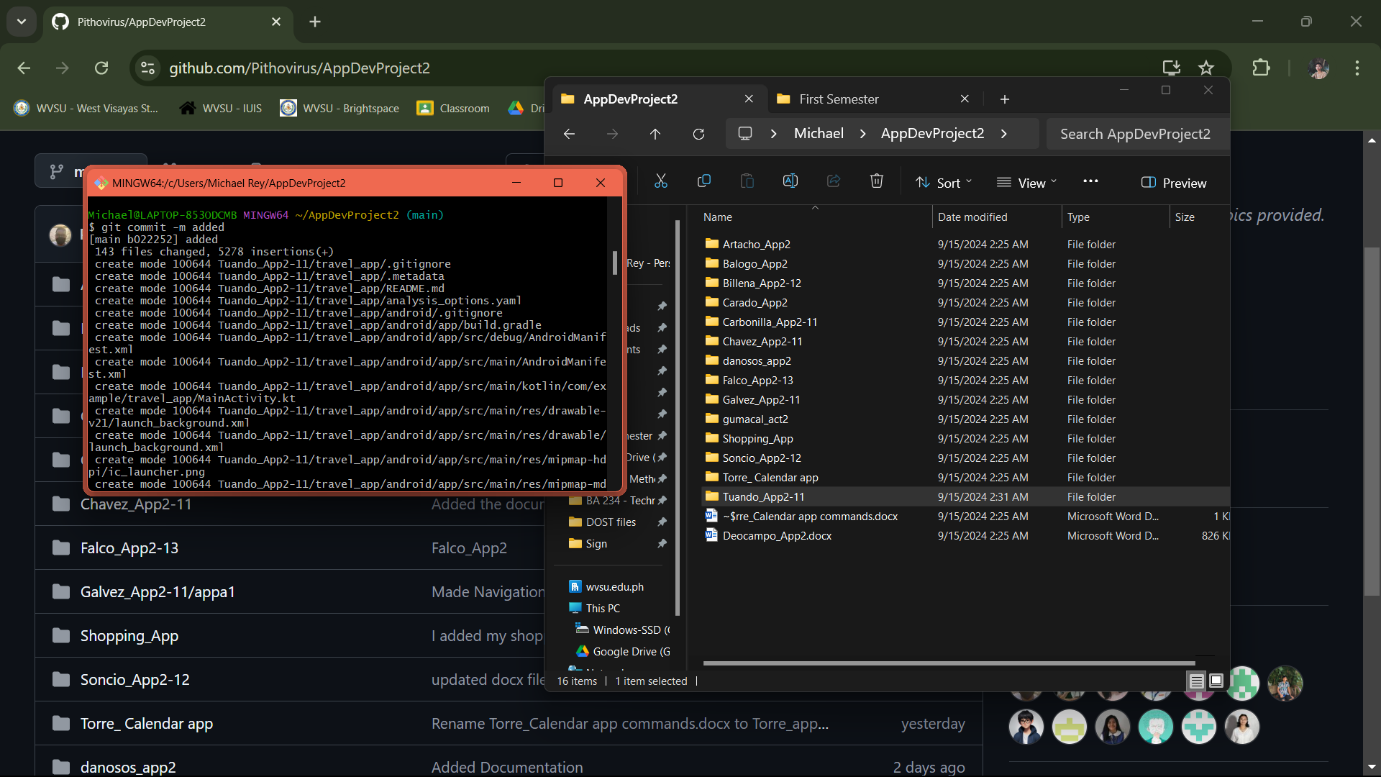Used ‘git commit -m’ to commit changes.

Used ‘git push origin main’ to push changes to my forked repository.

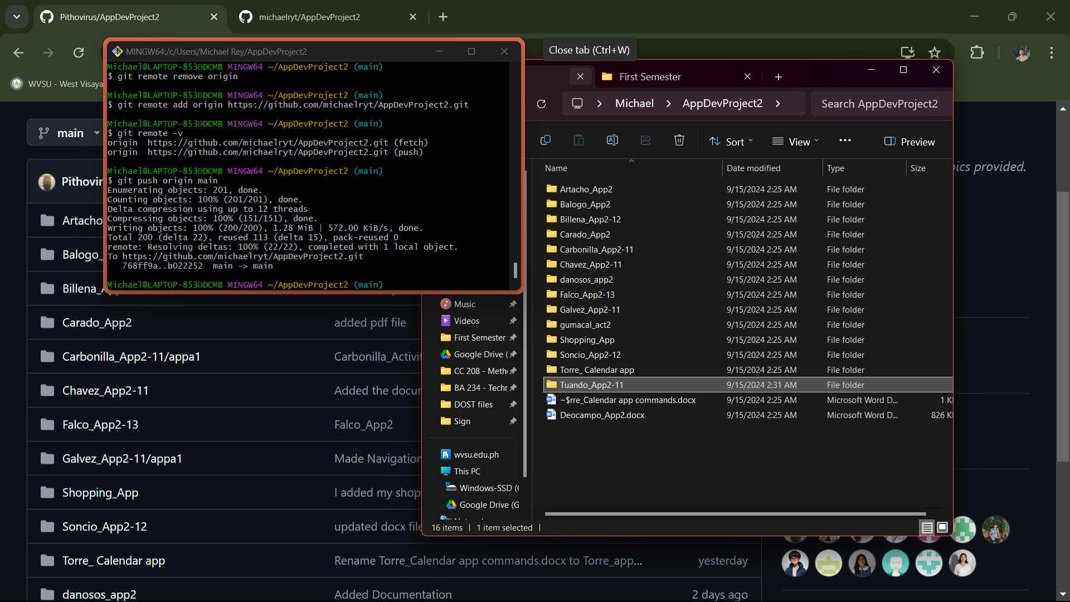

Lastly, I made a pull request to merge with the main branch. (I was unable to take screenshot)