**Guidance for calculating your productive utilisation**

1. Go into Online Time in Sparkpad and select 'Utilisation Report' from the T&E tab and select 'Next'

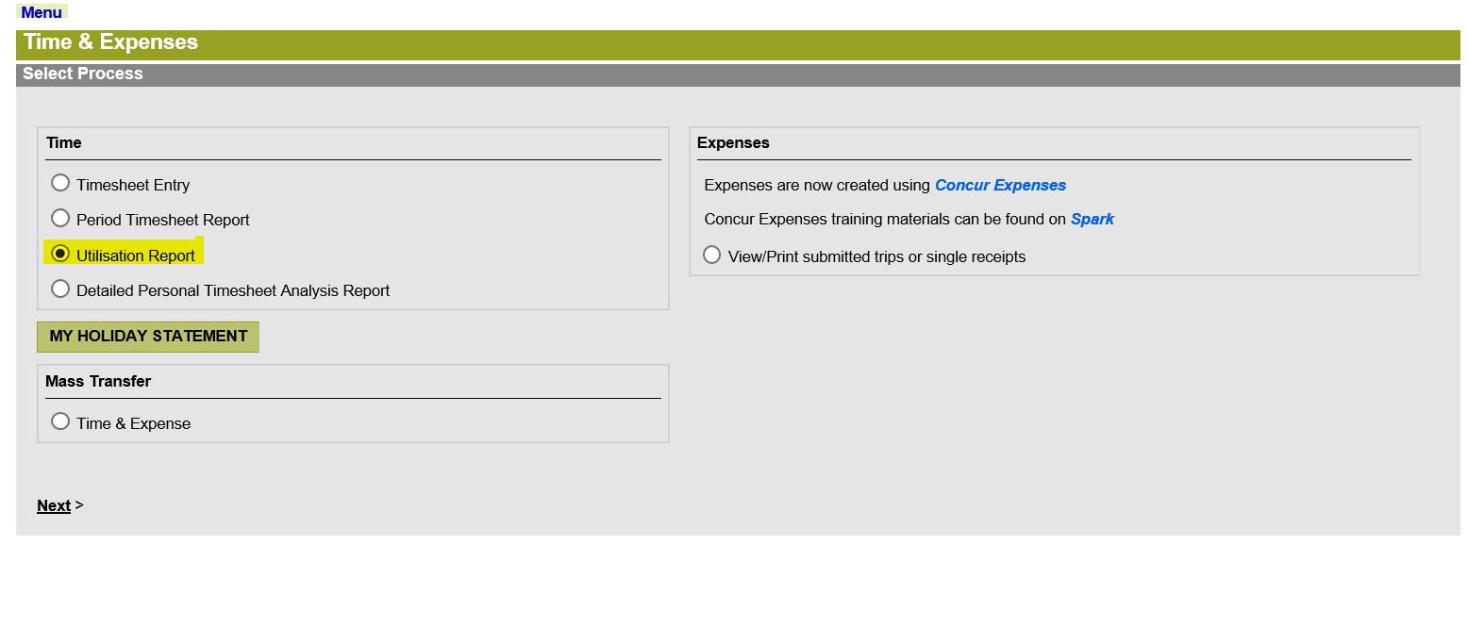

2. Enter the dates you want to report from and to in the format DD/MM/YYYY and select OK. Remember that performance years start in April. The illustration below shows you how it would look if you ran the data from April to July.

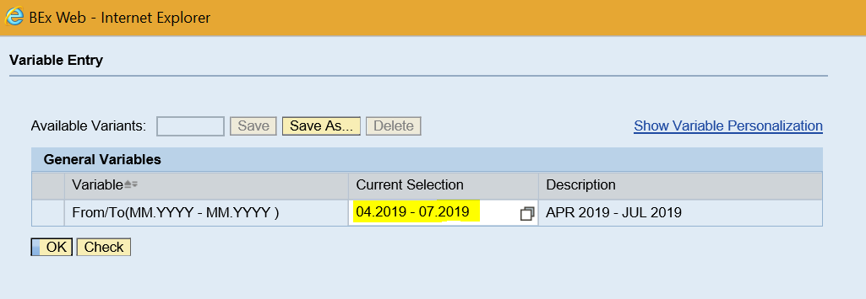

3. On the next screen, in the top right hand side, please click on the word Filter

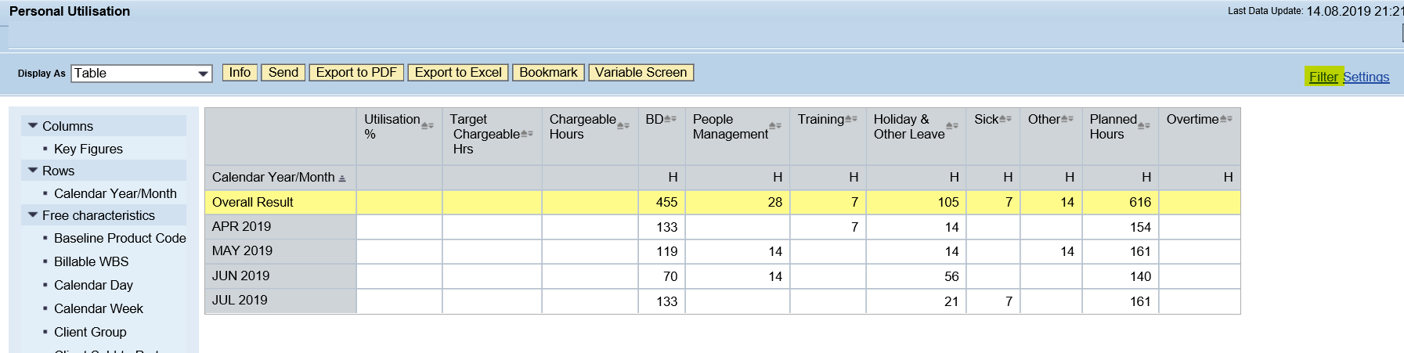

4. On the next screen on the left hand side, click on the drop down arrow next to Key Figures and select Edit

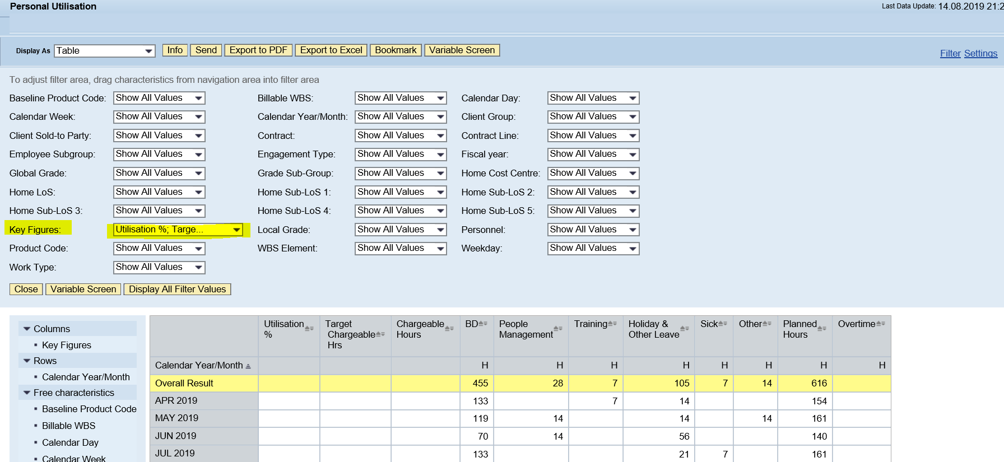

5. On the next screen, on the left hand side, scroll down and select 'Internal with Special Credit' and then 'Add'

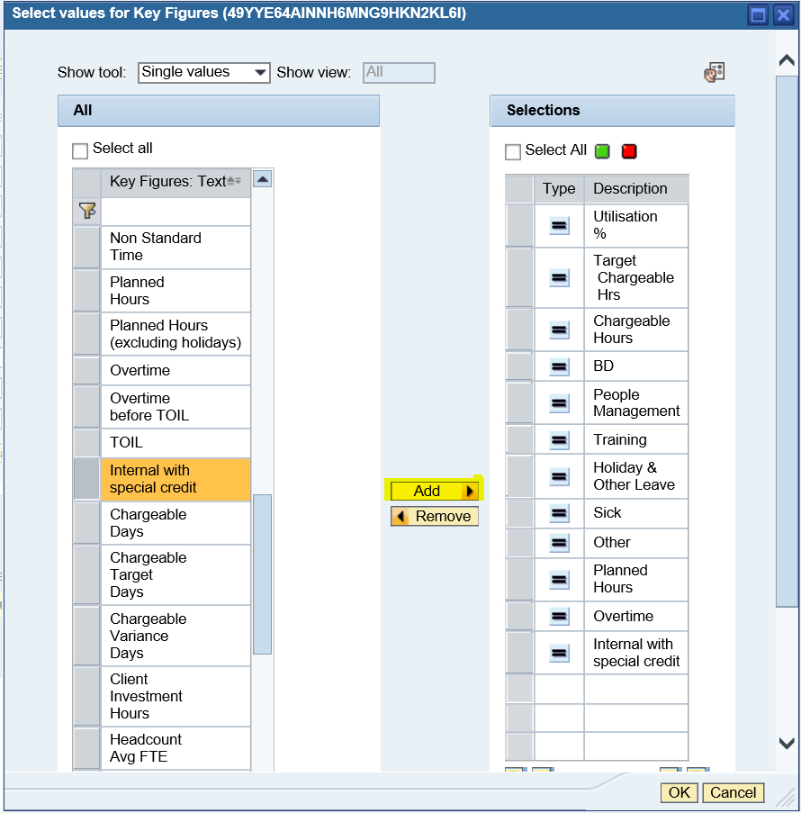

6. On the next screen, you will see your chargeable hours and your internal with special credit (FWAC)

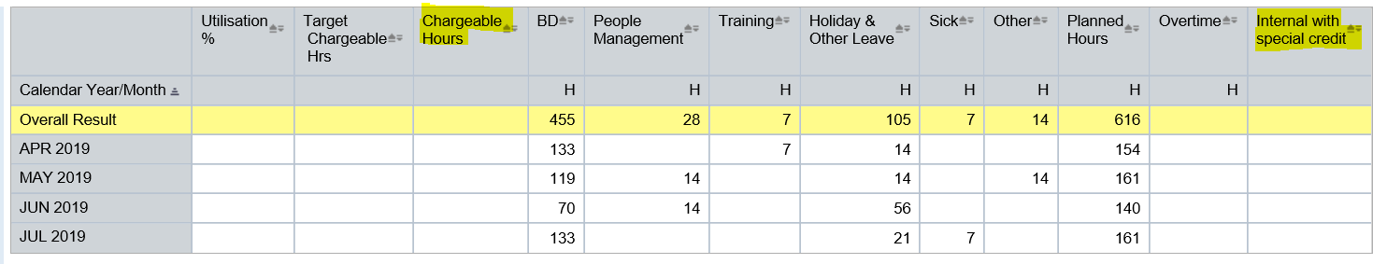

For ‘chargeable hours’ and ‘internal with special credit’ (highlighted above), **add the numbers in the overall result row, and divide by 8 to get your productive days for the period.**

7. You can then compare to your target for the year which for Core Consulting is specified in the table below.

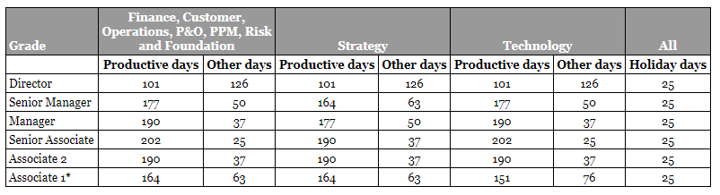

Please note that the table above is the target for the whole year. You will need to remember to pro-rate for the number of days so far in the year (see below) as well as if you are part time and/or joined since 1st April 2019.

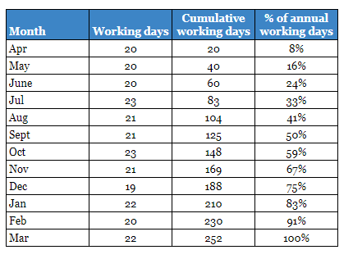

If you have any questions on how to calculate your productive utilisation, please contact Clare Clements.