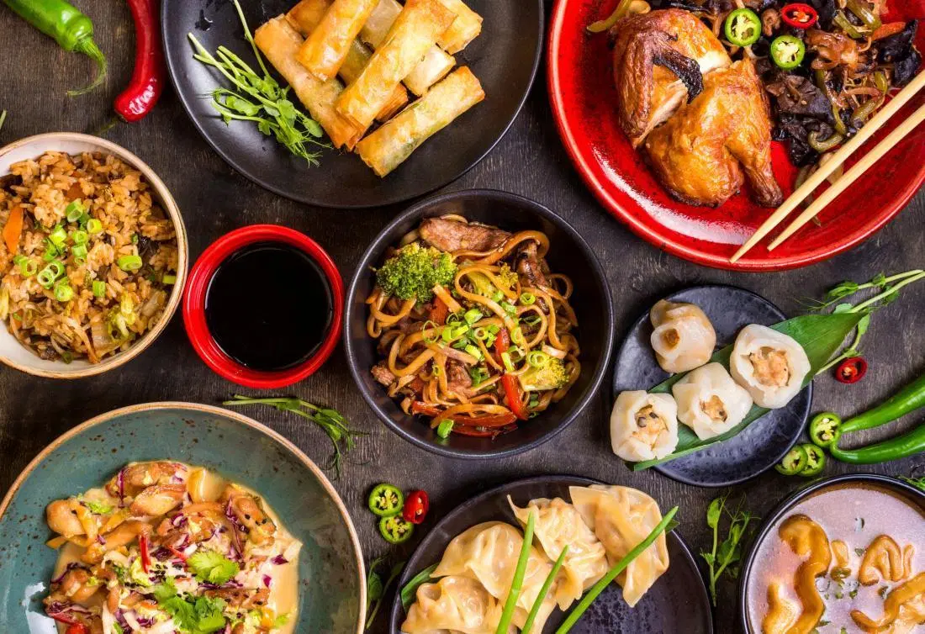Project 2

Food Analysis

Everything you need to know about food nutrients.

Cristina Carmona

Margarita Garza de Leon

Claudia Encinas

Keywords: food, vitamins, minerals, health, nutrition, calories

# Chosen topic

In today’s world, the vast world of food choices we have within our reach can leave us overwhelmed on our food choices and how they contribute to our overall nutrition. Fortunately, Food is very DATA oriented! The United States Department of Agriculture’s Food Composition Database has an extensive dataset that provides data for Categories and Subcategories of Foods that include nutrient content and caloric values. In this project, we provide the interactive means to explore data of this data set, for the user to understand the nutritional content and values of a large-scale food category data set. Additionally, so that the user understands the contribution of each nutrient, the interactive site provides descriptions of vitamins, minerals, and fats to answer questions on why each of these nutrients is important on our bodies.

# Data set link

<https://corgis-edu.github.io/corgis/csv/food/>

Data set description from the chosen site: The following data comes from the United States Department of Agriculture’s Food Composition Database. It contains data for various types of food including the amounts of different vitamins and minerals found in the foods as well as macronutrient percentages. The food covered spans a large variety of foods from butter to Campbell’s soup. Much of the supplementary documentation for each field comes directly from that pages’ Wikipedia article.

# “Inspiring” visualizations

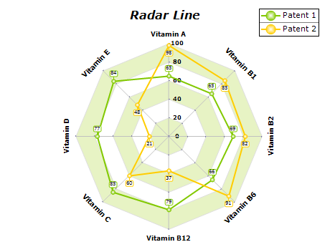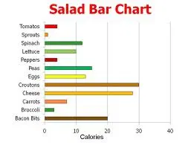

# GitHub repository link

<https://github.com/CristyCarmona/Project2.git>

# Tasks

|  |  |
| --- | --- |
| HTML Template & Nueva libreria .js | Claudia y Cristina |
| Web scrapping&csv(including Data cleaning) | scrapping-Margarita  Csv&cleaning- Claudia |
| Database | Cristina |
| Charts | Margarita |
| API-Flask | Cristina |

# Database Diagram

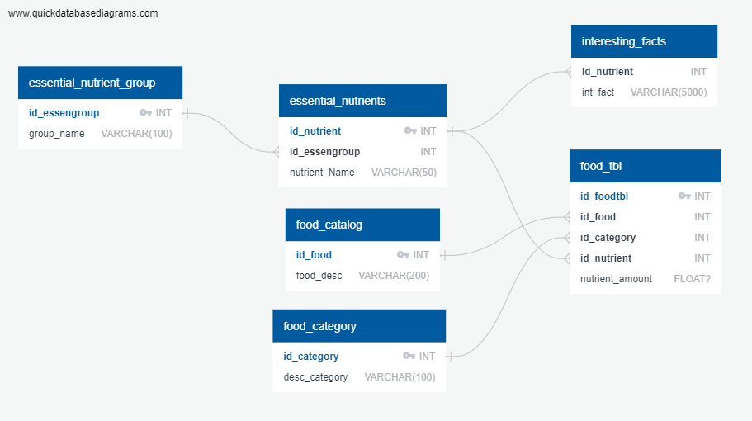

# Sketch of the final design

