The Problems of critical making

Matt Ratto ([Matt.ratto@utoronto.ca](mailto:Matt.ratto@utoronto.ca))

Faculty of Information

University of Toronto

<http://semaphore.utoronto.ca> <http://www.criticalmaking.com>

Introduction 1

I. Rocks 2

Making as Reflecting 3

Making as Intervening 5

Return to the rock 6

II. Critical Making: an exercise 7

Wrapping up 20

## Introduction

It is time to start critical making. As scholars, it is time for us to move beyond the linguistic and textual biases of the humanities and social sciences and engage directly with the material artifacts and systems that we study. As makers, crafters, designers, artists or engineers, it is time to move beyond propositions of instrumental or aesthetic value, to move beyond the exhibition or the demo or the one-off, and to reflect more explicitly and concretely on the relations between what things are made, how they are made, and our responsibilities for things and to things. To be clear, these dual moves are not my own, novel propositions but are situated within a number of long term projects working towards clearer articulations of what has been termed the socio-material world. Such projects are visible in a the scholarly trend in the humanities and social sciences towards the material (the so-called ‘material turn,) but are equally visible in conceptual work associated with the fields of art and design and in attempts to incorporate ‘social issues’ in engineering and other technical disciplines. Examples of such work include my own making experiences such as FLWR PWR, fixsels, electric dollhouse, or others, as well as the work of scholars including Carl Disalvo, Natalie Jermijenko, and designers such as Tony Dunne and Fiona Raby – to mention just a few.

For many years I have struggled with the contradictions of social constructivist (e.g. Pinch and Bijker) and material-semiotic forms of socio-technical analysis (Haraway, Latour). Specifically, I have (like many others) struggled to come to terms with the relations between material and semiotic forms, taking my initial cue from Foucault’s materialist accounts of the hybridity of the human lifeworld. My initial interest was relatively programmatic – I simply wanted to better parse the ways in which technical work and its results were co-constructed with the social collectivities through which specific artifacts and systems were produced. (Ratto, 2003; 2005) But as time has passed I have grown increasingly dissatisfied with the methods and theories associated with the above operations, seeking not just to parse the socio-technical but to explicitly address aspects that we might even call structural. Speaking of Foucault’s work on bodies and discourse, materialist feminist theorist Rosemary Hennessey has put it best:

“a rigorous materialist theory of the body cannot stop with the assertion that the body is always discursively constructed. It also needs to explain how the discursive construction of

the body is related to nondiscursive practices in ways that vary widely from one social formation to another” (1993, 46).” (cited in Barad, Posthumanist Performativity: Toward an Understanding of How Matter Comes to Matter , pg. 810)

Hennessey nicely captures an important issue not just with Foucault but also with many forms of analysis that address the discursive and the non-discursive, the material and the semiotic. Such forms often work to parse and define the relations of the moment, of a particular case without attempting to make a connection from these specific relations to the wider social formations that constrain them. This results in two problems; first, an intrinsic belief (often by readers rather than authors!) in the generalizability of the relations that are found; and second, a sense by critics that the analysis does not go beyond the local to address critical socio-economic and political structures.(for such criticisms see Winner, Opening the Black Box, Star, etc)

The criticality of socio-technical analysis has bounded my thinking for many years and I have often struggled to move beyond the local context and the descriptive rather than structural-analytic predispositions within STS and related fields. My attempts to make this move have often resulted in work (typically unpublished and unpublishable!) that has definite social or technologically deterministic overtones. I have come to believe that the key to addressing this concern is to take seriously the ‘material’ within the ‘material-semiotic’ and that one way of doing so is to find ways to incorporate materials themselves as a key resource in our analytic repertoire. In Section I, I trace out four problems that need to be addressed in order for forms of such hybrid material-conceptual practice to be legitimately included within STS and the humanities and interpretive social sciences more generally. In Section II, I walk the reader through an exercise in critical making. I end with some thoughts on how to proceed.

## I. Rocks

Before you begin to read this article, please go outside and find a largish stone, though not so big that it cannot be easily lifted and carried indoors. Bring it in, and immerse it in a pail of water or under a running tap. Then place it before you on your desk – perhaps on a tray or plate so as not to spoil your desktop. Take a good look at it. If you like, you can look at it again from time to time as you read the article. At the end, I shall refer to what you may have observed. (Ingold, 2007: 1)

Tim Ingold kicks off his article ‘Materials Against Materiality’ with the above instructions, encouraging readers to engage materially while simultaneously engaging discursively with his article. Like Ingold, I encourage you, the reader of this chapter, to carry out his instructions now. Like him, I will return to your experiences later in this piece. I do want to point out how these instructions capture what I believe is key to critical making – the hybridity of material and discursively mediated experiences and how both can act as resources for individual and social transformation.

Taking this a step further, I understand critical making to encompass a recursive relation between two modes of engagement with the material world - making oriented towards self-reflection and discovery, and making oriented towards external impact and social benefit. This relation is the pivot point around which we can highlight modes of engagement that offer up novel ways forward. The work that needs to be done regarding critical making is therefore not so much developing new practices and forms of work, but in simply revealing and highlighting modes that are already present but undervalued or even deliberately hidden. We need to describe and cultivate what is common to critical making engagements - no matter the context or ultimate goal. Whether the focus is on material intervention, exhibition and display (as in the work of critical designers), or scholarly extension and critique (as in the work of the digital humanities), all these engagements share moments where the material and the conceptual are brought together in generative ways. These moments and the development of the skills, perspectives, and ‘habits of mind’ that help instantiate them are the ultimate goal of my work.

Making - understood in its simplistic sense as engagements intended to transform the material environment - can therefore be understood as critical in two different ways. These are of course analytic differences, but they serve as a useful starting point for a more detailed engagement with the theory and the practice of critical making.

## Making as Reflecting

First, we can consider making as critical when the processes and activities highlight the role of material resources in both processes of discernment and in communicating the results[1]. Here, critical making can be considered as sensuous engagements where the materials in play serve as a resource for reconceptualizing the acts of production and the subjectivity of the producer.

There is a long history in conceptualizing and activating the general concept of making as part of a process of reflection and learning. From constructivist forms of pedagogy such as those developed by Papert, to reflexivity in practice articulated by Dewey and later Schoen, to concepts of craft knowledge described by Harper, Sennett, and Crawford - all of these forms share an interest in how individuals develop the capacity to engage and reflect through material engagements. This is a well-studied phenomenon, particularly within the disciplines of Education and Cognitive Science, though often bounded, perhaps not surprisingly, by a realist ontology that focuses attention on a natural world. In other words, much of this work remains stoutly focused on how individuals parse a natural world and the laws that govern it.

The work of Papert serves as an influential example. Papert’s constructionism emphasizes the importance of material engagement in processes of intellectual development and the role materials play in three specific elements of learning. First, Papert incorporates the emotional dimension of learning, noting that the assimilation of new models of the world always involves endowing new understandings with a “positive, affectual tone” (Papert et al. 1998). Second, Papert emphasizes the use of transitional objects—gears, computers, other physical objects—as a way of connecting the sensorimotor “body knowledge” of a learner to more abstract understandings. Here, he emphasizes that these objects do not just serve to “illustrate” concepts but act as means for projecting oneself into an abstraction. Third, Papert, referencing Hawkins (1965) notes the importance of “messing about” with computers in order to overcome the “rigid style of work” typically associated with them. These three elements - affect, embodiment, and the overcoming of traditional instrumental perspectives - seem prescient given the ways these themes have more recently dominated social theory on technology. However, for the most part, constructionism has remained as part of a learning theory deeply embedded in science and technology education, maintaining the forms of realism related to both. Hints at how a more epistemically pluralist form of learning might be fostered are present in Papert’s work, and in particular in a chapter written by him and Sherry Turkle (Papert and Harel, 1991, Constructionism, ch. 9) but these remain under-explored.

**Problem one - there remains a commitment to realist ontological claims often held within constructionist pedagogy that needs to be overcome in order for these forms to be embraced within disciplines (such as the interpretive humanities and social sciences) where such claims are held as suspect.**

Leaving aside the realist ontological claims, critical making in this form parallels the hermeneutic approach described by some (Habermas for one) as typical of literary critical theory (cite). Critical here is taken to be synonymous with reflexivity and the primary activities are those of reflection and interpretation. In this light, making is critical in so far as it allows us to interpret and understand the world. In a recent book, David Gauntlett - well-known for his pioneering work ‘Making is Connecting’ highlights precisely this focus on material production, noting that “Making things has always been a way for humans to think about things, critically and reflectively.” (Gauntlett, 2014: Making Media Studies). In the conclusion to this book, Gauntlett worries about separating critical making from everyday acts of making, concerned that “…the idea that the ‘critical’ and thoughtful version of making is something done by politically-aware professionals positioned – perhaps unintentionally – in contrast to other acts of making done by others, is unfortunate.” (126).

Gauntlett’s points are well-made - it is certainly not the case that reflexive making is only the domain of professional ‘critical makers’. The carpenter who makes a decision to use lumber from sustainable agricultural practices or the plumber who decides to use lead-free solder are both examples of everyday practices of reflexive making. From the 'tinkery business' of science (Norris, 1993) to the bricolage of Harper's 'jack-of-all-trades' (1992), detailed ethnographies of work have tended to highlight the ways material labour often involves coming to terms with local contingencies (Knorr, 1979), addressing the resistance of materials to our attempts to make use of them (Ingold,2007) while, at the same time, engaging in complex cognitive operations (Rose, 2004). In fact, some of the major outcomes of anthropologies of work have been to understand material practice as not merely the following of plans (Suchman, 1987) or as simple habitual non-cognitive action (Harper, 1987). Still, culturally, we continue to struggle with strong separations between intellectual work - often seen as happening beyond the sphere of the material world - and material labour - often depicted as a-conceptual and non-cognitive. Mike Rose, in his groundbreaking study of the intellectual aspects of manual labour writes:

It is as though in our cultural iconography we are given the muscled arm, sleeve rolled tight against biceps, but no thought bright behind the eye, no image that links hand and brain. (Rose, 2004: xiii)

So it seems more work must be done to reveal the ‘bright eyes’ as well as muscled arms of making. Insights regarding the reflexivity of making are found in both classic accounts of material work and reflexivity (e.g. Pirsig, 1974) as well as in newer articulations that focus on the value and importance of physical labour, particularly given the seemingly immaterial nature of so much modern work (e.g. Crawford, 2010). But despite the importance of such work in overcoming the simplistic platonic divides between body and mind that have troubled so much modern thought, the reconnections highlighted in these texts often seem retrospective and romantic. One reason for this may be the focus on the individual mind and singular body, with the value of reconnection being about reducing individual alienation and encouraging a kind of Maslowian self-actualization.

**Problem Two – in our move to incorporate making as part of a critical repertoire we need to avoid the material romanticism and individualism that often colors this work.**

There is, therefore, work to be done in better understanding not just the intellectual nature of material work but also how such work connects up and engages with larger conceptualizations of society. We are not just interested in reflexive making per se but in how making can help us better understand the socio-technical nature of society. The pure focus on making and its cognitive nature needs to be extended to encompass theories of knowledge, of power, and, given the technical mediation of society, the role of technoscience itself as a dominant form.

I agree therefore with Gauntlett that “…all making…can be critical making; and critical making – or, as I would call it, making – is a ‘tool for thinking’ for everybody,” (127). But I do think that the key phrase in this text is ‘can be’. Yes, all making ‘can be’ critical making - but activating this possibility requires, first, overcoming the cultural tropes and disciplinary conventions that position making as merely an instrumental, habitual, hand but not brain, activity, and second, reconnecting making to the larger social structurings that work to determine social life. To review the two main points above, we need to overcome realist predicilictions often associated with constructionist modes and, as well, move beyond the individualistic and often romantic forms associated with making.

## Making as Intervening

We also understand making as critical when the intention is to transform or change the world. Here, critical making can be understood as material engagements intended to increase our understanding and ability to intervene productively in the larger socio-technical world. These forms of critical making are more directly attached to criticality in its Frankfurt School sense (Horkheimer, others) as focused on increasing the liberatory forces within modern society. If critical making in the first sense tends us towards engagements that focus on individuals and the material world, then critical making in the second sense focuses our attention outward, from the individual to the society, and asks us to think/make work that posits and performs socio-technical transformations.

I want to elide two types of activity that are often held separate; interventions from science and engineering aimed at instrumental ‘utility’ outcomes, and those from art and design directed towards expressive and social criticism. Engagements that use such names as ‘critical design’, ‘tactical media’, and ‘civic science’ link material practices and critical thinking in productive and insightful ways. Artist-designer-scientist-scholars such as Natalie Jerimijenko, Bill Gaver, Tony Dunne, Carl DiSalvo, Fiona Raby, Dara O’Rourke, Gwen Ottinger, Sara Wylie, Joanna Drucker, William Turkel, Phoebe Sengers, Helen Nissenbaum, Ian Bogost, Jonathan Sterne - to name just a few[2] - use material work to expand the register of scholarship on issues such as the natural and digital environment, the role of industrial design and technologies, history, science, and more. Recently, Garnet Hertz, then an Artist-in-Residence and Research Science at UC Irvine now Associate Professor at Emily Carr University, solicited contributions on the topic of ‘critical making’ from a broad range of artists and academics, including some of the people named above. He compiled these into a series of handmade critical making booklets that cover a gamut of topics from childhood to making to manifestos. The resonance of the term can be taken to indicate great interest not just in social critique and not just in the maker movement more generally, but in the conjoined material-conceptual practices shared by many of the contributors.[3]

I have been suspicious of critical making endeavours aimed at external show, and have written about this elsewhere. (medium piece) Here I only want to note the potential issues with too heavy a focus on the making of things for others but also the issues with too insular a focus on making for ones self. Moving beyond both issues requires direct attention to the epistemic commitments of the disciplines of technical work – including from engineering as well as design.

**Problem three – how to work within, critique, and remain cognizant of the epistemic commitments of the science and engineering as well as art and design communities in which we engage in order to maintain the commitments of our own disciplinary affiliations?**

The different modes described above are of course analytic rather than real – most critical making activities partake of both kinds of activities, often shifting implicitly between personal reflection through making and forms of intervention through making. I believe both modes are valuable and that successful projects of either overt goal can benefit from clearer relations to the other. For example, work aimed at increasing the technical literacies of children by exposing them to coding or basic electronics (increasingly prevalent activities within public institutions such as libraries) might benefit from the kinds of social thinking that is necessary to contemplate intervention. Equally, interventionist goals can benefit from enhanced ‘thinking through’ the potentialities of the physical systems being engaged, a process where material reflection is paramount.

## Return to the rock

Return to Ingold - asks us to examine to rock, see how it has changed as it has dried etc:

Stoniness, then, is not in the stone’s ‘nature’, in its materiality. Nor is it merely in the

mind of the observer or practitioner. Rather, it emerges through the stone’s

involvement in its total surroundings – including you, the observer – and from

the manifold ways in which it is engaged in the currents of the lifeworld. The

properties of materials, in short, are not attributes but histories. (Ingold, Materials Against Materiality, Archaeological Dialogues 14 (1):1)

His point here is not so novel – basically deessentializing aspects of material object, demonstrating the environmental links etc. But what is novel is the means through which he asks us to experience and better understand this insight, utilizing hands-on material experience as a supplement to conceptual reflection. This is an important reminder, and for me, a model of critical making activity. But I reference this article for a different reason. I do wonder how many readers of Ingold’s article actually followed his instructions, finding a rock, putting it in water? Instead, how many people simply take the instructions as a kind of conceptual exercise, letting to textual description of another’s actions stand in for personal material experience? I have to come clean here myself – I probably read the article two or three times before feeling the needs to actualize the experience. This points to the fourth problem with critical making:

**Problem four: How to address continuing deep belief, ‘habit’ of relying on discursive, linguistic description as ‘site’ for critical reflection (even within ourselves!)**

These four issues are both problems to be addressed but are also productive in the sense that our attempts to engage with them produce novel insights that may be productively deployed in STS and other fields. I want to make it clear here that I do not believe that individual scholars working alone can actually come to terms with these issues – addressing them will require ongoing, collaborative, and institution-changing work that is both fraught and potentially transformative within the humanities and social sciences more generally. To flesh out some of these issues more specifically (and taking our lead from Ingold’s rock) I turn next to a conceptual-material exercise.

## II. Critical Making: an exercise

Critical Making prompts us to consider engagements with the material world as part of processes of critical scholarship. Here in this section, I provide an illustrative example of what such a practice might look like, using a pedagogical interaction with the Arduino microcontroller system in order to expand and try out a critical material practice that engages seriously with the material-discursive practices and phenomena of the Arduino. This engagement provides a rough cut at a critical hybrid material-discursive experience that links theory and practice. Equally, this experience highlights the issues regarding the typical modes of engaging in critical material work noted in section I.

In my teaching and research I frequently make use of the arduino microcontroller system.. By this focus, I do not mean to imply that the arduino is inherently necessary for critical making. I believe that critical making can engage with any material form but that, importantly, the materials chosen should match the critical questions and domains being addressed. This ‘matching’ is an important component to critical making. Just as we choose insights and theories that ‘match’ our conceptual needs, so too must we choose materials that provide resources appropriate to our questions. Arbitrary theoretical choices reveal themselves by not providing guidance and help through our scholarly processes. Arbitrary material choices result in a similar lack, most obviously by not ‘pushing back’ on our conceptualizations in ways that encourage a deeper engagement with the materials and questions that are the focus of the work. The curation of material resources is an under-addressed aspect of research that engages materially with things, though, as we will see later in this chapter, examples from good work in this area can help us figure out ways forward.

My particular interest is on the increasing hybridity of our digital/material environment. The arduino is a good tool for exploring this hybridity because of its own conjoined nature, e.g. That it partakes of both digital (software) and material (hardware) components. Also, the arduino makes it possible for critical makers to construct hybrid objects that call attention to the critical domain we want to study. Equally, the open nature of the Arduino ecosystem means that source code and hardware examples proliferate and can be repurposed and transformed by critical makers. This is one way the maker movement⁠1 and free/libre open source software and hardware facilitates and supports critical making (Ratto, 2011, Open design now chapter.) As I will describe later in this chapter, the origins of the Maker Movement and its continuing relationship to art and design values and forms of expertise stand us in good stead for critical making.

In this critical making experience, I will walk you through the process of installing and developing using the arduino, focusing on a simple and ubiquitous example of blinking LEDS. Our goal here is to use our engagement with the Arduino as a way to explore the importance of material choice and embodied experiences regarding critical making and to set the stage for a more detailed examination of how materials and experiences need to be considered as part of critical reflection.

**Preparation**

Obtain the following hardware;

arduino microcontroller, (official, clone, compatible, or counterfeit)

USB A-B cable (any length)

Single color LED (preferably 5 MM)

A PC running Windows or Linux, or MacOSX.

Find a workplace where you can concentrate for some time. Make sure you have power for your laptop or desktop computer, internet access (if you need to download the arduino software,) and adequate light for examining and using your arduino. If you have access to a magnifying glass , you may find it helpful for looking at the arduino.

**Step 1: Arduino, definitions and descriptions**

Originally developed by interaction designers looking for a less expensive way to prototype digital/physical interactions, the arduino is a physical electronics board and accompanying software development environment that facilitates connections between the digital and the physical world. It allows developers to easily connect input components such as temperature sensors and buttons or output actuators like motors and lights and to program how these function using software code. The arduino can act as a stand-alone device or it can serve as an input/output device for a desktop or laptop computer. It has been widely adopted by artists and designers looking for simple ways to create interactive objects, spaces, and exhibitions, but also by engineers and scientists for prototyping and early development.

The arduino system is typically considered as having three main technical components; first the hardware board design that provides reliable power, a microcontroller chip, and a USB interface for programming and access; second, a software IDE or Integrated Development Environment, that provides a way to write and debug code and upload this code onto the arduino hardware; and third, software code running on the arduino hardware called a ‘bootloader’ that makes it possible for the IDE to program the arduino hardware. Importantly, the developers of the Arduino have licensed the electronic design of the arduino hardware as open source (Creative Commons CC-SA-BY License), the IDE software is licensed under the GPL and the bootloader under the LGPL free software licenses.

As many have noted, the arduino’s technical capabilities are matched or exceeded by a range of alternatives. Before the arduino became popular, many computer science and electronic engineering experimenters used the BASIC Stamp, a microcontroller and environment developed by Parallax, Inc. that provided many of the same capabilities as the arduino. Similarly, both the Lego Mindstorms (link) and the Phidgets (link) systems have been used for digital/physical experimentation. Explaining the arduino’s popularity, despite these alternatives helps unpack it as more than simply the sum of its technical components.

There are a number of reasons for the popularity of the arduino platform and, not unrelated, my use of it for critical making. First, the hardware and software design make learning and use fairly easy - the hardware is mostly based on commodity parts and is inexpensive, all software is available online, and many tutorials are available to help beginners get started. Second, the focus by the original developers of the arduino was on encouraging adoption by designers rather than engineers. Therefore, early example code and the creation of the IDE itself focused on simple functions rather than technical sophistication. Third, the community of current users is very active and, due in part to the open source nature of arduino, many tutorials and sample projects, including wiring diagrams and code are online and available to be repurposed.

These aspects help explain the popularity of the platform but also reveals the ‘arduino’ as more than just a singular technical artifact. Instead, it can better be understood as the focal point of a number of technical, political, discursive and social moves, as a network, assemblage, or constellation. (Latour, Callon, Akrich) Actor-Network Theorists originally noted the multiplicity of objects and the ways in which they necessarily involve a range of ‘actants’, including both human and non-human elements. Importantly, ANT scholars also highlighted the instability of objects and demonstrated the ongoing work that is required for them to cohere and maintain the semblance of durability. Latour, for example, initially described this process as a ‘trial by strength’ in which ‘actor-networks’ compete to ‘enroll’ others and thereby secure their own consistency as a ‘fact’ or ‘artifact’. (Latour and Callon) Alternatively, from the viewpoint of agential realism (Barad, 2003) we might describe the arduino as a phenomena and its particular material instantiations as the result of material-discursive practices that work to ‘cut’ it in ways that highlight particular attributes.

There is, I believe, a strong recognition of the multiplicity/complexity of the arduino by its users. Few would claim that the arduino would be the arduino if licensed under a more restrictive license or without the strong community of developers and their willingness to share. Most recognize that the arduino is not simply what we might reductively consider its technical parts - electronic components and software code - but include social attributes as well. Reading the arduino through the lens of ANT or of agential realism is simplified by the public nature of the work involved in maintaining it as an object. Unlike many other technical systems which actively seek to hide the ongoing labor of their constructed nature, the work of managing the objectness of arduino and its appearance of consistency is done at open conferences, in public forums, and in fierce debates where motives, licenses, political discourse, and technical facts are deployed with little differentiation.

Here then we can see a fourth reason the arduino works well for critical making - it actively reveals what is equally true (but often hidden) in all technical artifacts, namely, their socio-technical nature. Importantly, the work that is carried out in order to manage and maintain the arduino as arduino is for the most part public work and available to us as scholars and critical makers. In fact, in choosing an arduino, you have already potentially participated in this process of managing the object.

If you went to a local or online electronics store you might have noted that there are many different arduinos, compatibles and clones made by a variety of different vendors. The original developers of the Arduino have licensed the electronic design of the arduino as open source (Creative Commons CC-SA-BY License) and made the actual design files available online. This has allowed many others to develop their own often customized versions. There are many such versions, developed and sold (often alongside the original arduinos) by various vendors. For example, Sparkfun electronics (<http://www.sparkfun.com>) sells approximately 16 different arduino and arduino compatible boards, including boards developed and manufactured by the official arduino developers as well as derivatives developed and made in house. Similarly, Adafruit (<http://www.arduino.cc>) sells both official arduinos and their own arduino compatible versions. Both are considered official distributors of arduino and are listed as such on the distributor page at <http://arduino.cc/en/Main/Buy>.

But the openness of the arduino electronic design files has also allowed a number of other companies to develop direct copies of the official Arduino boards. In a blog post titled ‘send in the clones’ from 2010, one of the original developers, Massimo Banzi distinguished four different ‘types’ of arduino variations that are not an official arduino board, clones, derivatives, compatibles and counterfeits. While encouraging the development of derivatives such as the Sparkfun and Adafruit boards noted above, Banzi highlighted problems with the three other variations. Banzi and the other developers have maintained trademark control over the Arduino name, logo, and graphic design on the boards in an attempt to differentiate the quality of their boards from others and to prevent pure clones and counterfeits of their work. They specifically discourage others from reproducing the graphics and logo in an attempt to pass clone boards off as originals and will leverage trademark law in order to do so. Importantly, Banzi also described what constitutes an actual arduino:

An Arduino is a board which

it’s directly supported by the official Arduino IDE

it follows the Arduino layout we have standardised

it’s properly documented on our website

it’s properly licensed to bear the Arduino name and logo

it’s made by authorized manufacturers (Banzi, 2010, <http://blog.arduino.cc/2013/07/10/send-in-the-clones/>, accessed July 29,2013)

Here again we can see the public nature of the socio-technical work that stabilizes arduino as arduino. For Banzi and the other developers, the arduino is both a technical object that follows a standardized arduino layout and utilizes official arduino software, but is also named (by them), ‘properly licensed’, and made by manufactures who have been authorized. Banzi’s description of the Arduino importantly highlights the value of the agential realist ontology - note his language here - ‘follows the Arduino layout’ not ‘’has’ or ‘contains’ the layout, “properly licensed’ not ‘has’ or ‘contains’ the arduino license. In each case, Banzi is describing material-discursive practices that work to stabilize attributes by ‘cutting’ the phenomena of ‘arduino’ into two aspects - the arduino and the layout, and the arduino and the license. While it is possible to view the Arduino as a network that ‘contains’ hardware, software, licenses, layout, and documentation, such a description overly stabilizes each element and does not do credit to the intra actions through which they are constituted.

In deciding what arduino board to purchase, you are participating in the process by which the arduino is stabilized. More over, the choice of what to obtain does not involve simply ‘technical’ attributes, but engages you, however, actively or deliberately, in decisions that engage social, political, and legal considerations. Do you purchase an non-authorized arduino clone that, even if it is legal according to trademark law, is seen by the original developers as ‘not an arduino’? Do you purchase an actual counterfeit - or more importantly, do you spend the time to make sure the arduino you are purchasing is not a counterfeit?⁠2 Even in the sourcing of your components you are participating in processes of stabilization (or unstabilization.) We might carry out a similar process of reflection regarding the other parts of this exercise, including the USB cable and PC. Both of these objects are equally the result of complex legal, discursive, and technical engagements, though unlike the Arduino example, are much less available to us for review and critique.⁠3

Once you have decided and obtained your arduino (and the other equipment), take a few minutes to look at it. (For simplicity’s sake, my comments in the remainder of this experience will focus on the Arduino UNO. Your version may differ in some ways from my description.)

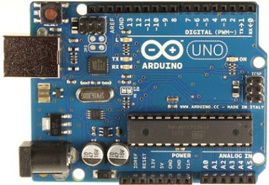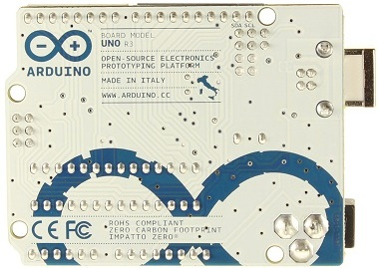

You will see a blue-green (front) and white (back) circuit board, with a number of different components on the front of the board. The most important part is the AVR microcontroller, the black rectangle located at the lower slight right of the board. This is the main component of the arduino, its ‘brain’ which provides the logic, memory, and input/output functions. A microcontroller is like an entire computer but in a single chip. Like a laptop of desktop computer, a microcontroller contains a processor core, static memory (like a hard drive) and volatile memory (like RAM), as well as ways to accept input (like a keyboard or mouse) and provide output (like a screen.) Other important parts of the arduino board include the barrel connector located on the bottom left (black cylinder) which allows you to connect battery or wired power connector, and the USB port (silver rectangle) which allows you to connect it to a computer for programming and other communications. Finally, the top and bottom of the board have female headers (rows of black sockets) which allow you to connect input devices such as switches, buttons, and sensors, or output devices such as lights or motors.

The board is also covered on the front with white letters, numbers, and logos, intending to, among other things, provide instructions to users. In particular, the top row of female headers is labeled ‘Digital’ and each hole is associated with a number or other label. Similarly, the bottom role of female headers is labeled ‘Power’ and ‘Analog In’ with labels such as ‘A0’ or ‘GND’ associated with each hole. Other visual elements include the Arduino logo, a web link, and the words ‘made in italy’. On the back, you can see the silver solder points which each of the components on the board are attached to the board traces that connect everything together. These traces are themselves visible on both the front and back of the board as a series of lines running between components. Also, words such as ‘open source electronics prototyping platform’ and ‘ZERO CARBON FOOTPRINT’ declare the political and social status of the device.

Spend a moment also reflecting on how it feels to hold and examine your arduino. If you have used the arduino before, have you ever looked at it in such detail before? Think back to critical making experience #1 and your reflections on the material technology object you examined then. How different is the arduino from your previous object? Are you experiencing any specific emotions as you engage with the arduino? What is engendering them?

**Step 2: Downloading and Installing the Software**

Go to <http://arduino.cc/en/Guide/HomePage> and follow the ‘Getting Started’ instructions.⁠4 Note that there are different procedures depending on whether your PC is running Windows, Linux, or MacOSX. These instructions will walk you through the following steps:

downloading the software,

installing it and any necessary drivers,

connecting the board,

launching the IDE application,

Opening example code,

Setting the IDE environment to your board,

Uploading code to your board.

I have found three steps to be the most trouble. First, the process for installing the software and drivers can be somewhat difficult. If you are running Windows, you must follow the driver installation process to the letter. This requires letting Windows try and fail to find and install the appropriate drivers before moving on to a manual process. If you need additional assistance, try looking at a different tutorial for installing the drivers, such as the one at <http://learn.adafruit.com/lesson-0-getting-started/installing-arduino-windows>. Also, I have found that many MacOSX users fail to copy the application to their ‘Applications’ folder and, instead, try to run it from the disk image or desktop. While this mostly works, you may sometime encounter strange errors including an inability to upload code to your arduino board.

Second, after launching the Arduino IDE, it is important to correctly set the Arduino IDE to your board and serial port. As noted above, there are many different Arduino and Arduino compatible boards. In order for the IDE to work properly, it must be told what board you are using. THis step is described in the guide listed above, but is a step that is sometimes missed. Similarly, the IDE needs to be told which serial port on your laptop or desktop is connected to your arduino board. It can sometimes be difficult to figure out which of the serial ports listed under the ’Tools/Serial Port’ menu item in the IDE corresponds to your Arduino board. The simplest way I have found to discover which it is, is to look under the Tools/Serial Port menu in the IDE **with your Arduino unplugged,** and make a note of what is there. Then, plug your Arduino into the USB and look again at the Tools/Serial Port menu item. Select the new item that you see there and you should be good to go. If you do not see any change, check to see if you properly installed the drivers.

Third, how do you know whether you are successful? Following the instructions in the guide requires you to open example code - File > Examples > 1.Basics > Blink and, following successful configuration, to click the ‘upload’ button (the right facing arrow icon). This kicks off a complex process involving the following steps;

1) the example code you selected (the ‘blink’ program) is compiled, e.g. translated from human-readable source code into machine code;

2) the arduino IDE sends a command over the USB cable to the bootloader software running on the Arduino board asking it if it is ready to receive a program;

3) the bootloader responds that it is ready;

4) the Arduino IDE streams the machine code to the arduino board;

5) the bootloader saves the code to static memory, notices when it is done, and reboots the arduino;

6) the arduino board executes the code.

Traces of these steps can be seen if you look carefully. The status bar will show ‘done compiling’ and the program notification area will respond with the size of the machine code as ‘Binary Sketch size” if the compilation and uploading is successful. Also, you can see the upload request, response, and the streaming of the machine code by watching the serial transmit (TX) and serial Receive (RX) lights on the arduino board.⁠5 Note here that tracing this process requires you to move between the software IDE and the hardware board, to look for error messages on a screen as well as physical changes (lights going on and off) in order to understand what is going on.

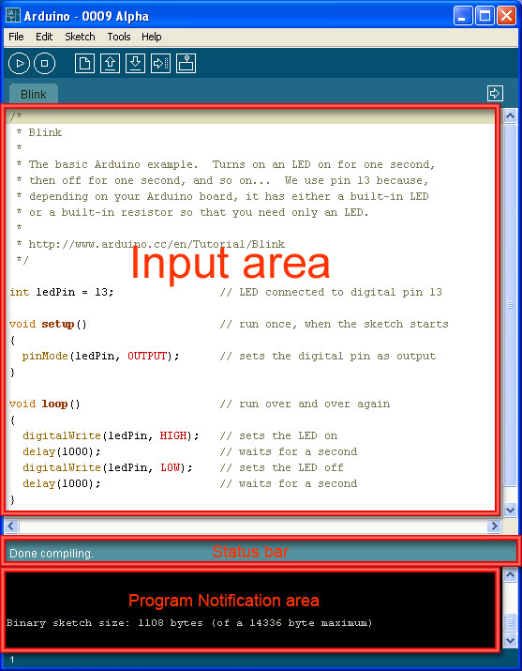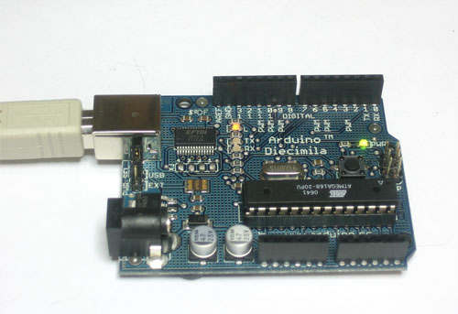

If you have successfully installed and uploaded code to your arduino board - congratulations! The steps involved are somewhat complex and involve operations and activities that are not entirely familiar to non-developers. It can be difficult to trouble-shoot problems when they occur, since the systems works at a number of different levels - software IDE and drivers, hardware board and serial ports - and making the whole chain work together requires you to think across these levels and to figure out where the problem occurs. Success can be as difficult to recognize as failure and the process of observation requires moving between the parsing of debug messages from the software as well as close observation of the hardware.

**Step 3: Controlling the blinky-blink**

The next step is to customize the example code and extend the arduino hardware. Currently, your Arduino board should be plugged in via USB to your laptop or desktop computer, and you should be running the Arduino IDE. The green PWR light (left middle top) should be lit and the yellow test LED (below Pin 13 close to the top) should be blinking. This test LED shows the status of Pin 13, turning on if power is flowing to this pin, and turning off when no power is flowing.

Take a look at your LED. It should look something like the one below. Note that one leg is shorter than the other. This is because LEDs are polarized, meaning that in order for the to work, the proper leg needs to be connected to GND and the other to PWR. The convention with LEDs like yours is for the shorter leg to be the GND leg. Try inserting your LED into the headers on your arduino. Insert the shorter leg into the top header pin marked ‘GND’ and the longer leg into the pin marked ’13’.

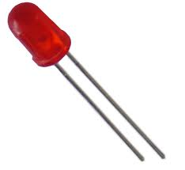

If you did this correctly, your LED should begin to blink in time with the test LED on your board. If it doesn’t blink, make sure you have inserted it into GND and pin 13 ,and try reversing the legs. If you cannot get it to blink (and your test LED is blinking) try a different LED.

Now try customizing the source code. Look again at the input area on the Arduino IDE. You should see the following code:

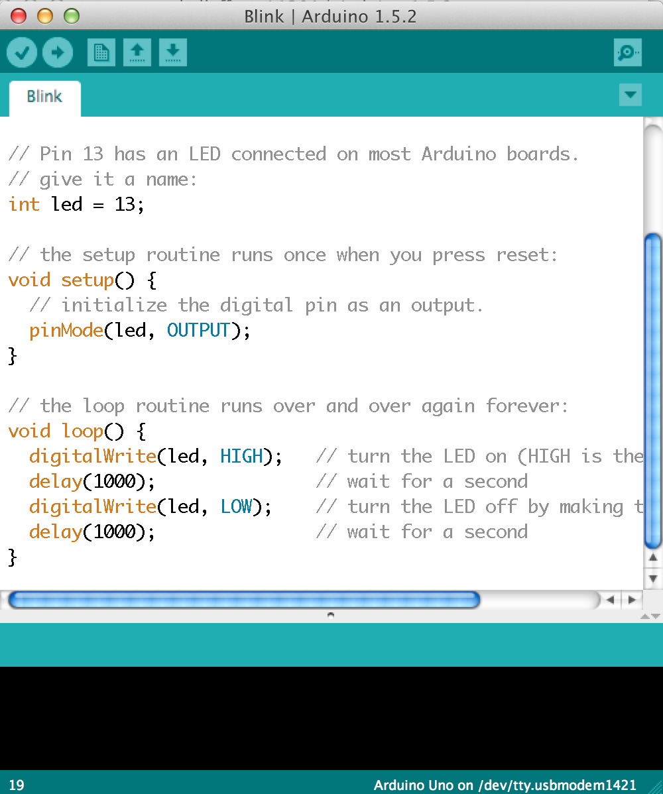

For a more detailed overview of what is happening in this code example, see <http://arduino.cc/en/Tutorial/Blink> or <http://learn.adafruit.com/adafruit-arduino-lesson-1-blink>. For now, just focus on the following section of code:

// the loop routine runs over and over again forever:

void loop() {

digitalWrite(led, HIGH); // turn the LED on (HIGH is the voltage level)

delay(1000); // wait for a second

digitalWrite(led, LOW); // turn the LED off by making the voltage LOW

delay(1000); // wait for a second

}

As noted in the comment (marked by the //) this is the section of the code that repeats over and over again as long as the arduino receives power. In it two commands are being executed; a ‘digitalwrite’ and a ‘delay’. The digitalwrite command is used to set the status of the led (actually pin 13 in this example), with HIGH sending power to the LED and LOW turning this power off. The delay command simply stops execution of the code for the number of milliseconds contained with the brackets. Delay(1000) therefore stops the code for approximately one second.

Try changing these delay statements to speed up or slow down the rate at which the LED is blinking. Once you have made changes to the code, remember that you need to re-upload it to the arduino by pressing the ‘upload’ button (the right facing arrow icon). What happens if you increase or decrease the numbers equally in both delay statements? What if you increase one and decrease another? What happens if you add additional digitalwrite statements and delays with different values to this section? How would you create a blinking morse code ’SOS’ pattern - pause-long blink-short blink-long blink-pause?

**Step 4 - Review**

What might you have learned from this encounter with the arduino system? First, you hopefully have a better sense of the complexity of technological objects. As the arduino example highlights, technical features alone do not determine a technological artifact. Instead, they are better addressed as complex phenomena and as resulting from and maintained by material-discusrive practices through which the political, the technical, and the social are depicts and deployed. Further, you have participated in this process through the decision-making you engaged in when sourcing your arduino, an experience which highlights our complicity even as consumers in the complex arrangements through which objects are stabilized and maintained.

Although it seems obvious to state, your own engagement with the arduino was markedly different if you actually obtained the parts listed above and attempted to carry out the above steps, rather than reading them and imagining yourself doing so. The experiences of finding an arduino and the other parts, downloading and installing code, and working through the example code make use of different physical and cognitive resources than the apprehension and act of imagining yourself engaged in such operations. Even if your experience matched act for act and cognitive operation to cognitive operation the depiction of the process in the text above, your phenomenological experience would be different. Of course, your experience probably did not match all that well, given the reductive way the text and images above depicted what you were expected to accomplish. You might have borrowed an arduino from a friend and had a heated discussion regarding its status as ‘official’ or not, or ordered one from an online vendor through a complex process involving drop down menus, credit cards, and postal codes. The phrase ‘obtain an arduino’ could not hope to capture all the possible complexities attending such a process. You might have had difficulty connecting the arduino to the USB cable and to your PC because of the resistance of the cable and the way it can flip the arduino around. The phrase ‘plug it in’ could not hope to capture the complicated physical moves you needed to carry out to accomplish this.

One way to parse these differences is by noting the differences between tacit and explicit knowledge and, following Polyani and others (Polyani, 1958, 1966; Lam, 1996, Nonaka and Takeuchi, 1995; Collins, 2001) highlight the difficulties in formally and explicitly articulating even simple activities such as using a hammer to hit a nail. More over, we might emphasize the need for a ‘knowing subject’ and practical and shared experiences in order to engage in activities requiring tacit knowledge. We can also affirm the importance of an individual’s commitment and relation to the context of action (Nonaka, 1994:21) as other key elements in making sure we can move easily between these two levels. We do not need to defend the importance of tacit knowledge or the value of explicit articulations - that has already been done for us. But critical value can be found by examining how these levels are established and maintained, what kinds of information are made explicit within relevant communities, and how such practices work to normalize certain activities and denormalize others. But leveraging definitions of tacit/explicit do little to explain the relevance and importance of the differences between your experiences and the textual and pictorial descriptions above, particularly since we are not interested in coherence between explicit descriptions and tacit experience. Instead, we need to focus on the differences and incommensurable aspects, given our goal is to better understand how the physical, embodied engagement supplements and extends critical reflections that are typically considered through explication and formal means.

## Wrapping up

Despite my best attempts, the arduino critical making experience described above does not entirely steer clear of reductive separations of ‘social’ and ‘technical’ due in part to a desire to make the process comprehensible - requiring a certain obedience to genres and processes associated with technical work. In section I I noted Problem one:

**Problem one - there remains a commitment to realist ontological claims often held within constructionist pedagogy that needs to be overcome in order for these forms to be embraced within disciplines (such as the interpretive humanities and social sciences) where such claims are held as suspect.**

I have noted above that Arduino developers and users do recognize the politics and social nature of the Arduino object and that they engage in this work as part of the process by and through which the Arduino is constituted as Arduino. However, it is clear that the ‘social and political’ work of Arduino is kept separate from the ‘technical’ work. The tutorials linked above and, in fact, all tutorials that I have seen that teaches how to use and develop with the Arduino, provide resources for carrying out technical operations - writing code, installing drivers and libraries, and assembling hardware. Breaking out of this domain to engage in subjective reflection (e.g. ‘How do you feel when…’) or political critique seems foreign precisely because of “the whole tacit system of intellectual procedures” (Agre, 1997) associated with the technical disciplines.

Most experiences with the arduino are bounded in part by this reliance on a genre of technical writing - the tutorial which instantiated realist commitments, leaving little room for social reflection or thought that does not fit within an instrumental logic. Without acknowledging the limits of this genre as it is typically performed, it is difficult to move beyond the strong social and technical separations that are a core component of ontological realism. However, upon reflection one might use our experiences butting up against this limit to analyse the obdurancy of material-discursive practices and to start to analyze how social formations and objects are co-constructed through specific ‘agential cuts’ (Barad) that create and normalize relations between discursive and non-discursive practices. In this sense, the obdurancy of the ontological commitments of technical work and related constructivist educational forms acts both as something to be overcome but also as a prompt for better understanding social formations marked by these forms of work.

Equally, the above tutorial engages but also extends upon the typical technical tutorial. It walked you through a technical process, makes use of example code, and even uses the ubiquitous ‘hello world’ of physical computing, the blinking of an LED. However, it also intersperses this technical focus with prompts for other kinds of reflection, asking you to think about the social and political work associated with the Arduino licenses and to examine your own feelings and emotions regarding your engagement with the device. Such extensions into the realm of the affectual and the political demonstrate that it is possible to break genre conventions and associated realist commitments to open the ground for alternative ontologies.

In Section II, I also noted Problem Two:

**Problem Two – in our move to incorporate making as part of a critical repertoire we need to avoid the material romanticism and individualism that often colors this work.**

You may now have some knowledge with this issue, potentially having experienced the heady glow of successful Arduino blinking. It is tempting to bask in the power of technical work and to be captured by the sense of control and agency that it offers. But making in and of itself is not enough (for a critical maker.) Instead, one must remain cognizant of the ultimate purpose of the work and be ready to move outside the individual moment of making to engage with other scholars and thinkers. As noted in Section I, like Gauntlett I believe that all making can be critical making, but it requires moving outside the material romanticism often associated with making to address the larger socio-material issues.

**Problem three – how to work within, critique, and remain cognizant of the epistemic commitments of the science and engineering as well as art and design communities in which we engage in order to maintain the commitments of our own disciplinary affiliations?**

Addressing problem three requires an initial focus on processes and not objects as the most important outcome of critical making experiences. Rather than work on creating things intended to have an effect on others either through aesthetic or instrumental forms, critical makers must carry out non-object oriented making activities in order to exercise new ways of thinking through making. This process focus can help prevent the kinds of end-gaming

**Problem four: How to address continuing deep belief, ‘habit’ of relying on discursive, linguistic description as ‘site’ for critical reflection (even within ourselves!)**

Need to do stuff! Story about book manuscript – of course won’t do the exercises!! Big resistance to making, difficulty believing. Need to exercise these muscles as well. What did you learn by doing the arduino thing not just reading about it. CF Descartes ball of wax example… etc.



1 I will return to the value of the maker movement for critical making later in this chapter. For now, suffice it to say that the openness and willing to share expertise

2 This turns out to be relatively difficult to do, given the ways most arduino counterfeits mimic the design characteristics of official arduinos. See here for guidance by the official developers regarding counterfeits - <http://arduino.cc/en/Products/Counterfeit>.

3 Though note the emergence of this complexity when controversy arises. For example, USB as a social, technical, and institutional standard is revealed by cases involving the emergence of new standards and the ways tech companies jockey for power regarding these developments, e.g. Intel and USB 3.0 specifications.

4 If you need additional assistance, there are a variety of excellent online tutorials that can walk you through the process of installing the Arduino software. My personal favorites are the tutorials up at http://learn.adafruit.com.

5 images pulled from arduino.cc and adafruit guides.

1. It is misleading to distinguish critical thinking and critical making by saying that the latter involves material mediation while the former is entirely ‘mental.’ There is a diversity of work that notes the importance of material mediation in processes of cognition, including scholarship associated with Cultural Historical Activity Theory (Vygotsky, Leontiev, Engestrom, Nardi & Kaptelinin) and third-wave cognitive science of which Hutchins is a primary example (Cognition in the Wild, Hutchins, 1995) However, what differentiates critical making practices are their explicit attention to the role of the material world and the resources it provides for conceptualization and communication.
2. This list of names is not in any way exhaustive - but it is intended to represent the diversity of contexts and disciplines involved in material-conceptual practice. These include computer science, Design, STS, Law, History, Literature, Environmental Science, and Art.
3. do I need to add links here to scholars such as Mathew Fuller - media ecology, Lisa Gitelman, Parikka, Kittler? that do not do art of their own but do provide frameworks and methods for contextualizing, analysing, and relating it? think about this