## Working with Forms in SharePoint Online

**Lab Time**: 45-60 minutes

**Lab Folder**: C:\Student\Modules\Forms

**Lab Overview:** In this lab you will customize the forms for a SharePoint list and you will also create a Forms library, create a basic InfoPath Form, and create a New, Edit, and Display Form for a List library.

### Exercise 1: Create Custom Form for SharePoint List

In this exercise you will learn how to create a custom form using an existing SharePoint list and learn how to hide controls from a form.

#### Log in to SharePoint Online Site

1. Make sure you have the login information for the SharePoint environment where you will work on your lab exercises. You should have received this log in information from the hosting training company or from your instructor.
2. Make sure you have the URL to the **Team Site** that has been created for you to do your lab work. This URL will be in a form that looks something like this.

https://cptclassroom101.sharepoint.com/sites/Student_Teamsite

1. Launch Internet Explorer and navigate to the URL of the Team Site mention in the previous step. Note that you should be logged in with a user account that has full control and access to the site collection, and therefore will be permitted access and be able to create lists.
   1. When prompted to login, enter the user name and password that has been supplied to you and then click **OK**.

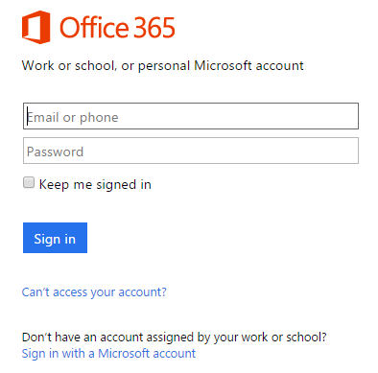

* 1. You should be able to confirm that you are logged into the SharePoint site. For example, if you were logged in as a student named **John Doe**, your name would appear in the SharePoint Welcome menu as shown in the following screenshot.

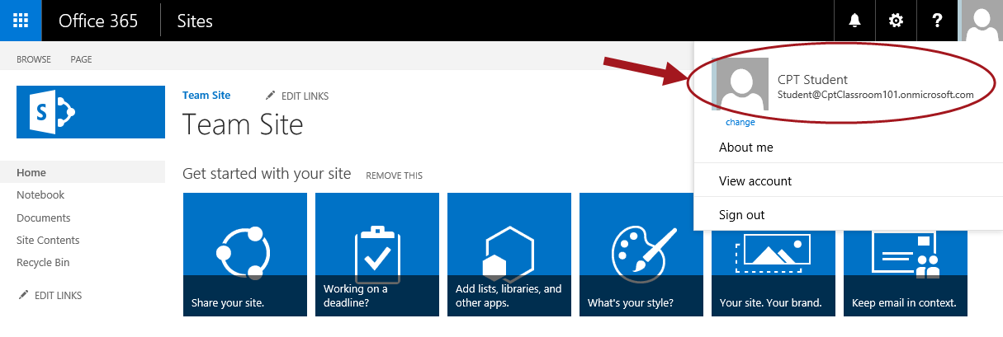

#### Use Customize Form Option

1. Navigate to the Site Contents:
   1. Click on the **Settings** icon and select **Site contents**.
2. **Click on the Issue Tracking tile.**



1. From the **All Issues** view, click on the **+ new item** link to open the New form and notice how the default form looks.

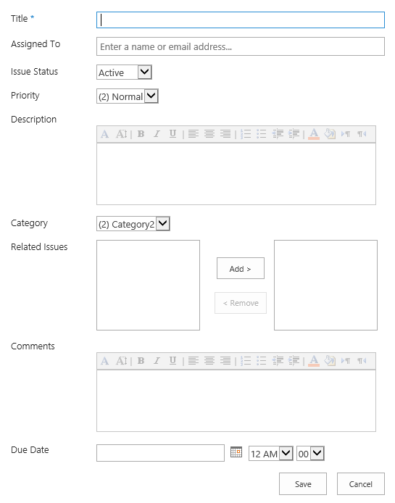

1. Once you have seen what the standard **New** form looks like for the **Issue Tracking** list, click **Cancel**.
2. From the **LIST** tab in the **Customize** **List** group, click **Customize** **Form**.

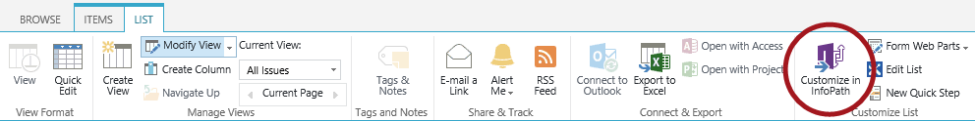

1. From the **Internet Explorer** confirm open dialog, click **Allow**.

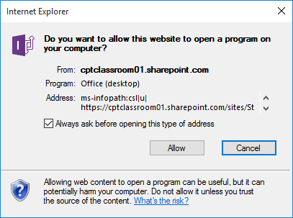

1. From the **Microsoft** **Office** open file confirmation dialog, click **Yes**.

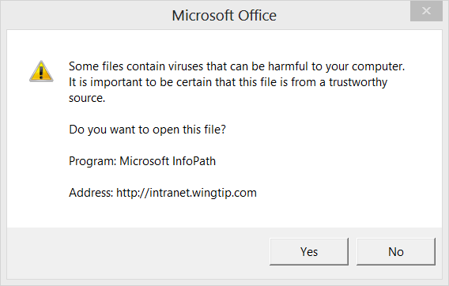

1. When prompted for credentials, enter your **O365 User ID** and click **Next**.

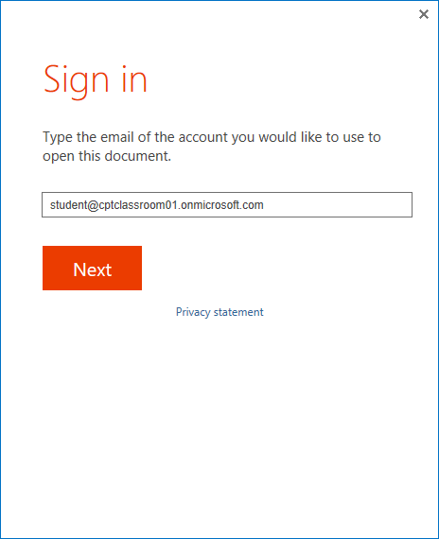

1. Then enter your **Password** and click **Sign in**.

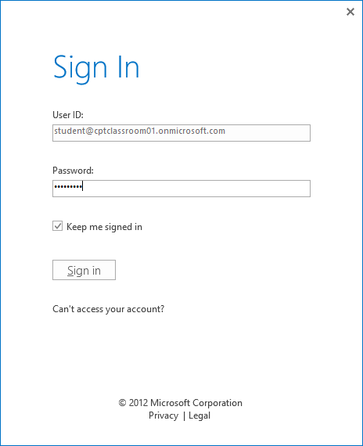

1. **InfoPath Designer 2013** will open with the form in Design mode.

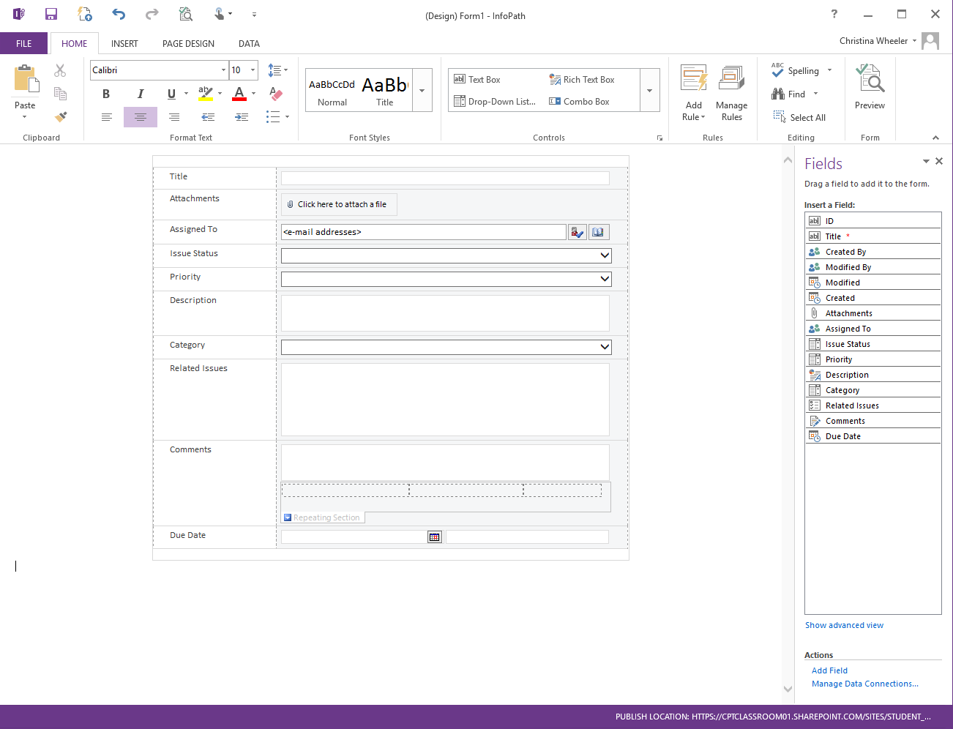

#### Publish the Form

1. Click the **Quick** **Publish** icon above the ribbon to publish the form.

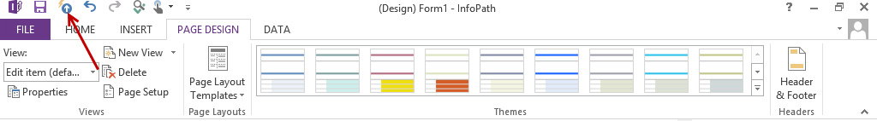

1. From the **Publish** dialog, click **OK**.

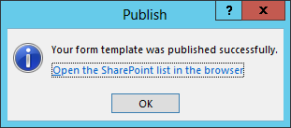

1. Go back to the browser and navigate back to your **Issue Tracking** list.
2. From the **All Issues** view, click on the **+ new item** link to open the New form and notice the form has been changed to the customized form you published.

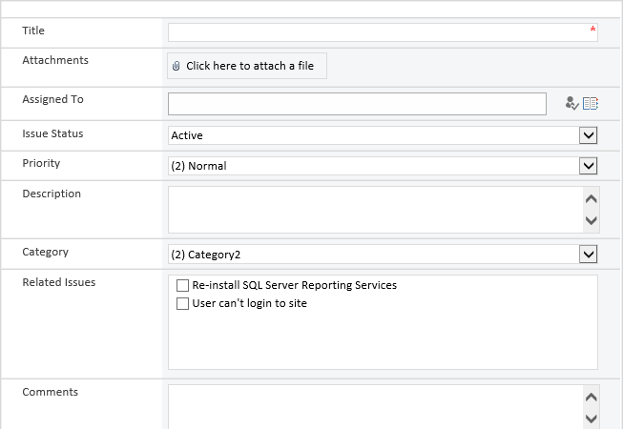

1. From the **EDIT** tab in the **Commit** group, click **Close**.
2. From the **All Issues** view click on **Issue ID 1** to see how the form is displaying for viewing the item.

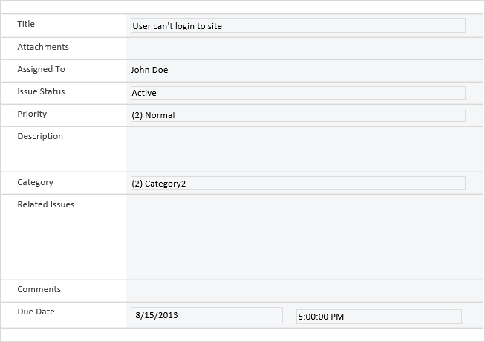

#### Edit the Custom Form

1. Go back into **InfoPath Designer 2013**. Make changes to the form such as hiding the borders, deleting the Attachments row, changing background colors.
2. Once all desired changes are complete, re-publish the form using **Quick Publish**:
   1. Click the **Quick** **Publish** icon above the ribbon to publish the form.



* 1. From the **Publish** dialog, click **OK**.

1. From the browser, navigate back to the **Issue Tracking** list.
2. **Edit** or **create a new item** to see how the form is being displayed.

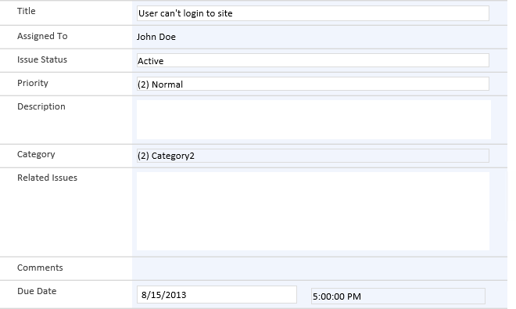

1. Go back to the browser and navigate back to your **Issue Tracking** list. Test your form by creating a new item.

### Exercise 2: Creating Form Template and Forms Library

In this exercise you will learn how to create a form using the blank form template, add controls to the form, and preview the form using InfoPath Designer 2013.

#### Create Form Using Blank Form Template

1. Open the **InfoPath Designer 2013** client if it is not already open.



1. From the **New** tab in the **Available Form Templates** section under the **Popular Form Templates** group, double-click on  **Blank Form**.

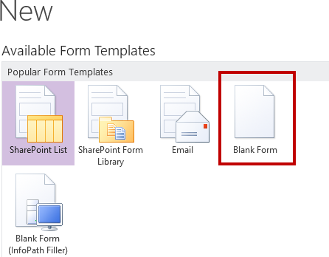

1. InfoPath creates a new form using the default Blank Form template.

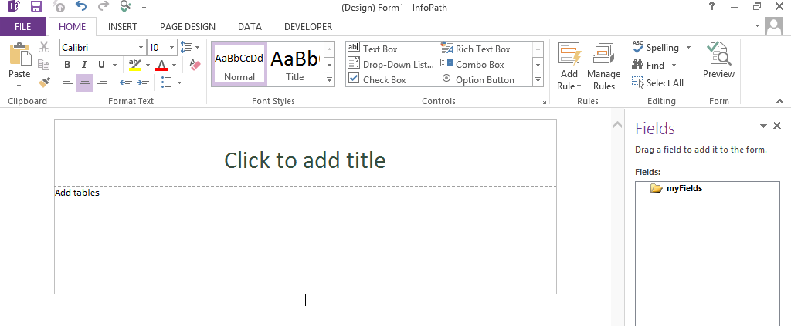

1. Modify the form:
   1. Click the **Click to add title** text that appears and enter a title for the form.

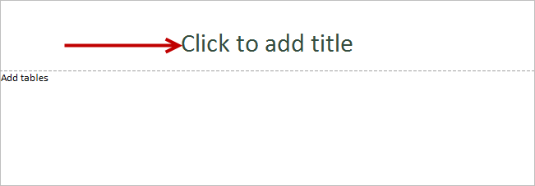

* 1. At the bottom section of the form, click on **Add tables**.

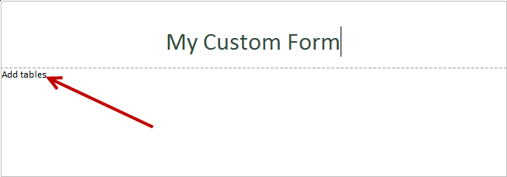

* 1. From the **INSERT** tab, select the **Two-Column 4** **No Heading** table in the Tables section.

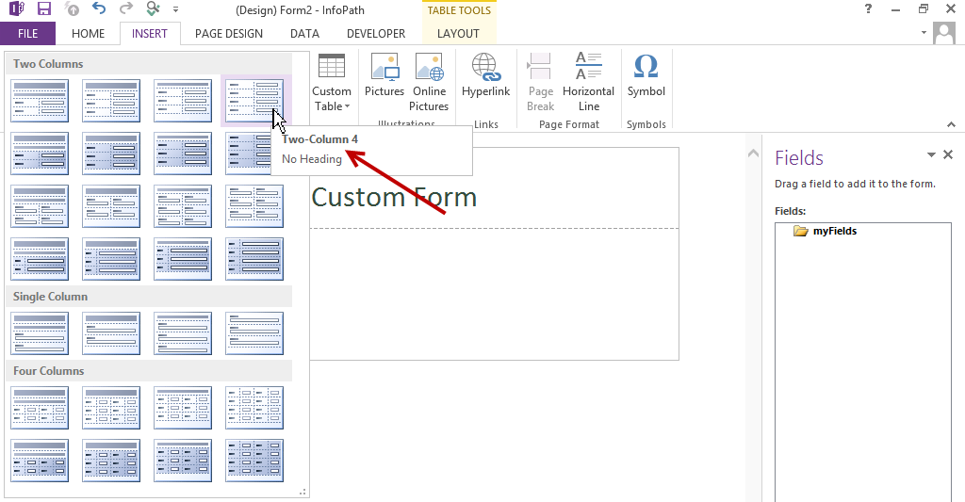

1. The table is now updated on your form.

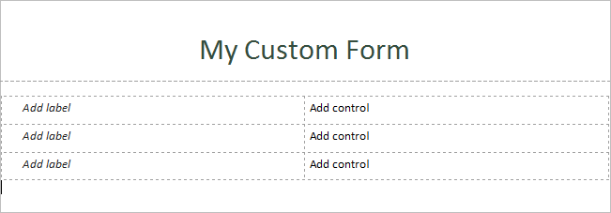

1. Click the **Save** icon to save the file.
2. From the **Save As** dialog, navigate to **C:/Student/Modules/Forms**.
3. Enter a **File name** for the form such as **MyCustomForm.xsn** and click **Save** to save a local copy of the form.

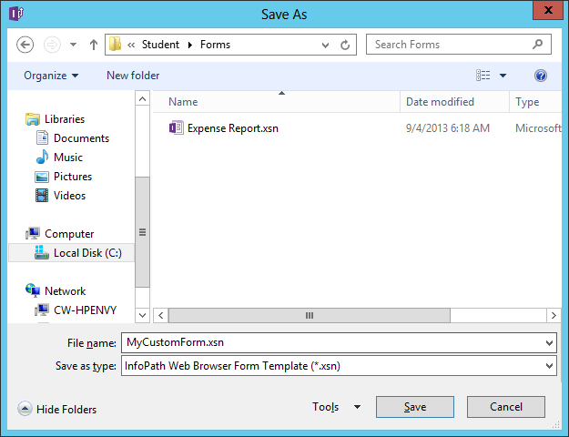

#### Add Controls to your Custom Form

1. Update the labels:
   1. Click on the first **Add label** cell and type **Name**.
   2. Click on the second **Add label** cell and type **Email**.
   3. Click on the third **Add label** cell and type **Phone**.

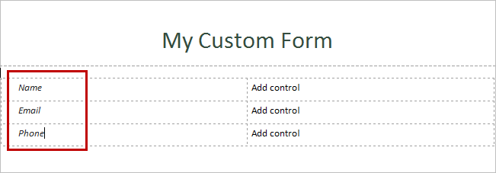

1. Add text box controls:
   1. Click on **Add control** in the cell next to the **Name** cell.
   2. From the **HOME** tab in the **Controls** group, click on **Text Box**.

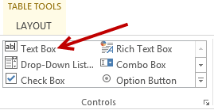

* 1. Notice the **field1** text box has been added.

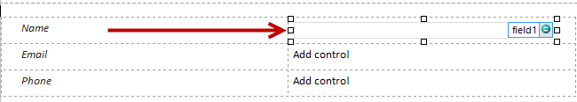

1. Repeat the steps to add a text box for Email and Phone.

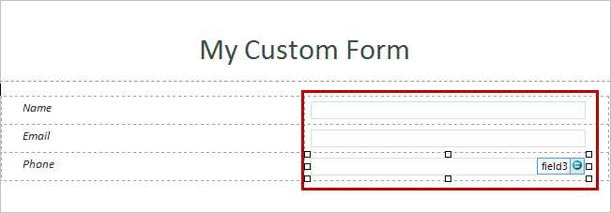

1. Rename the text box fields:
   1. Right-click on **field1** and select **Text Box Properties**.
   2. In the **Field name** text box, rename **field1** to **txtName**.

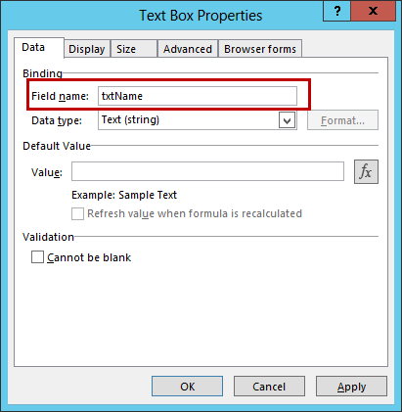

* 1. Click **OK**.

1. Repeat the steps for the renaming text boxes:
   1. Change **field2** to **txtEmail**.



* 1. Change **field3** to **txtPhone**.



1. Click the **Save** icon to save the file.

#### Preview the Form

1. From the **HOME** tab in the **Form** group, click the **Preview** button.

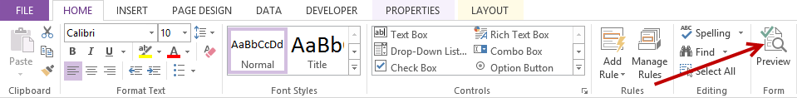

1. The form is now in Preview mode.

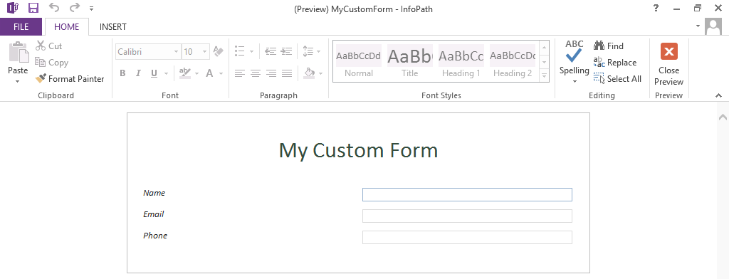

1. To exit preview, click the **Close Preview** button located in the HOME tab Preview section.

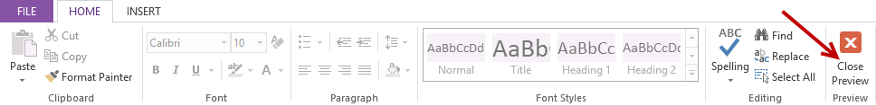

1. **Save** the form by clicking on the **Save** icon in the ribbon tools.

### Exercise 3: Publish Form and Configure Submit Options

In this exercise, you will publish your My Custom Form, configure the submit options, as well as fill out and submit the form.

#### Publish Form

1. Click on the **FILE** tab in the ribbon.

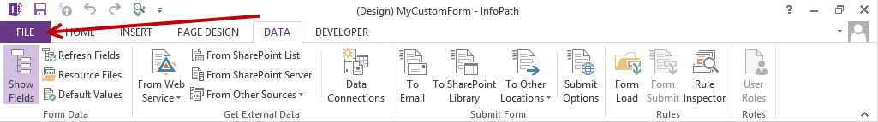

1. From the **FILE** panel, click on **Publish** in the left category options and then click on the **SharePoint** **Server** button.

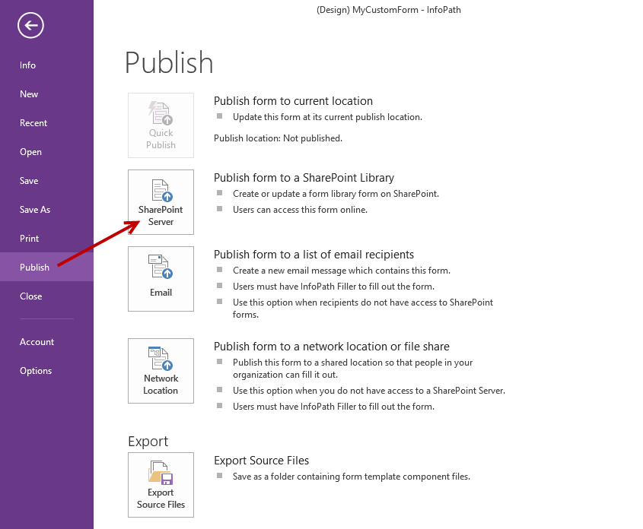

1. In the **Enter the location of your SharePoint of InfoPath Forms Services site** text box, type the URL of your Team Site and then click **Next**.

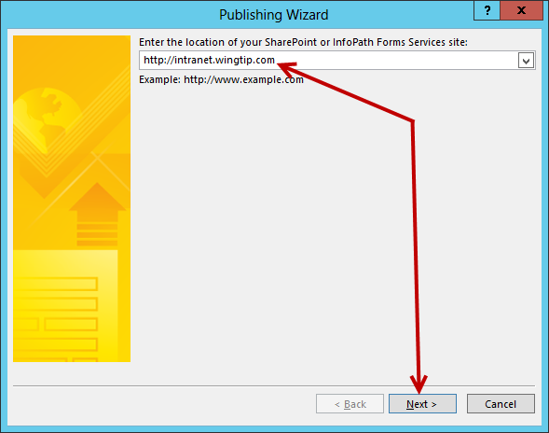

1. Ensure the **Enable this form to be filled out by using a browser** is checked and **Form Library** is selected and then click **Next**.

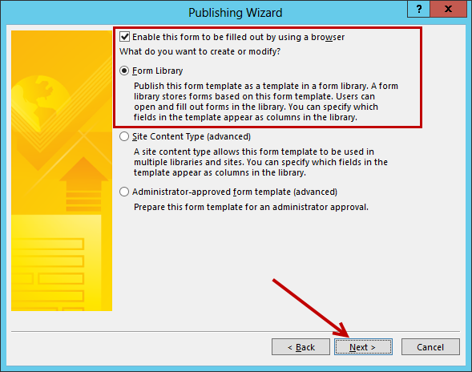

1. In the **What do you want to do option**, ensure **Create a new form library is selected** and then click **Next**.

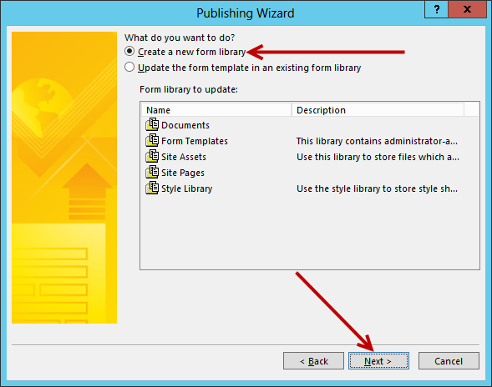

1. In the **Name** text box, type **Forms** and then click **Next**.

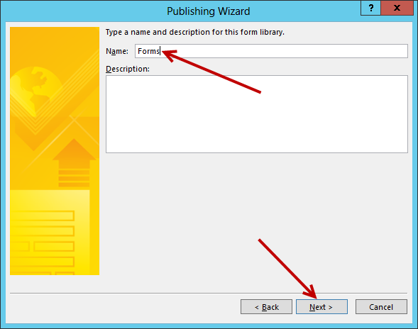

1. In the step to add columns and parameters, leave everything as default and then click **Next**.

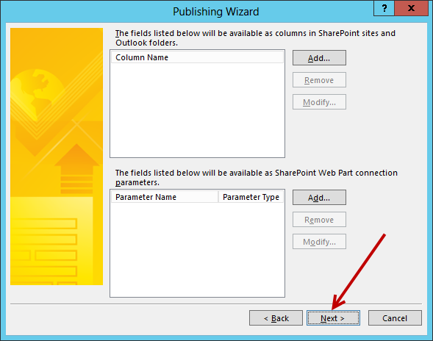

1. In the **Verify the form information below and then click publish** step, click **Publish**.

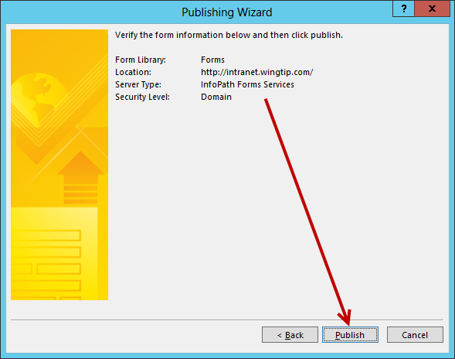

1. A **Publishing** dialog will display with the **Connecting to InfoPath Form Services** message.

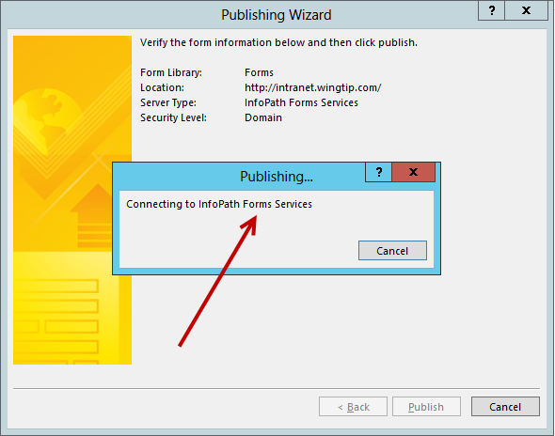

1. Once the publishing is complete, you will see the **Your form template was published successfully** status message along with a summary of the information. You can click on the **Open this form in the browser** link to open the form in the browser and/or check **Open this form library** and click **Close**.

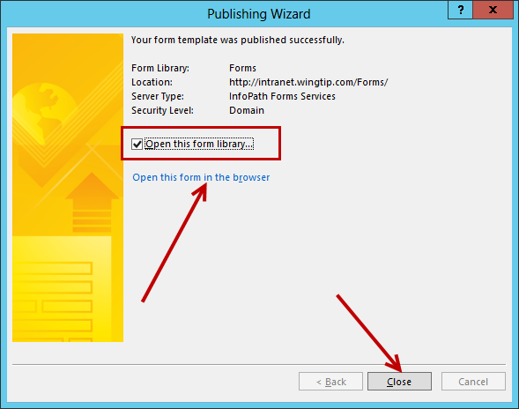

1. The **Forms** library is now open in the browser.

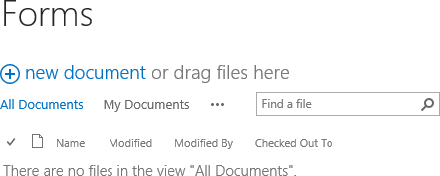

#### Configure Submit Options

Now that you have published the form, the next step is to setup the Submit Options of the form.

1. Go back into **InfoPath Designer 2013** and make sure the **MyCustomForm.xsn** file open.
2. Click on the **DATA** tab in the ribbon and then click on the **Submit Options** ribbon button.

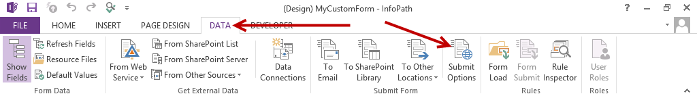

1. From the **Submit Options** dialog:
   1. Ensure **Allow users to submit this form** is selected.
   2. From the **Send form data to a single destination** drop-down list, select **SharePoint document library**.

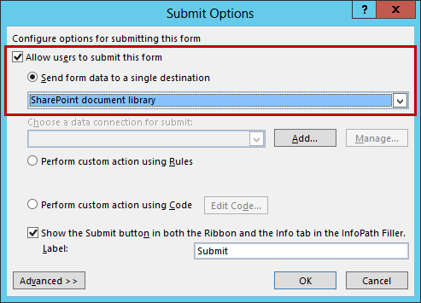

* 1. Click the **Add** button next to the grayed out **Choose a data connection for submit** drop-down list.

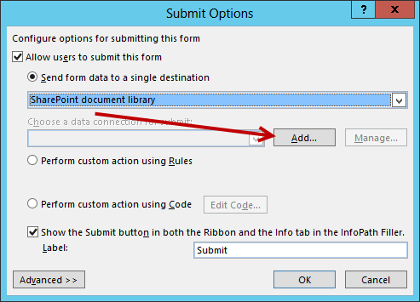

1. In the **Data Connection Wizard** dialog step:
   1. In the **Document library** text box, type the URL to the newly created Forms library you created in the previous steps. **https://cptclassroom101.sharepoint.com/sites/Student_Teamsite/Forms**

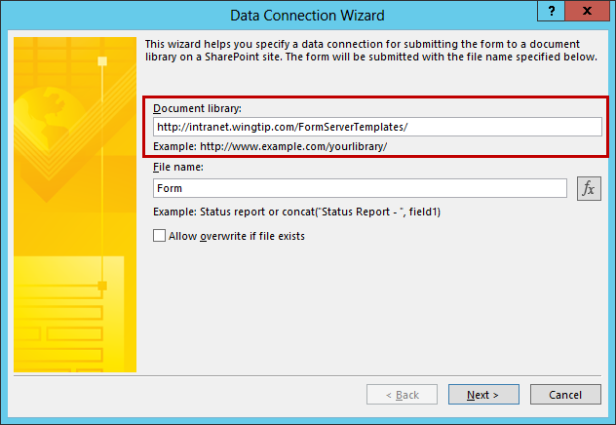

* 1. Click the **function button (fx)** next to **the File name** text box.

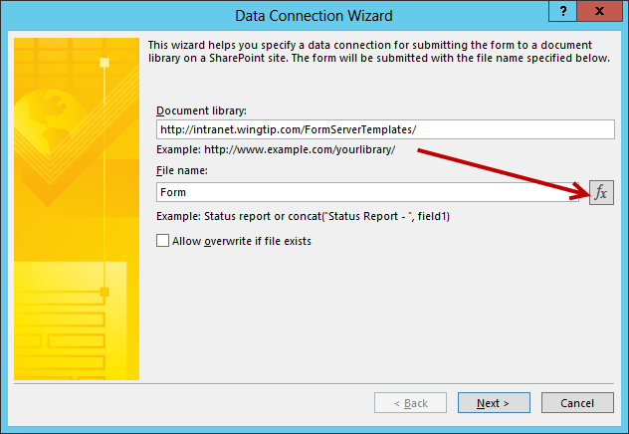

* 1. From the **Insert Formula** dialog, click on the **Insert Function…** button.

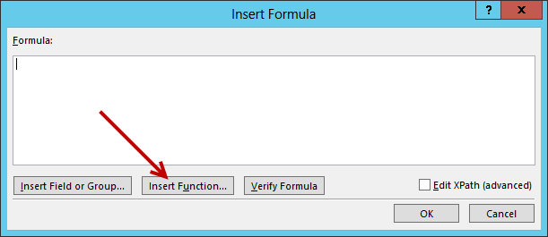

* 1. From the Insert **Function** dialog in the **Functions** list, select **concat** and click **OK**.

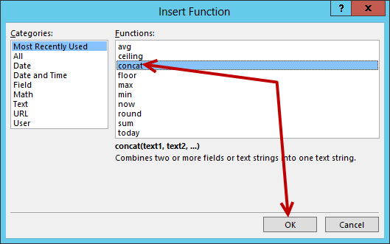

* 1. Inside the **concat** function, double-click on the first **double click to insert field** link.

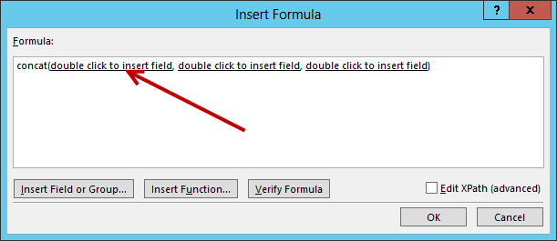

* 1. From the **Select a Field or Group** dialog, select **txtName** and then click **OK**.

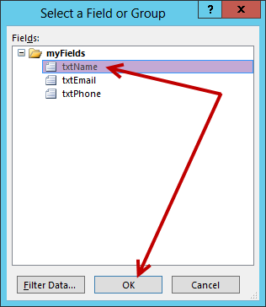

* 1. Inside the **concat** function, select the **double click to insert field** link next to **txtName** hit the **Delete** key. Do the same for the last **double click to insert field**.

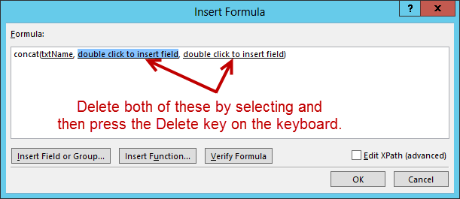

* 1. Delete the extra commas and then place your cursor after **txtName,** and then click on **Insert** **Function**.

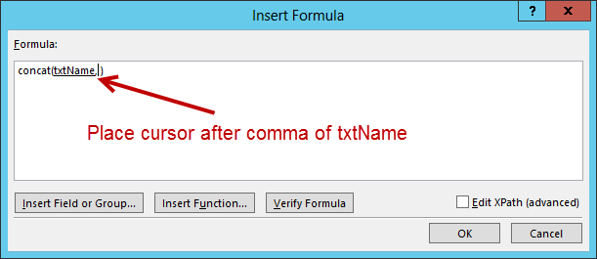

* 1. From the **Insert Function** dialog, select **Date** from the **Categories** list and select **today** in the **Functions** list and click **OK**.

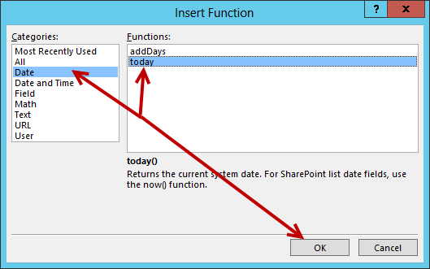

* 1. Click on **Verify Formula** to ensure there are no errors in the syntax.

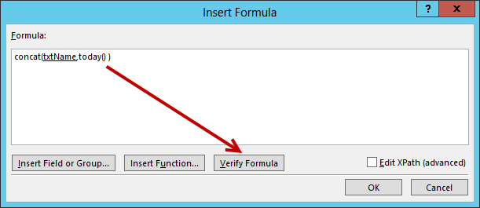

* 1. If there are no errors an information dialog will display with the message **The formula does not contain any errors.** If there are no errors click **OK.**

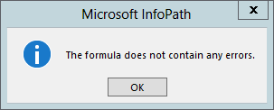

* 1. From the **Insert Formula** dialog, click **OK** to close the dialog.

1. The **Data Connection Wizard** dialog will now display your new formula in the **File name** text box.
2. Check **Allow overwrite if file exists** (optional) and then click **Next**.

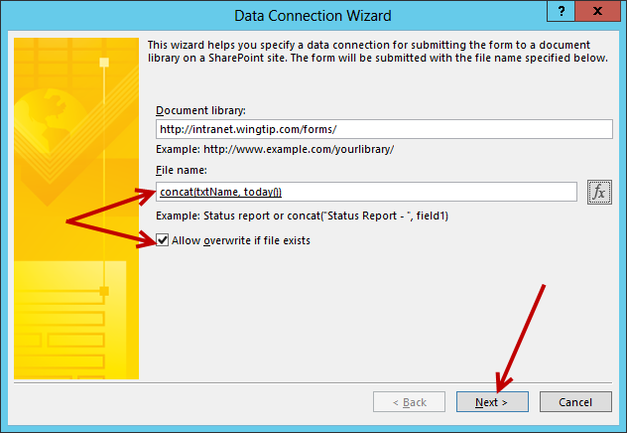

1. If prompted for a password, type the password for the credentials supplied at the beginning of this lab and click **OK**.

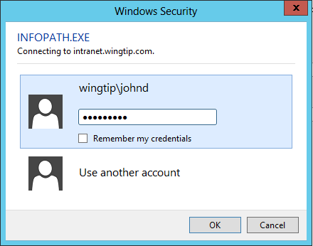

1. In the **Enter a name for this data connection** text box, leave the value set to **Main submit**. Ensure the Summary information is correct and then click **Finish**.

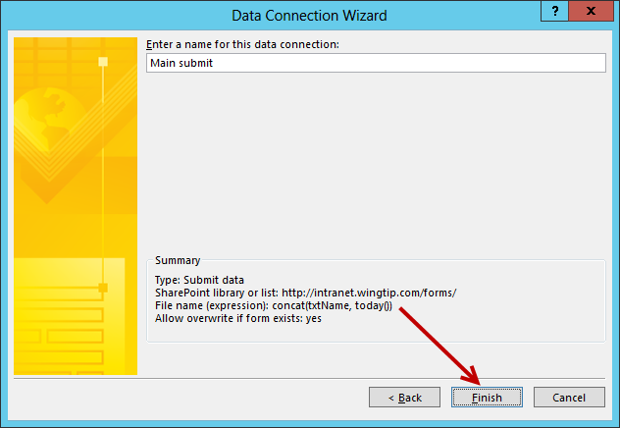

1. In the **Submit Options** dialog, notice the **Main submit** is now set as the **Choose a data connection for submit** and click **OK**.

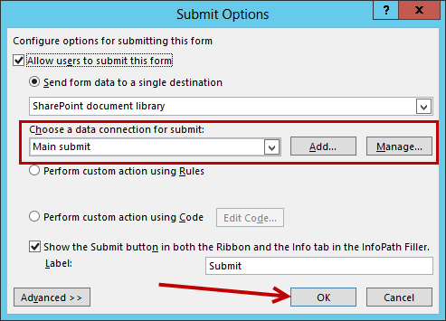

1. Re-publish the form to SharePoint. To **Quick Publish**:
   1. Click the **Quick Publish** icon located in the ribbon.

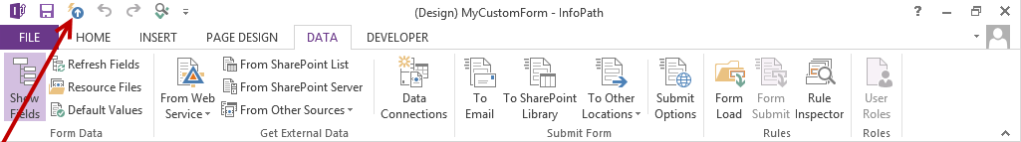

* 1. Once the form is successfully published, a Publishing information dialog will display with the message **Your form template was published successfully.**
  2. Click on the link **Open this form in the browser** to view your published form.

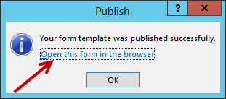

1. The form is now is now opened in the browser.

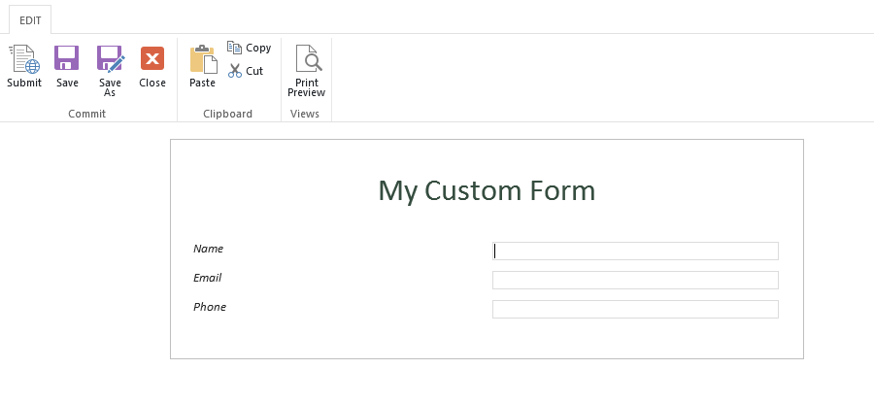

#### Fill Out Form and Submit

1. With the form open, fill in desired information in the **Name**, **Email**, and **Phone** text boxes.

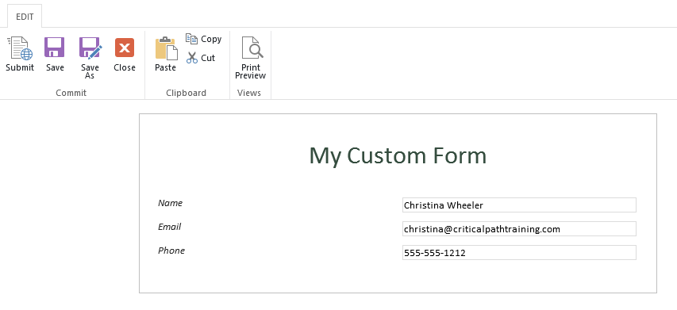

1. Once complete, click the **Submit** button located in the **EDIT** tab ribbon.

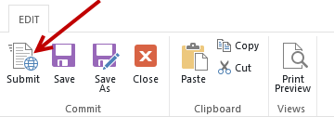

1. A notification displays with the message **Sending data to the server**.

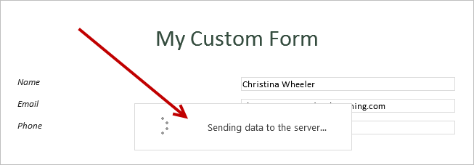

1. Once complete, the form will save to the library and you will be redirected to the **Forms** library.
2. Notice the file is saved and the file name is based on the formula that was set in the submit and data connection options.

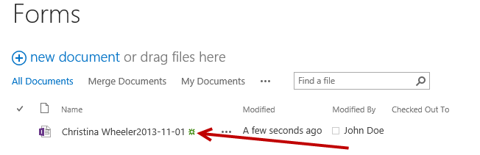

### Exercise 4: Customize Form and Re-publish

In this exercise, you will customize the existing custom form created in previous steps. You will add submit and cancel buttons, disable some of the controls in the form options, and set controls to required fields.

#### Add a Submit Button

1. Go back into **InfoPath Designer 2013** and make sure the **MyCustomForm.xsn** file open.
2. Place your cursor inside the form below the **Name**, **Email**, and **Phone** fields. Press the **Enter** key **twice** to make new lines.

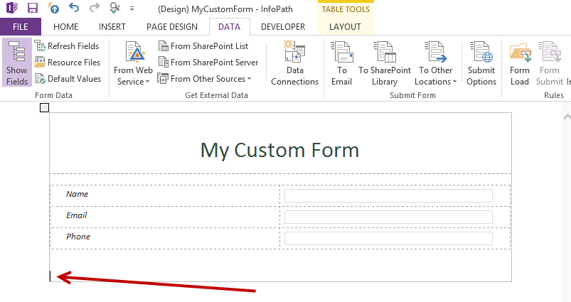

1. From the **HOME** tab in the **Controls** group, click the arrow to drop-down the list of menu buttons. Click on **Button** located in the **Objects** section.

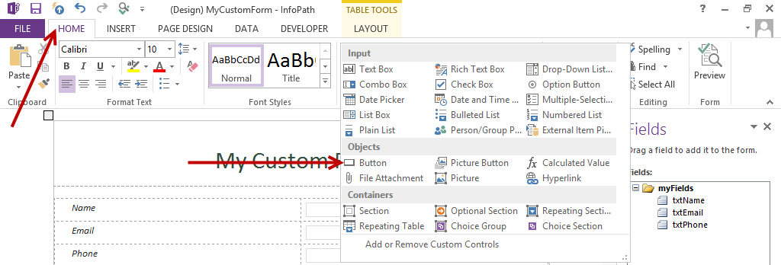

1. A button control is now added to the form with the text **Button**.

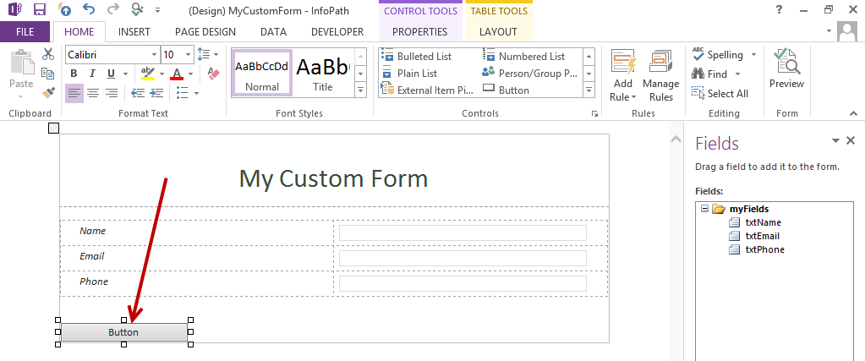

1. Right-click on the button and select **Button Properties…**

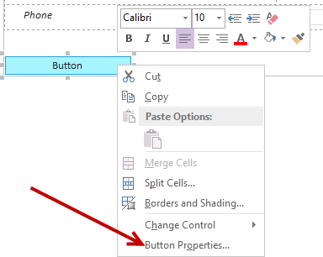

1. From the **Button Properties** dialog, in the **Action** drop-down list select **Submit** and then click on the **Submit Options…** button.

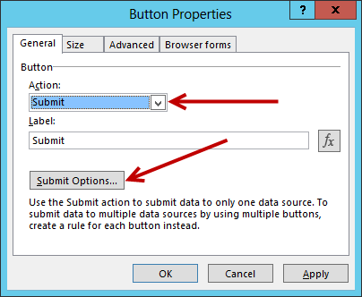

1. From the **Submit Options** dialog, ensure **Allow users to submit this form** is set to **SharePoint document library** and the **Choose a data connection for submit** is set to **Main submit**.
2. Click **OK**.

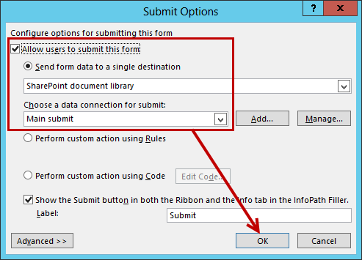

1. In the Button Properties dialog, click **OK**.

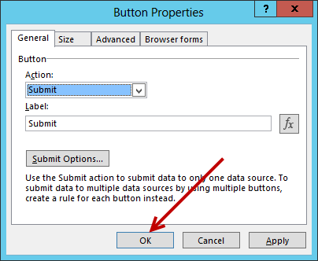

1. The button now has been updated with the text **Submit**.
2. To align the button center, click on the **center** icon in the **Format** **Text** group of the **HOME** tab ribbon.

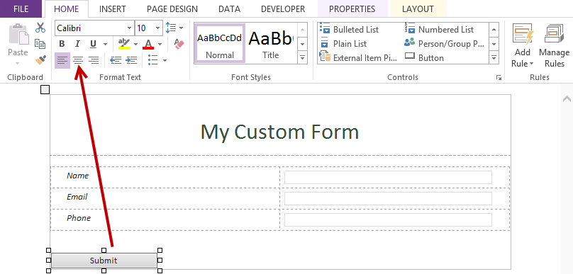

1. **Save** the file.

#### Add a Cancel Button

1. Place your cursor to the right of the **Submit** button and press the **space** key 5 times to add space after the button.
2. Now insert another button in the space where your cursor is:
3. From the **HOME** tab in the **Controls** group, click on **Button** to add another button to the right of the **Submit** button.

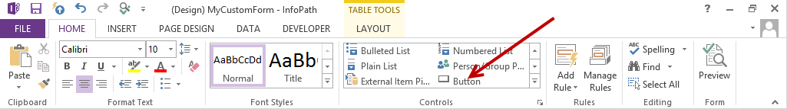

1. Right-click on the new button and select **Button Properties…**

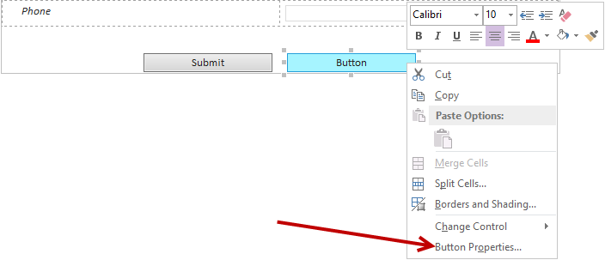

1. From the **Button Properties** dialog, in the **Action** drop-down list select **Rules and Custom Code**.
2. In the **Label** text box, type **Cancel** and then click **OK**.

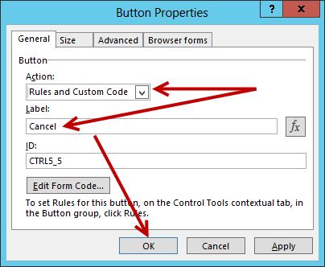

1. From the **Rules** panel located on the right, click **New** and select **Action**.

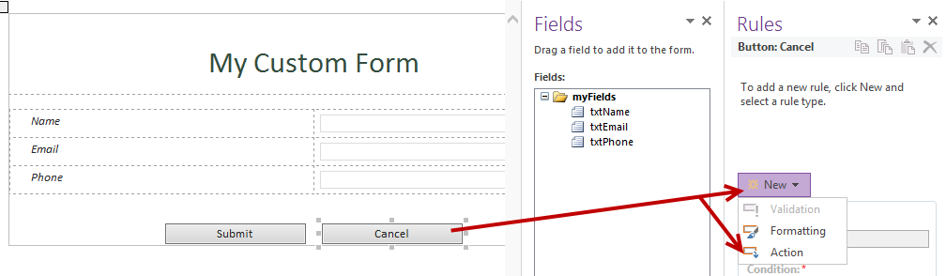

1. In the **Details** for text box, type **Cancel** and in the **Run these actions** click on **Add** and select **Close** the form.

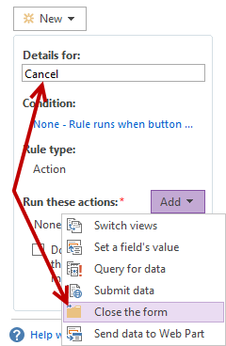

1. From the **Rule** **Details** dialog, ensure **Action** is set to **Close the form** and click **OK**.

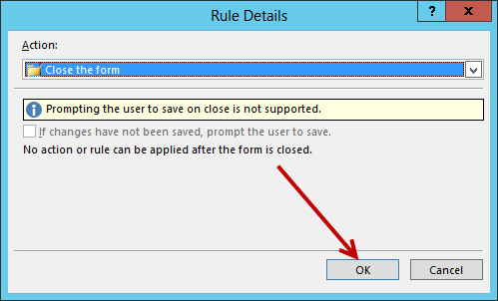

1. Check the option, **Don’t run remaining rules if the condition of this rule is met**.

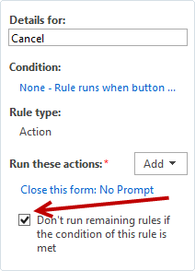

1. **Save** the file.

#### Disable Form Options

Since Submit and Cancel buttons have been added it is not necessary to have the form options in the ribbon for saving and canceling. Therefore, follow the next steps to update the browser form options.

1. Click on the **FILE** tab to open **Backstage**. From **Backstage** in the **Info** panel, click **Form** **Options**.

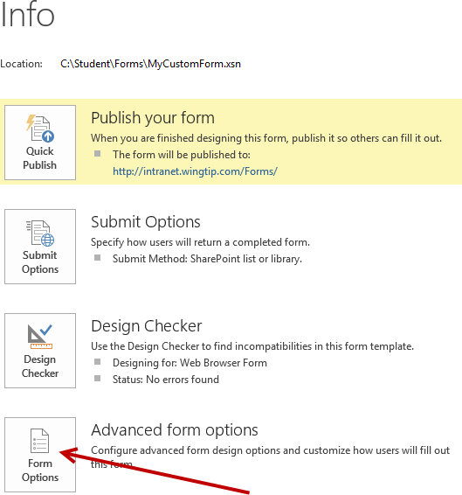

1. From the **Form Options** dialog, select **Web Browser** in the **Category** and uncheck the following:
   1. Uncheck **Submit**, **Save**, **Save** **As**, and **Close**.
   2. Click **OK**.

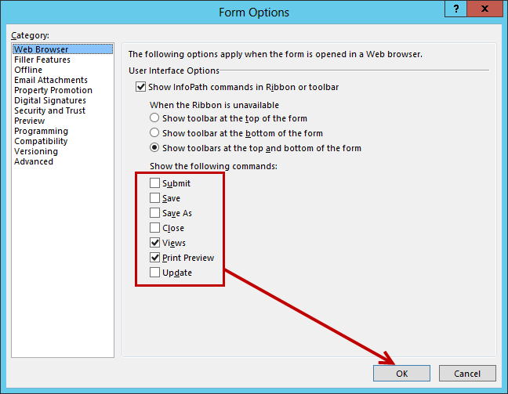

1. **Save** the file.
2. **Re-publish** the file using **Quick Publish**. Click the **Quick Publish** icon located next to the **Save** icon.
3. Once the form is published, from the **Publishing** dialog click the **Open this form** link.

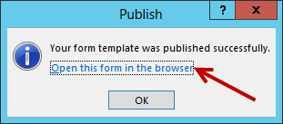

1. When the form opens in the browser, notice the **EDIT** tab ribbon no longer contains the **Submit**, **Save**, and **Save** **As** controls and the **Submit** and **Cancel** buttons are now on the form.

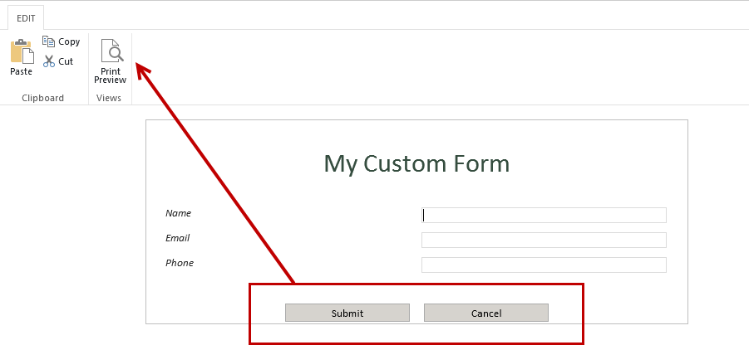

1. Fill out the form and click **Submit** to ensure the submit button works.
2. Once the form has been submitted you will be redirected to the Forms library.
3. Click on the name of the newly submitted form to open the existing form. Click **Cancel** to ensure that the cancel button works.

#### Make Fields Required

1. Go back into **InfoPath Designer 2013** and make sure the **MyCustomForm.xsn** file open.
2. Right-click on the **Name** text box control and select **Text Box Properties…**
3. From the **Data** tab in the **Text Box Properties** dialog, under the **Validation** section check **Cannot be blank**. Click **OK**.

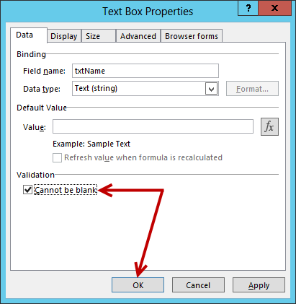

1. Repeat the steps for the remaining controls if desired.
2. Once complete, **Save** the file.
3. **Re-publish** the file using **Quick Publish**. Click the **Quick Publish** icon located next to the **Save** icon.
4. Once the form is published, from the **Publishing** dialog click the **Open this form** link.
5. Test the form by leaving any of the fields (you set to required) blank and then click **Submit**.
6. A dialog should pop-up displaying a message about required fields.

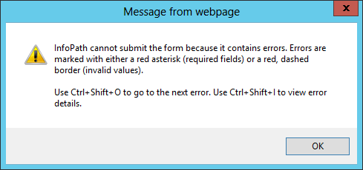

1. Click **OK** correct the errors and then **Submit** the form.
2. Close **InfoPath Designer 2013**.

You have now completed this lab exercise