## Designing Lists using Site Columns and Content Types

**Lab Time**: 45 minutes

**Lab Folder**: C:\Student\Modules\ListDesign

**Lab Overview:** In this lab you will create new lists from existing list templates, customize the columns of a list, add validation rules to lists, and import content into a SharePoint list.

### Exercise 1: Creating Site Columns for Wingtip Product Items

In this exercise you will create a set of site columns that will be used track Wingtip products in the Wingtip Intranet.

#### Log in to SharePoint Online Site

1. Make sure you have the login information for the SharePoint environment where you will work on your lab exercises. You should have received this log in information from the hosting training company or from your instructor.
2. Make sure you have the URL to the **Team Site** that has been created for you to do your lab work. This URL will be in a form that looks something like this.

https://cptclassroom101.sharepoint.com/sites/Student_Teamsite

1. Launch the Internet Explorer and navigate to the URL of the Team Site mention in the previous step. Note that you should be logged in with a user account that has full control and access to the site collection, and therefore will be permitted access and be able to create lists.
   1. When prompted to login, enter the user name and password that has been supplied to you and then click **OK**.

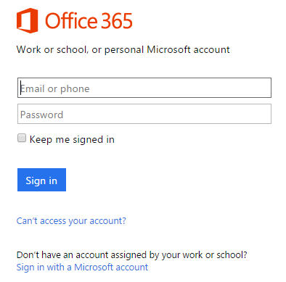

* 1. You should be able to confirm that you are logged into the SharePoint site. For example, if you were logged in as a student named **John Doe**, your name would appear in the SharePoint Welcome menu as shown in the following screenshot.

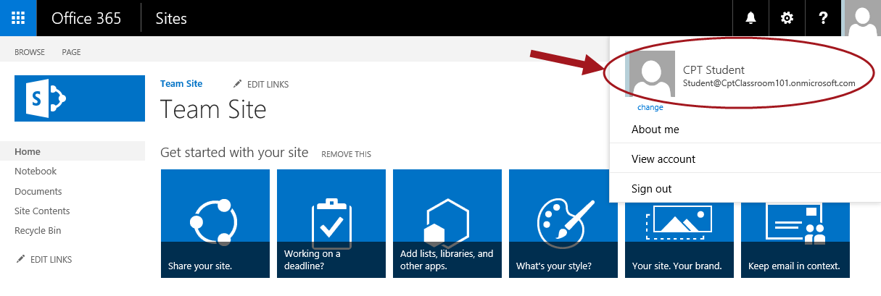

#### Create Site Columns

1. Inspect the set of site columns that come out-of-the-box with SharePoint Online.
   1. Use the **Site Actions** menu to navigate to the **Site Settings** page.
   2. Locate and click the **Site columns** link in the **Web Designer Galleries** section.

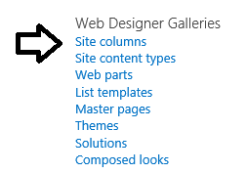

* 1. Review the set of existing site columns on the **Site Columns** page. Use the **Show Group** dropdown box to filter site columns so you can see the site columns in each individual group.

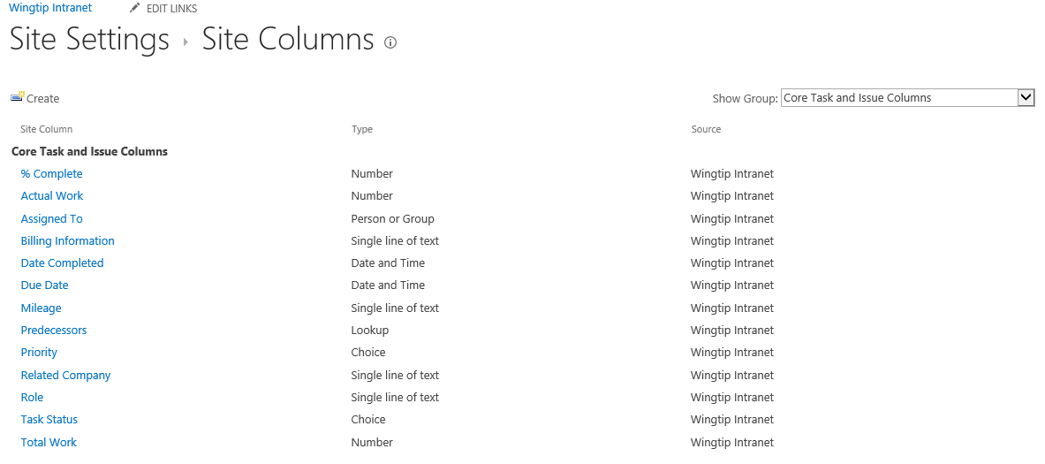

1. Create the **Product Code** site column.
   1. Navigate to the **Site Columns** page
   2. Click the **Create** link to navigate to the Create Column page.

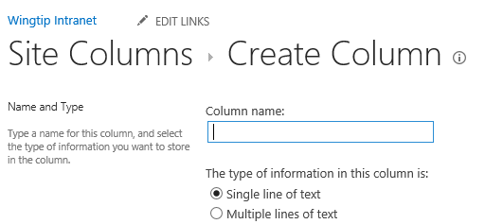

* 1. Enter a **Column name** of **ProductCode** and make sure the column type is set to **Single line of text**.

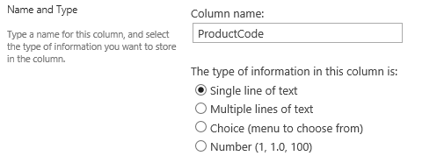

Remember you are intentionally avoiding a space in the column name so SharePoint doesn’t generate an internal site column name that includes that hideous **_x0020_**. In a later step you will modify the site column’s display name to add a space between **Product** and **Code** to make it more readable to users.

* 1. Down in the **Group** section add a **New group** value of **Wingtip**.

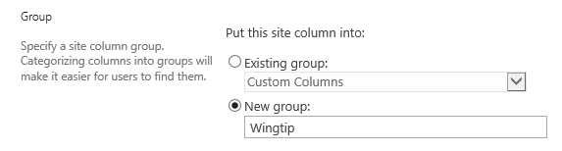

* 1. In the **Additional Column Settings** section, select **Yes** for both the options **Require that this column contains information** and **Enforce unique values**. Also set the **Maximum number of characters** to a value of **6**.

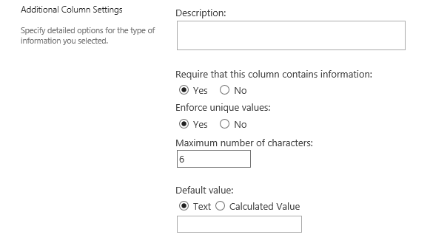

* 1. Click **OK** to create the new site column. When you do this you will be prompted with the following dialog which informs you that SharePoint must configure an index for the site column in order to ensure unique column values within a list. Click **OK** to continue.

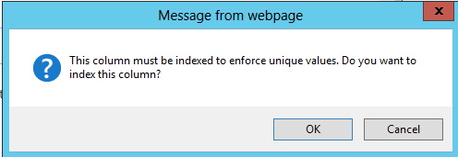

* 1. On the **Site Columns** page, filter the page using the **Show Group** dropdown to show only site columns in the Wingtip group. At this point, the **ProductCode** site column should be the only site column you see.

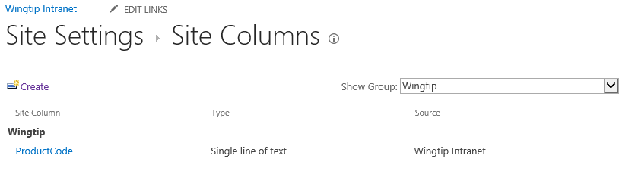

* 1. Now you can update the site column to add a space to its display name. Click on the **ProductCode** link to navigate to the **Edit Column** page. Add a space between **Product** and **Code** and click **OK** to save your work.

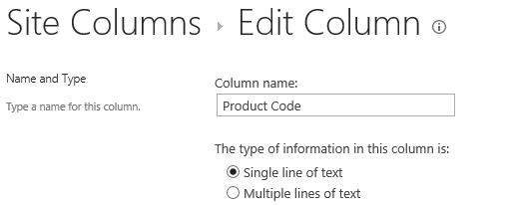

* 1. At this point you have completed the work to create your first site column.

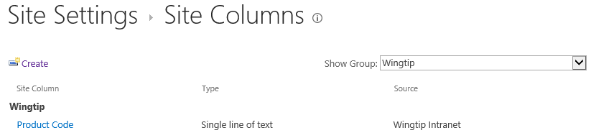

1. Create the **Product Description** site column.
   1. On the **Site Columns** page, click the **Create** link to navigate to the **Create Column** page.
   2. Enter a column name of **ProductDescription** and set the column type to **Multiple lines of text.**

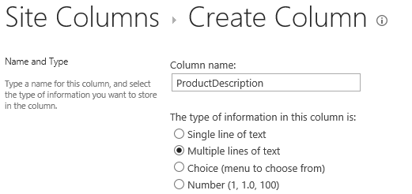

* 1. In the **Group** section, assign the new site column to the **Existing group** of **Wingtip**.

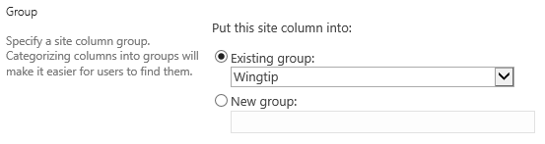

* 1. In the **Additional Column Setting** section assign a value of **4** to the **Number of lines for editing** setting. Also set the **Specify the type of text** **to allow** setting to **Plain text**.

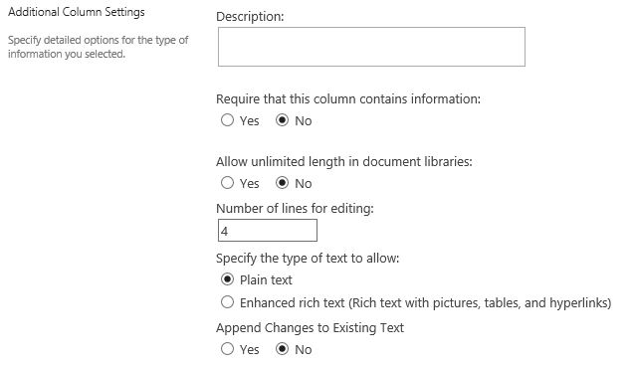

* 1. Click **OK** to create the new site column.
  2. Once the site column has been created, open it in the **Edit Column** page and add a space to its display name to update it from **ProductDescription** to **Product Description**.

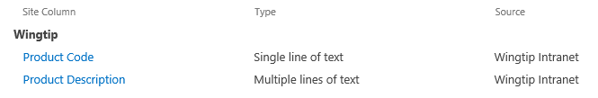

1. Create the **Product List Price** site column.
   1. On the **Site Columns** page, click the **Create** link to navigate to the **Create Column** page.
   2. Enter a column name of **ProductListPrice** and set the column type to **Currency.**

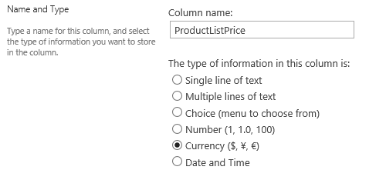

* 1. In the **Group** section assign the new site column to the **Existing group** of **Wingtip**.



* 1. In the **Additional Column Setting** locate the textbox for the **Min** settings located under the caption. Specify a **minimum allowed value** of **0**. Also set the **Number of decimal places** setting to a value of **2**.

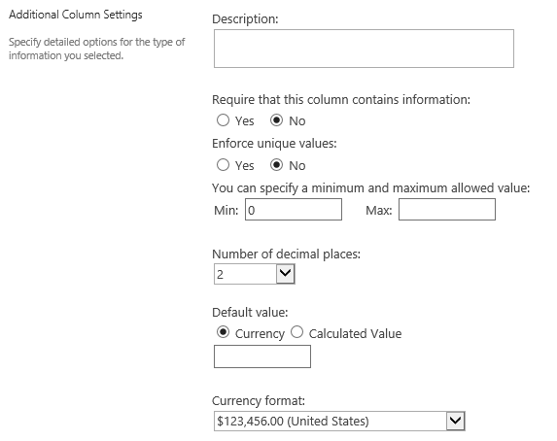

* 1. Click **OK** to create the new site column.
  2. Once the site column has been created, open it in the **Edit Column** page and add spaces to its display name to update it from **ProductListPrice** to **Product List Price**.

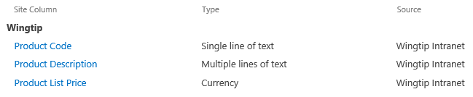

1. Create the **Product Color** site column.
   1. On the **Site Columns** page, click the **Create** link to navigate to the **Create Column** page.
   2. Enter a column name of **ProductColor** and set the column type to **Choice.**

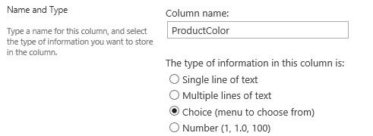

* 1. In the **Group** section assign the new site column to the **Existing group** of **Wingtip**.



* 1. In the **Additional Column Setting** section, locate the input control under the caption **Type each choice on a separate line** and add the following choice values.
     1. White
     2. Black
     3. Blue
     4. Red
     5. Green
     6. Yellow
  2. In the **Additional Column Setting** section, after adding the choice value, also assign the **Display choices using** setting to **Checkboxes (allow multiple selections)**.

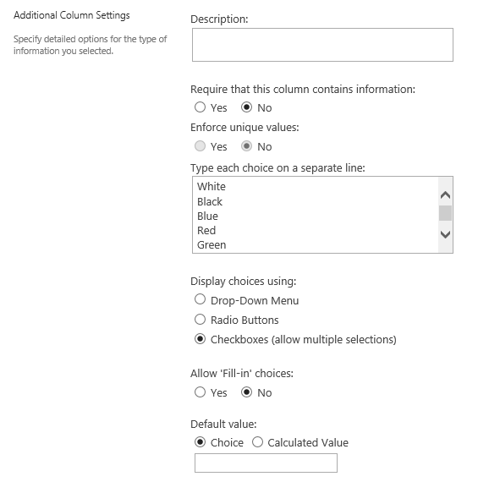

* 1. Click **OK** to create the new site column.
  2. Once the site column has been created, open it in the **Edit Column** page and add a space to its display name to update it from **ProductColor** to **Product Color**.

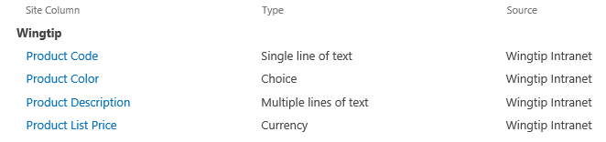

1. Create the **Minimum Age** site column.
   1. On the **Site Columns** page, click the **Create** link to navigate to the **Create Column** page.
   2. Enter a column name of **MinimumAge** and set the column type to **Number.**

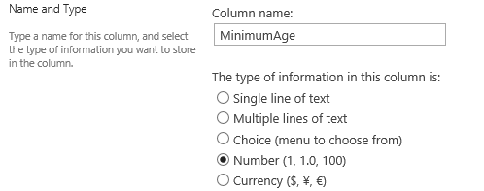

* 1. In the **Group** section assign the new site column to the **Existing group** of **Wingtip**.



* 1. In the **Additional Column Setting** section set the **Min** allowed value to **1** and the **Max** allowed value to **100**. Also configure the **Number of decimal places** setting with a value of **0**.

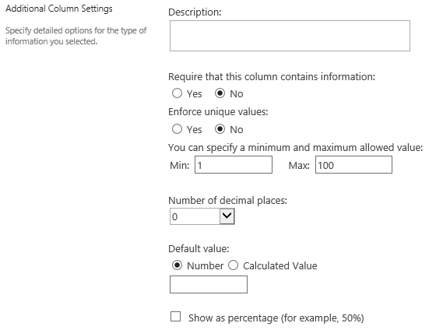

* 1. Click **OK** to create the new site column.
  2. Once the site column has been created, open it in the **Edit Column** page and add a space to its display name to update it from **MinimumAge** to **Minimum Age**.

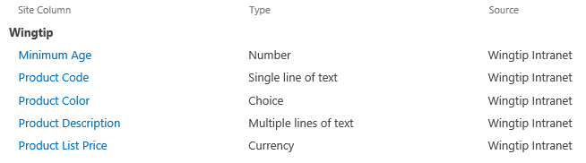

1. Create the **Maximum Age** site column.
   1. On the **Site Columns** page, click the **Create** link to navigate to the **Create Column** page.
   2. Enter a column name of **MaximumAge** and set the column type to **Number.**

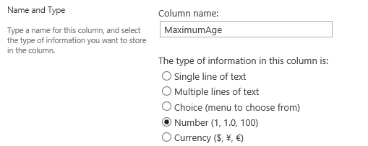

* 1. In the **Group** section assign the new site column to the **Existing group** of **Wingtip**.



* 1. In the **Additional Column Setting** section set the **Min** allowed value to **1** and the **Max** allowed value to **100**. Also configure the **Number of decimal places** setting with a value of **0**.



* 1. Click **OK** to create the new site column.
  2. Once the site column has been created, open it in the **Edit Column** page and add a space to its display name to update it from **MaximumAge** to **Maximum Age**.

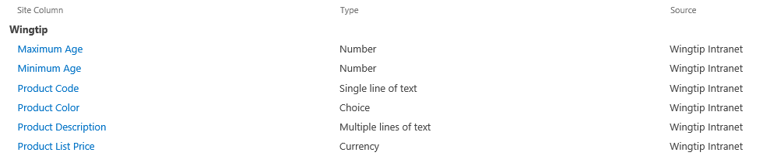

At this point, you are done creating the required set of site columns to track Wingtip products. In the following exercise you will create a new content type that puts these site columns to use.

### Exercise 2: Creating a Content Type for Wingtip Products

In this lab you will create a new content type named **Products** that will use all the site columns you created in the previous exercise.

#### Create new Content Types

1. Inspect the set of content types that come out-of-the-box with SharePoint Online.
   1. Use the **Site Actions** menu to navigate to the **Site Settings** page.
   2. Locate and click the **Site content types** link in the **Web Designer Galleries** section to navigate to the **Site Content Types** page.

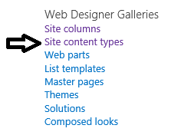

* 1. Review the set of content types available on the **Site Content Types** page. Use the **Show Group** filter control to inspect each group individually.

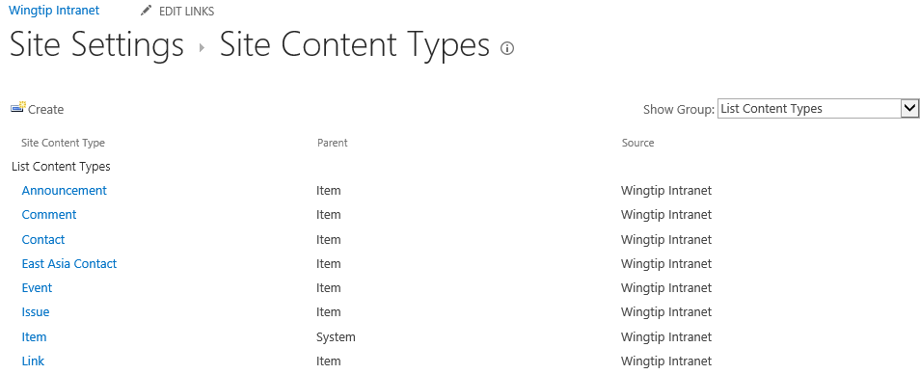

Now that you have seen the set of standard content types that come out-of-the-box with SharePoint Online, it’s time to move on to the next step where you will create a custom content type.

1. Create the **Product** content type.
   1. Click the **Create** link on the **Site Content Types** page to navigate to the **New Site Content Types** page.
   2. Enter a **Name** of **Product**.
   3. Set the **Select parent content type** setting to **List Content Types**.
   4. Set the **Parent Content Type** setting to **Item**.
   5. In the **Group** section add a New Group value of **Wingtip**.
   6. Ensure your input values look as they do in the following screenshot.

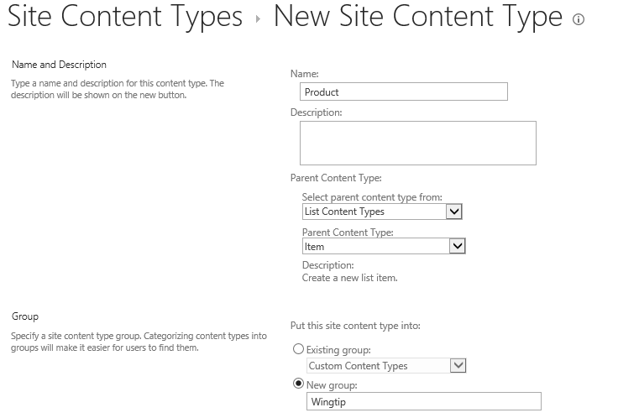

* 1. Click OK to create the **Product** content type.

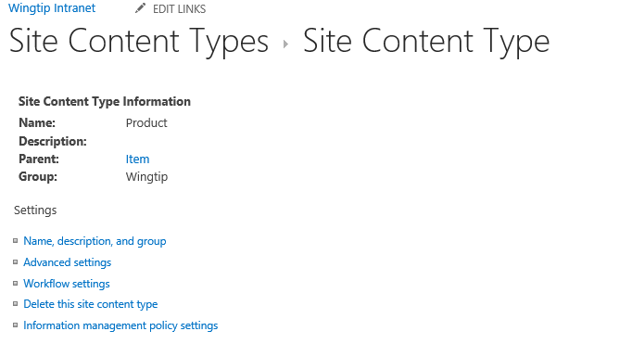

1. Add the Wingtip product site columns to the **Product** content types.
   1. On the **Site Content Type** page, move down to the Columns section. You should be able to see that the Product content type has only a single column named **Title**.

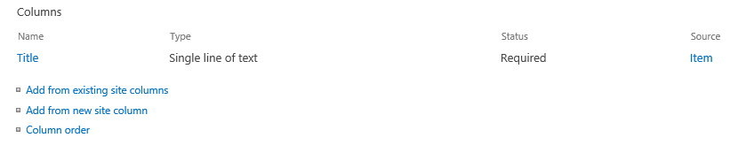

* 1. Click the **Add from existing site columns** link to navigate to the **Add Columns** page. Set the Select columns from the dropdown control to Wingtip to show only the site columns you created in the previous exercise.

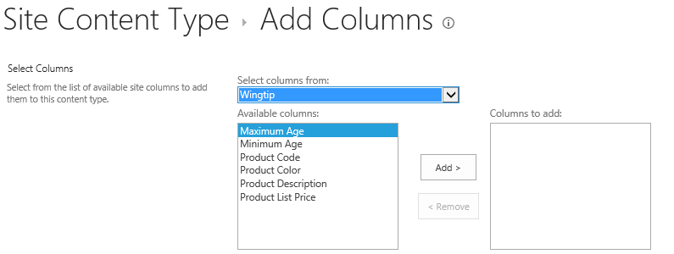

* 1. Remember that the order in which columns are added can be significant. Therefore, add the site columns in the following order.
     1. Product Code
     2. Product Description
     3. Product List Price
     4. Product Color
     5. Minimum Age
     6. Maximum Age
  2. When you are done, the **Add Columns** page should look like the following screenshot.

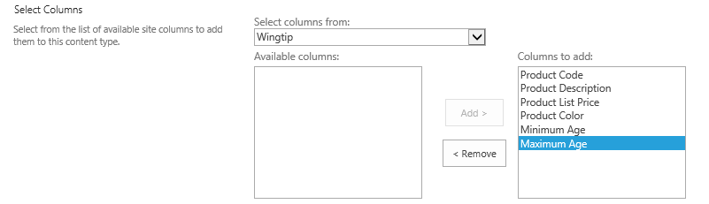

* 1. When you are done adding the site columns, click **OK** to save your changes. The Product content type should now include all the site columns you created in the previous exercise.

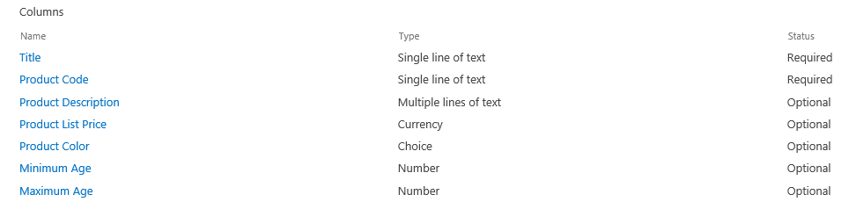

You have just created the **Product** content type. However, you must remember that this content type has no purpose until you have used it in one or more lists. In the next exercise you will create a new Products list and configure it to use the Product content type.

### Exercise 3: Configuring a List to Use the Product Content Type

In this exercise you will create a new custom list and configure it to use the Product content type you created in the previous exercise.

#### Configure List

1. Create the **Products** list.
   1. From the **Site Actions** menu, select **Add an app** to navigate to the **Your Apps** page.
   2. Click the **Custom List** tile to create a new list based on the **Custom List** type.

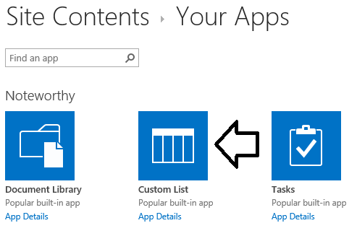

* 1. Enter a name of **Products** and click the **Create** button to create the new list.

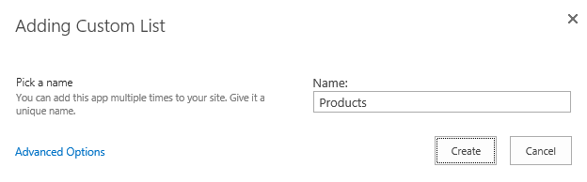

* 1. After the **Products** list has been created, you should be able to see a tile for it on the **Site Contents** page. Click the ellipse (…) menu in the top-right of the tile for the **Products** list and then click the **SETTINGS** link to navigate to the list

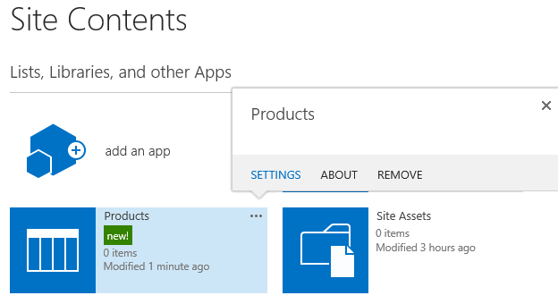

* 1. At this point you should be at the **Setting** page for the **Products** list. You can see that the list has a **Name** of **Products** and a **Web Address** of <http://intranet.wingtip.com/Lists/Products/AllItems.aspx>.

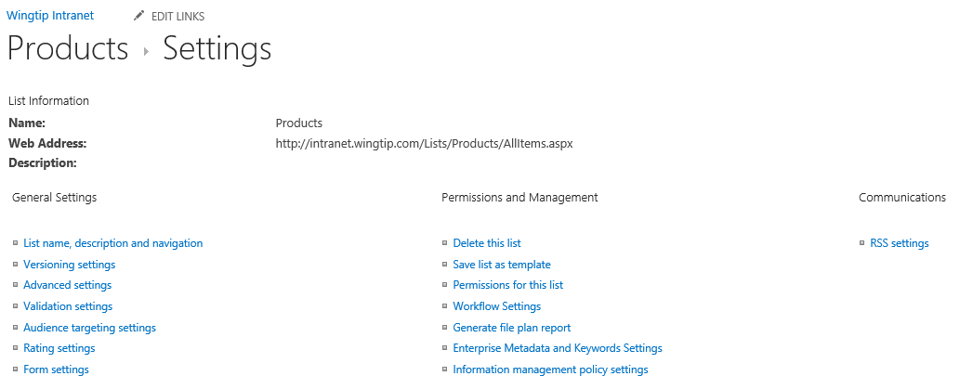

* 1. Inspect the existing set of columns in the list.

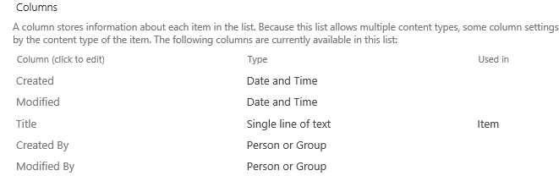

1. Configure the Products list to support Product content type.
   1. From the **Setting** page for the **Products** list, click the **Advanced settings** link.

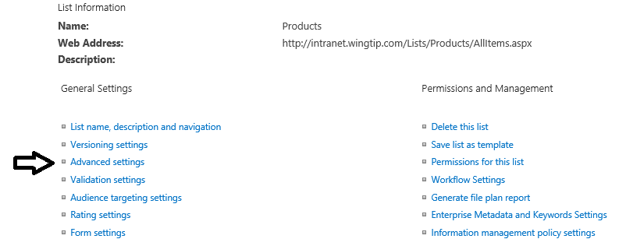

* 1. On the **Advanced Settings** page, change the value of the **Allow management of content types** setting from **No** to **Yes**.

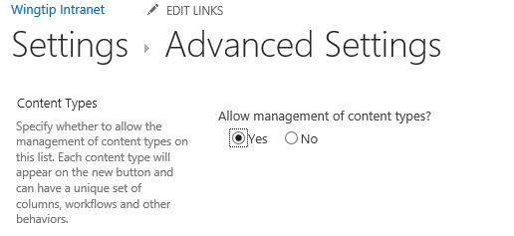

* 1. Click the **OK** button to save your changes. You should now see a new **Content Types** section in the **Settings** page for the **Products**. At this point, you should be able to observe that the list now contains the **Item** content type.

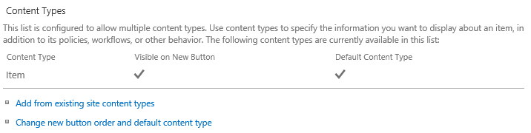

* 1. Click the **Add from existing site content types** link to navigate to the **Add Content Types** page.
     1. Select **Product** from the available site content types.
     2. Click **Add**.
     3. Click **OK**.

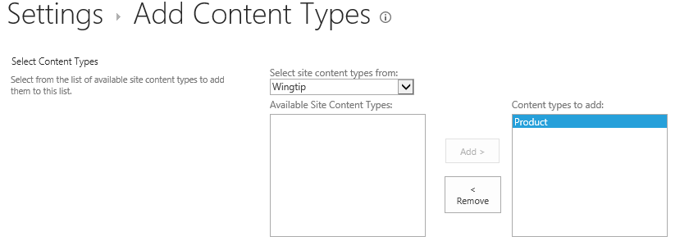

* 1. Now, you should be able to see that the **Product** content type is included under the **Item** content type. However, there is an issue in that the **Product** content type is not currently configured as the **Default Content Type** for the **Products** list.

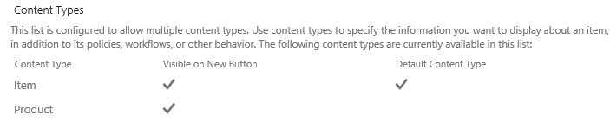

* 1. Remove the **Item** content type from the **Products** list. Begin by clicking on the link for the **Item** content type

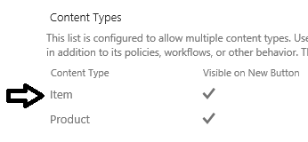

* 1. On the **List Content Types** page, complete the process for removing the **Item** content type by clicking the **Delete this content type** link.

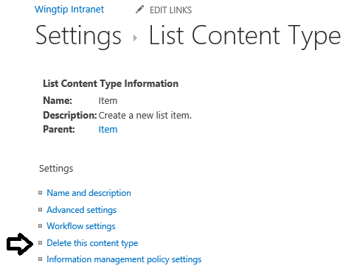

* 1. Now you should see that the **Products** list contains a single content type named **Product**.

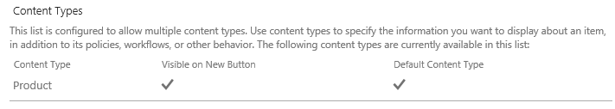

* 1. Inspect the Columns section of the **Products** list to see what columns are there. As you can see, it contains all the site columns from the **Product** content type such as **Product List Price**, **Maximum Age**, **Minimum Age**, **Product Code**, **Product Color** and **Product Description**. When you added the **Product** content type to the **Products** list, SharePoint automatically added all the site columns from the **Product** content type that were not already present in the columns collection of the **Products** list.

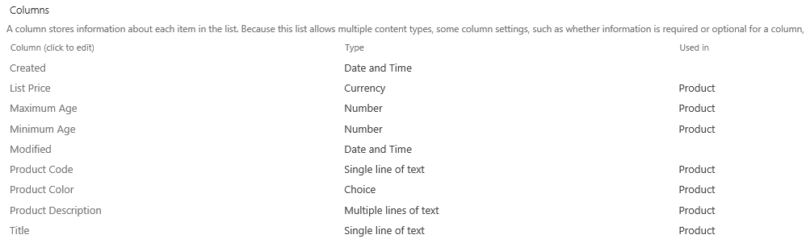

1. Add a new **Product** item.
   1. Navigate to the default view of the **Products** list.
   2. Click the **new item** link to navigate to a new item page.

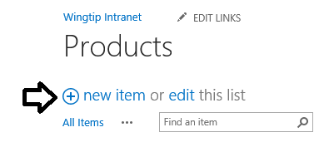

* 1. On the new item page, fill in the input values for a new **Product** item as shown in the following screenshot.

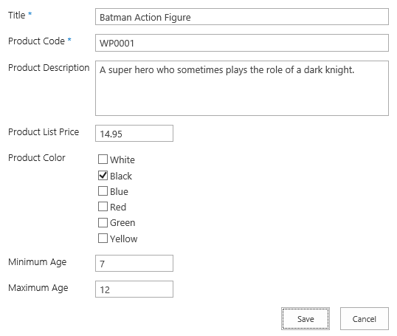

* 1. Click the **Save** button to save the new **Product** item. When you return to the default view of the **Products** list, you can see that this view is currently displaying the **Title** column but no other column.

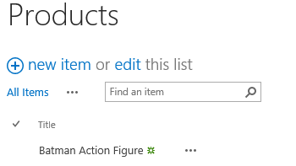

From this you can observe that SharePoint adds the site columns from a content type in the list’s columns. But it does not update any views to include those columns. In the next step you will modify the default view for the Products list to include the site columns from the **Product** content type.

1. Update the **All Items** view of the **Products** list to include the site columns from the **Product** content type.
   1. Navigate to the default view for the **Products** list.
   2. In the ribbon, activate the **List** tab and then click the **Modify View** button to edit the default view for the **Products** list.

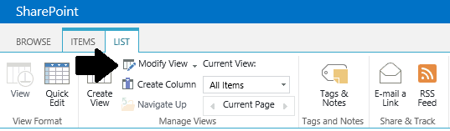

* 1. Include the site columns from the **Product** content type and order them as shown in the following screenshot.

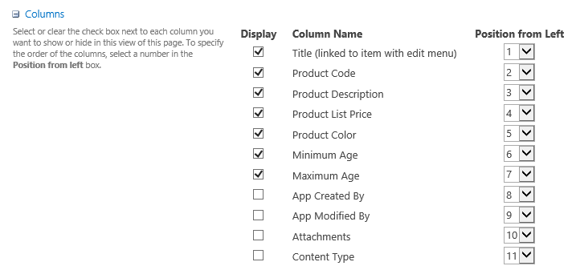

* 1. Click **Ok** to save your changes. You should now see that the default view is showing the proper set of columns.

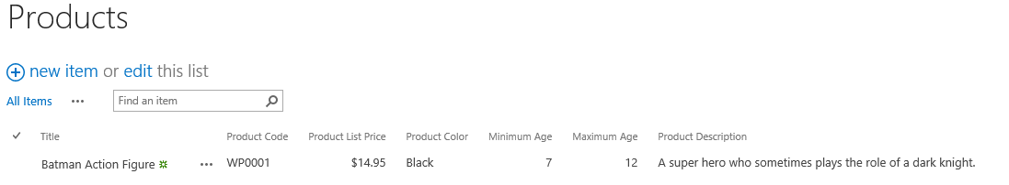

1. Add a few new Product item in edit mode.
   1. Enter edit mode for the Products list and add a second product for the **Captain America Action Figure** using the values shown in the following screenshot.

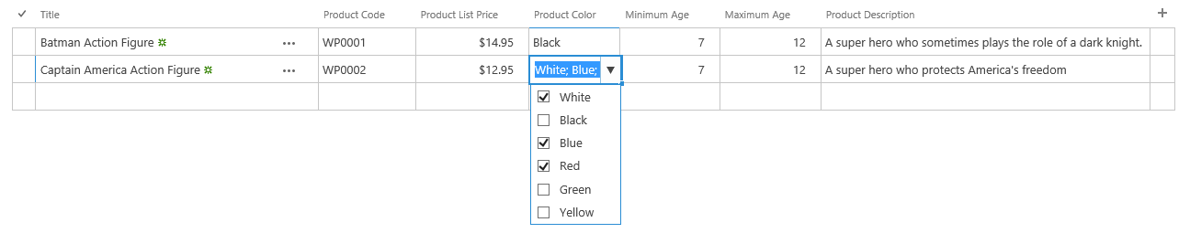

You have now completed this lab exercise.