## Working with Lists in SharePoint Online

**Lab Time**: 45 minutes

**Lab Folder**: C:\Student\Modules\Lists

**Lab Overview:** In this lab you will create new lists from existing list templates, customize the columns of a list, add validation rules to lists, and import content into a SharePoint list.

### Exercise 1: Working with List Items

In this exercise you will become familiar with the different list template options that can be used to create lists.

#### Log in to SharePoint Online Site

1. Make sure you have the login information for the SharePoint environment where you will work on your lab exercises. You should have received this log in information from the hosting training company or from your instructor.
2. Make sure you have the URL to the **Team Site** that has been created for you to do your lab work. This URL will be in a form that looks something like this.

https://cptclassroom101.sharepoint.com/sites/Student_Teamsite

1. Launch Internet Explorer and navigate to the URL of the Team Site mention in the previous step. Note that you should be logged in with a user account that has full control and access to the site collection, and therefore will be permitted access and be able to create lists.
   1. When prompted to login, enter the user name and password that has been supplied to you and then click **OK**.

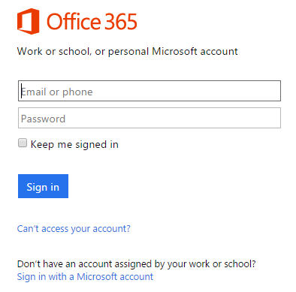

* 1. You should be able to confirm that you are logged into the SharePoint site. For example, if you were logged in as a student named **John Doe**, your name would appear in the SharePoint Welcome menu as shown in the following screenshot.

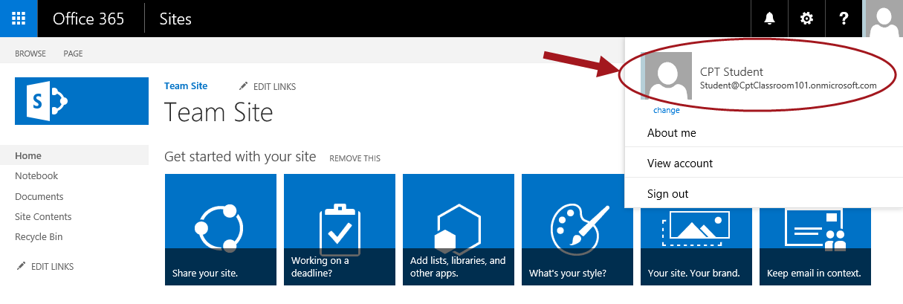

#### ****Navigate to the Out-of-the-Box (OOTB) List Templates****

1. Navigate to the Site Contents from the quick launch menu.
   1. Click **Site Contents** located in the left navigation quick launch menu.

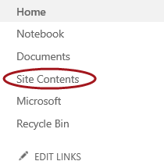

1. **This takes you to the Site Contents Page. Now click add an app.**

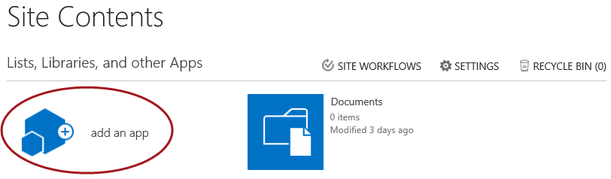

**Note:** From the **Site Contents > Your Apps** page, you will notice two different sections which include **Noteworthy** and **Apps you can add**. Noteworthy apps contain Document Library, Custom List, and Tasks.

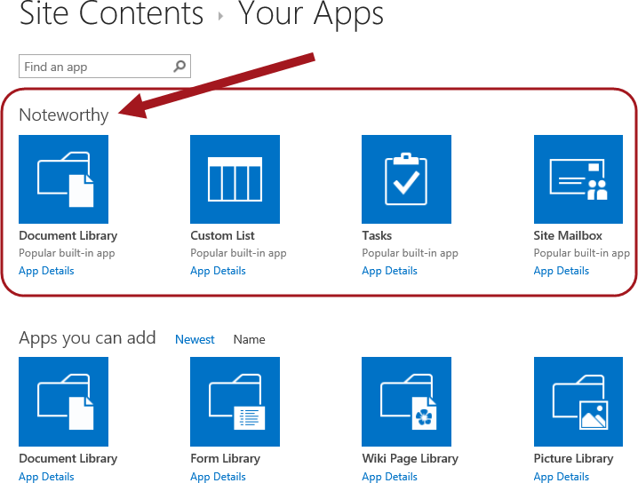

1. To sort alphabetically, click on **Name** link next to **Apps you can add**.

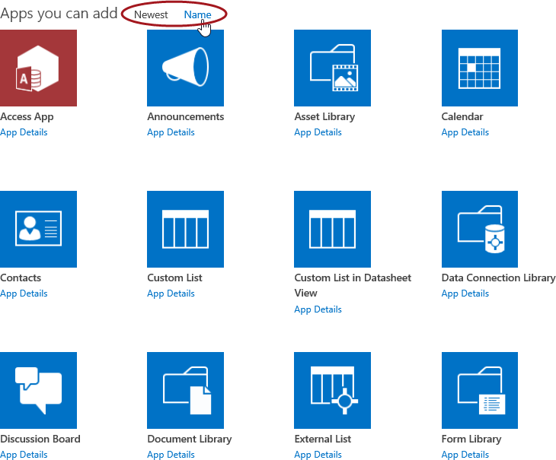

1. Click on the **right arrow** (pagination control) below the tiles to navigate to the remainder of the available apps.

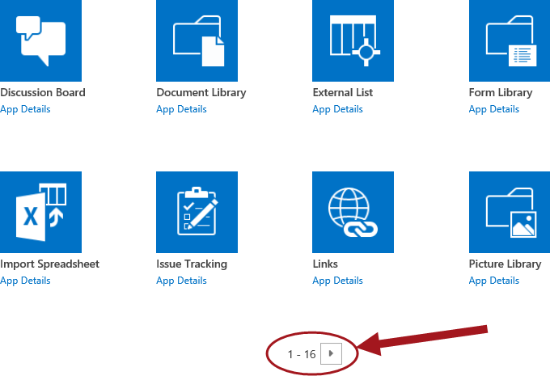

### Exercise 2: Creating a New List

In this exercise you will create an Announcements list, Tasks list, Calendar, as well as edit items and delete items.

#### Create an Announcements List

To create a new Announcements list, follow the steps below:

1. You should still be on the **Add an app** page that you navigated to in previous steps. If you are not on this page anymore, go back to the page by click **Site contents > add an app.**
2. Continue with the steps below to create an Announcements list
   1. Click on the **Announcements** tile.

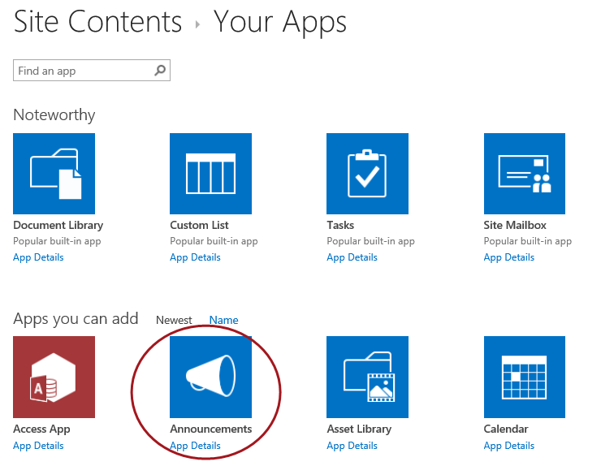

1. In the **Name** text box from the popup dialog, type **Announcements** and click **Create**.

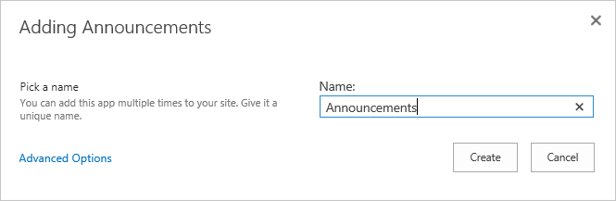

1. Click on the new **Announcements** list tile to view the list.

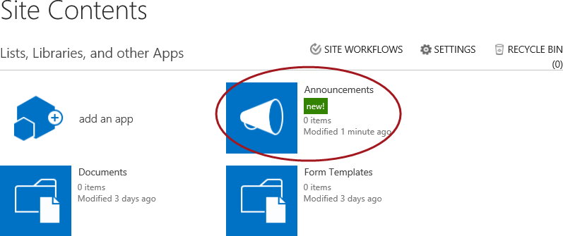

1. Click **new announcement** to open the New Form to create a new announcement.

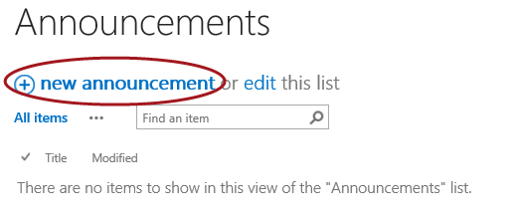

1. Enter your preferred announcement title and body text into the appropriate fields and then click **Save**.

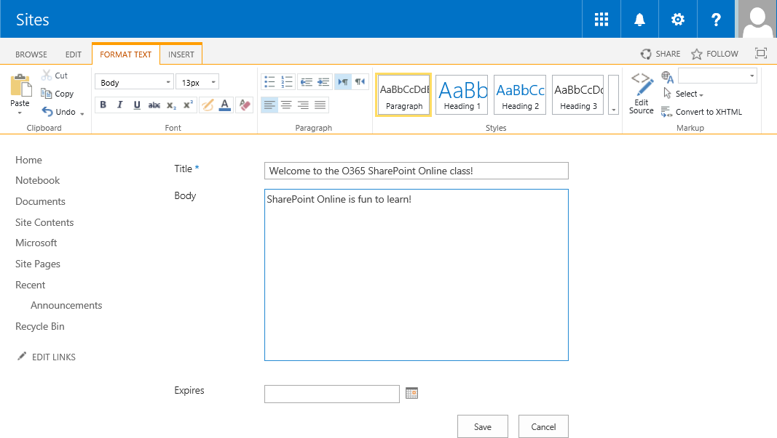

1. The new announcement will now show up as an item in your Announcements list.

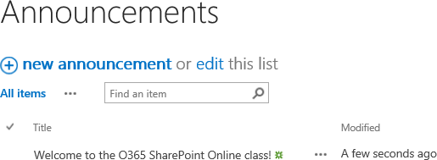

1. You will add more items in the Announcements list later in this lab so go ahead and move on to the next steps to create a Task list.

#### Create a Task List

To create a new Task list, follow the steps below:

1. Navigate to **Add an app** to create a new Task list.
   1. Click on the **Settings** icon.
   2. Click **Add an app** or click **Site contents >> add an app**.

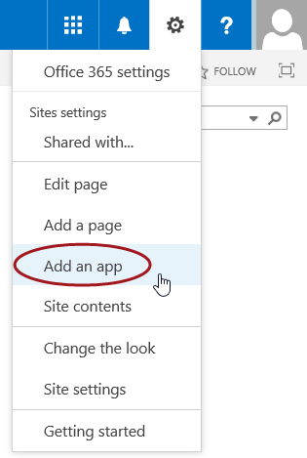

* 1. Click on the **Tasks** tile.

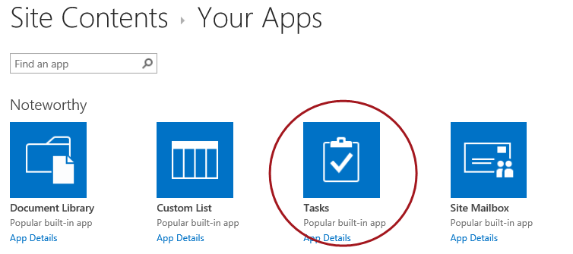

1. In the **Name** text box from the popup dialog, type **Tasks** and click **Create**.

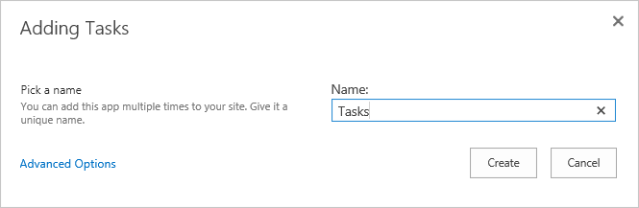

1. Click on the new **Tasks** list tile to view the list.

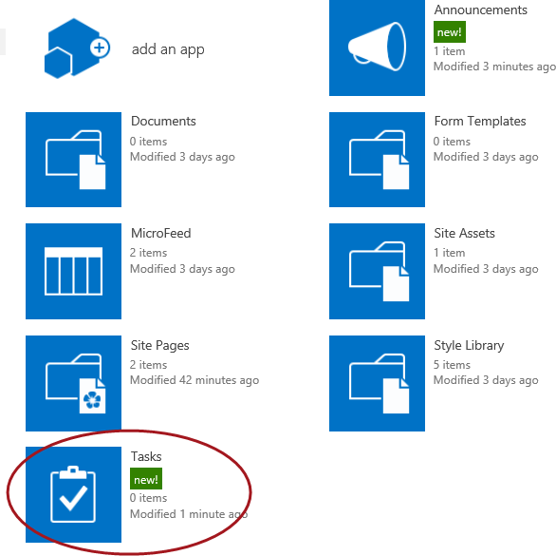

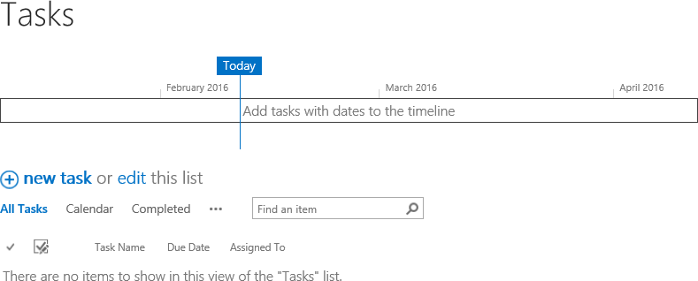

1. Click **new task** to open the New Form to create a new task.

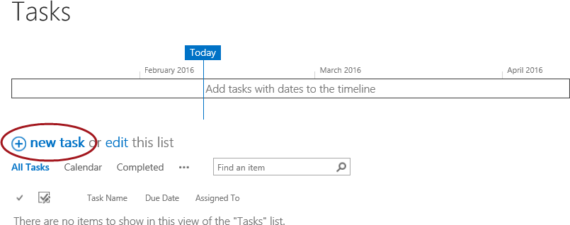

1. Fill in the desired fields and then click **Save**. Continue to add a few more if desired. The new tasks will display as items in the Task list.

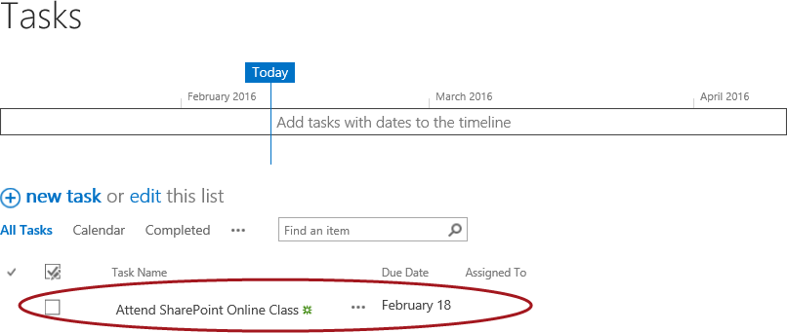

#### Create a Calendar

To create a new Calendar, follow the steps below:

1. Navigate to **Add an app** to create a new Calendar.
   1. Click on the **Settings** icon.
   2. Click **Add an app** or click **Site contents >> add an app**.



* 1. Click on the **Calendar** tile.

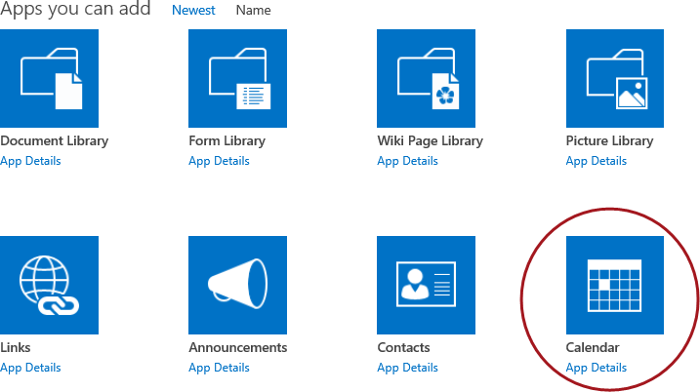

1. In the **Name** text box from the popup dialog, type **Calendar** and click **Create**.

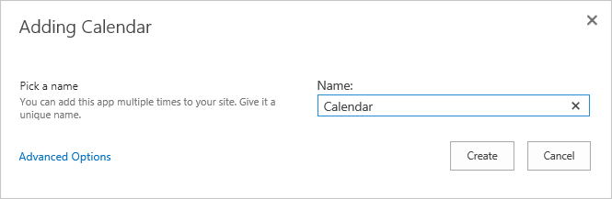

1. Click on the new **Calendar** list tile to view the list.

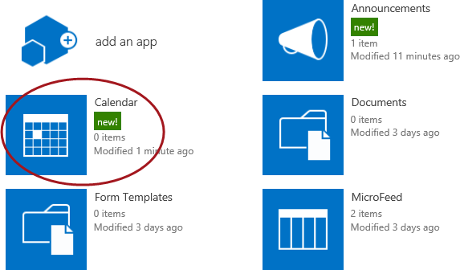

1. Notice the calendar is displayed in a visual view.

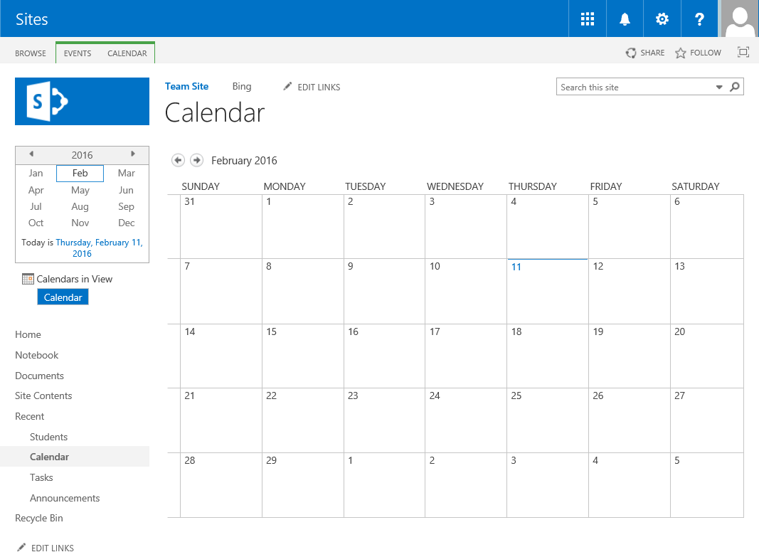

1. Click on a date in the calendar to open the day view.

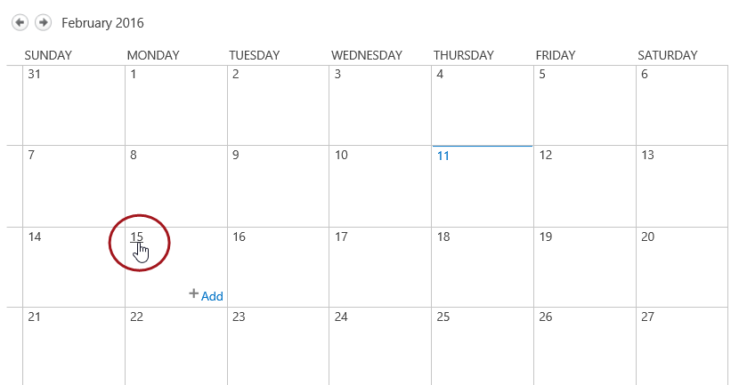

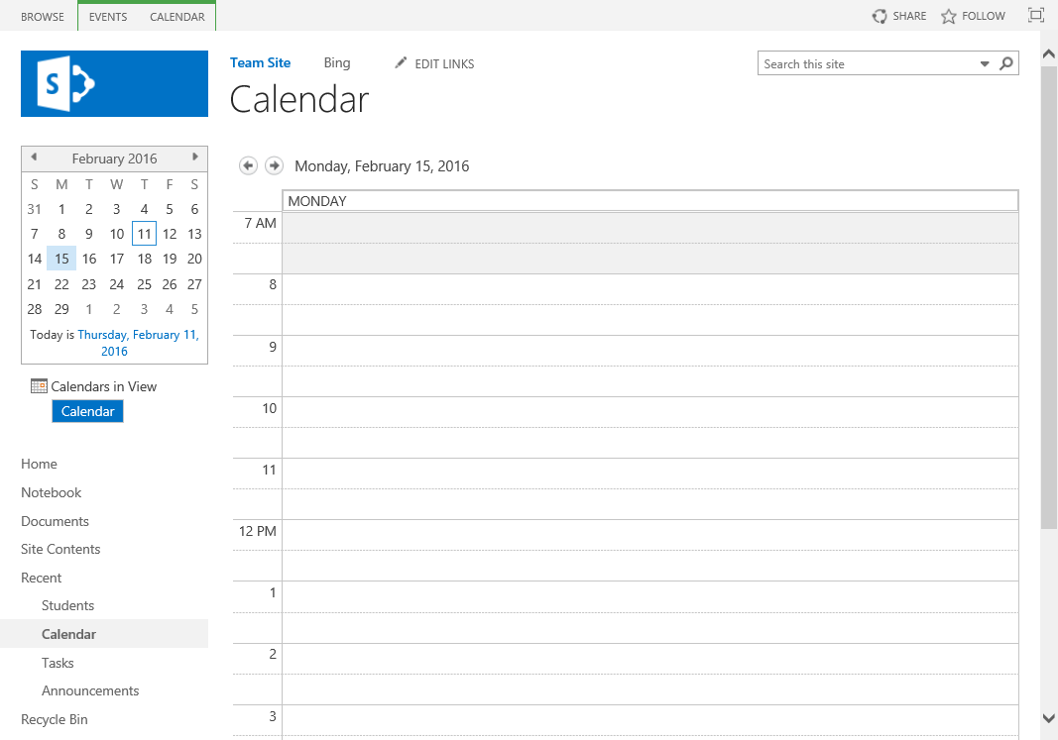

1. To add an item from the day view, double-click on a desired time to open the New Item dialog. Fill in desired text into the required fields and then click **Save**.

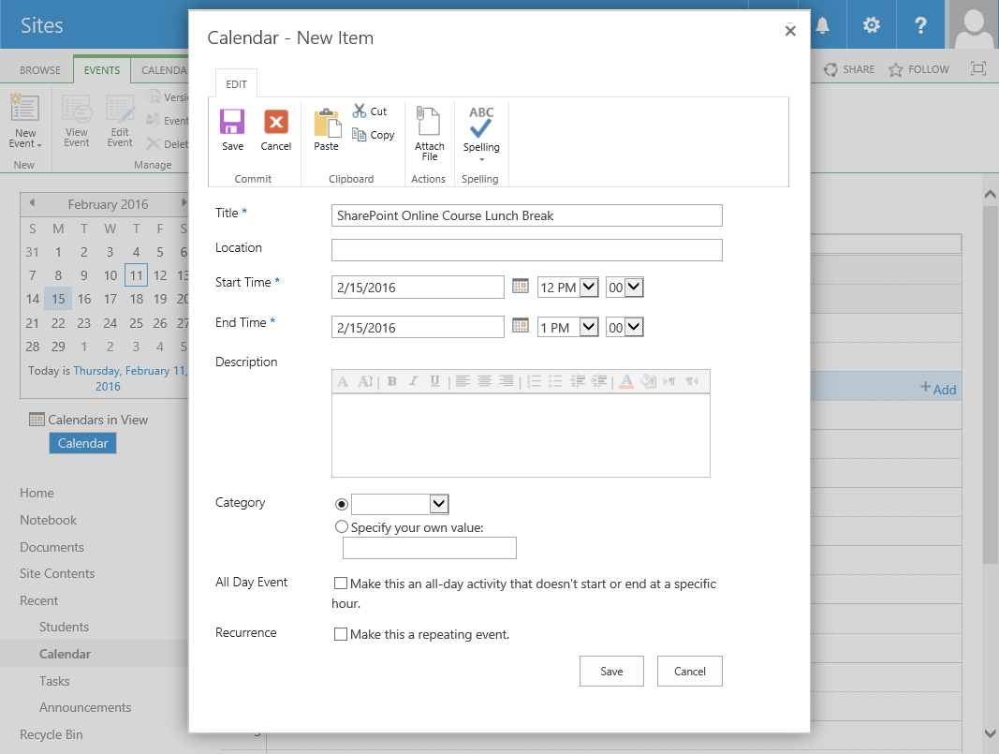

1. You should now see your new event in the Calendar day view.

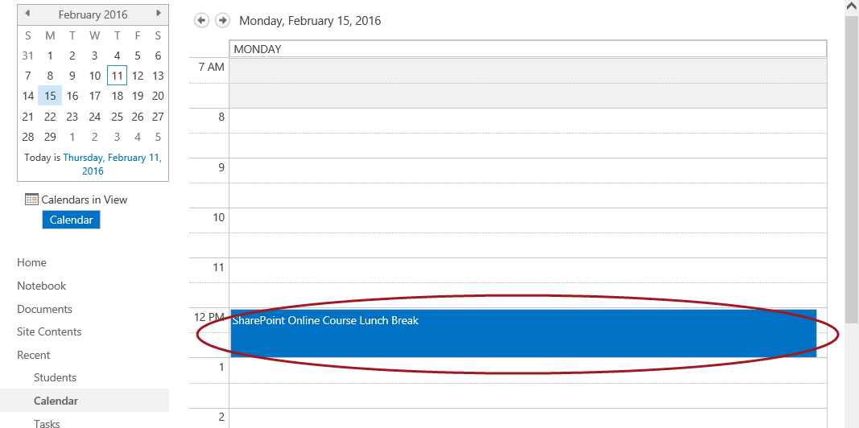

**Note:** You can also add items from the Calendar view by double-clicking in the white area inside the cell of the day you want to add or single-click in the cell and click on **+Add**.

1. To go back to the default Calendar view, click on the **Calendar** title.

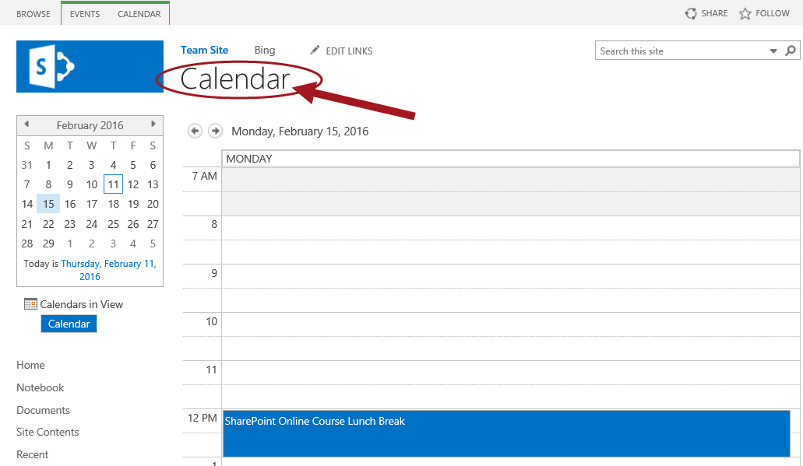

1. You should now be back in the default calendar view which will also display your newly created event.

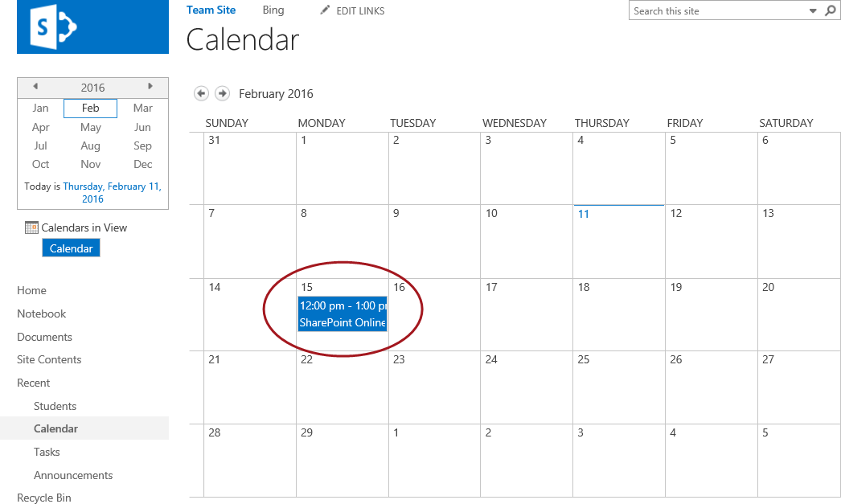

### Exercise 3: Manipulating SharePoint Online List Items

In this exercise you will populate an existing list with items then manage those items by editing them and eventually deleting them.

#### Add Items to Announcements List

1. Navigate to the newly created Announcements list.
   1. Click **Site Contents** located in the left navigation quick launch menu.
   2. **Click on the Announcements** list tile to view the list.

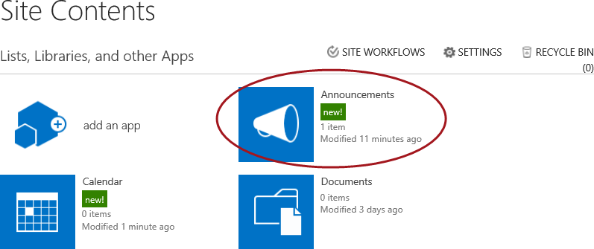

1. Click **new announcement** to open the New Form to create a new announcement.

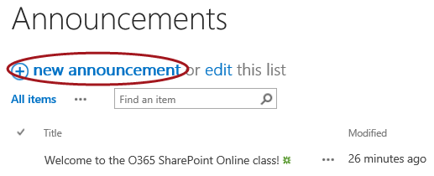

1. Fill out the required fields and then click **Save**.

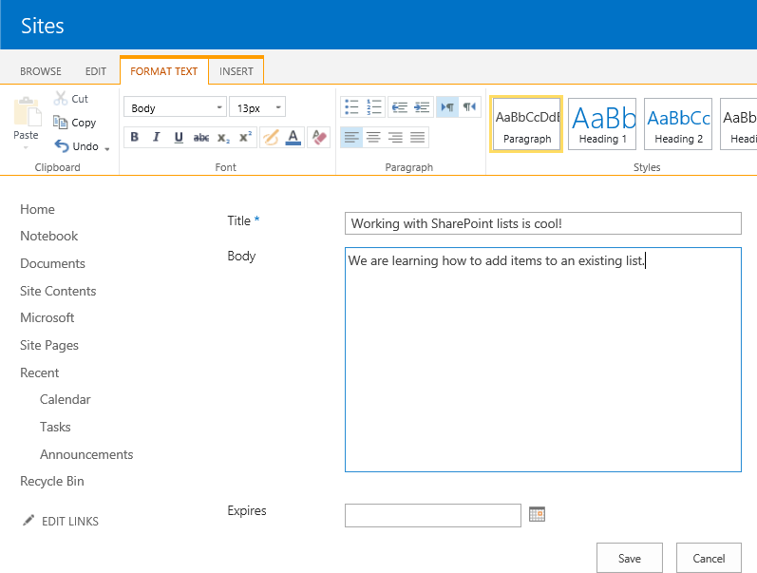

1. Your new announcement will now display in the list of items.

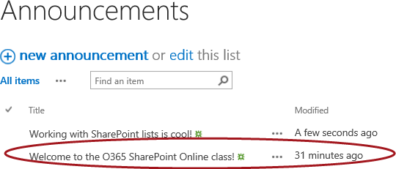

#### Edit a List Item

To edit an existing list item, follow the steps below:

1. Now let’s make a change to an existing announcement.
2. Find the first announcement you added earlier in this lab. To modify, click the **ellipsis (…)** and click **Edit Item**.

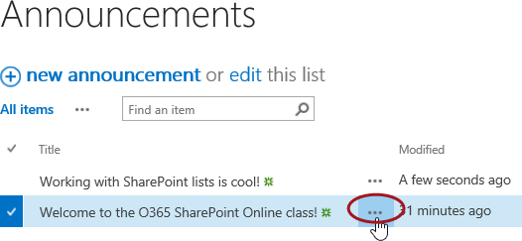

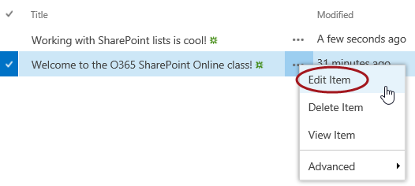

1. Modify the text and then click **Save**.

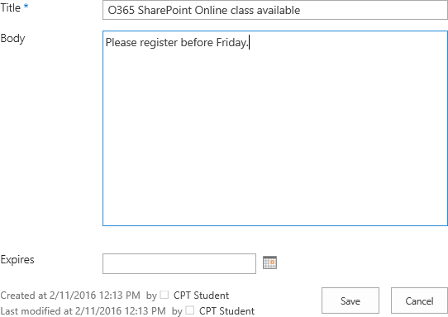

1. Your list item has now been updated and should reflect the changes.

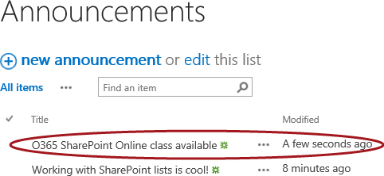

#### Delete a List Item

To delete a list item follow the steps below:

1. Now let’s delete the announcement you just modified.
2. To delete, click the **ellipsis (…)** and click **Delete Item**.

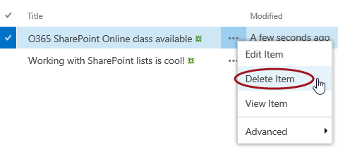

1. From the delete confirmation dialog, click **OK**.

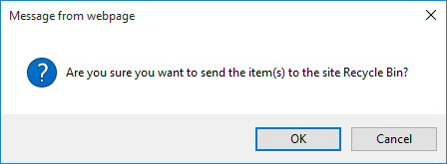

1. Notice your list item has now been deleted and does not show up in the list of items anymore.

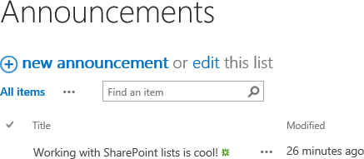

The list item has been deleted from the list but it wasn’t permanently deleted. The deleted item was moved into the SharePoint Recycle Bin. You will learn more about the recycle bin and how to recover items from the recycle bin later in this course

### Exercise 4: Customizing Columns of a SharePoint Online List

In this exercise you will create a custom list to store a list of students and customize the set of columns behind it for storing additional student information such as phone number and email address.

#### Create a Custom List

To create a new custom list, follow the steps below:

1. **Navigate to Add an app to create a new custom list.**
   1. **Click on the Settings icon.**
   2. **Click Add an app or click Site contents > add an app.**



* 1. **Click on the Custom List tile.**

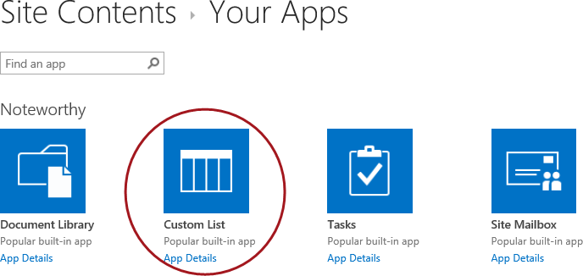

1. **In the Name text box from the popup dialog, type Students and click Create.**

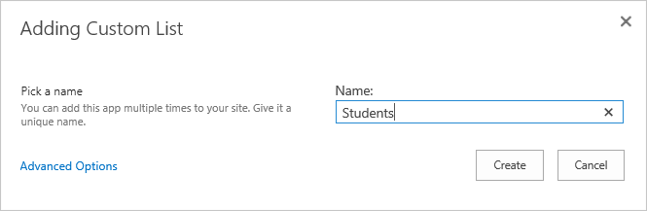

1. Click on the new **Students** tile to view the list.

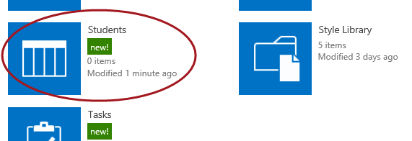

1. The list will display as shown in the figure below.

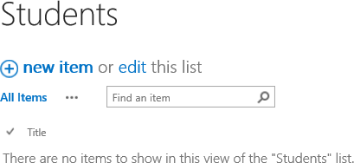

A custom list will only contain the Title columns as this is a starting point but you can add new and/or existing columns to the list. To modify the list columns, proceed to the next steps.

#### Customize List Columns

To edit the columns of your newly created list, follow the steps below:

1. Click on the **LIST tab** in the ribbon and then click on **List Settings**.

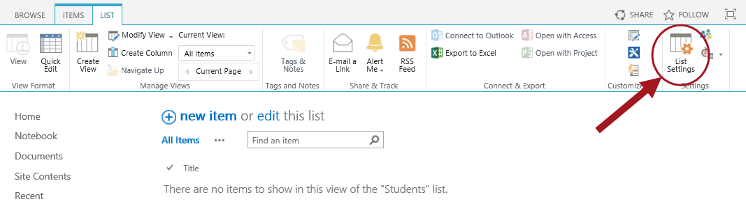

1. From the List Settings page, observe the **Columns** section.

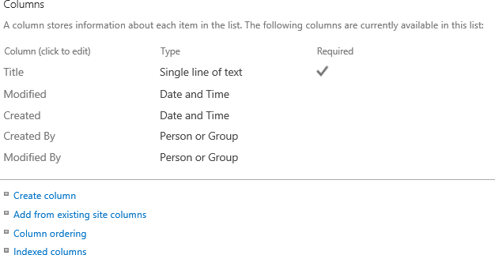

**Note:** The default columns for a Custom list include **Title**, **Modified**, **Created**, **Created** **By**, and **Modified** **By**. The **Columns** section provides the links to create a new list column, add an existing site column, adjust the column ordering, and set the indexed columns. The default **Title** column is a required field which cannot be deleted; however, you can change the **Display Name** of the **Title** column to something else if desired.

1. Click on the **Title** column to access the properties.
2. 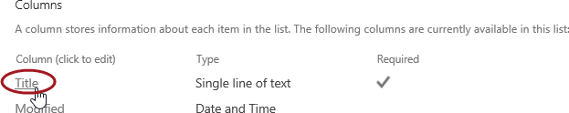
3. Change the **Column name** from **Title** to **Student Name** and then click **OK**.

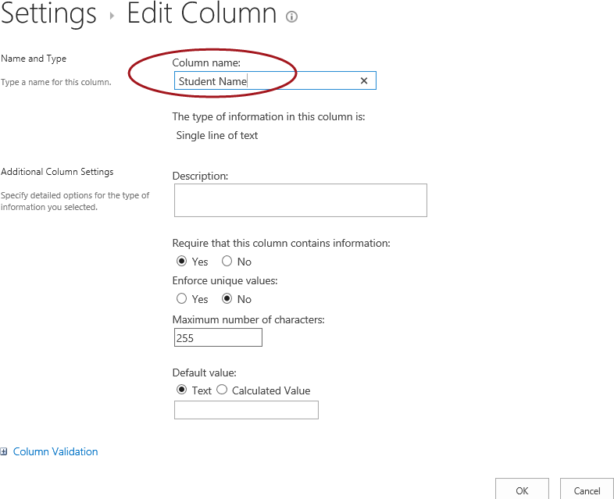

Now, create a column to store the student’s phone number:

1. Click **Create Column**.

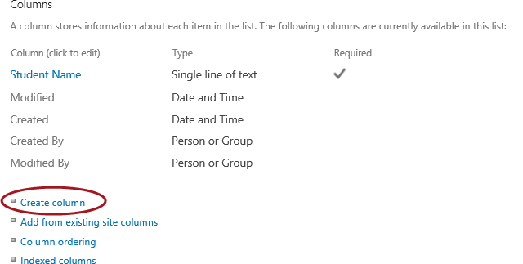

1. Type **Phone** for the **Column name**.Leavethe **Single line of text** option selected and leave all other settings as is then click **OK**.

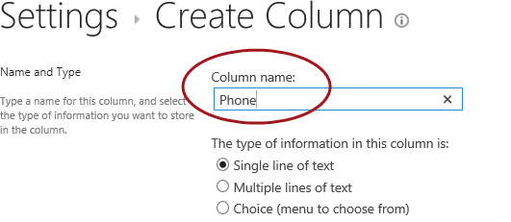

Now, create a column to store the student’s email address:

1. Click **Create Column**.
2. Type **Email** for the **Column name**. Leavethe **Single line of text** option selected and leave all other settings as is then click **OK**.

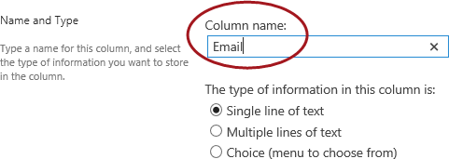

1. You will now have the following columns as displayed in the figure below.

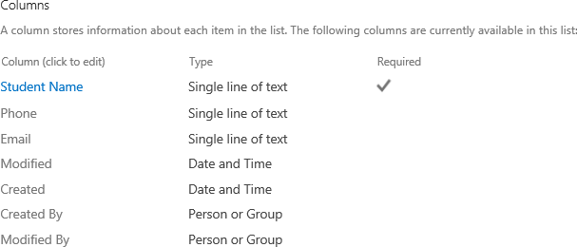

#### Save as List Template

It is common to create custom lists and then save them as list templates so that the template can become the basis of a new list on a site. To save a list as a list template, follow the steps below:

1. From the list settings page under the Permissions and Management section, click **Save list as template**.

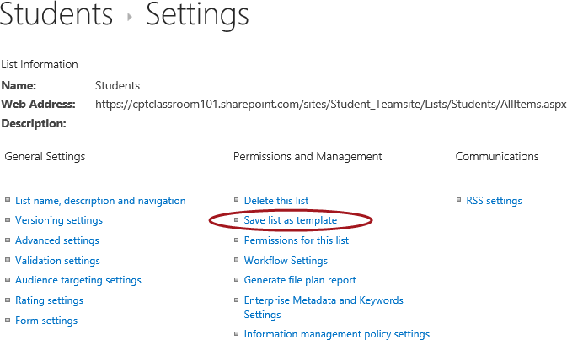

1. In the **File Name** text box, type **Students**.
2. In the **Template** name text box, type **Students** **List** **Template**.

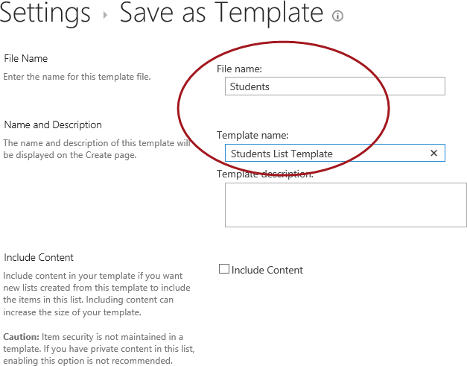

1. Click **OK**.

The option **Include Content** is unselected by default because it’s an option you only select when you want the template to include all items that are in the list. However, because your newly created list does not contain any items this setting will not matter.

1. The list template gallery success message will display. Click on the **list template gallery** link.

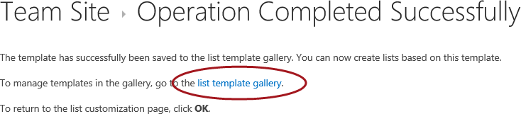

1. The newly created **Students** list template will be displayed in the **List** **Template Gallery**.

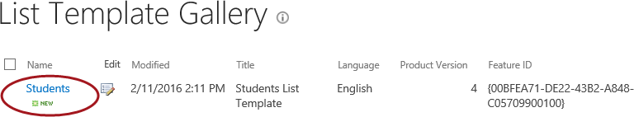

1. The new template will now be available when creating new content.
2. To see the new template tile, follow the steps below as if you were creating a new list.
   1. From the left navigation pane, click **Site** **Contents** then click **Add an app**.
   2. You can page through the tiles using the bottom pagination control or type Students in the search box and click enter. Your Students List Template tile should display similar to the image below.

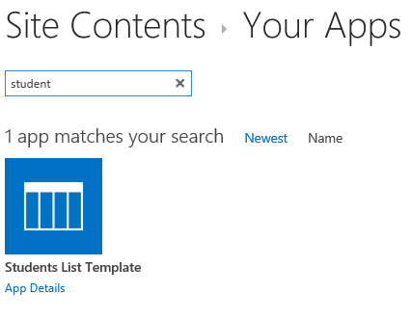

### Exercise 5: Adding Validation Rules

In this exercise you will learn how to customize a list by adding column-level and item-level validation rules.

#### Date Column Validation Rule

In this section, you will add column validation to validate an email address for the Email column.

1. Navigate back to the Students list.
   1. Click **Site Contents** located in the left navigation quick launch menu.
   2. Click on the **Students** tile**.**
2. Click on the **LIST tab** in the ribbon and then click on **List Settings**.
3. Click on **Create Column.**
4. Type **Birth Date** for the **Column name.**
5. Change the data type to **Date and Time** and click **OK**.
6. From the List Settings page, in the **Columns** section, click on the **Birth Date** column link.
7. Expand the **Column Validation** section.

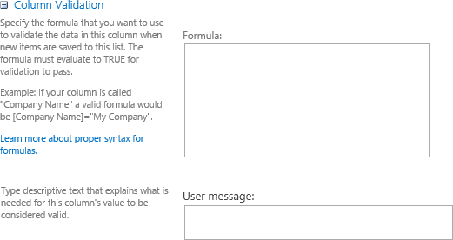

**Note:** The **Formula** property is used to input the column validation formula and the **User message** property is used for inputting the message you want to display to the user.

1. Type the following in the **Formula** input box:

=[Birth Date] < DATE(2000,1,1)

1. In the **User message** property, type **Birth Date must be before January 1, 2000.**

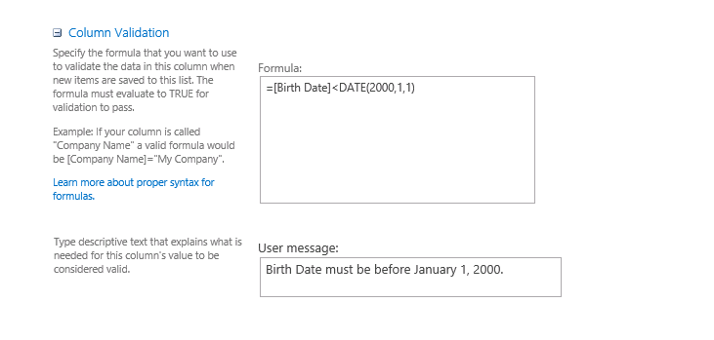

1. Click **OK**.
2. Navigate back to the **Students** list and add a new item. Input a **Birth Date** after January 1, 2000 and click **Save** to test the validation.

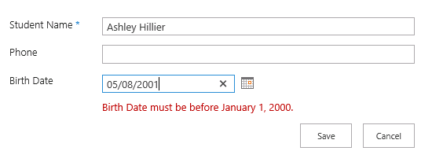

### Exercise 6: Importing Content into a SharePoint list

In this exercise you will learn how to import content from external sources such as an Excel spreadsheet.

1. Navigate to **Add an app** to import content from an Excel Spreadsheet.
   1. Click on the **Settings** icon.
   2. Click **Add an app** or click **Site contents >> add an app**.



* 1. **Click on the Import Spreadsheet tile.**

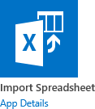

1. From the Import Spreadsheet page, type in a value for the **Name**.
2. In the **File location** property, click **Browse** and browse to your custom Spreadsheet you want to import.

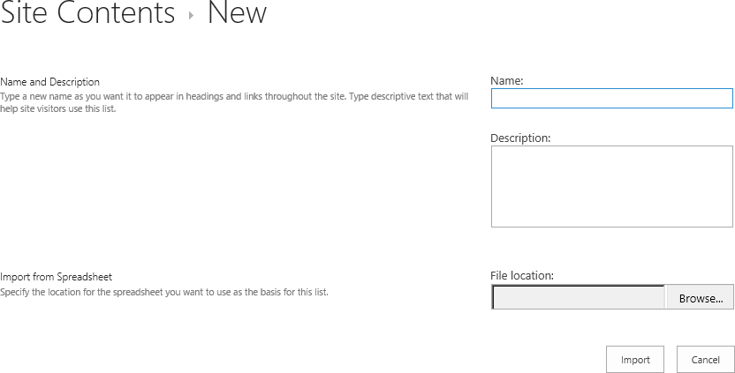

You have now completed this lab exercise.