## Using Pages in SharePoint Online

**Lab Time**: 45 minutes

**Lab Folder**: C:\Student\Modules\Pages

**Lab Overview:** In this lab you will create Wiki pages, Web Part pages, and work with Web Parts on both types of pages.

### Exercise 1: Working with Wiki Pages

In this exercise you will learn how to create, edit and delete Wiki pages. You will also learn how to add content such as images and tables to a Wiki page.

#### Log in to SharePoint Online Site

1. Make sure you have the login information for the SharePoint environment where you will work on your lab exercises. You should have received this log in information from the hosting training company or from your instructor.
2. Make sure you have the URL to the **Team Site** that has been created for you to do your lab work. This URL will be in a form that looks something like this.

https://cptclassroom101.sharepoint.com/sites/Student_Teamsite

1. Launch Internet Explorer and navigate to the URL of the Team Site mention in the previous step. Note that you should be logged in with a user account that has full control and access to the site collection, and therefore will be permitted access and be able to create lists.
   1. When prompted to login, enter the user name and password that has been supplied to you and then click **OK**.

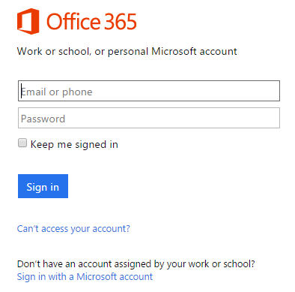

* 1. You should be able to confirm that you are logged into the SharePoint site. For example, if you were logged in as a student named **John Doe**, your name would appear in the SharePoint Welcome menu as shown in the following screenshot.

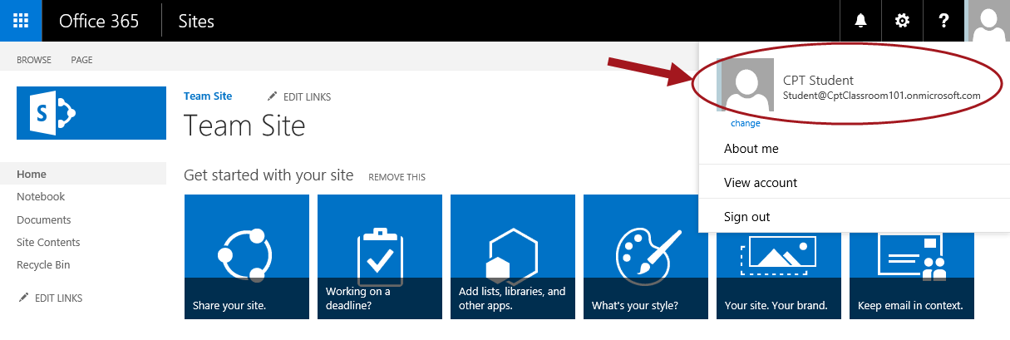

#### Create a Wiki Page

1. Navigate to Site Contents.
   1. Click **Site Contents** located in the left navigation quick launch menu.

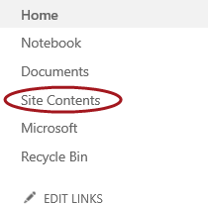

1. **Click on the Site Pages tile.**



1. **To create new Wiki page:**
   1. **Click on the FILE tab, expand the New Document drop-down list and select Wiki Page.**

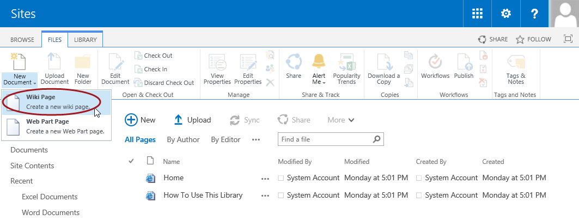

* 1. **In the New page name text box, type My First Wiki Page and then click Create.**

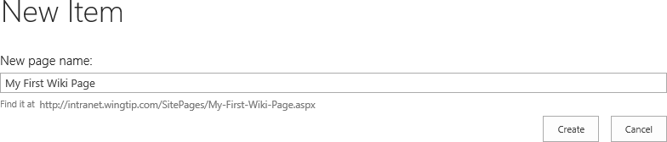

1. **The Wiki page will now be open in Edit mode containing one rich text content area.**

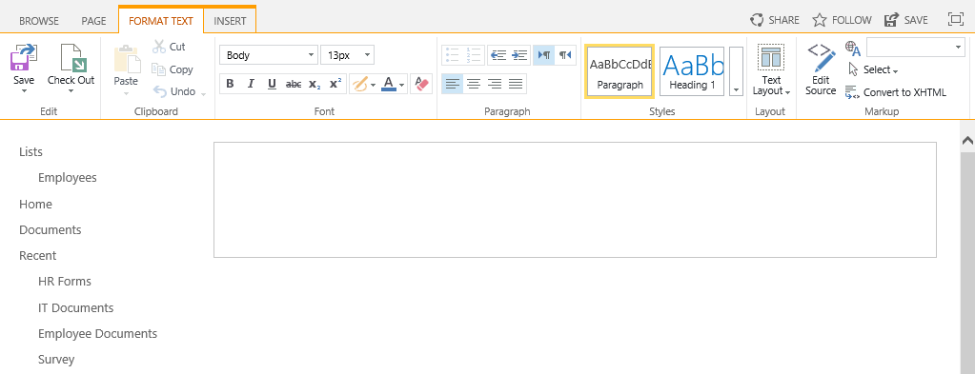

1. **In the rich content area, click to make cursor active in area and then type Hello and welcome to my first wiki page!.**
2. **Change the format of the text by:**
   1. **Highlight (select) the text you just typed.**
   2. **From the FORMAT TEXT tab in the Styles group, click on Heading 1.**

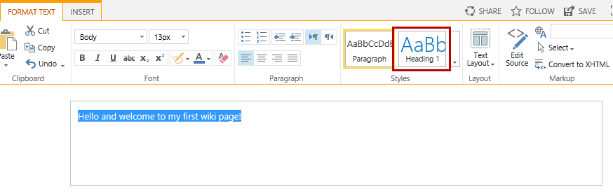

* 1. **Hit Enter and then type This page will be used to add free-form text, images, and web parts.**



1. **From the FORMAT TEXT tab in the Edit group, click the Save button.**

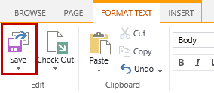

1. **Your page will now be saved and will no longer be in Edit mode.**

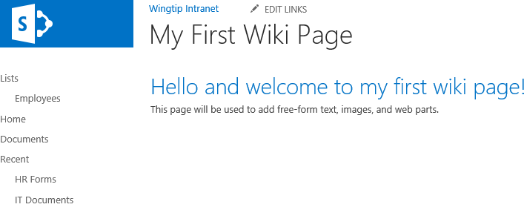

#### Edit Wiki Page

1. To go into Edit mode:
   1. Make sure the Wiki page you want to edit is open on the site.
   2. From the **PAGE** tab in the **Edit** group, click the **Edit** button.

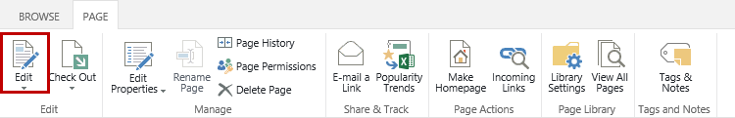

1. Make any desired changes to the content and when complete save the page.
   1. From the **PAGE** tab, click **Save**.

#### Delete Wiki Page

1. To delete a Wiki page:
   1. Make sure the Wiki page you want to delete is open on the site.
   2. From the **PAGE** tab in the **Manage** group section click **X** **Delete Page**.

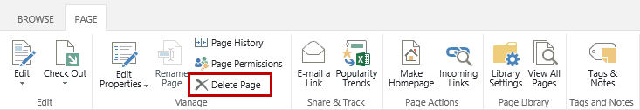

* 1. From the Message from webpage delete confirmation dialog box, click **OK**.

1. The page will delete and you will be redirected to the home page of the site.

#### Recover Deleted Wiki Page

1. Navigate to Site Contents.
   1. Click on the **Settings** icon and select **Site contents**.
2. From the **Site Contents** page, click on the **RECYCLE BIN** link located above the app tiles.

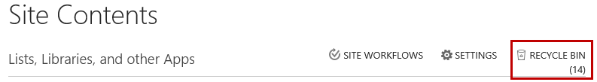

1. Select the **My First Wiki Page.aspx** check box, and then click **Restore** **Selection**.

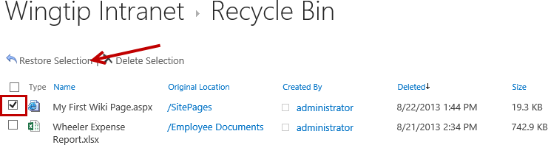

1. From the **Message from webpage** restore confirmation dialog, click **OK**.

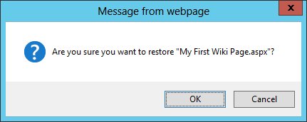

1. Navigate back to your restored Wiki page:
   1. Click on the **Site Contents** link from the left navigation quick launch menu.
   2. From the **Site Contents** page, click on the **Site Pages** tile.
   3. Click on the **My First Wiki Page** link.

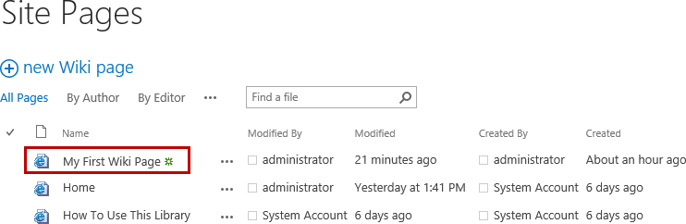

#### Add/Delete Images on Wiki Page

Before adding images to the Wiki Page you will first create an Images Library to store the images in.

1. Navigate to **Add an app** to create a new Document library.
   1. Click on the **Settings** icon.
   2. Click **Add an app** or click **Site contents >> add an app**.

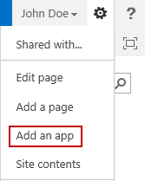

* 1. Click on the **Picture Library** tile.



* 1. In the **Name** text box, type **Site Images** and then click **Create**.

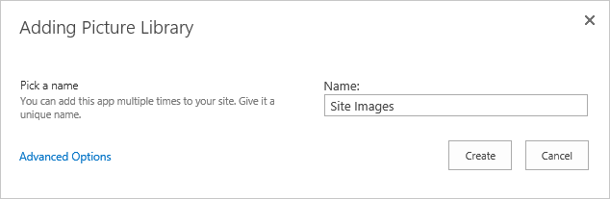

1. From the **Site Contents** page, click the **Site** **Pages** tile.
2. From the **Site Pages** library, click the **My First Wiki Page** link.
3. Go into Edit mode:
   1. From the **PAGE** tab in the **Edit** group, click the **Edit** button.



1. Place your cursor in the content area where you want the image to be placed.
2. From the **INSERT** tab in the **Media** group, expand the **Picture** drop-down list.

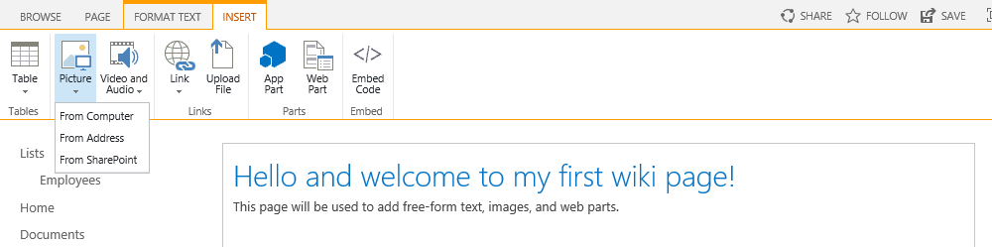

**Note:** The three ways you can insert pictures into a Wiki page is **From Computer**, **From Address**, or **From SharePoint**. The **From Computer** option gives you the ability to upload a picture from your local machine. The file will upload to the designated library you select from the dialog. The **From Address** option is for typing in a URL to point to the image you want to use and the **From SharePoint** option is to select an image from a library that exists in SharePoint.

1. Select **From Computer**.
2. From the **Upload Image** dialog, click **Browse**.
3. Browse to **C:\Student\Modules\Pages**, select **PagesPhoto.jpg** and then click **Open**.
4. From the **Destination Library** drop-down list, select **Site Images** and then click **OK**.

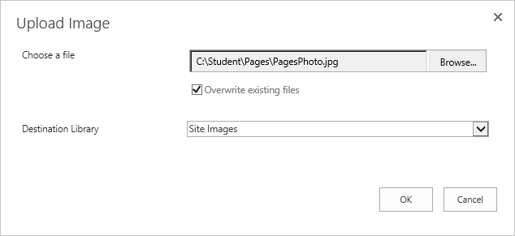

1. The **Site Images** dialog will open for the image; click **Save**.
2. Make any desired changes such as making the image smaller or dragging the photo around on the page to move the location.

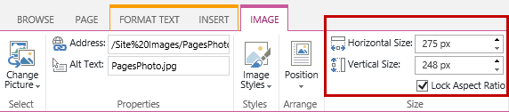

1. Once complete, from the **PAGE** tab click **Save**.

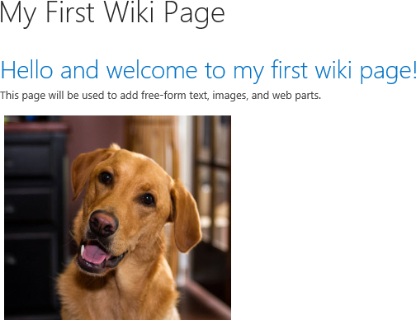

1. To delete the image:
   1. From the **PAGE** tab in the **Edit** group, click the **Edit** button.
   2. Click on the image you want to delete then press the **Delete** key.
2. Save the page.
   1. From the **PAGE** tab, click **Save**.

#### Add/Format/Delete Tables on Wiki Page

1. Go back into Edit mode:
   1. From the **PAGE** tab in the **Edit** group, click the **Edit** button.
2. Place the cursor in the content area where you want to add the table.
3. From the **INSERT** tab, click **Table.**
4. Highlight two of the rows and cells and click to **Insert a 2x2 Table** on the page.

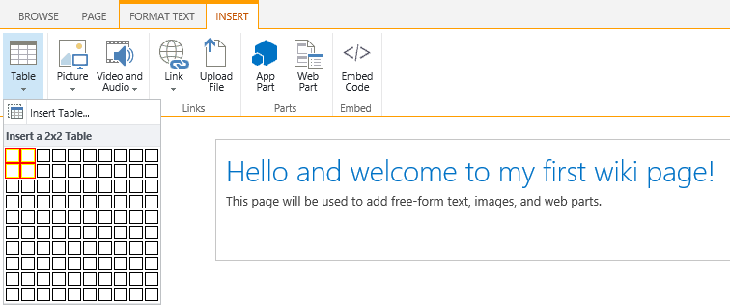

1. The table will now be inserted on the page. Type **Name** and **Email** in the first row cells and type **John** **Doe** and **johndoe@wingtip.com** in the second row of cells as displayed in the image below.

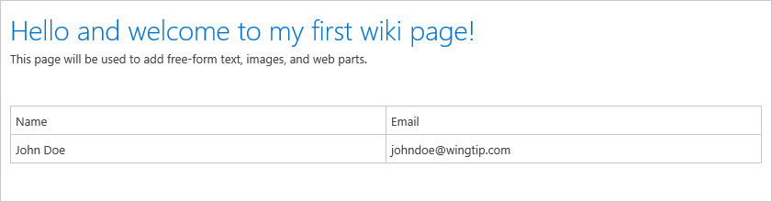

1. To modify the formatting of the table:
   1. Place your cursor in the Name cell.
   2. From the **DESIGN** tab in the **Table Style Options** group, click **Header Row**.
   3. Expand the **Styles** drop-down list, and click **Table Style 6 – Accent 1** (or any other desired accent style).

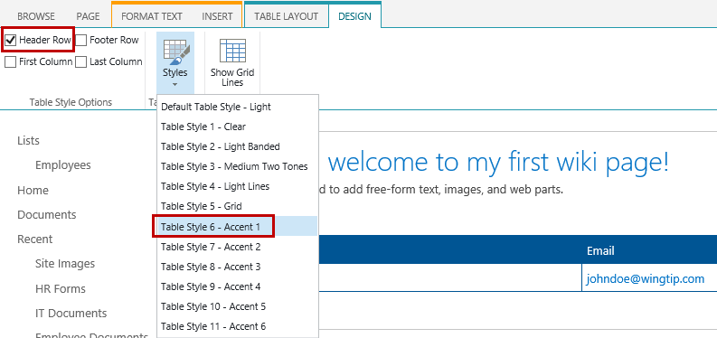

1. Save the page.
   1. From the **PAGE** tab, click **Save**.
2. The page will now be saved and should look similar to the image below.

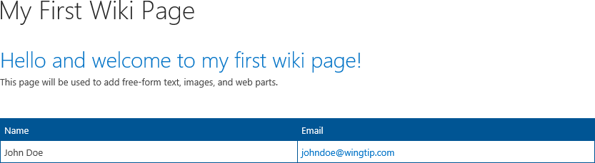

1. To delete the table:
   1. From the **PAGE** tab in the **Edit** group, click the **Edit** button.
   2. Click on the table to activate the **TABLE LAYOUT** and **DESIGN** tabs.
   3. From the **TABLE LAYOUT** tab, click the **Delete** button and select **Delete Table**.

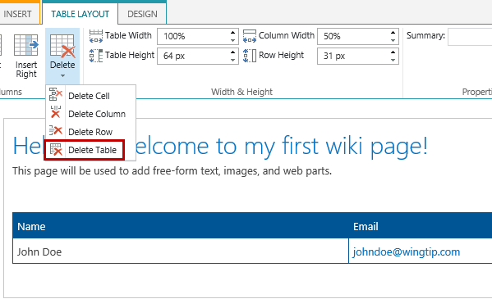

1. Save the page.
   1. From the **PAGE** tab, click **Save**.

### Exercise 2: Adding Web Parts to Wiki Pages

In this exercise you will updating the formatting of the Wiki page and then add, move, and add Web Parts to the page.

#### Update Wiki Page Text Layout

1. Go back into Edit mode for the Wiki page:
   1. From the **PAGE** tab in the **Edit** group, click the **Edit** button.
2. From the **FORMAT TEXT** tab, click the **Text** Layout button.
3. Choose **Two columns with header**.

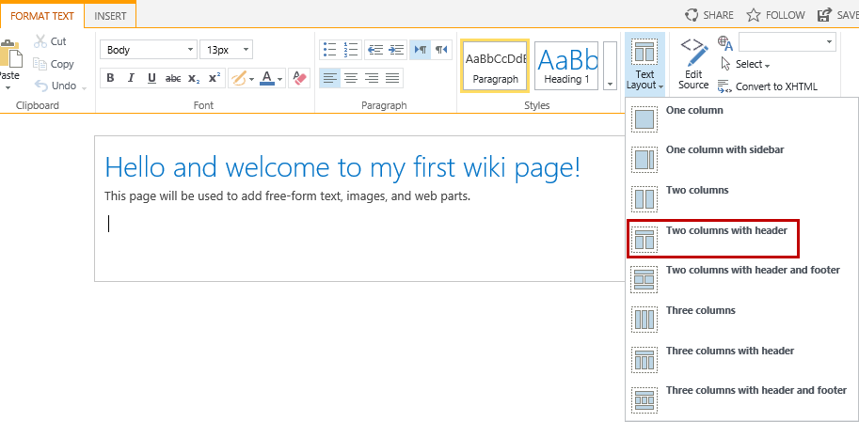

1. The content areas will change from one to three (header and two columns below the header) and the content created earlier in this lab is now in the left cell.

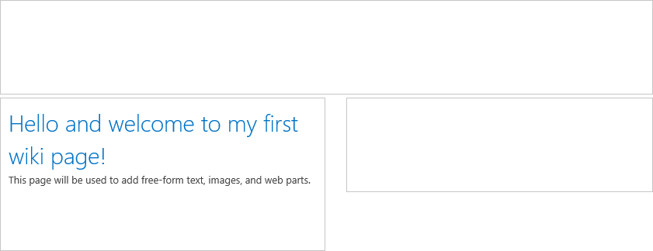

1. Move the content in the left content area to the header content area:
   1. Select all the content in the left cell (Keyboard shortcut is Ctrl + A)
   2. From the **FORMAT TEXT** tab in the **Clipboard** group, click **Cut** or use the keyboard shortcut **Ctrl + X.**
   3. Move your cursor to the **Header** content area and paste the content by clicking the **Paste** button.
   4. If a confirmation dialog pops up, click **Allow Access**.

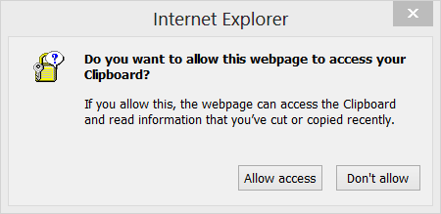

1. The content is now in the Header content area.

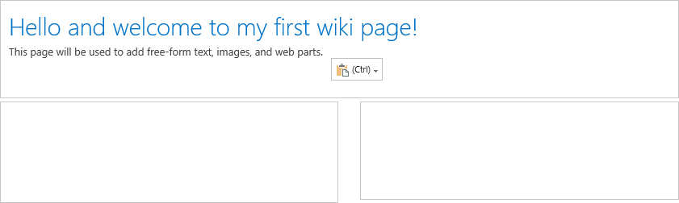

#### Add Web Parts to Wiki Page

1. In edit mode, find a place on the Wiki page you want to insert the Web Part and click to place your cursor.
2. From the **INSERT** tab in the **Parts** group, click the **Web** **Part** button.

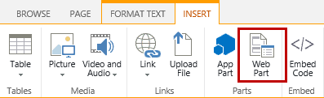

1. To add a **Note Board** Web Part, from the **Add a Web Part** panel:
   1. In the **Categories** section, select **Social** **Collaboration**.
   2. In the **Parts** section, select **Note Board** then click **Add**.

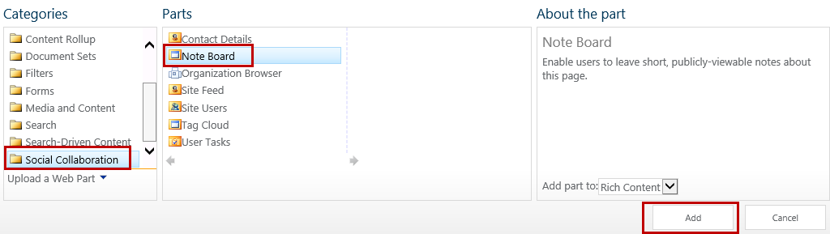

1. The **Note Board** Web Part is now on the Wiki page.

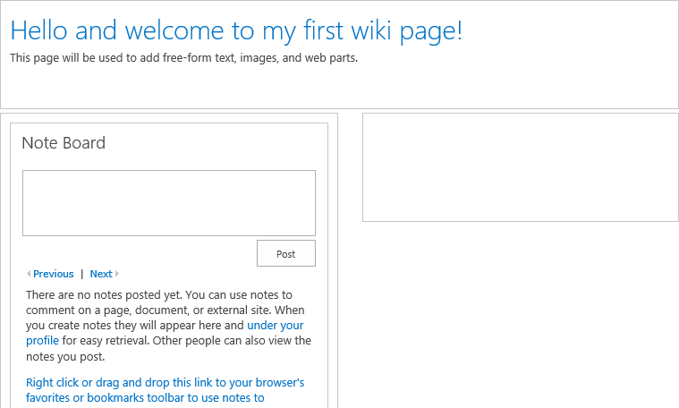

1. Save the page.
   1. From the **PAGE** tab, click **Save**.

#### Move Web Parts on Wiki Page

Moving Web Parts on a Wiki page is not as easy as it is to move on a Web Part page because Wiki pages do not contain Web Part Zones. Unfortunately, the only way to move Web Parts on a Wiki Pages is by moving around the HTML tags in the Edit Source of the Page.

1. Go back into Edit mode for the Wiki page:
   1. From the **PAGE** tab in the **Edit** group, click the **Edit** button.
2. Place your cursor in the area of the page that contains the Web Part you want to move.

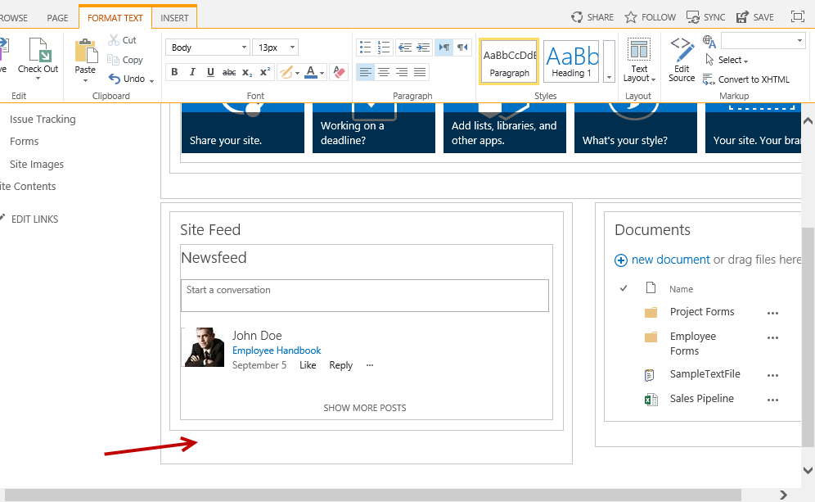

1. From the **FORMAT TEXT** tab in the **Markup** group, click on the **Edit Source** button.

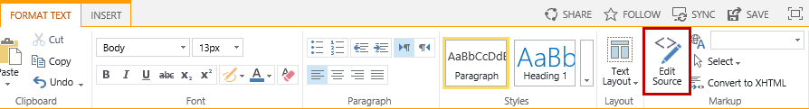

1. Select the HTML markup and cut the text by using **right-click Cut** or using the keyboard shortcut **Ctrl V.**

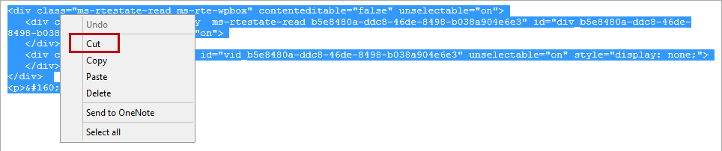

1. Click **OK**.
2. Place your cursor inside the area you want to paste the copied Web Part into.

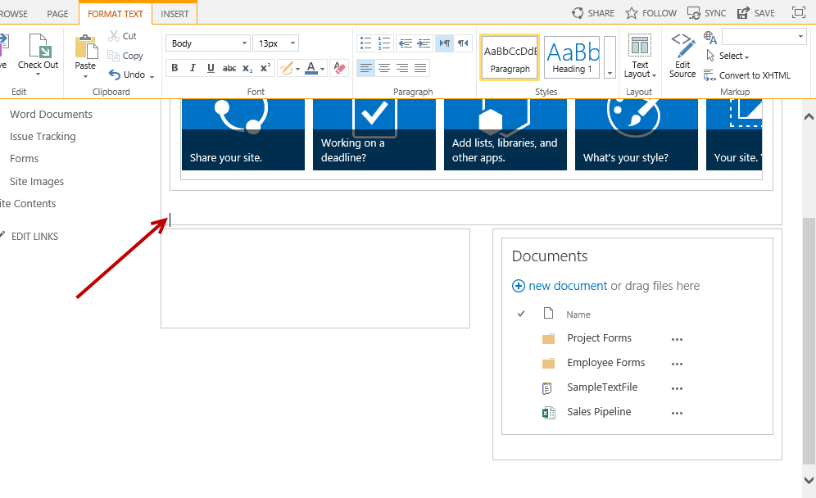

1. From the **FORMAT TEXT** tab in the **Markup** group, click on the **Edit** **Source** button.
2. To paste the Web Part below the current Web Part:
   1. Place your cursor below the existing HTML markup.

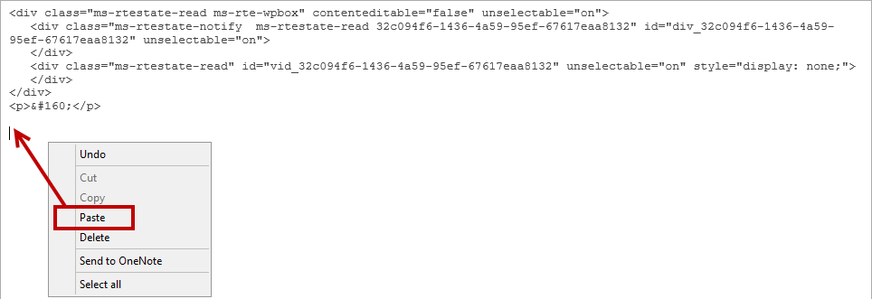

* 1. Paste the HTML markup (**right-click Paste** or using the keyboard shortcut **Ctrl X**).

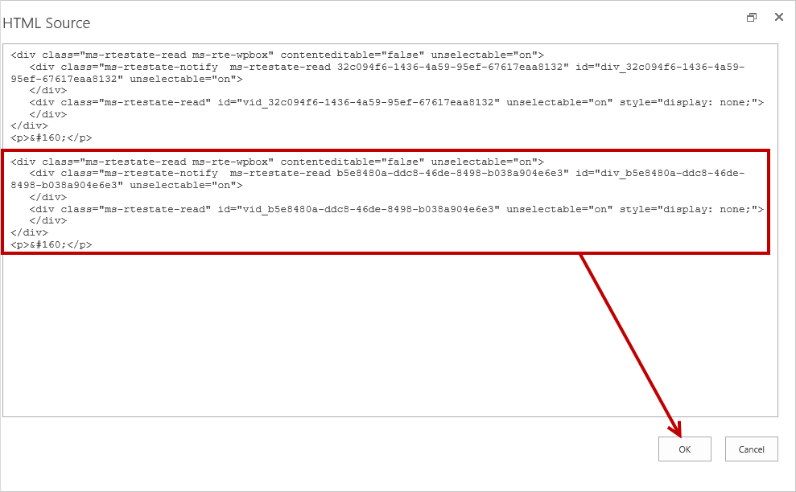

1. The pasted Web Part is now below the existing Web Part in the same area.

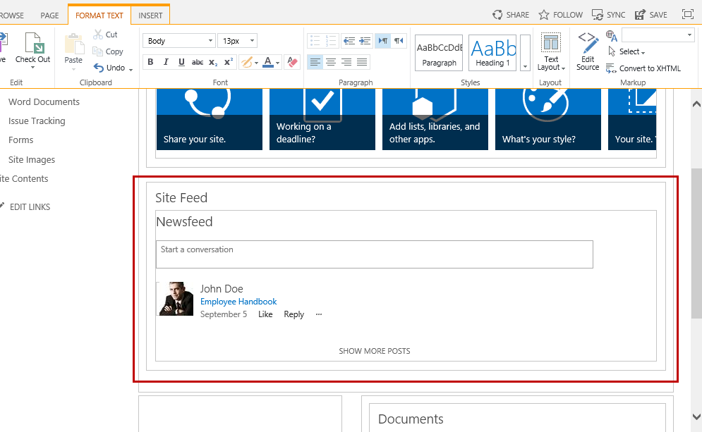

1. To move the Web Part to another location repeat the steps until you achieve the desired results.
2. Once complete, save the page.
   1. From the **PAGE** tab, click **Save**.

#### Delete Web Parts on Wiki Page

Web Parts can be deleted either through the ribbon or directly through the Web Part menu options.

1. Go back into Edit mode:
   1. From the **PAGE** tab in the **Edit** group, click the **Edit** button.
2. Delete a Web Part using the Ribbon option:
   1. Click on the **Note Board** Web Part to activate the **WEB PART** tab.
   2. From the **WEB PART** tab in the **State** group, click the **Delete** button.

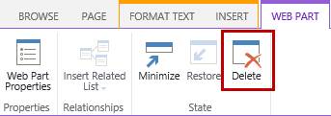

* 1. From the **Message from webpage** delete dialog, click **OK**.

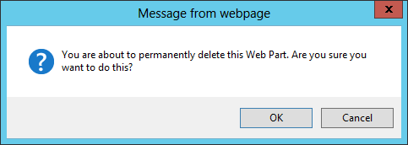

1. Delete Web Part using the Web Part menu option.
   1. Click the down arrow on the **Note Board** Web Part and select **Delete**.

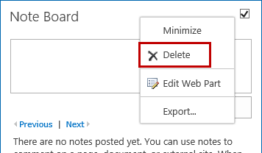

* 1. From the **Message from webpage** delete dialog, click **OK**.



### Exercise 3: Working with Wiki Page Links

In this exercise you will learn how to create links for Wiki pages.

#### Insert a Link to another Wiki Page

1. Go back into Edit mode:
   1. From the **PAGE** tab in the **Edit** group, click the **Edit** button.
2. Place your cursor in the content area you want to insert a link.
3. Type **[[** and click on **How To Use This Library**.

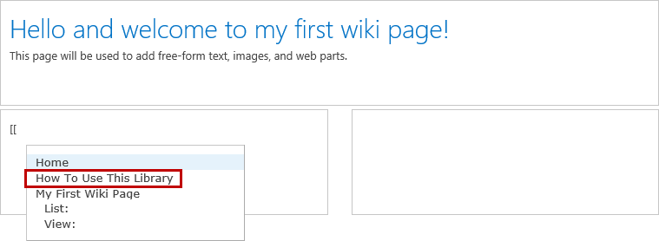

1. Type **]]** after the **[[How To Use This Library** text.
2. Save the page.
   1. From the **PAGE** tab, click **Save**.
3. The Wiki page now contains a **How to Use This Library** link. Click on the link to test.

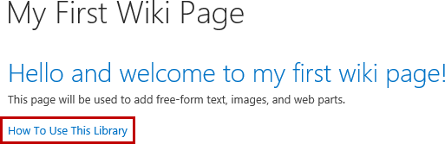

1. Click the browser back button to go back to the **My First Wiki Page**.

#### Creating Link and Page at the Same Time

1. Go back into Edit mode:
   1. From the **PAGE** tab in the **Edit** group, click the **Edit** button.
2. Place your cursor at the end of the **[[How To Use This Library]]** and then hit **Enter** to create a new line.
3. Type **[[** and then type **My Second Wiki Page]]**.
4. Save the page to generate the link.
   1. From the **PAGE** tab, click **Save**.
5. To generate the page, click on the dotted underlined **My Second Wiki Page** link.

**Note:** The dotted underline indicates the Wiki page still needs to be created. Clicking on the dotted underlined My Second Wiki Page link will automatically generate the page.

1. From the **Add a page** confirmation dialog, click **Create**.
2. The page will create and open in edit mode. Type some text in the rich text content area and then hit **Enter** to create a new line.
3. Add a link to the My First Wiki Page.
   1. Type **[[** and click on My First Wiki Page and then type **]]**.



1. Save the page.
   1. From the **PAGE** tab, click **Save**.
2. The Wiki page now contains a **My First Web Page** link. Click on the link to test.

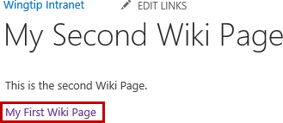

### Exercise 4: Working with Web Part Pages and Web Parts

In this exercise you will learn to create

#### Create Web Part Page

1. Navigate to the site home page:
   1. Click on the **SharePoint** **logo** **image** or the **Wingtip Intranet** link.
2. From the **PAGE**, click the **View All Pages** button in the **Page Library** group.

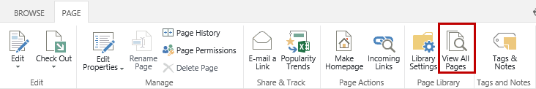

1. From the **FILES** tab in the **New** group, expand the **New Document** drop-down list and select **Web Part Page**.

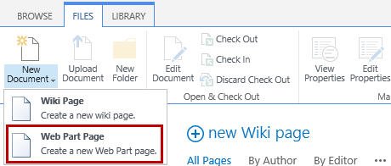

1. From the **New Web Part Page** settings page:
   1. In the **Name** text box, type **Exercise 5** and ensure the **Overwrite if the file exists** option is selected.

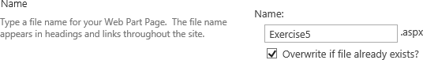

* 1. From **Choose a Layout Template**, select **Header, Right Column, Body**.

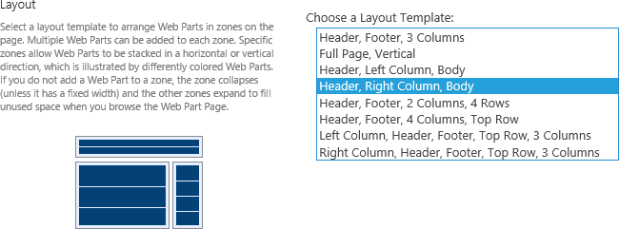

* 1. In the **Document Library** drop-down list, ensure **Site Pages** is selected.



1. Click **Create**.
2. The page is created and opened in Edit mode.

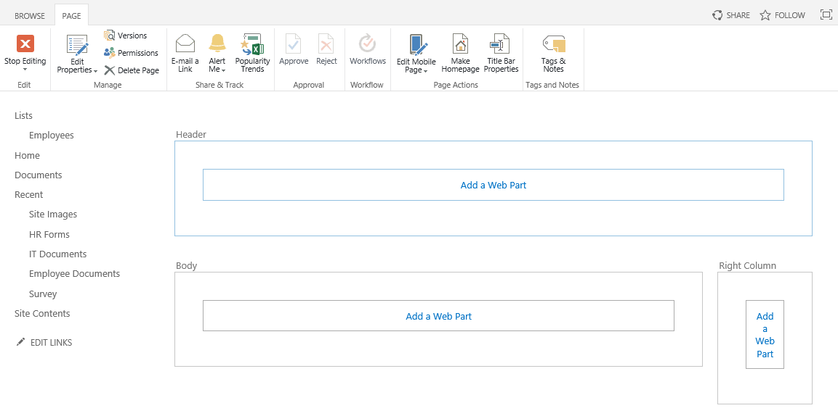

#### Modify Web Part Page Properties

In these steps you will modify the **Title Bar Properties** of the Web Part Page. The only required property that needs to be set is the **Title** field. The **Caption** is a supplemental description that if exists appears above the title in the title bar of the page. The **Description** is supplemental information for the title or caption, and if exists appears when the user rests the mouse pointer on the title or caption of the page. The **Image Link,** if set, will appear to the left of the page title. This optional property can be set to a company logo or any other desired image. The image must exist and can be stored in SharePoint or retrieved from another web address.

1. To update the title bar properties of the page:
   1. From the **PAGE** tab in the **Page Actions** group, click the **Title Bar Properties** button.

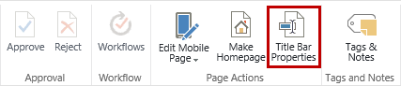

1. From the **Web Part Page Title Bar** web part properties panel:
   1. In the **Title** text box, type **Exercise 5 Lab**.
   2. In the **Caption** (optional) text box, type **Critical Path Training**.
   3. In the **Description** (optional) multi-line text box, type **Learning how to use Wiki Pages and Web Part Pages**.
   4. Leave the **Image** **Link** text box empty and click **OK**.

#### Add Web Parts on Page

1. To add a **Get started with your site** Web Part in the **Header** zone:
   1. Click on **Add a Web Part** for the **Header** zone to open the **Add a Web Part** panel.
   2. In the **Categories** section, select **Media and Content**.
   3. In the **Parts** section, select **Get started with your site** then click **Add**.

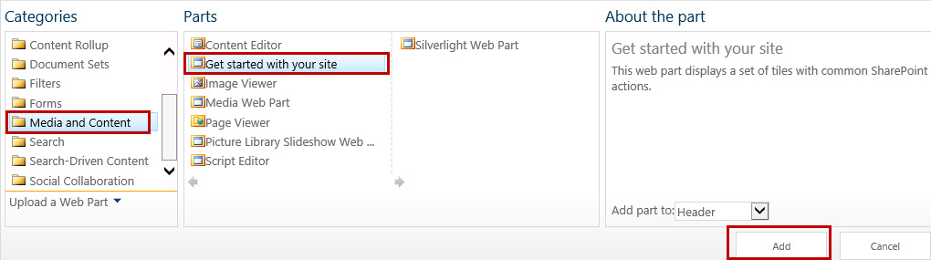

1. The **Get started with your site** Web Part is now on the page in the Header Web Part Zone.

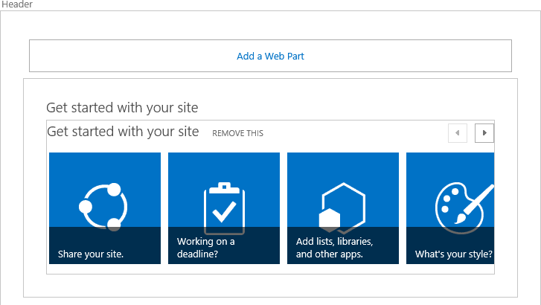

1. To add an **Announcements** Web Part in the **Body** zone:
   1. Click on **Add a Web Part** for the **Body** zone to open the **Add a Web Part** panel.
   2. In the **Categories** section, ensure **Apps** is selected.
   3. In the **Parts** section, select **Announcements** then click **Add**.

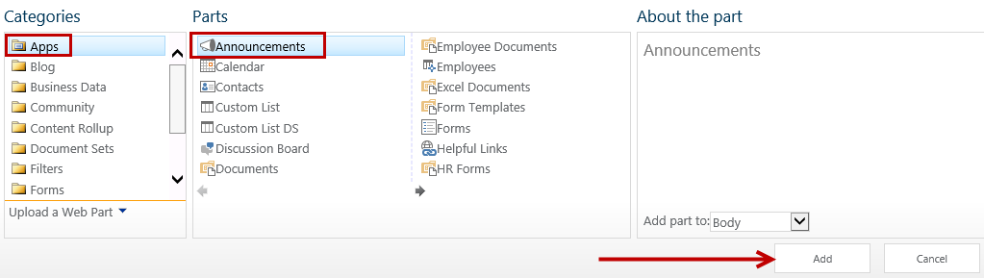

1. The **Announcements** Web Part is now on the page in the Body Web Part Zone.

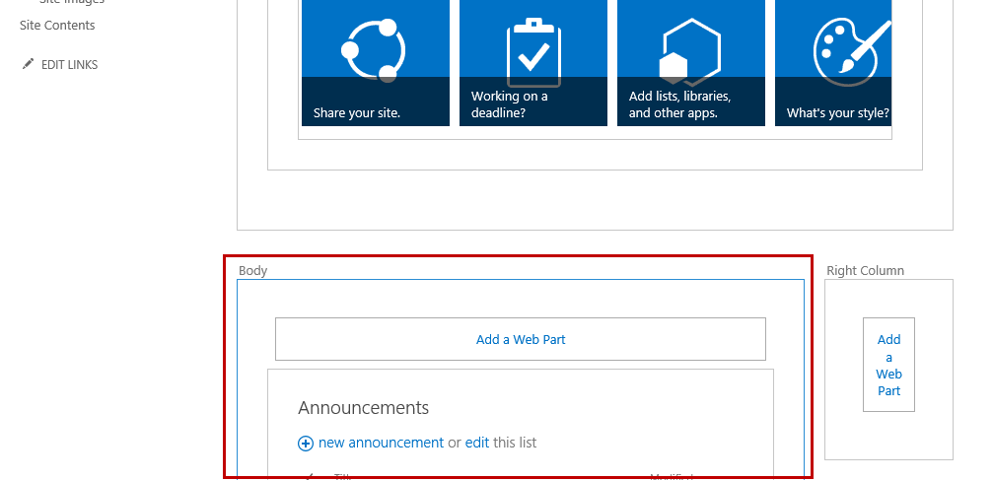

1. Exit edit mode:
   1. From the **PAGE** tab in the **Edit** group, click **Stop Editing**.

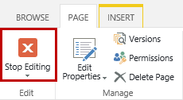

1. The page is now saved.

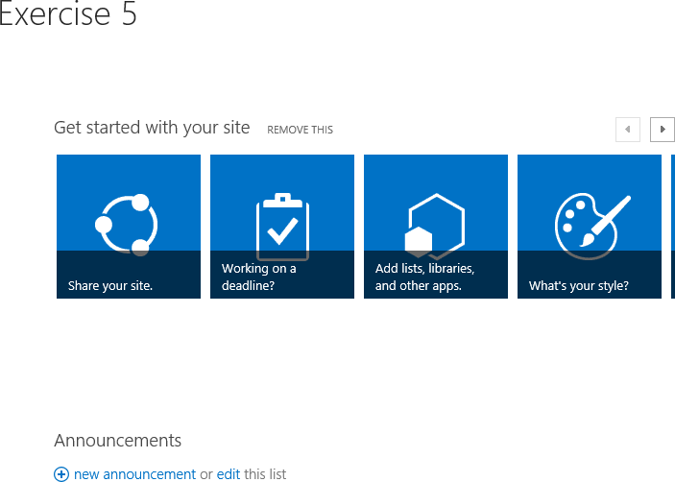

#### Move Web Parts on Page

1. Go back into Edit mode for the Exercise 5 Web Part page:
   1. From the **PAGE** tab in the **Edit** group, click the **Edit Page** button.

There are two options to move Web Parts to different zones on the page, which are dragging and dropping or using Edit Web Part.

1. To move a Web Part to a different zone using drag and drop:
   1. Place your mouse over the Web Part header until your cursor changes into a 4-way cursor.



* 1. Hold down the mouse and drag the Web Part into a different zone.

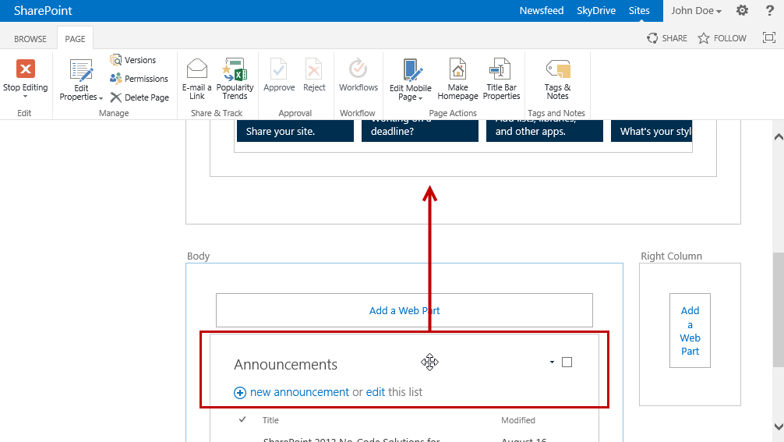

1. The **Announcements** Web Part is now below the **Get started with your site** Web Part in the **Header** zone.

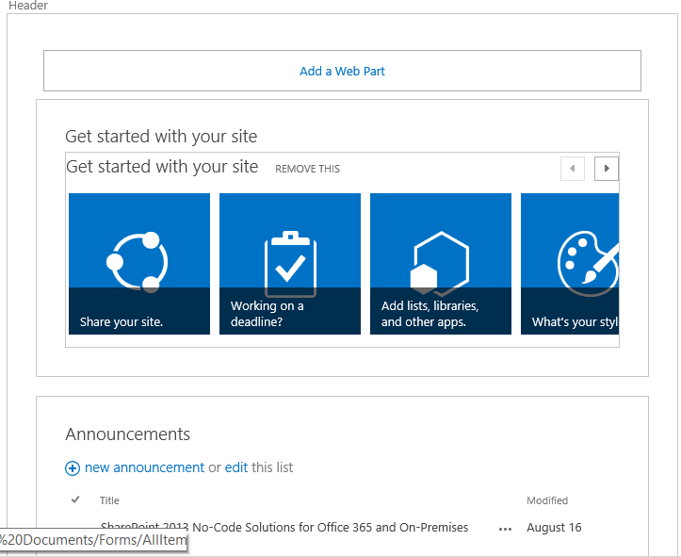

1. To use the Edit Web Part method to move a Web Part on a page:
   1. Click the down arrow on the **Announcements** Web Part and select **Edit Web Part**.

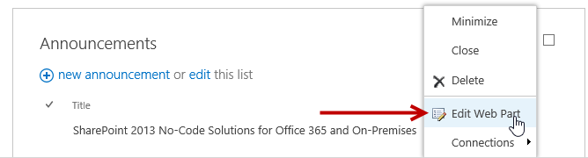

* 1. Click the **+** sign next the **Layout** section to expand the Layout properties.
  2. From the **Zone** drop-down menu, select the zone you want the Web Part to be in.

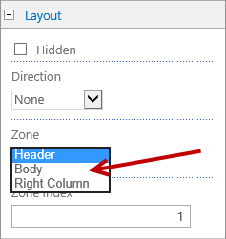

* 1. Once complete, click **OK**.

1. To reorder Web Parts in the same zone, use the drag-and-drop method to drag the desired Web Part above or below another Web Part in the same zone.
2. Once all desired changes are complete, exit edit mode:
   1. From the **PAGE** tab in the **Edit** group, click **Stop Editing**.

#### Minimize and Restore Web Part on Page

1. Go back into Edit mode for the Web Part page.
   1. From the **PAGE** tab in the **Edit** group, click the **Edit Page** button.
2. To minimize a Web Part:
   1. Click the down arrow on the **Announcements** Web Part and select **Minimize**.

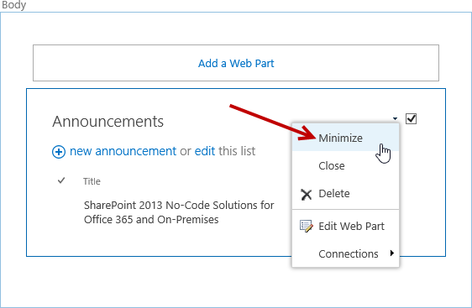

1. Save the page to see the results. From the **PAGE** tab in the **Edit** group, click **Stop Editing**.
2. Notice the Announcements Web Part is now minimized.

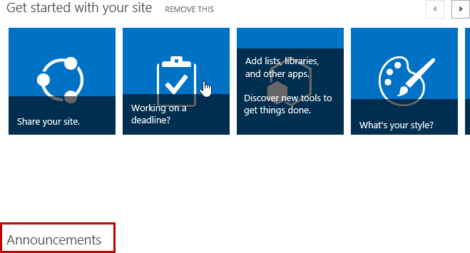

1. To restore a minimized Web Part:
   1. Go back into Edit Mode for the page. From the **PAGE** tab in the **Edit** group, click the **Edit Page** button.
   2. Click the down arrow on the **Announcements** Web Part and select **Restore**.

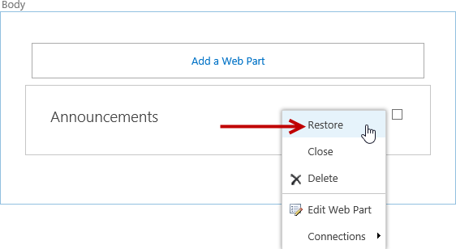

1. The **Announcements** Web Part is now restored.

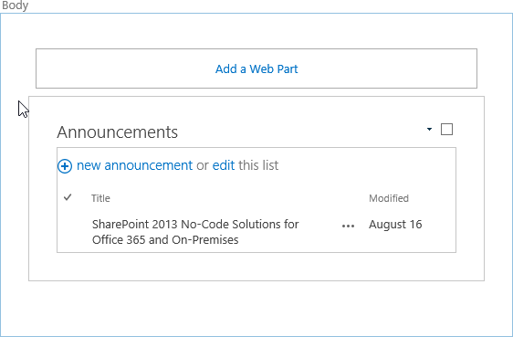

1. Exit edit mode:
   1. From the **PAGE** tab in the **Edit** group, click **Stop Editing**.
2. The page is now saved and the Announcements Web Part is restored.

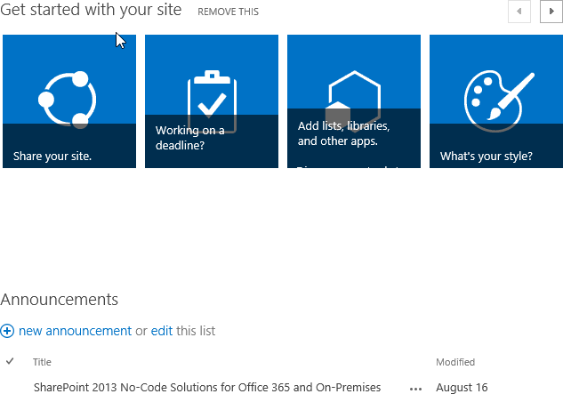

#### Delete Web Parts from Page

1. Go back into Edit mode for the Web Part page:
   1. From the **PAGE** tab in the **Edit** group, click the **Edit** **Page** button.
2. To delete the **Announcements** Web Part from the page:
   1. Click the down arrow on the **Announcements** Web Part and select **Delete**.

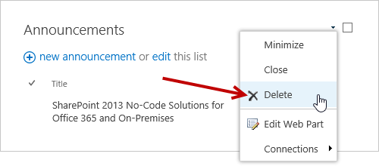

* 1. From the **Message from webpage** delete dialog, click **OK**.



1. Exit edit mode:
   1. From the **PAGE** tab in the **Edit** group, click **Stop Editing**.