## Working with Publishing Sites

**Lab Time**: 45 minutes

**Lab Folder**: C:\Student\Modules\Publishing

**Lab Overview:** In this lab you will learn how to work with a publishing site. You will learn how to add content to the site, update the page settings, and change the look of the site using Composed Looks.

### Exercise 1: Add Content to Publishing Site

In this exercise you will add a few images to the Images library and add them to pages.

#### Log in to SharePoint Online Publishing Site

1. Make sure you have the login information for the SharePoint environment where you will work on your lab exercises. You should have received this log in information from the hosting training company or from your instructor.
2. Make sure you have the URL to the **Team Site** that has been created for you to do your lab work. This URL will be in a form that looks something like this.

https://cptclassroom101.sharepoint.com/sites/Student_Publishingsite

1. Launch the Internet Explorer and navigate to the URL of the Publishing Site mention in the previous step. Note that you should be logged in with a user account that has full control and access to the site collection, and therefore will be permitted access and be able to create lists.
   1. When prompted to login, enter the user name and password that has been supplied to you and then click **OK**.

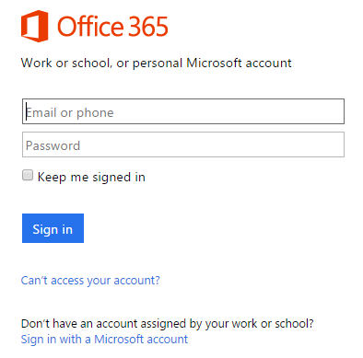

* 1. You should be able to confirm that you are logged into the SharePoint site. For example, if you were logged in as a student named **John Doe**, your name would appear in the SharePoint Welcome menu as shown in the following screenshot.

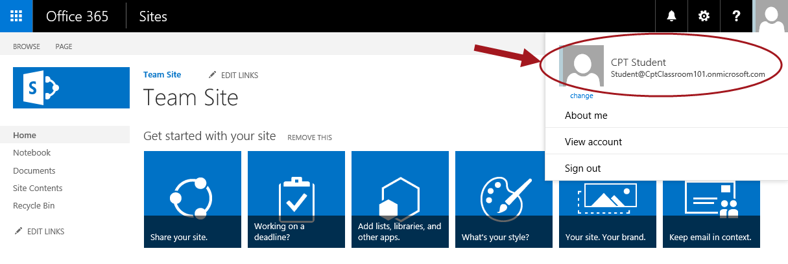

#### Add Images to Site

1. Add a set of images to the site to use in a new page:
   1. In the **Quick Launch** navigation, click the **Site Contents** link.
   2. On the **Site Contents** page, select the **Images** library tile.

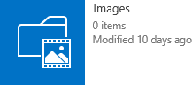

* 1. Using **Windows Explorer**, navigate to the following folder:

C:\Student\Modules\Publishing\Images

* 1. Within this folder you’ll find several images that have been supplied by the Marketing department of Wingtip Toys. Select all these files in the Windows Explorer and drag-and-drop them into the browser near where it says **Drag files here or click to add an item** under the **Images** library title:

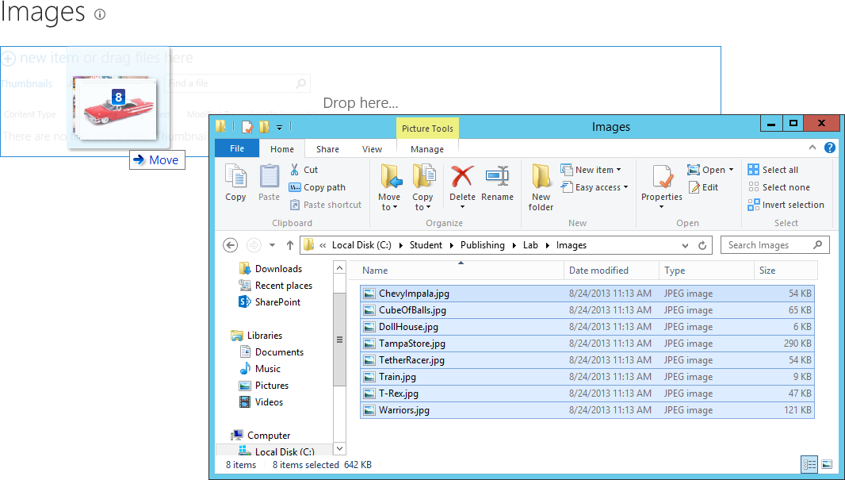

* 1. After a moment the images will be visible in the **Images** library. You will also see a status message below the Images library title. Click on **DISMISS**.

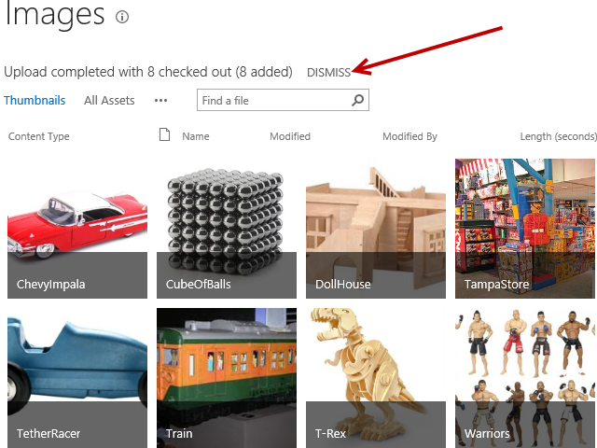

1. After uploading the images, you need to check them in so they can be used.
   1. Do this by moving to the **All Assets** view and selecting all the images at once.

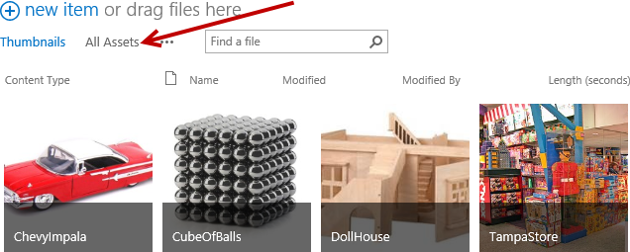

* 1. Once all the items have been selected, click on the **FILES** tab and then click the **Check In** ribbon button.

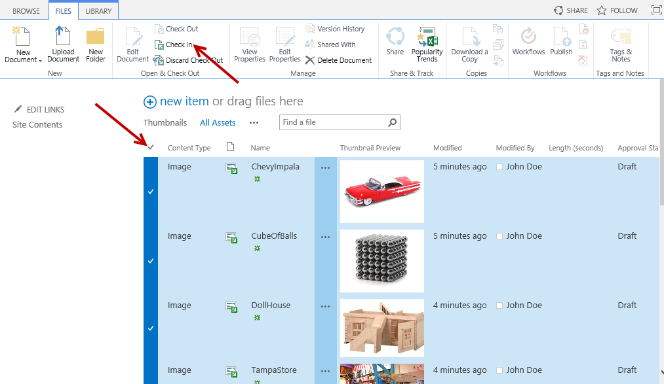

* 1. When prompted select **Major Version (Publish)** and click **OK**.

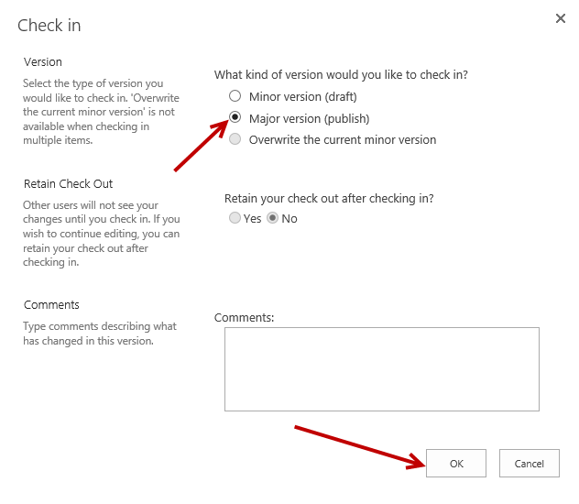

* 1. You should be able to confirm that the **Approval Status** of all the images is now **Approved**.

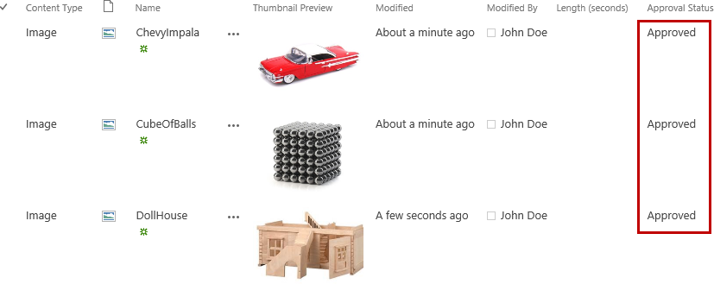

#### Update Site Home Page

In these steps, you will update the site content and properties of the Publishing site’s home page.

1. Navigate back to the Publishing site’s home page.
2. Go into **Edit Mode** for the page:
   1. Click the **Edit page** command from **Site Actions** to transition the page into edit mode.
3. Change the **Title** to **Wingtip Toys**.



1. In the **Page Content** edit control, change the heading to **Welcome to Wingtip Toys**.

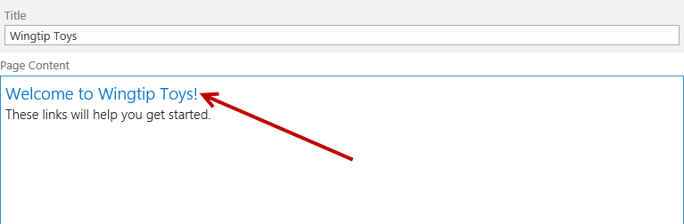

1. Add three to four placeholder paragraphs of sample Wingtip marketing copy under the heading as shown in the screenshot below. If you would like to copy-and-paste some placeholder text, you can use the content in the file named **HomePageCopy.txt** in the folder for this lab.
   1. To copy/paste, copy the text from the **HomePageCopy.txt** file and Paste using the Paste ribbon button. Click on **Paste Clean** or **Paste Plaintext**.

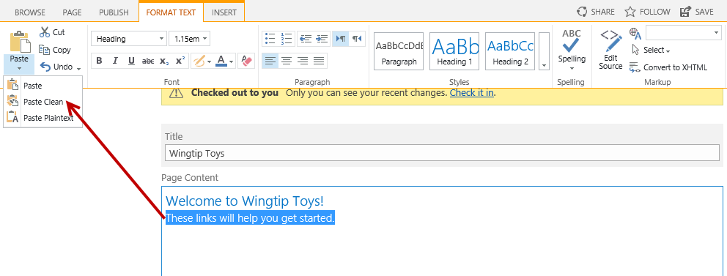

1. When prompted, click on **Allow access**.

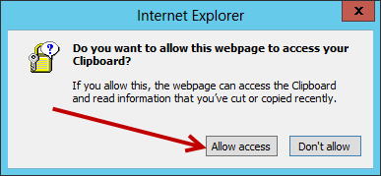

1. The Page Content is now updated with the pasted text.

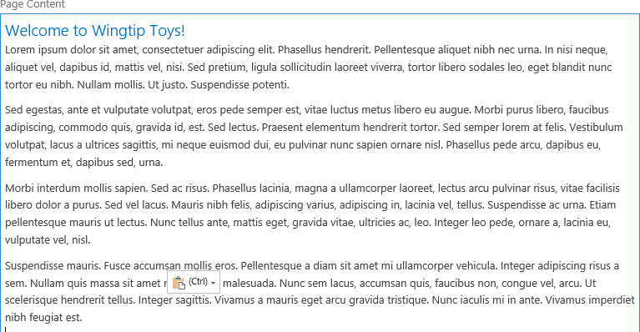

1. Scroll down below the **Page Content** field in the home page and locate the four web parts that are on the page. Use the **Delete** command in the web part menu to delete all four of these web parts.

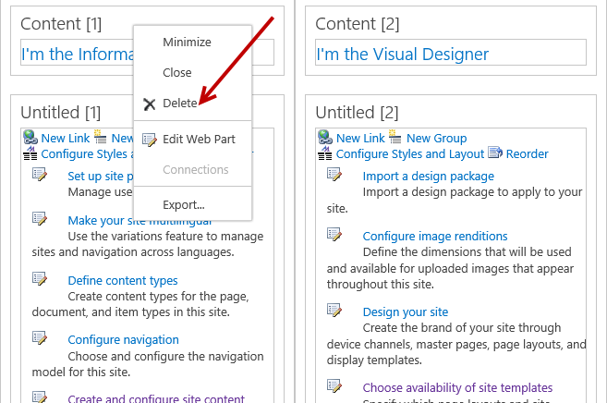

1. When you are done, all the web part zones on the page should be empty.

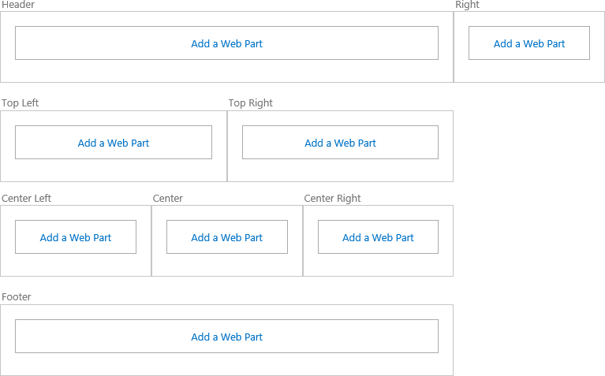

1. Save your changes to the home page using the **Save** button in the ribbon.

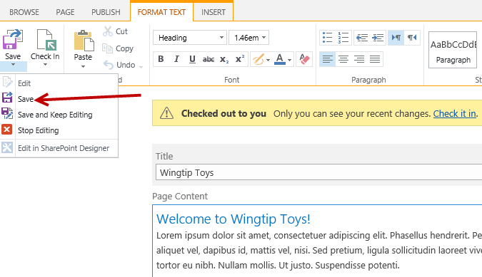

1. Check in you changes to the home page by clicking the **Check it in** link.

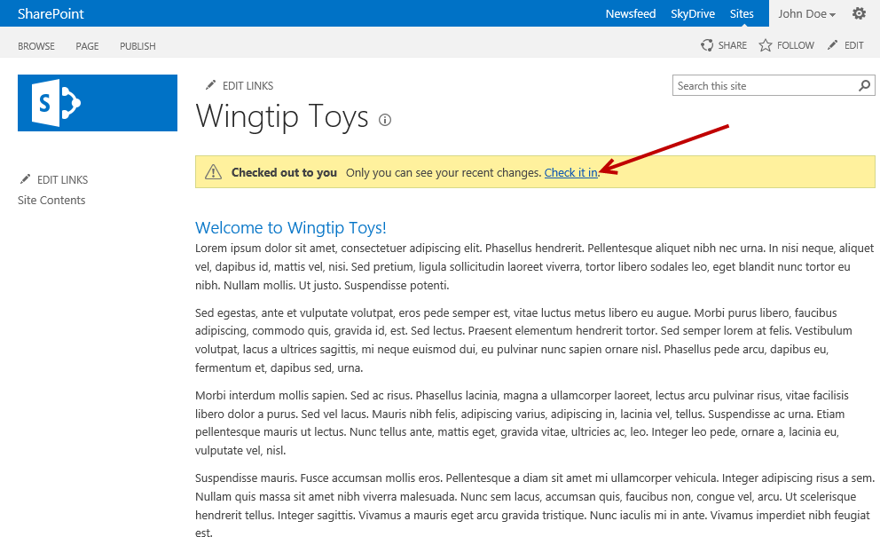

1. Add a small comment to the **Check In** dialog and click **Continue**.

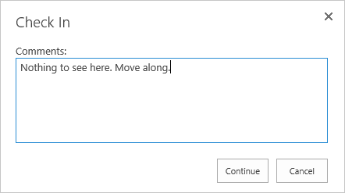

1. Click **Publish this draft** to publish your changes.

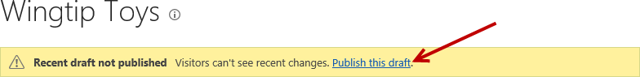

1. The page is now published and the page should look similar to the screenshot below.

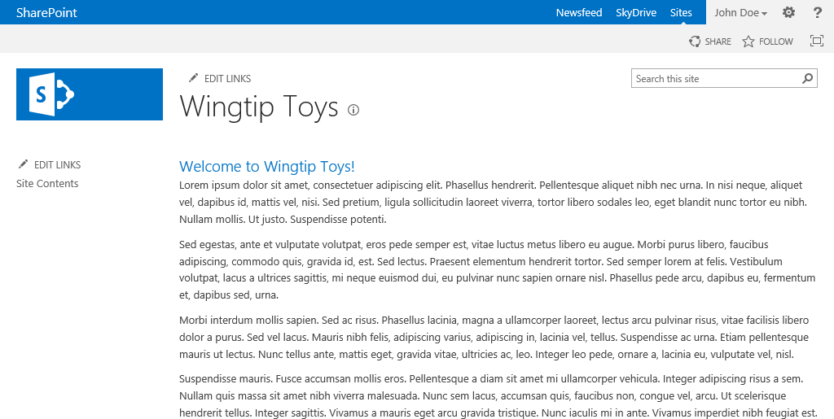

#### Create New Content Page

In the next steps, you will create a new page and edit the contents.

1. Add a new page by clicking the **Add a Page** command in **Site Actions**.

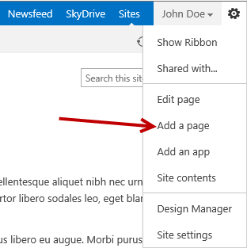

1. In the **New Page** dialog, enter **About Us** and click **Create**.

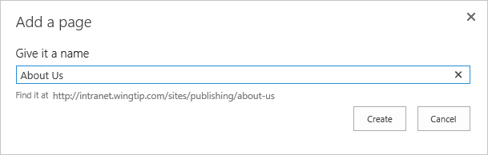

Notice the URL of the new page being created. This URL is a SEO-friendly URL and once created the page will show up in the navigation automatically.

1. Enter some text on the page so it looks somewhat like the following screenshot. Feel free to use the text in the **AboutPageCopy.txt** file in the lab folder.
   1. To copy/paste, copy the text from the **HomePageCopy.txt** file and Paste using the Paste ribbon button. Click on **Paste Clean** or **Paste Plaintext**.

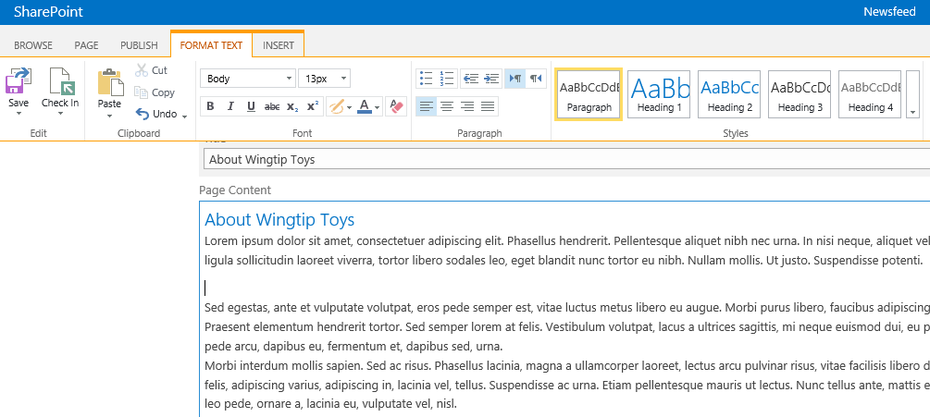

1. Place the cursor after the first paragraph and add a new line. Add an image to the page by going to the ribbon and selecting the **Insert** tab, then the arrow below the **Picture** button and select **From SharePoint**:

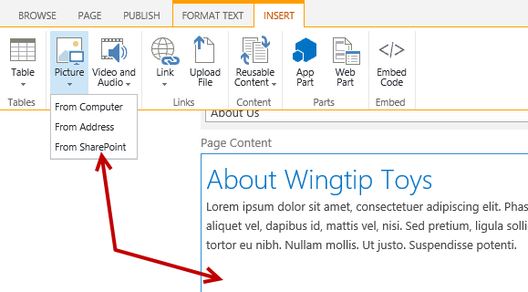

1. From the **Select an Asset** dialog, select the **ChevyImpala.jpg** image you uploaded in a previous step and click **Insert**.

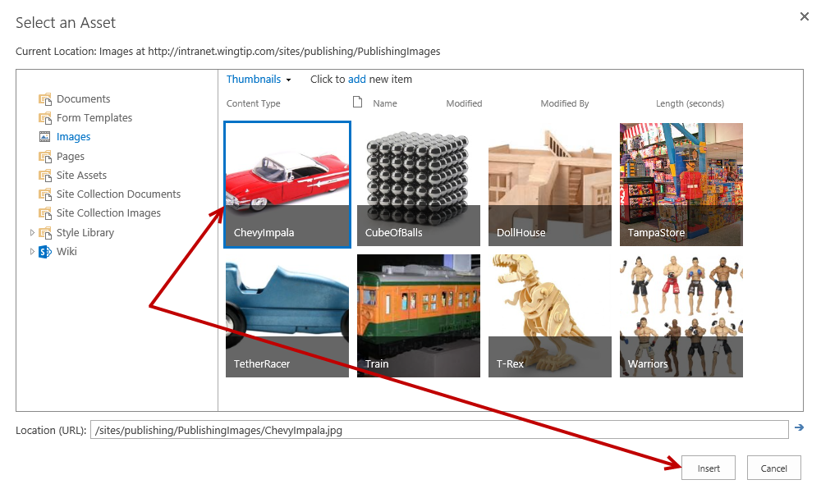

1. Resize the image and float it to the Left or Right using the ribbon as shown in the following screenshot.

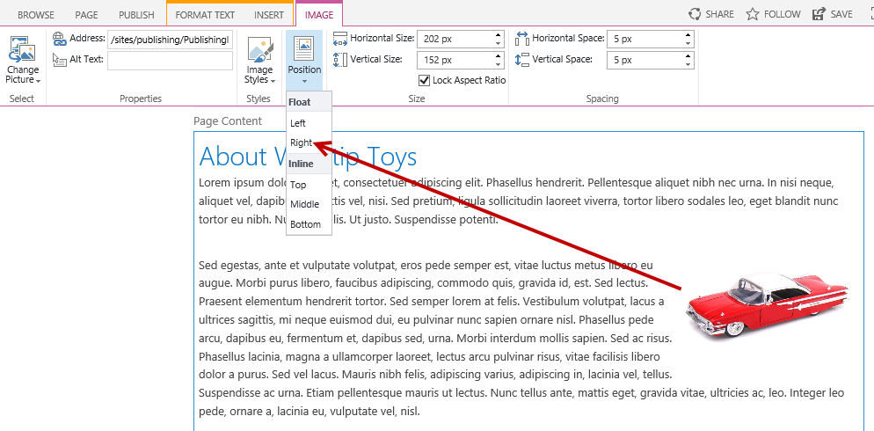

1. When finished, click the **Check In** button found in the **Page** tab of the ribbon.

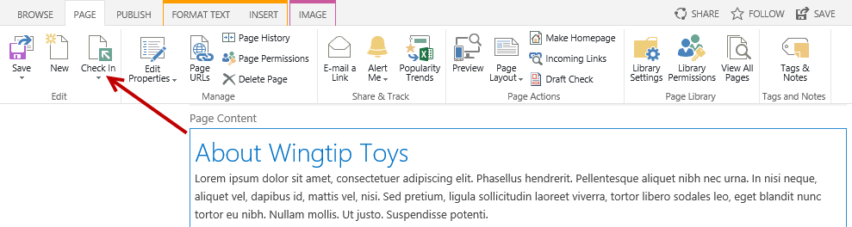

1. From the Check In dialog, (optional) type **Added a car image** in the **Comments** text box and then click **Continue**.

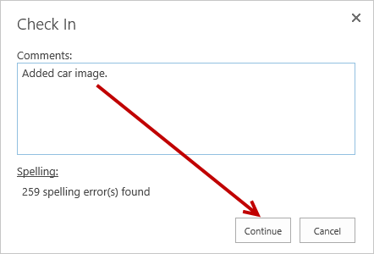

1. The About Us page is now checked in. To publish the page, click the **Publish** **It** link located in the **Not published yet** message. The page is now published and all viewers can now see the updated content on the page.

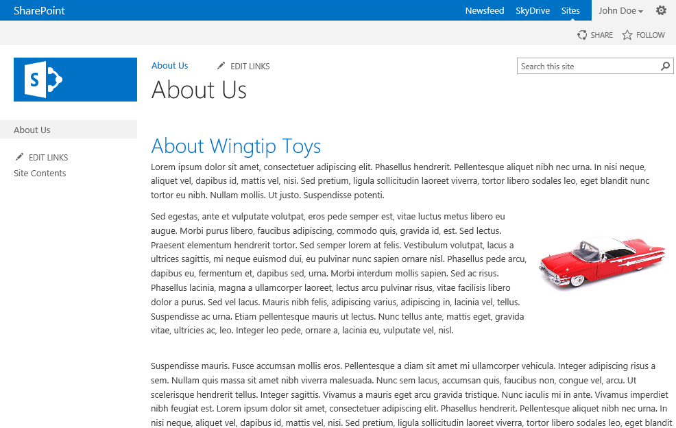

### Exercise 2: Update Page Settings

In this exercise, you will change the page layouts of the content pages and update various page settings.

#### View Properties of Page

1. Ensure you are on the **About Us** page.
2. Show the ribbon but clicking on **Show Ribbon** located in the **Site Actions** menu.

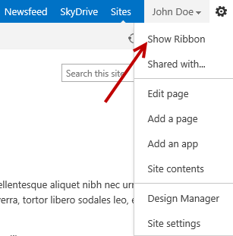

1. From the **PAGE** tab, expand the **Edit Properties** drop-down ribbon button and select **View Properties**.

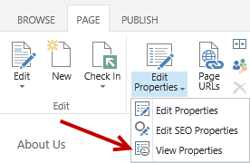

1. From the **View Properties** dialog, notice the different properties set for the page. The properties are in read-only mode however the **VIEW** tab contains available commands for the page.

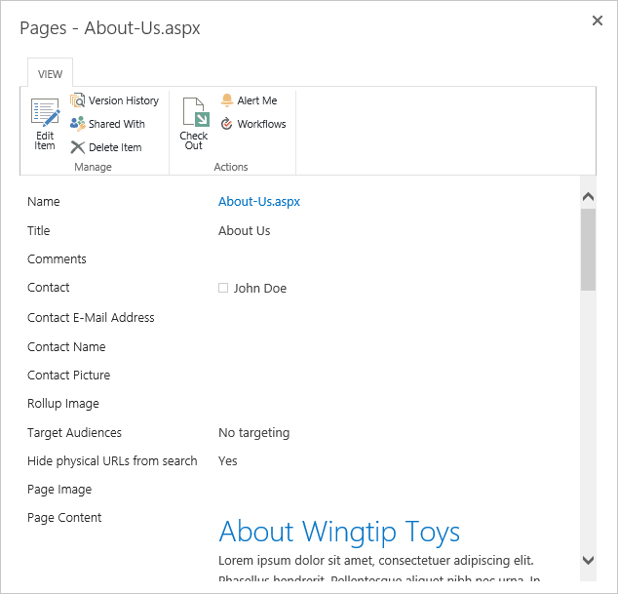

1. To **close**, scroll down to the bottom of the content in the dialog and click on the **Close** button.

#### Update Properties of Page

1. From the **PAGE** tab, expand the **Edit Properties** drop-down ribbon button and select **Edit Properties**.

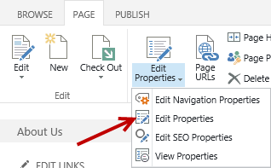

1. In the **Name** text box, remove the dash between **About-Us** to page Name will now be **AboutUs**.



1. Save the changes by clicking on the **Save** button located in the **EDIT** tab or by clicking on the **Save** button located at bottom of page.
2. To view the updated URLs click on **Page URLs** located in the **PAGE** tab of the **Manage** ribbon buttons group.

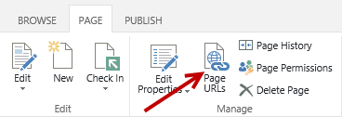

1. Notice the **Physical Page Address** displays the page name as **AboutUs.aspx** instead of as **About-Us.aspx**.

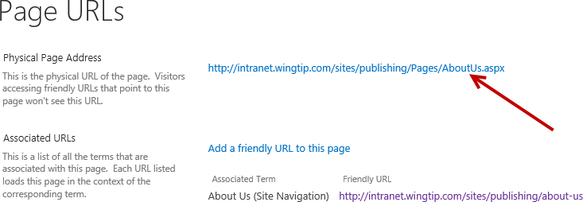

1. Click **Finish**.

#### Edit Navigation Properties of Page

1. From the **PAGE** tab, expand the **Edit Properties** drop-down ribbon button and select **Edit Navigation Properties**.

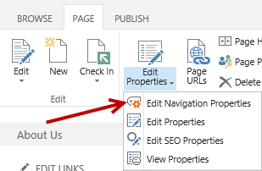

1. In the Friendly URL Segment text box, change the value from **about-us** to **about** and then click **OK**.

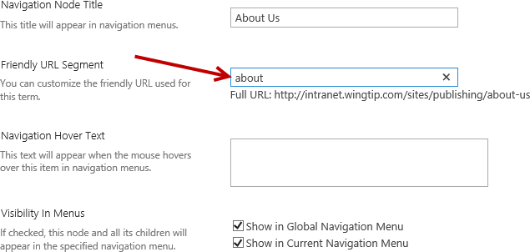

1. Notice the friendly URL of the page has been updated and is now showing about instead of about-us.

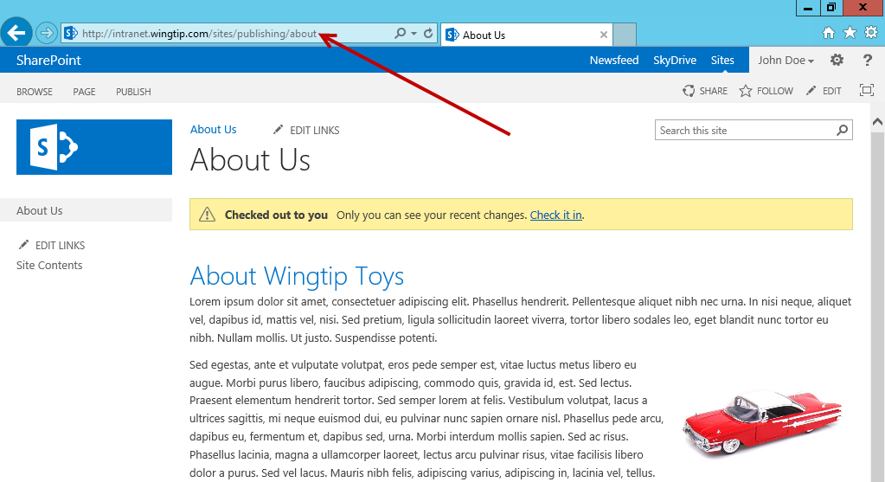

#### Edit SEO Properties of Page

1. From the **PAGE** tab, expand the **Edit Properties** drop-down ribbon button and select **Edit SEO Properties**.

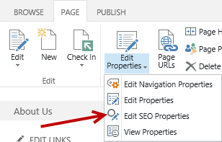

1. Update the settings if desired. You can update the **Browser Title**, **Meta Description**, **Keywords**, and set the property to include/exclude from Internet search engines.

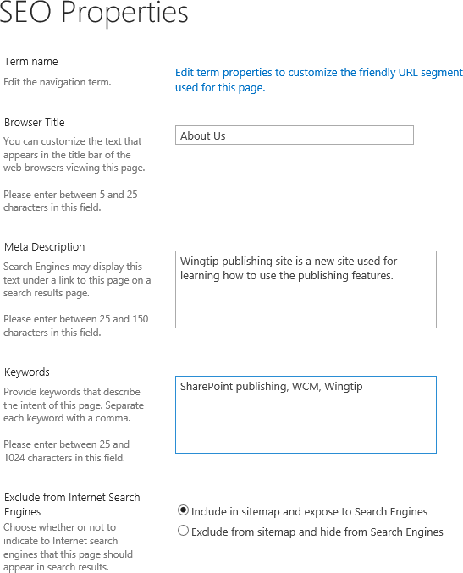

1. Once all desired settings are complete, click **OK**.

#### Change Page Layout of Page

1. Go into **Edit Mode** for the page:
   1. Click the **Edit page** command from **Site Actions** to transition the page into edit mode.
2. From the **PAGE** tab in the **Page Actions** group, expand the **Page Layout** ribbon button to see the list of available page layouts.

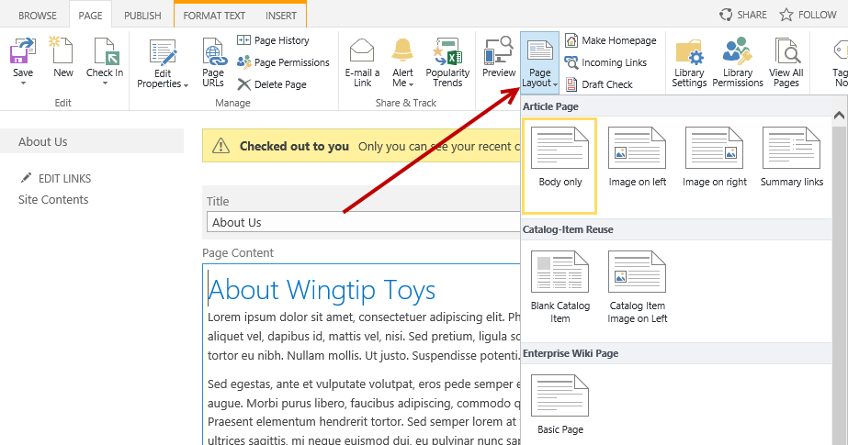

1. Select a different **Page Layout** such as **Image on Left** and notice your page update based on the layout.

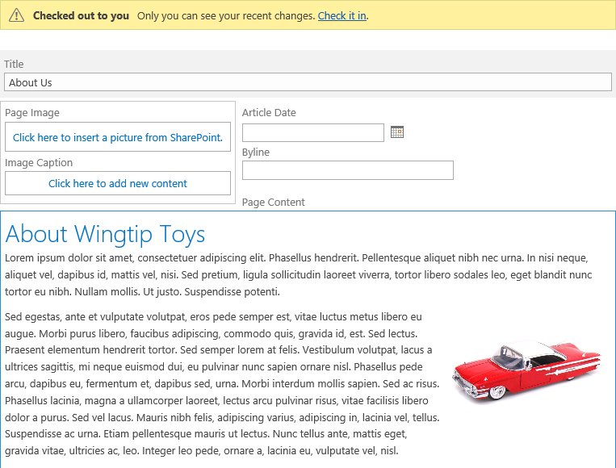

1. Repeat the steps changing to a different page layout and continue with a few different layouts to see the differences on how the content updates based on the layout.
2. Once you’re done experimenting with the layouts, change the **Page Layout** back to the default called **Blank Web Part** **page**.

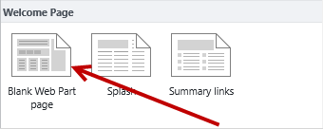

1. In the **PAGE** tab ribbon of the **Edit** group, click the **Save** ribbon button.
2. In the **Checked out to you** display message, click on the **Check it in** link.
3. To publish the page, click the **Publish** **It** link located in the **Recent draft not published** message. The page is now published and all viewers can now see the updated content on the page.

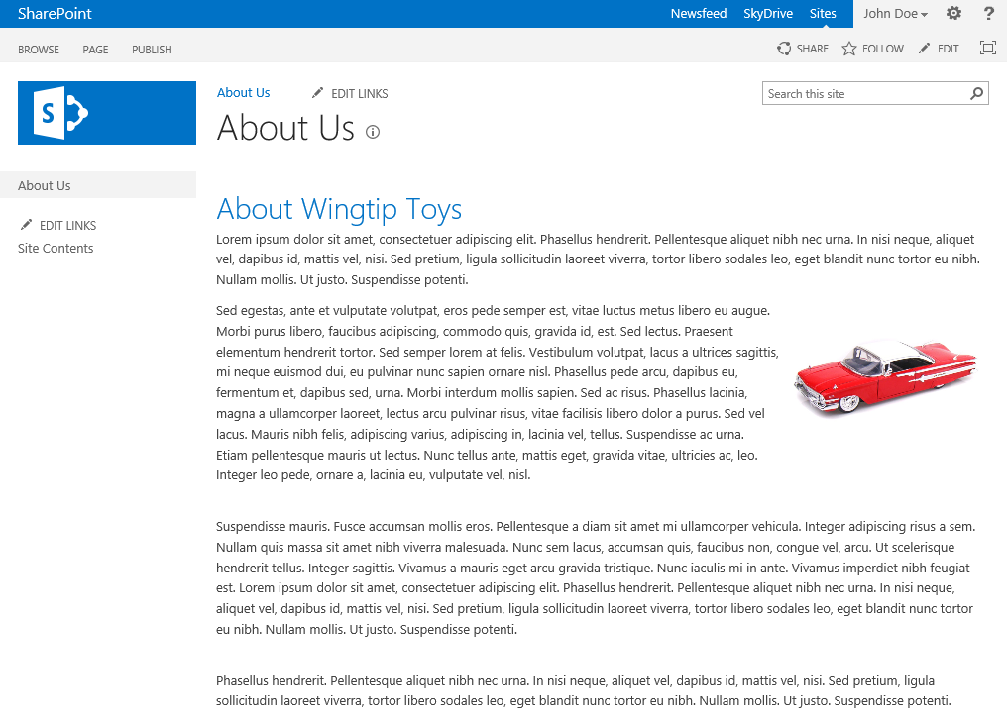

### Exercise 3: Update Site Branding

In this exercise, you will learn how to change the look of the site using Composed Looks.

#### Change Site Branding with Change the Look

1. Navigate to the **Site Settings** page by click on **Site Actions > Site settings**.
2. Under the **Look and Feel** group, click on the **Change the look** link.

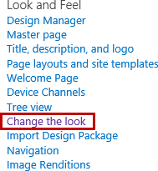

1. From the **Change the Look** page, select a desired site design.

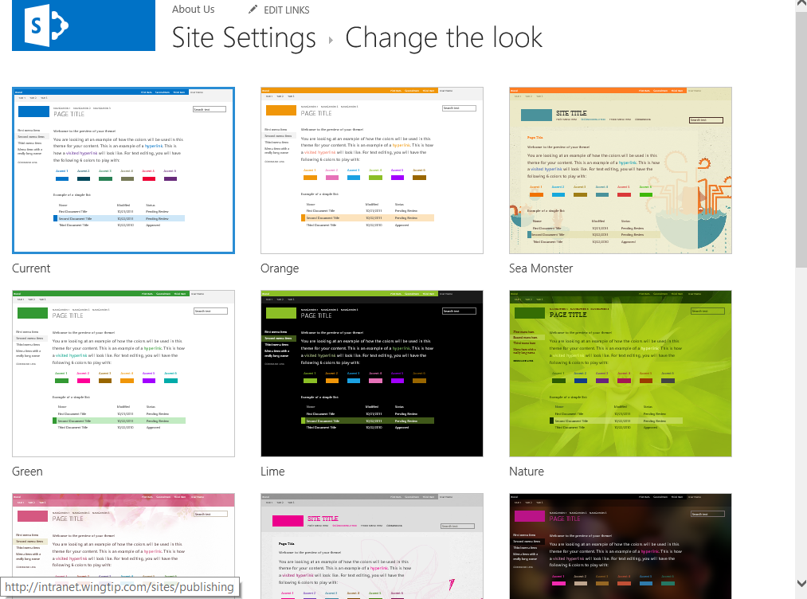

1. From the **Change the look** preview page, make any other desired updates such as selecting a different color scheme from the Colors drop-down menu.

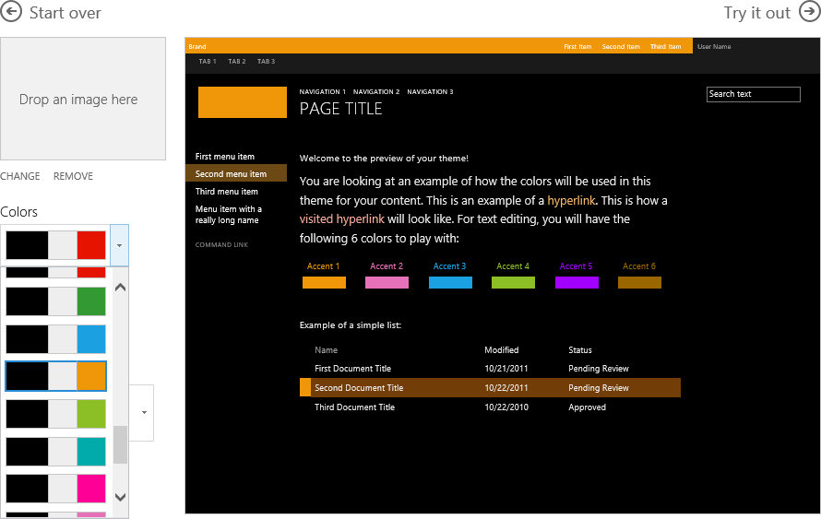

1. Once all desired settings are complete, click the **Try It Out** button located above the preview image.
2. If you are happy with your design click on **Yes, Keep It** to commit the changes or click on **No, not quite there** to make more changes. Repeat the steps if more changes are desired.

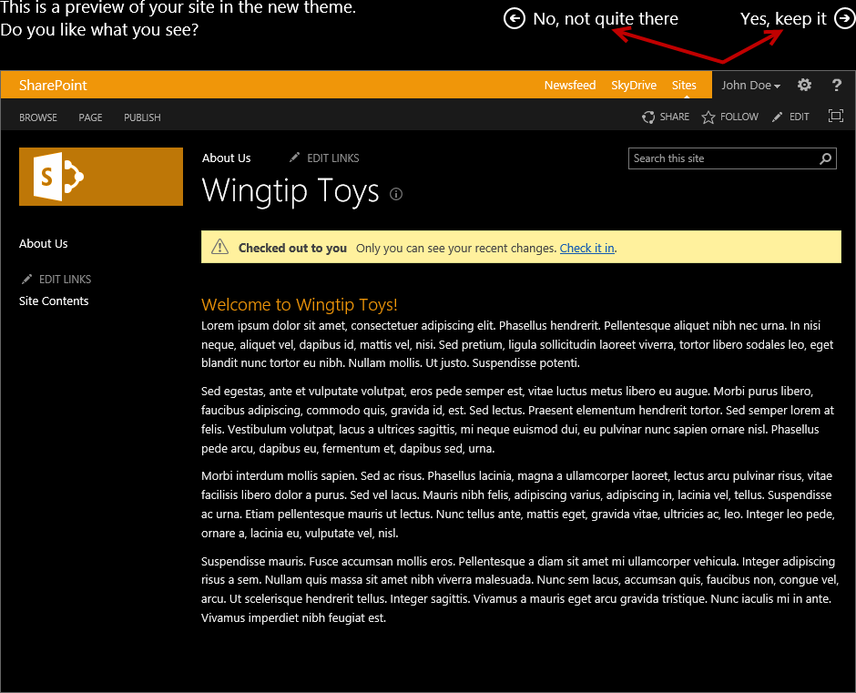

1. Once you are done experimenting set the Composed Look back to the default look by repeating steps 1-4 and using the **Office** Composed Look.