## Configuring Site Security

**Lab Time**: 45 minutes

**Lab Folder**: C:\Student\Modules\Security

**Lab Overview:** In this lab you will learn how to configure site permissions and add users and Active Directory groups as members of a SharePoint site collection. You will create new permission levels, and associate them with new SharePoint groups. Finally, you will learn to configure unique permissions in a Document Library.

### Exercise 1: Configuring Site Permissions

In this exercise you will learn to add users to SharePoint, and to set permissions on a document library.

#### Log in to SharePoint Online Site

1. Make sure you have the login information for the SharePoint environment where you will work on your lab exercises. You should have received this log in information from the hosting training company or from your instructor.
2. Make sure you have the URL to the **Team Site** that has been created for you to do your lab work. This URL will be in a form that looks something like this.

https://cptclassroom101.sharepoint.com/sites/Student_Teamsite

1. Launch Internet Explorer and navigate to the URL of the Team Site mentioned in the previous step. Note that you should be logged in with a user account that has full control and access to the site collection, and therefore will be permitted access and be able to create lists.
   1. When prompted to login, enter the user name and password that has been supplied to you and then click **OK**.

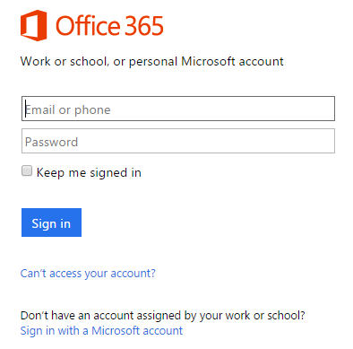

* 1. You should be able to confirm that you are logged into the SharePoint site. For example, if you were logged in as a student named **CPT Student**, your name would appear in the SharePoint Welcome menu as shown in the following screenshot.

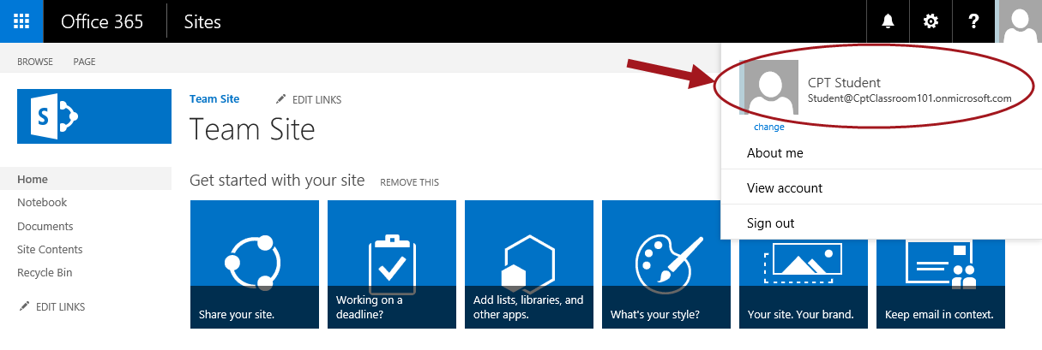

#### Share Team Site

1. On the home page of the site collection, click the **Share** button.

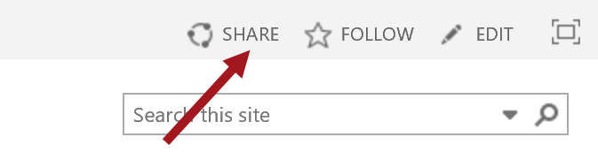

1. In the dialogue that opens, enter the following names **Anne Wallace;John Doe;Jane Smith;**

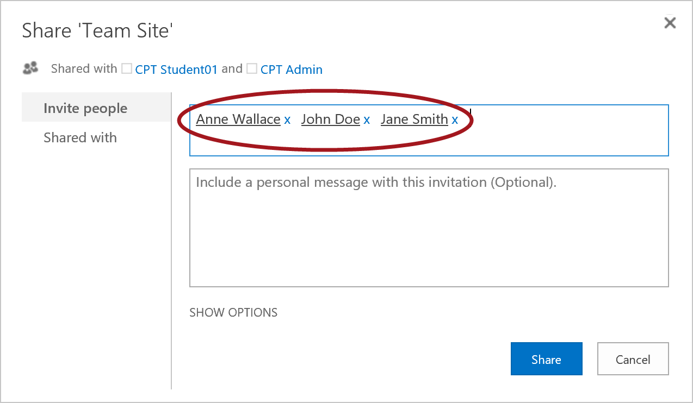

When adding new users, you can type their display name, username or email address.

1. Next, click the link to **Show Options**. You should be able to confirm that the drop down menu shows that the users will be added to the SharePoint group named **TeamSite Members** which have been given **Edit** permissions.

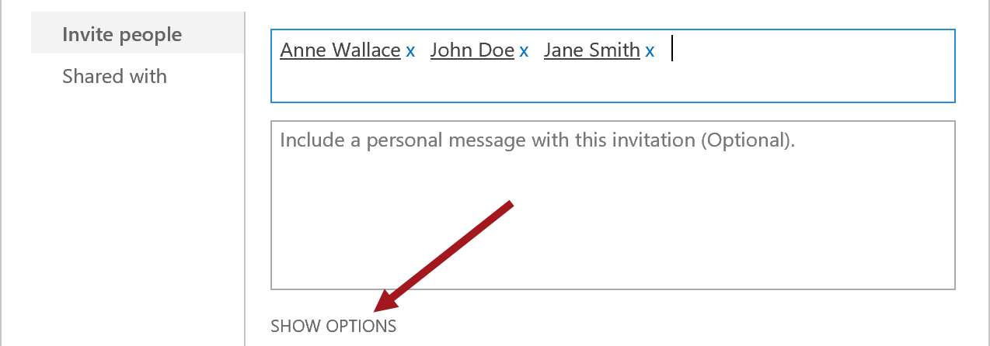

1. Click the **Share** button.
2. The following is another way to get to the same dialogue to add users:
   1. Click the **Settings** button and select **Site Settings.**
   2. In the Site Settings page, under the **Users and Permissions** heading, select **Site Permissions**

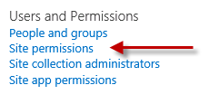

* 1. In the ribbon, under the **Permissions** tab, click the button **Grant Permissions**

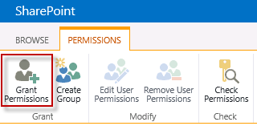

* 1. From here, follow steps 3-5 above to add users.

#### Add an Active Directory Group to SharePoint

1. From the home page of the site collection, click on the **Settings** icon and select **Site Settings**
2. On the Site Settings page, under the **Users and Permissions** heading, click the link **Site Permissions**



1. In the ribbon, under the **Permissions** tab, click the button **Grant Permissions**



1. In the dialogue that appears, type the name of the Active Directory Group **Wingtip Sales Team**
2. Next, click the link to **Show Options**. Based on the permissions you want the new user to have, choose a group to add the person to.
3. Click **Share.**
4. Click on the **Members** group to see the users and Active Directory Groups now associated with **Members**.

#### Set Permissions on a Document Library

1. On the home page of the site collection, click the **Settings** icon and select **Site Contents**
2. On the Site Contents page, click **add an app**



1. Click the tile for **Document Library**

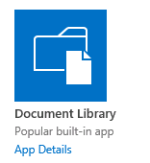

1. Name the new document library **Management Reports** and click **Create**.
2. On the Site Contents Page, click the tile for **Management Reports**.



1. In the ribbon, click the **Library** tab

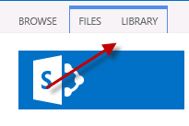

1. In the ribbon, click **Library Settings** in the **Settings** group

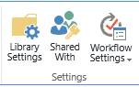

1. In the settings page, under the **Permissions and Management** column, click the link **Permissions for this document library**

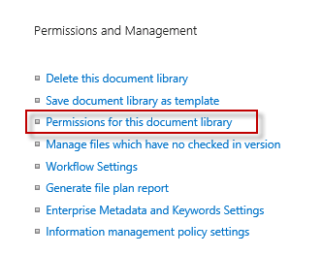

1. In the Permissions page, you should be able to see that the document library does not have its own unique permissions.

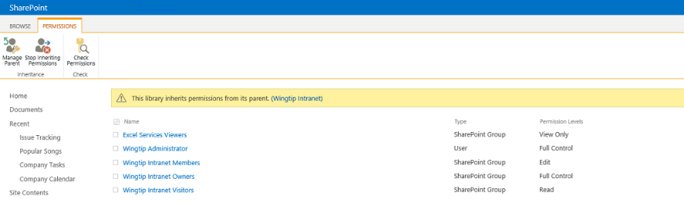

1. On the **Permissions** tab in the ribbon, click the **Stop Inheriting Permissions** button to create a unique permissions list.

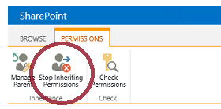

1. After clicking the **Stop Inheriting Permissions** button, you will be prompted with a dialog asking you confirm that you really want to create iuni9que permissions for this document library. Click **Ok** to continue.

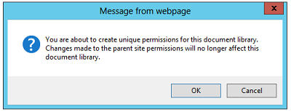

1. You will notice that the button on the ribbon change after you have created unique permissions. On the **Permissions** tab in the ribbon, click **Grant Permissions**.

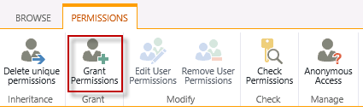

1. In the dialogue that appears, enter the user name of **Chandler Bing**. Also click the **Show Options** button and set the permission level to **Contribute**. Once your dialog looks like the following screenshot, click **Share** to assign the new permissions.

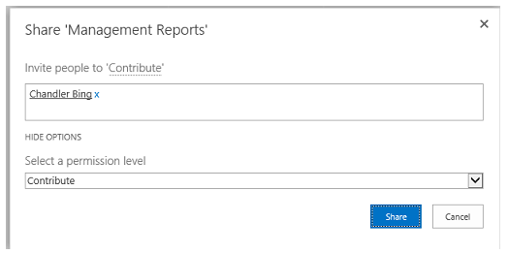

### Exercise 2: Creating a Custom Permission Level

In this exercise you will create a custom permission level

1. From the home page of the site collection, click the **Settings** icon and select **Site Settings**.
2. In the Site Settings page, under the **Users and Permissions** heading, click the link **Site permissions**

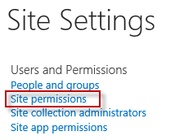

1. In the ribbon, under the **Permissions** tab, locate the **Manage** section.
2. In this section, click **Permission Levels**

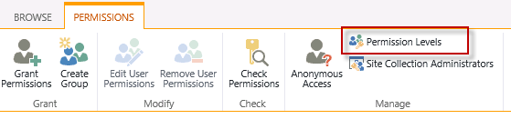

1. In the Permission Levels page, click **Add a Permission Level**



1. Name this new permission level **Manage Content**
2. Grant this new level the same permissions as the **Edit** permission level, with the additional ability to create subsites. The sections of the new permission level should match the following:

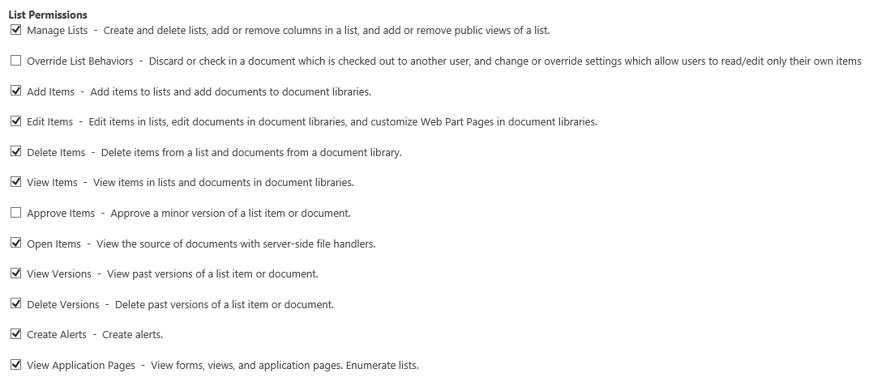

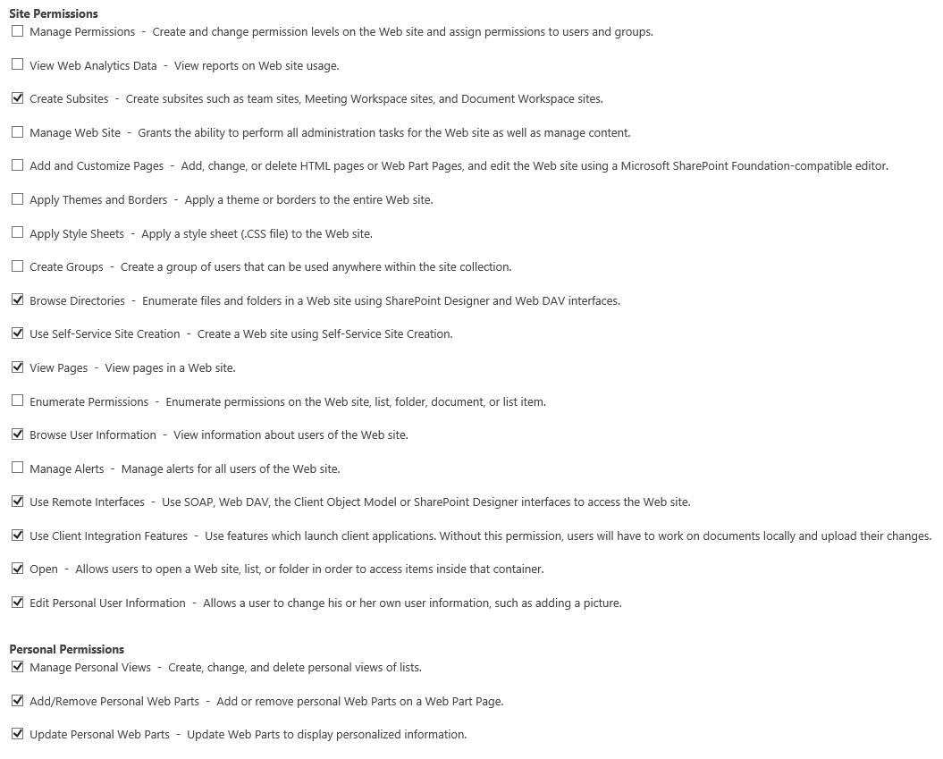

1. Click **Create.**
2. Confirm that you can see the new permission level in the list of permission levels.

At this point you have created a new custom permission level. Next, you will create a SharePoint group that will be assigned this permission level.

### Exercise 3: Creating SharePoint Groups

In this exercise you will create a new SharePoint Group, and associate a custom permission level with that group. Then, you will add users and Active Directory groups to the new SharePoint Group.

1. From the home page of the site collection, click the **Settings** icon and select **Site Settings**.
2. In Site Settings, under the heading **Users and Permissions,** click the link **Site permissions.**
3. In the ribbon, under the **Permissions** tab, click the button **Create Group.**

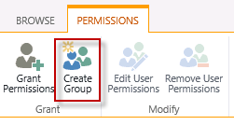

1. Name this new group **Content Managers**
2. Set your preferences for the **Group Settings** and **Membership Requests** sections, setting an appropriate email address for membership requests.
3. In the section **Give Group Permission to this Site**, select the permission level created earlier, **Manage Content**.

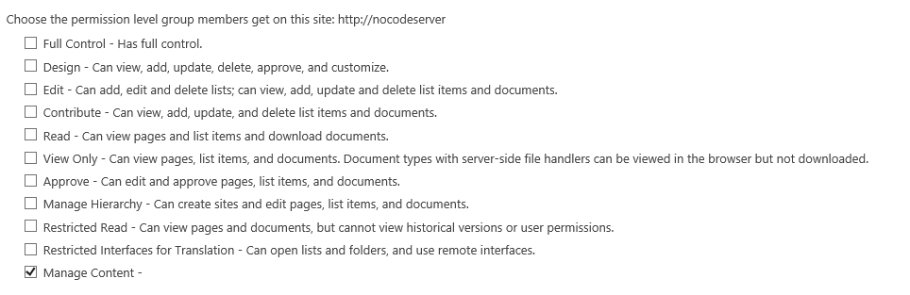

1. Click **Create. When you do this, t**he new group you have just created will open in the **People and Groups** section.
2. Add a new member into this group by following these familiar steps:
   1. Click **New**
   2. In the dialogue that appears, enter the name of the Active Director group **Wingtip Content Managers** to add to this group.
   3. Click the resolved version of the name that appears. The name should then appear as **WINGTIP\WingtipContentManagers**.

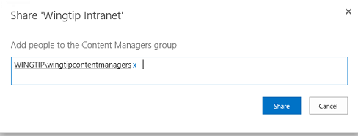

* 1. Click **Share** to add the Active Directory group as a member of the SharePoint group.

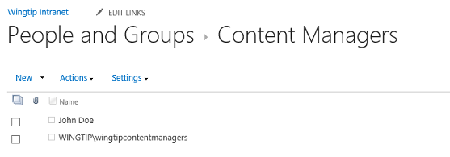

You have now worked through the basics steps of security by creating a custom permission level and a SharePoint group. After this, you manage security just by adding and removing external security principals from SharePoint groups such as Content Managers.

### Exercise 4: Using Best Practices

In this exercise you will use the skills learned in this lab so far to create a new permission level, a new group, and add users for the Management Reports Document Library created earlier. This “best practice” approach replaces what you did in Exercise 1, when you gave a single user unique permission to the library.

1. From the home page of the site collection, click the **Settings** icon and select **Site Settings**.
2. In Site Settings, under the heading **Users and Permissions,** click the link **Site permissions.**
3. In the ribbon, under the **Permissions** tab, click the button **Create Group.**
4. Name this new group **Management**
5. Set your preferences for the **Group Settings** and **Membership Requests** sections, setting an appropriate email address for membership requests.
6. In the section **Give Group Permission to this Site**, select the permission level created earlier, **Manage Content**.
7. Click **Create**
8. The new group will open in the People and Groups section.
9. Add the same user to this group that you granted unique permissions to the Management Reports library.
10. Navigate to the **Management Reports** library.
11. Click the **Library** tab and click on **Library Settings**.
12. In the settings page, click **Permissions for this document library**.
13. Click the button **Grant Permissions**
14. In the dialogue that appears, type **management** and select the resolved name that appears for the management group you created.
15. Click **Show Options**
16. Select permission level **Manage Content** and click **Share**.

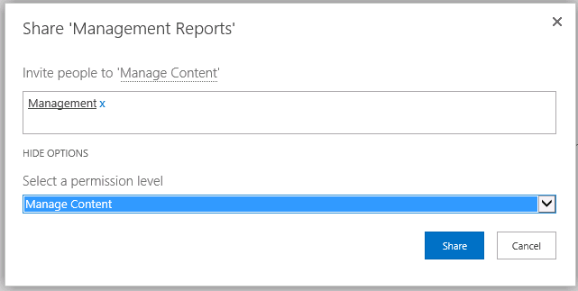

You have now completed this lab exercise.