## Overview of Site Administration

**Lab Time**: 45 minutes

**Lab Folder**: C:\Student\Modules\SiteAdministration

**Lab Overview:** In this lab you will create subsites within existing site collections, configure site settings for the sites, create custom site templates, and manage custom site template solutions.

### Exercise 1: Creating Subsites

In this exercise you will learn how to create various subsites within the existing Team Site and Publishing Site site collections.

#### Log in to SharePoint Online Site

1. Make sure you have the login information for the SharePoint environment where you will work on your lab exercises. You should have received this log in information from the hosting training company or from your instructor.
2. Make sure you have the URL to the **Team Site** that has been created for you to do your lab work. This URL will be in a form that looks something like this.

https://cptclassroom101.sharepoint.com/sites/Student_Teamsite

1. Launch Internet Explorer and navigate to the URL of the Team Site mention in the previous step. Note that you should be logged in with a user account that has full control and access to the site collection, and therefore will be permitted access and be able to create lists.
   1. When prompted to login, enter the user name and password that has been supplied to you and then click **OK**.

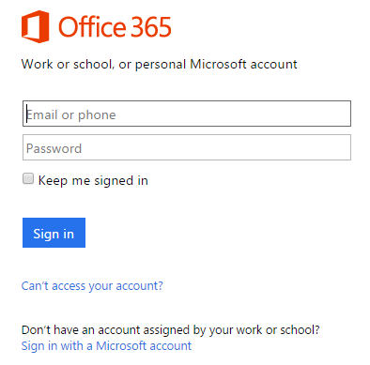

* 1. You should be able to confirm that you are logged into the SharePoint site. For example, if you were logged in as a student named **John Doe**, your name would appear in the SharePoint Welcome menu as shown in the following screenshot.

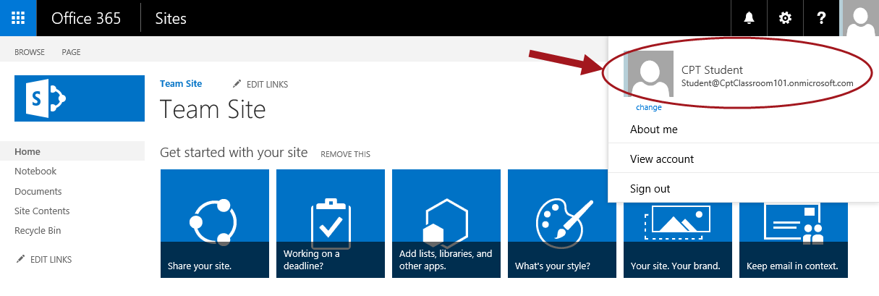

#### Create a Project Site

1. Navigate to the Site Content.
   1. Click on the **Settings** icon and select **Site contents**.

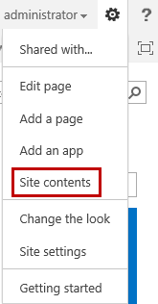

1. Scroll down to the bottom of the page. Under the **Subsites** section click **+ new subsite**.

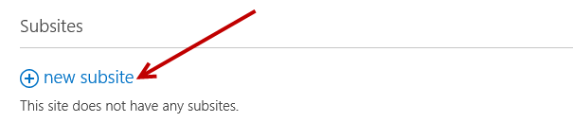

1. Under the Title and Description section:
   1. In the **Title** text box, type **Projects**.
   2. (Optional) In the **Description** multi-line text box, type **Team project site.**

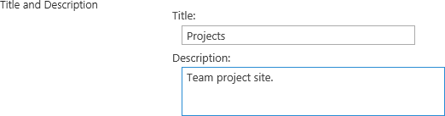

1. In the **URL name** text box, type **projects**.



1. In the **Template Selection** under the **Select a template** setting, ensure the **Collaboration** tab is selected and select **Project Site**.

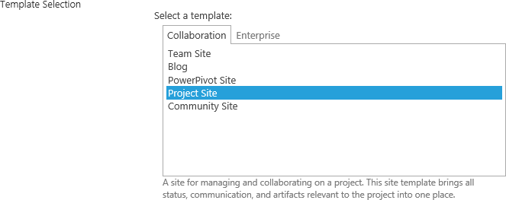

1. Leave the remaining settings set to the default settings and then click **Create**.
2. Once the site is created you will be redirected to the new **Projects** site homepage.

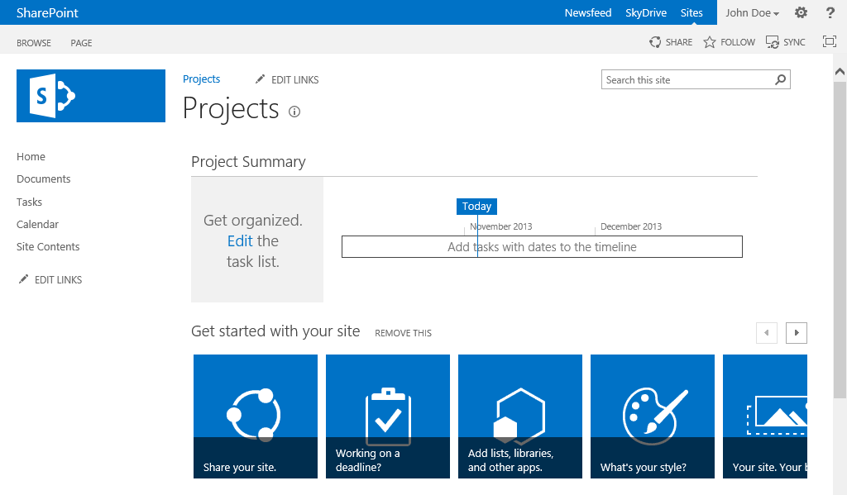

### Exercise 2: Customize Site Properties

In this exercise, you will customize the Projects site title, description, and site icon. You will also learn how to activate and deactivate site features.

#### Customize Site Properties

1. Open the Projects site located at <https://cpt.atrackspace.com/sites/TeamSite_Student01/Projects>.
2. On the site’s homepage in the **Getting started with your site** Web Part, click **REMOVE THIS**.

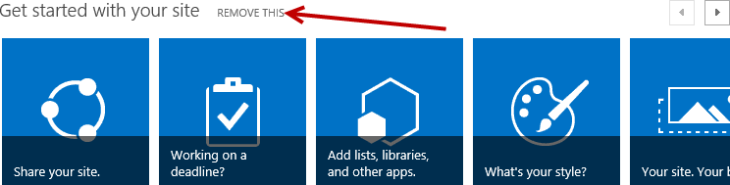

1. The **Getting started with your site** is now removed.

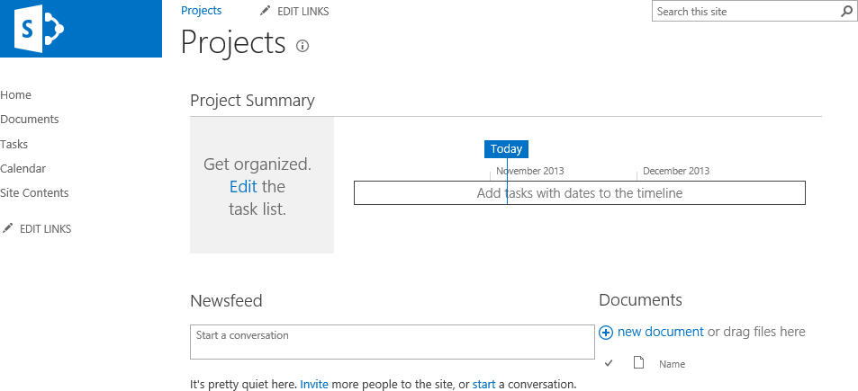

1. Use the **Site Actions** menu to navigate to the **Site settings** page.
2. Under the **Look and Feel** group, select **Title, description, and logo**.

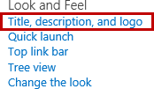

1. In the Title text box, replace **Projects** with **Wingtip Projects**.
2. In the Description multi-column text box, replace **Team project site** with **Wingtip team project one site**.

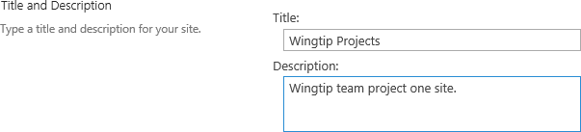

1. Under **Insert** **Logo**, click on **FROM COMPUTER**.

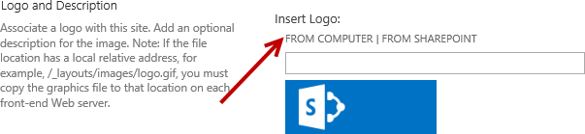

1. From the **Add a document** dialog, click **Browse…**

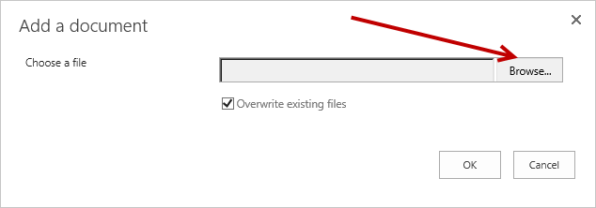

1. Navigate to **C:/Student/SiteAdmin/SiteLogo**. Click on **WingtipProjectsLogo.png** and then click **Open**.

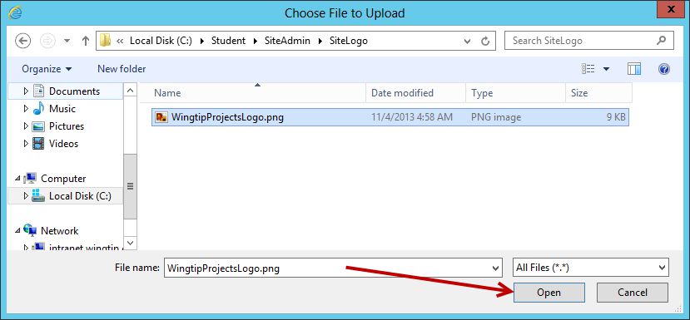

1. From the **Add a document** dialog, ensure the path is in the **Choose a file** text box and then click **OK**.

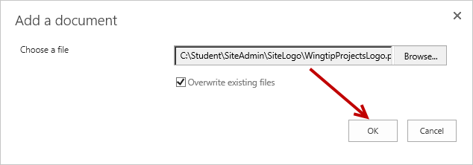

1. Notice the Insert Logo text box now contains the path to your WingtipProjectsLogo.png and the preview image has been updated.

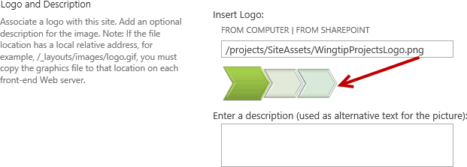

1. Leave everything else as default and then click **OK**.
2. The site title, description, and site icon has now been updated.

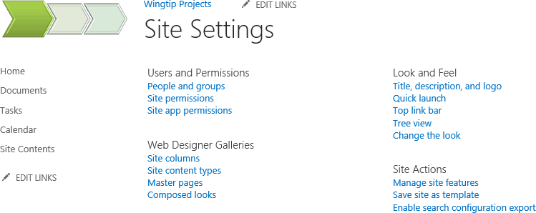

#### Activate/Deactivate Site Features

1. To **activate** the **Wiki Page Home Page** feature:
   1. From the **Site Settings** page under the **Site Actions** group, click on **Manage site features**.

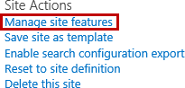

* 1. From the **Site Features** page, scroll down until you find the **Wiki Page Home Page** feature.

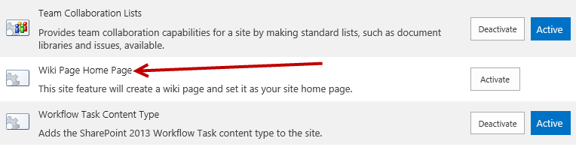

* 1. Click on **Activate** for the **Wiki Page Home Page** feature.



* 1. To test the feature, click on the **Wingtip Projects** link in the top navigation or the **Home link** in the left navigation to navigate back to the site’s home page.

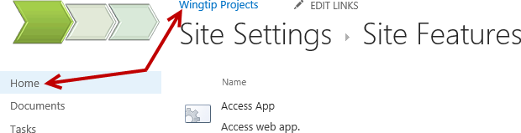

* 1. Notice the homepage is now set to the Wiki home page.

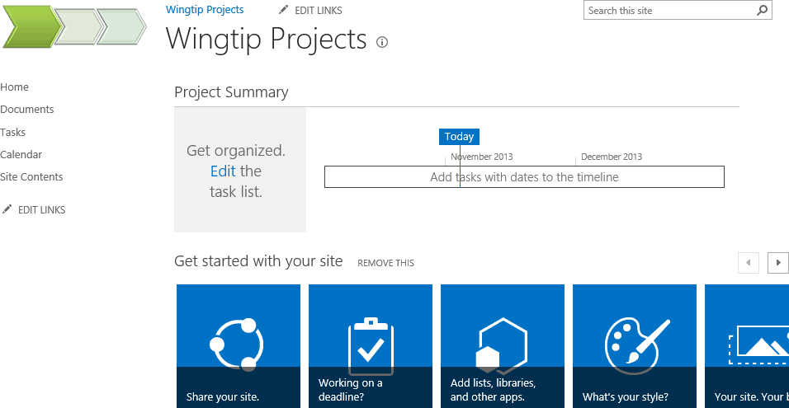

1. To **deactivate** the **Wiki Page Home Page** feature:
   1. Navigate back to the **Site Settings** page. **Site Actions** icon **> Site settings**.
   2. From the **Site Settings** page under the **Site Actions** group, click on **Manage site features**.
   3. From the **Site Features** page, scroll down until you find the **Wiki Page Home Page** feature.
   4. Click on **Deactivate** for the **Wiki Page Home Page** feature.



* 1. From the **You are about to deactivate the Wiki Page Home Page feature** confirmation page, click **Deactivate this feature**.

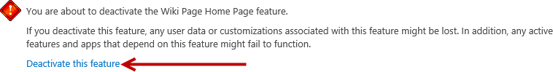

* 1. To test the feature, click on the **Wingtip Projects** link in the top navigation or the **Home link** in the left navigation to navigate back to the site’s home page.
  2. Notice the **Wingtip Projects** site has been set back to the original site’s home page.

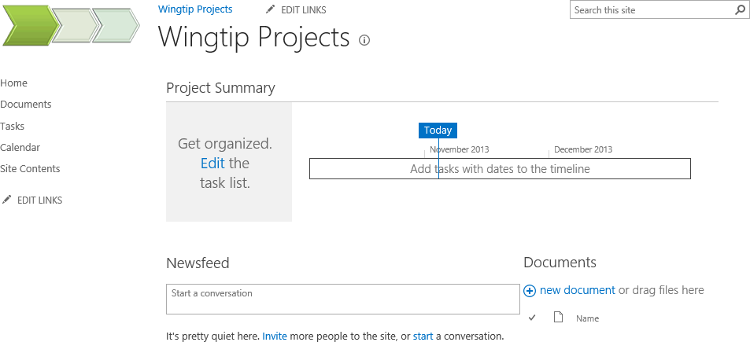

#### Upload Document

1. From the left navigation, click on **Documents**.

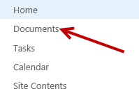

1. Click on **+ new document**.

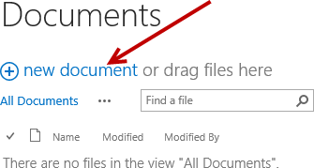

1. From the **Add a document** dialog, click **Browse…**

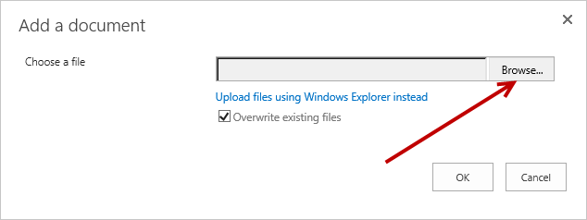

1. Navigate to **C:/Student/SiteAdmin/Documents**. Click on **PWA Access Guide.docx** and then click **Open**.

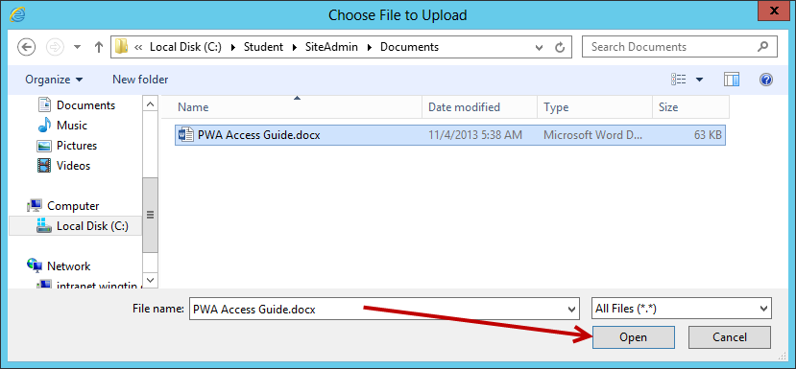

1. From the **Add a document** dialog, ensure the path is in the **Choose a file** text box and then click **OK**.

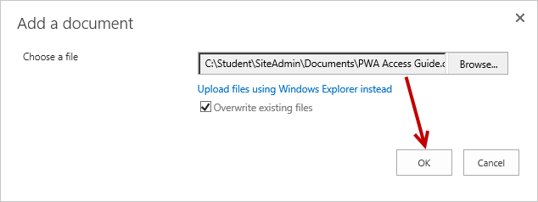

1. Notice the document is now uploaded.

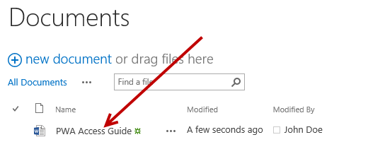

### Exercise 3: Working with Site Templates

In this exercise, you will save the Projects site as a site template and then create a new site based off the new site template.

#### Save Site as Template

1. From the **Wingtip** **Projects** site, use the **Site Actions** menu to navigate to the **Site settings** page.
2. From the **Site Settings** page under the **Site Actions** group, click on **Save site as template**.

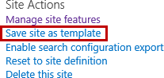

1. In the **File name** text box, type **Project Site Template**.



1. In the **Template** **name** text box, type **Project Site Template**.

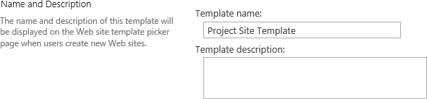

1. Check **Include Content** and then click **OK**.

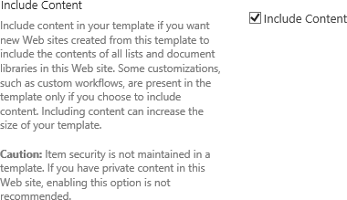

1. From the **Operation Completed Successfully** page, click on the **solution gallery** link.

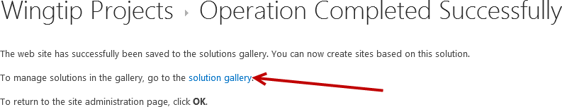

1. Notice the **Project Site Template** template is in the solutions gallery and is **Activated**.

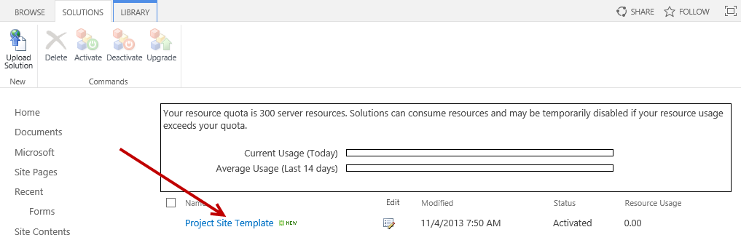

#### Create new Site from Template

1. Go back to the **Project** site.
   1. Click on the **BROWSE** tab and then click on **Projects**.

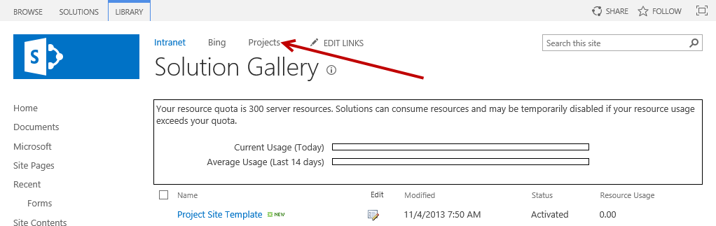

Because the Solutions gallery is located at the site collection level, clicking on the solution gallery took you to the top-level site.

1. Navigate to the **Site Contents** page either from the left navigation or **Site Actions** menu.
2. Scroll down to the bottom of the page. Under the **Subsites** section click **+ new subsite**.



1. Under the Title and Description section:
   1. In the **Title** text box, type **Project One**.
   2. (Optional) In the **Description** multi-line text box, type **Wingtip project one** t**eam project site.**

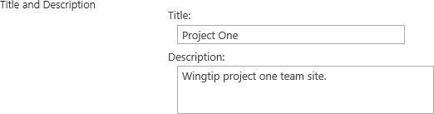

1. In the **URL name** text box, type **projectone**.



1. In the **Template Selection** under the **Select a template** setting, click on the **Custom** tab and select **Projects Site Template**.

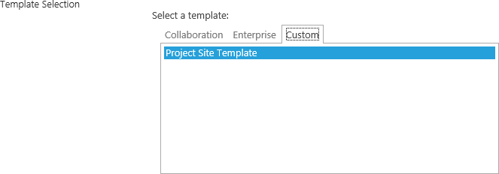

1. Leave the remaining settings set to the default settings and then click **Create**.
2. Once the site is created you will be redirected to the new **Project One** site homepage.

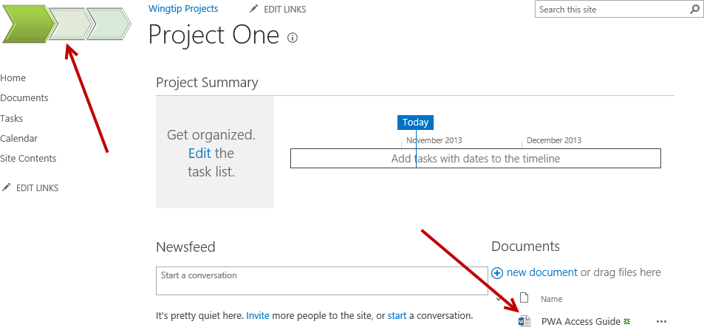

Notice the site is exactly how it was saved in the template which includes the site logo, no Getting Started Web Part, and a PWA Access Guide document in the Documents library. If you created the Site Template without checking Include Content, then the Documents library would be empty and everything else would be the same.

### Exercise 4: Manage Custom Site Template

In this exercise, you will learn how to deactivate, activate, and delete the custom site template solution you created in the previous exercise.

#### Deactivate Custom Site Template

You can deactivate custom site templates which will make the site templates no longer be available for creating new sites. Deactivating a custom site template will not affect existing sites that were created with site templates and will only affect the ability to create new sites.

1. From the **Wingtip** **Projects** site, use the **Site Actions** menu to navigate to the **Site settings** page.
2. Under the **Site Collection Administration** group, click on **Go to top level site settings**.

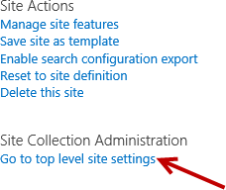

1. Under the **Web Designer Galleries** group, click on **Solutions**.

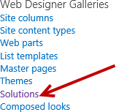

1. Check the box for **Project Site Template** to enable the ribbon commands and then click on **Deactivate**.

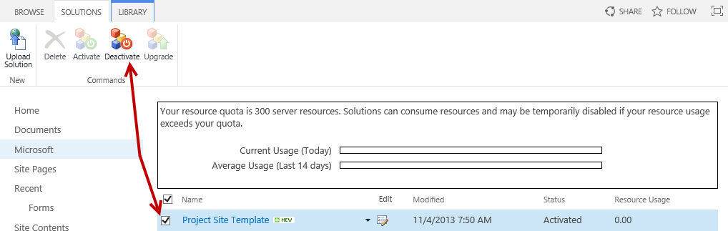

1. From the **Deactivate** **Solution** dialog in the **VIEW** tab, click on the **Deactivate** button.

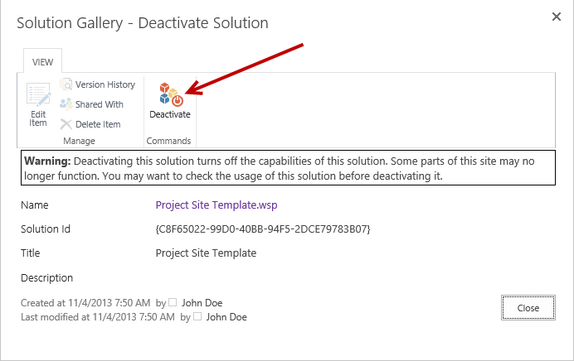

1. Once the **Deactivate Solution** dialog automatically closes, you may have to refresh the page to see the updated status.
2. Notice the **Status** for the **Project Site Template** solution is no longer showing **Activated**.

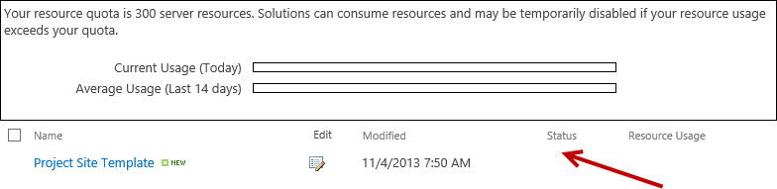

1. Go back to the **Project** site.
   1. Click on the **BROWSE** tab and then click on **Projects**.
2. Navigate to the **Site Contents** page either from the left navigation or **Site Actions** menu.
3. Scroll down to the bottom of the page. Under the **Subsites** section click **+ new subsite**.

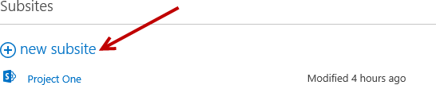

1. In the **Template Selection** under the **Select a template** setting, notice the **Custom** tab is no longer available.

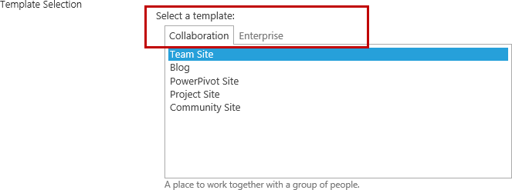

Because there was only one custom site template, the Custom tab no longer shows up because the site template has been deactivated. If there were more custom site templates in the Solutions gallery then the Custom tab will still show up however the deactivated site template would not be in the list.

1. Click **Cancel** to cancel creating a new site.

#### Activate Custom Site Template

1. From the **Wingtip** **Projects** site, use the **Site Actions** menu to navigate to the **Site settings** page.
2. Under the **Site Collection Administration** group, click on **Go to top level site settings**.



1. Under the **Web Designer Galleries** group, click on **Solutions**.



1. Select the box for **Project Site Template** to enable the ribbon commands and then click on **Activate**.

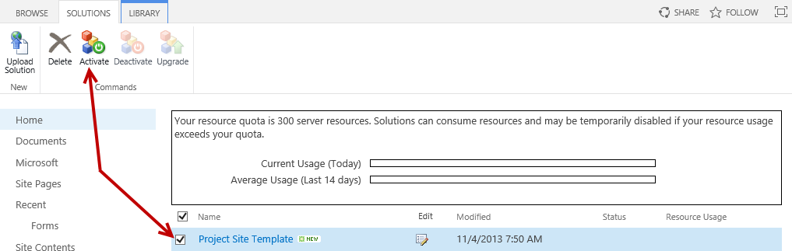

1. From the **Activate** **Solution** dialog in the **VIEW** tab, click on the **Activate** button.

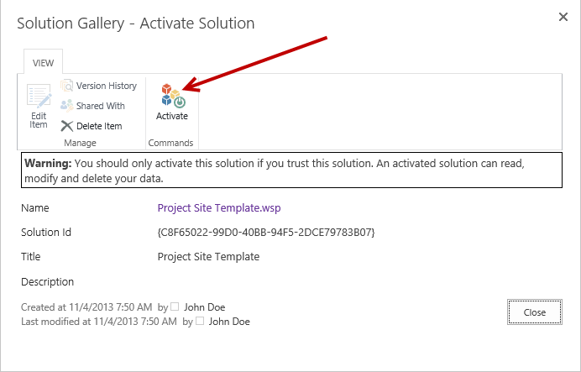

1. Once the **Activate Solution** dialog automatically closes, you may have to refresh the page to see the updated status.
2. Notice the **Status** for the **Project Site Template** solution is showing **Activated**.

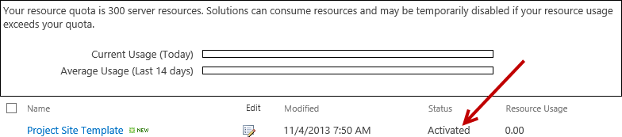

1. Now that the Project Site Template is activated, the custom site template is available again for creating new sites. To test follow repeat the steps to create a new **subsite**. Notice the **Custom** tab is available again and the **Project Site Template** is listed.

#### Delete Custom Site Template

To delete a custom site template, you must first deactivate the solution and then delete the solution.

1. Repeat steps **16-22** in the **Deactivate Custom Site Template** steps.
2. Once the solution is deactivated you can proceed with Deleting the solution by following these steps:
   1. Select the box for **Project Site Template** to enable the ribbon commands.
   2. Click the **Delete** ribbon button.

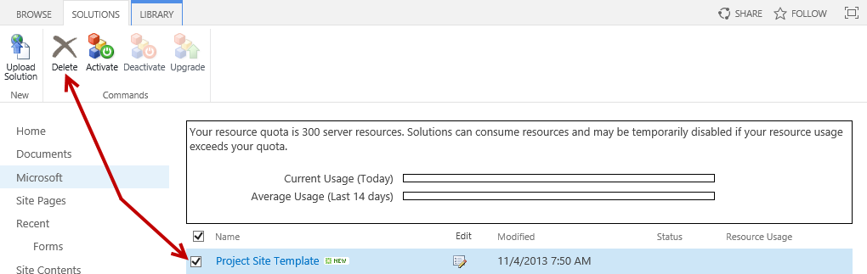

* 1. From the **delete confirmation** dialog, click **OK**.

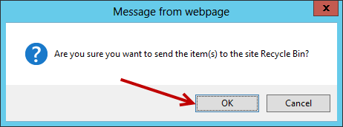

1. Your Custom Site template solution is now deleted.

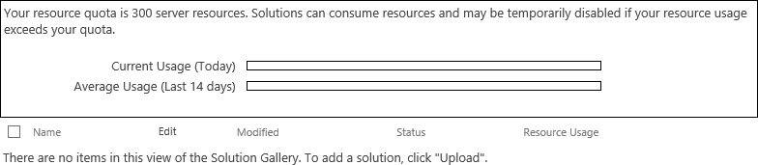

You have now completed this lab exercise.