## Getting Started with Office 365 Development

**Lab Time**: 45 minutes

**Lab Folder**: C:\Student\Modules\DeveloperRoadmap\Lab

**Lab Overview**: In this lab you will get up and running with the Office 365 Developer Student VM created by Critical Path Training. You log onto the VM and make sure you are able to use the developer tools such as launching Visual Studio 2015. You will also perform the necessary work of installing Office 2013 Professional on the VM so the Office applications such as Microsoft Word and Microsoft Excel are available when you begin develop Office add-ins earlier in the course. You will also move through the process of creating a trial Office 365 developer tenancy and a Windows Azure subscription if you have not already done this. The last part of this introductory

### Exercise 1: Getting Up and Running with the Student VM

In this exercise will you begin by logging into your copy of the Office 365 Developer VM from Critical Path Training. Once you have successfully logged into the VM, you will verify that the VM has a reliable connection to the Internet.

1. Login to the Student VM using the login **Student** and a password will be **Password1**.

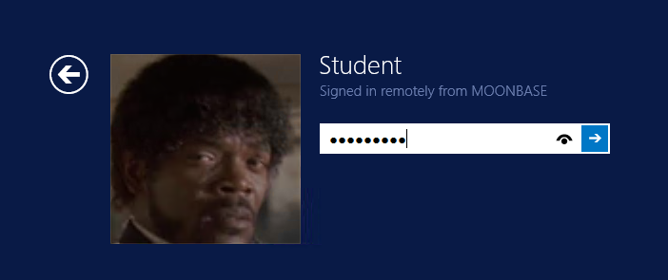

Note that the VM is based on a simple installation of Windows 8.1 which runs standalone without a domain. The **Student** account is a local account on the VM which has been configured with administrator privileges. If you would rather connect to the VM using a remote desktop connection instead of the Hyper-V console, you might need to use an account name of **localacount\Student** instead of **Student**.

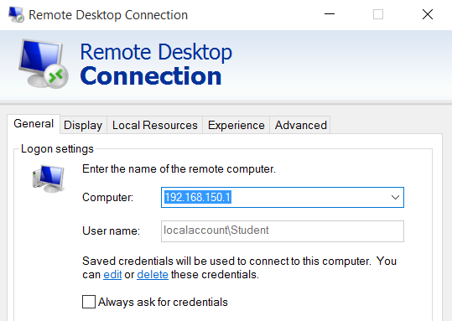

1. Once you have logged on to the student VM, launch the Internet Explorer or Chrome and navigate to a familiar site on the Internet such as <http://bing.com> or <http://google.com>. The purpose of this step is to ensure you have a reliable Internet connection. Once you validate that your copy of the VM can connect to the Internet, you can move onto the next exercise.

If a browser on your student VM cannot connect to the Internet, you must troubleshoot this issue and correct it before moving on.

### Exercise 2: Installing Office 2013 Professional

To complete all the labs, the student VM requires an installation of Microsoft Office 2013 Professional. If your student VM does not already have an installation of Office 2013 Professional, you will install a trial version so that you can complete the student lab exercises.

1. Press the **Windows** key and determine whether the Office 2013 Professional suite of products such as **Microsoft Word 2013** have already been installed.
   1. If Office 2013 Professional has already been installed, you are done with this lab exercise and you can move on to **Exercise 3**.
   2. If Office 2013 Professional has not yet been installed on your student VM, complete the following steps in this exercise.
2. Using Windows Explorer, locate the folder with the Office and Visio installation files on your student VM at **C:\Install**.
3. Install Microsoft Office 2013 Professional.
   1. Locate the file named **en_office_professional_plus_2013_with_sp1_x64_dvd_3928183.iso**.
   2. Right-click on **en_office_professional_plus_2013_with_sp1_x64_dvd_3928183.iso** and click the **Mount** menu command.

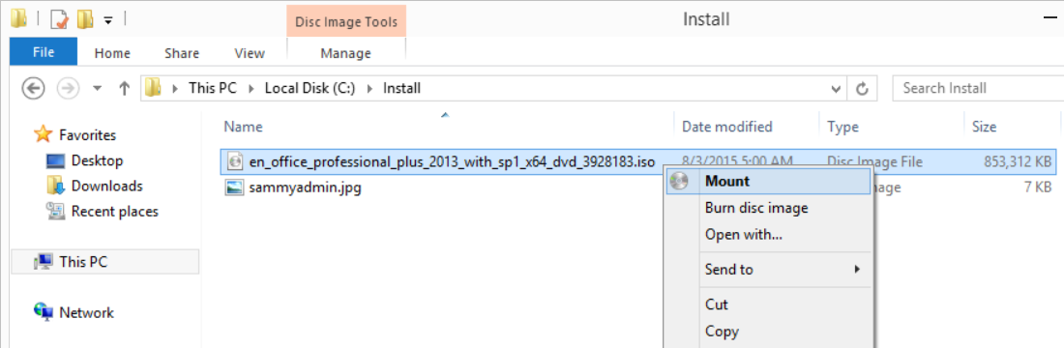

* 1. The Office 2013 installation files will open in a new window.
  2. Double click **setup.exe** to install the Office 2013 Professional.
  3. Wait until the installation completes. This might be a good time to grab a cup of coffee because this installation will take about 5-10 minutes to complete.

1. Once the Office 2013 installation has completed, launch Microsoft Word 2013. You will notice that you will be prompted when launch Office 2013 products such as Microsoft Word and Microsoft Excel to activate the product. You can dismiss the dialog which prompts you to activate Office 2013 and continue to use the product. However, you should take note that you are now in a trial mode that lasts about a week after installation. Once the week-long trial ends, Microsoft Office product begin to operate in a reduced functionality mode.

It will make your life as a developer easier if you can successfully activate your installation of Office 2013. If you can activate the product, you will no longer experience all those obnoxious activate products as you are using Office 2013 products. We recommend that you activate this copy of Office 2013 using the same Office 365 account that you will be using for your Office 365 developer account that is discussed in the following exercise.

### Exercise 3: Create an Office 365 Trial Tenant

In this step you will create a trial Office 365 Enterprise E3 Tenant.

1. Navigate to **https://go.microsoft.com/fwlink/p/?LinkID=403802&culture=en-US&country=US**.
   1. Fill out the form with your personal information and click **Next** to continue to step 2. The information you provide here will be used throughout your tenant so if you do not wish for your actual company name to be utilized then provide something you are comfortable with utilizing.
   2. Provider a user ID (such as your first name and/or last name) and a company name and password. For the company name field you may wish to simply use your first and/or last name with a number which you can increment each time you have to create a new trial account (e.g. EricClapton1.onmicrosoft.com). Don’t use your actual company name as that may cause some conflict when your company decides to create their own official tenant. Throughout the remainder of this guide you will see a **[your tenant]** placeholder value which you should replace with the value specified for the company name.
   3. Click **Next** to continue to step 3.
   4. Complete the validation form in step 3 by entering in the code provided via text or voice and click **Create my account** to provision the new tenant.
   5. When complete, click the **You’re ready to go…** link to proceed to the portal welcome screen.

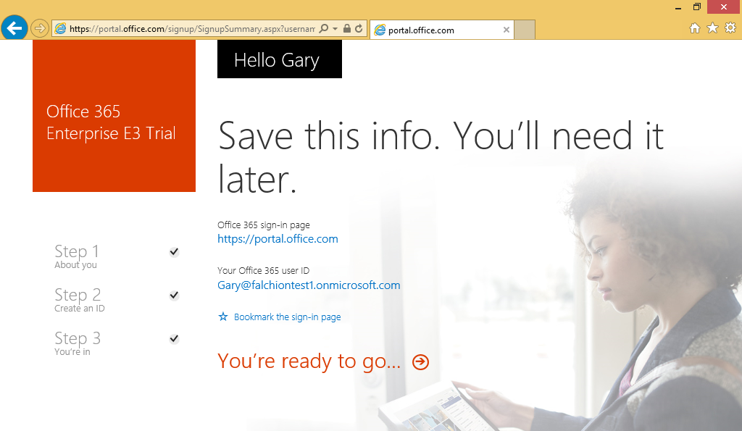

* 1. On the portal welcome screen you will notice that it is slowly setting up each of the individual services that make up your new Office 365 tenant. Click the Admin tile to proceed to the Office 365 Tenant Admin site.

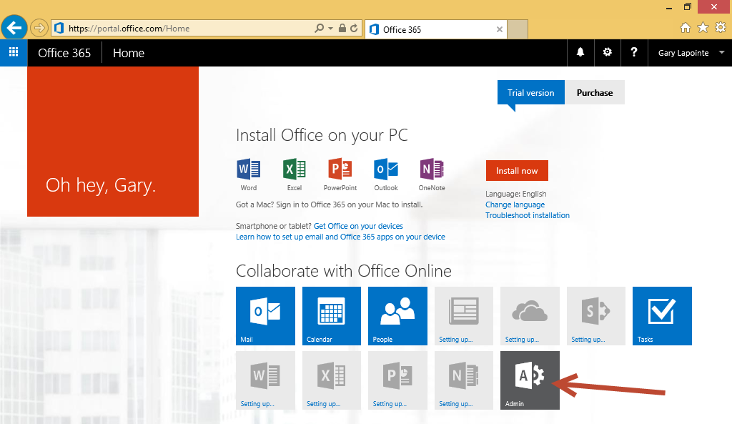

* 1. Verify that the admin center loads.

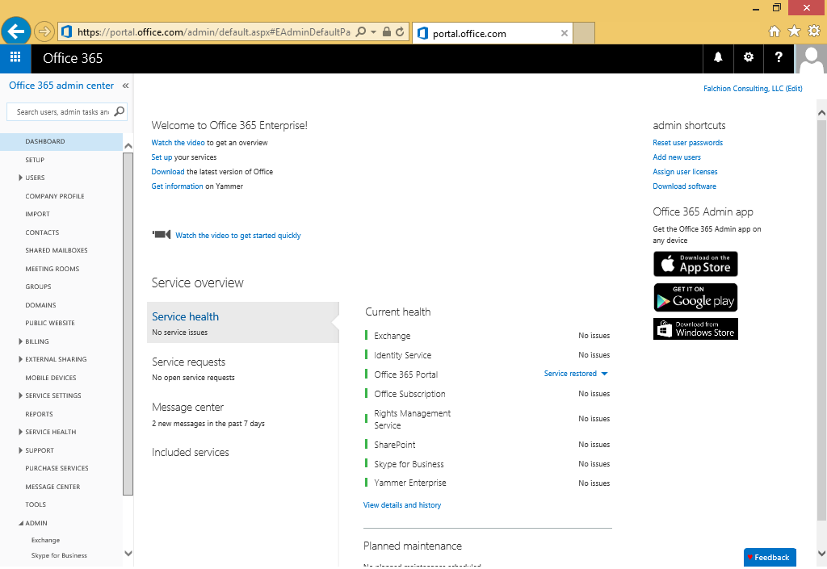

1. Open the Outlook web client and verify you can send and receive emails.
   1. Navigate to **https://outlook.office365.com** or click the **Mail** icon in the Application Launcher accessible via the **Waffle** **Button**.

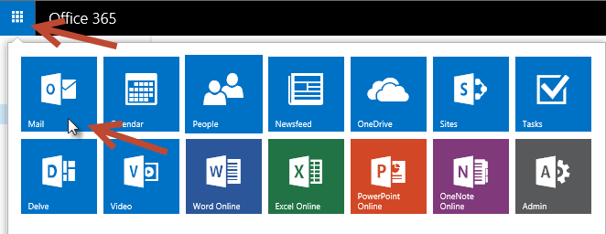

* 1. If prompted, specify your language and time zone for Outlook.

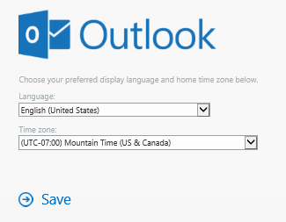

* 1. In the Outlook Web Client, click **New** to create a new email and specify the **To**, **Subject**, and email content. Be sure to provide a valid email address
  2. Click **Send** to send the email.

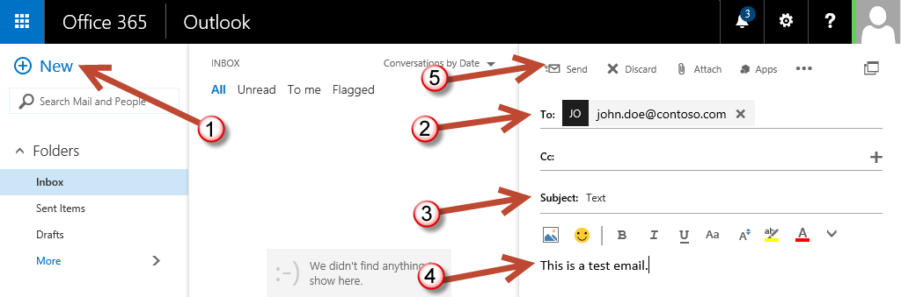

* 1. Check the email account you sent the email to and verify that you received the email.
  2. Reply to the email to verify that you can send an email to your new account.
  3. Return to the Outlook Web Client and verify receipt of your reply.

### Exercise 4: Create an Azure Trial Account

In this exercise you will create a trial Azure subscription.

1. Navigate to **https://azure.microsoft.com/en-us/pricing/free-trial/**.
   1. Click the **Try it now** button to go to the sign up screen.

Note that you should still be logged in with the account created during the Office 365 trial creation, however, if you are not then make sure you log in using that account – this is critical to ensure that the Azure account is properly associated with your Office 365 tenant. Also, if you attempt to create more than one Azure trial account using the same personal information, credit card and/or verification number you may get an error as you are only allowed to create one trial account (Microsoft will not share what the specific combination of data is that constitutes a duplicate trial account).

* 1. On the sign up page provide the required information including the verification and credit card details. The credit card information is required but you will not be charged anything unless you explicitly choose to upgrade to a paid offering.
  2. Click **Sign up** to continue.
  3. Go through the entire process until the trial account has been created.

### Exercise 5: Verify PowerShell Connectivity

In this step you will use the previously installed PowerShell modules to verify connectivity and create a new Site Collection.

1. Use the **Windows** key to navigate to the Start screen and type **azure** to search for the Windows Azure Active Directory Module for Windows PowerShell.

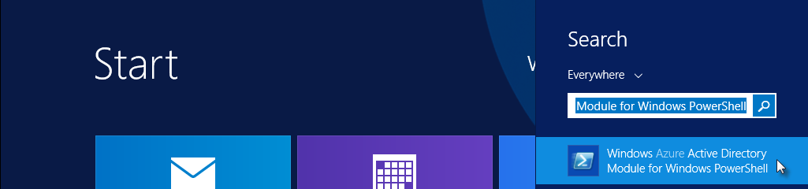

* 1. Click the **Windows Azure Active Directory Module for Windows PowerShell** application to open the PowerShell console window.
  2. Type the following command to store your credentials and establish a connection to the tenant (use the same username and password you used when creating the Office 365 trial - we’ll use these credentials later so keep the console window open when complete):

$cred = Get-Credential

Connect-MsolService -Credential $cred

* 1. Run the following command to retrieve your company information that you provided when creating the tenant

Get-MsolCompanyInformation

1. Now that you’ve verified your Azure Active Directory PowerShell module can connect to your tenant you can now validate that the SharePoint Online Management Shell module works.
   1. It’s not necessary to load the SharePoint Online Management Shell as the PowerShell module we need will be loaded automatically when you attempt to use one of the applicable cmdlets.
   2. Run the following command to connect to your SharePoint Online tenant:

Connect-SPOService -Url https://[your tenant]-admin.sharepoint.com -Credential $cred

* + 1. Be sure to replace **[your tenant]** with the value you provided when creating your Office 365 tenant (this will be the same value that is preceding **onmicrosoft.com** in your login).
  1. Run the following command to retrieve the list of existing Site Collections:

Get-SPOSite -Limit All | select Url

1. Create a new Site Collection using the **New-SPOSite** cmdlet.
   1. Be sure to replace **[your tenant]** with the value you provided when creating your Office 365 tenant:

New-SPOSite -Url https://[your tenant].sharepoint.com/sites/Test -Owner $cred.UserName -StorageQuota 1000 -Title "Test Site" -Template "STS#0"

* 1. This command could take several minutes to complete.

1. Verify creation of the Site Collection.
   1. Navigate to **https://[your tenant]-admin.sharepoint.com**
   2. You should see your new Site Collection listed. Click the URL of the Site Collection to open its properties.
   3. Click the Web Site Address to open the Site Collection in a new window.

### Exercise 6: Create a New User

In this step you will use Windows PowerShell to create a new test user and assign a license to that user.

1. If not already created, create a new directory named **Scripts** on the **C:\** drive of the student VM.
   1. Once created, the path to this directory should be **C:\Scripts**
2. Use the **Windows** key to navigate to the Start screen and type **powershell ise** to search for the Windows PowerShell ISE.

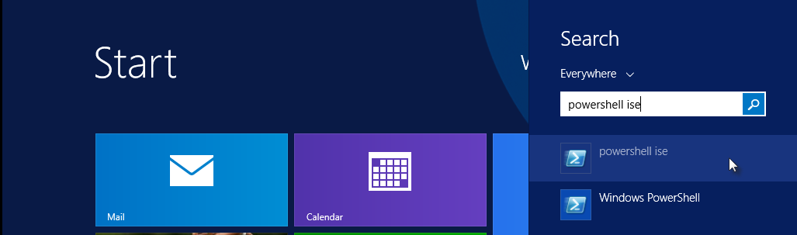

* 1. Click the **PowerShell** **ISE** application to open the PowerShell ISE window.

1. Click the **New** icon to create a new script file.

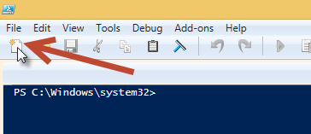

1. Enter the following script:
   1. Note the tick marks (`) to denote a new line when calling the various cmdlet.

function New-Student($username, $password, $displayName, $alternateEmail) {

# Get the tenant name (license prefix).

$tenant = (Get-MsolAccountSku)[0].AccountSkuId.Split(":")[0]

# Create the user

New-MsolUser -UserPrincipalName $username `

-DisplayName $displayName `

-UsageLocation "US" `

-UserType Member `

-LicenseAssignment "$tenant`:ENTERPRISEPACK" `

-AlternateEmailAddresses $alternateEmail `

-Password $password `

-PasswordNeverExpires $true

# Create a license options object that removes SharePoint Online Plan 2 from Power BI Standalone.

$licenseOption = New-MsolLicenseOptions -AccountSkuId "$tenant`:POWER_BI_STANDALONE" `

-DisabledPlans "SHAREPOINTENTERPRISE"

# Add the Power BI license to the user.

Set-MsolUserLicense -AddLicenses "$tenant`:POWER_BI_STANDALONE" `

-LicenseOptions $licenseOption `

-UserPrincipalName $username

}

1. Click the **Save** icon to save the file as **C:\Scripts\New-Student.ps1**.

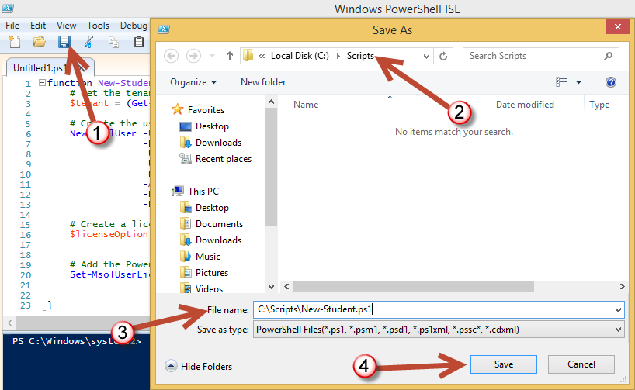

1. Click **Save** to save the file.
2. Use the **Windows** key to navigate to the Start screen and type **azure** to search for the Windows Azure Active Directory Module for Windows PowerShell.



* 1. Click the **Windows Azure Active Directory Module for Windows PowerShell** application to open the PowerShell console window.

1. Ensure that the current execution policy allows the execution of scripts by running the following command:

Set-ExecutionPolicy Bypass -Force -Scope CurrentUser

1. Load the **New-Student** function by executing the following command which uses PowerShell’s dot source notation (note the space after the first dot):

. C:\Scripts\New-Student.ps1

1. Run the following command to connect to your tenant:

$cred = Get-Credential

Connect-MsolService -Credential $cred

1. Run the following command replacing the **-username** and **-alternateEmail** parameters with appropriate values for your new tenant.
   1. The username should be in the form <user>@<your tenant>.onmicrosoft.com.
   2. The alternate email should be a valid email address that you have access to.
   3. Enter the entire command on one line.

New-Student -username "student1@yourtenant.onmicrosoft.com" -password "Password1" -displayName "Student One" -alternateEmail "john.doe@contoso.com"

1. Verify account creation in the Office 365 admin center.
   1. Navigate to **https://portal.office.com/admin/default.aspx** and click **Active Users** within the **Users** node.
   2. Select the checkbox next to the new user and click **Edit** under the **Assigned license** section in the right panel.

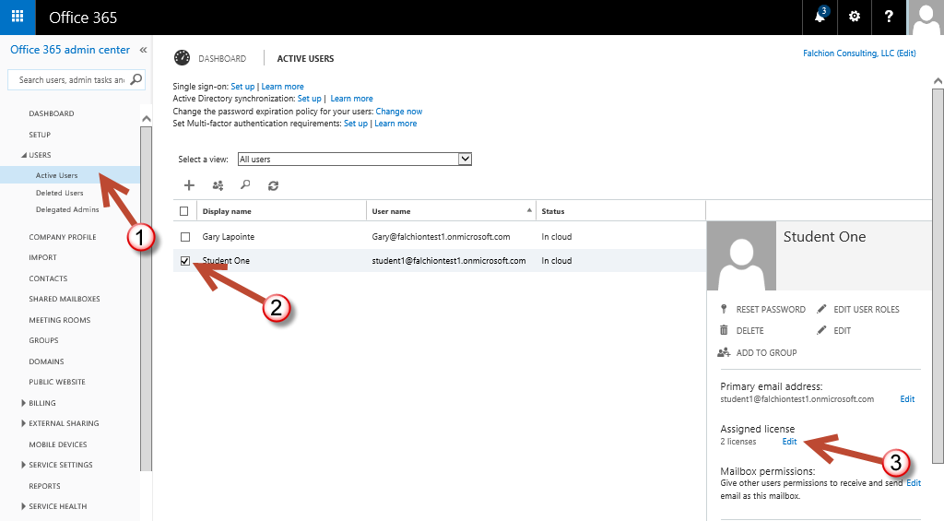

* 1. Verify the license assignment is as shown:

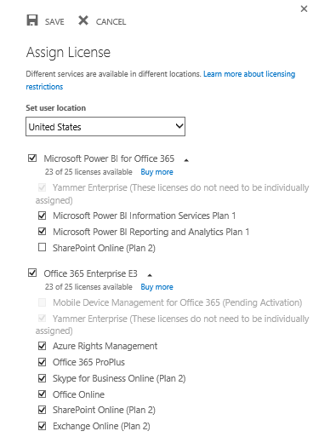

* 1. Click **Cancel** to close the Assign license dialog.

### Exercise 6: Create a Unified Group

In this step you will connect to Exchange Online to create a new Unified Group.

1. Use the **Windows** key to navigate to the Start screen and type **powershell** to search for Windows PowerShell.

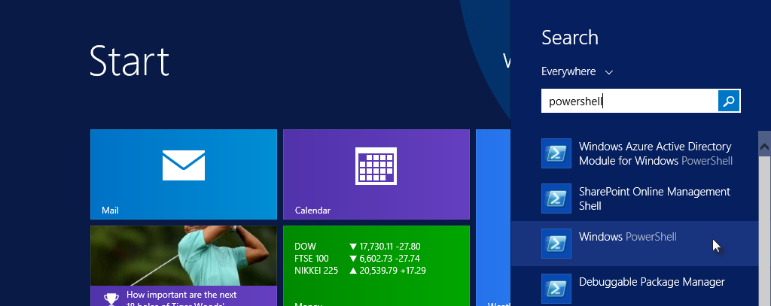

* 1. Click the **Windows PowerShell** application to open the PowerShell console window.

1. Create a new remote PowerShell session by running the following command:

$session = New-PSSession -ConfigurationName Microsoft.Exchange -ConnectionUri "https://outlook.office365.com/powershell-liveid/" -Credential $cred -Authentication Basic –AllowRedirection

1. Run the following command to import the available cmdlets into the current PowerShell runspace:

Import-PSSession $session

1. User the imported New-UnifiedGroup cmdlet to create a new Unified Group:

New-UnifiedGroup -DisplayName "My First Group" -Alias "MyFirstGroup" -AccessType Public

1. Use the Remove-PSSession cmdlet to end the remote session:

Remove-PSSession -Session $session

1. Verify group creation.
   1. Return to the Office 365 admin center if not already open: **https://portal.office.com/admin/default.aspx**
   2. Click the **Waffle** **Button** in the top left and select **People**.

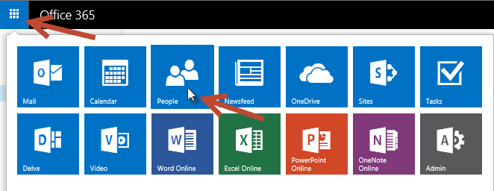

* 1. In Outlook, verify that **My First Group** is present and click it to view the Group.

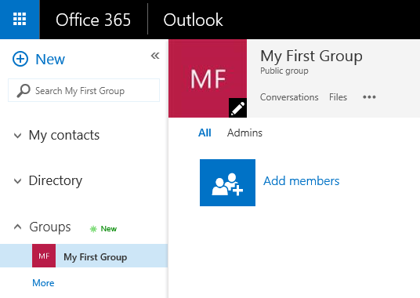

1. Close all windows and prepare to shut down your Virtual Machine…

You have now completed building the VM that can be used as the starting point to complete the lab exercises for the Office 365 Developer courses offered by Critical Path Training. You may now shut down the VM in preparation for the course start.

To shut down the VM press **Windows Key + I** and then on the Settings window select the **Power** button.  
(Note: it is always a good idea to take a backup of this VM Image just in case you would like to try something again after you begin the course)