## App Deployment, Installation and Upgrade

**Lab Time**: 60 minutes

**Lab Folder**: C:\Student\Modules\PublishingApps\Labs

**Lab Overview**: Learning how to deploy publish and install apps correctly is a core skill that every SharePoint developer should know. In this lab you will create an app catalog, deploy apps, and update versions. Through the first few exercises, you will work with a SharePoint-hosted app named **Calculator App**. In the last exercise, you will also move through the steps required to deploy a provider-hosted app named **Wingtip Search App** in an on-premises environment which will require you to work directly with the Internet Information Services administration tool.

### Exercise 1: Setup Lab Environment

In this exercise you will setup your environment.

All exercises in this lab assume you will work in your developer site collection in SharePoint Online.

### Exercise 2: Creating an App Catalog Site Collection

In this exercise you will create an app catalog to support app deployment and installation.

1. Navigate to the Tenant admin site collection (i.e. SharePoint admin center) for your Office 365 tenancy.

https://[tenancy name]-admin.sharepoint.com

1. Click on the **apps** link to see the **apps** page.

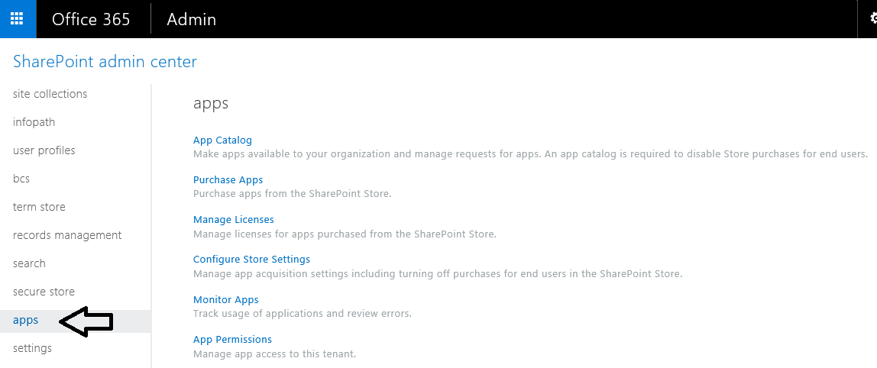

1. Click on the first link in the **apps** page with the caption of **App Catalog**.
2. On the **App Catalog Site** page, leave the default selection of **Create a new app catalog site** and click **OK**.

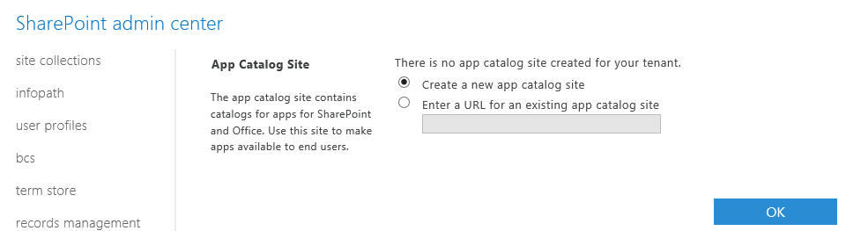

1. On the **Create App Catalog Site Collection** page, fill in the info as shown in the following screenshot and click **OK** to begin the process of creating the new site collection for the app Catalog.

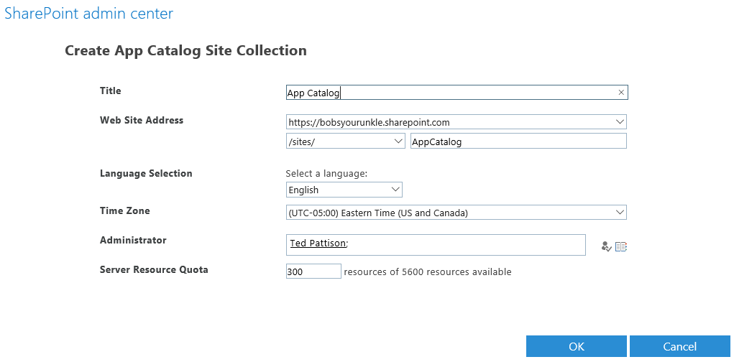

1. You should be able to see that the new site collection is being created.

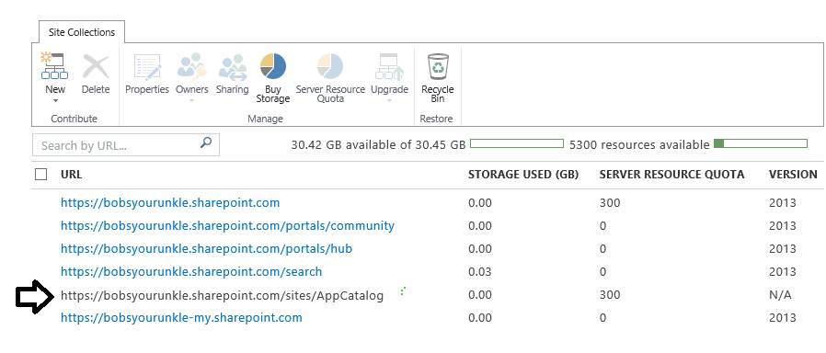

1. Once the new site collection has been fully created, navigate to it to see the App Catalog site.

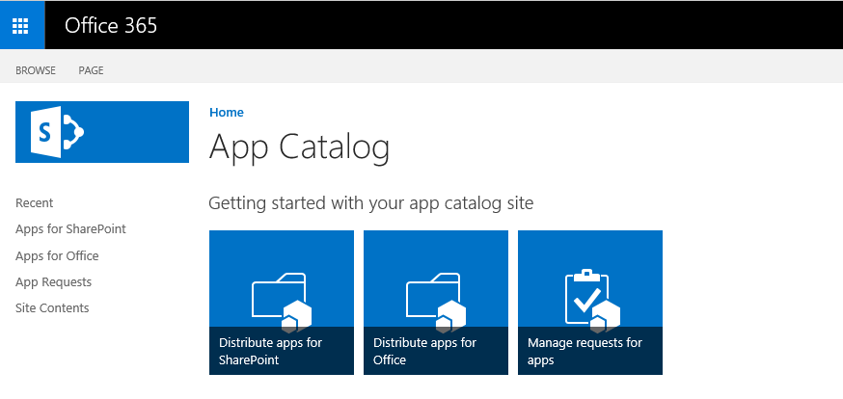

Note that the Quick Launch menu has an **Apps for SharePoint** link which you can use to navigate to the document library that is used to upload app packages in the app publishing process.

Now you are done configuring the local SharePoint Online tenancy for publishing and deploying apps. Now, you will work to publish and install several different SharePoint apps so you can get first-hand experience deploying SharePoint apps in an Office 365 tenancy.

### Exercise 3: Package and Deploy a SharePoint-Hosted App

In this exercise you will package an existing SharePoint-Hosted app and publish it to the Wingtip App Catalog site.

1. Launch **Visual Studio 2015** as administrator:
2. Open the starter solution in Visual Studio 2015:
   1. In Visual Studio, select **File 🡪 Open 🡪 Project/Solution**
   2. In the **Open Project** dialog:
      1. Browse to the **C:\Student\Modules\PublishingApps\Lab\StarterProjects\Calculator** folder
      2. Double click on **Calculator.sln** to openthe solution.
3. Examine the structure of the **Calculator** project. The project has the standard structure for a SharePoint-hosted app with a start page named **Default.aspx** in the **Pages** folder.

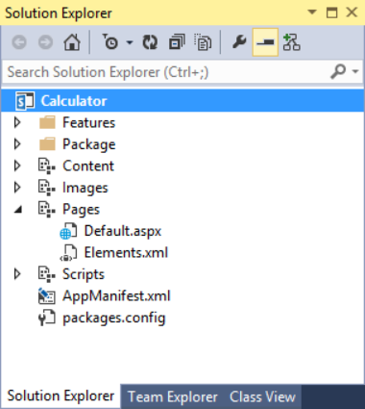

1. Inspect the App Manifest.
   1. Double-click on the **AppManifest.xml** to take a look at the app manifest settings.
   2. Review the current settings in the app manifest and take note that many of these settings are used by SharePoint when you publish, install and upgrade apps though the App Catalog.

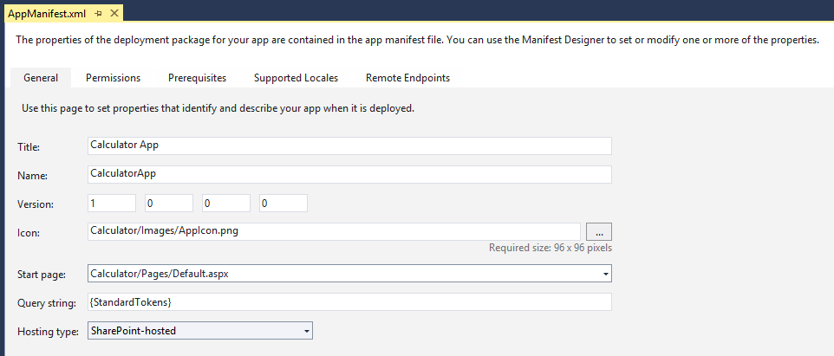

1. Package the App.
   1. In the **Solution Explorer**, right-click the **Calculator** project node.
   2. Select **Publish…** from the context menu.

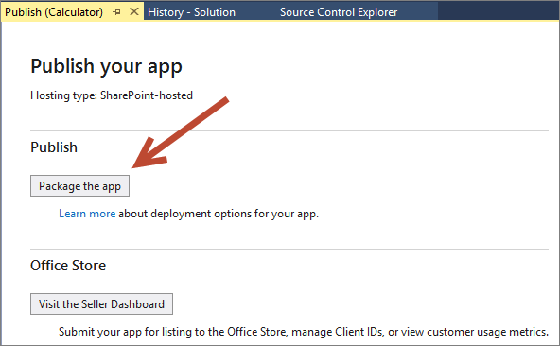

* 1. In the Publishing Wizard, click **Package the app**.
  2. When you click **Package the app**, Visual Studio builds the app package and then opens the Windows Explorer at the folder which contains the new app package.

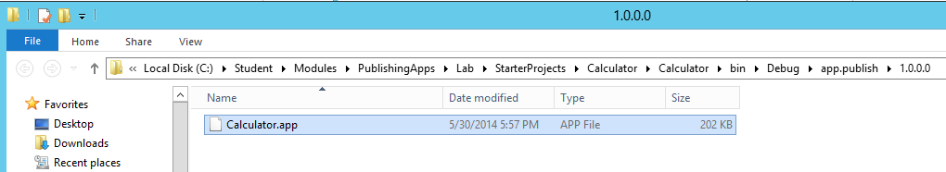

* 1. Keep Visual Studio opened as we will need this same solution in a later exercise.

1. Publish the App
   1. In the browser, navigate to the **App Catalog** site you created earlier..
   2. Click the **Apps for SharePoint** link in the left navigation area.

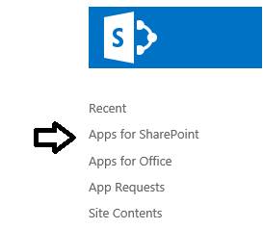

* 1. On the page for the **Apps for SharePoint** library, you will see a **new app** link as shown in the following screenshot.

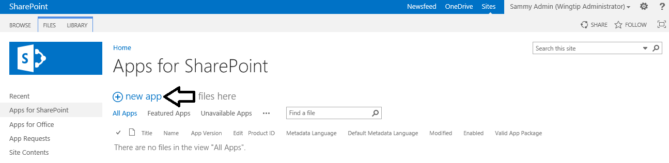

* 1. Upload the package:
     1. Click the **new app** link to display the **Add a document** dialog.
     2. On the Add a document dialog, click **Browse** to display the **Choose File to Upload** dialog.
     3. Select the app package named **Calculator.app** and then click **Open** to close the **Choose File to Upload** dialog.

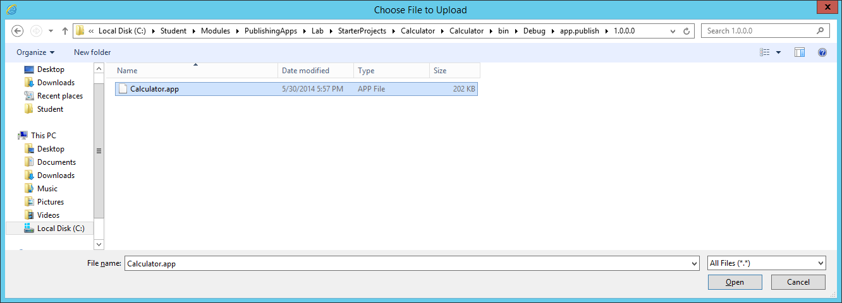

* + 1. Click **OK** to upload the app package and close the **Add a document** dialog.
  1. At this point you should be prompted with a properties page for **Calculator.app**.
  2. Accept the default value for **Name** which is just the file name of the app package.
  3. Enter **Calculator App** for the **Short Description**.

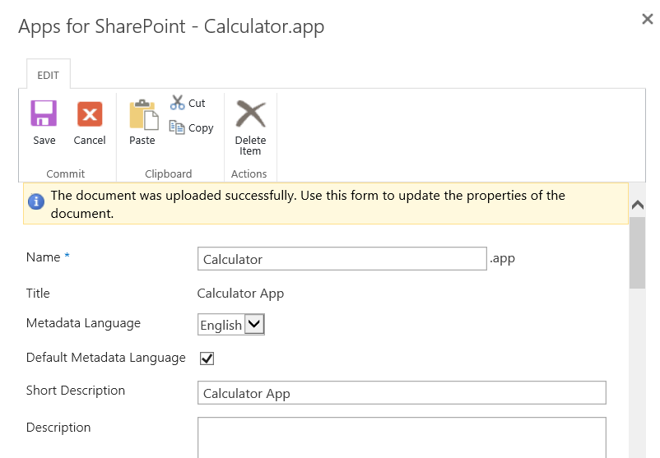

* 1. Enter **Tools** for the **Category**.
  2. Enter **Wingtip Toys** for the **Publisher Name**.

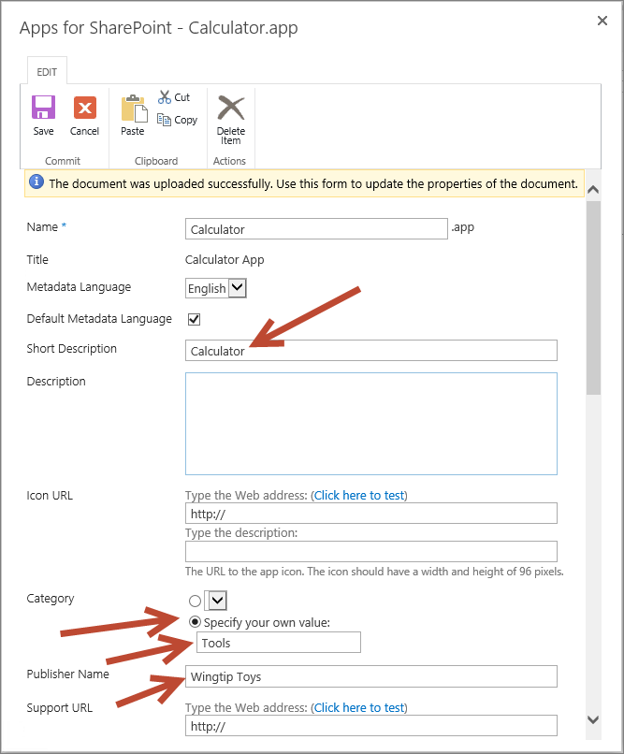

* 1. Scroll down to the bottom of the properties page for **Calculator.app** and select the **Featured** property by checking the checkbox.

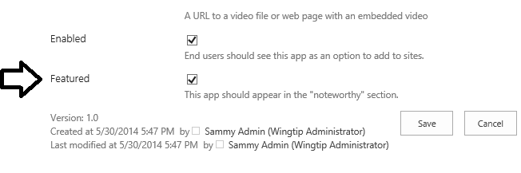

* 1. Click **Save** to save the metadata properties associated with the **Calculator** app.

#### Install the Calculator App at Site Scope

1. In Internet Explorer, **Navigate** to your site <http://publishing.wingtip.com>, where you can test install the app.
2. Click **Site Contents** in the Quick Launch menu**.**
3. Click **Add an App**.

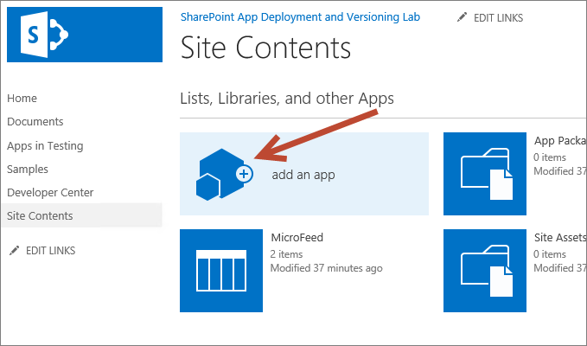

1. On the **Site Content – Your Apps** page, you should see that **Calculator App** listed as the first app in the **Apps you can add** section. The reason that the **Calculator** app is listed first in this section is because you configured it as a **Featured** app.

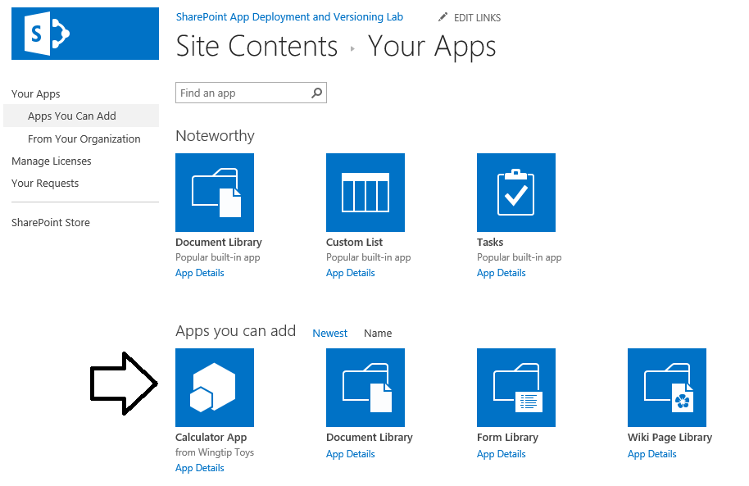

1. Click **App Details** under the Calculator App icon.

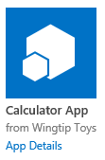

1. When you click **App Details**, you are redirected to the **Calculator App** page which list the app's details and provides a big blue **ADD IT** button.
2. Install the app.
   1. Click the **ADD IT** button to begin the app installation process.

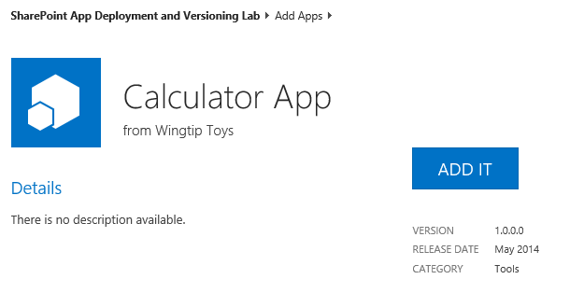

* 1. When prompted **Do you trust Calculator App**, click **Trust it**.

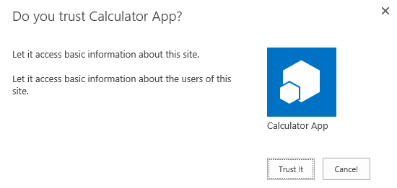

* 1. At this point, you should see the app installing with a new tile on the Site Contents page. After a second or two the app will appear to be completely installed.

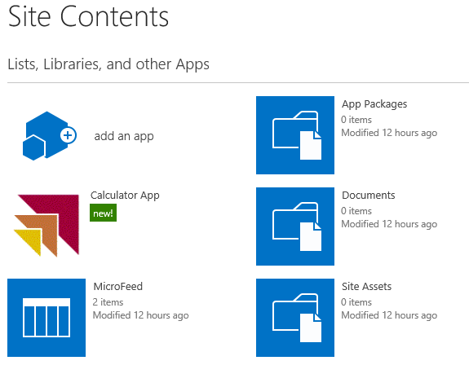

This is the point in the installation process where SharePoint has created an app web for the installed app instance.

* 1. Hover over the tile for the **Calculator App** and expand the flyout menu.

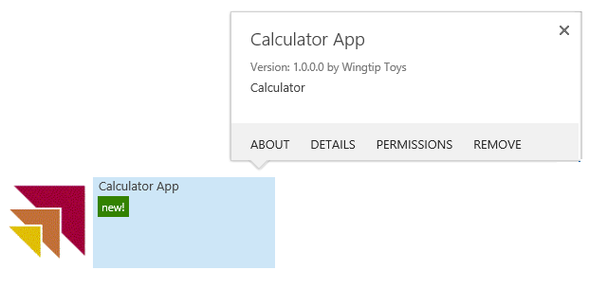

1. Give the **Calculator App** a quick test drive.
   1. Click on the **Calculator App** tile on the **Site Content** page to navigate to the **Calculator App** start page.
   2. Click the little calculator icon to display Calculator.

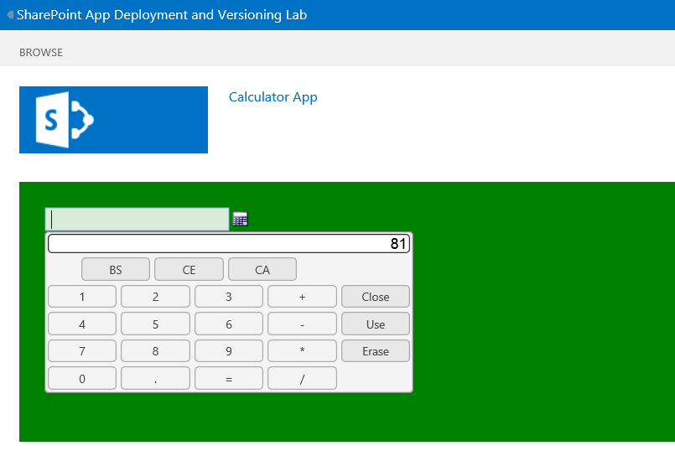

* 1. Try and add two numbers together.
  2. OK, so this app really doesn't do too much. But now you know what this app does.
  3. Click the link at the top left-hand side of the screen to navigate back to the host web at **http://publishing.wingtip.com**.

1. Now that you have tested Calculator App, let’s see how to **uninstall** it.
   1. Return to the **Site Contents** page.
   2. From the flyout menu associated with **Calculator App**, click **Remove**.

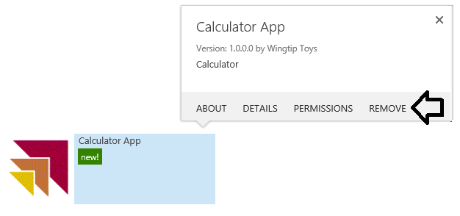

* 1. When prompted, click **OK** to confirm the app removal.

1. You should be able to confirm that the app has been uninstalled by seeing that it no longer appears on the **Site Contents** page.

You have just gone through the basic steps of packaging, publishing and installing apps in a SharePoint Online tenancy. However, the previous app installation took place at site scope. Now think about a scenario in which you want the Calculator App to be available to man users across multiple site collections. While you could repeat the exact same site-scoped app installation process across many site collections, this type of approach can lead to maintenance issues down the road with respect to installation, upgrade and app removal. In the next exercise you will learn to install an app at tenancy scope which can offer many benefits with respect to managing the app lifecycle.

### Exercise 4: Install a SharePoint Hosted App at the Tenancy Scope

In this exercise, you will install **Calculator App** at the tenancy scope and configure it for use across all sites in a web application.

The only real trick to performing a tenancy-scoped installation is knowing where to install the app. Everything can be done from within the App Catalog site. After you have uploaded the app package to publish the app, you then install the app in the App Catalog site.

1. In the browser, navigate to the **App Catalog**.

Remember earlier in this lab that you already published **Calculator App** to the App Catalog site. Next you will install the Calculator App into the same App Catalog site where it is published.

1. Install the **Calculator App** in the **Wingtip App Catalog site**.
   1. Click **Site Contents** link in the Quick Launch menu.
   2. Click **Add an App**.
   3. Underneath **Apps you can add** Click **Calculator App**.
   4. When prompted, click **Trust it**.
   5. The **Calculator App** should now be installed and appear on the **Site Contents** page of the App Catalog site.

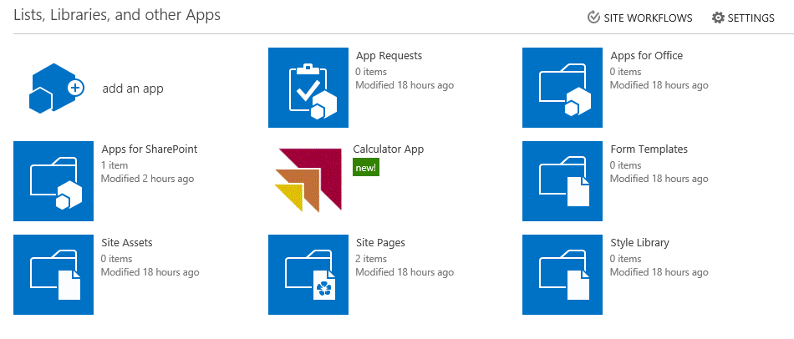

1. Configure the Deployments of Calculator App.
   1. From the **Calculator App** flyout menu, click **Deployment** to navigate to the **Manage App Deployments** page.

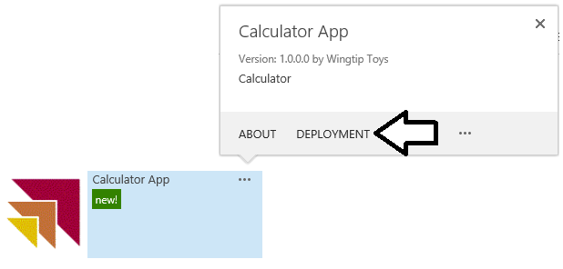

* 1. As you can see, the **Manage App Deployments** page provides you with the ability to a URLs to site collections one by one. However, you will not use that approach in this lab.

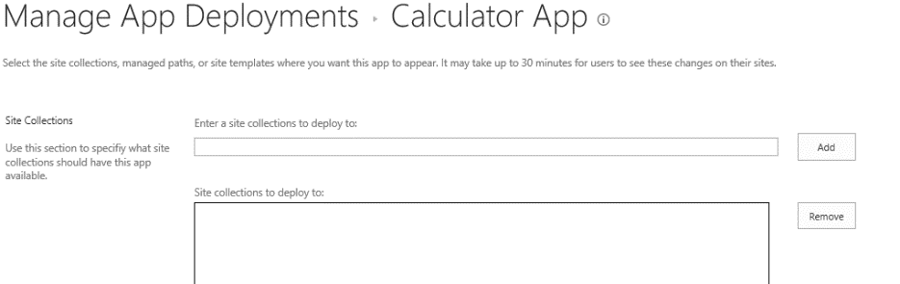

There are many different schemes you can to deploy the app to a set of sites within the current web application. For this lab, you will configure a catch-all deployment technique which will make Calculator App available to every site in the current web application.

* 1. In the **Managed Paths** section, select **(All Paths)** to make the app available to all site.

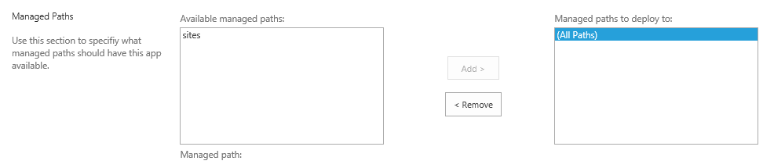

* 1. In the Site Templates section, select **Team Site** and **Developer Site**.

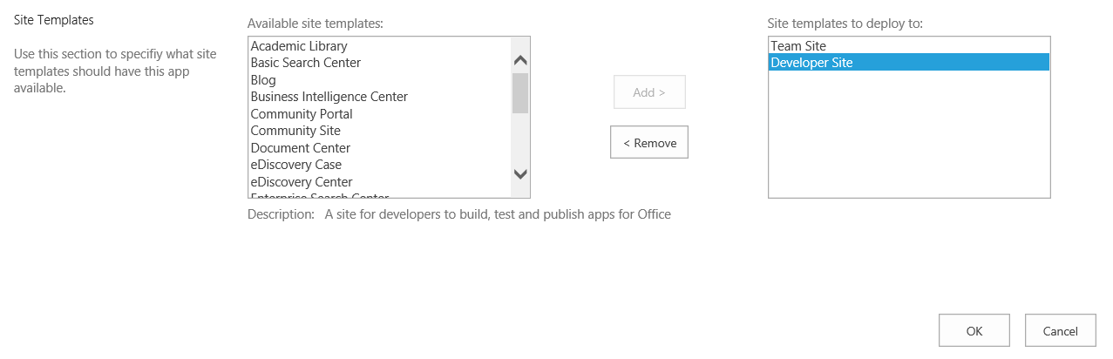

In general, you would not need to set anything in the **Site Templates** section given that the setting in the **Managed Paths** section that has been configured to target all sites in the current web application. We just want you to get a better sense of how you can configure target sites for the deployment.

* 1. At the bottom of the **Manage App Deployments**, click to OK button to push out your deployment configuration changes.
  2. When prompted **Do you trust Calculator App**, click **Trust It**.

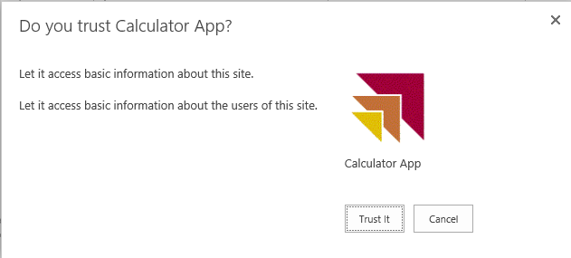

1. Take a second and think through the advantages of a tenancy-based installation you have just performed.
   1. Apps installed in this manner can only be uninstalled by an App Catalog administrator.
   2. Updates to the app become centrally managed.
   3. Updating the app can only be done by an App Catalog administrator.
   4. Updating a tenancy-scoped installation cascades all sites where the app is installed.

When you deploy apps with a tenancy-based installation, there is often a delay before the app actually appears in the target sites. It might take 10-20 minutes before these changes show up in Office 365.

1. Make sure **Calculator App** is available in the team site.
   1. In the browser, navigate to your developer test site.
   2. Click on the **Site Contents** link in the Quick Launch menu.
   3. Verify you can see a tile for the **Calculator App** on the **Site Contents** page.

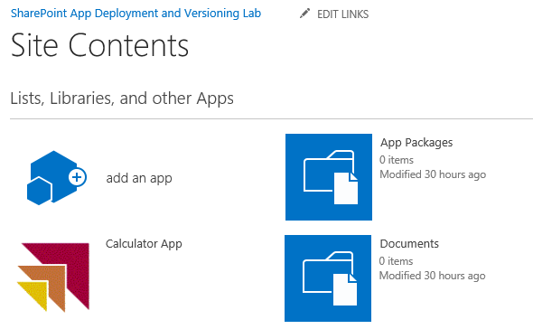

* 1. If you expand the flyout menu for **Calculator app** you can see that that it only provides the **About** link. There is no option for the user to uninstall or configure the app in any way. Any configuration needs to be done back in the App Catalog site.

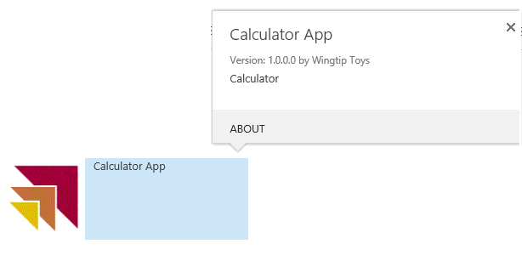

* 1. Give the app a test drive by clicking on the **Calculator App** tile on the **Site Contents** page. You should see that the app appears just as before in that you can use the calculator.

### Exercise 5: Deploy an App Update

In this exercise, you will learn what is involved with updating an existing App by making a small update to the start page of an app and deploying the new version.

1. Return to Visual Studio 2015.
2. Open the Calculator project in Visual Studio if it is not still open.
   1. In Visual Studio, select **File 🡪 Open 🡪 Project/Solution**
   2. In the **Open Project** dialog:
      1. Browse to the **C:\Student\Modules\PublishingApps\Lab\StarterProjects\Calculator** folder
      2. Double click on **Calculator.sln** to openthe solution.

In this lab you will make a minor change to the app to demonstrate how to deploy an update. The change you will make is to change the behavior of the input control on the start page to be read-only.

1. Modify the App
   1. In the Solution Explorer, expand the **Pages** nodes.
   2. Double-click **Default.aspx**.
   3. Edit the HTML in the **PlaceHolderMain** content placeholder by replacing all of the content in the placeholder with the following code:

<p>Calculated Value: <input type="text" readonly="readonly" id="basicCalculator"/></p>

* 1. Double-click **elements.xml**.
  2. Modify the **File** element to replace the app home page with the Default.aspx page by including a **ReplaceContent** attribute as shown in the following code:

<File Path="Pages\Default.aspx" Url="Pages/Default.aspx" ReplaceContent="TRUE" />

* 1. In the Solution Explorer, double-click **AppManifest.xml**.
  2. Modify the **Version** attribute to be **2.0.0.0**.
  3. **Save** all changes to the project.

1. Modify the Feature manifest
   1. In the Solution Explorer, expand the **Features** folder.
   2. Double-click **Feature1**.
   3. Click the **Manifest** tab in the designer.
   4. Expand the **Edit Options** at the bottom of the designer.
   5. In the text block, replace all text with the following XML, which will be merged with the existing feature manifest:

<Feature xmlns="http://schemas.microsoft.com/sharepoint/">

<UpgradeActions>

<VersionRange BeginVersion="1.0.0.0" EndVersion="2.0.0.0">

<ApplyElementManifests>

<ElementManifest Location="Pages\Elements.xml" />

</ApplyElementManifests>

</VersionRange>

</UpgradeActions>

</Feature>

1. Package the App
   1. In the **Solution Explorer**, right-click the **Calculator** project node.
   2. Select **Publish…** from the context menu.
   3. In the Publishing Wizard, click **Package the app**.
   4. When finished, the File Explorer will open to the directory where the 2.0.0.0 version of the Calculator.app has been packaged.
2. Publish the App
   1. Navigate to the App Catalog site at http://wingtipserver/sites/AppCatalog.
   2. Click the **Apps for SharePoint** link in the Left Navigation area.
   3. Upload the version 2.0.0.0 package:
      1. Click **New App**.
      2. Click **Browse** and locate the version 2.0.0.0 **Calculator.app** package you created.
      3. Click **OK**.
   4. In the Properties dialog, click **Save** to keep the same properties as the previous version.
3. In the Office 365 environment, upgrade notifications might take several hours before they appear. However, you should eventually see the notification that an upgrade is available.



1. Upgrade the App
   1. In the **App Catalog,** click the **Site Contents link** from the Left Navigation area.
   2. Using the flyout associated with the Calculator app, click **About**.
   3. On the **About** page, click **Get It** to upgrade version of the app which is **2.0.0.0**.
   4. When prompted, click **Trust It**.
   5. Wait for the upgrade to complete.
   6. Use the flyout menu of **Calculator App** to verify the version number is now **2.0.0.0**.

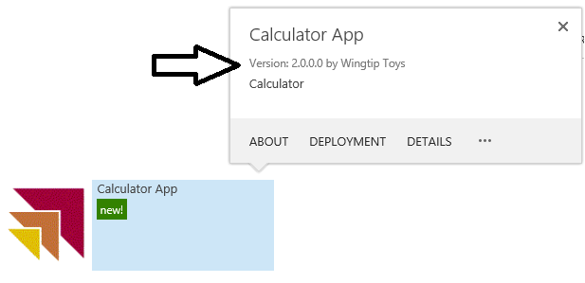

1. Test the upgraded version of **Calculator App** from the App Catalog site.
   1. **Launch** the **Calculator App**.
   2. Verify that the upgraded home page is visible.