## Creating Site Columns and Content Types

**Lab Time**: 45 minutes

**Lab Folder**: C:\Student\Modules\ContentTypes\Lab

**Lab Overview:** In this lab you will create a set of site columns and a content type that will be used to track Wingtip products. After you create the **Product** content type, you will then create a custom list and configure it to use the **Product** content type.

### Exercise 1: Creating Site Columns for Wingtip Product Items

In this exercise you will create a set of site columns that will be used track Wingtip products in the CPT Lab Environment Team Site.

1. Log onto the Student team site as **<Login>** using the appropriate password for your environment.
2. Navigate to the Wingtip Intranet site at **<Team Site>_TeamSite**.
3. Inspect the set of site columns that come out-of-the-box with SharePoint Online.
   1. Use the **Site Actions** menu to navigate to the **Site Settings** page.
   2. Locate and click the **Site columns** link in the **Web Designer Galleries** section.

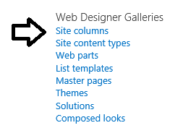

* 1. Review the set of existing site columns on the **Site Columns** page. Use the **Show Group** dropdown box to filter site columns so you can see the site columns in each individual group.

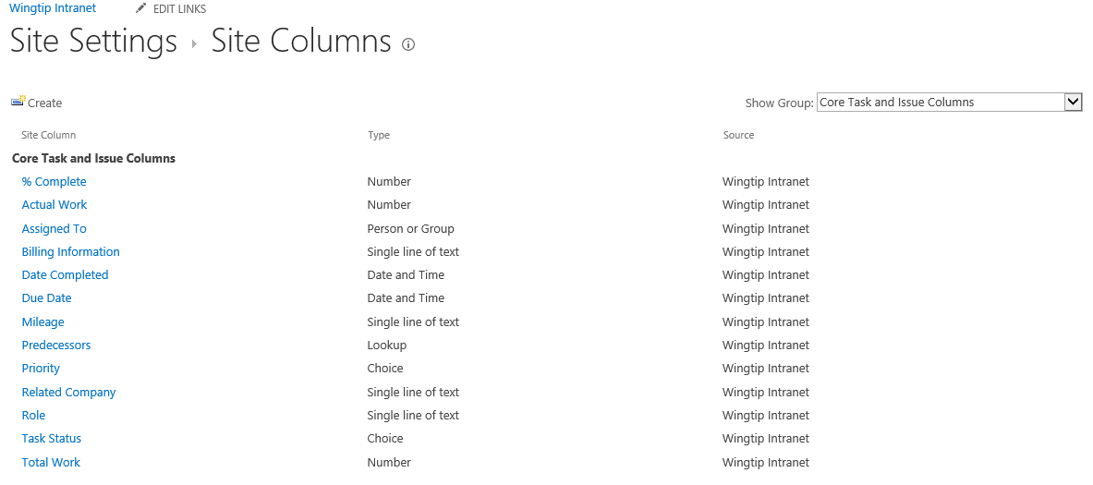

1. Create the **Product Code** site column.
   1. Navigate to the **Site Columns** page
   2. Click the **Create** link to navigate to the Create Column page.

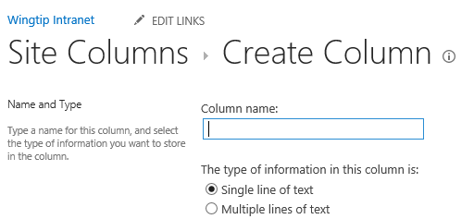

* 1. Enter a **Column name** of **ProductCode** and make sure the column type is set to **Single line of text**.

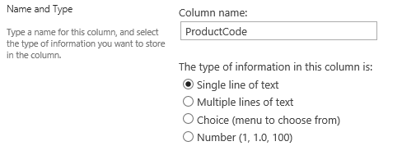

Remember you are intentionally avoiding a space in the column name so SharePoint doesn’t generate an internal site column name that includes that hideous **_x0020_**. In a later step you will modify the site column’s display name to add a space between **Product** and **Code** to make it more readable to users.

* 1. Down in the **Group** section add a **New group** value of **Wingtip**.

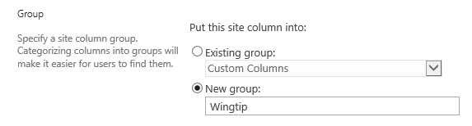

* 1. In the **Additional Column Settings** section, select **Yes** for both the options **Require that this column contains information** and **Enforce unique values**. Also set the **Maximum number of characters** to a value of **6**.

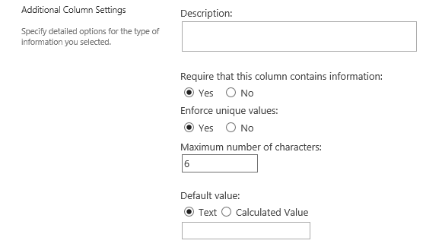

* 1. Click **OK** to create the new site column. When you do this you will be prompted with the following dialog which informs you that SharePoint must configure an index for the site column in order to ensure unique column values within a list. Click **OK** to continue.

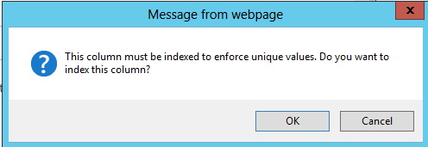

* 1. On the **Site Columns** page, filter the page using the **Show Group** dropdown to show only site columns in the **Wingtip** group. At this point, the **ProductCode** site column should be the only site column you see.

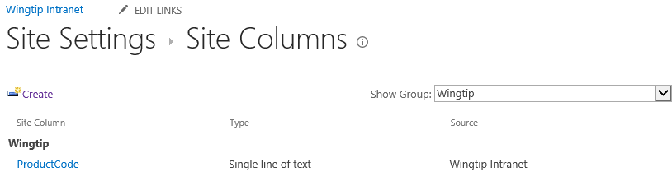

* 1. Now you can update the site column to add a space to its display name. Click on the **ProductCode** link to navigate to the **Edit Column** page. Add a space between **Product** and **Code** and click **OK** to save your work.

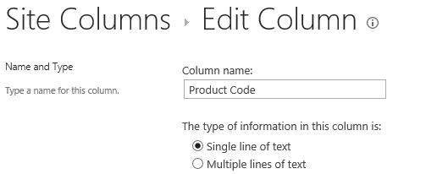

* 1. At this point you have completed the work to create your first site column.

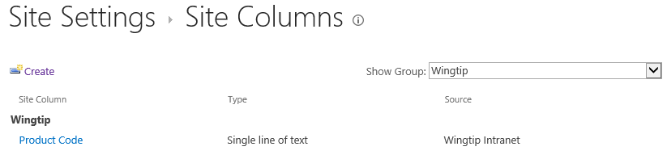

1. Create the **Product Description** site column.
   1. On the **Site Columns** page, click the **Create** link to navigate to the **Create Column** page.
   2. Enter a column name of **ProductDescription** and set the column type to **Multiple lines of text.**

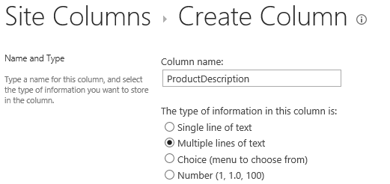

* 1. In the **Group** section, assign the new site column to the **Existing group** of **Wingtip**.

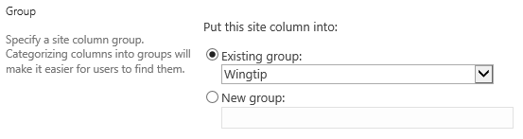

* 1. In the **Additional Column Setting** section assign a value of **4** to the **Number of lines for editing** setting. Also set the **Specify the type of text** **to allow** setting to **Plain text**.

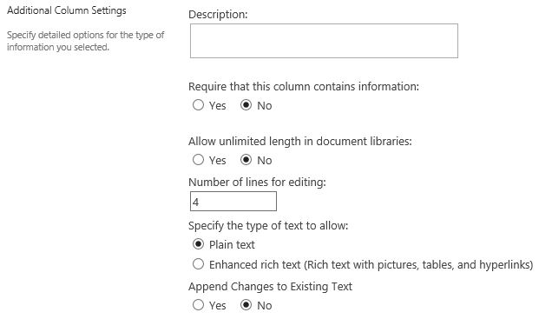

* 1. Click **OK** to create the new site column.
  2. Once the site column has been created, open it in the **Edit Column** page and add a space to its display name to update it from **ProductDescription** to **Product Description**.

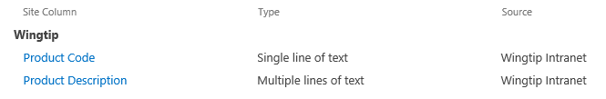

1. Create the **Product List Price** site column.
   1. On the **Site Columns** page, click the **Create** link to navigate to the **Create Column** page.
   2. Enter a column name of **ProductListPrice** and set the column type to **Currency.**

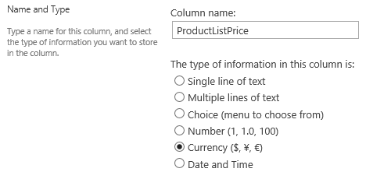

* 1. In the **Group** section assign the new site column to the **Existing group** of **Wingtip**.



* 1. In the **Additional Column Setting** locate the textbox for the **Min** settings located under the caption. Specify a **minimum allowed value** of **0**. Also set the **Number of decimal places** setting to a value of **2**.

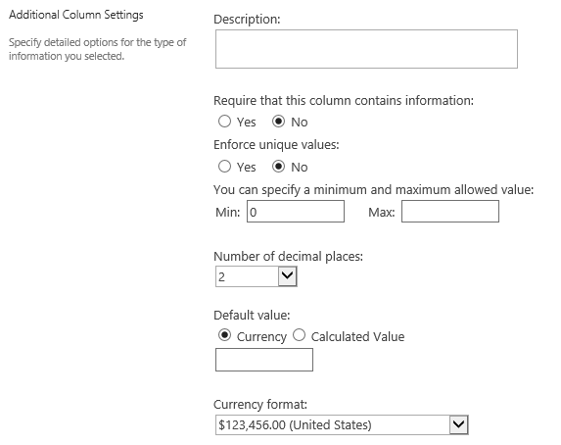

* 1. Click **OK** to create the new site column.
  2. Once the site column has been created, open it in the **Edit Column** page and add spaces to its display name to update it from **ProductListPrice** to **Product List Price**.

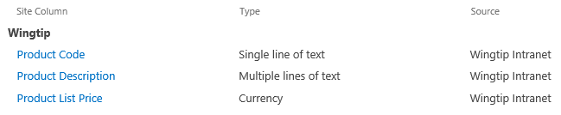

1. Create the **Product Color** site column.
   1. On the **Site Columns** page, click the **Create** link to navigate to the **Create Column** page.
   2. Enter a column name of **ProductColor** and set the column type to **Choice.**

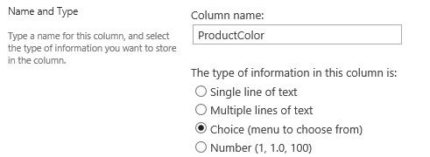

* 1. In the **Group** section assign the new site column to the **Existing group** of **Wingtip**.



* 1. In the **Additional Column Setting** section, locate the input control under the caption **Type each choice on a separate line** and add the following choice values.
     1. White
     2. Black
     3. Blue
     4. Red
     5. Green
     6. Yellow
  2. In the **Additional Column Setting** section, after adding the choice value, also assign the **Display choices using** setting to **Checkboxes (allow multiple selections)**.

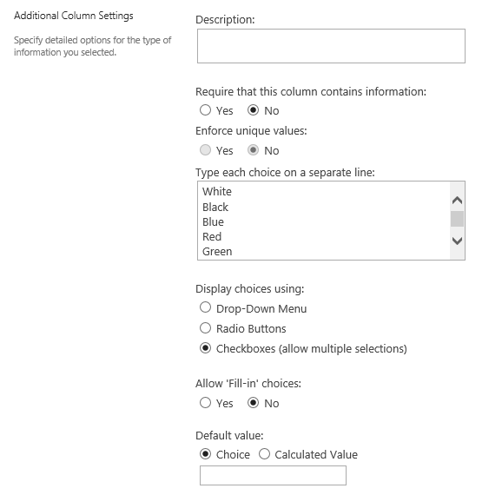

* 1. Click **OK** to create the new site column.
  2. Once the site column has been created, open it in the **Edit Column** page and add a space to its display name to update it from **ProductColor** to **Product Color**.

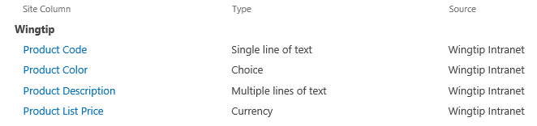

1. Create the **Minimum Age** site column.
   1. On the **Site Columns** page, click the **Create** link to navigate to the **Create Column** page.
   2. Enter a column name of **MinimumAge** and set the column type to **Number.**

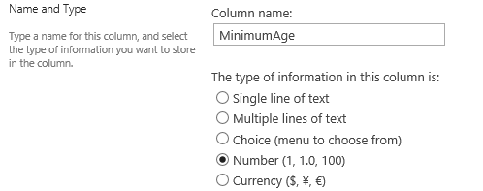

* 1. In the **Group** section assign the new site column to the **Existing group** of **Wingtip**.



* 1. In the **Additional Column Setting** section set the **Min** allowed value to **1** and the **Max** allowed value to **100**. Also configure the **Number of decimal places** setting with a value of **0**.

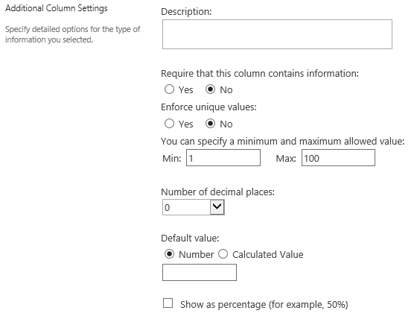

* 1. Click **OK** to create the new site column.
  2. Once the site column has been created, open it in the **Edit Column** page and add a space to its display name to update it from **MinimumAge** to **Minimum Age**.

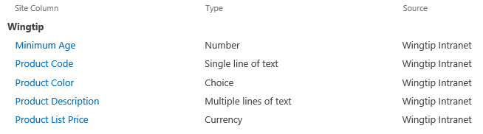

1. Create the **Maximum Age** site column.
   1. On the **Site Columns** page, click the **Create** link to navigate to the **Create Column** page.
   2. Enter a column name of **MaximumAge** and set the column type to **Number.**

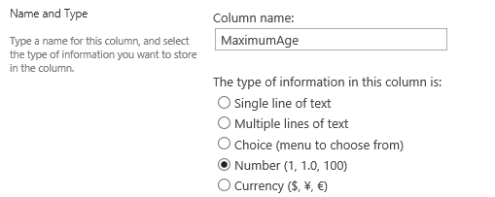

* 1. In the **Group** section assign the new site column to the **Existing group** of **Wingtip**.



* 1. In the **Additional Column Setting** section set the **Min** allowed value to **1** and the **Max** allowed value to **100**. Also configure the **Number of decimal places** setting with a value of **0**.



* 1. Click **OK** to create the new site column.
  2. Once the site column has been created, open it in the **Edit Column** page and add a space to its display name to update it from **MaximumAge** to **Maximum Age**.

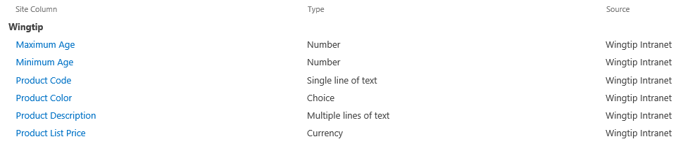

At this point, you are done creating the required set of site columns to track Wingtip products. In the following exercise you will create a new content type that puts these site columns to use.

### Exercise 2: Creating a Content Type for Wingtip Products

In this lab you will create a new content type named **Product** that will use all the site columns you created in the previous exercise.

1. Inspect the set of content types that come out-of-the-box with SharePoint 2013.
   1. Use the **Site Actions** menu to navigate to the **Site Settings** page.
   2. Locate and click the **Site content types** link in the **Web Designer Galleries** section to navigate to the **Site Content Types** page.

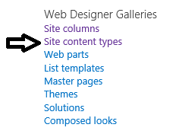

* 1. Review the set of content types available on the **Site Content Types** page. Use the **Show Group** filter control to inspect each group individually.

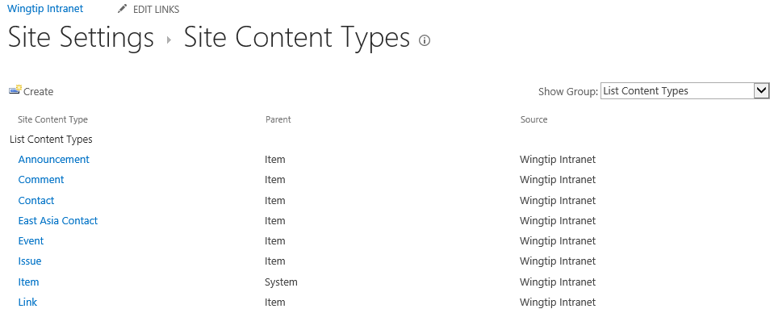

Now that you have seen the set of standard content types that come out-of-the-box with SharePoint Online, it’s time to move on to the next step where you will create a custom content type.

1. Create the **Product** content type.
   1. Click the **Create** link on the **Site Content Types** page to navigate to the **New Site Content Types** page.
   2. Enter a **Name** of **Product**.
   3. Set the **Select parent content type** setting to **List Content Types**.
   4. Set the **Parent Content Type** setting to **Item**.
   5. In the **Group** section add a New Group value of **Wingtip**.
   6. Ensure your input values look as they do in the following screenshot.

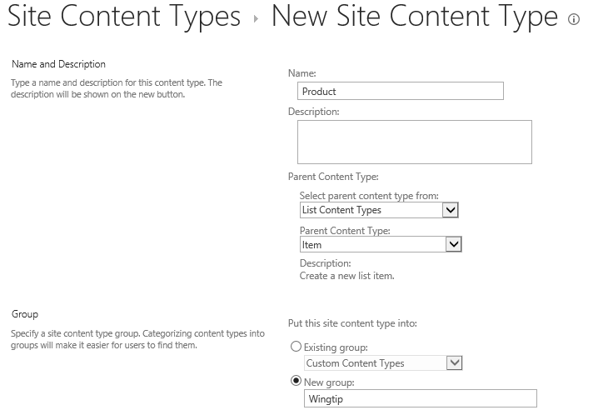

* 1. Click OK to create the **Product** content type.

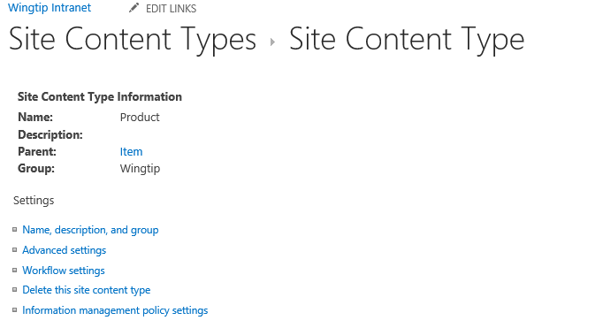

1. Add the Wingtip product site columns to the **Product** content types.
   1. On the **Site Content Type** page, move down to the Columns section. You should be able to see that the Product content type has only a single column named **Title**.

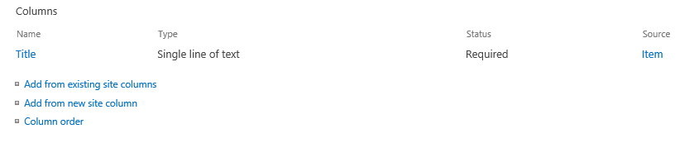

* 1. Click the **Add from existing site columns** link to navigate to the **Add Columns** page. Set the **Select columns from** dropdown control to **Wingtip** to show only the site columns you created in the previous exercise.

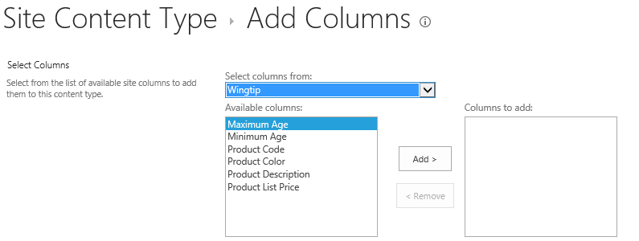

* 1. Remember that the order in which columns are added can be significant. Therefore, add the site columns in the following order.
     1. Product Code
     2. Product Description
     3. Product List Price
     4. Product Color
     5. Minimum Age
     6. Maximum Age
  2. When you are done, the **Add Columns** page should look like the following screenshot.

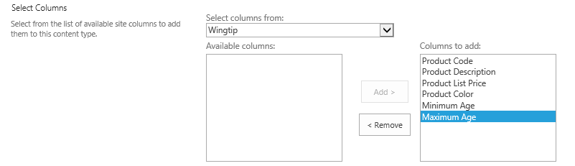

* 1. When you are done adding the site columns, click **OK** to save your changes. The Product content type should now include all the site columns you created in the previous exercise.

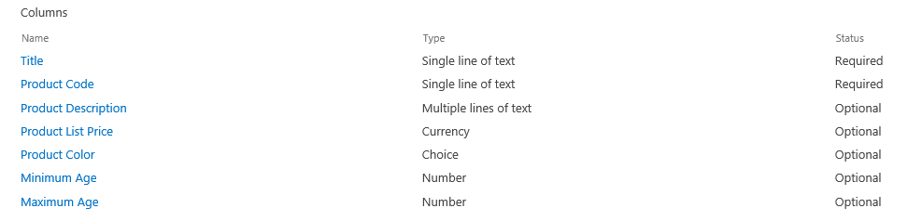

You have just created the **Product** content type. However, you must remember that this content type has no purpose until you have used it in one or more lists. In the next exercise you will create a new Products list and configure it to use the Product content type.

### Exercise 3: Configuring a List to Use the Product Content Type

In this exercise you will create a new custom list and configure it to use the Product content type you created in the previous exercise.

1. Create the **Products** list.
   1. From the **Site Actions** menu, select **Add an app** to navigate to the **Your Apps** page.
   2. Click the **Custom List** tile to create a new list based on the **Custom List** type.

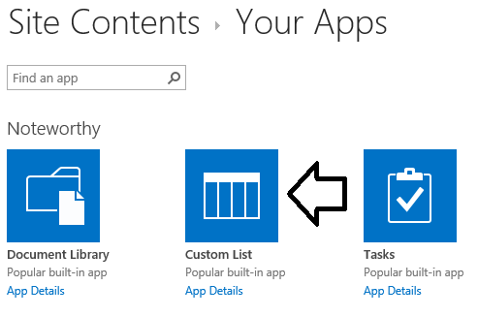

* 1. Enter a name of **Products** and click the **Create** button to create the new list.

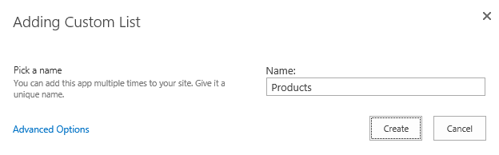

* 1. After the **Products** list has been created, you should be able to see a tile for it on the **Site Contents** page. Click the ellipse (…) menu in the top-right of the tile for the **Products** list and then click the **SETTINGS** link to navigate to the list

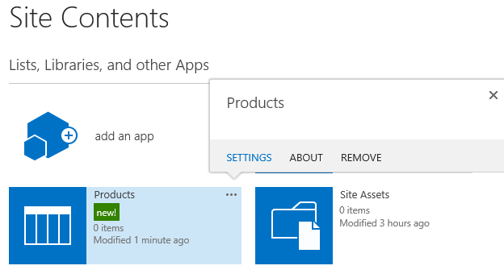

* 1. At this point you should be at the **Setting** page for the **Products** list. You can see that the list has a **Name** of **Products** and a **Web Address** of **<Team Site>/Lists/Products/AllItems.aspx**.

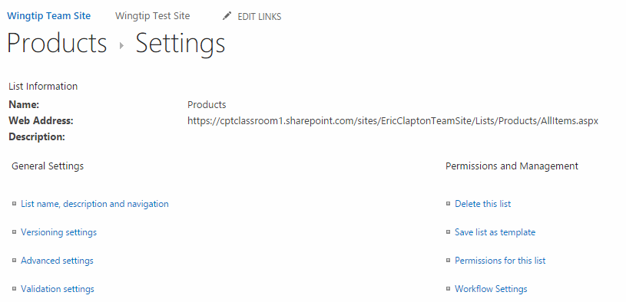

* 1. Inspect the existing set of columns in the list.

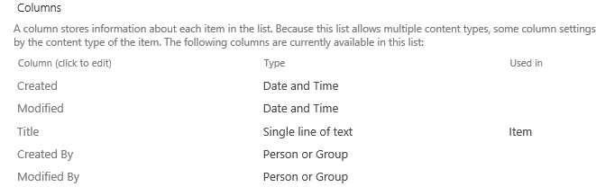

1. Configure the Products list to support Product content type.
   1. From the **Setting** page for the **Products** list, click the **Advanced settings** link.

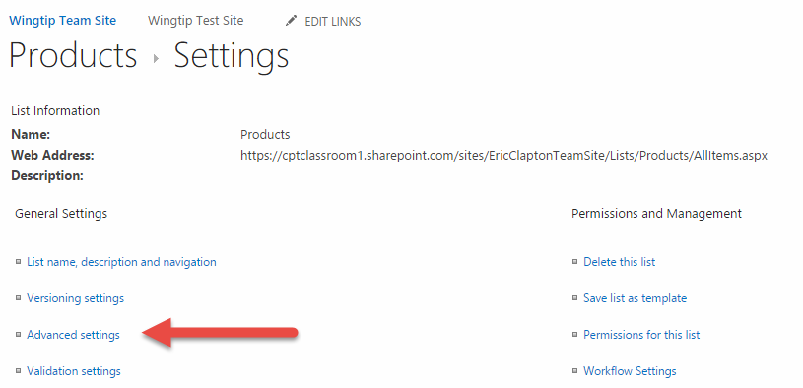

* 1. On the **Advanced Settings** page, change the value of the **Allow management of content types** setting from **No** to **Yes**.

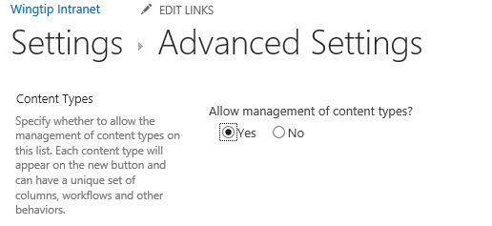

* 1. Click the **OK** button to save your changes. You should now see a new **Content Types** section in the **Settings** page for the **Products**. At this point, you should be able to observe that the list now contains the **Item** content type.

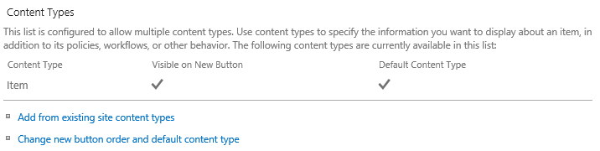

* 1. Click the **Add from existing site content types** link to navigate to the **Add Content Types** page.
     1. Select **Product** from the available site content types.
     2. Click **Add**.
     3. Click **OK**.

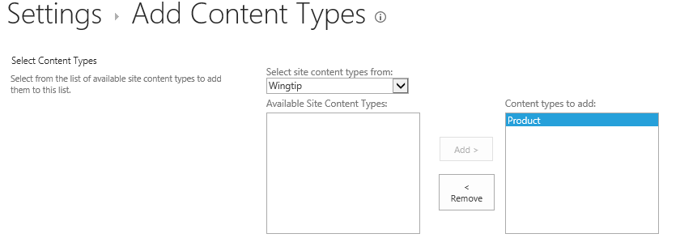

* 1. Now, you should be able to see that the **Product** content type is included under the **Item** content type. However, there is an issue in that the **Product** content type is not currently configured as the **Default Content Type** for the **Products** list.

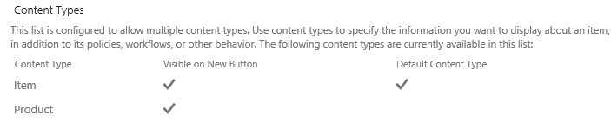

* 1. Remove the **Item** content type from the **Products** list. Begin by clicking on the link for the **Item** content type

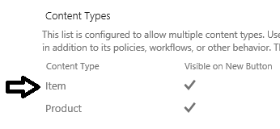

* 1. On the **List Content Types** page, complete the process for removing the **Item** content type by clicking the **Delete this content type** link.

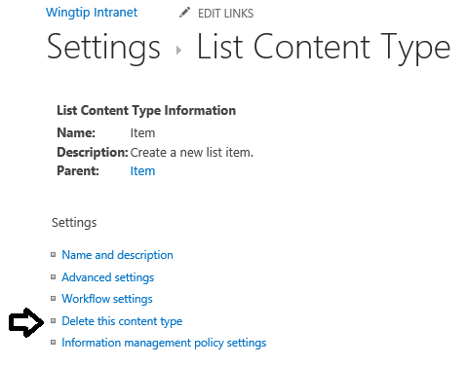

* 1. Now you should see that the **Products** list contains a single content type named **Product**.

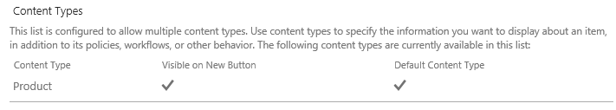

* 1. Inspect the Columns section of the **Products** list to see what columns are there. As you can see, it contains all the site columns from the **Product** content type such as **Product List Price**, **Maximum Age**, **Minimum Age**, **Product Code**, **Product Color** and **Product Description**. When you added the **Product** content type to the **Products** list, SharePoint automatically added all the site columns from the **Product** content type that were not already present in the columns collection of the **Products** list.

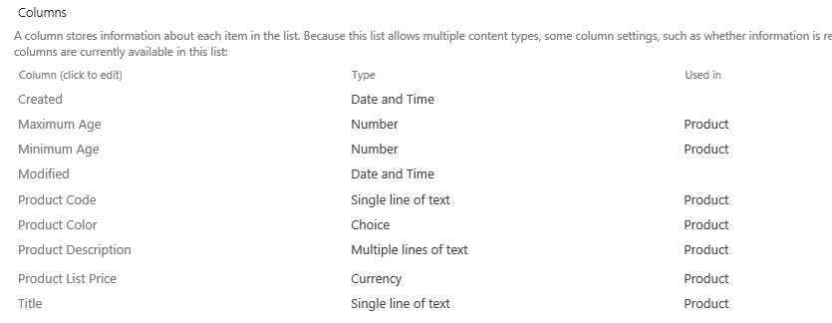

1. Add a new **Product** item.
   1. Navigate to the default view of the **Products** list.
   2. Click the **new item** link to navigate to a new item page.

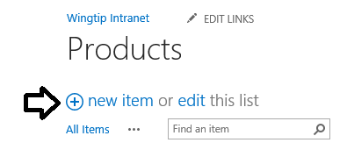

* 1. On the new item page, fill in the input values for a new **Product** item as shown in the following screenshot.

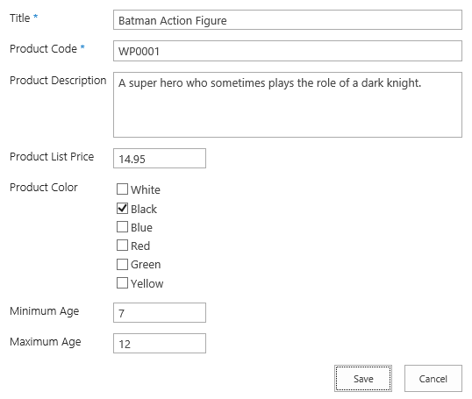

* 1. Click the **Save** button to save the new **Product** item. When you return to the default view of the **Products** list, you can see that this view is currently displaying the **Title** column but no other column.

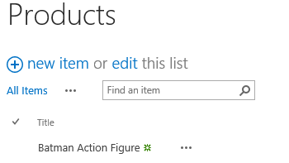

From this you can observe that SharePoint adds the site columns from a content type in the list’s columns. But it does not update any views to include those columns. In the next step you will modify the default view for the Products list to include the site columns from the **Product** content type.

1. Update the **All Items** view of the **Products** list to include the site columns from the **Product** content type.
   1. Navigate to the default view for the **Products** list.
   2. In the ribbon, activate the **List** tab and then click the **Modify View** button to edit the default view for the **Products** list.

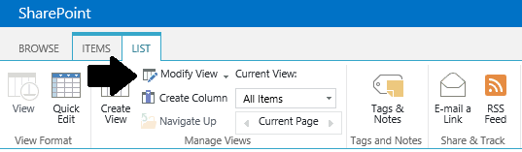

* 1. Include the site columns from the **Product** content type and order them as shown in the following screenshot.

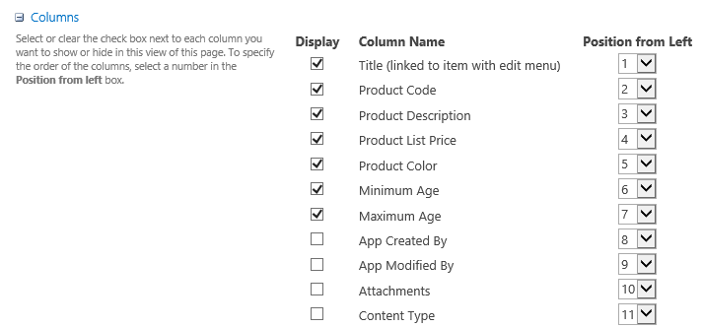

* 1. Click **Ok** to save your changes. You should now see that the default view is showing the proper set of columns.

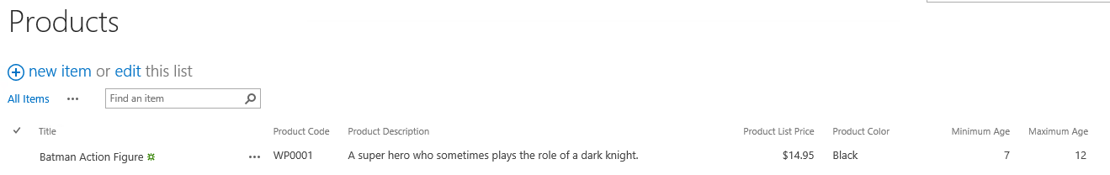

1. Add a new Product item in edit mode.
   1. Enter edit mode for the Products list and add a second product for the **Captain America Action Figure** using the values shown in the following screenshot. When you are done editing click **Stop Editing**.

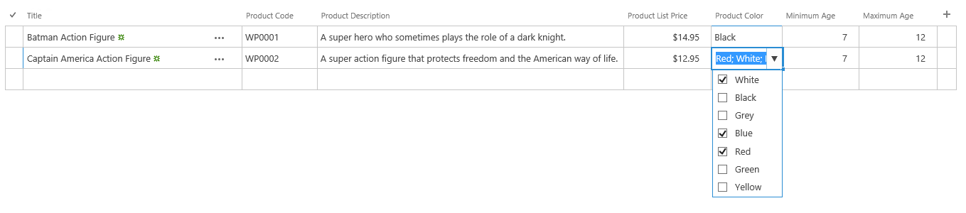

At this point, you have been through all the required steps to create and use site columns and content types. In the next exercise you will run a utility program which is supplied as part of the class lab files which will populate the Products list with a sample set of Products.

### Exercise 4: Populating the Products List with Product Items

In this exercise you will run the **ProductListPopulationUtility.exe** utility which will automate add 32 Product items to the **Products** list you created in the previous exercise. Note the utility deletes any existing items before adding the new set.

1. Launch Windows Explorer and navigate the folder for this lab at **C:\Student\Modules\ContentTypes\Lab**.
2. Look inside the **C:\Student\Modules\ContentTypes\Lab**.You should see a child folder named **Utilities**.
3. Look inside the **\Utilities** folder and locate the EXE file named **ProductListPopulationUtility.exe**.

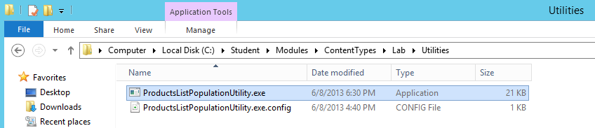

1. Run the utility by double-clicking **ProductListPopulationUtility.exe**.
2. Supply the password for your Student Team Site.

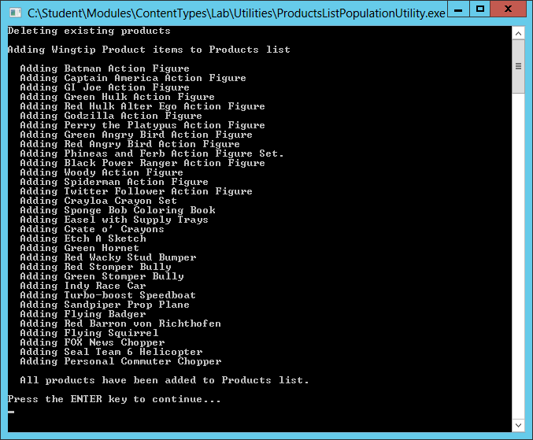

If the utility fails, the most likely cause it that you have an incorrect name for a site column or a content type. The utility requires that you created your site columns without spaces so they have internal names such as **ProductCode** instead of **Product_x0020_Code**. You will have to go back and find the problem and fix it before you can successfully run the utility.

1. Once the **ProductListPopulationUtility.exe** utility has run successfully, you should be able to return to the **Products** list and verify that this list has been populated with a new set of **Product** items.

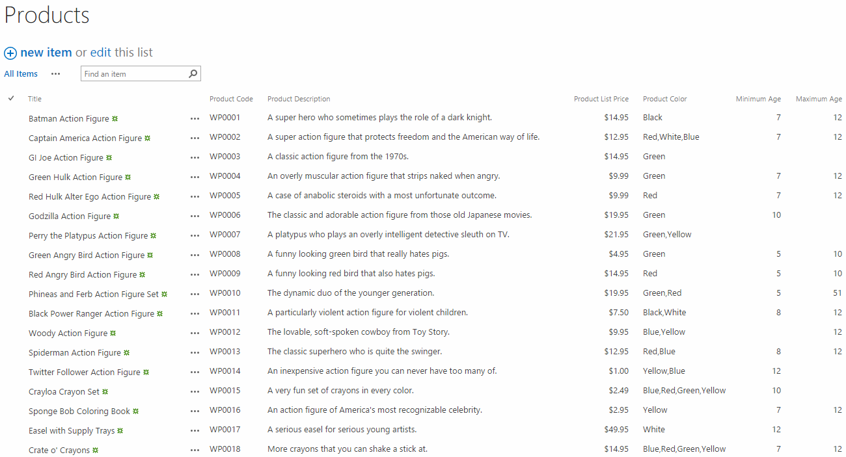

1. Take a moment to review the new set of **Product** items. Is there one of these products that takes you back to your childhood?

At this point, you have created the **Products** list and populated it with content. You can now move on to the next exercise.

### Exercise 5: Add a Calculated Column to Display Age Range

In this exercise you will add a calculated column to the **Products** list to display the age range for each product. You will create this calculated column using a formula that reads the values of the **Minimum Age** column and the **Maximum Age** column and uses those values to generate a display string with the age range.

1. Take a look at the default view of the **Products** list.

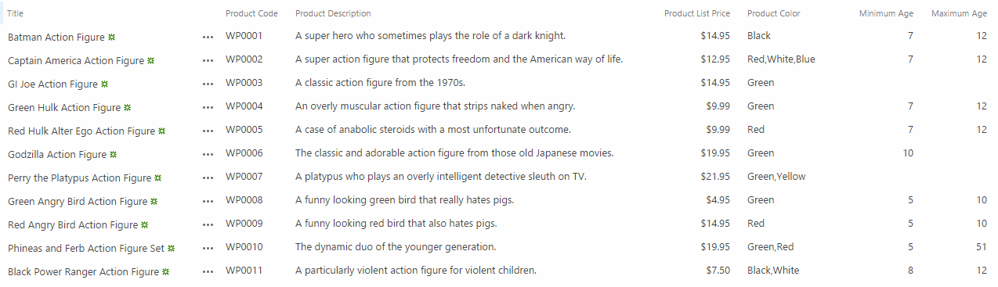

1. Create a new calculated column in the **Products** list.
   1. Navigate to the **Settings** page of the **Products** list.
   2. Scroll down to the **Columns** section.

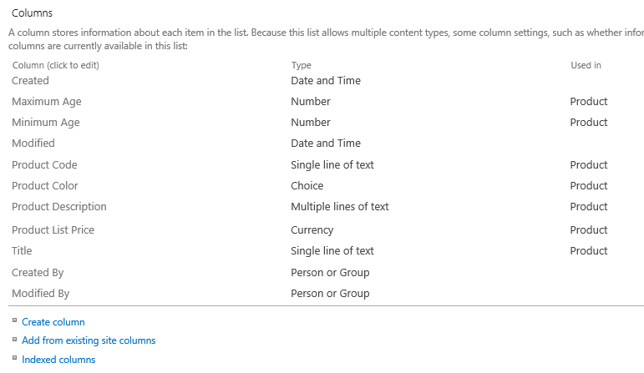

* 1. Click the **Create column** link to navigate to the **Create Column** page.
  2. On the **Create Column** page, create a new list column with a name of **AgeRange** (rename it to **Age Range**). Set **The type of information in this column is** setting to **Calculated (calculation based on other columns)**.

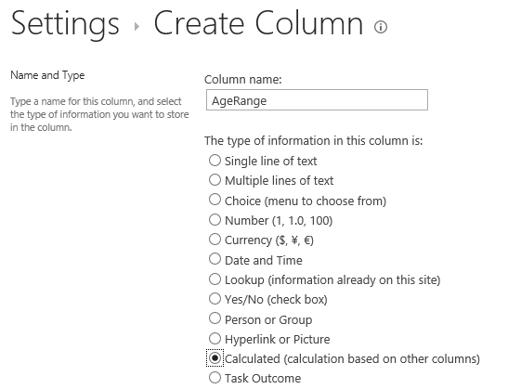

* 1. Scroll down to the **Additional Column Settings** section and locate the **Formula** text box. Remember that every formula starts with an equals sign **(=**) which is followed by an expression that can be evaluated. Start by adding a very simple formula using the following text.

="Hello"

* 1. When you have entered the formula, your screen should match the screenshot below. Also make sure the other settings on our page match the ones in the following screenshot.

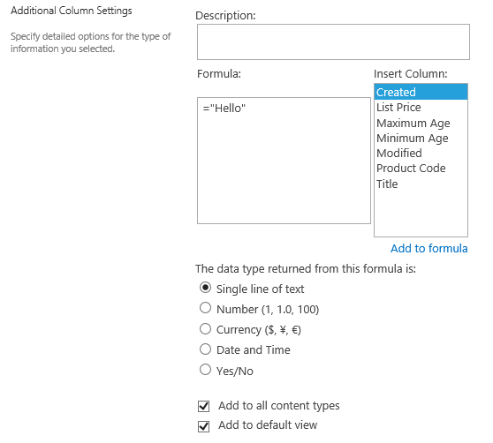

* 1. Click **OK** to save your work and create the new **Age Range** list column.
  2. Return to the default view for the **Products** list. You should be able to verify that the **Age Range** column has been added as the last column in the default view of the **Products** list.

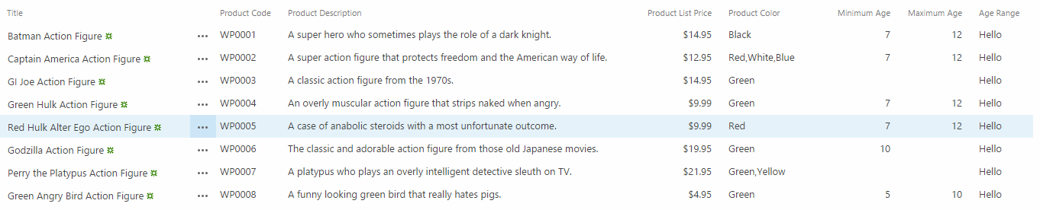

* 1. Modify the default view of the **Products** list to remove the **Minimum Age** column and the **Maximum Age** column. Also move the **Age Range** column up in the column ordering so it appears before the **Product Description** column.

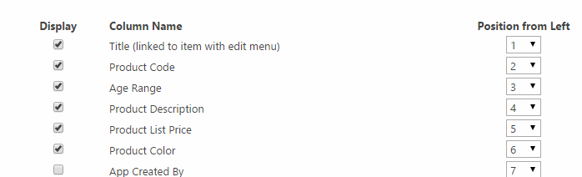

* 1. When you are done, click **OK** to save your changes and return to the default view of the **Products** list. You should now see the columns in the default view of the Products list appear as they do in the following screenshot.

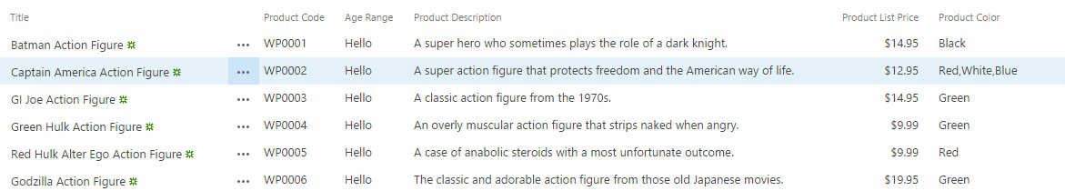

1. Write the required formula for the **Age Range** list column.
   1. Navigate to the **Settings** page for the **Products** list.
   2. Scroll down to the **Columns** section.
   3. Locate and click the link for the **Age Range** column to navigate to the **Edit Column** page.

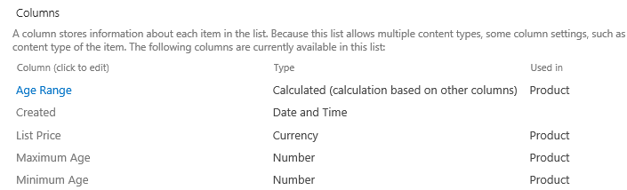

* 1. You should be able to see that the calculated column still has the original **Formula** value.

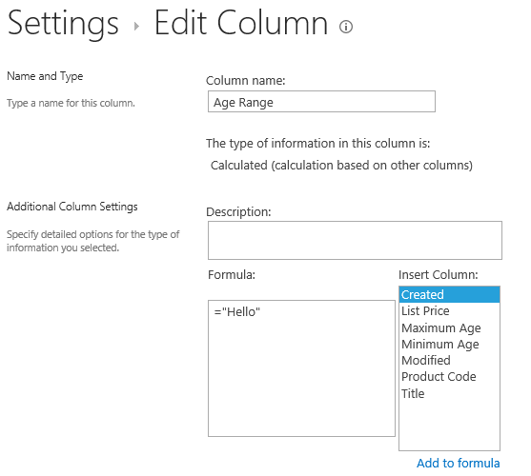

* 1. Update the **Formula** for the calculation with the following text.

="Ages "&[Minimum Age]&" to "&[Maximum Age]

* 1. When you have entered this, it should appear as the following screenshot.

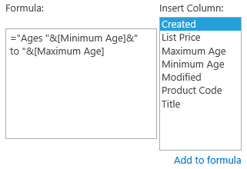

* 1. Click **OK** to save your changes.
  2. Return to the default view of the **Products** list and examine the results of your work on the formula for the **Age Range** column.

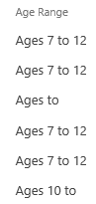

The formula is correct for **Product** items that have a non-blank value for both **Minimum Age** and **Maximum Age**. However, the **Minimum Age** site column and the **Maximum Age** site column can accept null values in the case where a **Product** item doesn’t have a minimum age and/or a maximum age.

1. Improve the formula for the **Age Range** list column.
   1. Return to the Edit Column page for the Age Range list column.
   2. Update the formula using the following text value.

=IF(AND(ISBLANK([Minimum Age]),ISBLANK([Maximum Age])),

"All ages",

"Ages "&[Minimum Age]&" to "&[Maximum Age])

* 1. Click **OK** to save your changes.
  2. Return to the default view of the **Products** list and examine the results of your work on the formula for the **Age Range** column.

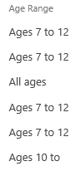

* 1. You should be able to verify that **Product** items which contain blank values for both the **Minimum Age** column and the **Maximum Age** column have an **Age Range** column value of **All Ages**. However, our work is not done. There are still two more scenarios that the current formula does not handle correctly.

The next step in completing the formula is tricky and the SharePoint Online editing experience for working with formulas in a calculated column can be frustrating. Students that enjoy pain and suffering and the satisfaction of completing a tough task should move to the next step and complete the formula by continuing to edit it in the tiny text box that SharePoint provides.

In you are not into SharePoint-centric masochism, feel free to copy-and-paste the final solution for the **Age Range** column formula from a text file named **CalculatedColumnSolution.txt** which can be found in the in the **ContentTypes\Lab** folder. If you open this text file, you can copy its contents to the clipboard and then paste it into the browser page where you are editing the formula for the **Age Range** calculated column.

1. Note that the final step in completing the formula for the **Age Range** list column is adding the logic to handle these two scenarios.
   1. When a **Product** item has a non-blank **Minimum Age** value but the **Maximum Age** value is blank.
   2. When a **Product** item has a non-blank **Maximum Age** value but the **Minimum Age** value is blank.
2. Complete the logic required in the formula by adding the following text.

=IF(AND(ISBLANK([Minimum Age]),ISBLANK([Maximum Age])),

"All ages",

IF(ISBLANK([Maximum Age]),

"Ages "&[Minimum Age]&" and older",

IF(ISBLANK([Minimum Age]),

"Ages "&[Maximum Age]&" and younger",

"Ages "&[Minimum Age]&" to "&[Maximum Age])))

1. When you are done, you should be able to verify that the Age Range formula is correct for all scenarios.

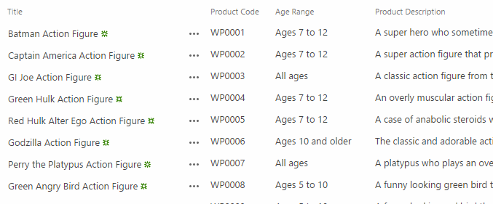

You have now completed this lab. We certainly hope you learned a good deal about working with site columns and content types.