## Getting Started with SharePoint Online

**Lab Time**: 45-60 minutes

**Lab Folder**: C:\Student\Modules\GettingStarted\Lab

**Lab Overview:** In this lab you will get up and running with the SharePoint Online in Office 365 and begin to experience the user interface of SharePoint. You will start off by logging into your SharePoint Online site and navigating around the CPT Lab Environment Team Site at **https://<classroom site>/sites/<student name>_TeamSite**.

### Exercise 1: Getting Up and Running with the Student Team Site

In this exercise will you begin by logging into your SharePoint Online student team site. Once you have successfully logged in, you will navigate to the CPT Lab Environment Team Site and become more familiar with the new changes to the SharePoint Online user interface experience.

1. Login to the Student team site using the login **<Login>** and the appropriate password.
2. Once you have logged on to the Student team site navigate to the site at **<Team Site>**.
   1. It might take a minute or two before the first page of the CPT Lab Environment Team Site appears.
   2. When the home page of the CPT Lab Environment Team Site appears, you should be able to see that it is a brand new SharePoint Online Team site.

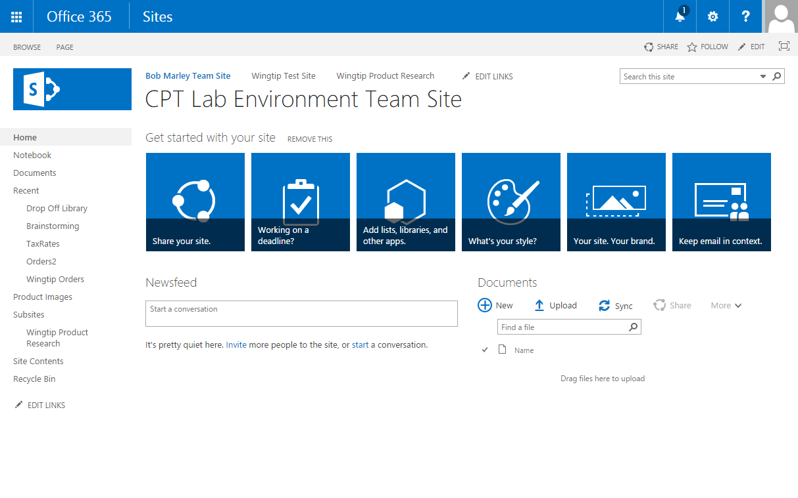

1. Locate the **Site Actions** menu which displays the gear icon on the top right-hand side of the page.
   1. Be careful not to confuse the SharePoint **Site Actions** menu with the Internet Explorer Settings menu which also displays a similar gear icon and is located just slightly above.
   2. Drop down the **Site Actions** menu and review the menu commands inside.

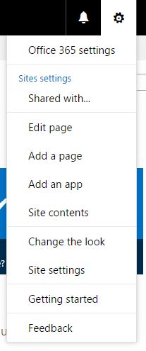

1. In the **Site Actions** menu, click the **Site Contents** menu command to navigate to the **Site Contents** page.
   1. Note that the **Site Contents** page shows list, documents, libraries and apps. Since the CPT Lab Environment Team Site is a brand new Team Site, it has several pre-existing document libraries including **Documents**, **Form Templates**, **Site Assets**, **Site Pages** and **Style Library**.

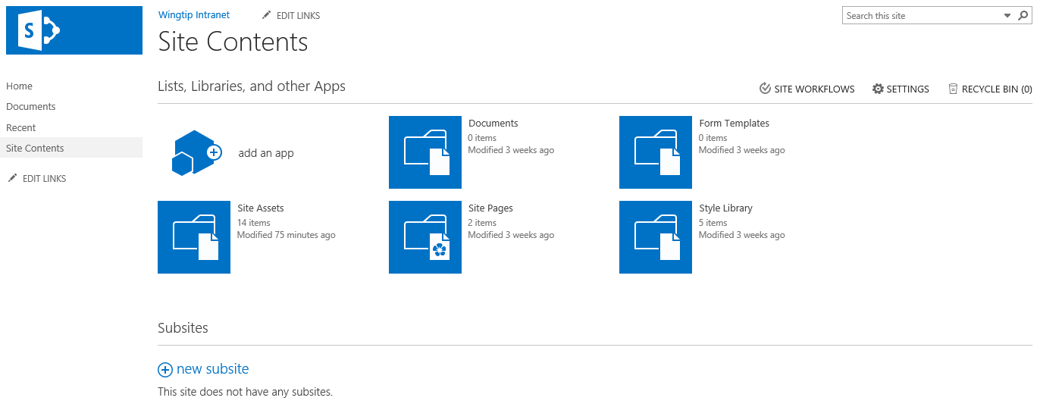

1. In the **Site Actions** menu, click the **Site Settings** menu command to navigate to the **Site Settings** page.
   1. You can see that the **Site Settings** page has sections of administrative links with captions such as **Users and Permissions**, **Look and Feel**, **Web Designer Galleries**, **Site Actions**, **Site Administration**, **Site Collection Administration**.

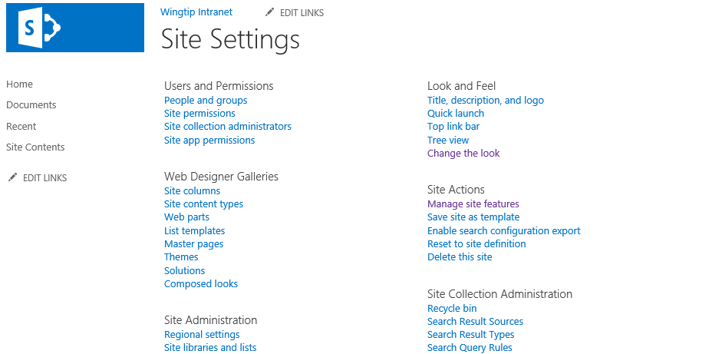

* 1. Take a moment to review each link section on the **Site Settings** page because you will be using many of these site administration links throughout the labs exercises in this course.
  2. Return to the home page of the Team Site.

In this exercise you took a quick look at the CPT Lab Environment Team Site and learned the basics of moving around in a Team site using the **Site Actions** menu. After installing the necessary Office Applications, you will create a new site so you can begin to experiment with the process of creating lists and changing the look and feel of the site.

### Exercise 2: Installing Office 2013/2016 Professional and Visio 2013/2016 Professional

To complete all the labs, the Student team site requires an installation of Microsoft Office 2013 or 2016 Professional as well as Microsoft Visio 2013 or 2016 Professional. **If you don’t have these products installed, you can get them from your Student team site**.

1. Choose the **Settings Menu | Office 365 Settings**.
2. On the **Office 365 Settings** page choose **Software**.
3. Click **Install**.

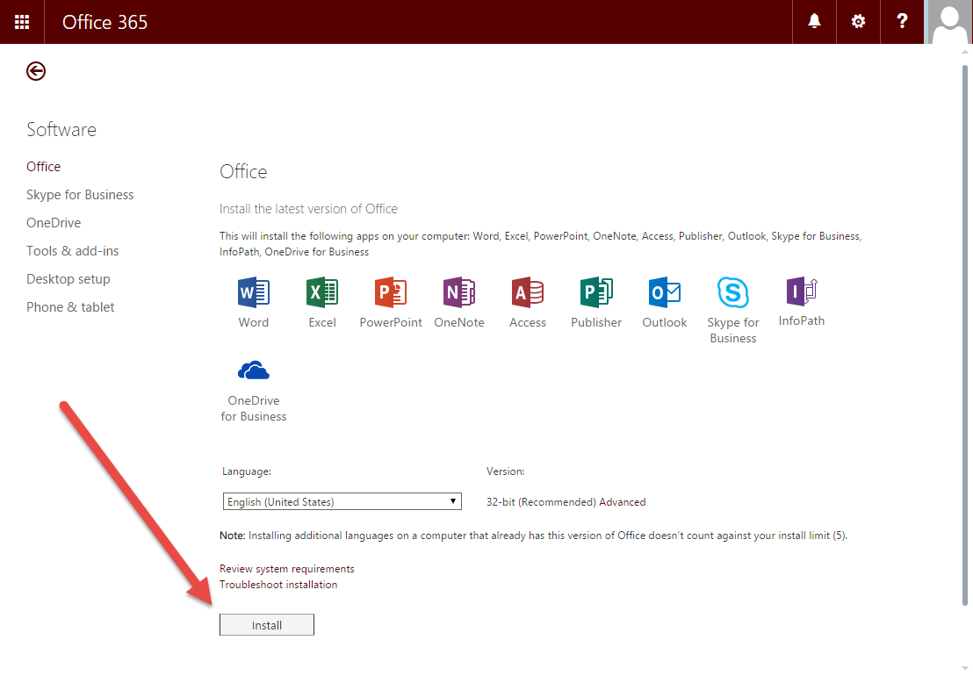

1. Once the installation is complete, choose **Tools & add-ins**.
2. On the **Tools & add-ins** page, install **SharePoint Designer**.

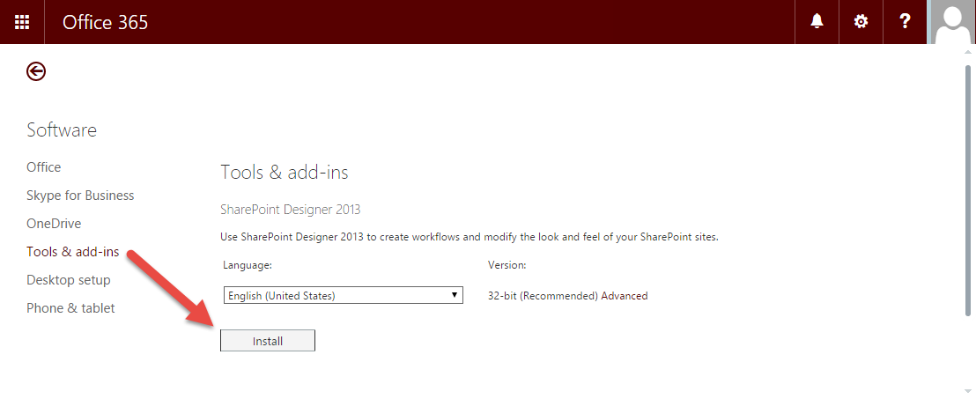

1. Next you will install **Visio Professional 2013**. Navigate to the following link: <http://www.microsoft.com/en-us/evalcenter/evaluate-visio-professional-2013> and click **Download**.
2. Once the Visio installation completes you may proceed with the lab.

At this point you have installed Office 2013 or 2016 Professional, SharePoint Designer 2013 and Microsoft Visio 2013 Professional.

### ****Exercise 3:**** Getting Around in Site Administration

In this exercise you will navigate to Site Administration and create a new Team Site for testing purposes.

1. Create a new SharePoint Online Team Site for testing purposes.
   1. Return to the **Site Settings** page for your Team Site.
   2. In the **Site Administration** section click **Sites and Workspaces**.
   3. Click **Create**.
   4. In the **Title and Description** section of the **New SharePoint Site** page, add the following entries.
      1. **Title**: Wingtip Test Site
      2. **Description**: A test site for experimenting with the new SharePoint Online Team Site
      3. **Web Site Address**: **<Team Site>/Testing**
   5. Your input values should match those in the following screenshot.

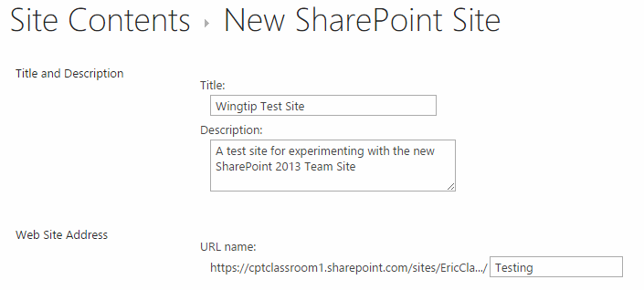

* 1. In the **Template Selection** section of the **New SharePoint Site** page, ensure that the **Select a template** setting is set to **Team Site**. Leave the **Permissions** set to **Use same permissions as parent site**.

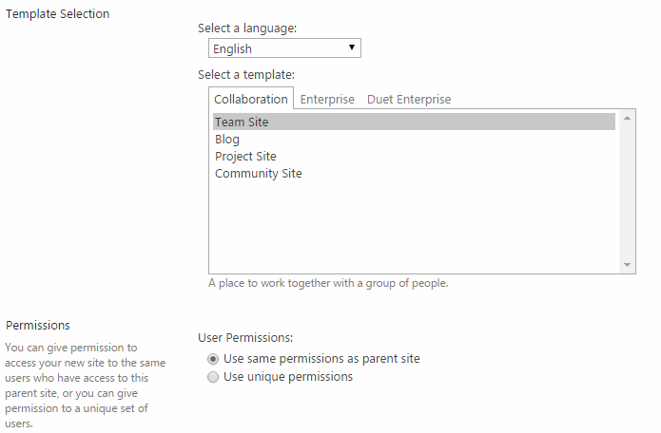

* 1. Click the **Create** button to begin the process of provisioning the new Team site. This might take a few minutes to complete. When the new site collection has been created you should be redirected to the newly created team site.
  2. Wait until the home page displays for the site at:

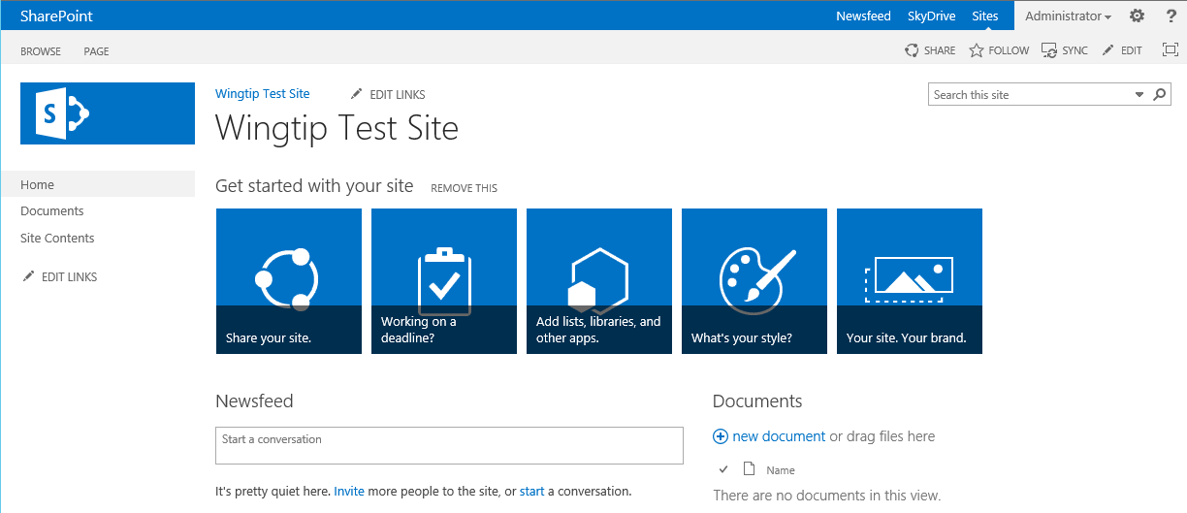

* 1. Once you can see the home page of the new Team site, you can move on to the next exercise.

In this exercise you used Site Administration to create a Team site in the current site collection. In the following exercises, you will begin working with this new site to add content and change its look and feel.

### ****Exercise 4: Activating and Deactivating Site Features****

In this exercise, you will begin to manage features which activate at both the site level and the site collection level.

1. If you are not already there, navigate to the Team site at **<Team Site>/Testing** that you created in the previous exercise.
2. Review the site-scoped features available for activation within a Team site.
   1. Use the **Site Actions** menu to navigate to the **Site Settings** page.
   2. On the **Site Settings** page, locate and click the **Manage site features** link in the **Site Actions** section.

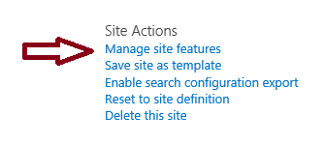

* 1. Take a moment and review all the site-level features shown on this page. You should also note which site-level features are activated by default in a new Team site and which features are not.

1. Deactivate the **Minimal Download Strategy** feature in the test site.
   1. Return to the home page of the testing site.
   2. Inspect the URL shown in the address bar of the browser which is used to navigate to the home page of the test site.

<Team Site>/Testing/_layouts/15/start.aspx

* 1. On the **Site Settings** page, locate and click the link titled **Manage site features** in the **Site Actions** section.
  2. Locate the feature with the title of **Minimal Download Strategy**.

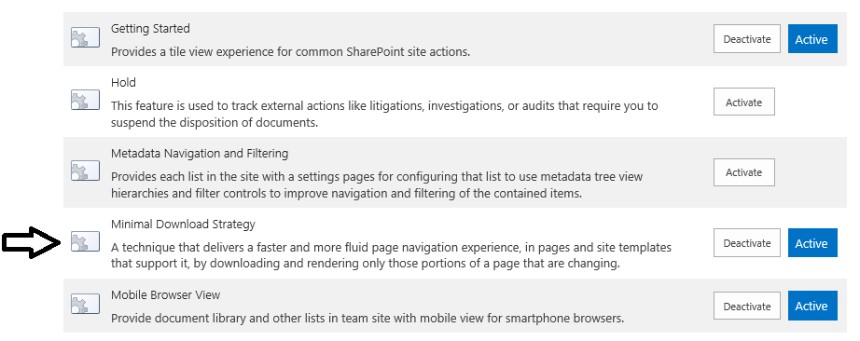

* 1. Click the **Deactivate** button to the right of the **Minimal Download Strategy**. When you do this, the SharePoint UI prompts you to confirm that you want to deactivate the feature, Click the **Deactivate this feature** link to complete the deactivation process.

Note: If the feature is deactivated the instructions here are reversed. Roll with it.

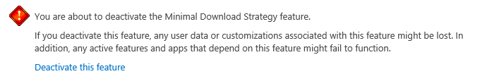

* 1. Once the feature has been deactivated, return to the home page of the site.
  2. Inspect the URL in the address bar of the browser. You should be able to see that the URL to the site is now easier to read.

<Team Site>/Testing/SitePages/Home.aspx

* 1. Return to the home page of the test site.

In this lab, you began working with feature management. It’s essential that you know how to manage features and that you also have an understanding about which features activate at the site level versus features that activate at the site collection level.

### ****Exercise 5: Working with Lists and Items in SharePoint Online****

In this exercise you will create and customize a simple list for tracking the list of products that are sold by Wingtip Toys. You will accomplish this by creating a custom list and then adding list columns so you can track the required information for each product.

1. Inspect the pre-existing set of list and document libraries in the new Team site.
   1. Use the **Site Actions** menu to navigate to the **Site Contents** page.
   2. Review the contents of the **Site Contents** page. At this point, it only contains a few pre-existing document libraries including **Documents**, **Site Assets**, **Site Pages** and **Microfeed**.

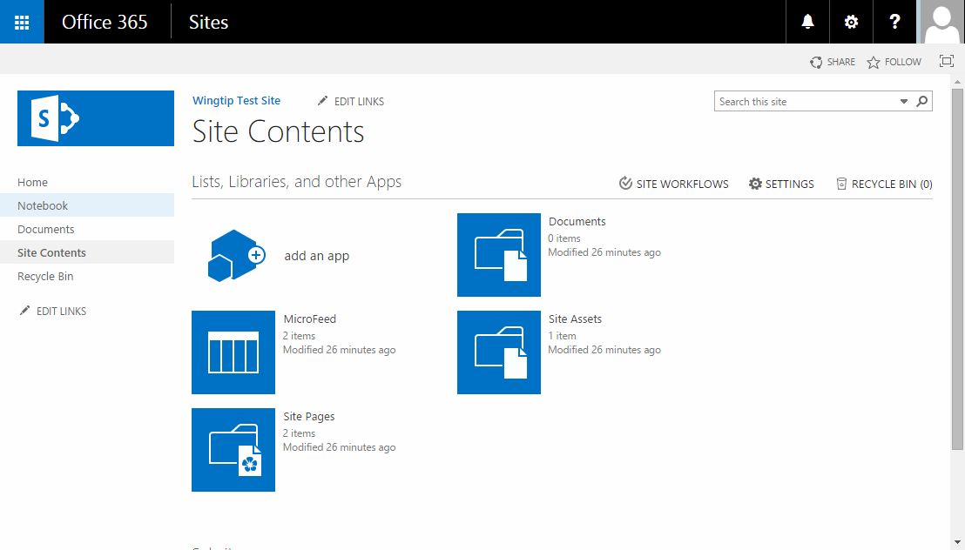

1. Create a new custom list to track product information.
   1. From the **Site Actions** menu, click the **Add an app menu** item to navigate to the **Your Apps** page.
   2. On the **Your Apps** page, click the **Custom List** tile to begin the process of creating a new custom list.

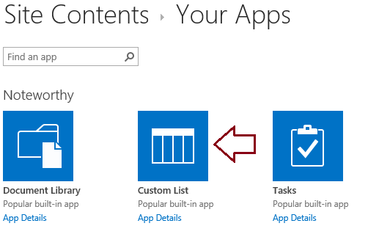

* 1. When prompted, enter a list name of **Products** and click **Create**.

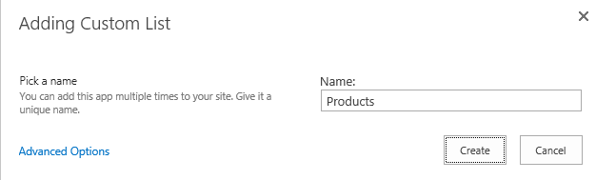

* 1. Once the list has been created you should be able to see a tile for it in the **Site Contents** page.



* 1. You have now finished the steps of creating a new list. Now it’s time to configure it.

1. Navigate to the list Settings page.
   1. On the **Site Contents** page, click the ellipse (**…**) fly out menu in the top, right-hand corner of the Products tile and then click the **SETTINGS** link to navigate to the **Settings** page for the new **Products** list.

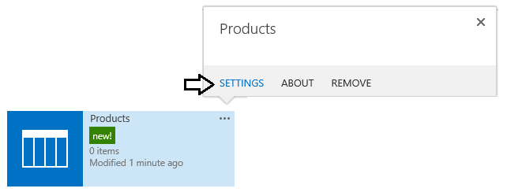

* 1. Review the information and links shown on the **Settings** page for the **Products** list.

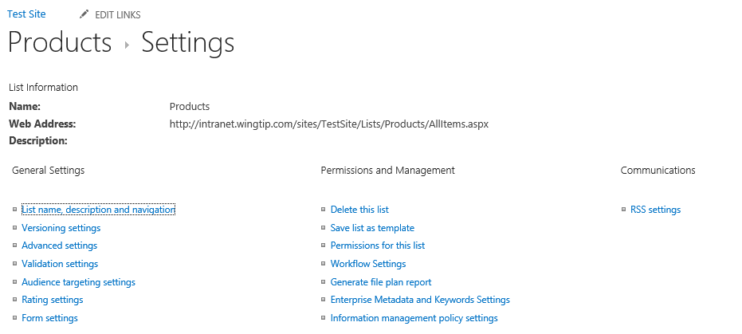

* 1. Scroll down to the **Columns** section and inspect the current set of columns in the **Products** list. The current set of columns includes **Title**, **Modified**, **Created**, **Created By** and **Modified By**.

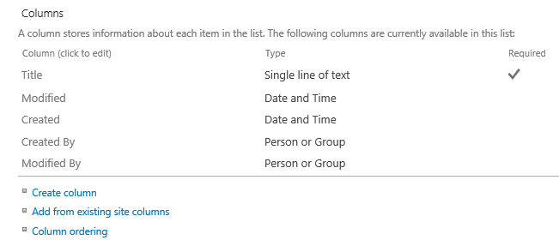

1. Add a new **Text** column named **Product Code**.
   1. Click on the **Create column** link in the **Columns** section under the list of columns to navigate to the **Create Column** page.
   2. On the **Create Column** page, add a **Column name** of **Product Code** and ensure that **The type of information in this column is** setting is set to **Single line of text**.

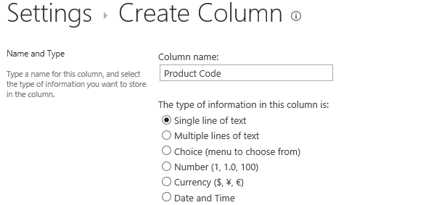

* 1. Click **OK** to create the new list column.

1. Add a new column named **Product Category** using the **Choice** field type.
   1. Click on the **Create column** link in the **Columns** section under the list of columns to navigate to the **Create Column** page.
   2. On the **Create Column** page, add a **Column name** of **Product Category** and ensure that **The type of information in this column is** setting is set to **Choice**.

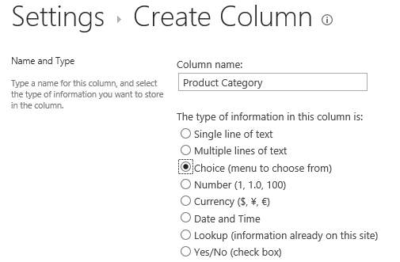

* 1. Below in the textbox which has the caption **Type each choice on a separate line**, add the following three choice values
     1. Action Figures
     2. Arts and Crafts
     3. Vehicles and Remote Control
  2. When you have entered the choice values, they should appear as they do in the following screenshot. Also change the **Display choices using** setting to **Radio Buttons**.

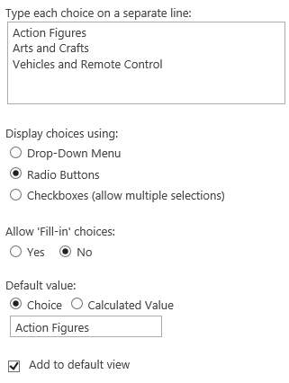

* 1. Click the **OK** button to create the new list column.

Now you have completed the creation of a custom list. Next, you will add a few items to familiarize yourself with the new user interface experience for adding and editing items in SharePoint Online.

1. Add a new product to the **Products** list.
   1. Click on the **Products** link in the Quick Launch to navigate to the default view of the **Products** list.

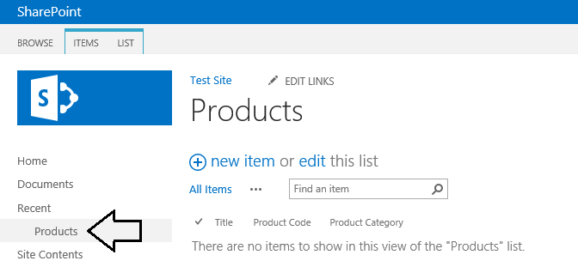

* 1. Click the **new item** link to display the new item page.

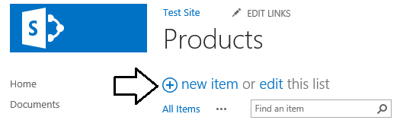

* 1. On the new item page, enter the data and save the first product item using the following values.
     1. **Title**: Batman Action Figure
     2. **Product Code**: WP0001
     3. **Product Category**: Action Figures
  2. When the form looks like the following screenshot, click the **Save** button to save the item.

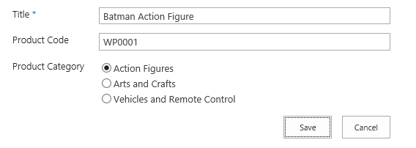

* 1. After you click **Save**, you should return to the default view for the Products list where you can see that your new item has been added to the list.

1. Add items to the list while in Edit view.
   1. Now you are going to create new product items in edit view which often makes things faster. To enter edit view, simply click the **edit** link and the default view of the Product list.

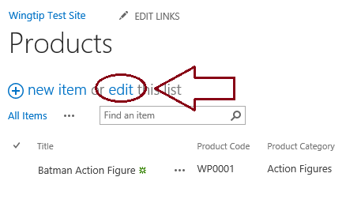

* 1. Once you are in edit mode, you can add or edit an item while still being able to see other items. Add a new item for the **Captain America Action Figure** in edit mode using the values shown in the following screenshot.

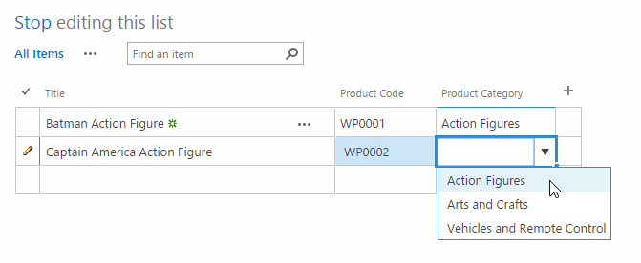

* 1. You should be able to see that you can usually edit items significantly faster when you are in edit mode. Enter a few more Product items as shown in the following screenshot. When you are done editing click **Stop Editing**.

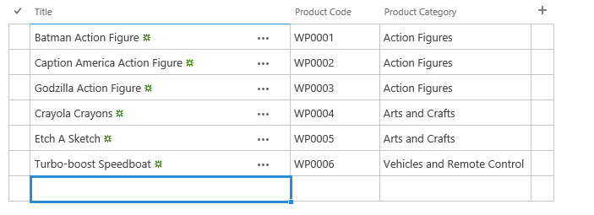

When you are done, the Products list should contain these six items.

### ****Exercise 6: Adding a Picture Library****

In this exercise, you will create a new picture library and upload a set of product images.

1. Create a new picture library to store product images.
   1. From the **Site Actions** menu, click the **Add an app menu** item to navigate to the **Your Apps** page.
   2. On the **Your Apps** page, click the **Picture Library** tile to begin the process of creating a new custom list.

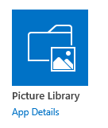

* 1. Provide a name of **Product Images**.

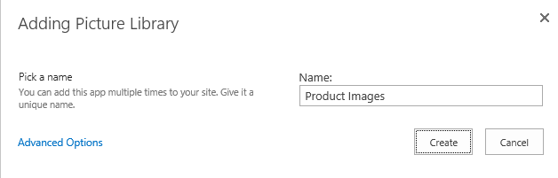

* 1. Click the **Create** button to create the new picture library. After the picture library has been created, you should be able to see a tile for it on the **Site Contents** page.

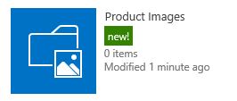

* 1. Click on the **Product Images** tile in the **Site Content** page to navigate to the default view of the **Product Images** library.

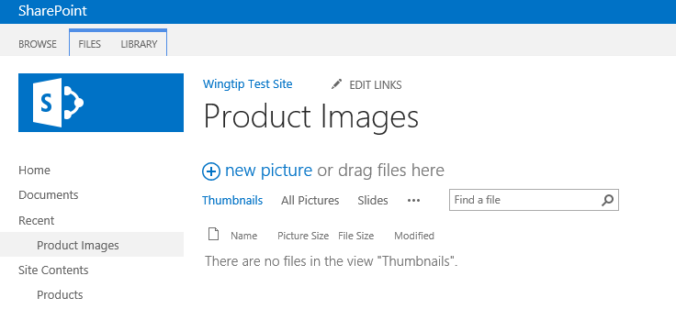

* 1. Now you have completed the steps of creating a new picture library. It’s time to move ahead and upload some product images.

1. Upload product image files to the Product Images library.
   1. Using the Windows Explorer, navigate to the folder at **c:\Student\Modules\GettingStarted\Lab\ProductImages**. You should be able to confirm that this folder contains six JPG files that represent Wingtip product images.

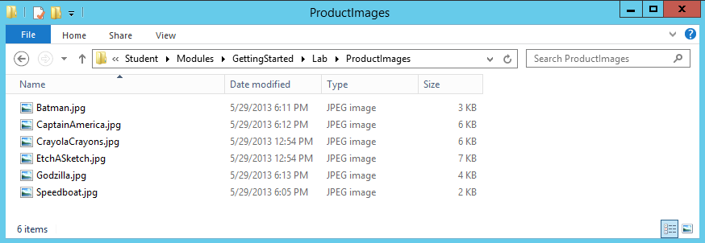

* 1. This next step is a bit tricky because you must perform a drag-and-drop operation between the Windows Explorer and the browser. Select all six JPG files from the **ProductImages** folder and drop them onto the middle section of the default view of the Product Images library as shown in the following screenshot. Ensure that you see the blue outline drop target and the text **Drop Here** before you drop the images.

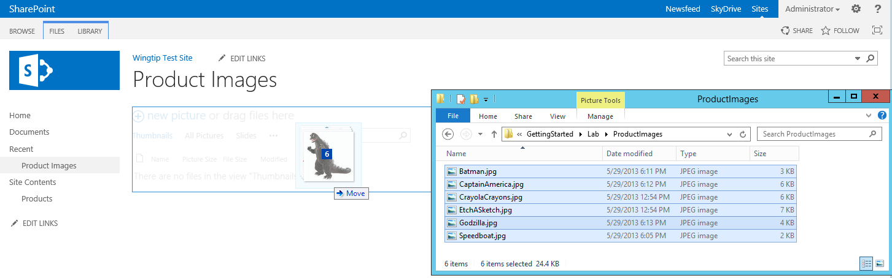

* 1. After you have performed the drag-and-drop operation to upload the product images, they should appear in the picture library in a viewable state as shown in following screenshot.

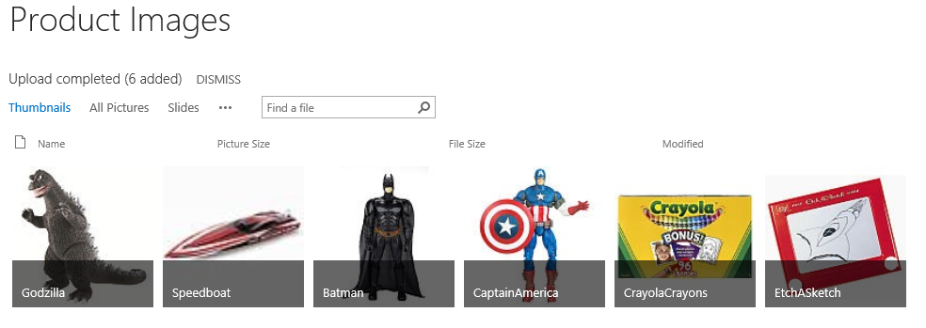

* 1. You have now completed this exercise.

In this exercise you created a picture library and used it to import a set of JPG image files for Wingtip products.

### ****Exercise 7: Customize Site Appearance Using Composed Looks****

In this exercise, you will make a few simple changes to modify the look and feel of the Testing site.

1. Configure the Testing site to use a custom site logo.
   1. Use the **Site Actions** menu to navigate the **Site Settings** page.
   2. Click the **Title, description, and logo** link to navigate to the **Title, Description, and Logo** page.

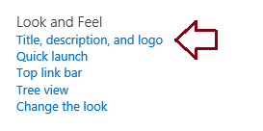

* 1. On the **Title, Description, and Logo** page, you should see that it is possible to change the site’s **Title** property and **Description** property.

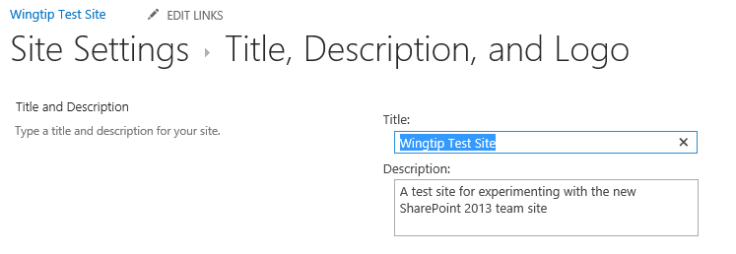

* 1. Scroll down to the **Logo and Description section**. Under the **Insert Logo** caption, locate and click the **FROM COMPUTER** link and click on it to begin the process of configuring the site to use a custom site logo.

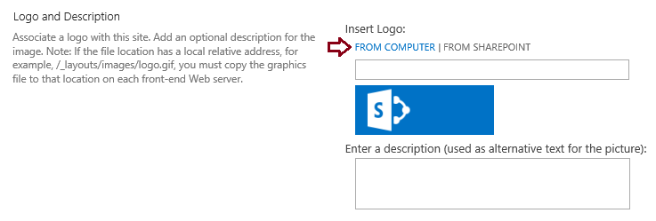

* 1. The SharePoint UI will provide a dialog for you to add the path to a local file. Select the GIF file with the following path.

C:\Student\Modules\GettingStarted\Lab\SiteLogo\wingtip-logo.png

* 1. After you have selected the file, click the **OK** button to return to the **Title, Description, and Logo** page.

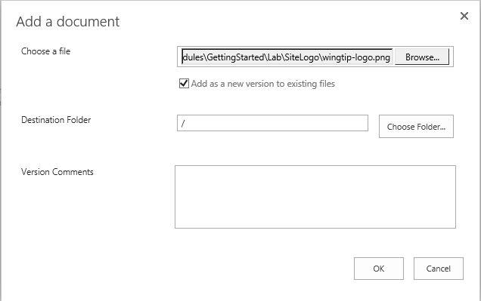

* 1. After you click **OK**, you should be able to see the new site logo on the **Title, Description, and Logo** page. In the **Enter a description** textbox, enter a text value of **Wingtip Toys Logo**.

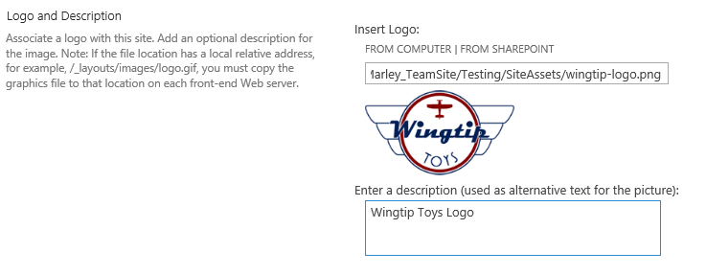

* 1. At the bottom of the **Title, Description, and Logo** page, click **OK** to save your changes.
  2. Click the logo to return to the home page of the test site and confirm that the custom site logo is showing properly.

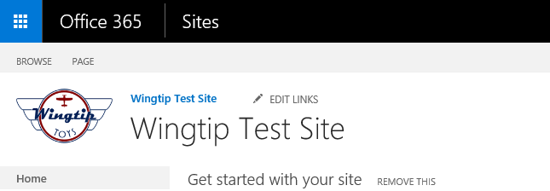

1. Use Composed Looks to change the look and feel of the site.
   1. Use the **Change the look** command from the **Site Actions** menu to navigate to the **Change the look** page.

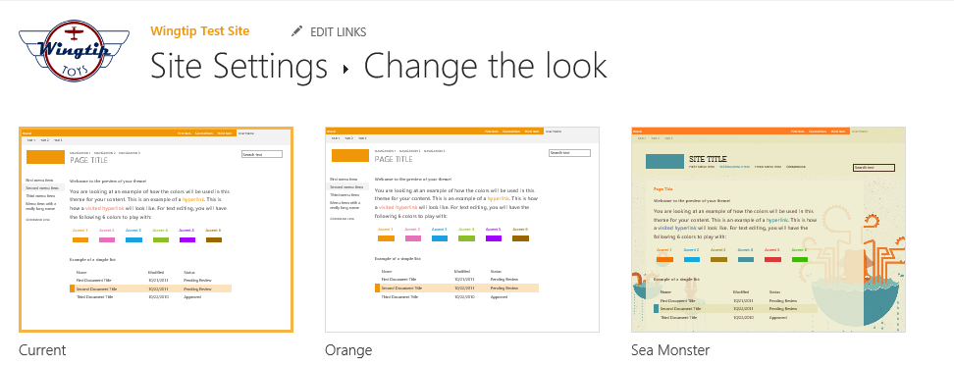

* 1. At this point you are on your own to experiment with different looks to come up with something that is visually appealing.

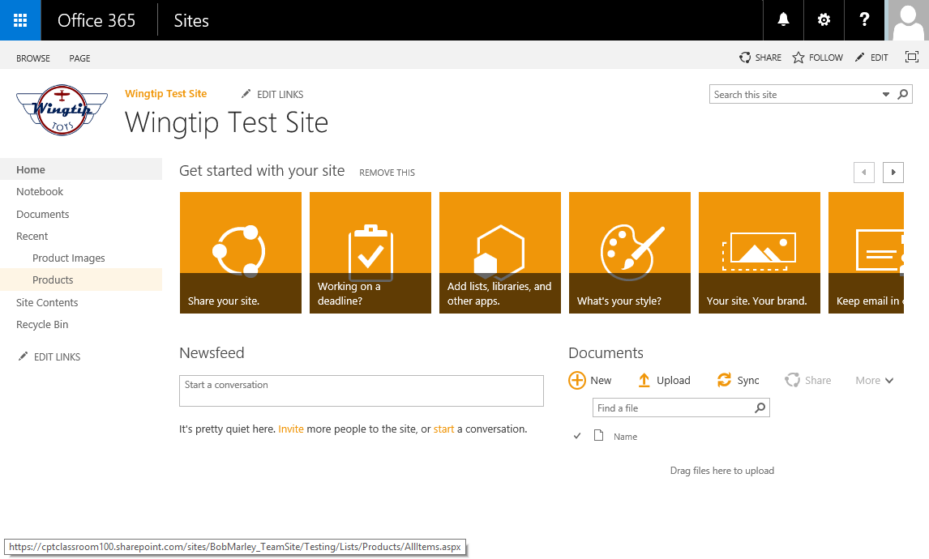

* 1. Once you run out of time or get bored changing the look and feel, the work on this lab is complete.

This lab has given you a chance to play around with the testing site at **<Team Site>/Testing**. Note that none of the upcoming labs have any dependencies of this test site collection so you can continue to experiment with it to your heart’s desire. Starting with the next lab on Content Types and running throughout the remainder of the course, you will begin work on the site collection for the Critical Path Training Lab Environment Team Site as you begin to build out an actual business solution from one lab to the next.