## Creating and Deploying InfoPath Forms

**Lab Time**: 30 minutes

**Lab Folder**: C:\Student\InfoPath\Lab

**Lab Overview:** In this lab you will work with InfoPath Forms and Forms Services. You will use InfoPath to modify an existing form of a list to provide the end user with a richer experience.

### Exercise 1: Customizing List Forms

In this exercise you will customize the list form of the Tasks list using InfoPath.

1. Launch Internet Explorer and navigate to the Wingtip Toys research site which is located at the URL of **<Team Site>/research**.

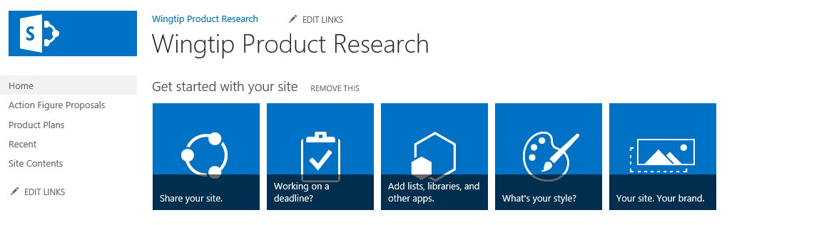

Remember that you created the Wingtip Research site in the Document Libraries lab. If you have not completed the Document Libraries lab, your student team site will not have a site at that URL. If this is the case, you can create a new site with a team site template at the URL of **<Team Site>/research**. This will give the ability to work through this lab without first having to go through the Document Libraries lab.

1. Create a new custom list to track product information.
   1. From the **Site Actions** menu, click the **Add an app** menu item to navigate to the **Your Apps** page.
   2. On the **Your Apps** page, click the **Custom List** tile to begin the process of creating a new custom list.

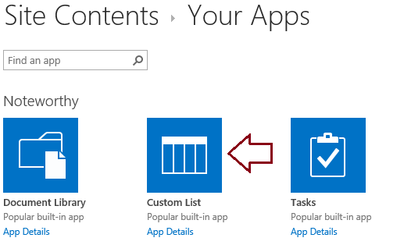

* 1. When prompted, enter a list name of **ProductReviews** and click **Create**.

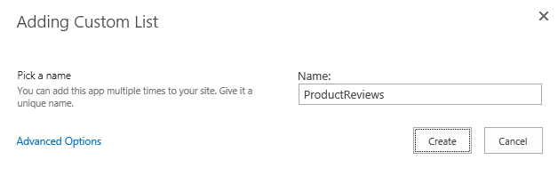

* 1. Once the list has been created you should be able to see a tile for it in the **Site Contents** page.



* 1. You have now finished the steps of creating a new list. Now it’s time to configure it.

1. Configure the new **ProductReviews** list using the list Settings page.
   1. On the **Site Contents** page, click the ellipse (**…**) fly out menu in the top, right-hand corner of the ProductReviews tile and then click the **SETTINGS** link to navigate to the **Settings** page for the new **ProductReviews** list.

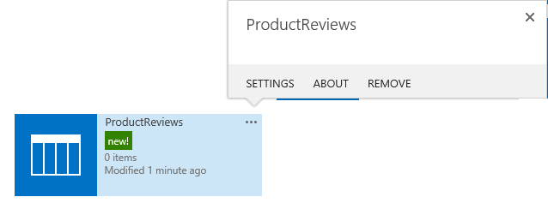

* 1. Click on the **List name, description and navigation** link to navigate to the **General Settings** page.
  2. On the General Setting page, update the Name setting from **ProductReviews** to **Product Reviews**.
  3. Set the **Display this list on the Quick Launch** setting to **Yes**.
  4. Click **Save** button to save your changes and return to the list **Settings** page.

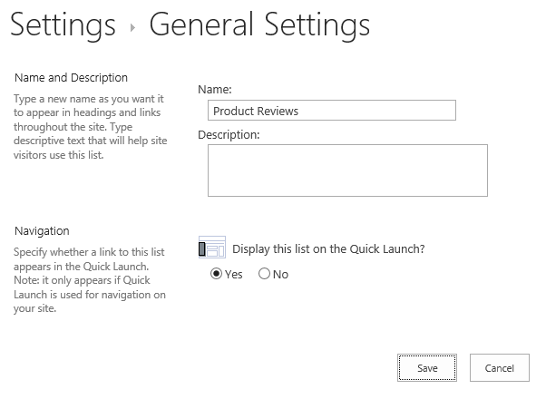

* 1. Click on the **Advanced Settings** link to navigate to the **Advanced Settings** page for the list.
  2. On the **Advanced Settings** page in the **Attachments** section, change the **Attachments to list items are** setting to **Disabled**.

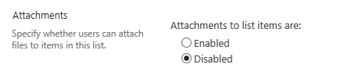

* 1. Click **Ok** button to save your changes and return to the list **Settings** page.

You may receive a warning message. Click **OK**.

1. Add a few columns to the **Product Reviews** list.
   1. In the list **Settings** page, scroll down to the **Columns** section and inspect the current set of columns in the **Product Reviews** list. The current set of columns includes **Title**, **Modified**, **Created**, **Created By** and **Modified By**.

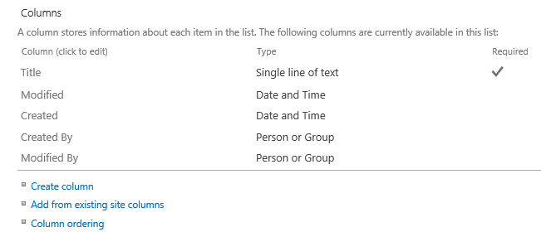

1. Add a new single-line text column named **Product Code**.
   1. Click on the **Create column** link in the **Columns** section under the list of columns to navigate to the **Create Column** page.
   2. On the **Create Column** page, add a **Column name** of **Product Code** and ensure that **The type of information in this column is** setting is set to **Single line of text**.

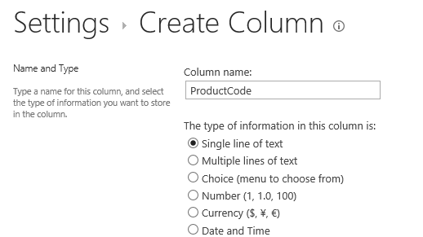

* 1. Click **OK** to create the new list column.

1. Add a new multiline textcolumn named **Product Assessment**.
   1. Click on the **Create column** link in the **Columns** section under the list of columns to navigate to the **Create Column** page.
   2. On the **Create Column** page, add a **Column name** of **Product Assessment** and ensure that **The type of information in this column is** setting is set to **Multiple lines of text**.

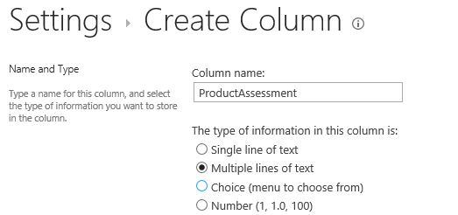

* 1. Click **OK** to create the new list column.

1. Add a new multiline textcolumn named **Areas for Improvement**.
   1. On the **Create Column** page, add a **Column name** of **Areas for Improvement** and ensure that **The type of information in this column is** setting is set to **Multiple lines of text**.
   2. Click **OK** to create the new list column.
2. Add a new single-line text column named **Need for Redesign**.
   1. Click on the **Create column** link in the **Columns** section under the list of columns to navigate to the **Create Column** page.
   2. On the **Create Column** page, add a **Column name** of **Need for Redesign** and ensure that **The type of information in this column is** setting is set to **Single line of text**.
   3. Click **OK** to create the new list column.
3. After you are done adding columns, the **Columns** section of **the Product Reviews** list should look like the following screenshot,

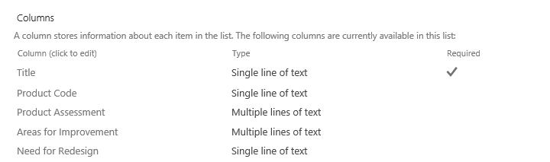

1. Create and edit an item in the **Product Reviews** using the default forms supplied by SharePoint
   1. Click on the **Product Reviews** link in Quick Launch to navigate to the default view of the **Product Reviews** list.
   2. Click the **new item** link to navigate to the new item form of the **Product Reviews** list.

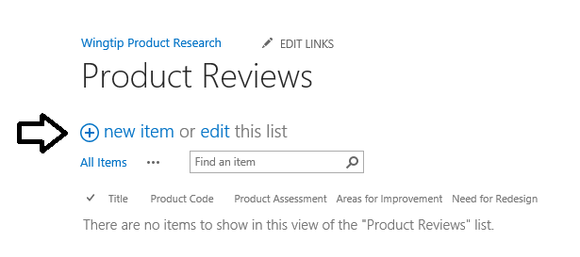

* 1. Create and save item in the **Product Reviews** list using sample data such as that shown in the following screenshot.

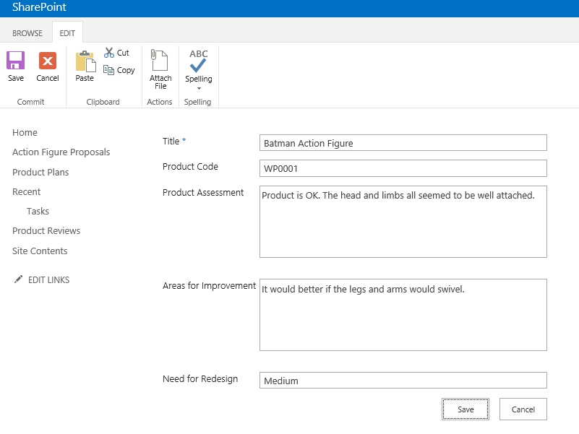

* 1. Click the **Save** button to save the new item. Once you save the item, it should appear in the default view.

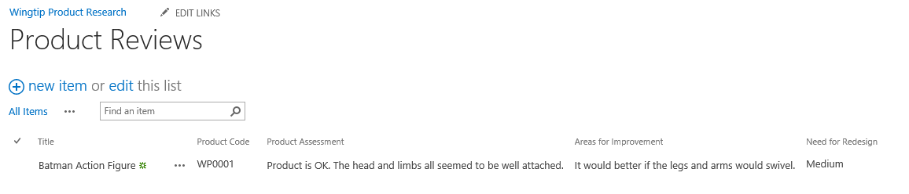

Now that you have seen the out-of-box editing experience for a task item, you will now customize the editing experience for items in the **Product Reviews** list by creating a new InfoPath form.

1. Now use InfoPath Designer 2013 to modify the new form and edit form for the **Product Reviews** list.
   1. Navigate to the page with the default view of the **Product Reviews** list.
   2. Activate the **LIST** tab in the ribbon and then click the **Customize Form** button in the **Customize List** group.

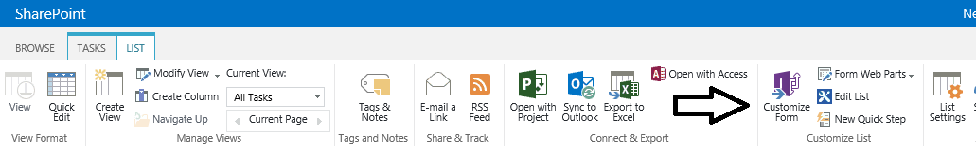

* 1. When you attempt to open a form for the first time in InfoPath Designer 2013 using this technique, Internet Explorer displayed a security-related dialog asking you if you want to continue. Uncheck the **Always ask before opening this type of address** checkbox and then click the **Allow** button to continue loading the form into InfoPath Designer 2013.

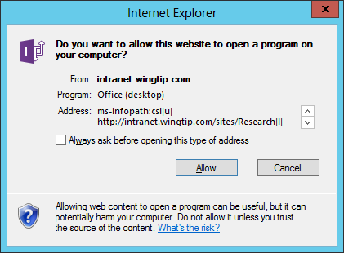

* 1. If you are prompted for Office 365 Credentials, use the same account and password to connect to your student site.

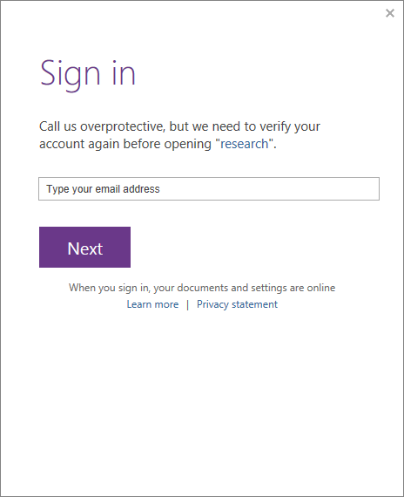

* 1. InfoPath Designer 2013 should launch and load a default version of the form imported from the **Product Review** list.

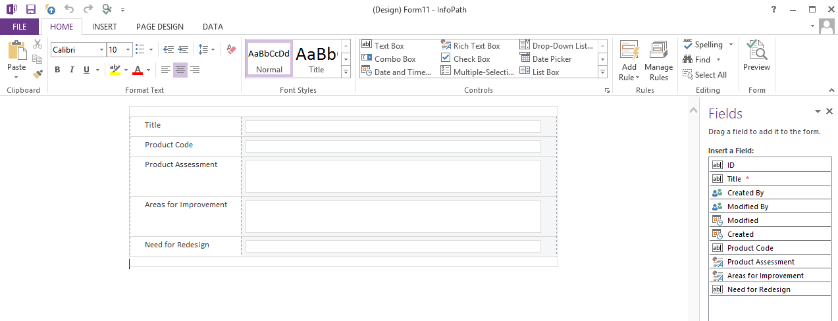

1. Click the top row of this form that is the one above the **Title** field, use the ribbon to **Insert » Picture**.
   1. Select the picture C:\Student\Modules\InfoPath\Lab\WingtipLogo.gif.
   2. Resize the logo to be about 50% of the original size.

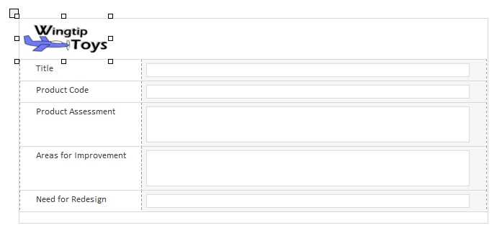

1. Click the **Title** text box and drag it to the right of the Wingtip logo. It should automatically get inserted at the bottom of the Wingtip logo. **NOTE: Be sure you move the control and not the label. If you delete the control your users cannot enter data!**
2. Click the **Title** text box control and using the ribbon, change the styling of the control: **Home » Font Size**=18, **Font Weight** = Bold, **Color** = Blue
3. Place the cursor inside the row where the Title textbox used to be. Then use the ribbon to remove the row
   1. Table Tools » Layout » Delete » Rows.

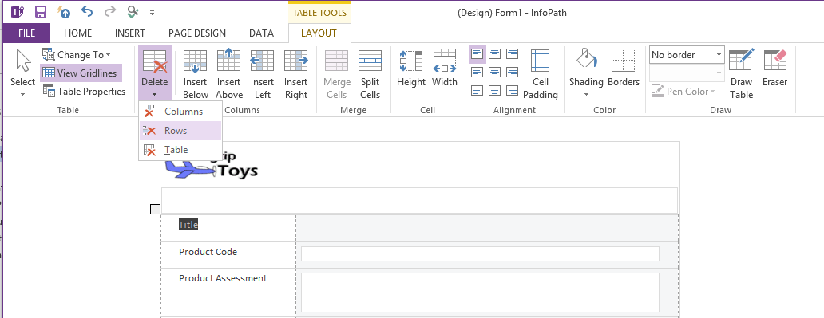

* 1. Once you completed this operation, you should see you have removed the row.

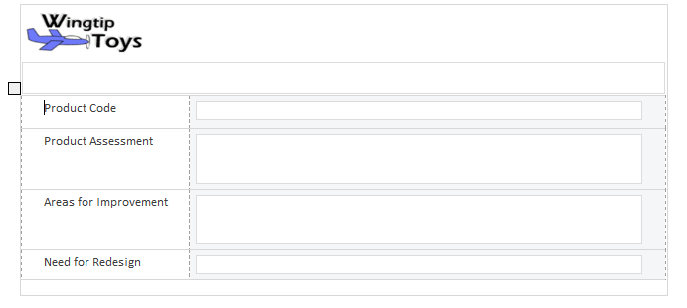

1. Change the theme of the form.
   1. Activate the **PAGE DESIGN** tab in the ribbon.
   2. Drop down the Themes drop-down menu and select a color scheme that you find appealing.

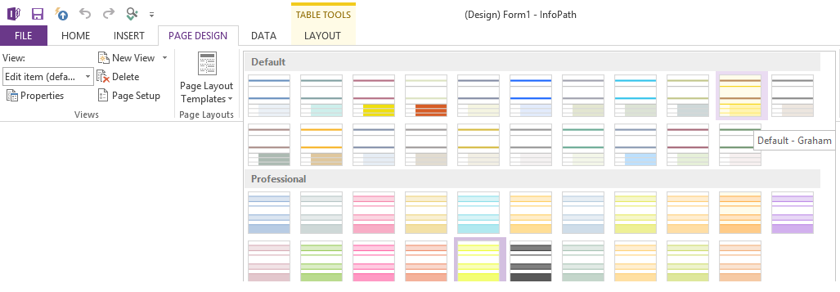

* 1. You form should adapt the colors of the theme you have selected.

1. Publish the modified form back to the server:
   1. Click the **File** tab to bring up the backstage page.
   2. Click the **Quick Publish** button. This works because InfoPath already knows where the form came from and that it should be published back to the same location.

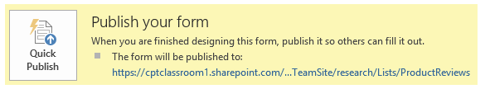

* 1. InfoPath Designer 2013 will confirm the form was published using the following dialog.

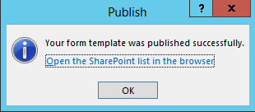

1. Go back to the browser. You should now be looking at the **Products Reviews** list.
2. Click the **Add new item** link. The new form that you just modified should now appear. Fill in data as it appears below.

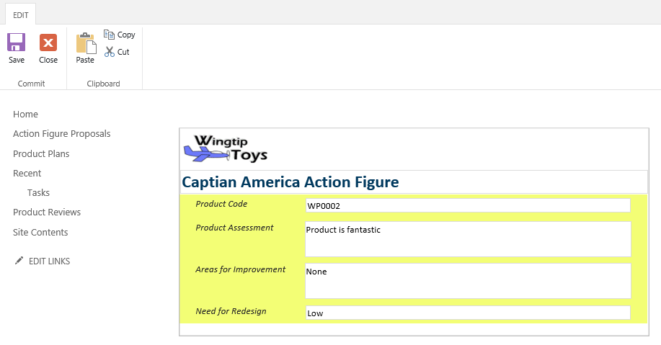

1. Complete the form and click the **Save** button in the ribbon.

In this exercise you used InfoPath Designer 2013 to customizing an existing list form.

### ****Exercise 2: Create an InfoPath Forms Library Form****

**In this exercise you will create a forms library for a new Info Path form and publish it to SharePoint.**

1. **Open InfoPath Designer 2013.**
2. **In backstage on the New pane, choose SharePoint Form Library.**

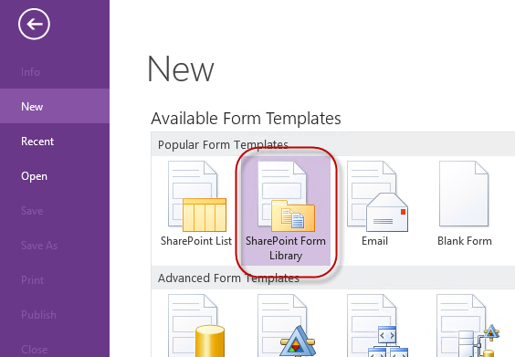

1. **Click Design Form.**
2. **Click in the title area and change the title of the form to Product Test Results.**
3. **Click the first heading and change it to Product Test Parameters.**
4. **Notice that the Product Test Parameters section is composed of Labels and Controls in pairs. Work your way through the form and change the Labels to the following values:**

|  |  |  |  |
| --- | --- | --- | --- |
| **Lead Tester** |  | **Assistant Tester** |  |
| **Test Performed** |  | **Test Date** |  |
| **Product Tested** |  | **Product Name** |  |

1. **When you are done with changing the labels your form should look like this:**

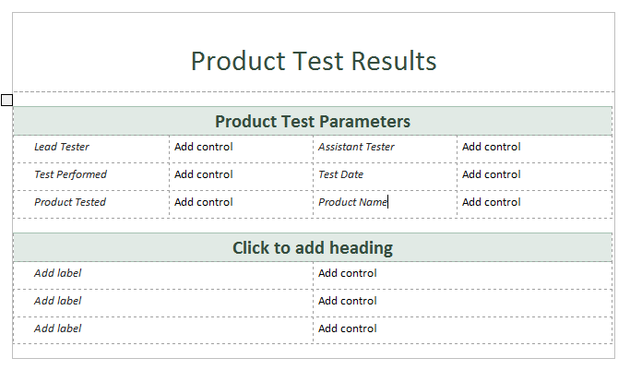

1. **You now need to add controls to the form so that you have places to add data. Next to Lead Tester click Add control. On the Home tab in the Controls Group choose Person/Group control. (You may have to expand the control to see all the items)**

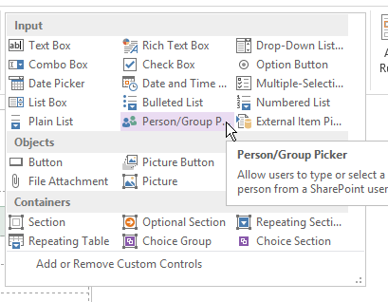

1. **Carefully adjust the width of the columns so that the Person/Group control fits.**

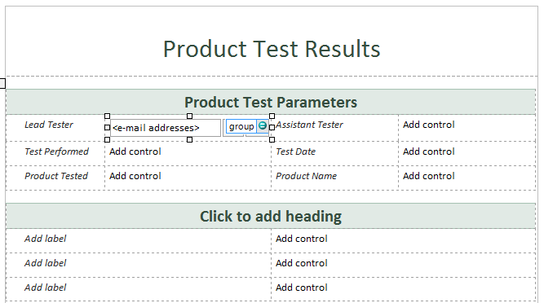

1. **Right click the control and choose Person/Group Picker Properties.**

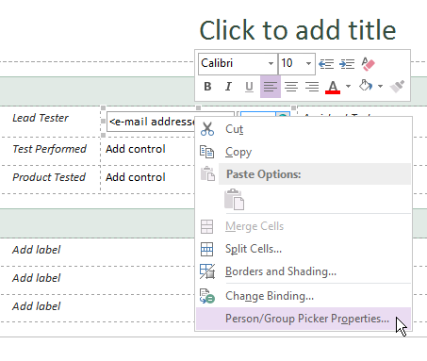

1. **In the Person/Group Picker Properties dialog, change the Field or group name to leadTester.**

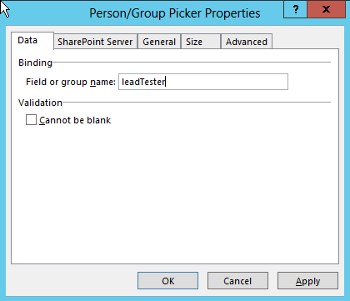

1. **Click OK.**
2. **Click Add control next to the Assistant tester and insert another Person/Group control.**
3. **Adjust the column width so that the control fits.**
4. **Right click the control and choose Person/Group Picker Properties.**
5. **Change the Field or group name to assistantTester. Click OK.**
6. **Save the form to your local Documents library. Name the form TestForm.xsn.**
7. **Click Add control next to Test Performed and insert a Combo Box control.**
8. **Right click the control and choose Combo Box Properties.**
9. **Change the Field name to testPerformed.**
10. **Add two additional test options to the list:**

|  |  |
| --- | --- |
| **destructive** | **Destructive Test** |
| **nondestructive** | **Nondestructive Test** |

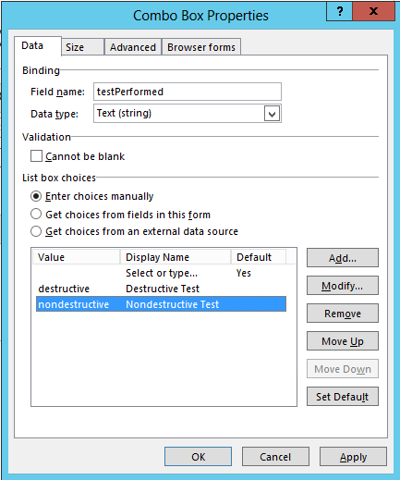

1. **Click OK.**
2. **Click Add control next to Test Date and add a Date Picker control. Change the Field name to testDate.**
3. **Save the form.**

**At this point you have created a basic data entry form for InfoPath. You may continue by enhancing the bottom of the form with additional details for the Test operations and outcomes.**

### **Exercise 3: Publish an InfoPath Form to a SharePoint Forms Library**

**To make a form available to your company you want to publish it to a SharePoint forms library. In this section you will do just that.**

1. **In InfoPath, choose File | Publish your form.**

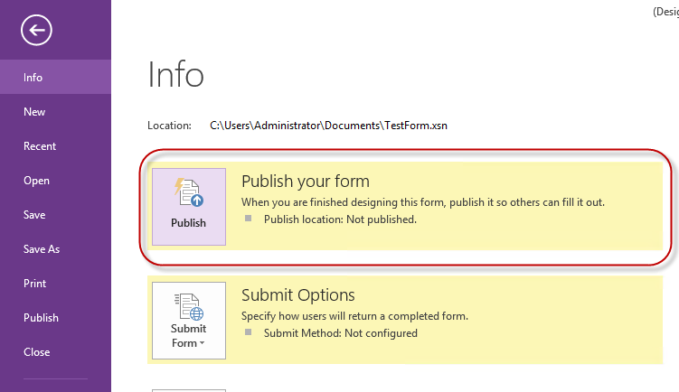

1. **On the Publish page choose SharePoint Server to launch the Publishing Wizard. *(Please note: this is not an actual wizard. If this were an actual wizard you would receive three questions to determine your fate.)***
2. **Enter the address <Team Site>/research and click Next.**

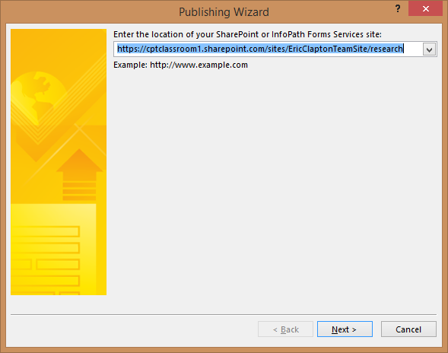

1. **Leave the Form Library selected and choose Next.**

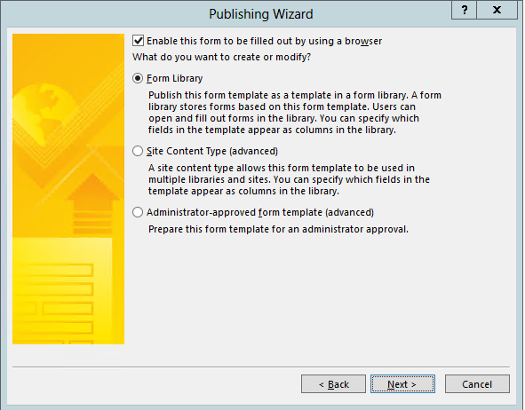

1. **Leave the option for Create a new form library and choose Next.**

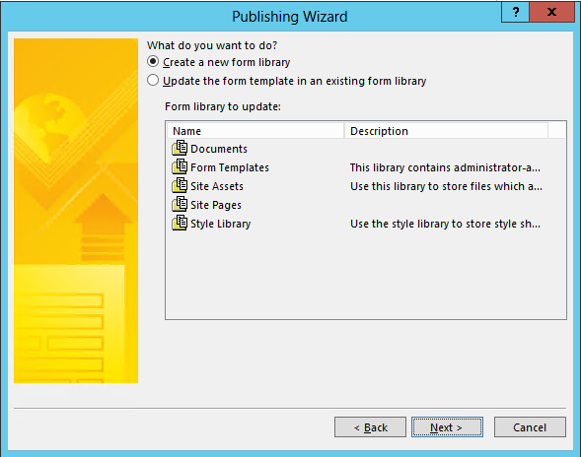

1. **Name the library TestingForms and add a description.**

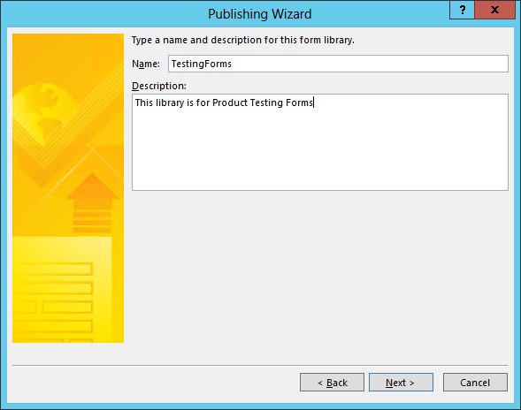

1. **Click Next.**
2. **Use the Add button to add the following fields Lead Tester, Assistant Tester, Test Performed and Test Date. Adjust the display name of each field so that they are properly cased and spaced as in the image below.**

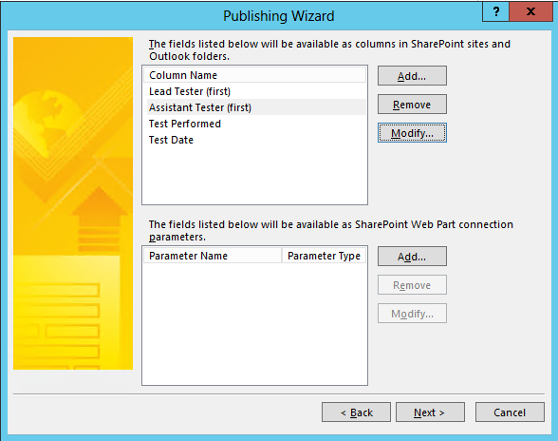

1. **Click Next and confirm the configuration.**

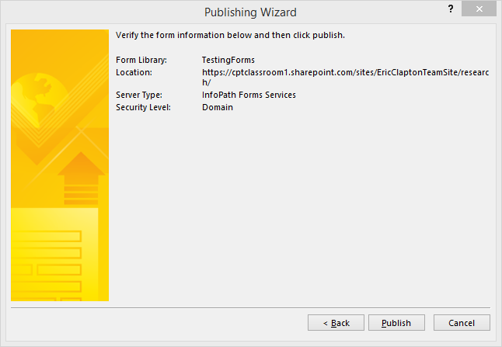

1. **Click Publish.**

**If you are prompted for authentication at this step use the appropriate credentials.**

1. **If the publish process is successful you will see the Success page. Check the box for Open this form library and click Close.**

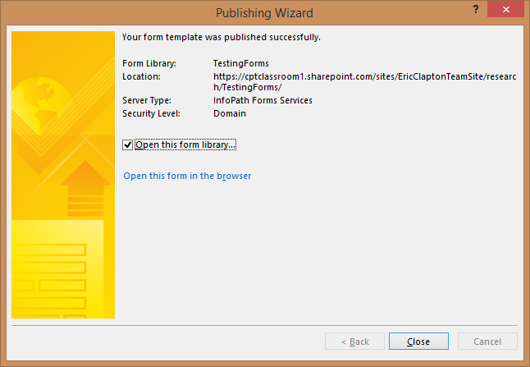

1. **You should now see the Form library you created.**
2. **From the Ribbon of the new form library click New Document.**

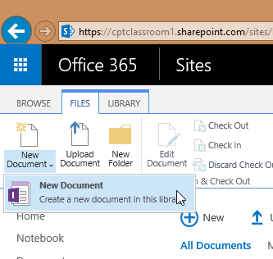

1. **Your new form should render in the browser window.**

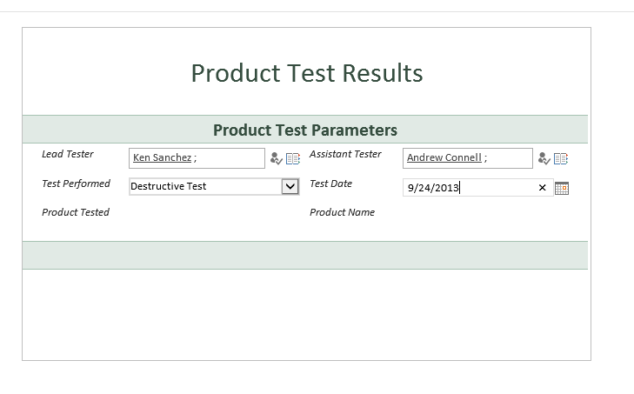

1. **Test the basic functions of the form to ensure that it is working correctly.**

**You have now completed the lab exercises which focus on creating input forms with Microsoft InfoPath 2013.**