## Working with the Managed Metadata Service

**Lab Time**: 60 minutes

**Lab Folder**: C:\Student\Modules\ManagedMetadata\Lab

**Lab Overview**: In this module you will gain hands on experience working with SharePoint Online Managed Metadata service application. The Managed Metadata Service Application (MMS) provides services for Content Type Syndication, Metadata Term Set Management and other key farm wide features that are used by other services like Search and the User Profile Service.

### Exercise 1: Create a Local Term Set

In this exercise you will create a Local Term Set. As the name suggests, local term sets are restricted to use in the current Site Collection. This is good for Term Sets that will not be used in a broader enterprise. If you want to share your terms across Site Collections, you will create an Enterprise Term Set in the next exercise.

1. Browse to the site **<Team Site>.**
2. From the **Site Actions** menu choose **Site Contents**.
3. On the **Site Contents** page choose **Add an App**.
4. Choose the **Issue Tracking** list template and give it a name of **Brainstorming**.
5. Click the tile for the new **Brainstorming** list.
6. From the **List Tab** choose **Create Column** in the ribbon.
7. Configure the new column as follows:
   1. Column Name: **Phase**
   2. Type: **Managed Metadata**
8. Under **Term** **Set Settings**, choose **Customize your term set**. This will create a **Phase** term group.

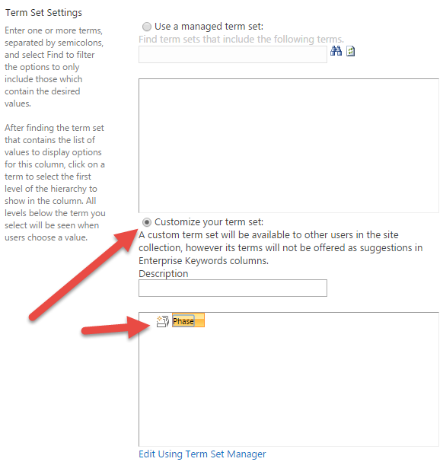

1. Click the arrow on the **Phase** group and choose **Create Term**.

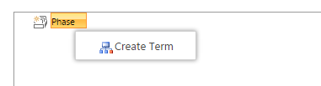

1. Create the following Terms:
   1. Initiation
   2. Ideation
   3. Financial Evaluation
   4. Board Approval
   5. Approved

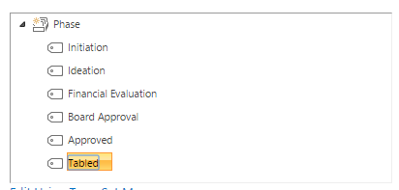

1. Click **OK** to add the field to your list.
2. Click **new item** and notice your new field and the terms associated with it.

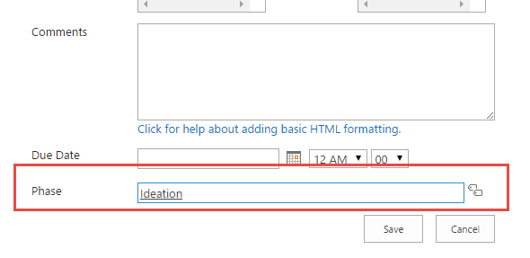

1. Click **Save** to return to your list.
2. Choose **Site Actions | Site Settings**.
3. Under Site Administration choose Term Store Management
4. Notice that under your **Team Site** there is a Term Set for **Phase**. You created a “local” term set, but it is still stored in the **Managed Metadata Service**.

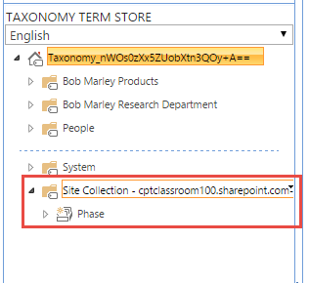

In this exercise you created a local term set for the Site Collection, in the next exercise you will create a term set that will be available for the entire tenant.

### Exercise 2: Create a New Enterprise Term Set

In this exercise you will create a new taxonomy group using the Managed Metadata term store tool and use it within a site. This metadata term set will enable researchers working on new products to tag their products based on the phase of development. You will also import a hierarchical term set prepared for you by your corporate taxonomist.

1. Browse to the site **<Team Site>.**
2. Navigate **to Site Settings | Term store management** under the **Site Administration** section.
3. In the **Term Store Management Tool** click the **Managed Metadata Service** and choose **New Group**.

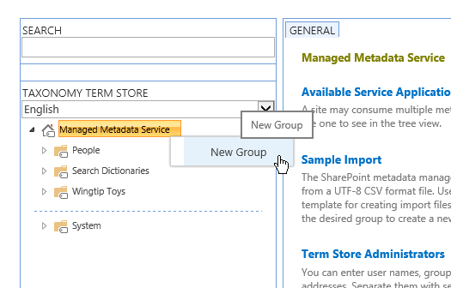

1. Name the group “**<Team Site> Research Department**”.

Because we are working in a shared training environment you are adding your Team Site name to the beginning of this Enterprise Term Set to avoid stepping on each other. If this were a real Enterprise Term Set you would have only one and not need this prefix.

1. Click the **<Team Site>** **Research Department** node and choose **New Term Set**. Name the term set **Project Status**.
2. Click the **Project Status** node and choose **Create Term**. Create the following terms under **Project Status.**

* Development
* Financial Evaluation
* Technical Evaluation
* Safety Evaluation
* Patent Application
* Approval Requested
* Approved
* On Hold
* Cancelled

1. Your complete term set should look like this:

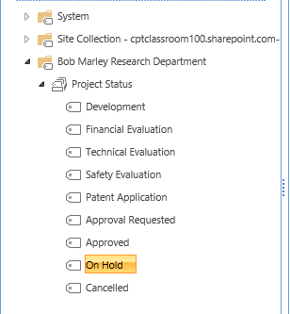

You just manually created a flat term set. This is a great option for simple term sets that would also work in a Choice field. Choice fields cannot contain hierarchical data, which requires the Managed Metadata field type. In the next exercise you will import a hierarchical term set rather than create it by hand.

1. In the **Term Store Management Tool** click the **Managed Metadata Service** and choose **New Group**.
2. Name the group **<Team Site>** **Products**.
3. Hover and click on the new **<Team Site>** **Products** group and click **Import Term Set**.

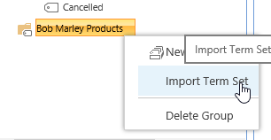

1. In the **Term set import** dialog browse to C:\Student\Modules\ManagedMetadata\Lab\WingtipProductCategories.csv

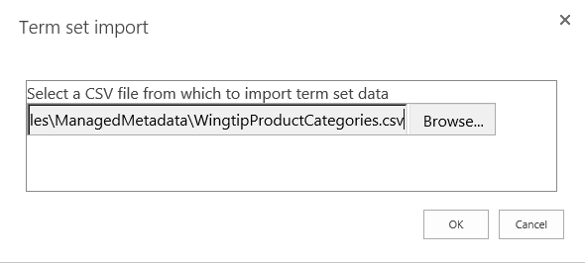

1. Click **OK**.

The Term Set import file is a comma separated value file with a hierarchical structure that enables Term Store administrators to quickly create Term Sets in SharePoint Online. If you are interested in the structure open the file in Excel and see for yourself!

1. If the process completed successfully you should now see the imported hierarchical term set **Product Category**.

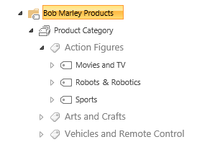

In this exercise you used two techniques to create term sets, one manual and one via import. Which did you prefer? I thought so.

### Exercise 3: Add a Managed Metadata Column to a Content Type

In this exercise you will add Managed Metadata columns to the Product content type to enhance the functionality of the content type. You will use the Term Sets that you just created and update the Product with the Product Category. Since the research department has a unique need, you will enhance the Product content type specifically for the Research Department.

1. Navigate to the **<Team Site> Site Settings** page. This can be accomplished by clicking **Site Settings** at the top of the Term Store Manager.
2. On the Site Settings page, navigate to **Site Content Types**.
3. Choose **Show Group: Wingtip**.
4. Click the **Product** content type.
5. On the **Site Content Type settings** page in the **Columns** section, choose **Add from new site column**.
6. Create a new **Site Column** with the following settings:
   1. Name: **ProductCategory**
   2. Type: **Managed Metadata**
   3. Group: **Wingtip**
   4. Description: **Wingtip Product Category**
   5. Display Format: **Display the entire path to the term in the field**
   6. Term Set Settings: **Use managed term set: Product Category.** Choose the one in your **<Team Site> Products** group.

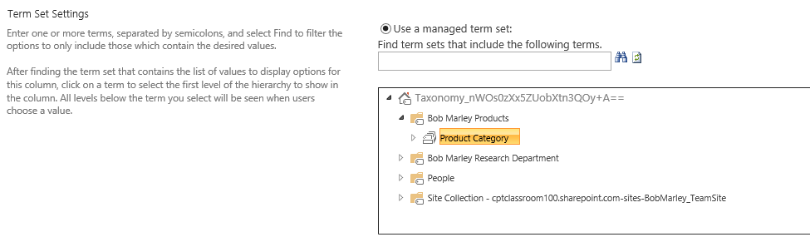

* 1. Ensure that **Update List and Site Content Types** is set to **Yes**.
  2. Click **OK**. You will be returned to the **Content Type Settings** page.
  3. Rename the Column by clicking the **ProductCategory** column name.
  4. On the Change Content Type Column page chose **Edit site column**.
  5. Add a space so that the column name reads: **Product Category**
  6. Click **OK** to save your changes. Click **OK** to complete the edit.

Now that you have updated the content type, you need to see the fruits of your labor in the Products list. In this next exercise you’ll open the Products list and see the new Managed Metadata column that is bound to the Product Category term set.

1. Navigate back to the **<Team Site>** and click on the **Products** list.
2. Edit the **Batman Action Figure** (or any other product) and notice that there is now a **Product Category** field bound to your new term set.

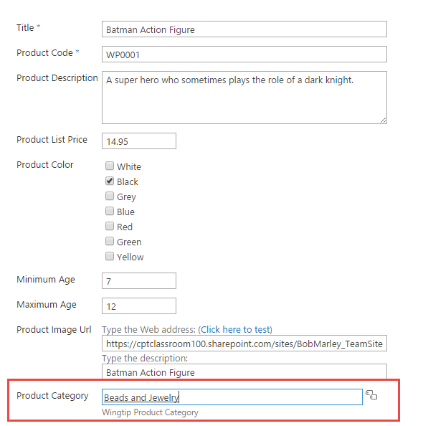

1. Update the product record with a **Product Category**. Continue to add a few more Product Categories to 4-5 products. You will need these entries for the Search Lab later.

### Exercise 5: Extend an Enterprise Content Type

The research department has a unique need to add a new column to the Wingtip Enterprise Document content type. The Enterprise Document is not specific enough for the testing team so you are going to “enhance” the Enterprise Content Type by creating a new content type based on it. You cannot add columns to an Enterprise Content type, but you can create a new content type based on an enterprise content type. In this section we’ll do just that.

1. Browse to the Research site at **<Team Site>/research**
2. Navigate to **Site Settings | Site Content Types**. Click **Create** to create a new content type.
3. Create a new content type with the following settings:
   1. Name: **Research Product Document**
   2. Description: **Research product Document based on the Wingtip Enterprise Document content type**
   3. Parent Content Type: **Wingtip Enterprise > Wingtip Enterprise Document**
   4. Group: **Wingtip**

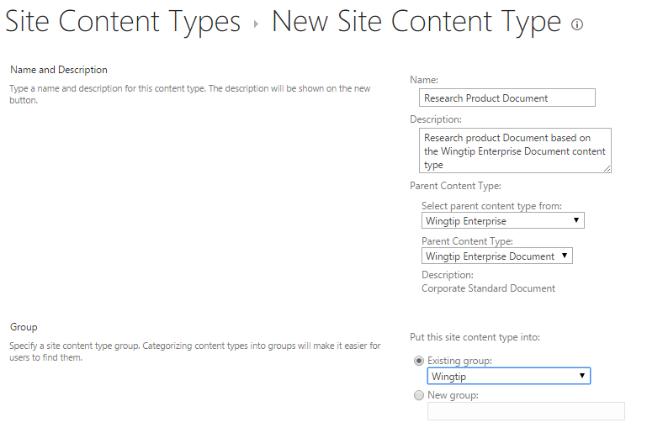

1. Click **OK** to create the content type.
2. Click the **Site Content Types** heading to return to the list of Site Content types. Change the **Show Group** selector to **Wingtip**.
3. Scroll to the bottom of the page and you should see that you now have a new content type **Research Product Document** under **Wingtip**.
4. Click **Research Product Document** to edit the content type.
5. Under Columns choose Add from new site column.
6. On the **Create Column** screen enter a Column name of **ProductCategory** and choose a Type of **Managed Metadata** and a Group of **Wingtip**.
7. Under **Term Set Settings** choose your **<Team Site> Product Category** term set.

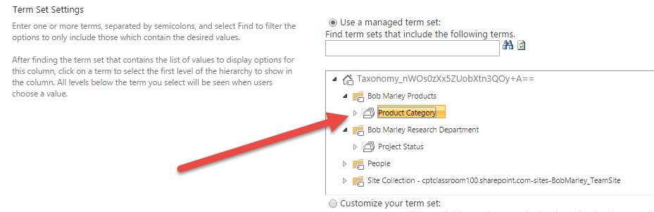

1. Click **OK** to save your changes.

Now that you have created the Research Product Document content type, you need to create a library so that we can begin tracking our Research Product Document.

1. Navigate to **Site Contents**.
2. Click **Add an App**. Choose **Document Library** and give it the name **ProductEvaluations**. Click **Create**.
3. Rename the list by choosing the **List tab** and clicking **List Settings** from the ribbon.
4. Choose **List name, description and navigation** and rename the list **Product Evaluations**.
5. Provide a description of “**Research Department Product Evaluations**”.
6. Change the Quick Launch setting to **Show on Quick launch** and click **Save**.
7. Click **Advanced settings** and click the **Allow management of content types?** Radio button to **Yes**.
8. Click **Ok**.
9. In the Content Types Section choose **Add from existing site content types**.
10. From the **Wingtip** group choose the **Research Product Document** content type and choose **Ok**.
11. Click **Change new button order and default content type** and change **Research Product** to order 1. **Uncheck** the **Visible** checkbox for **Document** content type.
12. Click **OK**.
13. Click **Product Evaluations** to return to the library. Test your work by clicking **new**. You should see a new blank document. Add some text and choose **File | Save As | Rename**. Give the document a name. Return to the Product Evaluations library and Edit the Properties of the document.

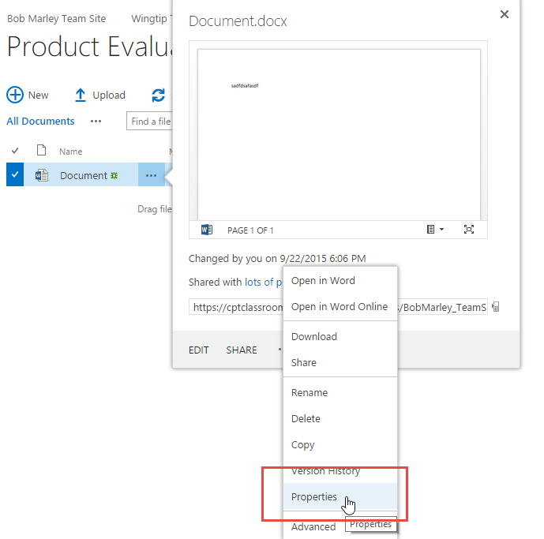

1. On the Edit Properties page notice that you have a mix of columns from the Enterprise Content Type and the additional field at the bottom added to your local content type.

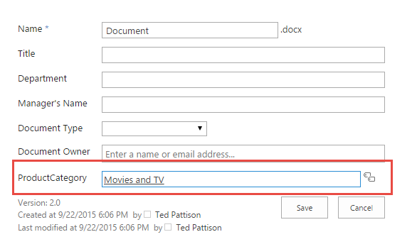

You just learned how to add metadata columns to an Enterprise Content Type to meet your specific needs.

### Exercise 6: Create and Configure an eDiscovery Site

In this exercise you will use the eDiscovery Center created at the beginning of the lab. You will create a new eDiscovery Case.

1. Navigate your browser to **http://<class site>/sites/ediscovery**
2. Create a new case by clicking the **Create new case** button.
3. Each case creates a new SharePoint eDiscovery Case site. Create your new case with the following settings:
   1. Title: **<Team Site>** (This is your full name)
   2. Description: **Heads fall off the action figures and present a choking hazard**.
   3. URL: **<Team Site> (no spaces)**
   4. Navigation: **Yes** (Show on Quick Launch)
   5. Navigation inheritance: **Yes** (Use top link bar)
4. Click **Create**.
5. You should see your new Case site.

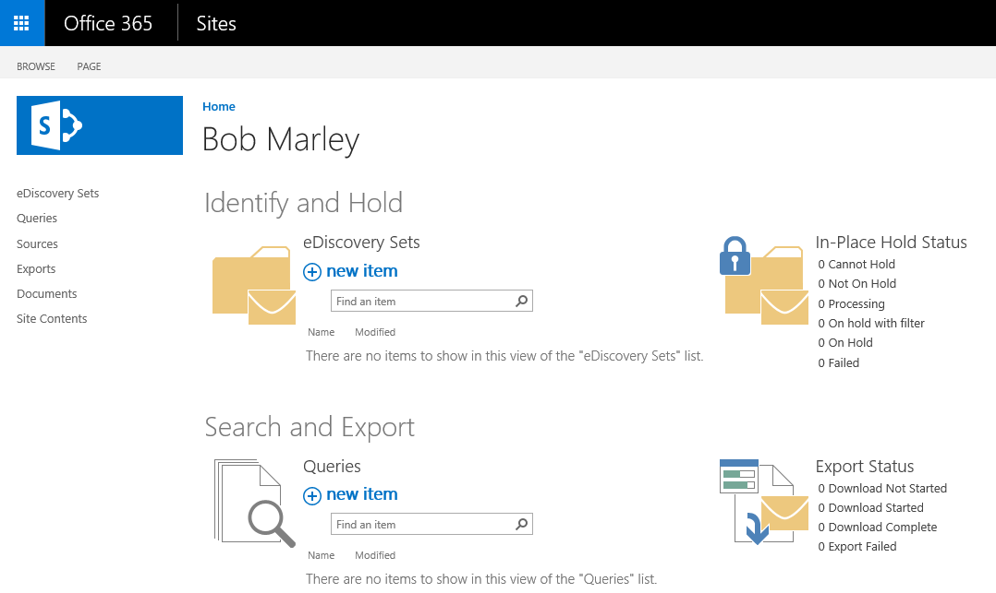

1. Create a new **eDiscovery Set** to begin the investigation of the issues. Under eDiscovery Sets click **new item** and provide the following information:
   1. eDisovery Set Name: **Testing Documents**
   2. Click **Add and Manage Sources**. Under **Locations** add the Research site **http://<class site>/sites/<Team Site>/research**. Click the button to resolve the address and it should change to the site title **Wingtip Product Research**. Add the Product Testing site **https://<class site>/sites/producttesting**. Click the button to resolve the address to **Wingtip Product Testing**. (The Product Testing site was created previously. In our lab scenario, it is used by a different team.)

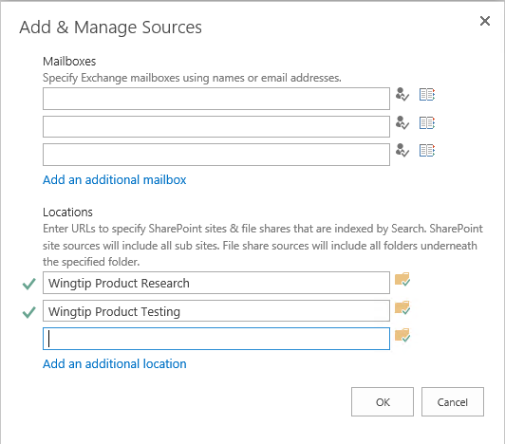

* 1. Click **OK**.
  2. In the Filter box enter the query **head OR failed OR “action figure”**. Click **Get Statistics**.
  3. You will see a number of results for your query. Click **Save**.

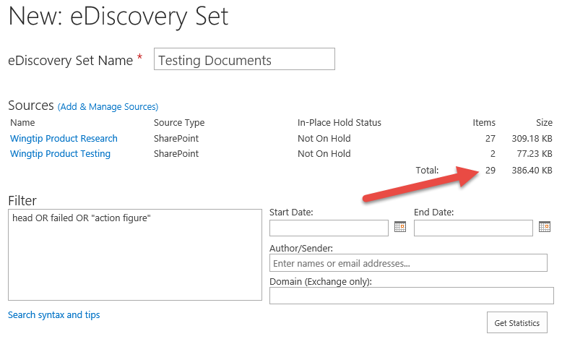

Note that is this step does not work correctly, you might need to wait for Office 365 to index the content.

1. Queries can be used to evaluate search queries and export the result sets from SharePoint.
   1. Click **Queries** on the quick launch
   2. Click **new item** and provide the following information:
      1. Name: **Failed Heads**
      2. Query: **head OR failed OR “action figure”**
   3. Click the **Search** button and see that you have some documents returned from **Wingtip Product Testing** and **Wingtip Research**. Switch to the **SharePoint** tab to see the details of documents from SharePoint. Use the File Extension refiner to view only files of a specific type.
   4. Click **Save**. Click **Close**
2. The legal team has decided they need to see the work related to the investigation. You have been requested to export all of the items related to the case.
   1. Click **Export** on the quick launch. On the **Exports page**, click **new item**.
   2. Place a **check mark** next to the **Failed Heads** Query you created earlier and click **Next**
   3. On the **Export New Item** page confirm the settings for the export and click **Ok**.
   4. On the **Export Download** page, click **Download Results**.
   5. The **eDiscovery Download Manager** will load.(If necessary click **Run** in the installer dialog for the **DownloadDiscoveryManager** app.)
   6. Use the **Browse** button to select your **Desktop** as the download location. Click **OK**.
   7. Use the **Export Location** link in the eDiscovery Download Manager to view the exported files.
3. Review the different types of documents that were exported.
   1. In Windows Explorer navigate to the **Wingtip Product Testing** folder and see that there is a folder structure similar to the site. Follow the folders to the Shared Documents folder and locate the files that were exported.
   2. Return to the root folder and locate the **Wingtip Product Research** folder. Follow the folders to the research folder and note how the contents of the site is contained in folders that match the lists you previously created. Lists are exported as Excel compatible files and documents are exported in their original format.
4. Based on your review the legal team has decided to place a hold on the content.
   1. Return to the **eDiscovery Sets** list and choose the **Testing Documents** item.
   2. Choose the **Enable In-Place Hold** radio button and chose **Save**.

In this module you created an eDiscovery site and then initiated a Case and executed queries to locate documents related to a case. When necessary, you then exported the relevant documents and placed a legal hold.