## Using the SharePoint 2013 Search Service

**Lab Time**: 60 minutes

**Lab Folder**: c:\Student\Modules\Search\Lab

**Lab Overview**: In this lab you will learn how to work with the improvements Microsoft made to the search platform in SharePoint Online. This includes seeing how to create custom search experiences as well as executing search queries.

### Exercise 1: Configure the SharePoint Search Site

In this exercise you will explore the SharePoint 2013 Search Settings available to the Site Collection.

1. Browse to Search Center site located at **<Team Site>_Search**.
2. This Search Site Collection is going to be the location for your search configuration.

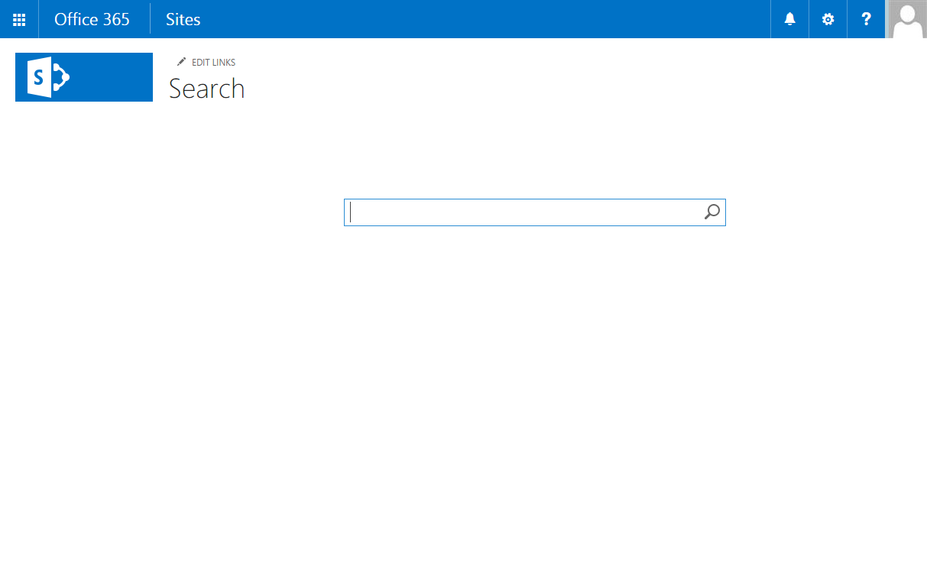

1. By this time in the class the Office 365 Search Engine should have had time to index the content on your site. You can test this by performing a search. Enter **Action** in the search box and click the **Search icon**. You should see a page of results that include the Action Figures you entered in previous labs.

SharePoint 2013 introduces a greater delegation of control of Search Administration than was found in previous versions of SharePoint. In the next Exercise we’ll explore these features of the Site Collection. For now, you will see how those same features are enabled for the tenant.

1. Click Site **Actions | Site Settings** and notice the Search related menu items under **Site Collection Administration**.
2. Click **Search Result Sources**.
3. Notice that there are Result Sources for content items like **Conversations** and **Documents**. These Result Sources help our users narrow their search to just items that are documents and conversations.
4. Return to Site Settings by clicking **Site Actions | Site Settings**.
5. Click **Search** **Query Rules** under **Site Collection Administration**.
6. Change the **Select a Result Source** combo box to **Local SharePoint Results (System)**. The list of Query Rules should change to show the rules that apply to Local SharePoint Results. We will create a few query rules in a later exercise. For now, you can test a query to see what rule applies by typing a phone number in the **find rules that fire for a query** box like **800-555-1212**.

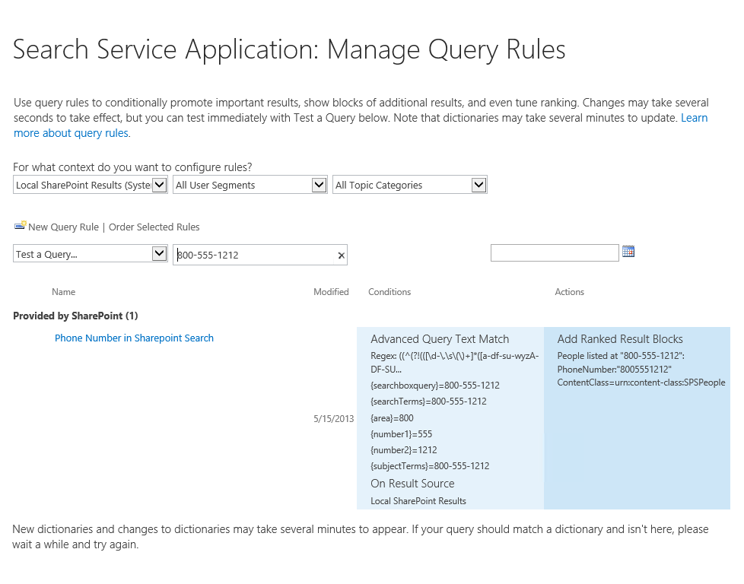

Managed properties are created so that document properties discovered by the indexer can be surfaced in Search Results and used for refinement, filtering and sorting. Managed properties are a key part of the Search Administration system and until SharePoint 2013 were largely the domain of Administrators. In the next exercise you will create your own managed properties. For now, we will look at those provided by the system.

1. Return to Site Settings by clicking **Site Actions | Site Settings**.
2. Click **Search Schema** under **Site Collection Administration**.
3. The Managed Properties section is broken into 3 sections:
   1. Crawled Properties – The full list of all properties discovered by the indexer. These could be properties from any indexable item (document, folder, email message, web page, etc.) that the crawler has encountered.
   2. Managed Properties – Crawled properties are “promoted” to Managed Properties by administrators so that they can be used in different ways by the Search System. Several crawled properties can be combined into a single Managed Property when the values they represent are equivalent, for example AssignedTo and Author.
   3. Categories – The crawled properties are grouped as they are discovered then grouped by category for easier discovery by administrators.
4. Review the list of Managed Properties on the first page. Each has attributes that control how they may be used within the search system.

In this exercise you reviewed the Search Configuration in in the Search Site Collection. There are additional controls available to the Tenant Administrator, your instructor can show you the details in a demo.

### Exercise 2: Executing Queries using Managed Properties

As Site Collection Administrators and Site Administrators you have some control available to you in SharePoint Online. In this exercise we’ll explore some of the controls available to Site Administrators. You will be pleasantly surprised at just how much control you have.

Remember back to previous Labs when you created Content Types for Products, Products Plans and Product Proposals? You also created Managed Metadata fields for Product Category. In this lab you will learn how to search for specific items using the SharePoint Keyword Query Language.

1. Browse to the Search Center site at **<Team Site>_Search**
2. Navigate to **Site Settings**. In the **Site Collection Administration** section choose **Search Schema**.
3. On the **Site Collection Administration – Managed Properties** page, choose **Crawled Properties**. This is the list of all properties discovered by SharePoint while crawling content.
4. In the **Filters** section, in the **Crawled properties** text box enter “**Product**” and click **Apply**. Notice that there are several Managed Properties created for us automatically by SharePoint and they follow this pattern.

|  |  |  |  |
| --- | --- | --- | --- |
| **Property Type** | **Site Column Name** | **Crawled Property Name** | **Managed Property Name** |
| Single line of text | ProductCode | ows_q_TEXT_ ProductCode | ProductCodeOWSTEXT |
| Choice | ProductColor | ows_q_CHCS_ProductColor | ProductColorOWSCHCM |
| Currency | ProductListPrice | ows_q_CURR_ProductListPrice | ProductListPriceOWSCURR |
| Managed Metadata | ProductCategory | ows_tax_q_ProductCategory | owstaxIdProductCategory |

These properties are created automatically for you by SharePoint if the fields are **Site Columns**. You will notice that some of the properties **ows_ProductCategory**, **ows_productCode** and **ows_ProductListPrice** are not mapped to Managed Properties. These crawled properties came from a list NOT using site columns. If you wish to use them in your search solution you will need to promote them to Managed Properties.

1. Return to the search center **<Team Site>_search**
2. In the search box enter the search term “Action” and click Search. This is the most basic keyword query. You should see results from the list of Products that includes “Action Figures” of various kinds.

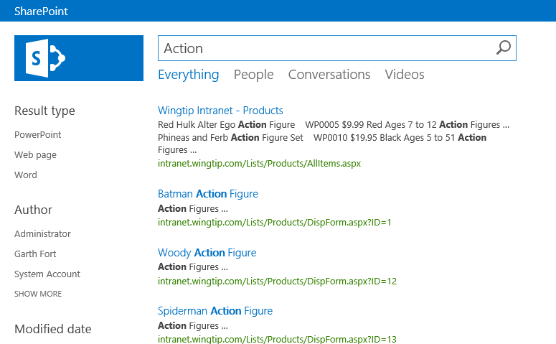

1. Enhance this query using the managed properties we observed earlier. To find all of the red figures add the ProductColor filter “**Action ProductColorOWSCHCM:Red**” the list should be shorter.

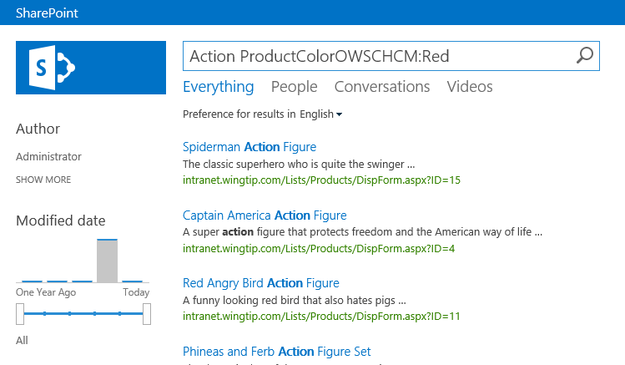

1. The automatically created Managed Properties serve a limited use as text values. If we wish to do more with them – and we do – we need to add them to specially provided Managed Properties for this purpose. Return to **Site Settings | Search Schema**.
2. On the Managed Properties page, search for **Refinable**. This is a list of specially provided generic, managed properties to which we can apply our special columns so we can do more with our data.
3. Click the Managed Property **RefinableDecimal00**. On the Edit Managed Property page scroll down to Mappings to crawled properties and click **Add a Mapping**.
4. In the Crawled property selection dialog change the Filter to SharePoint and add the property filter **Product**. From the resulting list chose **ows_ProductListPrice**.

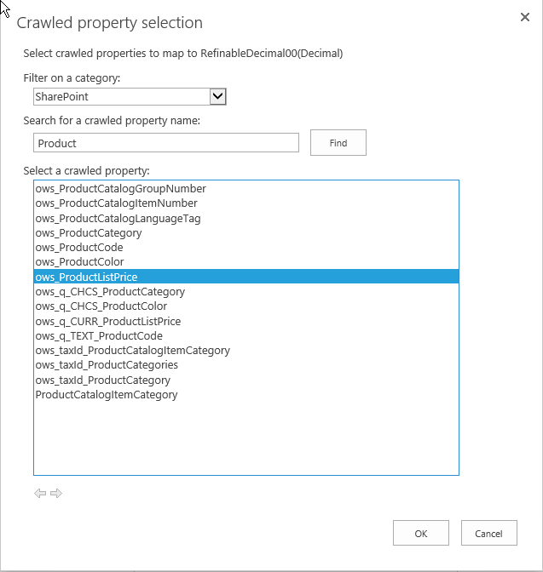

When you search for a crawled property, you may find two crawled properties that represent the same content. For example, a site column of type Date and Time named Created will during crawl discover two crawled properties: ows_Created and ows_q_DATE_Created. Crawled properties that begin with either ows_r<four letter code>, ows_q<four letter code> or ows_taxId are automatically created crawled properties. When you select a crawled property to map to a managed property, make sure that you don't map the automatically created crawled property. Instead, always map the crawled property that begins with ows_.

1. Click **OK**.
2. The property should be added to the Mapped properties list.

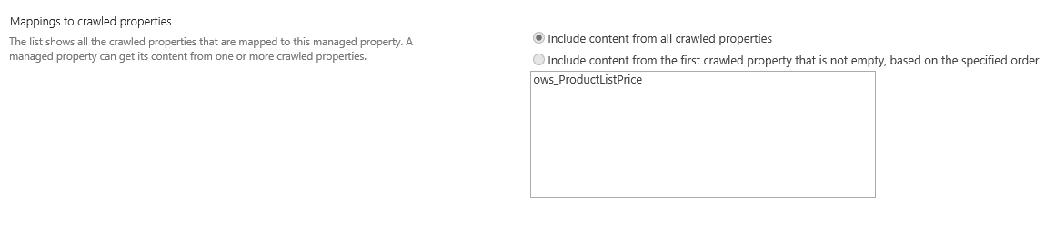

1. Click **OK**. You have just created your first managed property. We now need to repeat this for the other properties we wish to use in the search solution we are developing. Use the following table to assign the crawled properties to Managed Properties following these instructions:
   1. For each property use the Managed Property Filter box to locate the managed property.
   2. Click the Managed Property name.
   3. On the Edit Managed Property page click **Add a Mapping.**
   4. In the Crawled property selection dialog filter on SharePoint and enter the name of the Crawled property. Click Find.
   5. Select the property and Click OK.
   6. Confirm that you have the correct property and click OK.
   7. Repeat the steps for the next property.

|  |  |
| --- | --- |
| Managed Property | Crawled Property |
| RefinableInt00 | ows_MinimumAge |
| RefinableInt01 | ows_MaximumAge |
| RefinableString00 | ows_ProductCategory |
| RefinableString01 | ows_ProductColor |

1. Once you have completed this assignment of fields, the Search Service must re-crawl the content to populate the Managed Properties that you edited.
   1. Navigate to the main Team Site with the Products List **<Team Site>_TeamSite.**
   2. Choose the Products List from the left navigation.
   3. On the **List Tab** choose **List Settings**.
   4. Choose **Advanced Settings**.
   5. Locate the **Reindex List** setting and click **Reindex List**. Confirm the request by clicking **Reindex List** again.

The reindexing process can take as much as 15 minutes, though usually it will be done much sooner.

Now, let's recap where you are at. In this exercise you laid the groundwork for creating search solutions in SharePoint Online. In the next exercise you will use these fields.

### Exercise 3: Customizing the Refinement Panel

In this exercise, you will learn how to configure the refine panel on a search results page. If you don’t see results immediately, complete the lab and take a break. Your work will come together when indexing is complete.

1. Return to the Search Center **<Team Site>_search**
2. Search for **“Action”** and you will see a result set of Action Figures. Notice that the refiners are more appropriate for documents. In this exercise we’ll fix that.
3. Click **Site Actions | Edit Page**.
4. Click the **Refinement Web** part and choose **Edit Web Part**.

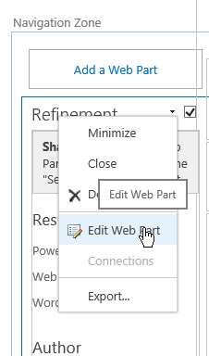

1. In the Refinement Edit Panel click **Choose Refiners…**
2. In the **Refinement configuration for Refinement** dialog locate the **RefinableDecimal00** property in the **Available refiners** list. Click **Add >** to move it to the **Selected refiners** list. Repeat these steps for:
   1. RefinableInt00
   2. RefinableInt01
   3. RefinableString00
   4. RefinableString01

You may see a warning about too many refiners at this point, you can remove the **Web Template** and **Content Type** refiners from the **Selected refiners** box.

1. Since the field names are not clear you need to edit each refiner as follows. Click **RefinableDecimal00** in the **Selected refiners** list and set the following properties:

|  |  |  |  |
| --- | --- | --- | --- |
| **Field** | **Display Name** | **Display Template** | **Intervals or Sort** |
| RefinableDecimal00 | List Price | Slider with Bar Graph | 10;15;25;50 |
| RefinableInt00 | Min Age | Slider with Bar Graph | 5;10;15;25 |
| RefinableInt01 | Max Age | Slider with Bar Graph | 5;10;15;25 |
| RefinableString00 | Category | Refinement Item | Count, Descending, 10 |
| RefinableString01 | Color | Refinement Item | Count, Descending, 10 |

1. Click **OK** to close the dialog.
2. Click **OK** in the Web part Tool Panel.
3. Click **Save**.
4. Click **Check In** on the ribbon in the Edit group. Supply a check-in comment and click **Continue**.
5. **Publish** the page.
6. Execute a search like “WP*” to return a bunch of Products. You should see your refiners.

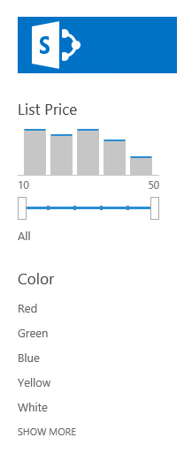

In this exercise you edited Managed Properties to create refinable attributes on the Search page.

### Exercise 4: Defining a Custom Search Result

Now that you have created the connections from your content to the Search Service and down to the Managed Properties, it’s time to show off your design talents. In this exercise you will create a new template for your Product results and include the custom metadata from the Product content type. This way, when your end users search for products, they will see your special Result Type.

Display Templates are the key to presenting Search results. You will begin in Design Manager and create a copy of an existing template. You will then modify that template to look the way you want it, including the picture of the product in the search result.

1. Browse to the Search Center at **<Team Site>_search**
2. Navigate to **Site Actions |** **Design Manager**.
3. From the Design Manager home page, choose **3. Upload Design Files**.
4. On the Design Manager: Upload Design Files page, click the link for **<Team Site>_Search/_catalog/masterpage**. This will open an Explorer window to the site’s Master Page Gallery.
5. Navigate to **Display Templates/Search**
6. Locate the **Item_Picture.html** file and copy it to your desktop.
7. Rename the file to **Item_Product.html**.
8. Open the file in **Notepad++**
9. Find the <title> tag and change it to **<title>Product Item</title>**
10. Locate the **<mso:ManagedPropertyMapping** node andadd the following properties, all on one line, as follows:
    1. ,'ProductCodeOWSTEXT':'ProductCodeOWSTEXT'
    2. ,'ProductColorOWSCHCM':'ProductColorOWSCHCM'
    3. ,'ProductDescriptionOWSMTXT':'ProductDescriptionOWSMTXT'
    4. ,'ProductImageUrlOWSURLH':'ProductImageUrlOWSURLH'
    5. ,'ProductListPriceOWSCURR':'ProductListPriceOWSCURR'
11. Locate the tag <div id="_#= $htmlEncode(itemId)tag and delete the highlighted lines below.

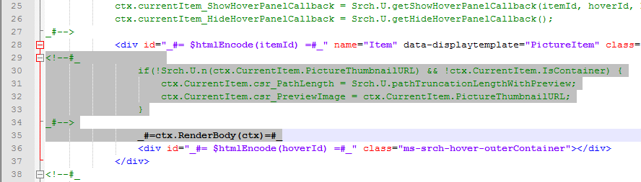

1. Locate the C:\Student\Modules\Search\Lab\nocode-code.txt file and paste it into the space you just created. (Or if you love typing, you can type it all in.)
2. **Save** the file.
3. Drag the file into the Search directory.
4. Refresh the directory and you should notice that SharePoint made a copy of your file with a .JS extension.

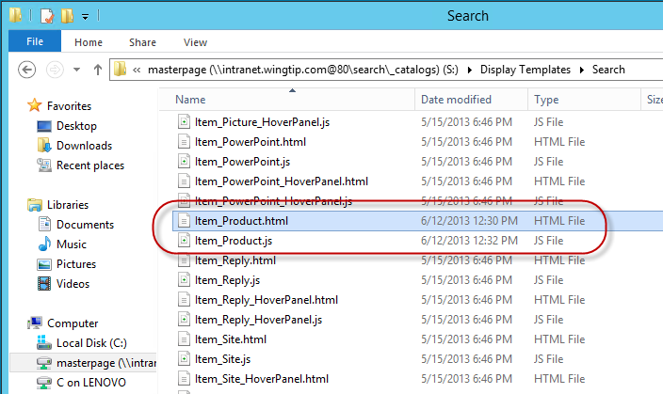

1. Now you need to tell SharePoint to use your display template. You do this by creating a **Result Type** rule. In the Search site **<Team Site>_search** choose **Site Actions | Site Settings**.
2. Click **Search Result Types** under **Site Collection Administration**.
3. In the **Manage Result Types** page chose **New Result Type**.
4. Complete the new **Result Type** as follows:
   1. Name: **Products**
   2. Which source should results match?: **Local SharePoint Results**
5. Click Show More Conditions and set the Custom Property as follows:
   1. Property: **ContentType**
   2. **Equals any of…**
   3. Value: **Product**

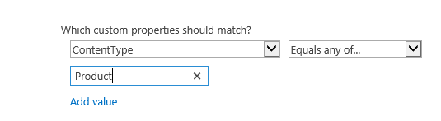

1. Complete the Result Type by assigning the Display Template you created to the **What should these results look like**: **Product Item**
2. Click **Save**.
3. To test your work return to the Search site and execute a Product search like **“ContentType:Product”** or **“Action”** and you should see a different result type. (Your action figures may be on page 2 of the results.)

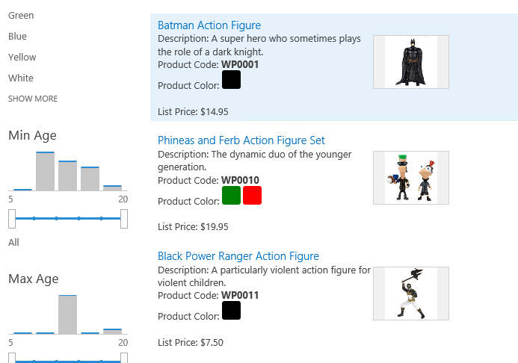

In this lab you created a custom display template and associated it with the Product Content Type with a Result Type.

### Exercise 5: Creating Custom Query Rules

In this exercise you will use Query Rules to promote content and help your users find additional content based on their query. The training department at Wingtip Toys has decided to provide a training class for SharePoint. What they would like is for anyone searching for SharePoint to see a banner about the training class. They would also like to see a list of SharePoint Experts in the Search Results.

1. On the Search site, navigate to **Site Actions | Site Content**.
2. Navigate into the **Documents** library.
3. Locate the design files in the **C:\Student\Modules\Search\Lab\training\** folder. Drag and Drop the two files into the document library.
4. Now let’s create a rule to display the banner. Navigate to **Site Actions | Site Settings**.
5. Under **Site Collection Administration** choose **Search Query Rules**.
6. On the **Manage Query Rules** page, change the Query context selector to **Local SharePoint Results**. The view should change to show you the out of the box rules that are already present for SharePoint.
7. Click **New Query Rule** and create a rule with the following attributes:
   1. Rule name: **SharePoint Training**
   2. Query Conditions: **Advanced Query Text Match**
      1. Query Contains one of these phrases: **sharepoint;sps;moss**
   3. Leave the rest of the condition fields as they are.

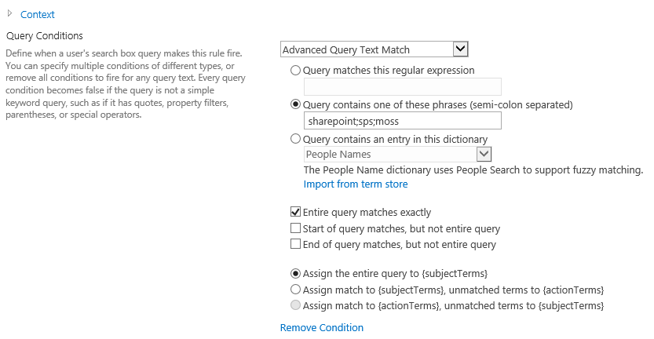

* 1. Under **Actions** click **Add promoted result** with the following attributes:
     1. Title: **SharePoint Class**
     2. URL: **http://<Team Site>_search/Documents/spclass.aspx**
     3. Render the URL as a banner instead of as a hyperlink: **Checked**

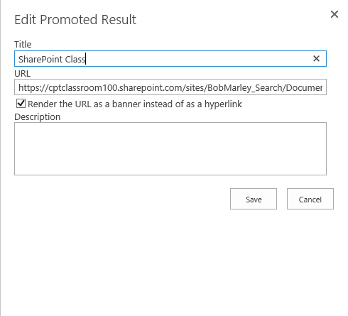

* 1. Click **Save**

1. Test your work by returning to the Search center at **http://<Team Site>_search** and entering **SharePoint** as a search term.
2. Click **Search** and you should see the banner for your class

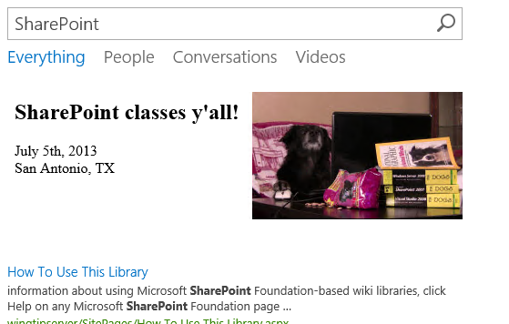

1. Now we need to get a list of SharePoint experts associated with the SharePoint keywords. Navigate to **Site Actions | Site Settings**.
2. Under Site Collection Administration choose **Search Query Rules**.
3. Change the context to **Local SharePoint Results**.
4. Select the **SharePoint Training** rule you created earlier and chose **Edit**.
5. Scroll down to Actions and choose **Add Result Block**.
6. In the Add Result Block dialog supply the following parameters:
   1. Block Title: **SharePoint Experts**
   2. Query: **Skills:SharePoint**
   3. Search this Source: **Local People Results**
   4. Items: **4**
   5. Under Settings change the **Item Display Template** to **People Intent Item**.

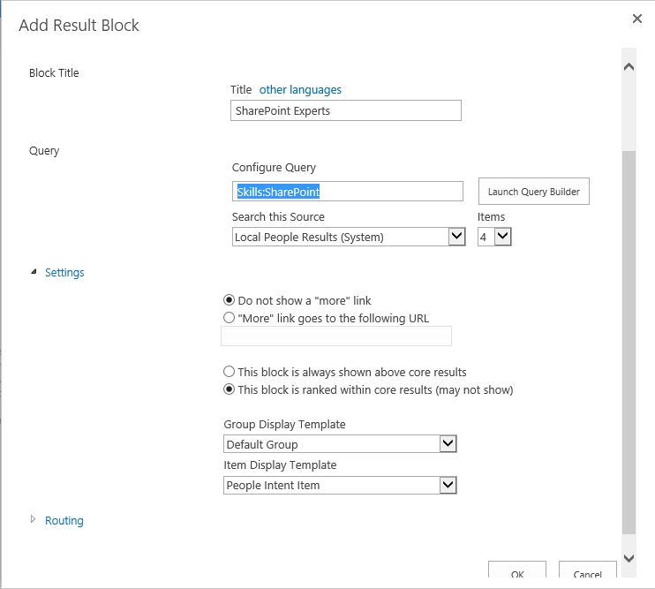

1. Click **OK**.
2. Click **Save**
3. Test your work by returning to the Search Center and executing a search for **SharePoint**.
4. You should see the results with your banner and SharePoint Experts.

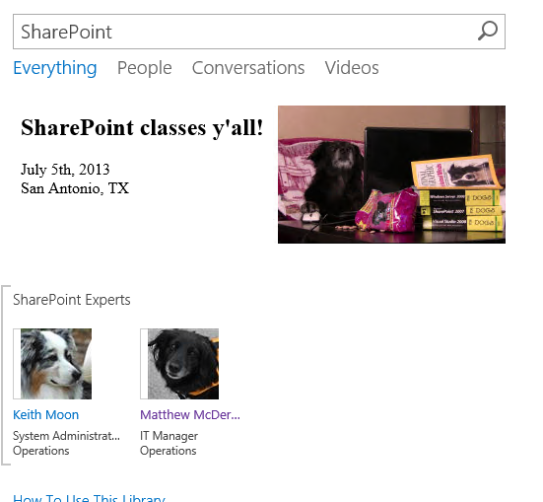

In this lab you created custom Query Rules to present content for users seeking help for SharePoint. You can use query rules for many purposes that help users find the information they seek.