Lab 01: Customizing a WSS Site

**Lab Time**: 45 Minutes

**Lab Directory**: C:/Student/Labs/01_Customization

**Lab Overview**: In this lab you will be familiarizing yourself with basic SharePoint tasks such as Creating a Site Collection/Top-level Site, Creating a Child Site, Creating a List/Document Library and Making some basic Customizations to a Site.

**Back Story:** The management team at Litware has decided to use Windows SharePoint Services 3.0 to assist with storing and managing the content associated with their consulting projects. You will be instructed to create a top-level team site with a list that tracks a profile for each consulting project. You will also create a document library for storing various project-related documents such as customer presentations and proposals. You will also create child sites to track information about consultants in various divisions of the Litware corporation.

**Important:** You must finish this lab as written for a later lab to work correctly!

# Exercise 1: Create a new site collection and a top-level site

1. Make sure you are logged on as **LITWAREINC\Administrator**. Launch the WSS Central Administration Web site by using the command in the Windows Start menu. You can find the command at **Start >> Administrative Tools >> SharePoint 3.0 Central Administration**.
2. Once the home page of the WSS Central Administration Web site appears, click on the **Application Management** link at the top of the page to get to the Application Management page.

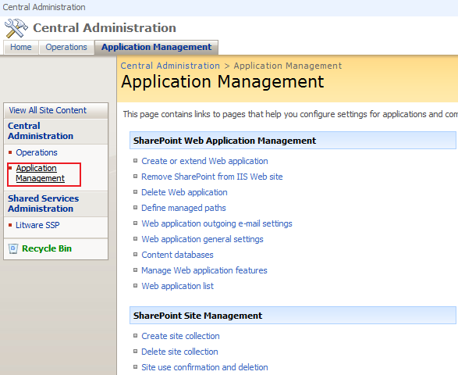

1. Under the **SharePoint Site Management** section, click the link with the caption **Create site collection**.

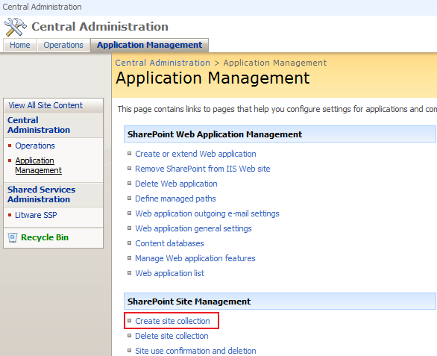

1. This will take you to the page where you can create a new site collection and a new top-level site.  On the **Create Site Collection** page, fill in the required information (see below for instructions) to create a new site collection.
   1. Make sure the Web Application used for site creation is the one named **Litware Public Site** that is accessible through the URL **http://litwareinc.com**.
   2. For the Title use **Litware Project Management**.
   3. Create the new site collection so that it's URL is **http://litwareinc.com/sites/ProjectManagementLab**.
   4. Under the **Template Selection** section, look at all the sites templates that are available. Choose **Blank Site** from the **Collaboration** tab as the site template for the new top-level site that will be automatically created.
   5. Assign the primary site collection owner as **LITWAREINC\Administrator**.  Be sure to verify this by using Ctrl+ k or by clicking the check person icon checkIcon (your entry should become LitwareInc Administrator)
   6. Leave the **Quota Template** with the default setting of **No Quota**
   7. Click **OK** to create the new site collection and top-level site. Once you see the page that confirms everything has been created, navigate to the top-level site using the browser (click the link <http://litwareinc.com/sites/ProjectManagementLab> ).
2. In this step, you will change the title of your site. The Title you entered of **Litware Project Management** is just a little too boring. Choose the **Site Settings** command under the **Site Actions** menu. Once you are at the **Site Settings** page, click the link with the caption **Title, description and icon** under the **Look and Feel** section.

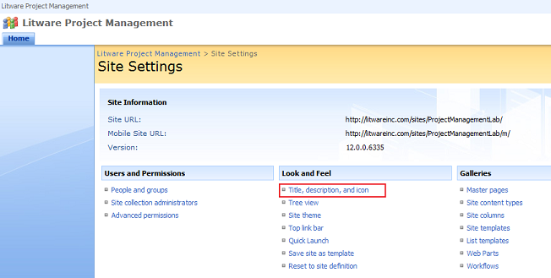

1. When you reach the **General Setting** Page, enter a different title that is a variation of **Litware Project Management**. Click **OK** and confirm that the home page now reflects the new site title.
2. Over the next several steps you will add custom Litware graphics to your new site to replace the standard Microsoft graphics.
   1. First, using the **Windows Explorer**, look inside the lab directory (**.../student/labs/01_Customization/**) and locate the subdirectory named **LitwareGraphics**. It contains several graphics files you will use to customize your site. Begin by copying the **LitwareGraphics folder** (not just the images inside but rather the folder itself along with everything it contains) to a location inside the WSS layouts directory so that you can make your graphics files accessible to all WSS sites within the farm. In particular, copy the **LitwareGraphics** directory into the directory at the following location:

C:/Program Files/Common Files/Microsoft Shared/web server extensions/12/TEMPLATE/IMAGES

Note that WSS configures the **IMAGES** directory with IIS so that it is a child virtual directory of the **_layouts** virtual directory. This means your graphics files should be accessible using a relative URL within any WSS site that looks like this:

**.../_layouts/images/LitwareGraphics/**

1. In this step, you will modify the Site Image Web Part on the site's home page so that it displays a custom Litware graphic instead of the default Microsoft graphic.
   1. Navigate to the home page of the site (<http://litwareinc.com/sites/ProjectManagementLab/>) and place the page into edit mode by choosing the **Edit Page** command under the **Site Actions** menu.

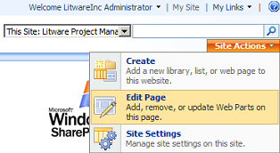

* 1. Once the page is in edit mode, find the **Site Image** web part (Right Zone, Top Choice) and on that web part's **edit** drop down **menu** select the **Modify Shared Web Part** command from the Web Part's action menu.

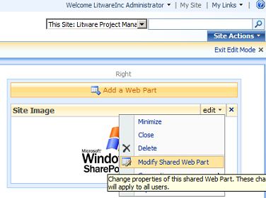

* 1. After you have run this command, you should see a task pane appear in the browser that allows you to modify the **Image Link** property.
  2. Assign the **Image Link** property a new value of **/_layouts/images/LitwareGraphics/LitwareSlogan.png** and click **OK**.

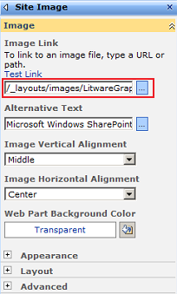

* 1. In the Right hand corner near the top of the page click **Exit Edit Mode.**

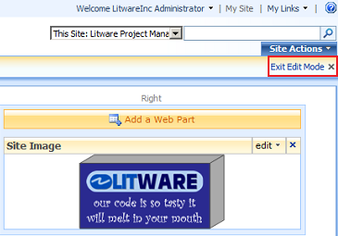

* 1. Confirm that the site's home page now shows the new Litware slogan graphic.

1. In this step we will add a Logo to the banner of our home page.
   1. Go to the Site Settings page  (**Site Actions** drop down menu > **Site Settings** )and click on the link with the caption **Title, description and icon** under the **Look and Feel** section.
   2. Now enter a path to assign an URL to the graphics file named LitwareLogo.png. You path should be **/_layouts/images/LitwareGraphics/LitwareLogo.png**.
   3. Click the **Click here to test** and make sure that you can see the small logo, if not check your Url and try again.
   4. Click the **OK** button.
   5. Click on the **Home tab** on your page to navigate back to the main page (upper left side first and only tab on the page)
   6. Verify that the Litware logo appears on the banner of the home page (Upper left corner of web page), if not go back to step 6 and try again.

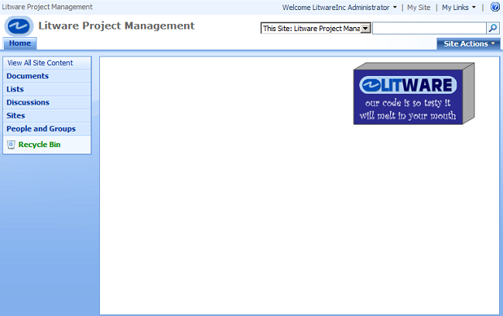

# Exercise 2: Create new list for tracking profiles for consulting projects

1. Over the next few steps, you will create and modify a new SharePoint custom list for managing Litware consulting projects.
   1. Start by clicking the **Create** command from the **Site Actions** menu to navigate to the **Create** Page.

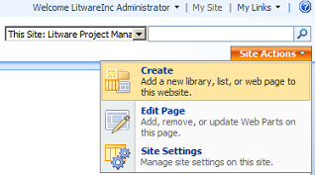

* 1. Create a new list by clicking the **Custom List** link in the **Custom Lists** section. This will take you to a page that allows you to name the new list.

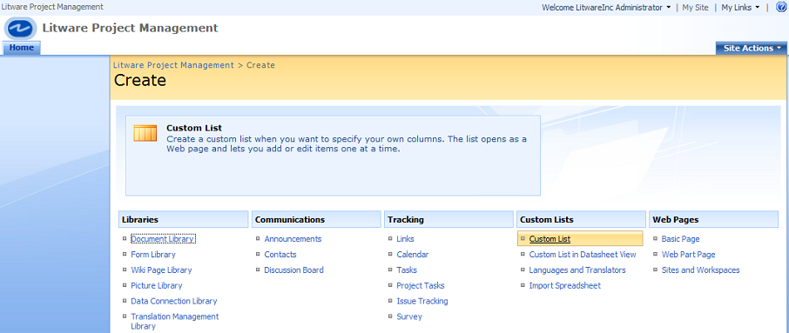

* 1. Name the new list **Projects** and click **Create**. This brings you to the **All Items** view of the new list.

1. Next you are going to modify the settings for our list to disable the uploading of attachments to the **Projects** list.
   1. Once the **Projects** list has been created, locate and drop down the **Settings** menu on the list's **AllItems.aspx page** (note: **NOT** the one on the Site Actions menu).

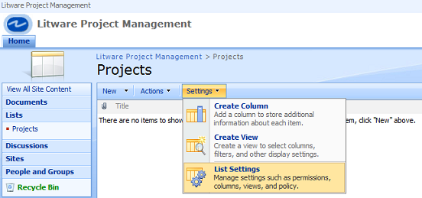

* 1. Click the **List Settings** command. This will take you to the list settings page that has a title of **Customize Projects** list.
  2. From this page, click on the **Advanced Settings** link in the **General Settings** section. Take note of the different modifications you can make to the list from the **Advanced Settings** page.

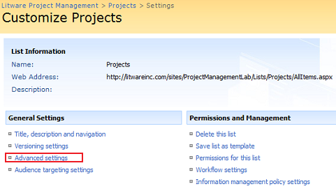

* 1. In the **Attachments** section, change the default option to **Disabled** and click **OK** to return to the list setting page. In this case, there is no need for the list to support attaching documents to items within the **Projects** list. If you get a warning message about erasing attachments, note what it says and then click **OK.**

1. From the **List Settings** page, you can add and modify columns for the **Project** list. In this step you will modify the **Projects** list so its set of columns matches the set of columns defined below.  (For detailed directions see steps a - d below)

|  |  |  |
| --- | --- | --- |
| **Column Name** | **Type** | **Notes** |
| **Project** | Single Line of Text | **Do not create this column as a new column.** Instead, rename the **Title** column to **Project**. |
| **Client** | Single Line of Text | Make this a required column |
| **Contract Signed** | Yes/No | Set default value to No |
| **Contract Amount** | Currency | Set currency formatting to whatever seems most appropriate |
| **Begin Date** | Date and Time | Format this column to show date only |
| **End Date** | Date and Time | Format this column to show date only |
| **Created By** | Person or Group | **You do not have to create this column**. It is automatically created when you create a new list |
| **Modified By** | Person or Group | **You do not have to create this column.** It is automatically created when you create a new list |

* 1. From the **Projects** **List** click on the **Settings** drop down and click on **List Settings** (Note: we are already on this screen from step 2).
  2. Scroll down to the **Columns section** and click on the **Title** Column to edit it.
  3. Change the **Column name** to **Project**  and click **OK**
  4. From the **Columns section** click **Create Column** and using the chart above configure the following settings:
     1. Type the **Column Name**
     2. Select the **data type** for the column
     3. Examine the **Notes field from the above table** for extra configuration options for each column
     4. Configure extra options as needed and then click **OK**
     5. Repeat until all columns are created and then from the **Customize Projects Menu** underneath the **Columns section** click on **Column ordering**
     6. Organize the order of the columns so that they match the order in the list above.  Note: there may be nothing to do here other than verify the order depending on how you created your columns.
  5. Using the breadcrumbs navigational element (i.e. the one that is near the top of the screen that looks like **Litware Project Management > Projects > Settings**) click on the Projects link to navigate back to the Projects List.

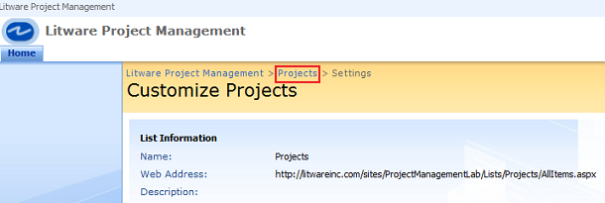

1. When you are done creating the **Projects** list structure, add the following four items so that you have some test data to work with.
   1. From the **Projects** List click on the **New** drop down menu and using the table below create 4 records.

|  |  |  |  |  |  |
| --- | --- | --- | --- | --- | --- |
| **Project** | **Client** | **Contract Signed** | **Contract Amount** | **Begin Date** | **End Date** |
| Wing001 | Wingtip Toys, Inc | Yes | $250,000 | 1/1/2005 | 4/15/2006 |
| AdWks001 | Adventure Works | No | $120,000 | 1/15/2006 | 6/1/2006 |
| NW001 | Northwind Traders | Yes | $1,200,000 | 4/1/2006 | 6/1/2007 |
| Cont001 | Contoso | No | $75,000 | 6/1/2005 | 9/1/2006 |

1. When finished navigate back to the **Litware Project Management** Home page (i.e. click on the **Home tab** on the left side near the top)

# Exercise 3: Creating a new document library for project-related documents

1. Over the next few steps, you will create and modify a new SharePoint document library for storing and managing documents associated with Litware consulting projects.
   1. Start by clicking the **Create** command from the **Site Actions** menu to navigate to the **Create** Page.
   2. Create a new document library by clicking the **Document Library** link in the **Libraries** section. This will take you to a page that allows you to name the new document library and click **Create** to create this document library.
2. In this step, you will add a new column to associate custom metadata with each document that is added to the document library.
   1. Locate and drop down the **Settings** menu on the document library's **AllItems.aspx** page and click the **Document Library Settings** command.  This will take you to the document library settings page that has a title of **Customize Project Documents**.
   2. Add a new lookup column to the document library named **Project**.
      1. Underneath the columns section of this page click **Create column**.
      2. We will use the **Project** column of the **Projects** list you created in the previous exercise as the source for this new lookup Column.
         1. Type Project for the **Column name:**
         2. Choose **Lookup (information already on this site)** for the **type** selection (i.e. the option button list)
         3. Type **Project identifications taken from the Project List** for the **Description.**
         4. Make sure to select the option so that the **Project** column is required.
         5. Be sure to choose **Projects** for the **Get information from:** drop down list choice.
         6. Choose **Project** for the **In this column:** drop down list choice.
         7. Click **OK** to add the new column.

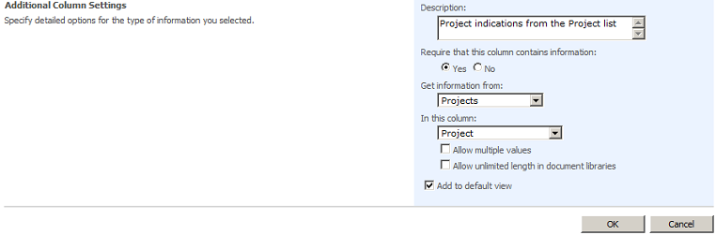

* + - 1. Using the breadcrumbs navigation bar on this page (i.e. **Litware Project Management > Project Documents > Settings** ) navigate back to the **Project Documents** library (i.e. click on the **Project Documents** link)

1. Now that you have created the **Project Documents** document library and added the lookup column Project, it's time to upload a few documents to test it out.
   1. Using the Windows Explorer, look inside the lab directory and locate the subdirectory named **LitwareDocuments**. It contains several .DOCX files and PPTX files that you can upload to your document library.
   2. Upload each document inside this directory. You should observe that whenever you upload a document into the **Project Documents** document library, WSS brings up a page to prompt you to assign a value to the **Project** column. You should observe that the **Projects** column provides extra metadata for each document and that WSS forces users to associate each and every document inside this document library with a specific project. **Important:  You MUST upload each document SEPARATELY if you use the Upload Multiple Documents choice you will bypass the metadata screen altogether for each document.**
      1. On the **Project Documents Library** Page select the **Upload** Drop Down arrowand then click **Upload Document** or just click on **Upload**
      2. Use the **Browse** button to navigate to **...\Student\Labs\01_Customization\LitwareDocuments\**
      3. You are going to repeat the next set of steps one time for each of the 4 items in this directory (3 PowerPoint and 1 Word document(s))
         1. **Select** the next **item** (From the top 3 PowerPoint and 1 Word document(s)) on the **Choose file** screen and click **Open**
         2. On the **Upload Document: Project Documents** screen click **OK.**
         3. The next screen informs you that the document is currently checked out to you; you need to fill in the requisite metadata and check the document into the library to finish this process.
            1. In the **Project** drop down box pick the appropriate project for this document matching up the Document Name field to the Project.  (use the table below for reference as necessary.

|  |  |
| --- | --- |
| **Project** | **Client** |
| **Wing001** | **Wingtip Toys, Inc** |
| **AdWks001** | **Adventure Works** |
| **NW001** | **Northwind Traders** |
| **Cont001** | **Contoso** |

* + - 1. Click the **Check In** button to finish the upload process.
      2. Repeat step 3.b. once for each of the 4 documents.
      3. When finished uploading the four documents navigate back to the Litware Project Management Home page (i.e. click on the **Home** **tab** near the top left corner of the screen).

# Exercise 4: Customizing the home page

1. In this exercise you will customize the appearance of the **Quick Launch** navigation control on the left-hand side of the home page.
   1. Start by clicking the **Site Settings** command from the **Site Actions** menu to navigate to the **Site Setting Page**.
   2. Next, click on the **Quick Launch** link under the **Look and Feel** section. Once you get to the **Quick Launch** page, you will be able to add, edit and delete links and headings from the **Quick Launch** control.  In this case, you want to remove the heading for **Discussions** .
      1. On the **Quick Launch page** click on the **Edit Discussions** icon edit item icon (i.e. the one to the left of the **Discussions** section)
      2. On the **Edit Heading page** click the **Delete** button
      3. Click **OK**
      4. Navigate back to the Litware Project Management home page (i.e. click on the **Home** **tab** near the upper left corner of the page)
   3. Verify that the **Quick Launch** control now looks like this:  
      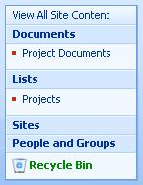
2. Next, you will add two Web Parts to the home page to display the **Projects** list and the **Project Documents** document library.
   1. If necessary, Navigate to the home page of the site
   2. From the site Home page, place the page into edit mode by choosing the **Edit Page** command under the **Site Actions** menu.
   3. Once the page is in edit mode, you should click the **Add a web part** link at the top of the left **Web Part Zone**.
   4. Select to add a Web Part for both the **Projects** list and the **Project Documents** document library.
   5. Click **Add**.
   6. Here is what your screen should look like: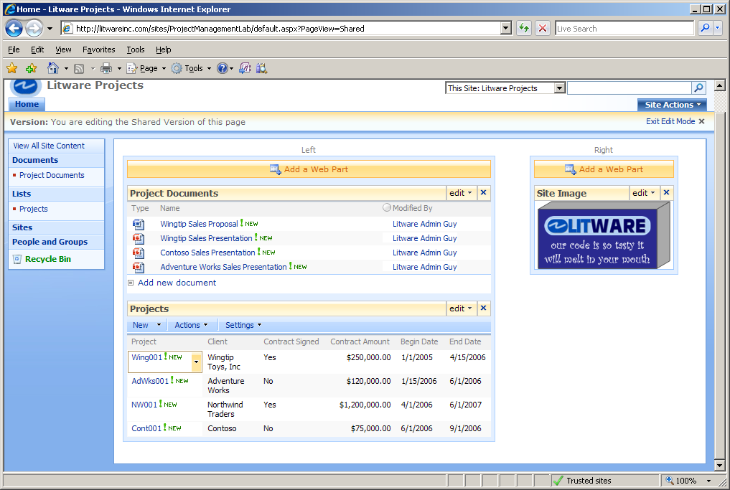
   7. When finished be sure to click the **Exit Edit Mode** hyperlink (near the upper right corner of the page).
3. Finally we will create a Portal Navigation Point to link our new Site Collection back to the main portal page.
   1. Click on **Site Actions > Site Settings**
   2. In the **Site Collection Administration** column select the **Portal site connection** choice.
   3. On the Portal Site Connection page:
      1. Select **Connect to portal Site**
      2. enter <http://litwareinc.com> as your Portal Web Address:
      3. enter **Litware Inc.** for the Portal Name:
      4. click **OK**

# Exercise 5: Creating child sites

1. Now you are going to create two new child sites to track Litware consultants by corporate division. One site will be for the **Litware North Division** and the other will be for the **Litware South Division**. However, keep in mind when you create these child sites you want to make it easy for users to navigate between them. Therefore, you want to create a resulting top link bar on the parent site and both child sites to look like this.  
   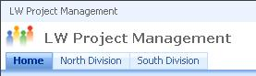
2. In this step, you will create a child site named **North Division**.
   1. Start by clicking the **Create** command from the **Site Actions** menu to navigate to the **Create** page.
   2. Create a child site by clicking the **Sites and Workspaces** link in the **Web Pages** section. This will take you to a page that allows you to create a new child site.
   3. Name the site **North Division**
   4. Make it's URL **NorthDivision** (no space in the name)
   5. choose **Blank Site** as the site template
   6. In the **Navigation** section of the New SharePoint Site page, choose **Yes** as the option to **Display this site on the Quick Launch of the parent site** and **Yes** for the option to **Display this site on the top link bar of the parent site**. (i.e. just accept the defaults)
   7. In the **Navigation Inheritance** section of the New SharePoint Site page, choose **Yes** as the option to **Use the top link bar from the parent site.** (i.e. just accept the defaults)
   8. Finally, click **Create** to create the new child site.
3. In this step, you will modify the Site Image Web Part in the **North Division** site so that it displays a Litware North graphic instead of the default Microsoft graphic.
   1. Navigate to the home page of the **North Division** site and place the page into edit mode by choosing the **Edit Page** command under the **Site Actions** menu.
   2. Once the page is in edit mode, find the **Site Image Web Part** (Right Zone) and select the **Modify Shared Web Part** command from the Web Part's **edit** menu.
   3. After you have run this command, you should see a task pane appear in the browser that allows you to modify the **Image Link** property. Assign the **Image Link** property a new value of **/_layouts/images/LitwareGraphics/LitwareNorth.png**
   4. Click **OK**.
   5. Confirm that the child site's home page now shows the Litware North graphic.
   6. Click **Exit Edit Mode** just underneath the **Site Actions** menu.
4. Now you should be able to navigate back and forth between the top-level **Project Management** site and the child **North Division** child site using the top link bar.
5. Now click the **home** **tab** to return to the top-level site and create a second child site named **South Division**.
   1. Create this new site using the same set of instructions (Exercise 5, Step 2) as you used to create the **North Division** site (note: replace North with South as appropriate).
   2. Also, modify the Site Image Web Part in the South Division site so that it displays the graphic file at **/_layouts/images/LitwareGraphics/LitwareSouth.png** (i.e. follow the instructions in Exercise 5, Step 3 if you need help)
6. At this point, you should be able to quickly navigate between the top-level site and either child site with a single click on the top link bar. This is all the work you will do within the child sites at this time. **Note: You will return to these child sites in a later lab and add some custom lists to track information about Litware consultants.**