Lab 09: Site Columns and Content Types

**Lab Time**: 45 Minutes

**Lab Directory**: C:/ Student/Labs/09_ContentTypes

**Lab Overview**: In this lab you will add tracking functionality—managing timesheets for Litware consultants. You will also improve the way that content is stored in the Project Management site and its child sites by using two new features introduced with WSS 3.0: site columns and content types.

1. In the first Exercise, you will create a site column definition in the top-level **Project Management** site that performs a lookup on the **Projects** list you created in the earlier lab.
2. In Exercise two, you will use this Lookup site column to define a column in the list of a child site (the **North Division** sub-site) within that same site collection.
3. In the Third Exercise, you will create several new content types that allow users to store their documents in the **Project Documents** document library in a more structured way.

# Exercise 1: Create a site column in the top-level site for doing Project lookups

In this first exercise, you will create a site column in the top-level **Project Management** site that performs look ups on the **Project** column of the **Projects** list.

1. Start by navigating to the **Project Management** site you created in the first lab on Customizing a WSS site.   
   (<http://litwareinc.com/sites/ProjectManagementLab/default.aspx>).
2. Click the **Site Settings** command in the **Site Actions** menu to navigate to the **Site Setting** page.
3. Then click the **Site columns** link under the **Galleries** section to navigate to the **Site Column Gallery** page.
4. Click the **Create** link on the toolbar to navigate to the **New Column** page where you will be able to create a new site column:
   1. Name the new site column **Project**.
   2. Make the new site column a **Lookup** column.
   3. Add the new column to a new group named **Litware**.
   4. In the **Additional Column Settings** section add a brief description and modify the site column so it requires information.
   5. Next, assign the **Projects** list as the source the lookup should get its information from.
   6. Then assign the **Project** column as the column to be used in the lookup.
   7. When you are done filling out the **New Column** page and it looks like the one below, click **OK** to create the new site column.

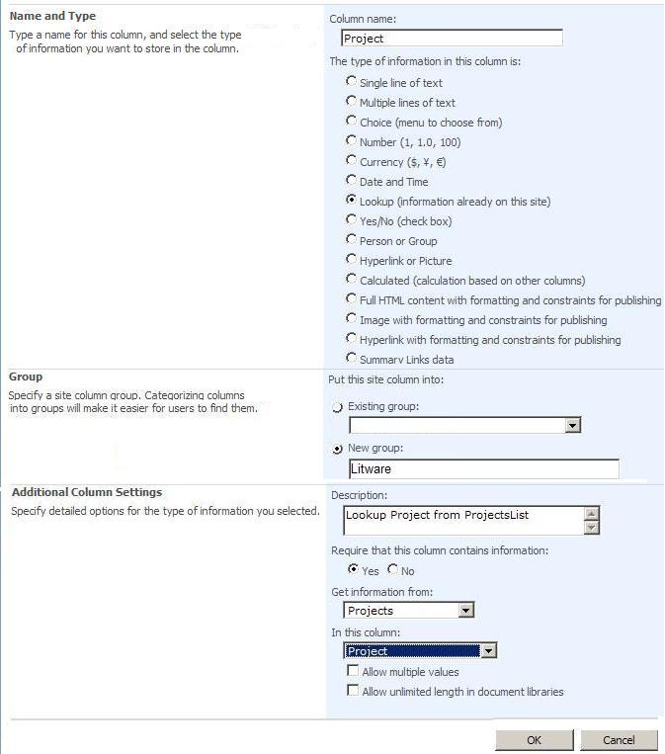

# Exercise 2: Create a custom list for tracking consultant timesheet information in the North Division sub-site using the Project lookup Column

Now that you have created the **Project** site column, it's time to use it in a new list.  You will create a list that uses this site column in the **North Division** site (you created this in Lab 1) that is a child site of the **Project Management** site. This scenario will demonstrate how a site column can easily enable lookups across sites within a site collection.

1. Begin by navigating to the **North Division** site (located on the tabs near the top of the **Litware Project Management** site).
2. Over the next few steps, you will create a new SharePoint custom list which we will then modify for tracking consultant timesheet information.
   1. Start by clicking the **Create** command from the **Site Actions** menu to navigate to the **Create** Page.
   2. Create a new list by clicking the **Custom List** link in the **Custom Lists** section. This will take you to a page that allows you to name the new list.
   3. Name the new list **Timesheets**  and click **Create**.
3. Once the **Timesheets** list has been created, locate and drop down the **Settings** menu on the list's AllItems.aspx page and click the **List Settings** command. This will take you to the list settings page that has a title of **Customize Timesheets**.
   1. From this page, click on the **Versioning Settings** link in the **General Settings** section.
   2. Modify the list from the **Versioning Settings** page to enable the option to **Create a version each time you edit an item in this list** and click **OK** to return to the list settings page. In this case, you will be able to track whenever and whoever makes changes to timesheet items in the list.
4. Now it's time to define the columns needed for the **Timesheet** list using the **List Settings** page. In this step, you will modify the **Timesheets** list so its set of columns matches the set of columns defined below.

|  |  |  |
| --- | --- | --- |
| **Column Name** | **Type** | **Notes** |
| **TimesheetID** | Single Line of Text | Do not create this column as a new column. Instead, rename the **Title** column to **TimesheetID**. |
| **Consultant** | Choice | To simplify this lab, make this a choice column with three choices for the consultant. The choices should be "**Britta Simon**", "**John Rodman**" and "**Mike Fitzmaurice**" |
| **Project** | Lookup | This column should be based on **Project** site column created earlier in this exercise. Create this by clicking the **Add from existing site columns** link, choosing **Litware** from the dropdown list, clicking on **Project** in the listbox, clicking **Add**, and then clicking **OK**. |
| **Submitted On** | Date and Time | Format this column to show date only. Make this a required column and make the default value the current date (i.e. "**Today's Date**". |
| **Hours** | Number | Make this a required column and set the minimum value to 1 hour and maximum to 24 hours. The maximum is due to the fact that each timesheet item will be for only one specific day. |
| **Hourly Rate** | Currency | Make this a required column and set currency formatting to whatever seems most appropriate |
| **Created By** | Person or Group | You do not have to create this column. It is automatically created when you create a new list |
| **Modified By** | Person or Group | You do not have to create this column. It is automatically created when you create a new list |

1. When you are done creating the **Timesheets** list structure, add five timesheet items so that you have some test data to work with. Add the data from the items below. You should see that the Project column is performing lookup from the Projects list in the parent **Project Management** site.

|  |  |  |  |  |  |
| --- | --- | --- | --- | --- | --- |
| **TimesheetID** | **Consultant** | **Project** | **Submitted On** | **Hours** | **Hourly Rate** |
| Timesheet01 | Britta Simon | AdsWks001 | January 2, 2007 | 6 | 50 |
| Timesheet02 | Britta Simon | AdsWks001 | January 3, 2007 | 5 | 50 |
| Timesheet03 | Britta Simon | AdsWks001 | January 4, 2007 | 8 | 50 |
| Timesheet04 | Britta Simon | AdsWks001 | January 5, 2007 | 4 | 50 |
| Timesheet05 | Britta Simon | AdsWks001 | January 6, 2007 | 3 | 50 |

# Exercise 3: Create a document library that uses custom content types

In this exercise, you will create a few new custom content types and use them within the **Project Documents** document library. First, you will create a content type named **Litware Document** that will serve as a base content type. Next you will create two derived content types named **Litware Proposal** and **Litware Presentation** that derive from this base content type.

1. Start by navigating back to the **Litware Project Management** site (i.e. click on the **Home** tab near the top left of your screen).
2. Click the **Site Settings** command in the **Site Actions** menu to navigate to the **Site Setting** page.
3. Then click the **Site content types** link under the **Galleries** section to navigate to the **Site Content Type Gallery** page.
4. Click the **Create** link in the toolbar to navigate to the page that allows you to create a new content type. Fill in the page with the information that is supplied below.  When you are finished be sure to click **OK**.

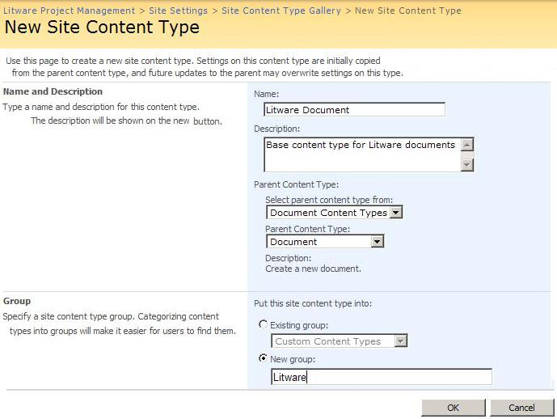

1. Next, add three columns to the new **Litware Document** content type from the existing set of site columns (click on **Add from existing site columns** link). In particular:
   1. Add the **Author** column
   2. Add the **Project** column
   3. Add the **Append-Only Comments** column.
   4. Note: the **Author** column and the **Append-Only Comments** column are provided as standard WSS site columns while the **Project** column is the custom one you created in the previous lab exercise.

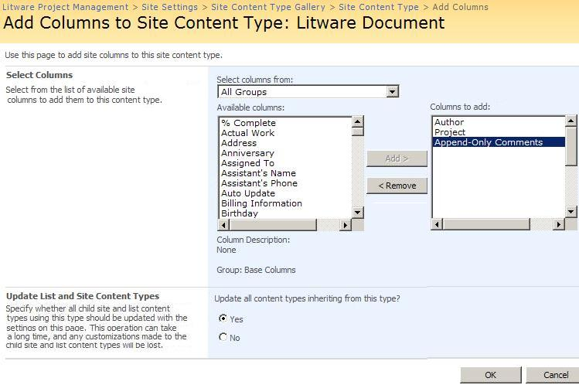

1. Click **OK** to finish adding columns to your **Litware Document** content type and then navigate back to the **Site Content Type Gallery**.
2. Over the next few steps you will create two derived content types: **Litware Proposal** and **Litware Presentation**. These two content types will inherit **Litware Document** and, therefore, automatically contain the columns you created in the previous steps. You will extend these two derived content types by giving them different document templates.
   1. Create a new content type named **Litware Presentation** that inherits from **Litware Document**. To do this, fill in the new content type page using the information shown below and click **OK**.

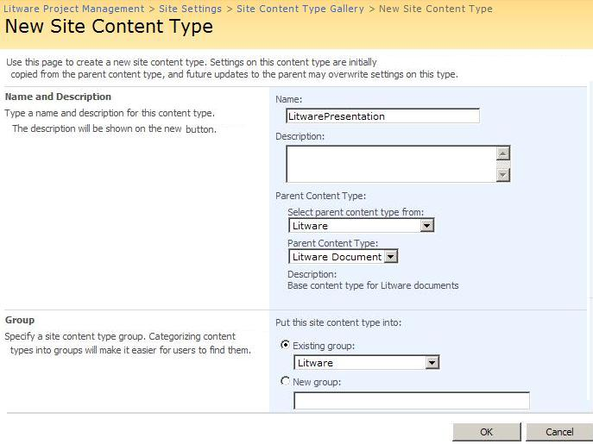

1. After you click **OK** to create the **Litware Presentation** content type, you will be taken to a page that shows the settings and columns for this new content type.
   1. You should observe that the **Litware Presentation** content type contains the same columns that you defined in the base content type **Litware Document**.
   2. Now click on the **Advanced Settings** link to get to the page that allows you to upload a document template for this content type.
   3. Click on **Upload a new document template:**, and the click **Browse**. Use the template file named **LitwarePresentationTemplate.potx** that is located in the **..Labs\09_ContentTypes\LitwareDocumentTemplates** directory.   Once you locate this file be sure to click **Open**.
   4. Click **OK** when you are done to upload the document template.  
        
      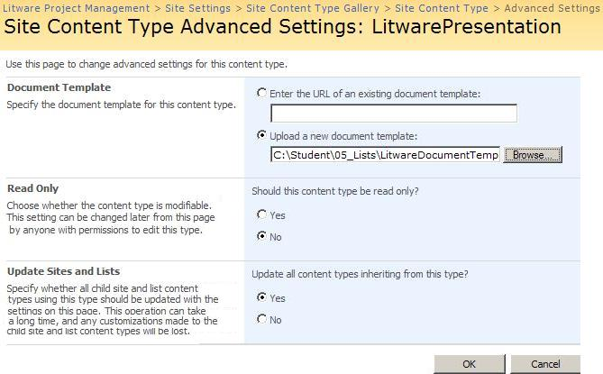
   5. Click on **Site Content Type Gallery** in the breadcrumb list at the top of the page to return back to the **Site Content Type Gallery**.
2. Create a second derived content type named **Litware Proposal** using the exact same steps you used to create the **Litware Presentation** content type. The only thing you should do differently other than giving this content type a different name is to use **LitwareProposalTemplate.dotx** as the file for the document template instead of **LitwarePresentationTemplate.potx**. When you are done with this step you will have two content types that you can now use within the document library named **Project Documents**.
3. Now you will modify an existing document library to utilize your new content types
   1. Navigate back to your **Litware Project Management** site (i.e. Click on the **Home** tab)
   2. Navigate to your document library named **Project Documents.**
   3. Go to the **Document Library Settings** page for the **Project Documents** library (i.e. **Settings** Drop Down > **Document Library Settings**).
   4. Click the **Advanced Settings** link to get to the page where you can enable the setting that allows for multiple content types as shown below. Click **OK** after you have enabled this setting.

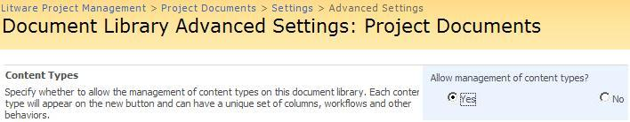

1. Add the content types **Litware Proposal** and **Litware Presentation** to the document library.
   1. In the **Customize Project Documents** page locate the **Content Types** section and click on the **Add from existing site content types** link.
   2. Select **Litware** in the **Select site content types from** dropdown.
   3. select **Litware Presentation** and **Litware Proposal** in the **Available Site Content Types** list and click **Add**.  Be sure to click **OK** when done

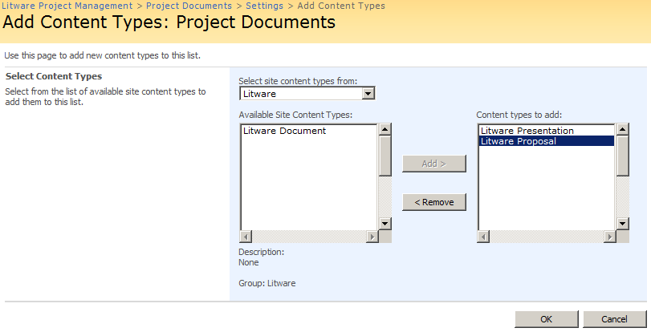

1. Now, navigate back to your **Project Documents** page and examine the files that are already in the **Project Documents** document library by choosing the **Edit Properties** command in the drop-down menu for each individual document. This will bring you to a page that allows you to change the content type for each document.
   1. Change the content type for each document in the document library to either **Litware Proposal** or **Litware Presentation** (**Hint**: match up the names of the Documents with their associated document type—Proposal to Proposal, and Presentation to Presentation).
   2. When you are done, be certain that there are no documents still assigned to the standard content type named **Document**.
2. Go back to the **Document Library Settings** page for the document library named **Project Documents** (**Settings** > **Document Library Settings**) and remove the original content type named **Document**.
   1. On the **Customize Project Documents** page in the **Content Types** section click on the **Document** Content type which will take you the **List Content Type: Document** page
   2. On the **List Content Type: Document**page in the **Settings** section click on **Delete this content type** and click on **OK** on the popup window that appears.
   3. **Note**: you will not be able to remove the **Document** content type if there are still one or more documents in the document library that have this content type. If you have trouble removing the **Document** content type, go through each document in the **Project Documents** library and make sure they are configured with a content type of either **Litware Proposal** or **Litware Presentation** and not **Document**.
3. **IMPORTANT:** In a single machine virtual world (like our lab setup) you may encounter problems saving to the document library (weird error about how there is no connectivity) or using the document information panel tie in with SharePoint (appears in each Office app near the top of the document) . To fix this we must **stop** the **System Event Notification Service**.
   1. Open a command prompt (**start menu - run -** type **cmd -** press **enter**).
   2. From the cmd prompt type **net stop sens** and press **enter** this will stop the System Event Notification Service and you should now be able to use the Office-SharePoint integration features.
4. Use the **New** drop down menu of the **Project Documents** library to create and save a new Litware proposal and a new Litware presentation.
   1. Give these new documents titles like **Presentation Test** and **Proposal Test**.
   2. Allocate both of these documents to the **NW001** **Project**.
   3. Save these documents back to the **Project Documents** library with the names: **New Litware Presentation** and **New Litware Proposal**
   4. When you have successfully completed the lab steps up through this point, the **New** menu should look like the one shown below. (It is possible that you first have to enter the URL to the document library when saving the document in Word).   
      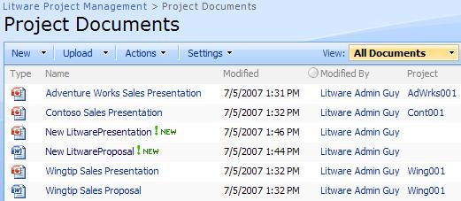
5. **Important:**You will notice that in this view Project information is only showing up for the existing documents and not for the two new ones you just added... let's investigate this behavior.
   1. Navigate to the Project Document Settings page **(Settings** > **Document Library Settings)**
   2. Look at the Columns section, note that there are **TWO** Project items:  One from the Document Library itself (created in Lab 01A) and the other from our Content Types.  
      (i.e. Even though these two columns are identical in information because they come from two separate sources they are stored as separate information.)
   3. **As time permits:** To fix this you would need to **remove the Project Column that is not Used in anything** (i.e. you remove the Project setting marked remove in the figure below) and then you would need to re-enter the project information in the old documents (that now utilize the Content Types we created).  As well you would need to add this Project Column to the default view.  
      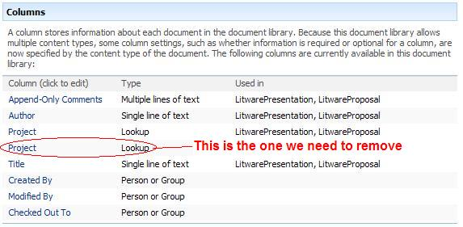
   4. When you have fixed this the **Project Documents** library should look like this:  
      