Lab 14: Creating and Customizing a Corporate Portal Site

**Lab Overview:** In this lab you will create and grow out a new site collection created from the **Collaboration Portal** site template. This will give you an opportunity to see how working with a MOSS site template adds quite a bit of functionality on top of the site templates included with WSS such as Blank Site and Team site.

# Exercise 1: Creating a new Corporate Portal site

1. You will begin by creating a new site collection with a top-level site based on the **Corporate Portal** site template. This **Corporate Portal** site will be used as an intranet site to provide information to Litware employees.
   1. Make sure you are logged onto the VPC as **LITWAREINC\Administrator**.
   2. Open **SharePoint 3.0 Central Administration** and navigate to the **Application Management** page.
   3. On the **Application Management** page, click the **Create Site Collection** link in order to navigate to the **Create Site Collection** page.
   4. Create a new site collection using the following values.
      1. The target Web Application is **http://litwareinc.com**
      2. Title is **Litware Portal**
      3. Web Site Address is **http://litwareinc.com/sites/LitwarePortal**
      4. The Template Selection is **Collaboration Portal** which can be found under the **Publishing** tab
      5. The Primary Site Collection Administrator is **LITWAREINC\Administrator**. (Note that when SharePoint resolves this account it changes it to display the name of **Litware Admin Guy**).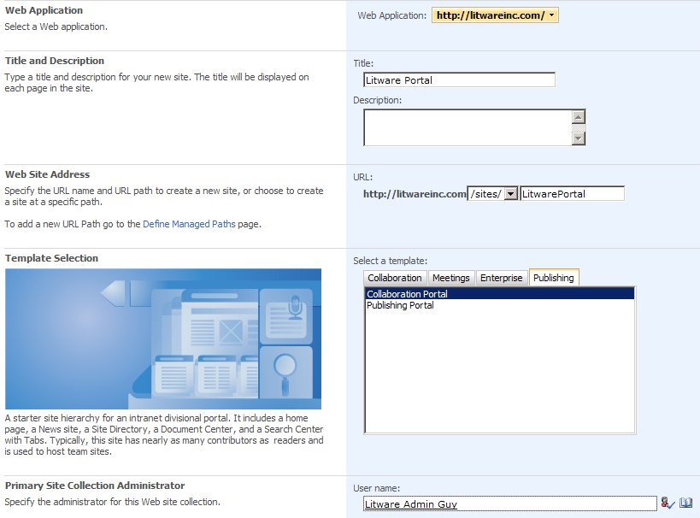
   5. Click **OK** to create the new Portal site.
   6. Once the site has been provisioned, click the link in the **Central Administration** site to navigate to the site at http://litwareinc.com/sites/LitwarePortal**.**
2. Once you have opened the site, take a moment to explore what is inside.
   1. Click on the **View All Site Content** link on the top of the **Quick Launch** bar to navigate to the standard WSS application page which displays what lists, document libraries and child sites exist. Answer the following questions.
      1. What lists have already been created in this top level site?
      2. What document libraries have already been created in this top level site?
      3. What child sites have already been created?
   2. Drop down the **Site Actions** menu and inspect the way the menu commands are structured. You should notice that the Corporate Portal site has a **Site Actions** menu structure that is very different from a standard WSS site. This is due to the fact that the Corporate Portal site template automatically activates a feature named **Office SharePoint Server Publishing**. This feature adds quite a bit of additional functionality on top of what is contained in a standard WSS site.
   3. Within the **Site Actions** menu, choose the click on the command **Site Actions >> Modify All Site Settings**.This will allow you to navigate to the standard WSS site settings page (_layouts/settings.aspx). However, you should notice that the links are arranged differently than in a standard WSS site.
      1. Some standard WSS links have disappeared from the **Site Settings** page. For example, you should notice there is no longer a standard link to modify the Top link bar or the **Quick Launch** menu. That's because SharePoint Server provides a different way to modify navigation links with this site.
      2. Many new links have been added to the **Look and Feel** sections as well as the **Site Administration** section and the **Site Collection Administration** section.
3. Add the user **LITWAREINC\BrianC** as a visitor of the site.
   1. From the Site Settings page, click the **People and groups** link under the **Users and Permissions**.
   2. Drop down the **New** menu and click **New User**.
   3. Add the user account **LITWAREINC\BrianC** as a new member of the **Litware Portal Visitors** group. Note that SharePoint will change the account name to its display name of Brian Cox when it resolved the account against Active Directory).
   4. Choose **Litware Portal Visitors [Read]** from the **Give Permission** section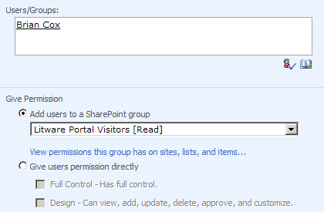
   5. Click **OK**
4. Log in as Brian Cox and access the new Corporate Portal site. This will allow you to see what the site looks like to a user that has no permissions to add and modify content. You will use a Remote Desktop connection to log on as Brian Cox.
   1. Minimize all Windows so you can see the desktop. You should be able to see four shortcuts that allow you to start Remote Desktop sessions under the identities of different users. Click the shortcut with the caption of **RemoteDesktop.msc** to launch the Remote Desktop management console. Make sure the management console is maximized.
   2. Right-click the node **Brian Cox** and choose **Connect**.

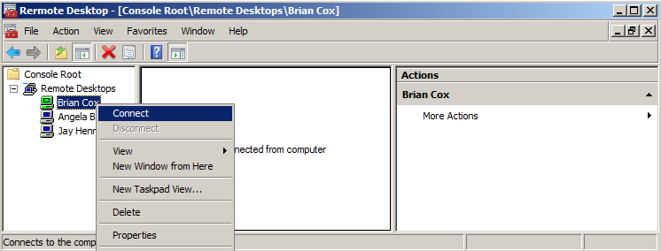

* 1. Enter the password **pass@word1**. This launches a remote desktop session for the user Brian Cox.
  2. While running in the remote desktop session for Brian Cox, access the new portal site at **http://litwareinc.com/sites/LitwarePortal**. You should be able to access the home page of the Litware Portal site and navigate to the various lists, document libraries and child sites below.
  3. While running as Brian Cox, you should note that you cannot see the **Site Actions** menu. However, you do have navigation menus that allow you to move around the site and examine its content.
  4. Do not close out Brian's session. Leave it open so you can return to it later. Minimize the remote desktop Windows so you can resume running as the **Litware Administrator**.

1. While running as **LITWAREINC\Administrator**, return to the Litware Portal site. Now it is time to create a new child site for Litware Human Resources department.
   1. Make sure you are at the top-level site at http://litwareinc.com/sites/LitwarePortal**.**
   2. Drop down the **Site Actions** menu and click the **Create Site** command.
   3. Create the new child site using the following settings.
      1. Site Title is **Human Resources**.
      2. URL name is **http://litwareinc.com/sites/LitwarePortal/HumanResources**.
      3. Template Selection is **Publishing Site** available under the **Publishing** tab.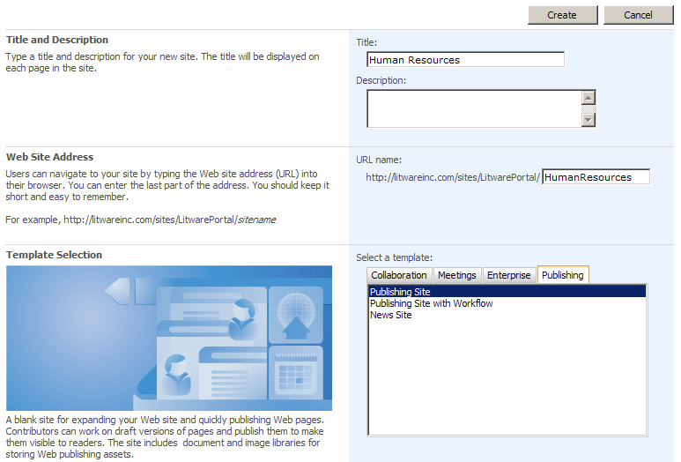
   4. Click the **Create** button to create the new child site.
   5. Once SharePoint has created the new site, you will see the landing page for the site as shown below. Notice there is a new toolbar know as the **Page Editing Toolbar** that allows an authorized user to approve the site so it can be seen by site members. Also note that a new link has been added to the top-link bar so users can navigate to the new **Human Resources** site. Do not click on the **Publish** link until you are instructed to do so.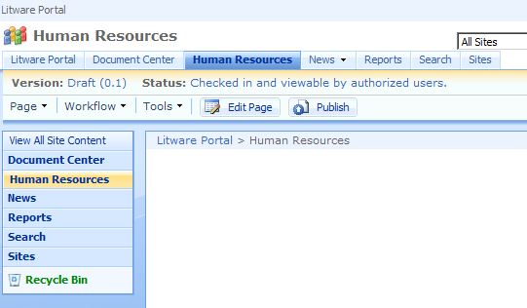
   6. Click the **Edit Page** button to take the current page into editing view. Find the Field Control with the caption of **Page Content** and click the **Edit Content** link to go into editing mode. Add some text that would be a typical announcement on a page within a Human Resources site. When you are done editing the text, find and click the button on the **Page Editing Toolbar** with the caption **Check In to Share Draft**.
   7. Return to the **Remote Desktop Session** for Brian Cox and refresh the browser window showing the portal site. Note that you should not yet see the new child site titled **Human Resources** because it has not yet been published. An authorized user must publish this site before it can be seen by visitors such as Brian Cox.
   8. Leave the **Remote Desktop Session** for Brian Cox and start running as the **Litware Administrator** again.
   9. Now, it is time to make the new page and the entire **Human Resource** site visible to all site users. Click the **Publish** button on the **Page Editing Toolbar** to make the **Human Resource** site visible to everyone.
   10. Return to the **Remote Desktop Session** for Brian Cox and refresh the browser. Now this user should be able to see and navigate the **Human Resources** site and see the content you added to the home page.
   11. Leave the **Remote Desktop Session** for Brian Cox and start running as the **Litware Administrator** again.
2. Now it's time to create a new page within the **Human Resources** site.
   1. From the **Site Actions**, click on the **Create Page** command.
   2. On the **Create Page** page, fill in the following information.
      1. Title is **401K Plan**.
      2. URL Name is **401K**.
      3. Page Layout is **Article page with image on left**. 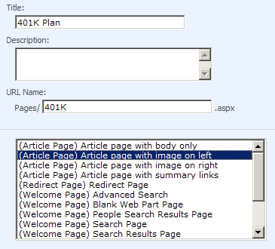
   3. Click the **Create** button to create the page.
   4. Once the page is created, you will find yourself in edit mode. Fill in content within the field controls with something similar to the sample content shown below. Note that you can upload pictures into the portal site from **C:\Student\Resources\Pictures** or **C:\Student\Resources\LitwareGraphics**.
   5. 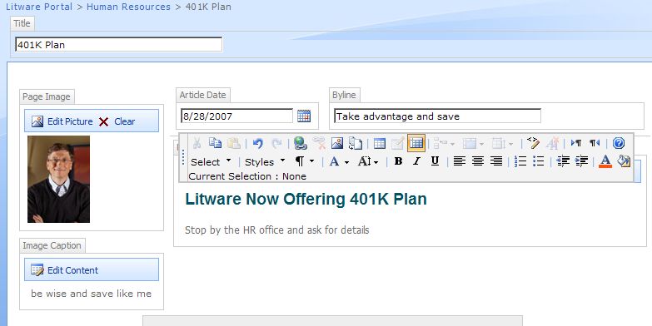
   6. Click the **Publish** button on the **Page Editing Toolbar** so that the page can be seen by all users.
3. On the top-left portion of the browser window, click on the **Litware Portal** link to return to the portal's top-level site. From the **Site Actions** menu, click the **Manage Content and Structure** command.
   1. On the **Site Content and Structure** page, Use the Tree View control on the left-hand side to drill down into the **Human Resources** site.
   2. Look inside the **Pages** document library and locate the page you just created named **401k.aspx**.
   3. Drop down the **ECB** menu for the page **401K.aspx** and see what commands are available.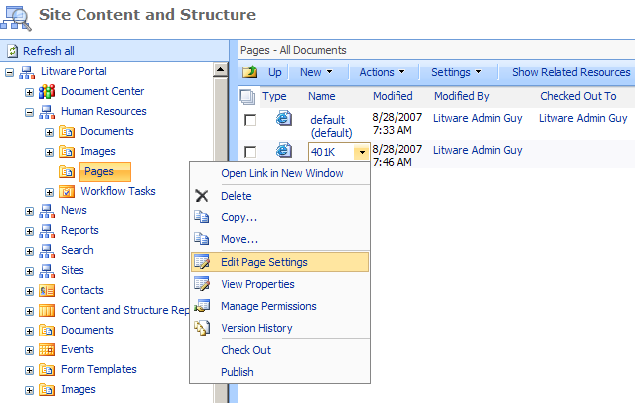
4. Congratulations! You have finished this Lab.