Lab 15: Web Content Management with MOSS 2007

**Lab Overview:** Litware management has decided to use **Microsoft Office SharePoint Server 2007** to create an Internet site that will be used to deliver information about the company and its services. The goal is to enable a number of persons in the company who are not IT/Dev-skilled to create and manage the content. Your job in this lab is to prepare the infrastructure to support this scenario.

# Exercise 1: Creating a new Publishing Portal site

To start, you will be asked to create the site based on the site definition that is made available with **Microsoft Office SharePoint Server 2007**.

1. Open **SharePoint 3.0 Central Administration** and navigate to the **Application Management** page.
2. Locate the **Application Security** group and click on the **Authentication Providers** link. Once you are at the Authentication Providers page, click on the link to configure the **Default Zone** for the Web Application at the URL of **http://litwareinc.com**. Enable **Anonymous Access** for the Web Application at the URL **http://litwareinc.com**.

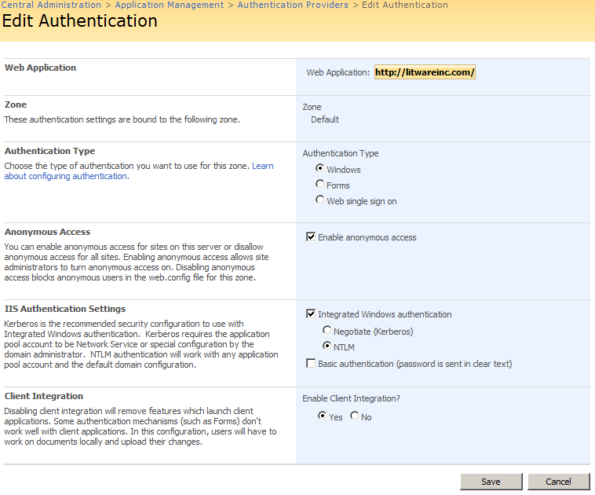

1. Click the **Save** button.
2. Locate the **SharePoint Site Management** group on the **Application Management** page and click the **Create Site Collection** link in order to navigate to the **Create Site Collection** page. Create a new site collection using the following values:
   1. Title: **Litware Inc**
   2. URL: **http://litwareinc.com/sites/PublicLitwareSite**
   3. Site template: **Publishing Portal**

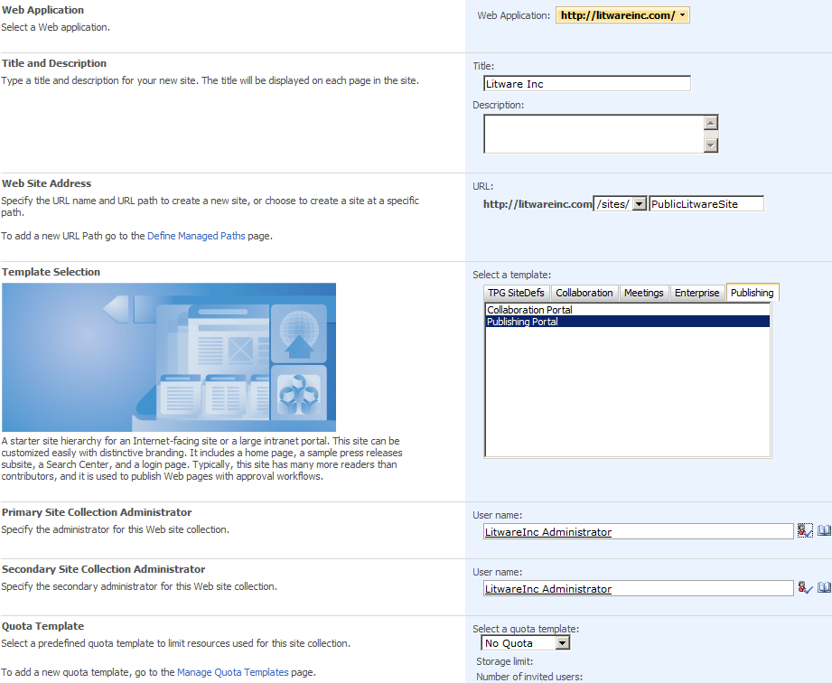

* 1. Primary site collection administrator: **LITWAREINC\Administrator**
  2. Secondary site collection administrator: **LITWAREINC\Administrator**

1. Press the **OK** button to start the process of creating the new site collection. When this process has completed successfully, you will see this administration page that links to the new site.

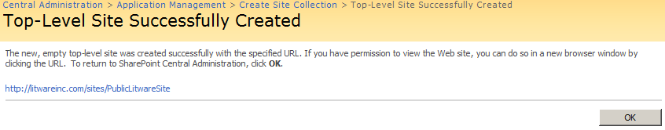

1. Click on the link **http://litwareinc.com/sites/PublicLitwareSite** to open a new browser session with the newly created WCM Publishing site.

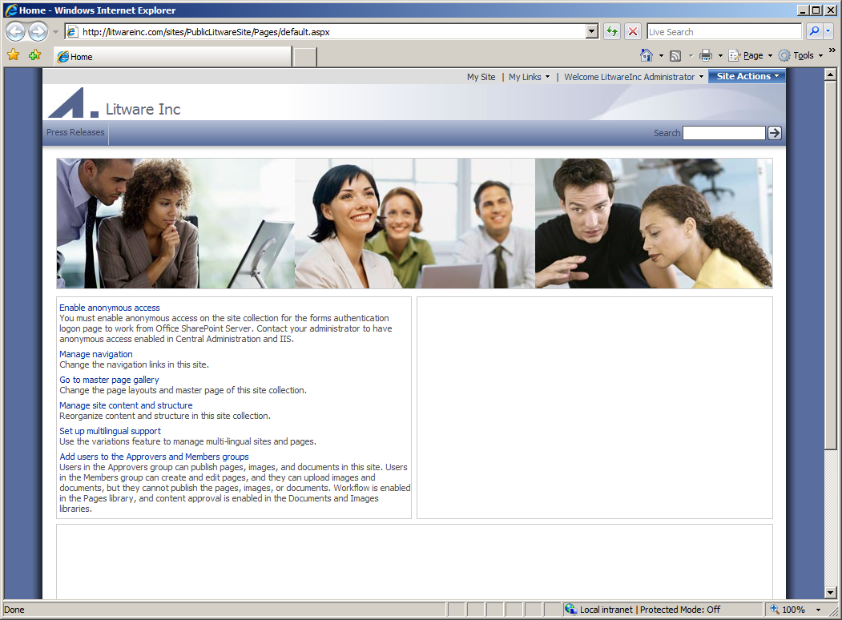

# Exercise 2: Configuring the site for anonymous access

1. Since this will be an Internet-facing Web site, you should enable anonymous access for this site. You have already done it at the level of IIS but now you need to also enable it for the site itself.
2. On the home page of the new site, click on **Enable anonymous access**.
3. Select **Entire Web Site** as the part accessible by anonymous users.

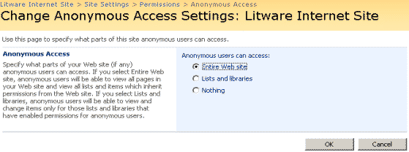

1. Click **OK** to navigate to the **Permissions** page. Here you have to add the anonymous user to the list
   1. Click **New** and the **Add Users.**

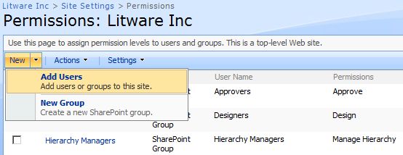

* 1. Add **LITWAREINC\BrianC** in the users box and verify the account.
  2. Set the group to **Litware Inc. Members [Contribute]**.

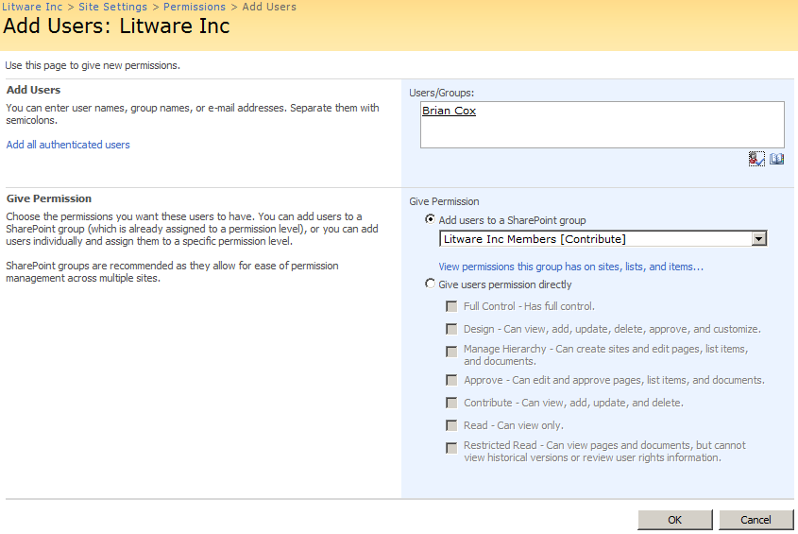

* 1. Press **OK**.

1. To test out your work, in the right hand corner click on **Welcome Litware Admin Guy**, and select sign out. At the pop up, select **No** and click the link to **Go back to site**.

# Exercise 3: Creating Sub Sites

At this moment, you have one top-level site and one sub site called **Press Releases**. In the exercise, you will create a couple more.

1. Sign back in, by clicking the **Sign In** hyperlink in the right hand corner.
2. Use the **Site Actions** to click on the **Create Site**.
   1. Title of the site is **Job Postings**.
   2. Last part of the URL is **JobPostings**.
   3. Click **Create** to start the process.
3. Navigate again to the home page of the top-level site.
4. Now use **Site Actions** to click on **Manage Content and Structure**
   1. Use the ECB on the root node and select **New | Site**.

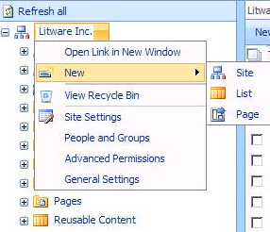

* 1. Title of the site is **Our Products.**
  2. Last part of the URL is **Products.**
  3. Click **Create** to start the process.

1. Create one more sub site under the top-level site with the title **SharePoint Explorer** and a URL **SharePointExplorer**.
2. The **SharePoint Explorer** sub site actually should have created under the **Products** site. Use the ECB for **the SharePoint Explorer Site** and select **Move**. On the **Move…**Web Page Dialog, select **Our Products** and Click **OK**.

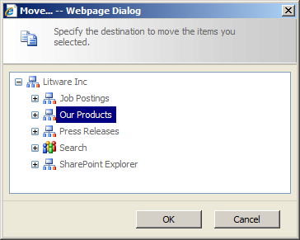

1. Navigate back to **http://litwareinc.com/sites/publiclitwaresite** and take a look at the navigation bar.

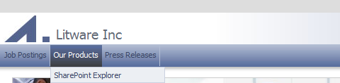

# Exercise 4: Creating a Page Layout

In this exercise you are asked to create templates or page layouts for a job posting and for a product description page.

1. Navigate to the home page of the top-level site.
2. Open the **Site Settings** page.
3. Locate the **Galleries** group and click on **Site Columns** link to open the **Site Column Gallery** page.
4. Create now a new **Site Column** with the following values:
   1. Set the name of the column to **Job Description** of type **Full HTML.**
   2. Create a new group called **Litware Columns.**
   3. Enter a small description like **'Type here the description of the job we are looking for'.**
   4. Press **OK.**
5. Create a second **Site Column** with the following values:
   1. Set the name of the column to **Required Skills** of type **Choice.**
   2. Use the **Litware Columns** group.
   3. Enter a small description like **'Select one or more skills that are required for the job.**'
   4. Enter a couple of choices, like **'SharePoint Administration'**, '.**NET Development'**, ...
   5. Display choices using: **Checkboxes.**
   6. Set the **Allow Fill-In Choices** to **Yes.**
   7. Press **OK.**
6. Create a third **Site Column** with the following values:
   1. Name: **JobTitle**
   2. Type: **Single Line of Text**
   3. Use the **Litware Columns** group.
   4. Press **OK.**
7. Open the **Site Settings** page again by clicking the **Site Actions** button choosing **Site Settings > Modify All Site Settings**.

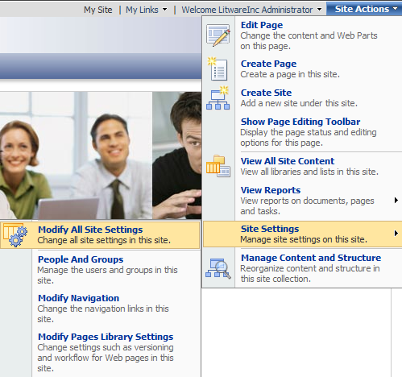

1. Locate the **Galleries** group and click on **Site Content Types** to open the **Content Types Gallery** of the site collection.
2. Create a new **Site Content** with the following values:
   1. Name of the content type is **Job Posting.**
   2. Enter a small description like **'Use this page layout when you want to create a page for a job posting at our company**.'.
   3. Select **Page** from the **Publishing Content Types** group as the parent.
   4. Create a new group called **Litware Publishing Content Types.**

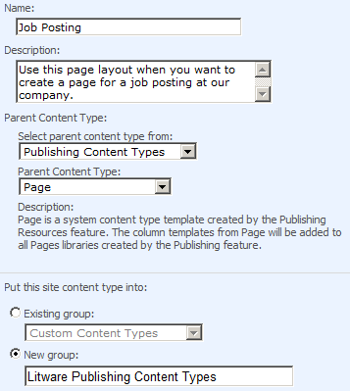

* 1. Press **OK**.

1. Now add 3 columns to the **Job Posting** content type. Click **Add from Existing Columns**.
   1. Add **Job Title** from the **Core Contact** and **Calendar Columns.**
   2. Add **Job Description** and **Required Skills** from the **Litware Columns.**

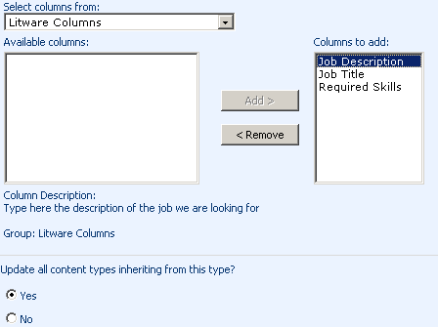

* 1. Press **OK**.

1. Click on **Site Settings** in the breadcrumb to return to the **Site Settings** page.
2. Under the **Galleries** group select **Master Pages and page layouts**. Click **New** and select **Page Layout**.

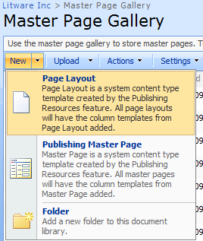

1. In the **New Page Layout** page fill out the following values:
   1. Content Type Group: **Litware Publishing Content Types**
   2. Content Type Name: **Job Posting**
   3. URL name: **JobPosting**
   4. Title: **Job Posting**
   5. Description: **Job Posting Template**
2. Click **OK** to create the page layout.
3. Your next task is to use the **SharePoint Designer** and populate the page layout file with the field controls. Open **SharePoint Designer** and open the **http://litwareinc.com/sites/PublicLitwareSite** site.
   1. In the **Folder List** under _**catalogs** click on **masterpage.**
   2. Double-click the **JobPosting.aspx** item.
   3. Position yourself in the **PlaceHolderMain** and insert a table of 6 rows and one column.

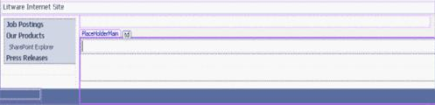

* 1. In the first row add **Are your looking for the following job?**. Apply the **.HeaderTitle_Large** as style.
  2. Drag and drop **Job Title** from the toolbox into the second row.

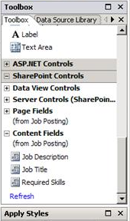

* 1. Set the **CssClass** property also to **.HeaderTitle_Large**.
  2. Drag and drop **Job Description** into the 3th row.
  3. In the **Properties** pane apply the following values:
     1. **AllowExternalUrls**: **false**
     2. **AllowTextMarkup**: **false**
  4. Type ‘**You must have the following skills:**’ in the 5th row and apply the **.HeaderTitle_Large** as style.
  5. Drag and drop **Required Skills** in the 6th row.
  6. Save the page.

1. Go back to the **Master Page and Layout Gallery** in the **Site Settings** page.
2. As you notice in the **Master Page Gallery** in your browser the **JobPosting.aspx** is in draft mode. Check in the page as a major version and next approve the page.

# Exercise 5: The Publishing Cycle

Now change your role and play the content author who is going to use the newly created job posting layout page.

1. Go to the **Job Postings** site and use the **Site Actions** to **Create a Page**.
2. Provide **Office Developer** as the name of the page and select the new **Job Postings** layout page. Press the **Create** button.

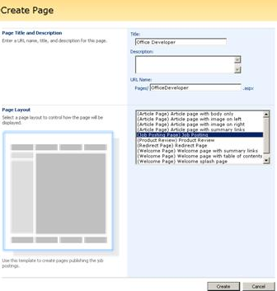

1. Type in some data in the field controls.

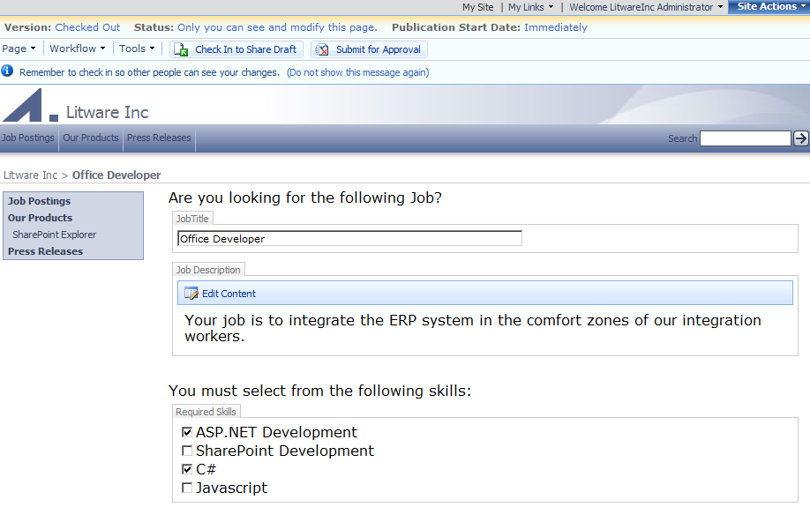

1. When finished, save your page in the database. Click the **Check in to Shared Draft** button in the **Page Editing** toolbar.
2. Now hit the **Submit for Approval** button.
3. Start the approval workflow.

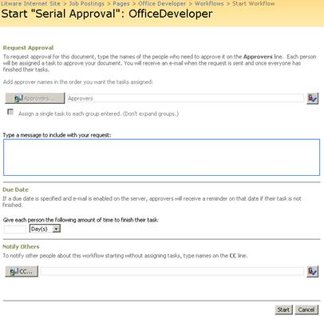

1. Navigate to the **Pages** library of the **Job Postings** site. You should see the page in pending mode.
2. Use the ECB to approve the page.
3. When approved, check out the page by going to the **Job Postings** site again.

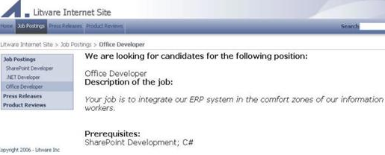

1. This finishes the exercise.

# Exercise 6: Utilizing and Customizing the Content Query Web Part

1. The first step in this exercise is to create the content type to roll up. The goal of this lab is to create a company news content type. This content type will be added to the announcements list in the different departments and then displayed for the public to see on the homepage. Out of the box, the content query web part only displays the title of the item; we will be customizing it to show both the title and the body using **SharePoint Designer**.
   1. Navigate back to the top level site: **http://litwareinc.com/sites/PublicLitwareSite**
   2. On the **Site Actions** menu, select Site **Settings > Modify** all site settings
   3. Under the **Galleries** section, click **Site content types**
   4. Click create and fill in the **New Site Content Type** page as seen below.

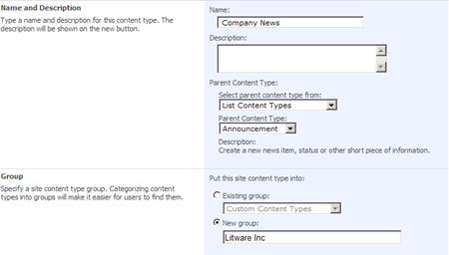

* 1. Click on **LitwarePortal** in the breadcrumb to return to the top level site.

1. In this step we will add an custom list to the **Job Postings** site and configure to use both the item and company news content types. This allows members of this site to go to one spot to create both news for just this division and news for the entire company.
   1. Navigate to the **Job Postings** site.
   2. On the **Site Actions** menu, select **View all Site Content**.
   3. Click **Create > Custom List.**
      1. Name: Announcements
      2. Click **Create**.
   4. On the **Announcements** page, click **Settings > List Settings.**
   5. On the **Customize Announcements** page, click **Advanced Settings.**
      1. The first option is **Content Types**, select **Yes > OK**
   6. Now you need to add the **Company News** content type, in the **Content Types** section, click **Add** **from existing site content types.**
   7. Select **Company News**, and click **Add**, then **OK.**
   8. Navigate back to the **Announcements** list and add one **Company News** list item and one **Announcement** list item.
      1. *Hint: If you select the drop down arrow next to* ***New****, you will see both* ***Company News*** *and* ***Announcement****, select* ***Announcement*** *the first time to create and item and company news the second time*.
2. On the **Litware Inc Portal** home page, you will be adding the content query web part and then customizing it to show the **Company News Content Type.**
   1. Make sure you are the **Litware Inc Portal** home page, **http://litwarinc.com/sites/publiclitwaresite.**
   2. On the **Site Actions** menu, select **Edit Page.**
   3. Delete the content out of the **Summary Links** control on the left, by clicking the icon to the left of each link, and selecting **Delete**. Delete the **Press Releases** web part in the top zone, by clicking **Edit** and **Delete**. At the warning, select **OK**.
   4. Click **Add a Web Part** in the **Top Zone**.
   5. Select **Content Query Web Part** and click **Add.**
   6. On the content query web part you have just added to the page, click **edit** > **modify** shared web part.
   7. In the task pane on the right hand side, expand **query.**
   8. Under **List Type**, select **Custom List.**
   9. Under **Content Type** select the following:
      1. Show items of the this content type group: **Litware Inc.**
      2. Show items of this content type: **Company News.**
   10. Expand the **Appearance** section and rename the web part, **“Important News”.**
   11. Click **OK**.



1. The content query web part should now be displaying on your home page only the announcement you created using the **Company News Content Type**. Currently it only shows the title, it would be helpful if it gave a bit more information for your users.
   1. On the content query web part select **Edit > Export.**
   2. Select **Save > Save**. This should save the file to your **Desktop** folder.
   3. Open the file with **SharePoint Designer**, **File > Open > Browse to the Desktop > Select Important_News.webpart > Open.**
   4. Locate the following line of code approximately line 68:

<Property name=”CommonViewFields” type=”String”/>

* 1. Change this line of code to: (Note: you are adding the field using the internal name of field and the type of field, separated by a comma. The internal name of the field can be found by locating the column, right clicking and selecting properties.

<property name=”CommonViewFields” type=”String”>Body, Rich HTML</property>

* 1. Save the file.
  2. Navigate back to the **Litware Portal** home page.
  3. Choose **Site Actions > Edit Page.**
  4. Select **Add a Web Part in the Top Zone**, in the bottom right corner select **Advanced Web Part Gallery** and options, this will allow us to import our newly configured web part.
  5. On the **Browse** bar in the right hand corner, click the drop down arrow, select **Import**.
  6. Click **Browse**, and navigate to the **Important_News.webpart** file you just edited (it should be saved on the desktop). Click **Upload > Import**.
  7. Navigate back to **SharePoint Designer** and open the site **http://litwareinc.com/sites/publiclitwaresite**/.
  8. In the **Folder List** on the left side, expand **Style Library** and then **XSL Style Sheets**
  9. Double click on **ItemStyle.xsl** to open it.
  10. Replace the following line of code, approximately line 40:

<div class="description">

<xsl:value-of select="@Description" />

</div>

With:

<xsl:variable name="body">

<xsl:call-template name="removeMarkup">

<xsl:with-param name="string" select="@Body"/>

</xsl:call-template>

</xsl:variable>

<div class="description">

<xsl:value-of select="$body"/>

</div>

* 1. Place your cursor at the beginning of the last line of code:

</Xsl:stylesheet>

And hit return.

* 1. Place your cursor in the line you just added and add the following piece of code:

<xsl:template name="removeMarkup">

<xsl:param name="string" />

<xsl:choose>

<xsl:when test="contains($string, '&lt;')">

<xsl:variable name="nextString">

<xsl:call-template name="removeMarkup">

<xsl:with-param name="string" select="substring-after($string, '&gt;')" />

</xsl:call-template>

</xsl:variable>

<xsl:value-of select="concat(substring-before($string, '&lt;'), $nextString)" />

</xsl:when>

<xsl:otherwise>

<xsl:value-of select="$string" />

</xsl:otherwise>

</xsl:choose>

</xsl:template>

* 1. Save the file.
  2. Right-click the file and select **Check in**. On the Check in menu, select **Publish a Major Version**.
  3. Go back to the homepage, select **Submit for Approval > Start**.
  4. On the page editing toolbar, select **Approve**. On the **Workflow Tasks** page, select **Approve**.



* 1. If you would like, delete the first content query web part you added to the page. Remember that since we exported the web part and customized it, they are not the same.

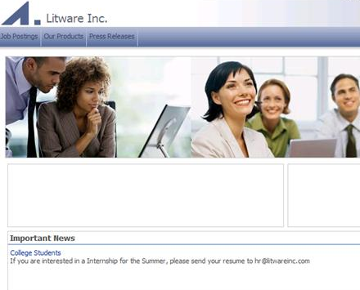

1. You finished this lab successfully.