Lab 16: Business Data Catalog

**Lab Time:** 60 Minutes

**Lab Directory:** C:/Student/Labs/16\_BDC

**Lab Overview:** The Business Data Catalog, or BDC in short, is a new feature introduced with Microsoft Office SharePoint Server 2007, which allows an easy integration between SharePoint and business data present in back-end systems such as SAP, Siebel and Microsoft SQL Server. The BDC is activated as a service within the Shared Services model of SharePoint 2007. The shared service can be utilized from various places inside a site such as Web Parts, lists, the search environment and from user profiles. One of the major design goals of the BDC is to enable minimal-code data retrieval from a disparate set of back-end systems. To achieve this goal the BDC provides a metadata model that provides a consistent environment for creating BDC enabled applications. In this lab exercise you will work with a predefined BDC application and find out where this application definition can be used to provide a value-add solution on top of the out of the box functionality provided by SharePoint 2007. You will begin with importing the BDC application into SharePoint. Next you will use various BDC enabled technologies such as the Web Part framework and SharePoint lists. You will finish the lab exercise by creating a custom Web Part that accesses the BDC through the BDC object model.

# Exercise 1: Import an existing BDC application definition

In this exercise you will examine a pre-built BDC metadata definition which retrieves data from the **AdventureWorks** data-warehouse. Next you will import this application definition into SharePoint and examine the elements it contains using the browser. You will also modify the BDC security settings to allow non-administrative level users to view the data contained in the BDC application. The exercise will finish with the creation of a simple site and Web Part page to allow the BDC data to be displayed.

### Examine the BDC metadata definition

The BDC metadata file is an elaborate XML definition containing the data types and operations available on the external data source. In this step you will examine a metadata file which contains information about products, product categories and product resellers from the **AdventureWorks** sample database.

1. Open **Windows Explorer** and navigate to the following location: **C:\Student\Labs\16\_BDC\Starter Files.**
2. Open the **AdventureWorksDWH.xml** BDC metadata definition in **Internet Explorer**. The metadata definition contains information about four entities, their relationships and their corresponding operations.
3. Begin by examining the root element called **LobSystem**. It contains three important fields. The **name** for the BDC application, **versioning information** and the **type** of application, database or web service.
4. Next examine the child elements of **LobSystem**.
   1. Look at the **Properties** node. It defines properties specific for this BDC application and can be thought of as an extra set of properties for the **LobSystem** element.
   2. Examine the **LobSystemInstances** node. This element defines the **connection** to the Adventure Works data-warehouse database.
   3. Take a look at the **Entities** element. An entity can be thought of as the **definition of a** **record** in the database (a table definition).
   4. Finish with the **Associations** element. This part of the definition is used to define the **relationships** between entities. This allows you to perform drill-down operations on business data.
5. Expand the **Entities** node and next expand the **Entity** node for the **Product** entity. Examine the child elements.
   1. Look at the **Properties** element, now used within an Entity element. It defines properties specific for the Product entity.
   2. The **Identifier** element is used to define the name of an identifying property. This name will later be attached to the fields of the entity to identify those fields as being part of the primary key for the entity.
   3. The **Methods** element is used to define the available operations on this entity and the data that the operation returns.
6. Expand the **Methods** element for the **Product** entity. Examine the structure that makes up an operation.
   1. The **Properties** element is again used as a container element for its parent, which in this case is the **Product** entity.
   2. The **FilterDescriptors** element defines the values to be used for filtering the retrieved items with the operation.
   3. The **Parameters** element defines the input and output parameters for the operation.
   4. The **MethodInstances** define the actual callable operations. The same Method definition can define multiple method instances. The **GetProducts** method can for instance return a single product or a set of products.

### Import the BDC metadata definition

Now that a basic understanding has been reached of the contents of the BDC metadata definition, this definition can be loaded into the BDC environment. The shared service provider has a configuration page where you can administer the BDC.

1. Open **SharePoint 3.0 Central Administration** and navigate to the **Application Management** page.
2. On the **Application Management** page locate the **Office SharePoint Server Shared Services** group.
3. Click **Create or configure this farm’s shared services** in order to navigate to the **Manage this Farm’s Shared Services** page.
4. On the **Manage this Farm’s Shared Services** page, open the ECB for **Litware SSP** and click **Open Shared Services Admin Site** in order to navigate to the shared services administration page.

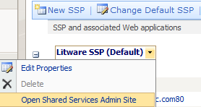

*Note: you could also have selected the* ***Litware SSP*** *from the* ***Quick Launch****.*

1. On the **Shared Services Administration** page, click **Import application definition** in order to import a new BDC application definition into the BDC environment. All the BDC related options are combined within the Business Data Catalog group.

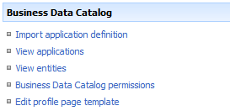

1. Import the BDC application using the following settings
   1. Application definition file is **C:\Student\Labs\16\_BDC\Starter Files\AdventureWorksDWH.xml**
   2. File type is **Model**
2. Click **Import** to begin the process of importing a BDC application.
3. After the process is finished, click **OK** to be redirected to the **View Application: AdventureWorksDW** page. Review the information on this screen and leave it open for the next task.

### Allowing user access to the BDC application

The imported BDC application is initially only available for administrative users. The BDC specific application management page allows the modification of these permissions to allow fine-grained control over who can access the BDC data and in what manner. First you will provide user access to the BDC application imported in the previous step. Next you will provide user access to the BDC subsystem as a whole.

1. On the **View Application: AdventureWorksDW**  page, click **Manage permissions** in order to change the default permissions of the BDC application.
2. On the **Manage Permissions: AdventureWorksDW** page, click the **Add Users / Groups** button in order to add permissions.
3. Add the following permissions:
   1. Users / Groups is **LitwareInc\Domain Users**
   2. Choose permissions is **Execute 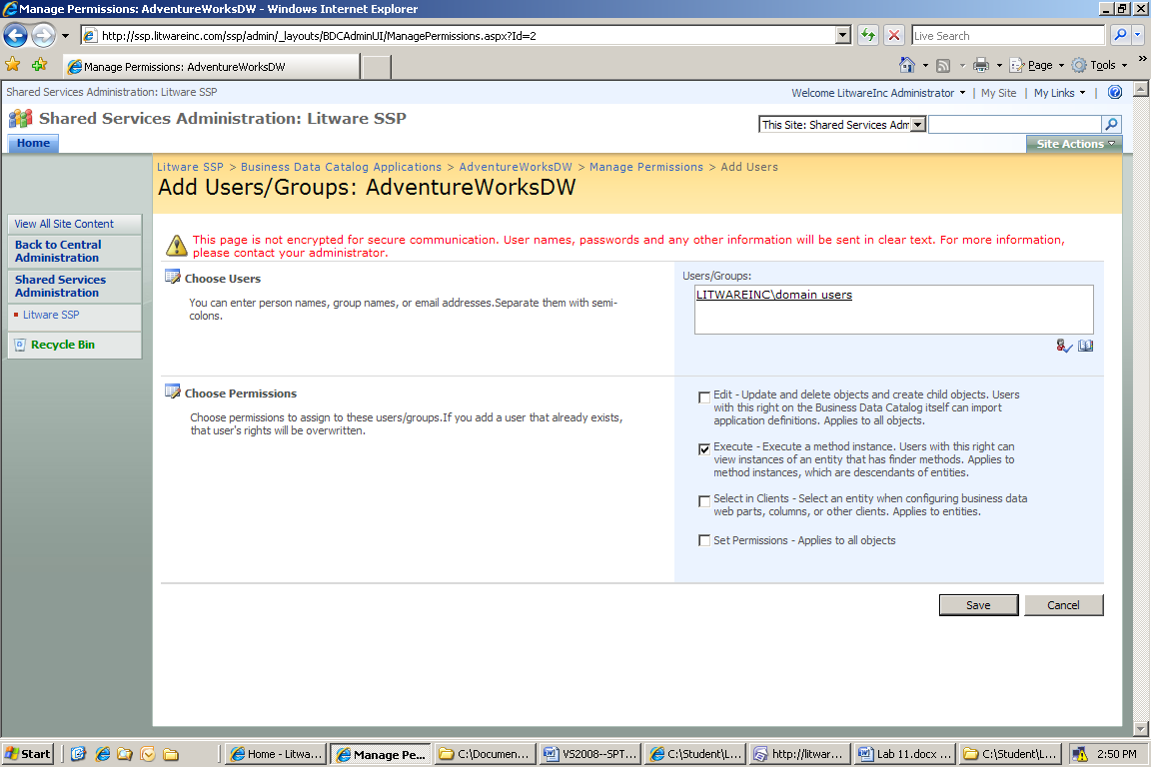**
4. Click **Save** in order to attach the new permissions to the BDC application.
5. Go back to the **Shared Service Administration: Litware SSP** page. If your browser window is closed, you can take the following steps to go back to this page, or use the breadcrumb control available on most SharePoint pages.
   1. Open **SharePoint 3.0 Central Administration** and navigate to the **Application Management** page.
   2. On the **Quick Launch** select Litware SSP.
6. On the **Shared Services Administration: Litware SSP** page, click **Business Data Catalog Permissions** in order to control the user access permission to the BDC subsystem.
7. On the **Manage Permissions: Business Data Catalog** page, click the **Add Users / Groups** button in order to add permissions.
8. Add the following permissions:
   1. Users / Groups is **LitwareInc\Domain Users**
   2. Choose permissions is **Execute**
9. Click **Save** in order to attach the new permissions to the BDC subsystem.

# Exercise 2: Using BDC Web Parts

Now that the BDC application has been defined and security has been set, it is time to start making use of the built-in Web Parts for accessing BDC data. In this exercise you will use various Web Parts deployed with SharePoint 2007 to access and display hierarchical data. Before working with the Web Parts, a separate top-level site will be created for this exercise.

### Create the BDC Web Part top-level site

While BDC Web Parts can be used on all sites that have the correct features activated, in this exercise you will create a separate top-level site to work with. This allows you to focus on the Web Parts and not worry about other details.

1. Open **SharePoint 3.0 Central Administration** and navigate to the **Application Management** page.
2. On the **Application Management** page, click the **Create Site Collection** link in order to navigate to the **Create Site Collection** page.
3. Create a new site collection using the following values.
   1. Be sure that the **Web Application** is set to [**http://litwareinc.com**](http://litwareinc.com)(not <http://ssp.litwareinc.com>).
   2. Title is **BDC Lab**
   3. Web Site Address is **http://litwareinc.com/sites/BDCLab**
   4. Template Selection is **Blank Site**, which you find under the **Collaboration** group.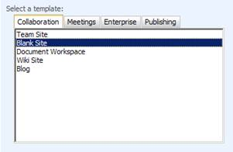
   5. Primary Site Collection Administrator is **LitwareInc\Administrator**.
4. Click **OK** to start the process of creating the new site collection. When this process has completed successfully you will be presented with an administration page that links to the new top-level site. Navigate to the new top-level site.

### Creating the main site layout

The new top-level site will contain a list of product categories and product subcategories. The final layout will allow a user to select a category and be presented with the list of subcategories for the selected category. The next task will expand on this model by altering the profile page for a subcategory to also display all the products within that subcategory. Before using the BDC features on the BDC Lab site, first the BDC needs to be activated through a feature.

1. On the main page of the **BDC Lab** site, click the **Site Actions** button and choose **Site Settings** from the menu that appears. This will allow you to edit the Web Parts on the main page.
   1. On the **Site Settings** page, choose **Site collection features** under the **Site Collection Administration** group.
   2. On the **Site Collection Features** page, click **Activate** next to the feature named **Office SharePoint Server Enterprise Site Collection features** in order to provision the **BDC Web Parts** to the site collection.
2. Navigate back to the **Site Settings** page of the BDC Lab site, and choose **Site features** under the **Site Administration** group.
   1. Click **Activate** next to the feature named **Office SharePoint Server Enterprise Site Collection features** in order to provision the BDC Web Parts to the site.
3. Use the breadcrumb or URL to navigate back to the site. The URL to navigate to is http://litwareinc.com/sites/BDCLab
4. On the main page of the **BDC Lab** site, click the **Site Actions** button and choose **Edit Page** from the menu that appears. This will allow you to edit the Web Parts on the main page.

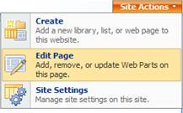

1. Click the **Add a Web Part** button available inside the **Left** Web Part Zone in order to add new Web Parts to the page.
2. In the **Add Web Parts to Left** dialog, choose the **Business Data List** and **Business Data Related List** Web Parts from the **All Web Parts** group. Click **Add** to close the dialog and add the Web Parts to the main page.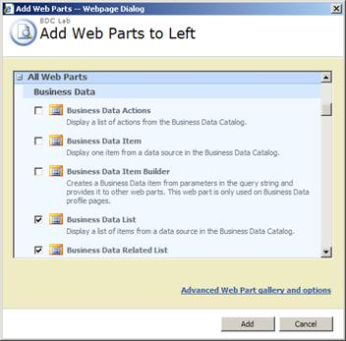
3. The **Left Web Part Zone** should resemble the following image. In the next task you will configure each of the two Web Parts. 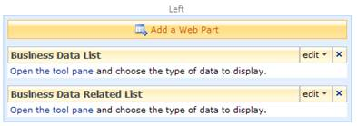

### Configuring the Business Data List Web Part

The first Web Part that will be using the BDC is the **Business Data List** Web Part. This Web Part can be used to display a list of records (BDC entities).

1. In the **Business Data List** Web Part, click **Open the tool pane** to configure the Web Part.
2. In the **Business Data List** tool pane, configure the Web Part with the following settings.
   1. Type is **Product Category**. You can find the **Type** property in the **Business Data List** group.

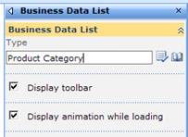

* 1. Click **OK** at the bottom of the tool pane in order to show the list of **Product Category** entities in the **Business Data List** Web Part.

1. In the **Business Data List** Web Part, click **Retrieve Data** to verify that the Web Part successfully retrieves data from the LOB system through the BDC. Note that the title of the Web Part has changed to reflect the type of data it is retrieving.

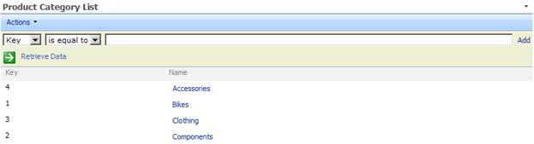

### Configuring the Business Data Related List Web Part

The second Web Part on the page is a Business Data Related List Web Part. This Web Part will display related records based on the selection of the Business Data List Web Part, forming a master-detail hierarchy. In this sample the Business Data Related List Web Part will display a list of Product Subcategory entities based on the selected Product Category.

1. In the **Business Data Related List** Web Part, click **Open the tool pane** to configure the Web Part.
2. In the **Business Data Related List** tool pane, configure the Web Part with the following settings.
   1. Type is **Product Subcategory**. You can find the **Type** property in the **Business Data Related List** group.

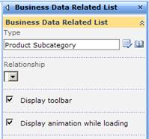

* 1. Press the **Check Types** D:\Data\Courseware\SP_Html2Word\SPT401\Student_xxx\Labs\11_BDC\default_files\image011.jpg button directly beside the **Type** field to verify whether you have entered the Product Subcategory correctly. This will also select the relationship to the Product Category.
  2. Click **OK** at the bottom of the tool pane in order to show the list of **Product Subcategory** entities in the **Business Data Related List** Web Part. Note that the title of the Web Part has changed to **Product Subcategory List**.

1. On the **Edit** menu of the **Product Subcategory List** Web Part, choose **Connections**, next choose **Get Related Item From** and choose **Product Category List** in order to have the sub category list populated from the selected item in the Product Category Web Part. Note that this modifies the Product Category List Web Part which now shows selection buttons for each item displayed.

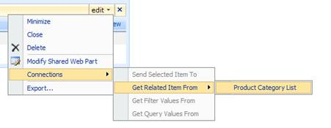

1. Verify that the final page looks like the following image. You can select an item in the **Product Category List** Web Part and display detail records in the Web Part listing sub-categories.

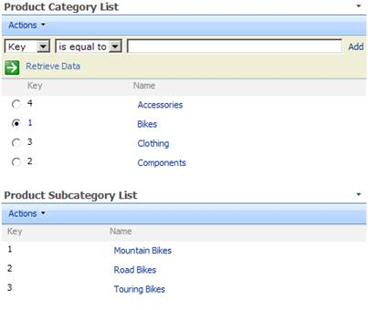

### Creating the profile page

Each BDC entity has a special page where the details of the entity can be viewed. This page is called the profile page. You can modify the contents of these pages to display unique content along with the entity details. In this task you will modify the profile page for the **Product Subcategory** entity in order to display a list of products contained in the category, creating an extra level in the master-detail hierarchy.

1. On the item menu for an item displayed by the **Product Subcategory List** Web Part, choose **View Profile** in order to navigate to the profile page of the sub category. Note that this page is part of the shared service provider architecture. You can notice this from the URL you are being redirected to.

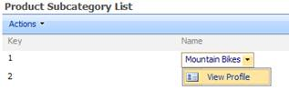

1. On the layout page of the Product Subcategory, click the **Site Actions** button and choose **Edit Page** from the menu that appears. This will allow you to edit the Web Parts on the profile page. When going to the edit mode, note the presence of the normally invisible Business Data Item Builder Web Part on the layout page. This Web Part takes the context on the query-string to retrieve the selected BDC entity.



1. Click the **Add a Web Part** button available from the **Bottom Zone** Web Part Zone in order to add new Web Parts to the page.
2. In the **Add Web Parts to Bottom Zone** dialog, choose the **Business Data Item** and **Business Data Related List** Web Parts from the **All Web Parts** group. Click **Add** to close the dialog and add the Web Parts to the main page.

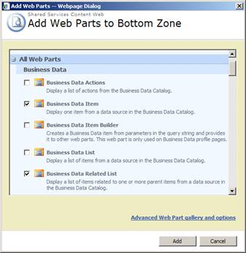

1. The profile page should resemble the following image. In the next task you will configure each of the two Web Parts added to the profile page. The first Web Part will display a list of products for the selected sub category. The second Web Part will display the product details for a selected product. You can also view these details on the product profile page.

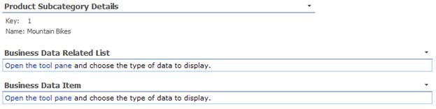

1. In the **Business Data Related List** Web Part, click **Open the tool pane** to configure the Web Part.
2. In the **Business Data Related List** tool pane, configure the Web Part with the following settings.
   1. Type is **Product**. You can find the **Type** property in the **Business Data List** group. Use the **Browse** D:\Data\Courseware\SP_Html2Word\SPT401\Student_xxx\Labs\11_BDC\default_files\image017.jpg button to choose the **Product** entity.

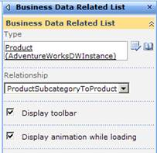

* 1. Click **OK** at the bottom of the tool pane in order to show the list of **Product** entities in the **Business Data Related List** Web Part. Note that the title of the Web Part has changed to **Product List.**

1. On the **Edit** menu of the **Product List** Web Part, choose **Connections**, next choose **Get Related Item From** and choose **Business Data Item Builder** in order to have the product list populated from sub category in context on the profile page. The Web Part should start retrieving data immediately.

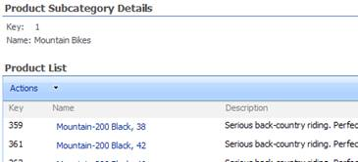

1. Finish the profile page for the **Product Subcategory** entity by configuring the **Business Data Item** Web Part using the following details.
   1. Configured display entity is **Product**
   2. Add a connection from **Product List**
2. Verify that you can now select a product in the **Product List Web Part** and see the details in the **Product Web Part**.

# Exercise 3: BDC List Column

The Business Data Catalog is available from many places within the SharePoint environment. In this exercise you will create a custom list which contains a BDC lookup column. You can use this column type to look up records in the BDC application and display the record inline in the list definition.

### To create a BDC enabled list

The first step consists of creating a new custom list. You will add and configure the list columns to include a BDC column.

1. Open a browser window and navigate to the root site for this lab exercise located at **http://litwareinc.com/sites/BDCLab.**
2. On the **Site Actions** menu, choose **Create** in order to go to the content creation page.
3. On the **Create** page, in the **Custom Lists** group, choose **Custom list** in order to add a new list to the site.
4. On the **New** **list** page, use the following information to create the new list.
   1. Name is “**Product Ratings**”
   2. Description is “**Rates the AdventureWorks product line.**”
5. Click **Create** in order to create the new list and open the default list view.
6. On the **Product Ratings** page, open the list settings by choosing **Settings** and next **List Settings**.
7. On the **Customize Product Ratings** page, choose **Create Column** in order to add a new BDC column to the list definition.
8. In the **Create Column: Product Ratings** page, use the following information for the column definition.
   1. Column name is **Product**
   2. Column type is **Business Data**
   3. Require information is **Yes**
   4. Type is **Product**
9. Click **OK** to close the column creation page and add the new column definition to the list.
10. Repeat steps 7 through 9 using the following column definition.
    1. Column name is **Rating**
    2. Column type is **Choice**
    3. Require information is **Yes**
11. Choices are:
    1. **Very good**
    2. **Somewhat good**
    3. **Not so good**
12. Display choice is **Radio Buttons**

### To view the BDC enabled list

1. Navigate to the list using the following location  
   **http://litwareinc.com/sites/BDCLab/Lists/Product%20Ratings**
2. Add new items to the list and view the results. The following image displays how this can look on your SharePoint environment.

