Lab 02: Exploring CSS in SharePoint

**Lab Overview**: In this lab, we will change some CSS directly in a master page to see the results on a SharePoint Team site. The lab will explore some of the important CSS topics that were covered in this module. Because we will be exploring simple changes that are easy to observe, we will not be focusing on a pleasing design at this point but instead exploring how CSS works.

**Lab Setup:** Run the batch file named **CreateSiteForLab2.bat** in order to create s new site collection with a Team site as the top level site. You will do all your work in this lab by creating customizations to this site with the SharePoint Designer. Note there is also a batch file in the lab directory named **RefreshSiteForLab2.bat.**You can use this second batch file if you delete the site you have been working on in this lab and to recreating a new site to start the these lab instructions from the beginning.

Exercise 1: Basics of editing the site with SharePoint Designer

1. Locate and run the batch file named **CreateSiteForLab2.bat.**
2. Open the Internet Explorer and browse the new site at the URL of <http://litwareinc.com/sites/Lab02>
3. Next we will open that site in SharePoint Designer and make a copy of the default master page and then set that new master page to be the default for our site
   1. Click Start > All Programs > Microsoft Office > SharePoint Designer
   2. Once SharePoint Designer opens, click File > Open Site…
   3. In the Site name box enter <http://litwareinc.com/sites/Lab02> and click Open
   4. The site opens in SPD and on the left hand side you will see the Folder List pane will show the contents of the site  
      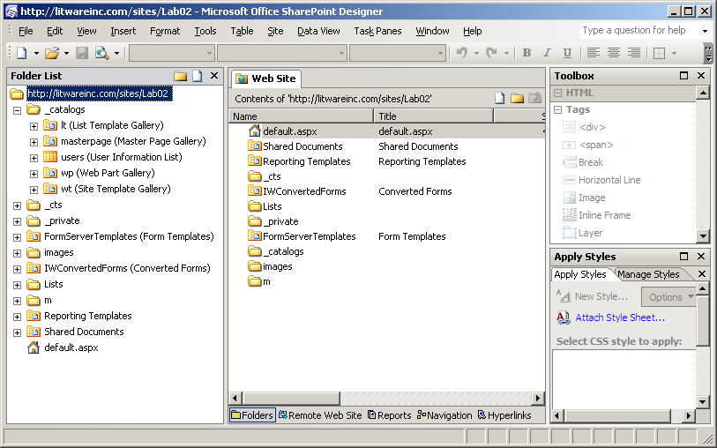
   5. In the Folder List pane, expand _catalogs > masterpage. You will see a list of master pages and page layouts for the site.
   6. 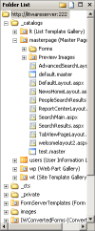Right-click on default.master and click copy, then right-click on the masterpage folder and click paste
   7. Right-click on the new master page “default_copy(1).master” and rename it to wingtip_css.master
   8. Right-click once more on the master page and select **Set as Default Master Page** and say **Yes** to the alert warning.This will make our team site utilize this master page instead of the original default.master
4. Explore some CSS that is showing in the master page
   1. Double-click wingtip_css.master and it will open the master page in Design view (assuming you haven’t used SharePoint Designer before and switched to Code view).
   2. Click on the title “Team” that is beside the icon of the four colorful people. Notice that the placeholder is highlighted in purple
   3. Switch to Code view by clicking the button at the bottom-center of SPD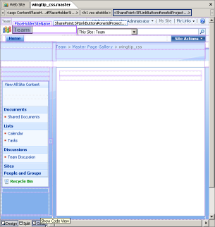
   4. This will show you the underlying code of the master page and preselect the title that is located in the placeholder that was selected in the Design view. It should have selected the following code: 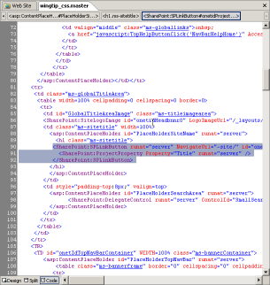
   5. In the left hand bottom Pane set, select CSS Properties and click the Summary button
   6. You can see from this Pane that the color has been overridden a few times finally ending up at #666666
   7. If you click that final color, the Applied Rules section will highlight **.ms-sitetitle** from the core.css. This is the CSS rule that is ultimately setting the text color
   8. From this Pane we could change the value of the color, but this would actually create a copy of the core.css and apply that to the master page, this is usually not preferred it complicates the branding effort. We will look at other ways of overriding core.css shortly

Exercise 2: Working with the Internet Explorer Toolbar and Firebug

1. We can also discover CSS that is being used on a page view the IE Developer Toolbar.
   1. Switch back to Internet Explorer and click the double arrow in the top right toolbar and turn on the IE Developer Toolbar   
      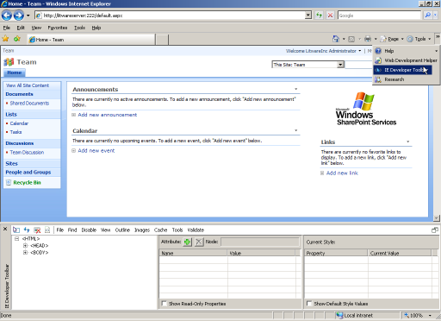
   2. You will see at the bottom of the screen the toolbar. Click the far left icon in the new toolbar that looks like an arrow over a box: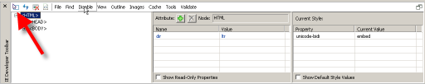
   3. This allows you to select HTML elements by simply rolling over them with the mouse and then clicking
   4. Mouse over the title tag in the browse and you will see that it is highlighted. Click it and the IE Developers Toolbar will display information about the applied styles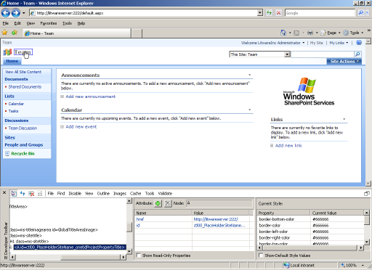
   5. In the right hand column of the IE Developers Toolbar you can scroll down to see that once again the color applied is #666666
2. Let’s examine the CSS one more time in Firebug just to get the full picture of using the tools
   1. Open Firefox by clicking Start > Mozilla Firefox
   2. Browse to the same URL: [http://litwareinc.com/sites/Lab02/default.aspx](http://litwareserver:222/default.aspx)
   3. Right-click on the title “Team” and select Inspect Element, Firebug will display the applied styles.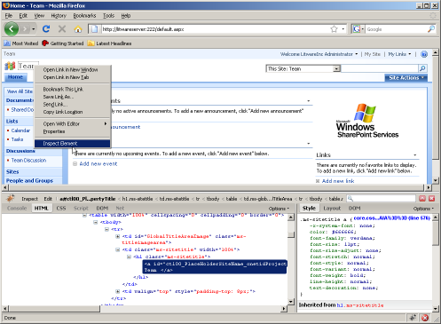
   4. Notice in the right hand column Firebug tells us that line 576 of core.css applies the style to this tag and obviously again it is applying the color of #666666.
   5. One nice feature of Firebug is that you can change values and see the result in real time (IE Developers Toolbar can do this to a certain degree but the interface is more clumsy to work with)
   6. Click on the value of color “#666666” and Firebug will highlight it, press Backspace and then the down arrow, Firebug will begin cycling through the available values for the color property.
   7. Cycle through the colors until you end up at “Lime”, notice that the color of the title has changed through the cycling
   8. Lets also change the font-family to “Times New Roman” and the font-size to “26px” (just enter that one manually)
   9. Note that these changes are purely cosmetic if you hit refresh now the changes would be lost forever (so don’t do it right now). In the next Exercise we will make the change permanent

Exercise 3: Changing some CSS

1. Rather than get bogged down with understanding how to add external stylesheets to master pages at this time we will focus on just adding an internal stylesheet directly to the master page (certainly not a best practice but we will look at that in a later Lab).
   1. Add the following lines between <SharePoint:SoapDiscoveryLink runat="server"/> and <asp:ContentPlaceHolder id="PlaceHolderAdditionalPageHead" runat="server"/>:

<style type=”text/css”>

</style>

* 1. Now we are going to copy and paste the CSS we previewed in Firebug, switch back to Firebug and carefully select the CSS class:

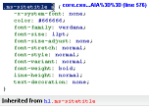

* 1. Next right click on that selection and choose “Copy” and then paste it between the style tags and then add an opening and closing { } after the class
  2. Go back to Firebug and select and copy the styles that we have changed:

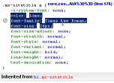

* 1. Paste these styles between the { } that you just added
  2. With some formatting you will hopefully have a style that looks like this:

<style type="text/css">

.ms-sitetitle a {

color:Lime;

font-family:Times New Roman;

font-size:26px;

}

</style>

* 1. Save the master page. You will get a warning about customizing the page from the site definition. Click Yes because we do want to customize it
  2. Now refresh Firefox and you will see that the changes have been finalized. You can refresh IE as well to see the change there
  3. What if we wanted to change all the links on the page to lime green instead of just the title? If you change the style to:

<style type="text/css">

a {

color:Lime;

}

</style>

Save the master page and refresh the browser, you will see that the links do NOT change to lime green. This is because all of the links on this page have their link styles specified with a class or some other identifier (as was the title that we just styled). In order to style all of the links you need

* 1. Change the style on the master page to:

<style type="text/css">

a:link {

color:Lime;

}

</style>

Save the master page and refresh the browser you will see that many of the links are now green, those that aren’t have actually had the a:link style specified. Another option would have been adding **!important** to the previous style like this:

<style type="text/css">

a {

color:Lime !important;

}

</style>

This would style all of the links on the page to green, but keep in mind there may be some links that SharePoint really wants colored a certain way (such as editor bar styles), this method may be a bit too much, it’s up to you.

* 1. Before we start the next exercise, you will probably want to clear out this lime style since it’s not very appealing. Simply remove all the styles back to just the <style></style> tag and save the master page.

Exercise 3: Styling Some of the SharePoint Elements

1. Now we will look at restyling some of the key areas of a SharePoint site using only CSS. We will start by hiding the Recycle Bin in the left hand menu.
   1. If we inspect the Recycle Bin through any of the means we have previously we can try to find a unique identifier that will allow us to hide it, without hiding all the other links in the left bar. 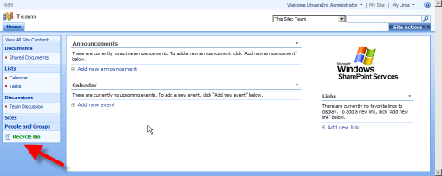
   2. You can see that the Recycle Bin sits in a Table that has a class of “ms-recyclebin” we can use this to hide it

From SPD add the following style to our existing <style></style> section:

<style type="text/css">

.ms-recyclebin {

display: none;

}

</style>

* 1. Save the master page and refresh your browser and you should see that the entire line that had the Recycle Bin has disappeared from the left navigation

1. Next, we will change the Site Actions menu button to something less obvious (no button background or border). The styles that will be used here can always be changed to add your own button background, colors, borders, or fonts if you would like to have a different look. 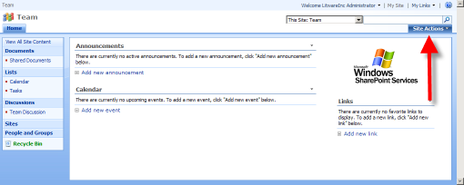
   1. If you inspect the HTML and CSS that surrounds the Site Actions menu, you will see that it is complicated.
   2. For simplicity sake here is the CSS that is need make the Site Actions look cleaner:

/* site actions bg */

.ms-siteactionsmenu div div div {

background-image:none;

background-color:transparent;

background-repeat:repeat-x;

border-left:1px solid transparent;

border-right:1px solid transparent;

border-top:1px solid transparent;

height: 15px;

line-height: 15px;

padding: 4px 10px;

}

/* site actions text */

.ms-siteactionsmenu div div div a {

color:#3966BF;

font-weight:bold;

}

* 1. Apply this style to the style section of the master page, save it and refresh the browser. You should see that the Site Actions menu looks much simpler: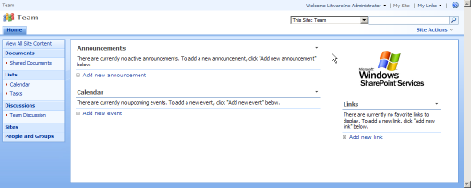
  2. However, if you mouse over the Site Actions you will see that Microsoft has added a completely new set of styles for just the hover state of the button. Here is the style for overriding that:

/* site actions hover */

.ms-siteactionsmenu div div div a:hover {

color:#3966BF;

font-weight:bold;

text-decoration:underline;

}

/* site actions hover */

.ms-siteactionsmenu div div div.ms-siteactionsmenuhover {

background-image:none;

background-position:center top;

background-color:transparent;

border-left:1px solid transparent;

border-right:1px solid transparent;

border-top:1px solid transparent;

}

.ms-siteactionsmenu div div div.ms-siteactionsmenuhover a {

color: #003399;

}

* 1. Add this to the existing styles on the master page, save it, and refresh the browser. Now when you mouse over the Site Actions you should see that it retains the clean look.

1. Next, we will add a background image to the header portion of the site. The header is actually made up of two long TD’s in a large Table. The first is behind the Title and Search sections and the second is behind the Top Navigation and the Site Actions. Two add a background that appears to be seamless we will need to override the styles from both of these. We have a gradient already created that will blend with the Top Bar.

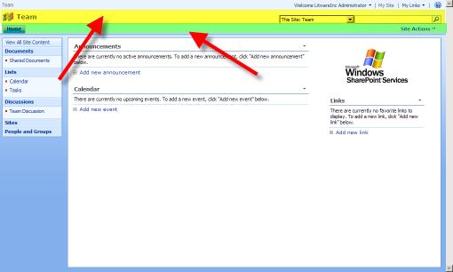

* 1. We begin by overriding styles from the first TD. Add the following style to the style block of the master page:

/* header */

.ms-globalTitleArea {

height: 75px;

background-image:url('/images/lab2_gradient.gif');

background-position: left top;

background-repeat: repeat-x;

}

* 1. This will pull in a gradient image that was already created for you and placed in the images directory and will make sure the background starts at the top-left and repeats across the page horizontally.
  2. Next, we will override the styles of the second TD. Add the following style to the style block of the master page:

/* header behind top navigation */

.ms-bannerContainer {

background-color:#A7D1FA;

background-image:none;

}

* 1. This adds a background color that matches with the last color in the gradient used in the TD above. In addition, we are overriding the background-image that Microsoft has applied to this second with “none” thus making it disappear.
  2. Save the master page and refresh the browser and you should see this:

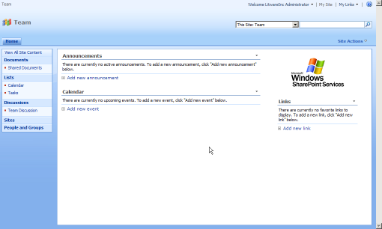

* 1. Notice though that the search box has a bit of the blue background shining through its edges thanks to the way it was originally designed. We can fix this by adding a white background to just the search box part of the search area. Because the search scopes dropdown and the search box use some of the same classes, we will have to override both of them to get just a white background on the search box.
  2. Add the following styles to the style block of the master page:

/* background behind search box */

td.ms-sbcell {

background-color:white;

}

/* background behind search scopes */

td.ms-sbscopes {

background-color: transparent;

}

* 1. Save the master page and refresh one more time and you should see that search box looks better.

1. We have already hidden the Recycle Bin from a previous step, but what if we decided we wanted to hide the entire left side menu with only CSS. While this can be achieved via changing settings in the master page itself, it can also be hidden from view just using CSS. This concept is important, as in the real world you may want to hide only the left navigation on certain pages and this same CSS can be used to do this.
   1. If you explore the left navigation HTML and CSS, you can traverse up the HTML tree and find that the base of the left navigation begins with a Table with a class of “ms-navframe”. This is the CSS class that we will be overriding to make it disappear.
   2. Add the following styles to the style block of the master page:

/* hide entire left nav */

.ms-navframe {

display: none;

}

* 1. Save the master page and refresh and you will see that the entire left side navigation is gone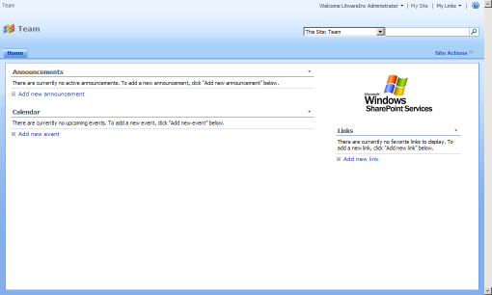
  2. While there is probably a lot more we could do to change this master page for a real branding effort, the changes we have made so far should highlight the power of CSS when it comes to changing the look and feel of a SharePoint site.