Lab 03: Exploring Themes in SharePoint

**Lab Overview**: In this lab, we will explore the creation of our own theme for the WingTip Farms SharePoint Team Site. We will copy an existing theme and then walk through to process of converting to our own design. Some of the CSS concepts will be familiar from the previous Lab while others may be new. All of the graphics that are needed for this Lab are already created but you will learn more about working with Photoshop to make similar graphics in another section.

**Lab Setup:** Run the batch file named **CreateSiteForLab3.bat** in order to create s new site collection with a Team site as the top level site. You will do all your work in this lab by creating customizations to this site with the SharePoint Designer. Note there is also a batch file in the lab directory named **RefreshSiteForLab3.bat.**You can use this second batch file if you delete the site you have been working on in this lab and to recreating a new site to start the these lab instructions from the beginning.

Exercise 1: Create our own Theme based on an existing Theme and apply it to our site

1. Locate and run the batch file named **CreateSiteForLab3.bat.**
2. Open the Internet Explorer and browse the new site at the URL of <http://litwareinc.com/sites/Lab03>
3. Now we need to explore the 12 Folder, which is where most of the actual code that runs SharePoint is located. Navigate to C:\Program Files\Common Files\Microsoft Shared\web server extensions\12
   1. The “TEMPLATE” directory is where everything we will be working on is located so navigate there
   2. Under the TEMPLATE directory is THEMES, this is where all of the Themes for SharePoint are located, navigate there
4. For our Theme, we are going to base it off the “Simple” theme, since it has probably the least colorful of all the themes and will let us apply our own branding. You could easily start with another one that is close to your own color theme.
   1. Make a copy of the “SIMPLE” folder and name it “WingTipFarms” 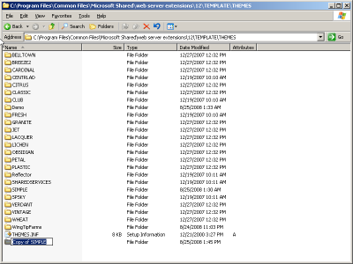
5. Next, we will make some changes to the XML files that make up the Simple Theme and have them reflect our new Theme
   1. Navigate to the new WingTipFarms directory
   2. Rename “SIMPLE.INF” to “WingTipFarms.INF”
   3. Open WingTipFarms.INF in Notepad
   4. Find all instances of the word “Simple” and replace with “WingTipFarms”. You can do this by clicking Edit > Replace and entering “Simple” in the Find and “WingTipFarms” in the Replace and clicking Replace All.

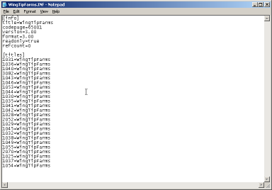

* 1. Save the INF file, we are done making changes to it

1. Next we need to edit the SPTHEMES.XML file
   1. Navigate to C:\Program Files\Common Files\Microsoft Shared\web server extensions\12\TEMPLATE\LAYOUTS\1033
   2. Open SPTHEMES.XML in Notepad
   3. Add the following XML before the </SPTHEMES> end tag:

<Templates>

<TemplateID>WingTipFarms</TemplateID>

<DisplayName>WingTipFarms</DisplayName>

<Description>WingTipFarms</Description>

<Thumbnail>images/th_wingtip.gif</Thumbnail>

<Preview>images/th_wingtip.gif</Preview>

</Templates>

* 1. You file should look like this:

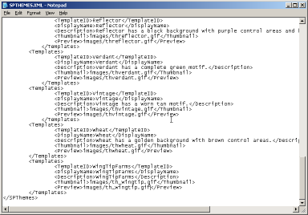

* 1. Save SPTHEMES.XML we are done making changes

1. Next, let’s make a copy of the Thumbnail image for Simple Theme and use it for our Theme. We will replace this thumbnail with a screenshot when we are done
   1. Navigate to C:\Program Files\Common Files\Microsoft Shared\web server extensions\12\TEMPLATE\IMAGES
   2. This is where many images are located including all the thumbnails for Themes
   3. Copy “thsimple.gif” and paste and rename it to “th_wingtip.gif”
2. Next, we need to run IISRESET in order to load or Theme as an available Theme in SharePoint
   1. Click Start > Run… and enter CMD
   2. At the command prompt type IISRESET and hit enter
   3. After IIS has reset you should see that it was successfully restarted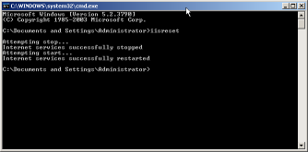
3. Lastly we need to activate the Theme for our SharePoint site
4. Return to the browser windows point to the site <http://litwareinc.com/sites/Lab03> and follow these steps.
   1. Click Site Actions > Site Settings and then click Site theme under Look and Feel
   2. At the bottom of the list of Themes you should see WingTipFarms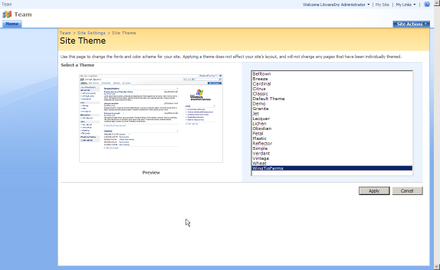
   3. Select WingTipFarms and click Apply
   4. Navigate back to the homepage and you will see the Simple Theme applied (actually our WingTipFarms Theme but you get the picture) 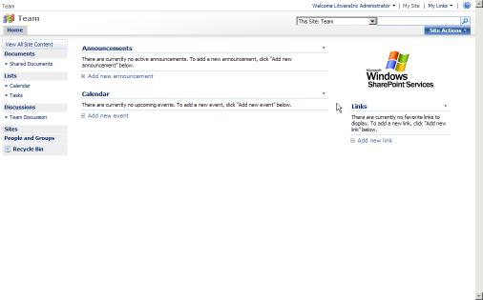

Exercise 2: Edit the Theme’s styles from SharePoint Designer

1. Now we will open the Theme directly from our site in SharePoint Designer. This is much faster than editing the site in the Themes directory, as you would need to reset IIS frequently and reapply the Theme. Just be careful that no one reselects the Theme while you are working on it or you could lose your work. For this section, much of the CSS and images that are needed will be provided for you.
   1. Launch the SharePoint Designer and open the site at
   2. Click in the Folder List pane and hit F5 to refresh the files shown
   3. Open the _themes folder
   4. You will see WingTipFarms, which is our applied Theme, SharePoint created this folder when the Theme was applied. It gets rewritten whenever a new Theme is selected
   5. Open the WingTipFarms folder
   6. Open “Wing1011-65001.css” this is the active Theme CSS that is being used, it is a combination of theme.css and mossExtension.css from the Theme folder
   7. Any changes that we make in “Wing1011-65001.css” will be reflected in the site as soon as the file is saved, to prove this lets add some obnoxious style and observe the change. Add this CSS to the top of the file:

div {

background-color: red;

}

* 1. Save the CSS and refresh your browser you should see many of the Div’s are now red:

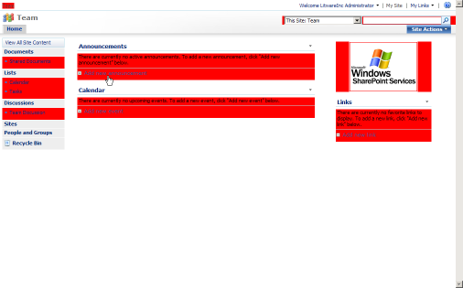

* 1. Remove that style and resave the file

1. Next, we will add our custom images into the Theme. We start by adding all of the premade images for the Theme. About half of these images are gray scale de-saturated versions of the background images and patterns that were used in the Simple theme (and found in the Theme directory). Many of them were blue or red, and gray just matches with everything. The other half of the images are backgrounds, logos, and branding for the WingTipFarms site. You will explore working with Photoshop in another section
   1. We start with all of the grayscale versions of the Simple Theme images, they are located on your computer at “C:\students\labs\lab3\ grayscale replacement images”
   2. Navigate into that folder and view thumbnails to see that they are grayscale versions of familiar images that are typically in the background of a Theme
   3. Drag all of the images that are in there to SharePoint Designer into the Folder List pane and into the /_themes/WingTipFarms directory
   4. All of these files replace existing files so click Yes to All in the replacement warning box
   5. Next, we will drag all of the custom branding images for Wing Tip Farms into the Theme
   6. Navigate to “C:\students\labs\lab3\ custom branding images” and drag all of these images to SharePoint Designer into the Folder List pane and into the /_themes/WingTipFarms directory
   7. This time there should be no warnings about overwriting files as they are all new
   8. Now all of the images are ready to be worked with in our Theme. Before we are finished with everything at a later step we will copy all these images to the actual Theme directory to finalize the Theme, but for now we just need them for working with our CSS
2. Next, we will prepare the CSS for our custom styles.
   1. Start by adding a comment to the top of the CSS so that we can remember what we did at a later date:

/* Wing Tip Farms Theme based on OOTB Simple Theme - This section all OOTB SIMPLE THEME styles */

* 1. Next, we add one universal style to the top that makes all the padding and margin 0px, we put this at the top because as a universal selector it would control too much if it were put at the bottom of the page. At the top, the styles below it have a chance to override it (especially important for some Microsoft styles that may need padding or margin

/* fix padding and margin for all elements */

* {

padding: 0px;

margin: 0px;

}

* 1. After this line we put another comment to designate all of the out-of-the-box Theme styles

/* ALL OOTB STYLES FROM Simple Theme */

* 1. The top of the CSS will now look like this:

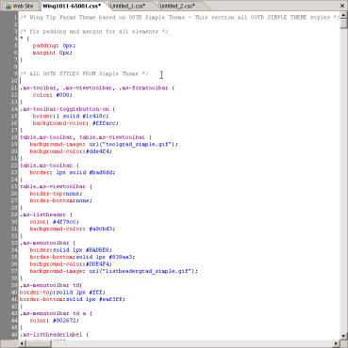

* 1. After this, we let all of the rest of the out of the box Theme style sit where it is and we will begin to put our styles after them so scroll all the way to the bottom of the CSS file
  2. One last thing we should do before adding our own styles is remove the styles that SharePoint added from mossExtension.css. Scroll up from the bottom about 66 lines until you see a CSS element named “table.ms-applyfiltersinactive”. Select from here all the way to the bottom of the CSS and remove all 66 or so lines of CSS. The reason we remove them is, when we put all this CSS back in our theme we don’t want SharePoint doubling it up and adding the lines a second time
  3. Where those lines were, place another large (easily seen when scanning code) comment like this

/* ========================================================== */

/* ========================================================== */

/* Everything under here is added by SharePoint */

/* ========================================================== */

/* ========================================================== */

* 1. Next, add one more large comment block above this one that will signify where we will be putting all of our custom CSS for the theme:

/* ========================================================== */

/* ========================================================== */

/* Theme custom Styles */

/* ========================================================== */

/* ========================================================== */

* 1. The bottom of the CSS file should now look like this:

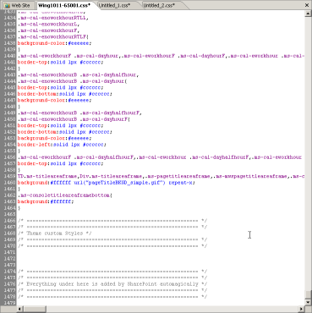

1. Now we are going to begin adding our custom styles to the Theme all of the following CSS will go between the two big comments we just added
2. First, we add the CSS for the top bar. These styles will handle the global breadcrumb, the welcome text, my sites, my links, and the help icon as well as the background for the top bar.

/* CUSTOM TOP BAR */

/* ------------------------------------------------------*/

/* top bar bg */

.ms-globalbreadcrumb {

background-color:#D3DEE9;

background-image:url(top.gif);

background-repeat:repeat-x;

height: 23px;

}

/* top links */

.ms-globallinks, .ms-globallinks a {

color:#006600;

display: inline-table;

}

.ms-globallinks a:hover {

color:#006600;

}

/* top link color */

.ms-SPLink a:link, .ms-SPLink a:visited {

color:#006600;

}

.ms-SPLink a:hover, .SpLinkButtonActive a:hover, .ms-SPLink ms-hovercellactive, .ms-SPLink ms-hovercellactive a , .ms-SPLink ms-hovercellactive a:link, .ms-SPLink ms-hovercellactive a:hover, , .ms-SPLink ms-hovercellactive a:visited {

color:green;

}

/* hover link color */

.SpLinkButtonActive a {

color:green;

}

td.ms-globalbreadcrumb {

border-bottom:none 1px transparent;

}

/* hover state for welcome and mylinks */

.ms-HoverCellActive, .ms-SpLinkButtonActive {

background-color: transparent;

background-image: none;

border: 0px none transparent;

margin: 1px;

}

/* welcome hover */

.ms-HoverCellActive a:hover, .ms-SpLinkButtonActive a:hover {

text-decoration: underline;

}

Save the CSS file and refresh your browser to see the changes.

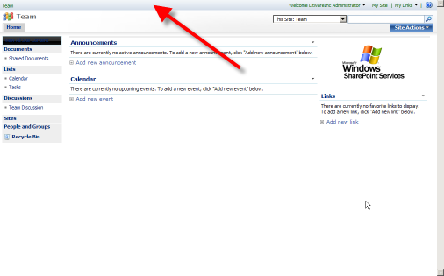

1. Next, we add the header section of the site, this will style the logo as well as the background of the header. Note that the logo is a transparent gif that is floated over the background, and the background has the cow pasture image that will repeat in large browsers.

/* CUSTOM HEADER */

/* ------------------------------------------------------*/

td.ms-titleimagearea {

background-image:url(wingtip_logo.gif);

background-repeat:no-repeat;

display:block;

height:87px;

left:16px;

position:absolute;

top:31px;

width:346px;

}

/* home link */

h1.ms-sitetitle {

display: none;

}

td.ms-titleimagearea img {

display: none;

}

/* header bar bg */

.ms-globalTitleArea {

background-image:url(header.jpg);

background-position:left top;

background-repeat:repeat-x;

height:108px;

}

Save the CSS file and refresh your browser to see the changes.

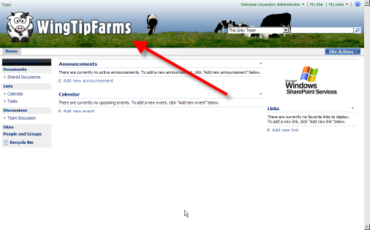

1. Next, we add the top navigation CSS, this will style the navigation buttons as well as flouts and hovers, and selected items. This CSS makes use of repeating gradient images that make the navigation elements look like shaded buttons

/* MAIN NAV ITEMS */

/* ------------------------------------------------------*/

/* nav bg */

.ms-bannerframe, .ms-GRHeaderBackground {

background-image:url(nav.gif);

background-color:green;

}

/* nav bg */

.ms-bannerContainer {

background-image:url(nav.gif);

background-color:green;

height: 24px;

background-position: center top;

padding-left: 0px;

padding-right: 0px;

}

/* top nav border */

.ms-topnavContainer {

border:0px solid black;

margin-left:165px;

height: 24px;

}

/* nav item bg */

.ms-topnav {

background-image:url(nav.gif);

background-color:green;

background-repeat:repeat-x;

border-color:white;

border-style:solid;

border-width:0px 0px 0px 0px;

color:white;

font-family:arial;

font-size:.8em;

line-height:17px;

margin:0px;

padding:0px 10px;

height: 24px;

}

/* top nav link color */

.ms-topnav a {

color:white;

background-image: none;

background-color: transparent;

font-weight: bold;

}

/* nav item hover bg */

.ms-topNavHover {

background-image:url(nav_hover.gif);

background-color:green;

border-color:black;

border-style:solid;

border-width:0px 0px 0px 0px;

color:white;

font-family:arial;

font-size:.8em;

line-height:17px;

margin:0px;

padding:0px 10px;

}

.ms-topNavHover a, .ms-topNavHover a:hover, .ms-topNavHover a:visited, .ms-topNavHover a:link {

color:white;

background-image: none;

background-color: transparent;

font-weight: bold;

}

/* nav selected item bg */

.ms-topnavselected {

background-image:url(nav_hover.gif);

background-color:green;

border-color:#575757 black;

border-style:solid;

border-width:0px 0px 0px 0px;

color:white;

}

.ms-topnavselected a, .ms-topnavselected a:hover {

color:white;

background-image: none;

background-color: transparent;

font-weight: bold;

}

/* sub item mouse over */

.ms-topNavFlyOutsHover {

background-color: white !important;

}

.ms-topNavFlyOuts {

background-color:#F5F6F3;

}

.ms-topNavFlyOuts a {

color: #3A4663;

font-weight: bold;

}

.zz1_TopNavigationMenu_8 {

background-color:white;

border:1px solid #CBD1E0;

}

.ms-consolemptablerow {

background:#ffffff none repeat-x;*/

border-color: black;

border-width: 0px;

background-color: white;

}

Save the CSS file and refresh your browser to see the changes.

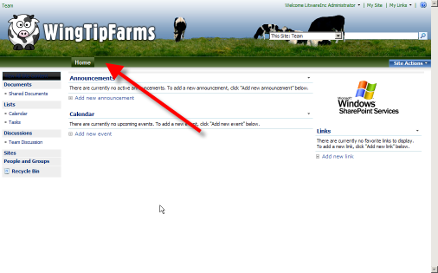

1. Next, we had the left navigation items, which include the background, the quicklaunch header, headings, items, sub items, hover states, and the recycle bin. Again repeating background colors or images are used to make the items look like buttons.

/* LEFT NAV */

/* ------------------------------------------------------*/

.ms-nav {

background:transparent none no-repeat scroll 0 0;

}

.ms-navframe {

background:transparent none no-repeat scroll 0 0;

padding-left:11px;

padding-top:11px;

}

.ms-quicklaunchheader {

color: white;

background-image: none;

background-color:black;

border:solid 1px #BADBE8;

font-weight: bold;

}

.ms-quicklaunchheader {

border:1px none transparent;

}

/* font color on left bar */

.ms-quicklaunchheader a {

color: white;

}

.ms-quicklaunchheader a:hover {

color: white;

}

/* left side stuff */

.ms-navsubmenu1 {

background-color:white;

}

/* left side stuff */

.ms-quickLaunch {

background-color:white;

border:1px solid black;

}

/* left side stuff */

.ms-quicklaunchouter {

border-bottom:1px none transparent;

border-right:1px solid transparent;

}

/* left side stuff */

.ms-quicklaunch table.ms-navheader td, .ms-navheader2 td, .ms-quicklaunch span.ms-navheader {

background-color:white;

border-left:1px solid white;

border-top:1px solid white;

border:1px none;

padding:1px 4px 4px;

}

table.ms-navitem td, span.ms-navitem {

background-image:url(bullet.gif)

}

/* left side stuff */

table.ms-recyclebin td {

background-color:white;

border-left:1px solid white;

border-top:1px solid white;

color: #0D2D84;

}

/* left side stuff */

.ms-quicklaunch table td {

border-top:1px dotted white;

}

/* left side stuff */

.ms-quicklaunch table.ms-selectednavheader td {

background-color:white;

background-image:none;

background-repeat:repeat-x;

border:1px none;

padding:1px 6px 3px;

}

/* left side stuff */

.ms-navsubmenu2 {

background-color:white;

margin-bottom:6px;

width:100%;

}

table.ms-recyclebin {

display: none;

}

/* left nav header fonts */

.ms-navheader a {

color:black;

}

/* left nav font color */

.ms-navItem a, .ms-navitem a:visited {

color:black;

}

/* recycle bin font */

table.ms-recyclebin td a {

color:black;

}

/* recycle bin page */

.ms-quicklaunch table.ms-selectednav {

background-color:white;

background-image:none;

background-repeat:repeat-x;

border:1px solid silver;

margin:2px 2px 0pt;

width:97%;

}

Save the CSS file and refresh your browser to see the changes.

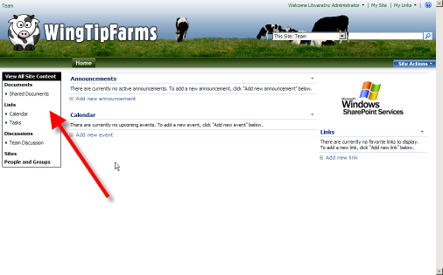

1. Next we will style the search box at the top right, mainly this just involves cleaning up some background colors and the advanced search link (for MOSS) to make it look appealing.

/* SEARCH ITEMS */

/* ------------------------------------------------------*/

/* background behind search box */

td.ms-sbcell {

background-color:white;

}

/* background behind search scopes */

td.ms-sbscopes {

background-color: transparent;

}

/* background behind advanced search */

td.ms-sblink {

background-color:transparent;

}

/* advanced link */

.ms-sblink a:link, .ms-sblink a:visited {

color: white;

}

Save the CSS file and refresh your browser to see the changes.

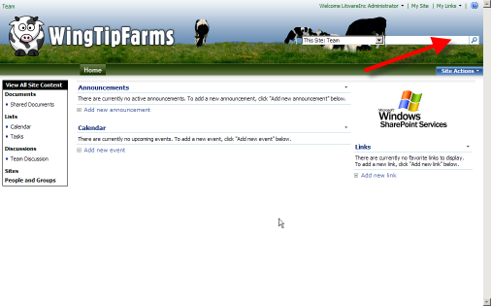

1. Next, we will style the Site Actions menu, this CSS is similar to the CSS used in the previous lab to make the Site Actions appear to be part of the main navigation

/* SITE ACTIONS SECTION */

/* ------------------------------------------------------*/

/* site actions bg */

.ms-siteactionsmenu div div div {

background-image:none;

background-color:transparent;

background-repeat:repeat-x;

border-left:1px solid transparent;

border-right:1px solid transparent;

border-top:1px solid transparent;

height: 15px;

line-height: 15px;

padding: 4px 10px;

}

/* site action font */

.ms-siteactionsmenu div div div a {

color:white;

font-weight:bold;

}

/* site actions hover */

.ms-siteactionsmenu div div div a:hover {

color:white;

font-weight:bold;

text-decoration:underline;

}

/* site actions hover */

.ms-siteactionsmenu div div div.ms-siteactionsmenuhover {

background-image:none;

background-position:center top;

background-color:transparent;

border-left:1px solid transparent;

border-right:1px solid transparent;

border-top:1px solid transparent;

}

.ms-siteactionsmenu div div div.ms-siteactionsmenuhover a {

color: white;

}

/* site actions item hover */

.ms-MenuUIItemTableHover {

background-color:#dddddd;

border:1px solid silver;

}

/* site actions menu color */

.ms-MenuUIPopupBody table {

color:#555555;

}

Save the CSS file and refresh your browser to see the changes.

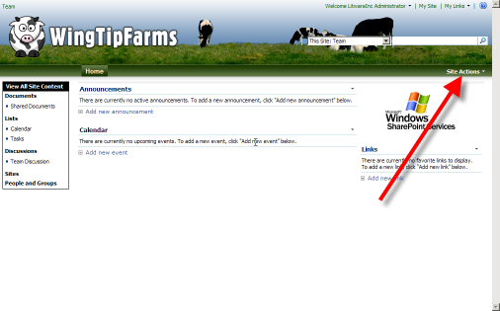

1. Next, we have a subtle change to the web parts on the page to show a silver line under them instead of the default blue line

/* WEB PARTS */

/* ------------------------------------------------------*/

.ms-WPHeader td {

border-bottom:1px solid silver;

}

Save the CSS file and refresh your browser to see the changes.

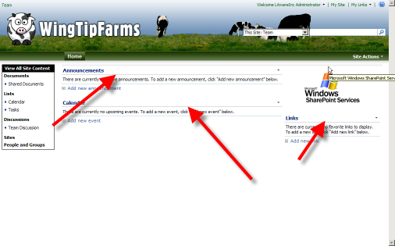

1. The next set of the styles are miscellaneous styles that need to be overridden on the pages themselves, many are just background images or color that need to match with our branding. This is also where we add the cow print behind all the elements.

/* MISC PAGE */

/* ------------------------------------------------------*/

.ms-main {

background-image:url(cowprint.gif);

}

.ms-pagemargin {

background-color: transparent;

background-image:none;

}

td.ms-bodyareaframe {

padding: 10px;

}

/*all site content divider */

.ms-gb {

border-bottom:1px solid silver;

}

/* title big blue bg */

.ms-pagetitleareaframe table {

background-image:none;

background-color:white;

}

/* right side bg */

td.ms-rightareacell div.ms-pagemargin {

background-color:transparent;

background-image:none;

background-repeat:repeat-x;

border-left:1px none transparent;

}

/* little line in top area of main frame */

.ms-listdescription {

border-bottom:1px solid transparent;

}

/* body frame border */

.ms-bodyareaframe, .ms-viewareaframe {

border: 1px solid black;

}

.ms-pagebreadcrumb {

background-color: transparent;

border: 0px transparent none;

}

/* divit on top left */

td.ms-areaseparatorleft {

background:transparent none repeat scroll 0%;

border-right:0px none transparent;

height:100%;

}

/* left top area */

td.ms-titleareaframe, div.ms-titleareaframe, .ms-pagetitleareaframe, .ms-mwspagetitleareaframe, .ms-consoletitleareaframe, .ms-titlearealeft {

background-color:transparent;

background-image:none;

}

/* divot on top right */

.ms-titlearearight .ms-areaseparatorright {

border-left:1px none transparent;

height:100%;

padding-right:2px;

}

.ms-titlearearight div.ms-areaseparatorright {

border-left:1px none transparent;

}

/* */

div.ms-areaseparatorleft {

background:transparent none repeat scroll 0%;

border-right:1px none transparent;

height:100%;

}

div.ms-areaseparatorright {

background:transparent none repeat scroll 0%;

border-left:1px none transparent;

}

.ms-bodyareapagemargin {

background:transparent none repeat scroll 0%;

border-top:1px none transparent;

}

/* footer bg */

.ms-pagebottommargin, .ms-pagebottommarginleft, .ms-pagebottommarginright {

background:transparent none repeat scroll 0%;

}

/* search results page top */

.ms-searchresultsareaSeparator {

background-color:#eeeeee;

padding:0;

}

Save the CSS file and refresh your browser to see the changes.

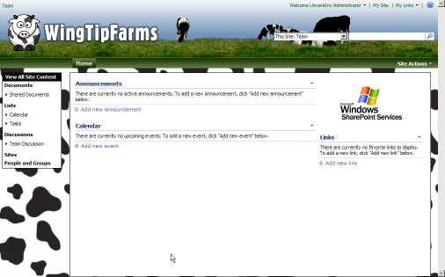

1. These last styles are for the page that shows when someone selects Site Actions > Site Settings. It has some nice background images and gray gradients.

/* SITE SETTINGS PAGE ITEMS */

/* ------------------------------------------------------*/

table.ms-pageinformation {

background-color:#FFFFFF;

background-image:url(settingsgraphic_Custom.jpg);

background-repeat:repeat-x;

}

.ms-areaseparator {

background-image: url("formtitlegrad_simple.gif");

background-color:#DBE2F1;

}

TD.ms-titleareaframe,Div.ms-titleareaframe,.ms-pagetitleareaframe,.ms-mwspagetitleareaframe,.ms-consoletitleareaframe{

background:transparent none repeat-x;

}

/* boxes around site settings headers */

td.ms-linksectionheader, th.ms-linksectionheader {

background-color:silver;

background-image:none;

background-repeat:repeat-x;

border:1px solid silver;

text-align:left;

}

/* site information font color */

.ms-pageinformation th, .ms-createpageinformation th {

color:black;

}

/* site settings page link color */

.ms-propertysheet a, .ms-propertysheet a:hover {

color:#0D2D84;

}

Save the CSS file and browse to Site Actions > Site Settings to see the changes.

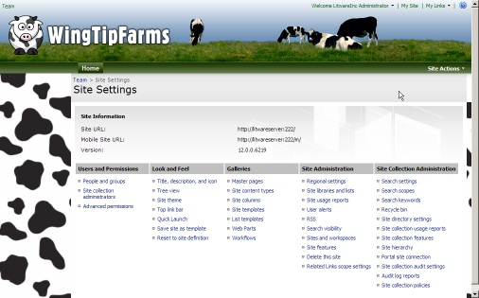

1. And that’s it. Woo Hoo. The Wing Tip Farms Theme is finished, but we still need to finalize the Theme by moving everything back to the Theme directory. If we were to skip this step all of our hard work could get ruined by someone activating a different Theme on us

Exercise 3: Finalize and Reapply the Theme

1. Now we will move all of our changes back to the Themes folder in the 12 folder
   1. Select all the Wing1011-65001.css file that is being edited in SharePoint Designer (Control-A) and copy it (Control-C)
   2. Then, navigate back to the Theme directory C:\Program Files\Common Files\Microsoft Shared\web server extensions\12\TEMPLATE\THEMES\WingTipFarms
   3. Open theme.css in Notepad and paste in all the code from SharePoint Designer and then save the file
   4. Next copy all of the images from both source folders “C:\students\labs\lab3\ grayscale replacement images” and “C:\students\labs\lab3\ custom branding images” into the same Theme directory “C:\Program Files\Common Files\Microsoft Shared\web server extensions\12\TEMPLATE\THEMES\WingTipFarms”
   5. Replace any files that already exist in the folder
   6. We also need to replace the thumbnail (we just used a copy of the Simple theme thumbnail before). Now navigate to C:\Documents and Settings\Administrator\Desktop\assets for lab3\thumbnail image
   7. Copy “th_wingtip.gif” which is resized screenshot of the final Theme into C:\Program Files\Common Files\Microsoft Shared\web server extensions\12\TEMPLATE\IMAGES and replace the existing file that we added earlier
   8. Lastly do an IISRESET to finalize the changes. Start > Run.. then enter “CMD” then in the command console type IISRESET enter
   9. Now browser back to the site in Internet Explorer and wait a second for IIS to reset, then refresh the page and go to Site Actions > Site Settings > Site Theme and select a different Theme and apply it, then re-select the WingTipFarms Theme and apply it. Note that you may have to clear your cache in order to see the new thumbnail
   10. Go back to the homepage at <http://litwareinc.com/sites/Lab03> and refresh the browser and you should see the Theme is finalized!