SBC301 SharePoint Brand Camp Labs – Day 1

Lab 01: Getting Started with SharePoint Branding 3

Exercise 1: Changing the Look and Feel of a Team Site 3

Exercise 2: Changing the Look and feel of a Publishing site 9

Lab 02: Customizing SharePoint Sites using CSS 13

Exercise 1: Customizing a Site with SharePoint Designer 13

Exercise 2: Working with the Internet Explorer Toolbar and Firebug 15

Exercise 3: Changing some CSS 17

Exercise 3: Styling Some of the SharePoint Elements 19

Lab 03: Customizing A SharePoint Theme 25

Exercise 1: Creating a new Theme based on an existing Theme 25

Exercise 2: Edit the Theme's styles from SharePoint Designer 28

Exercise 3: Finalize and Reapply the Theme 43

# 

# Lab 01: Getting Started with SharePoint Branding

**Lab Time**: 45 minutes

**Lab Folder**: C:\Student\Labs\01_GettingStarted

**Lab Overview:** This lab is focused on understand the basics of SharePoint branding without actually getting into using SharePoint Designer to create custom design. The first exercise will look at applying Themes to a Team site as well as changing the Site Icon to use a corporate logo graphic. The second exercise will look at applying master pages to a publishing site and also look at using Alternate CSS to make simple style changes.

Lab Setup Requirements

* Before you begin this lab, you must run the batch file named **CreateSitesforLab1.bat**. This batch file creates a new SharePoint site collection for exercise 1 at the location **http://litwareinc.com/sites/Lab01Ex1. The batch file also** creates a Publishing Portal for Exercise 2 at http://litwareinc.com/sites/Lab01Ex2.

## Exercise 1: Changing the Look and Feel of a Team Site

In this exercise you will see how far you can get changing the look and feel of a standard Team site using only out-of-the-box functionality provided by WSS.

1. Make sure you are logged into the VPC as the local administrator with a user name of LITWAREINC\Administrator and a password of pass@word1.
2. Make sure you have already run the batch file named **CreateSitesforLab1.bat** that was discussed in the setup section of this lab exercise. Open team site that was created for this lab exercise at [http://wingtip.com/sites/Lab01Ex1](http://litwareserver:222/default.aspx).

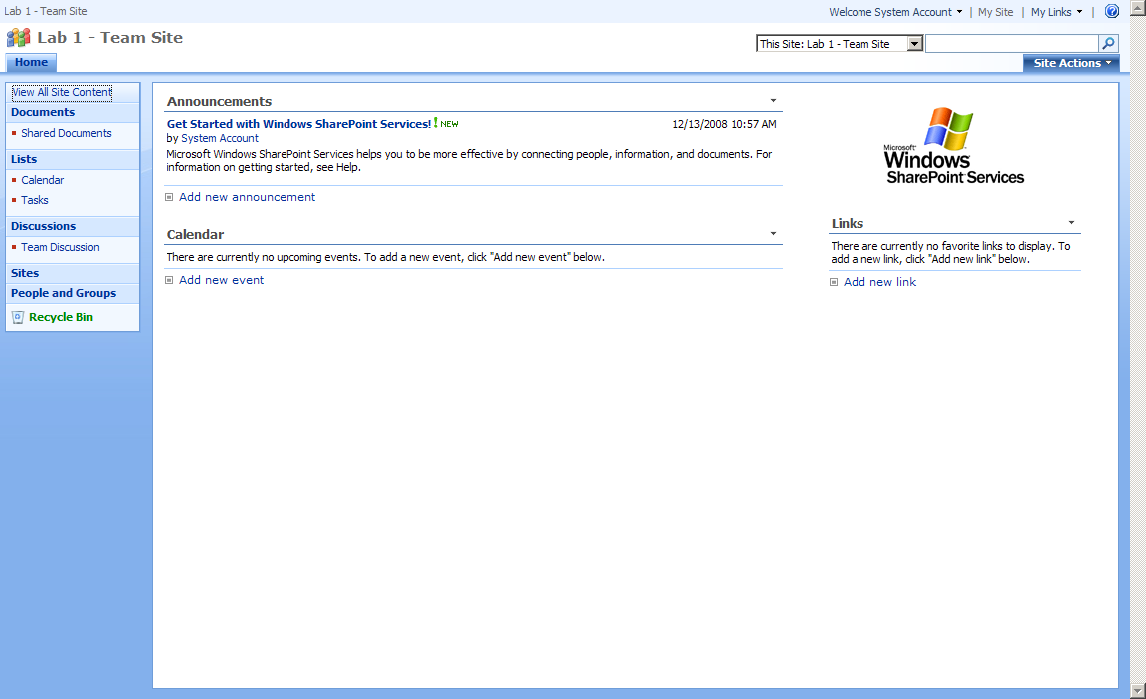

1. Take a moment to review the site and verify that it is nothing more than a standard Team site. Click on the All Site Content link from the quick-launch menu to see what lists and document libraries exist within this new site.

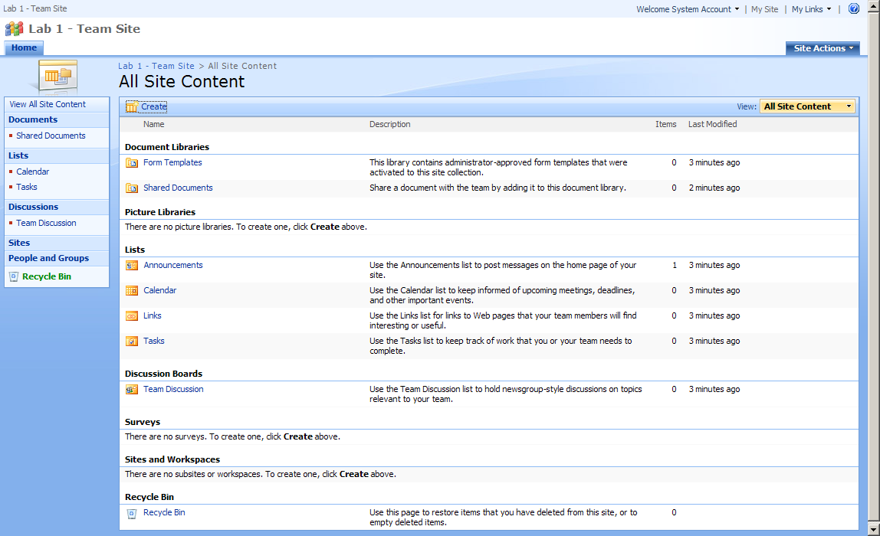

1. Now it is time to install a custom feature that was created to assist you in this lab. Run the batch file named InstallDataPopulator.bat. This batch file installs a solution package named BrandCamp.DataPopulator.wsp. Once you have run this batch file, you should now be able to activate this feature on any site collection in your local SharePoint farm.
2. Inside the site collection that was created for this lab exercise, navigate to the Site Settings page. In the section titled Site Collection Administration, click on the link titled Site collection features. You should now see a custom feature titled Brand Camp Data Populator Utility. Activate this feature.

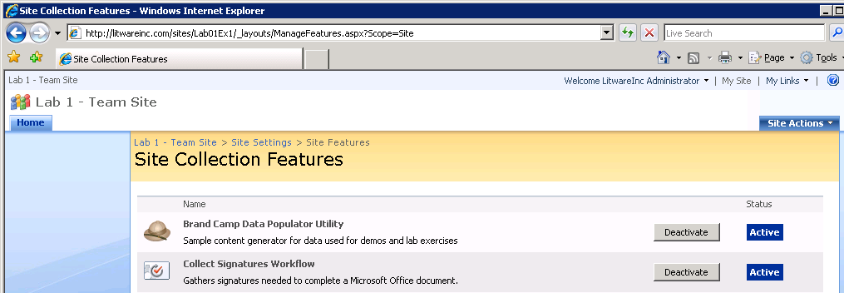

1. After you have activated the Brand Camp Data Populator Utility feature, you should be able to drop down the Site Actions menu and see a new menu item command with the title Brand Camp Data Populator. Click on this menu item to navigate to a custom application page named Populator.aspx.

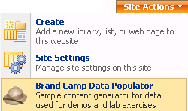

1. The custom application page named Populator.aspx has three command buttons that you can use to create lists with sample data. Click on the first command button to create the Customers List. The code behind this button will create a new Contacts list named Wingtip Customers and populate it with data.
2. Now return to the custom application page named Populator.aspx using the menu command in the Site Actions menu and click on the second command button to create an events list named Wingtip Calendar.
3. Now return to the custom application page named Populator.aspx using the menu command in the Site Actions menu and click on the third command button to create an custom list named Wingtip Products.
4. Navigate back to the homepage by clicking **Home** in the top left corner, then click **View All Site Content.** Notice that there are now three new lists with sample data.
5. Create a new child site under the current SharePoint site
   1. Click Site Actions > Create
   2. Under Web Pages, click Sites and Workspaces

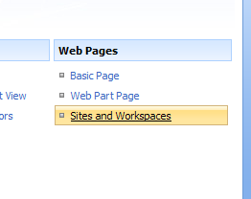

* 1. For the Title enter New Subsite
  2. For the **Description** enter anything you like
  3. For the **URL** name enter **NewSubSite**
  4. For the **Template**, select **Team Site**
  5. Leave all the other settings the same and click **Create**

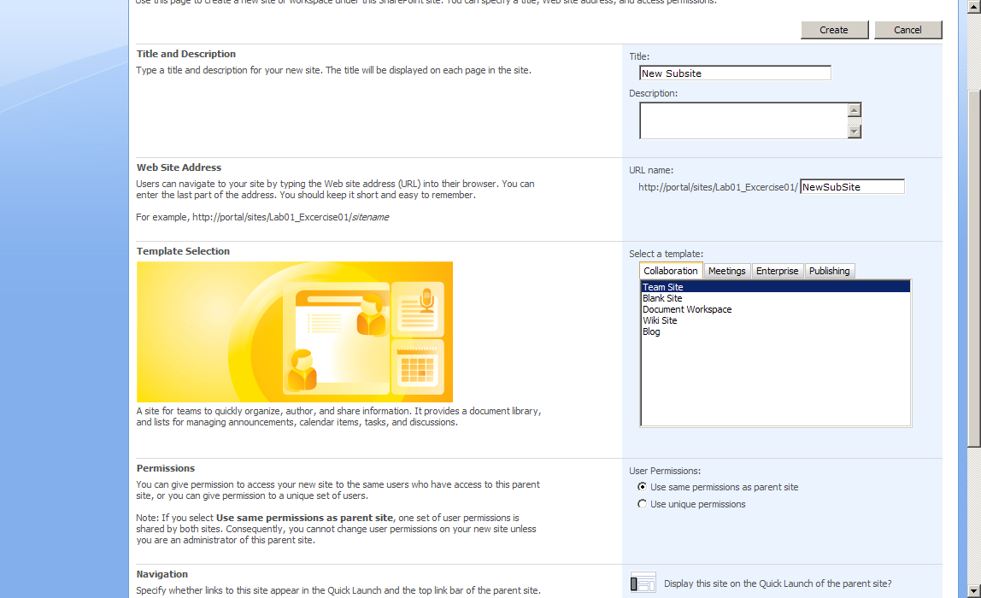

1. Next, we will create a Basic Page and edit it
   1. Click Site Actions > Create and under Web Pages click Basic Page

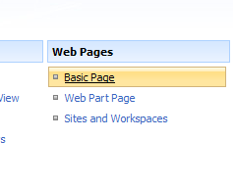

* 1. For Name, enter Basicpage
  2. Leave all of the other settings the same
  3. Click **Create**

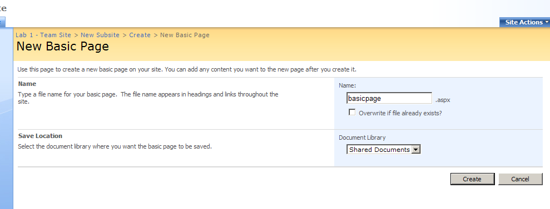

1. A rich text editor should appear. Enter some content (whatever you would like) and click **Save**

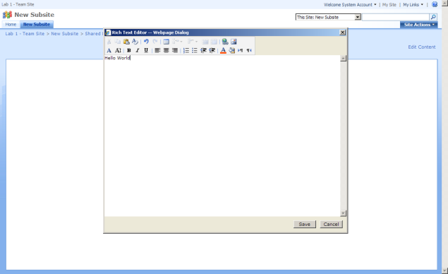

1. Note that there is not much involved to add content to a Basic Page in a Team Site
2. We will revisit this subsite shortly, for now, navigate back to the top-level site by click **Home**
3. Next, we will apply a theme to the current SharePoint site
   1. Click Site Actions > Site Settings and under Look and Feel click Site Theme

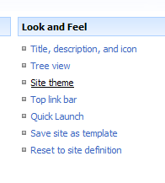

* 1. Click around these options and notice that a preview is shown on the left hand side for each
  2. Before clicking apply, be sure to select the **Lacquer** theme for this example
  3. Click **Apply**

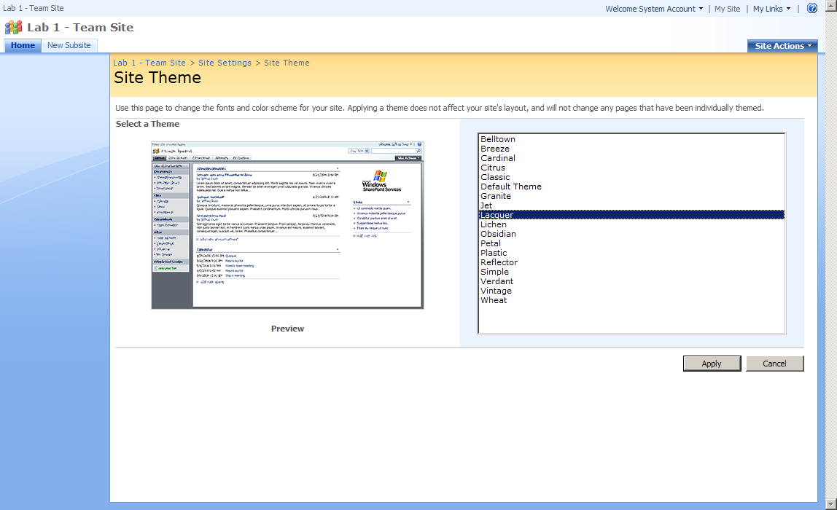

1. Click the **Home** link. You will notice right away that all of the colors for the site have changed, but all of the content and content placement is the same as before
2. View our subsite that we created earlier by clicking the **New Subsite** link in the top navigation. Notice that this sub site still has the default theme applied. This is because SharePoint themes are applied at the site level and do not update subsites automatically
3. Now we are going to create an image library and add an image that we will use as a logo that will be shown where for the Site Icon
4. Navigate back the main site, by clicking **Home**
5. Click Site Actions > Create and from Libraries click Document Library

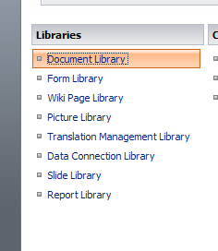

* 1. For the Name, enter Image Library
  2. For the **Description**, enter anything you would like
  3. Select No for Display this document library on the Quick Launch
  4. Select No for Create a version each time you edit the file in this document library
  5. For Document Template, select None
  6. Click **Create**

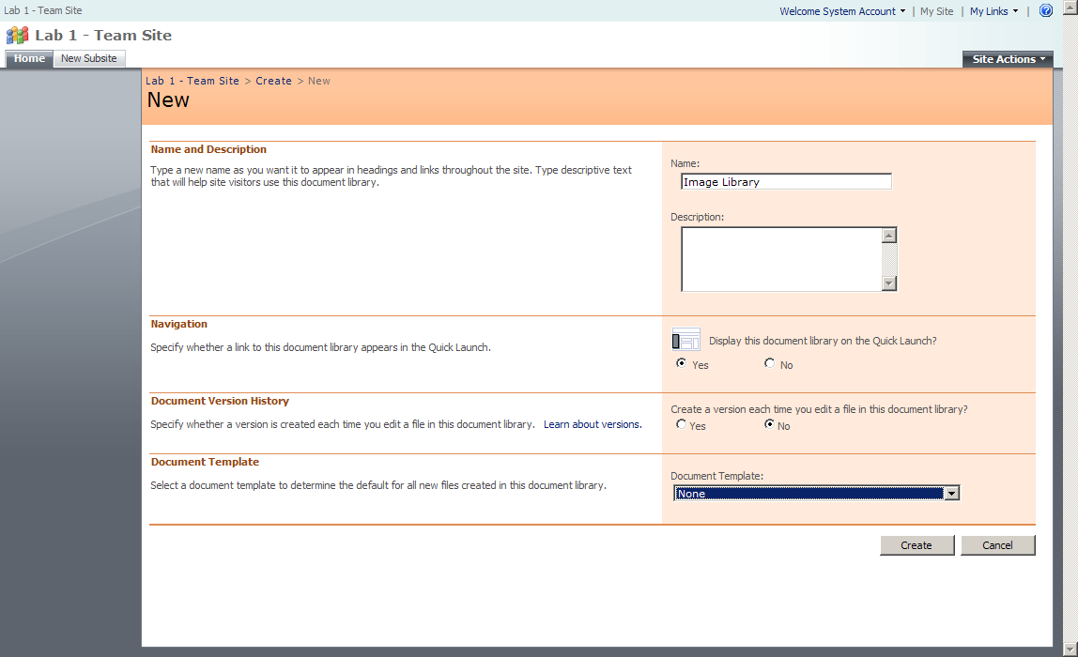

1. Click the **Image Library** link from the Quick Launch menu on the left
2. Click **Upload** from the toolbar

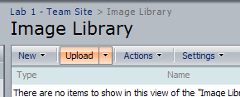

1. Browse the files for this lab and select **Logo.gif** and click **OK**
2. Lastly we will change the Site Icon to use the newly uploaded gif
   1. Click Site Actions > Site Settings and under Look and Feel click Title, description, and icon

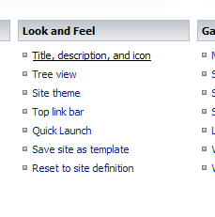

* 1. Leave all of the settings the same except change **URL** to **/sites/Lab01Ex1/Image%20Library/Logo.gif**
  2. Click the link for **Click here to test** and make sure the URL is correct for our new Site Icon
  3. Close the window that just showed the image
  4. Click **OK**

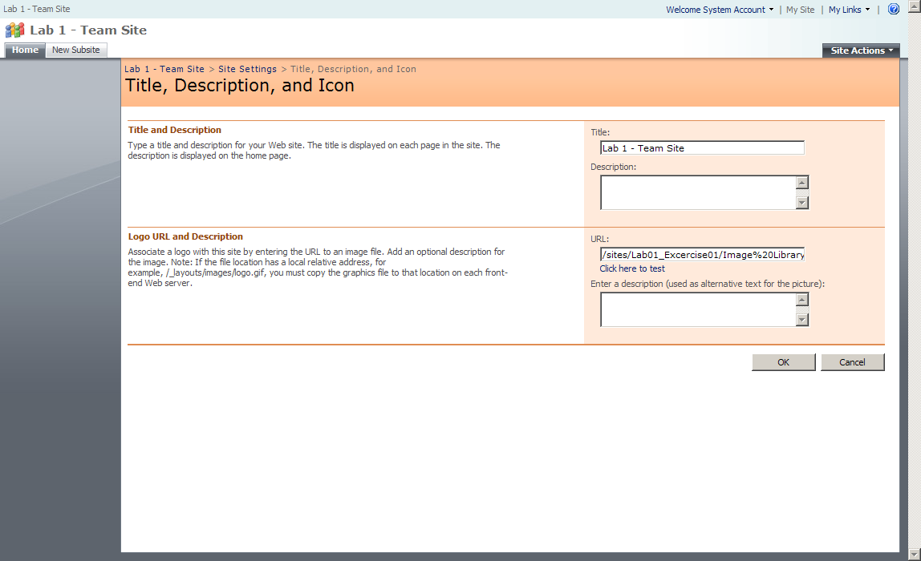

1. Navigate back to the main site by clicking **Home**. You will see that you have successfully added a new logo to the SharePoint site via the Site Icon, and also have changed the overall color scheme by selecting a SharePoint Theme

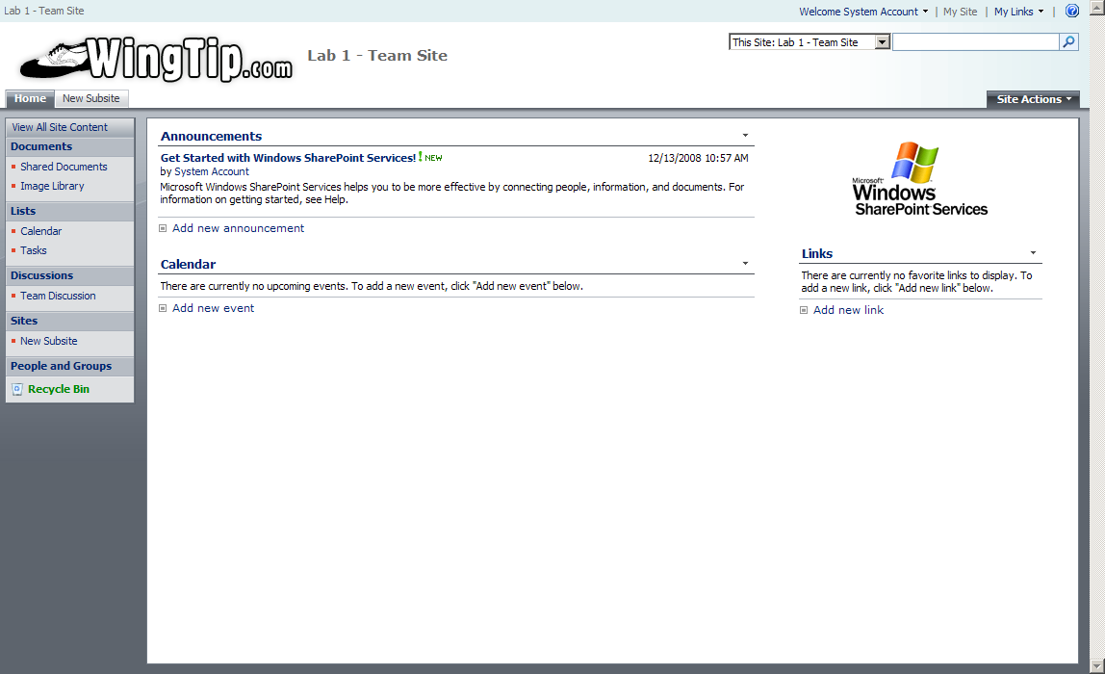

## Exercise 2: Changing the Look and feel of a Publishing site

1. Using the Internet Explorer, open the publishing site at http://litwareinc.com/sites/Lab01Ex2.

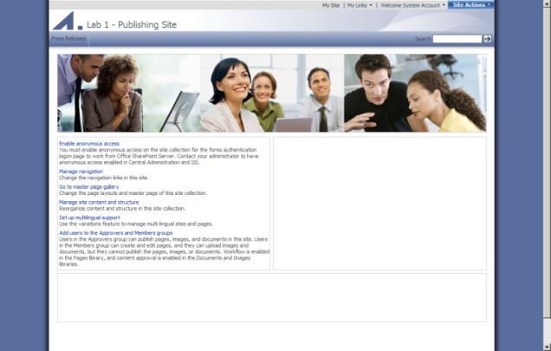

1. Notice that a publishing site is much different than a team site. One obvious difference is the URL has “/pages/” in it. Also this site has a more elaborate master page applied to it by default, known as BlueBand.master
2. Next we will create a subsite called Products
3. Click **Site Actions > Create Site**. Notice that creating a site is different in a publishing site
   1. For the **Title**, enter **Products**
   2. For the **Description**, enter anything you want
   3. For the **URL**, enter **Products**
   4. For the Template, select the Publishing Tab and then Publishing Site with Workflow
   5. Leave the rest of the settings the same
   6. Create **Create**.

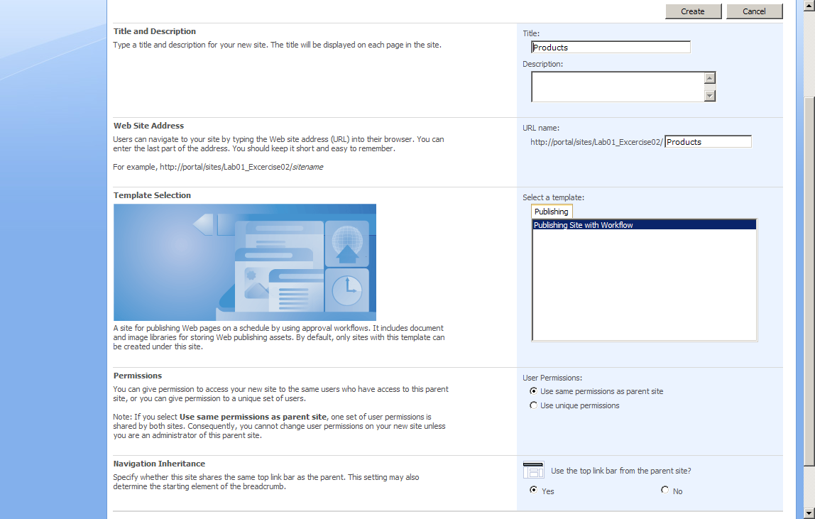

1. Edit the page content
   1. Click Site Actions > Edit Page
   2. Add some text to the **Page Content** section. Notice the Rich Text Editor bar is more robust than then editing a Team site page
   3. When you are happy with your changes, click out of the Page Content section and then click **Submit for Approval** from the Editor Toolbar



1. Because publishing sites have the approval workflow turned on by default, you will need to click **Start** to begin the approval process
2. Since your user is an Admin account, you can now click **Approve** to finalize the change

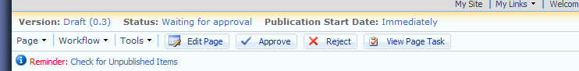

1. Now we will explore applying master pages to the publishing site
   1. Navigate back to the top site http://litwareinc.com/sites/Lab01Ex2.
   2. Click Site Actions > Site Settings > Modify All Site Settings and under Look and Feel click Master page
   3. Select default.master for the Site Master Page
   4. Check the check box to Reset all subsites to inherit this site master page settings
   5. Select default.master for System Master Page
   6. Check the check box to Reset all subsites to inherit this system master page settings
   7. Leave the **Alternate CSS** settings alone
   8. Click **OK**
2. Navigate back to the home page: **http://litwareinc.com/sites/Lab01Ex2**. Notice that the new master page has changed the overall look of the site
3. Navigate to the Products subsite by clicking **Products** in the top navigation. Notice that because we set the master page to reset all subsites, that the subsite has also received the new master page styling.
4. Now we will upload and publish both a custom CSS file and a header image that will be used for as an Alternate CSS for this master page.
5. Navigate back to the home page: **http://litwareinc.com/sites/Lab01Ex2**.
6. Click Site Actions > Manage Content and Structure
7. Select **Style Library** from the list of files and directories on the left-hand side. The Style Library will load on the right-hand side.
8. From there, click **New > Item** and browse and select **WingTipFarmsHeader.jpg** from the lab files, then click OK.

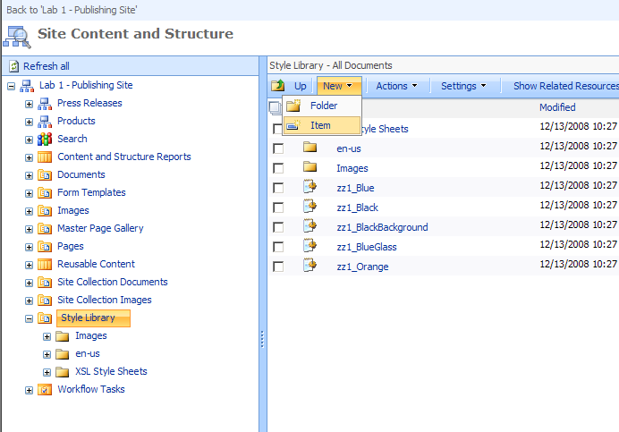

1. Leave the filename the same and click **Check In**
2. Next we will upload the CSS file using the same method
3. Click **New > Item** and browse and select **Alternate.css** from the lab files, then click **OK**
4. Leave the filename the same and click Check In
5. Finally, we need to publish both the CSS and the header image
6. From the **Site Content and Structure** menu, click the check boxes next to both **WingTipFarmsHeader** and **Alternate** (the file extensions are hidden in this menu), then click **Actions > Publish** from the toolbar

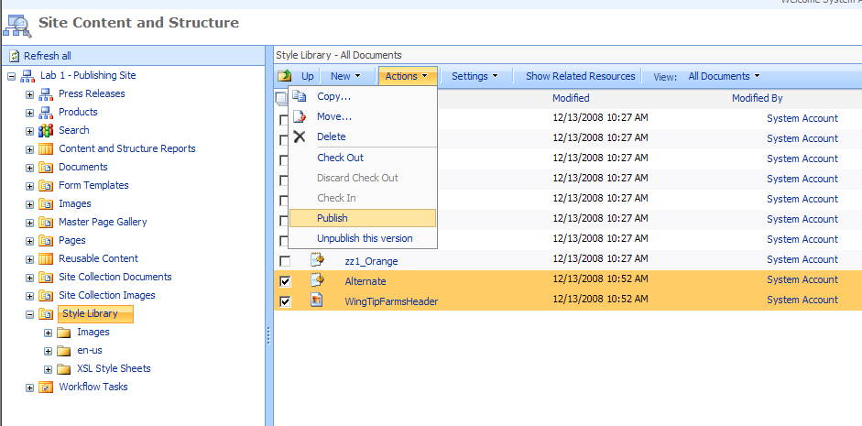

1. Click **OK** from the Publish dialog window
2. Finally we will add the Alternate CSS to this master page
   1. Navigate back to the home page: http://litwareinc.com/sites/Lab01Ex2.
   2. Click Site Actions > Site Settings > Modify All Site Settings and under Look and Feel click Master page
   3. Leave all of the setting the same except Alternate CSS URL. For this, select Specify a CSS file to be used by this publishing site and all sites that inherit from it and enter /sites/Lab01Ex2/Style Library/Alternate.css (or you can browse for it). Also click the check box next to Reset all subsites to inherit this alternate CSS URL
   4. Click **OK**
   5. When the page refreshes you will see the new header graphic applied to the top of the site via the Alternate CSS file.

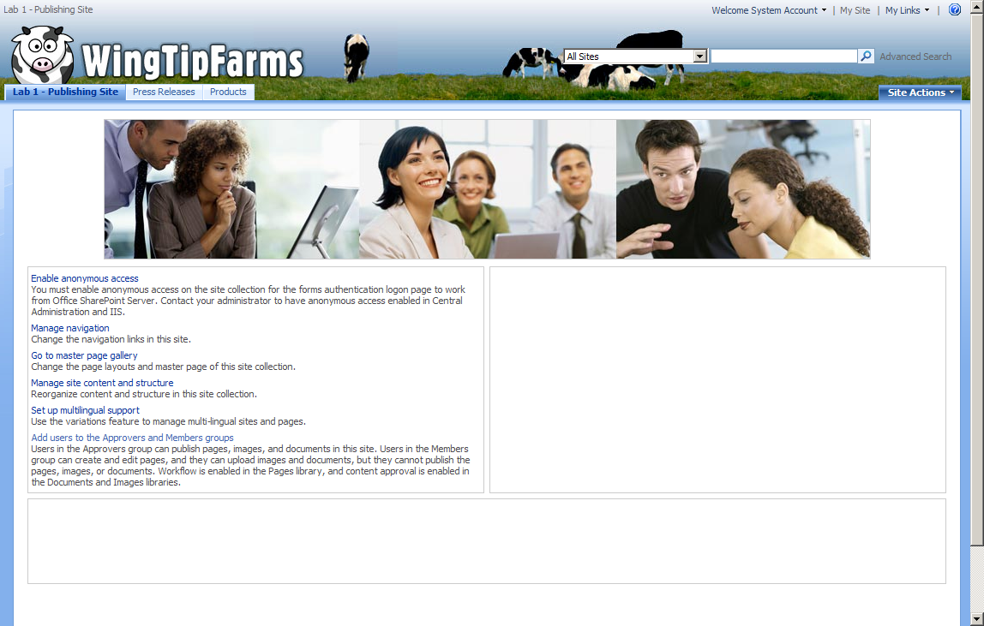

1. That concludes this lab, but if you wanted to make the site look even better you could apply a Theme that matches with the new header. Maybe Lacquer would look nice. Feel free to try it out.

# Lab 02: Customizing SharePoint Sites using CSS

**Lab Time**: 45 minutes

**Lab Folder**: C:\Student\Labs\01_Roadmap

**Lab Overview:** In this lab, we will change some CSS directly in a master page to see the results on a SharePoint Team site. The lab will explore some of the important CSS topics that were covered in this module. Because we will be exploring simple changes that are easy to observe, we will not be focusing on a pleasing design at this point but instead exploring how CSS works.

Lab Setup Requirements

* Before you begin this lab, you must run the batch file named **CreateSiteforLab2.bat**. This batch file creates a new SharePoint site collection at the location **http://litwareinc.com/sites/Lab02**.

## Exercise 1: Customizing a Site with SharePoint Designer

1. Begin by opening Internet Explorer and browsing to http://litwareinc.com/sites/Lab02.
2. Next we will open that site in SharePoint Designer and make a copy of the default master page and then set that new master page to be the default for our site
3. Launch SharePoint Designer by clicking Start > All Programs > Microsoft Office > SharePoint Designer.
4. Once SharePoint Designer opens, click File > Open Site… .
5. In the Site name box enter http://litwareinc.com/sites/Lab02 and click Open.
6. The site opens in SPD and on the left hand side you will see the Folder List pane will show the contents of the site.

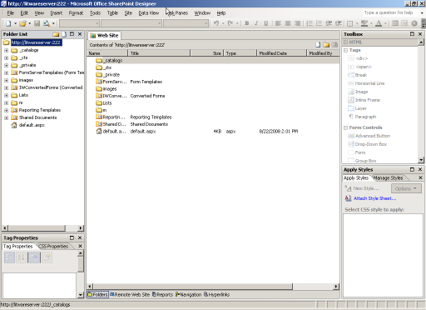

1. In the Folder List pane, expand _catalogs > masterpage. You will see a list of master pages and page layouts for the site.

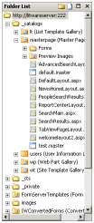

1. Right-click on default.master and click copy, then right-click on the masterpage folder and click paste
2. Right-click on the new master page “default_copy(1).master” and rename it to wingtip_css.master
3. Right-click once more on the master page and select **Set as Default Master Page** and say **Yes** to the alert warning.This will make our team site utilize this master page instead of the original default.master
4. Explore some CSS that is showing in the master page
5. Double-click wingtip_css.master and it will open the master page in Design view (assuming you haven’t used SharePoint Designer before and switched to Code view).
6. Click on the title “Team” that is beside the icon of the four colorful people. Notice that the placeholder is highlighted in purple
7. Switch to Code view by clicking the button at the bottom-center of SPD

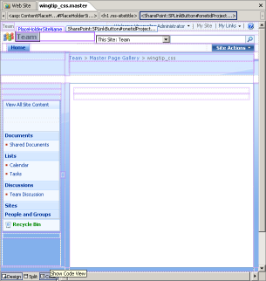

1. This will show you the underlying code of the master page and preselect the title that is located in the placeholder that was selected in the Design view. It should have selected the following code:

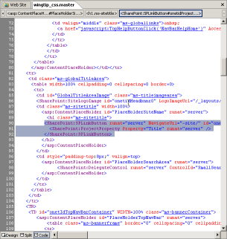

1. In the left hand bottom Pane set, select CSS Properties and click the Summary button
2. You can see from this Pane that the color has been overridden a few times finally ending up at #666666
3. If you click that final color, the Applied Rules section will highlight **.ms-sitetitle** from the core.css. This is the CSS rule that is ultimately setting the text color
4. From this Pane we could change the value of the color, but this would actually create a copy of the core.css and apply that to the master page, this is usually not preferred it complicates the branding effort. We will look at other ways of overriding core.css shortly

## Exercise 2: Working with the Internet Explorer Toolbar and Firebug

1. We can also discover CSS that is being used on a page view the IE Developer Toolbar. Make sure you have already installed the IE Developer toolbar from C:\Student\Install\ IEDevToolBarSetup.msi. Make sure to restart IE after running the install from the MSI file.
2. Launch Internet Explorer and navigate to the site for this lab at http://litwareinc.com/sites/Lab02. Click the double arrow in the top right toolbar and turn on the IE Developer Toolbar.

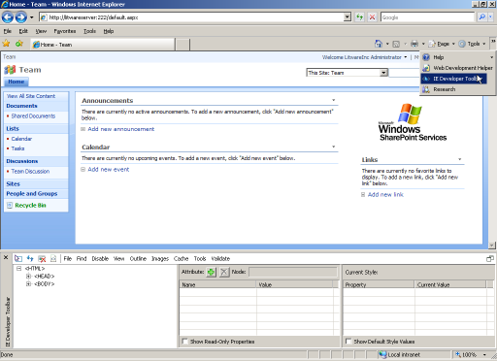

1. You will see at the bottom of the screen the toolbar. Click the far left icon in the new toolbar that looks like an arrow over a box:

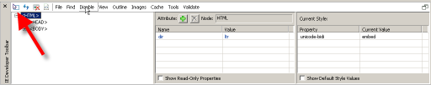

1. This allows you to select HTML elements by simply rolling over them with the mouse and then clicking
2. Mouse over the title tag in the browse and you will see that it is highlighted. Click it and the IE Developers Toolbar will display information about the applied styles.

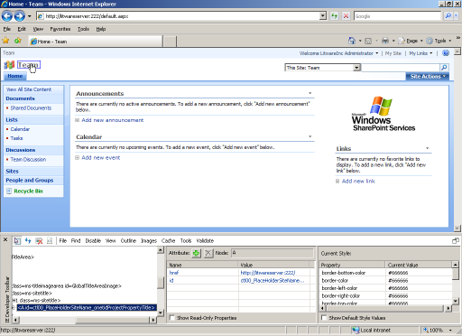

1. In the right hand column of the IE Developers Toolbar you can scroll down to see that once again the color applied is #666666
2. Let’s examine the CSS one more time in Firebug just to get the full picture of using the tools
3. Make sure you have already installed FireFox from **C:\Student\Install\Firefox Setup 3.0.1.exe**. After installing FireFox, make sure to install install the Firebug plugin from C:\Student\Install\firebug-1.2.0b13-fx.xpi. Ask your instructor if you require assistance with installation.
4. Open Firefox by clicking Start > Mozilla Firefox. Browse to the same URL at at [http://litwareinc.com/sites/Lab02](http://litewareserver:222)
5. Right-click on the title “Team” and select Inspect Element, Firebug will display the applied styles.

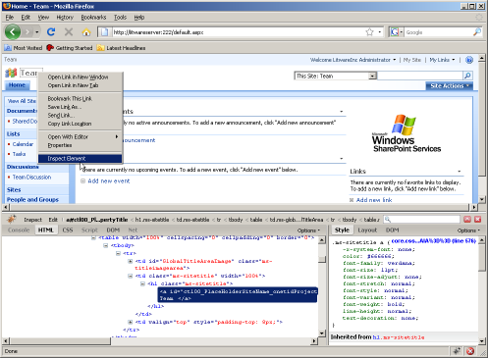

1. Notice in the right hand column Firebug tells us that line 576 of core.css applies the style to this tag and obviously again it is applying the color of #666666.
2. One nice feature of Firebug is that you can change values and see the result in real time (IE Developers Toolbar can do this to a certain degree but the interface is more clumsy to work with)
3. Click on the value of color “#666666” and Firebug will highlight it, press Backspace and then the down arrow, Firebug will begin cycling through the available values for the color property.
4. Cycle through the colors until you end up at “Lime”, notice that the color of the title has changed through the cycling
5. Lets also change the font-family to “Times New Roman” and the font-size to “26px” (just enter that one manually)
6. Note that these changes are purely cosmetic if you hit refresh now the changes would be lost forever (so don’t do it right now). In the next Exercise we will make the change permanent**.**

## Exercise 3: Changing some CSS

Rather than get bogged down with understanding how to add external stylesheets to master pages at this time we will focus on just adding an internal stylesheet directly to the master page (certainly not a best practice but we will look at that in a later Lab).

1. Add the following lines between <SharePoint:SoapDiscoveryLink runat="server"/> and <asp:ContentPlaceHolder id="PlaceHolderAdditionalPageHead" runat="server"/>:

<style type=”text/css”>

</style>

1. Now we are going to copy and paste the CSS we previewed in Firebug, switch back to Firebug and carefully select the CSS class:

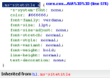

1. Next right click on that selection and choose “Copy” and then paste it between the style tags and then add an opening and closing { } after the class
2. Go back to Firebug and select and copy the styles that we have changed:

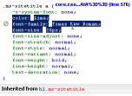

1. Paste these styles between the { } that you just added. With some formatting you will hopefully have a style that looks like this:

<style type="text/css">

.ms-sitetitle a {

color:Lime;

font-family:Times New Roman;

font-size:26px;

}

</style>

1. Save the master page. You will get a warning about customizing the page from the site definition. Click Yes because we do want to customize it
2. Now refresh Firefox and you will see that the changes have been finalized. You can refresh IE as well to see the change there
3. What if we wanted to change all the links on the page to lime green instead of just the title? If you change the style to:

<style type="text/css">

a {

color:Lime;

}

</style>

1. Save the master page and refresh the browser, you will see that the links do NOT change to lime green. This is because all of the links on this page have their link styles specified with a class or some other identifier (as was the title that we just styled). In order to style all of the links you need
2. Change the style on the master page to:

<style type="text/css">

a:link {

color:Lime;

}

</style>

1. Save the master page and refresh the browser you will see that many of the links are now green, those that aren’t have actually had the a:link style specified. Another option would have been adding **!important** to the previous style like this:

a {

color:Lime !important;

}

1. This would style all of the links on the page to green, but keep in mind there may be some links that SharePoint really wants colored a certain way (such as editor bar styles), this method may be a bit too much, it’s up to you.
2. Before we start the next exercise, you will probably want to clear out this lime style since it’s not very appealing. Simply remove all the styles back to just the <style></style> tag and save the master page.

## Exercise 3: Styling Some of the SharePoint Elements

1. Now we will look at restyling some of the key areas of a SharePoint site using only CSS. We will start by hiding the Recycle Bin in the left hand menu.
2. If we inspect the Recycle Bin through any of the means we have previously we can try to find a unique identifier that will allow us to hide it, without hiding all the other links in the left bar.

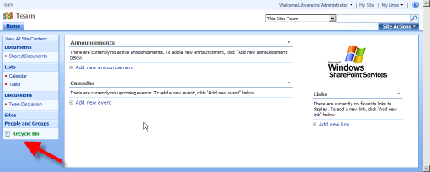

1. You can see that the Recycle Bin sits in a Table that has a class of ms-recyclebin we can use this to hide it.
2. From SPD add the following style to our existing <style></style> section:

<style type="text/css">

.ms-recyclebin {

display: none;

}

</style>

1. Save the master page and refresh your browser and you should see that the entire line that had the Recycle Bin has disappeared from the left navigation
2. Next, we will change the Site Actions menu button to something less obvious (no button background or border). The styles that will be used here can always be changed to add your own button background, colors, borders, or fonts if you would like to have a different look.

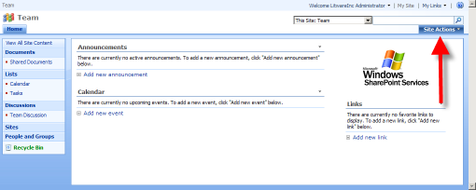

1. If you inspect the HTML and CSS that surrounds the Site Actions menu, you will see that it is complicated.
2. For simplicity sake here is the CSS that is need make the Site Actions look cleaner:

/* site actions bg */

.ms-siteactionsmenu div div div {

background-image:none;

background-color:transparent;

background-repeat:repeat-x;

border-left:1px solid transparent;

border-right:1px solid transparent;

border-top:1px solid transparent;

height: 15px;

line-height: 15px;

padding: 4px 10px;

}

/* site actions text */

.ms-siteactionsmenu div div div a {

color:#3966BF;

font-weight:bold;

}

1. Apply this style to the style section of the master page, save it and refresh the browser. You should see that the Site Actions menu looks much simpler:

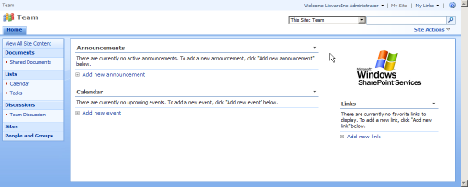

1. However, if you mouse over the Site Actions you will see that Microsoft has added a completely new set of styles for just the hover state of the button. Here is the style for overriding that:

/* site actions hover */

.ms-siteactionsmenu div div div a:hover {

color:#3966BF;

font-weight:bold;

text-decoration:underline;

}

/* site actions hover */

.ms-siteactionsmenu div div div.ms-siteactionsmenuhover {

background-image:none;

background-position:center top;

background-color:transparent;

border-left:1px solid transparent;

border-right:1px solid transparent;

border-top:1px solid transparent;

}

.ms-siteactionsmenu div div div.ms-siteactionsmenuhover a {

color: #003399;

}

1. Add this to the existing styles on the master page, save it, and refresh the browser. Now when you mouse over the Site Actions you should see that it retains the clean look.
2. Next, we will add a background image to the header portion of the site. The header is actually made up of two long TD’s in a large Table. The first is behind the Title and Search sections and the second is behind the Top Navigation and the Site Actions. Two add a background that appears to be seamless we will need to override the styles from both of these. We have a gradient already created that will blend with the Top Bar.

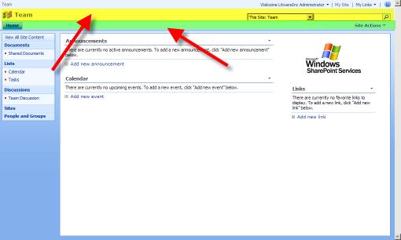

1. We begin by overriding styles from the first TD. Add the following style to the style block of the master page:

/* header */

.ms-globalTitleArea {

height: 75px;

background-image:url('/images/lab2_gradient.gif');

background-position: left top;

background-repeat: repeat-x;

}

1. This will pull in a gradient image that was already created for you and placed in the images directory and will make sure the background starts at the top-left and repeats across the page horizontally.
2. Next, we will override the styles of the second TD. Add the following style to the style block of the master page:

/* header behind top navigation */

.ms-bannerContainer {

background-color:#A7D1FA;

background-image:none;

}

1. This adds a background color that matches with the last color in the gradient used in the TD above. In addition, we are overriding the background-image that Microsoft has applied to this second with “none” thus making it disappear.
2. Save the master page and refresh the browser and you should see this:

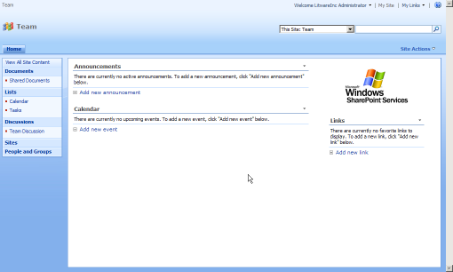

1. Notice though that the search box has a bit of the blue background shining through its edges thanks to the way it was originally designed. We can fix this by adding a white background to just the search box part of the search area. Because the search scopes dropdown and the search box use some of the same classes, we will have to override both of them to get just a white background on the search box.
2. Add the following styles to the style block of the master page:

/* background behind search box */

td.ms-sbcell {

background-color:white;

}

/* background behind search scopes */

td.ms-sbscopes {

background-color: transparent;

}

1. Save the master page and refresh one more time and you should see that search box looks better.
2. We have already hidden the Recycle Bin from a previous step, but what if we decided we wanted to hide the entire left side menu with only CSS. While this can be achieved via changing settings in the master page itself, it can also be hidden from view just using CSS. This concept is important, as in the real world you may want to hide only the left navigation on certain pages and this same CSS can be used to do this.
3. If you explore the left navigation HTML and CSS, you can traverse up the HTML tree and find that the base of the left navigation begins with a Table with a class of “ms-navframe”. This is the CSS class that we will be overriding to make it disappear.
4. Add the following styles to the style block of the master page:

/* hide entire left nav */

.ms-navframe {

display: none;

}

1. Save the master page and refresh and you will see that the entire left side navigation is gone.

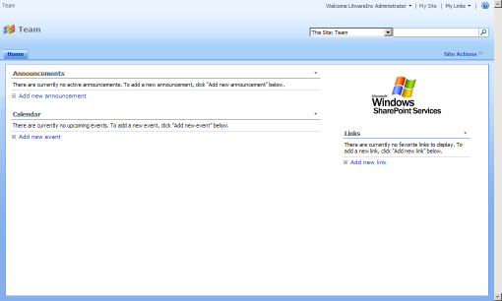

1. While there is probably a lot more we could do to change this master page for a real branding effort, the changes we have made so far should highlight the power of CSS when it comes to changing the look and feel of a SharePoint site.

# Lab 03: Customizing A SharePoint Theme

**Lab Time**: 45 minutes

**Lab Folder**: C:\Student\Labs\01_Roadmap

**Lab Overview:** In this lab, we will explore the creation of our own theme for the WingTip Farms SharePoint Team Site. We will copy an existing theme and then walk through to process of converting to our own design. Some of the CSS concepts will be familiar from the previous Lab while others may be new. All of the graphics that are needed for this Lab are already created but you will learn more about working with Photoshop to make similar graphics in another section.

Lab Setup Requirements

* Before you begin this lab, you must run the batch file named **CreateSiteforLab3.bat**. This batch file creates a new SharePoint site collection at the location **http://litwareinc.com/sites/Lab03**.

## Exercise 1: Creating a new Theme based on an existing Theme

1. Begin by resetting the master page for the site that we were working on in the previous lab (if you didn’t complete that lab feel free to skip this step). We don’t want that master page getting in the way of the Theme we will be creating.
2. Click Start > All Programs > Microsoft Office > SharePoint Designer
3. Once SharePoint Designer opens, click File > Open Site…
4. In the Site name box enter http://litwareinc.com/sites/Lab03and click Open
5. In the left hand Folder List pane, expand _catalogs > masterpage and right-click on default.master and select Set as Default Master Page and click Yes to the prompt
6. Now we need to explore the 12 Folder, which is where most of the actual code that runs SharePoint is located. Navigate to C:\Program Files\Common Files\Microsoft Shared\web server extensions\12
7. The “TEMPLATE” directory is where everything we will be working on is located so navigate there
8. Under the TEMPLATE directory is THEMES, this is where all of the Themes for SharePoint are located, navigate there
9. For our Theme, we are going to base it off the “Simple” theme, since it has probably the least colorful of all the themes and will let us apply our own branding. You could easily start with another one that is close to your own color theme.
10. Make a copy of the “SIMPLE” folder and name it “WingTipFarms”

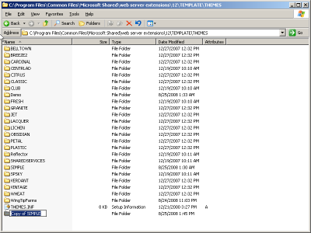

1. Next, we will make some changes to the XML files that make up the Simple Theme and have them reflect our new Theme
2. Navigate to the new WingTipFarms directory
3. Rename “SIMPLE.INF” to “WingTipFarms.INF”
4. Open WingTipFarms.INF in Notepad
5. Find all instances of the word “Simple” and replace with “WingTipFarms”. You can do this by clicking Edit > Replace and entering “Simple” in the Find and “WingTipFarms” in the Replace and clicking Replace All.
6. 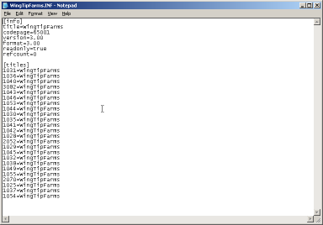
7. Save the INF file, we are done making changes to it
8. Next we need to edit the SPTHEMES.XML file
9. Navigate to C:\Program Files\Common Files\Microsoft Shared\web server extensions\12\TEMPLATE\LAYOUTS\1033
10. Open SPTHEMES.XML in Notepad
11. Add the following XML before the </SPTHEMES> end tag:

<Templates>

<TemplateID>WingTipFarms</TemplateID>

<DisplayName>WingTipFarms</DisplayName>

<Description>WingTipFarms</Description>

<Thumbnail>images/th_wingtip.gif</Thumbnail>

<Preview>images/th_wingtip.gif</Preview>

</Templates>

1. You file should look like this:

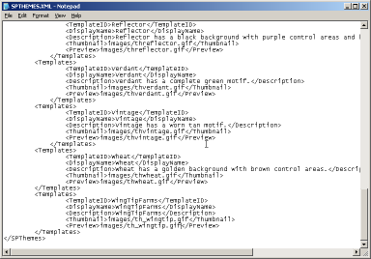

1. Save SPTHEMES.XML we are done making changes
2. Next, let’s make a copy of the Thumbnail image for Simple Theme and use it for our Theme. We will replace this thumbnail with a screenshot when we are done
3. Navigate to C:\Program Files\Common Files\Microsoft Shared\web server extensions\12\TEMPLATE\IMAGES.
4. This is where many images are located including all the thumbnails for Themes
5. Copy thsimple.gif and paste and rename it to th_wingtip.gif.
6. Next, we need to run IISRESET in order to load or Theme as an available Theme in SharePoint
7. Click Start > Run… and enter CMD
8. At the command prompt type IISRESET and hit enter
9. After IIS has reset you should see that it was successfully restarted.

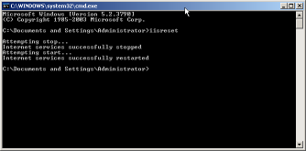

1. Lastly we need to activate the Theme for our SharePoint site
2. Open Internet Explorer and browse to [http://litwareserver:222/default.aspx](http://litwareinc.com/sites/Lab02)
3. Click Site Actions > Site Settings and then click Site theme under Look and Feel
4. At the bottom of the list of Themes you should see WingTipFarms.

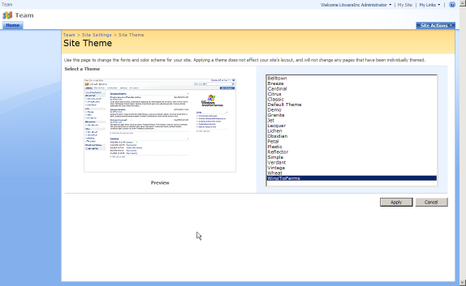

1. Select WingTipFarms and click Apply
2. Navigate back to the homepage and you will see the Simple Theme applied (actually our WingTipFarms Theme but you get the picture)

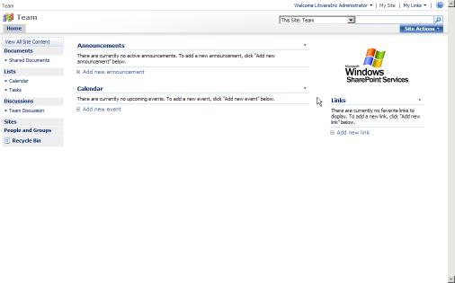

## Exercise 2: Edit the Theme's styles from SharePoint Designer

1. Now we will open the Theme directly from our site in SharePoint Designer. This is much faster than editing the site in the Themes directory, as you would need to reset IIS frequently and reapply the Theme. Just be careful that no one reselects the Theme while you are working on it or you could lose your work. For this section, much of the CSS and images that are needed will be provided for you.
2. Switch to SharePoint Designer and make sure the [http://litewareserver:222](http://wingtip.com/sites/Lab01_Exercise01) site is open
3. Click in the Folder List pane and hit F5 to refresh the files shown
4. Open the _themes folder
5. You will see WingTipFarms, which is our applied Theme, SharePoint created this folder when the Theme was applied. It gets rewritten whenever a new Theme is selected
6. Open the WingTipFarms folder
7. Open “Wing1011-65001.css” this is the active Theme CSS that is being used, it is a combination of theme.css and mossExtension.css from the Theme folder
8. Any changes that we make in “Wing1011-65001.css” will be reflected in the site as soon as the file is saved, to prove this lets add some obnoxious style and observe the change. Add this CSS to the top of the file:

div {

background-color: red;

}

1. Save the CSS and refresh your browser you should see many of the Div’s are now red:

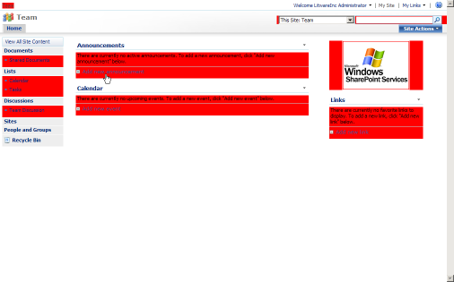

1. Remove that style and resave the file
2. Next, we will add our custom images into the Theme. We start by adding all of the premade images for the Theme. About half of these images are gray scale de-saturated versions of the background images and patterns that were used in the Simple theme (and found in the Theme directory). Many of them were blue or red, and gray just matches with everything. The other half of the images are backgrounds, logos, and branding for the WingTipFarms site. You will explore working with Photoshop in another section
3. We start with all of the grayscale versions of the Simple Theme images, they are located on your computer at C:\students\labs\lab3\ grayscale replacement images.
4. Navigate into that folder and view thumbnails to see that they are grayscale versions of familiar images that are typically in the background of a Theme
5. Drag all of the images that are in there to SharePoint Designer into the Folder List pane and into the /_themes/WingTipFarms directory
6. All of these files replace existing files so click Yes to All in the replacement warning box
7. Next, we will drag all of the custom branding images for Wing Tip Farms into the Theme
8. Navigate to C:\students\labs\lab3\ custom branding images and drag all of these images to SharePoint Designer into the Folder List pane and into the /_themes/WingTipFarms directory
9. This time there should be no warnings about overwriting files as they are all new
10. Now all of the images are ready to be worked with in our Theme. Before we are finished with everything at a later step we will copy all these images to the actual Theme directory to finalize the Theme, but for now we just need them for working with our CSS
11. Next, we will prepare the CSS for our custom styles.
12. Start by adding a comment to the top of the CSS so that we can remember what we did at a later date:

/* Wing Tip Farms Theme based on OOTB Simple Theme

This section all OOTB SIMPLE THEME styles

*/

1. Next, we add one universal style to the top that makes all the padding and margin 0px, we put this at the top because as a universal selector it would control too much if it were put at the bottom of the page. At the top, the styles below it have a chance to override it (especially important for some Microsoft styles that may need padding or margin

/* fix padding and margin for all elements */

* {

padding: 0px;

margin: 0px;

}

1. After this line we put another comment to designate all of the out-of-the-box Theme styles

/* ALL OOTB STYLES FROM Simple Theme */

1. The top of the CSS will now look like this:

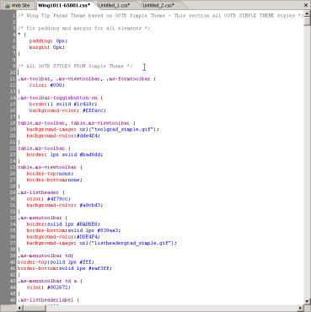

1. After this, we let all of the rest of the out of the box Theme style sit where it is and we will begin to put our styles after them so scroll all the way to the bottom of the CSS file
2. One last thing we should do before adding our own styles is remove the styles that SharePoint added from mossExtension.css. Scroll up from the bottom about 66 lines until you see a CSS element named “table.ms-applyfiltersinactive”. Select from here all the way to the bottom of the CSS and remove all 66 or so lines of CSS. The reason we remove them is, when we put all this CSS back in our theme we don’t want SharePoint doubling it up and adding the lines a second time
3. Where those lines were, place another large (easily seen when scanning code) comment like this

/* ========================================================== */

/* ========================================================== */

/* Everything under here is added by SharePoint */

/* ========================================================== */

/* ========================================================== */

1. Next, add one more large comment block above this one that will signify where we will be putting all of our custom CSS for the theme:

/* ========================================================== */

/* ========================================================== */

/* Theme custom Styles */

/* ========================================================== */

/* ========================================================== */

1. The bottom of the CSS file should now look like this:

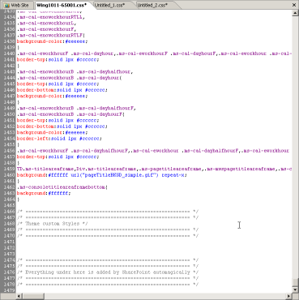

1. Now we are going to begin adding our custom styles to the Theme all of the following CSS will go between the two big comments we just added
2. First, we add the CSS for the top bar. These styles will handle the global breadcrumb, the welcome text, my sites, my links, and the help icon as well as the background for the top bar.

/* CUSTOM TOP BAR */

/* ------------------------------------------------------*/

/* top bar bg */

.ms-globalbreadcrumb {

background-color:#D3DEE9;

background-image:url(top.gif);

background-repeat:repeat-x;

height: 23px;

}

/* top links */

.ms-globallinks, .ms-globallinks a {

color:#006600;

display: inline-table;

}

.ms-globallinks a:hover {

color:#006600;

}

/* top link color */

.ms-SPLink a:link, .ms-SPLink a:visited {

color:#006600;

}

.ms-SPLink a:hover, .SpLinkButtonActive a:hover, .ms-SPLink ms-hovercellactive, .ms-SPLink ms-hovercellactive a , .ms-SPLink ms-hovercellactive a:link, .ms-SPLink ms-hovercellactive a:hover, , .ms-SPLink ms-hovercellactive a:visited {

color:green;

}

/* hover link color */

.SpLinkButtonActive a {

color:green;

}

td.ms-globalbreadcrumb {

border-bottom:none 1px transparent;

}

/* hover state for welcome and mylinks */

.ms-HoverCellActive, .ms-SpLinkButtonActive {

background-color: transparent;

background-image: none;

border: 0px none transparent;

margin: 1px;

}

/* welcome hover */

.ms-HoverCellActive a:hover, .ms-SpLinkButtonActive a:hover {

text-decoration: underline;

}

1. Save the CSS file and refresh your browser to see the changes.

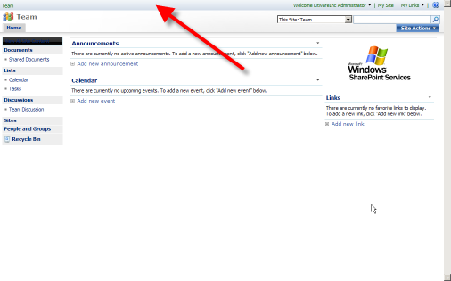

1. Next, we add the header section of the site, this will style the logo as well as the background of the header. Note that the logo is a transparent gif that is floated over the background, and the background has the cow pasture image that will repeat in large browsers.

/* CUSTOM HEADER */

/* ------------------------------------------------------*/

td.ms-titleimagearea {

background-image:url(wingtip_logo.gif);

background-repeat:no-repeat;

display:block;

height:87px;

left:16px;

position:absolute;

top:31px;

width:346px;

}

/* home link */

h1.ms-sitetitle {

display: none;

}

td.ms-titleimagearea img {

display: none;

}

/* header bar bg */

.ms-globalTitleArea {

background-image:url(header.jpg);

background-position:left top;

background-repeat:repeat-x;

height:108px;

}

1. Save the CSS file and refresh your browser to see the changes.

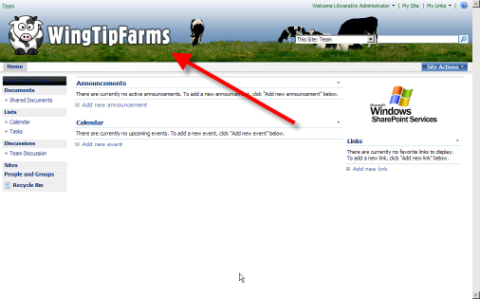

1. Next, we add the top navigation CSS, this will style the navigation buttons as well as flouts and hovers, and selected items. This CSS makes use of repeating gradient images that make the navigation elements look like shaded buttons

/* MAIN NAV ITEMS */

/* ------------------------------------------------------*/

/* nav bg */

.ms-bannerframe, .ms-GRHeaderBackground {

background-image:url(nav.gif);

background-color:green;

}

/* nav bg */

.ms-bannerContainer {

background-image:url(nav.gif);

background-color:green;

height: 24px;

background-position: center top;

padding-left: 0px;

padding-right: 0px;

}

/* top nav border */

.ms-topnavContainer {

border:0px solid black;

margin-left:165px;

height: 24px;

}

/* nav item bg */

.ms-topnav {

background-image:url(nav.gif);

background-color:green;

background-repeat:repeat-x;

border-color:white;

border-style:solid;

border-width:0px 0px 0px 0px;

color:white;

font-family:arial;

font-size:.8em;

line-height:17px;

margin:0px;

padding:0px 10px;

height: 24px;

}

/* top nav link color */

.ms-topnav a {

color:white;

background-image: none;

background-color: transparent;

font-weight: bold;

}

/* nav item hover bg */

.ms-topNavHover {

background-image:url(nav_hover.gif);

background-color:green;

border-color:black;

border-style:solid;

border-width:0px 0px 0px 0px;

color:white;

font-family:arial;

font-size:.8em;

line-height:17px;

margin:0px;

padding:0px 10px;

}

.ms-topNavHover a, .ms-topNavHover a:hover, .ms-topNavHover a:visited, .ms-topNavHover a:link {

color:white;

background-image: none;

background-color: transparent;

font-weight: bold;

}

/* nav selected item bg */

.ms-topnavselected {

background-image:url(nav_hover.gif);

background-color:green;

border-color:#575757 black;

border-style:solid;

border-width:0px 0px 0px 0px;

color:white;

}

.ms-topnavselected a, .ms-topnavselected a:hover {

color:white;

background-image: none;

background-color: transparent;

font-weight: bold;

}

/* sub item mouse over */

.ms-topNavFlyOutsHover {

background-color: white !important;

}

.ms-topNavFlyOuts {

background-color:#F5F6F3;

}

.ms-topNavFlyOuts a {

color: #3A4663;

font-weight: bold;

}

.zz1_TopNavigationMenu_8 {

background-color:white;

border:1px solid #CBD1E0;

}

.ms-consolemptablerow {

background:#ffffff none repeat-x;*/

border-color: black;

border-width: 0px;

background-color: white;

}

1. Save the CSS file and refresh your browser to see the changes.

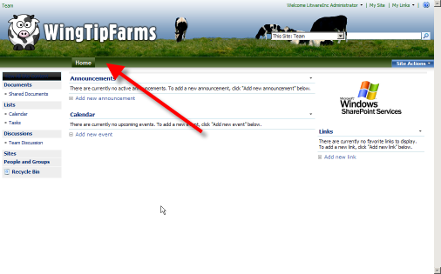

1. Next, we had the left navigation items, which include the background, the quicklaunch header, headings, items, sub items, hover states, and the recycle bin. Again repeating background colors or images are used to make the items look like buttons.

/* LEFT NAV */

/* ------------------------------------------------------*/

.ms-nav {

background:transparent none no-repeat scroll 0 0;

}

.ms-navframe {

background:transparent none no-repeat scroll 0 0;

padding-left:11px;

padding-top:11px;

}

.ms-quicklaunchheader {

color: white;

background-image: none;

background-color:black;

border:solid 1px #BADBE8;

font-weight: bold;

}

.ms-quicklaunchheader {

border:1px none transparent;

}

/* font color on left bar */

.ms-quicklaunchheader a {

color: white;

}

.ms-quicklaunchheader a:hover {

color: white;

}

/* left side stuff */

.ms-navsubmenu1 {

background-color:white;

}

/* left side stuff */

.ms-quickLaunch {

background-color:white;

border:1px solid black;

}

/* left side stuff */

.ms-quicklaunchouter {

border-bottom:1px none transparent;

border-right:1px solid transparent;

}

/* left side stuff */

.ms-quicklaunch table.ms-navheader td, .ms-navheader2 td, .ms-quicklaunch span.ms-navheader {

background-color:white;

border-left:1px solid white;

border-top:1px solid white;

border:1px none;

padding:1px 4px 4px;

}

table.ms-navitem td, span.ms-navitem {

background-image:url(bullet.gif)

}

/* left side stuff */

table.ms-recyclebin td {

background-color:white;

border-left:1px solid white;

border-top:1px solid white;

color: #0D2D84;

}

/* left side stuff */

.ms-quicklaunch table td {

border-top:1px dotted white;

}

/* left side stuff */

.ms-quicklaunch table.ms-selectednavheader td {

background-color:white;

background-image:none;

background-repeat:repeat-x;

border:1px none;

padding:1px 6px 3px;

}

/* left side stuff */

.ms-navsubmenu2 {

background-color:white;

margin-bottom:6px;

width:100%;

}

table.ms-recyclebin {

display: none;

}

/* left nav header fonts */

.ms-navheader a {

color:black;

}

/* left nav font color */

.ms-navItem a, .ms-navitem a:visited {

color:black;

}

/* recycle bin font */

table.ms-recyclebin td a {

color:black;

}

/* recycle bin page */

.ms-quicklaunch table.ms-selectednav {

background-color:white;

background-image:none;

background-repeat:repeat-x;

border:1px solid silver;

margin:2px 2px 0pt;

width:97%;

}

1. Save the CSS file and refresh your browser to see the changes.

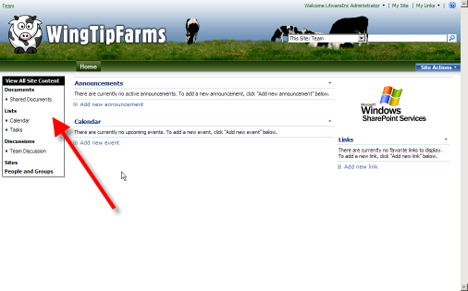

1. Next we will style the search box at the top right, mainly this just involves cleaning up some background colors and the advanced search link (for MOSS) to make it look appealing.

/* SEARCH ITEMS */

/* ------------------------------------------------------*/

/* background behind search box */

td.ms-sbcell {

background-color:white;

}

/* background behind search scopes */

td.ms-sbscopes {

background-color: transparent;

}

/* background behind advanced search */

td.ms-sblink {

background-color:transparent;

}

/* advanced link */

.ms-sblink a:link, .ms-sblink a:visited {

color: white;

}

1. Save the CSS file and refresh your browser to see the changes.

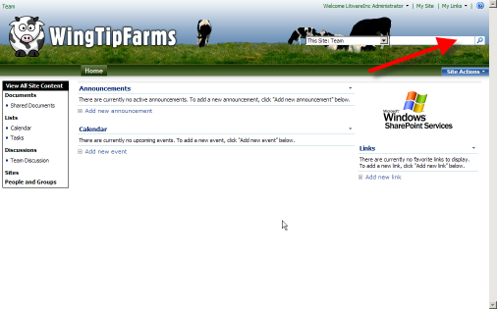

1. Next, we will style the Site Actions menu, this CSS is similar to the CSS used in the previous lab to make the Site Actions appear to be part of the main navigation

/* SITE ACTIONS SECTION */

/* ------------------------------------------------------*/

/* site actions bg */

.ms-siteactionsmenu div div div {

background-image:none;

background-color:transparent;

background-repeat:repeat-x;

border-left:1px solid transparent;

border-right:1px solid transparent;

border-top:1px solid transparent;

height: 15px;

line-height: 15px;

padding: 4px 10px;

}

/* site action font */

.ms-siteactionsmenu div div div a {

color:white;

font-weight:bold;

}

/* site actions hover */

.ms-siteactionsmenu div div div a:hover {

color:white;

font-weight:bold;

text-decoration:underline;

}

/* site actions hover */

.ms-siteactionsmenu div div div.ms-siteactionsmenuhover {

background-image:none;

background-position:center top;

background-color:transparent;

border-left:1px solid transparent;

border-right:1px solid transparent;

border-top:1px solid transparent;

}

.ms-siteactionsmenu div div div.ms-siteactionsmenuhover a {

color: white;

}

/* site actions item hover */

.ms-MenuUIItemTableHover {

background-color:#dddddd;

border:1px solid silver;

}

/* site actions menu color */

.ms-MenuUIPopupBody table {

color:#555555;

}

1. Save the CSS file and refresh your browser to see the changes.

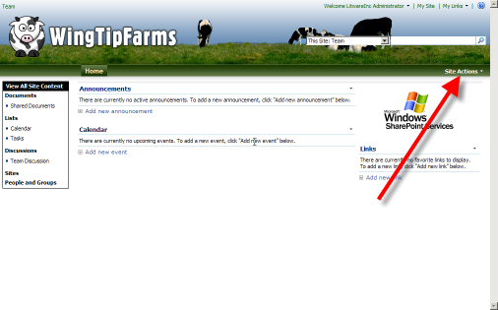

1. Next, we have a subtle change to the web parts on the page to show a silver line under them instead of the default blue line

/* WEB PARTS */

/* ------------------------------------------------------*/

.ms-WPHeader td {

border-bottom:1px solid silver;

}

1. Save the CSS file and refresh your browser to see the changes.

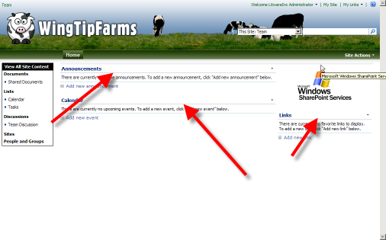

1. The next set of the styles are miscellaneous styles that need to be overridden on the pages themselves, many are just background images or color that need to match with our branding. This is also where we add the cow print behind all the elements.

/* MISC PAGE */

/* ------------------------------------------------------*/

.ms-main {

background-image:url(cowprint.gif);

}

.ms-pagemargin {

background-color: transparent;

background-image:none;

}

td.ms-bodyareaframe {

padding: 10px;

}

/*all site content divider */

.ms-gb {

border-bottom:1px solid silver;

}

/* title big blue bg */

.ms-pagetitleareaframe table {

background-image:none;

background-color:white;

}

/* right side bg */

td.ms-rightareacell div.ms-pagemargin {

background-color:transparent;

background-image:none;

background-repeat:repeat-x;

border-left:1px none transparent;

}

/* little line in top area of main frame */

.ms-listdescription {

border-bottom:1px solid transparent;

}

/* body frame border */

.ms-bodyareaframe, .ms-viewareaframe {

border: 1px solid black;

}

.ms-pagebreadcrumb {

background-color: transparent;

border: 0px transparent none;

}

/* divit on top left */

td.ms-areaseparatorleft {

background:transparent none repeat scroll 0%;

border-right:0px none transparent;

height:100%;

}

/* left top area */

td.ms-titleareaframe, div.ms-titleareaframe, .ms-pagetitleareaframe, .ms-mwspagetitleareaframe, .ms-consoletitleareaframe, .ms-titlearealeft {

background-color:transparent;

background-image:none;

}

/* divot on top right */

.ms-titlearearight .ms-areaseparatorright {

border-left:1px none transparent;

height:100%;

padding-right:2px;

}

.ms-titlearearight div.ms-areaseparatorright {

border-left:1px none transparent;

}

/* */

div.ms-areaseparatorleft {

background:transparent none repeat scroll 0%;

border-right:1px none transparent;

height:100%;

}

div.ms-areaseparatorright {

background:transparent none repeat scroll 0%;

border-left:1px none transparent;

}

.ms-bodyareapagemargin {

background:transparent none repeat scroll 0%;

border-top:1px none transparent;

}

/* footer bg */

.ms-pagebottommargin, .ms-pagebottommarginleft, .ms-pagebottommarginright {

background:transparent none repeat scroll 0%;

}

/* search results page top */

.ms-searchresultsareaSeparator {

background-color:#eeeeee;

padding:0;

}

1. Save the CSS file and refresh your browser to see the changes.

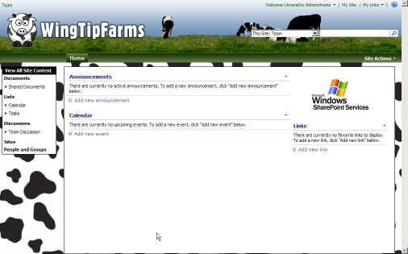

1. These last styles are for the page that shows when someone selects Site Actions > Site Settings. It has some nice background images and gray gradients.

/* SITE SETTINGS PAGE ITEMS */

/* ------------------------------------------------------*/

table.ms-pageinformation {

background-color:#FFFFFF;

background-image:url(settingsgraphic_Custom.jpg);

background-repeat:repeat-x;

}

.ms-areaseparator {

background-image: url("formtitlegrad_simple.gif");

background-color:#DBE2F1;

}

TD.ms-titleareaframe,Div.ms-titleareaframe,.ms-pagetitleareaframe,.ms-mwspagetitleareaframe,.ms-consoletitleareaframe{

background:transparent none repeat-x;

}

/* boxes around site settings headers */

td.ms-linksectionheader, th.ms-linksectionheader {

background-color:silver;

background-image:none;

background-repeat:repeat-x;

border:1px solid silver;

text-align:left;

}

/* site information font color */

.ms-pageinformation th, .ms-createpageinformation th {

color:black;

}

/* site settings page link color */

.ms-propertysheet a, .ms-propertysheet a:hover {

color:#0D2D84;

}

1. Save the CSS file and browse to Site Actions > Site Settings to see the changes.

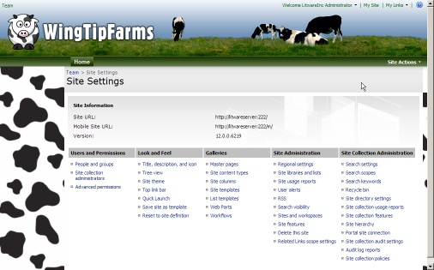

1. And that’s it. Woo Hoo. The Wing Tip Farms Theme is finished, but we still need to finalize the Theme by moving everything back to the Theme directory. If we were to skip this step all of our hard work could get ruined by someone activating a different Theme on us

## Exercise 3: Finalize and Reapply the Theme

1. Now we will move all of our changes back to the Themes folder in the 12 folder
2. Select all the Wing1011-65001.css file that is being edited in SharePoint Designer (Control-A) and copy it (Control-C)
3. Then, navigate back to the Theme directory C:\Program Files\Common Files\Microsoft Shared\web server extensions\12\TEMPLATE\THEMES\WingTipFarms
4. Open theme.css in Notepad and paste in all the code from SharePoint Designer and then save the file
5. Next copy all of the images from both source folders “C:\students\labs\lab3\ grayscale replacement images” and “C:\students\labs\lab3\ custom branding images” into the same Theme directory “C:\Program Files\Common Files\Microsoft Shared\web server extensions\12\TEMPLATE\THEMES\WingTipFarms”
6. Replace any files that already exist in the folder
7. We also need to replace the thumbnail (we just used a copy of the Simple theme thumbnail before). Now navigate to C:\Documents and Settings\Administrator\Desktop\assets for lab3\thumbnail image
8. Copy “th_wingtip.gif” which is resized screenshot of the final Theme into C:\Program Files\Common Files\Microsoft Shared\web server extensions\12\TEMPLATE\IMAGES and replace the existing file that we added earlier
9. Lastly do an IISRESET to finalize the changes. Start > Run.. then enter “CMD” then in the command console type IISRESET enter
10. Now browser back to the site in Internet Explorer and wait a second for IIS to reset, then refresh the page and go to Site Actions > Site Settings > Site Theme and select a different Theme and apply it, then re-select the WingTipFarms Theme and apply it. Note that you may have to clear your cache in order to see the new thumbnail
11. Go back to the homepage at http://litwareinc.com/sites/Lab03/default.aspx and refresh the browser and you should see the Theme is finalized!