# Lab 04: Windows Workflow Foundation Integration with SharePoint 2007

**Lab Overview:** Litware Inc. has been using SharePoint 2003 to store documents for several years and has recently upgraded to SharePoint 2007. They have read about the integrated workflow support in SharePoint 2007. Based on what they have read, they would like to evaluate it using a simple Approval process.

First, you will need to create a document library containing quotes submitted by others. Next, attach an Approval workflow to the Quotes document library. Configure the SharePoint to start a new Approval process for each new quote added to the list.

## Exercise 0: Setting up the project

### Open SharePoint and browse to the **Demo** site collection

#### The url is **http://litwareinc.com/sites/Demo**.

#### If the site collection does not exist, create it using the **CreateDemo.bat** file in the **C:\Labs\Files** folder.

## Exercise 1: Attaching an Approval Workflow

### Create a new **Quotes** document library.

#### Click the **Site Actions -> Create** menu option.

#### On the **Create** page, click the **Document Library** link under the **Libraries** section header.

#### Enter a name of **Quotes** and click the **Create** button to create the new document library.

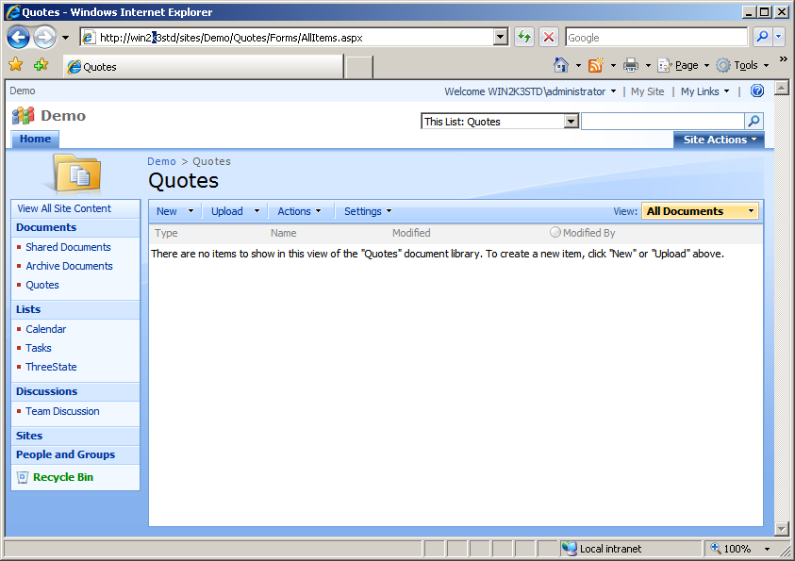

### Associate an **Approval** workflow named **Quote approval** to the new **Quotes** document library.

#### Starting from the **Quotes** document library, click the **Settings -> Document Library Settings** link.

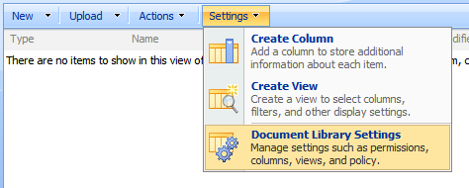

#### On the **Customize** page, click the **Workflow settings** link in the **Permissions and Management** section header.

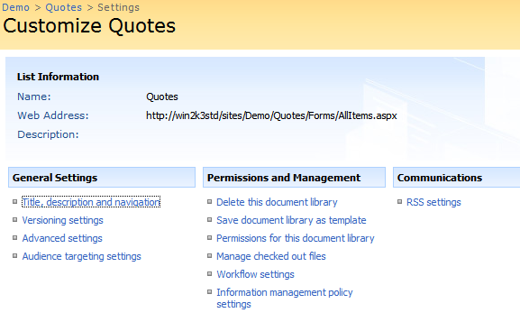

#### Choose the **Approval** workflow template and enter a name of **Quote Approval** in the name text box.

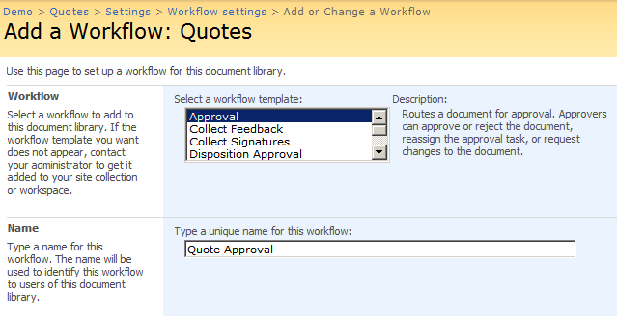

#### Choose the existing **Tasks** list for the task list and **Workflow History** list for the history list.

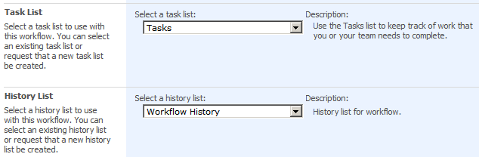

#### Choose the **Allow this workflow to be manually started** checkbox to allow manual workflow starting. Also choose the **Start this workflow when a new item is created** option to automatically start the workflow.

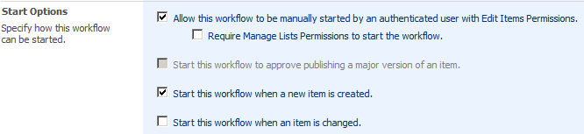

#### Click **Next** to move to the next step.

### Define the **Approval** workflow specific parameters needed to finish the association of the **Quote Approval** workflow.

#### In the **Workflow Tasks** section, leave the options as they are allowing only one approver to approve at a time and to give the approver the option of reassigning approval or resubmitting to the original submitter.

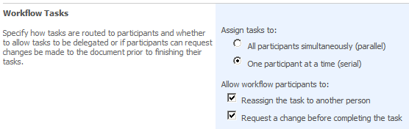

#### In the **Default Workflow Start Values** section, add the **Administrator** to the approver list. If you’d like, enter a default message as well.

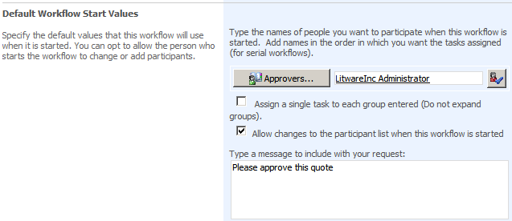

#### At the bottom of the **Default Workflow Start Values** section give each approver 1 day to complete their task and don’t notify anyone else of their task.

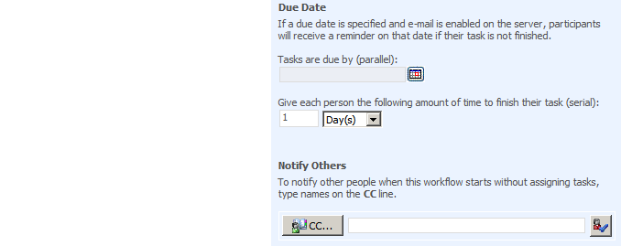

#### In the **Complete the Workflow** section, check the **Document is rejected** option to cancel the workflow if any approver rejects the quote.

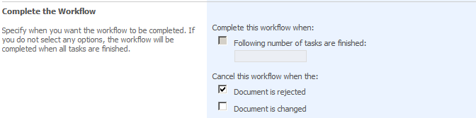

#### Click **OK** to complete the workflow association.

### Add a document to the **Quotes** document library.

#### Navigate to the **Quote** document library using the navigation links at the top of the page.

#### Add a new **Quote** to the document library by clicking the **New -> New Document** button.

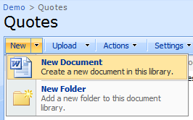

#### If the warning dialog appears, click **OK** to open the new document.

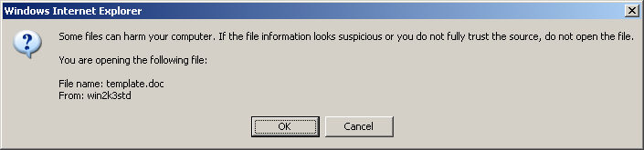

#### In Word 2007, enter some text into the document and click **Save**. Save the document using the name **Sample** **Quote.docx** to the **Quotes** library.

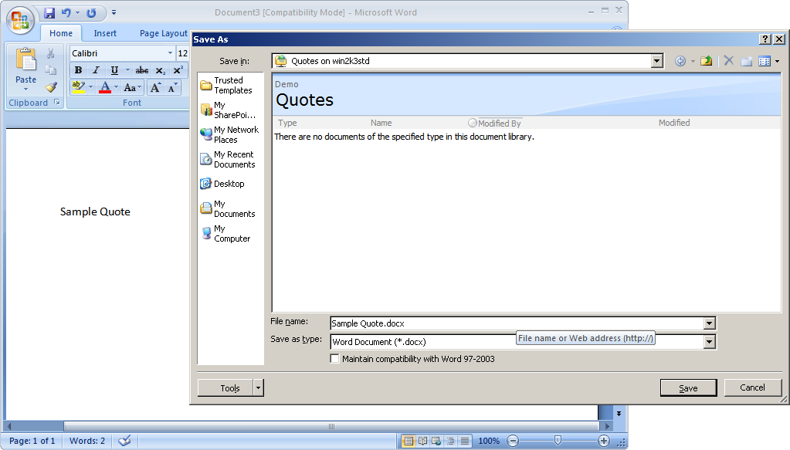

### Approve the new quote.

#### Switch back to the **Quotes** document library in **Internet Explorer** and refresh the page. You should see the new document with the **Quote Approval** column set to **In Progress**.

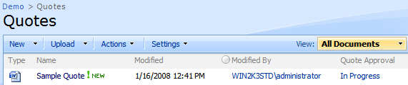

#### Click the **In Progress** link to view the workflow instance’s statistics.

#### In the **Tasks** section, locate the task item in the list and click its **Title**.

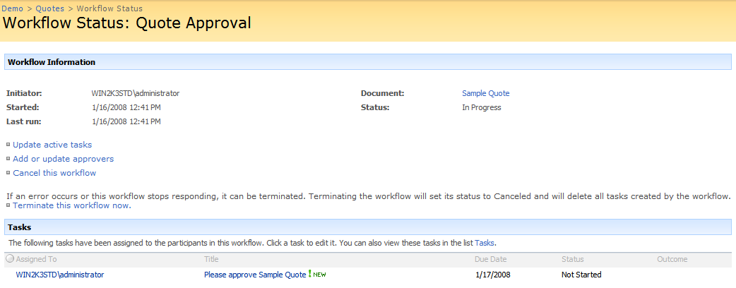

#### In the task form, enter some comments in the text box and click the **Approve** button to approve the workflow.

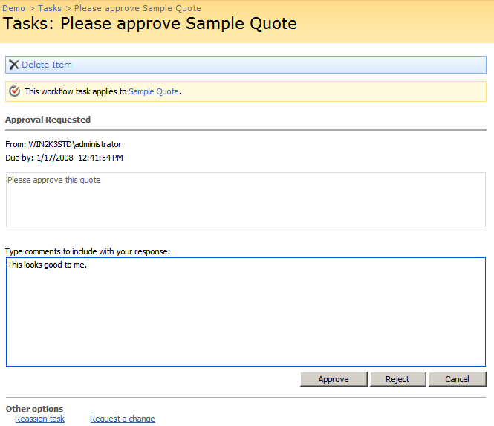

### View the quote’s approval status.

#### In the **Workflow Status** form, verify the **Status** in the **Workflow Information** section shows **Approved**.

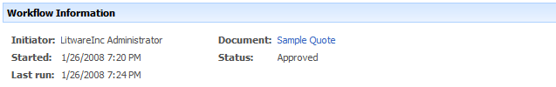

#### In the **Workflow History** section, you should see a list of four history list items detailing the steps taken by the **Approval** workflow.

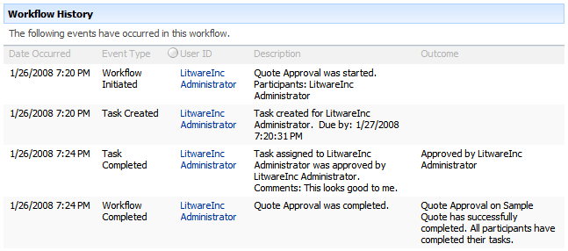

### Create another document and repeat the process with the exception of **Rejecting** the task instead of approving it.

#### Name the document **Second** **Quote.docx**.

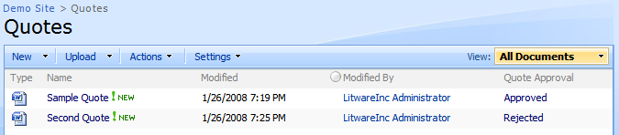

### View statistics on all workflow instances

#### Enable the **Reporting** Site collection feature.

##### Navigate to **Site Actions -> Site Settings**.

##### Click the **Site collection features** link in the **Site Collection Administration** section.

##### Verify that the **Reporting** feature is active.



#### Navigate to the **Quotes** document library and click the status link on one of the quotes.

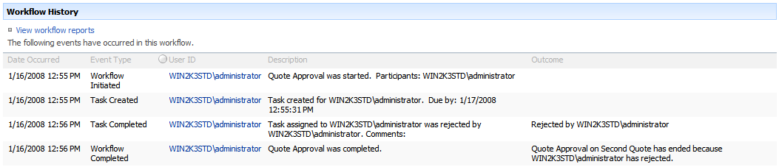

#### Click the **View** **workflow reports** in the **Workflow History** section.

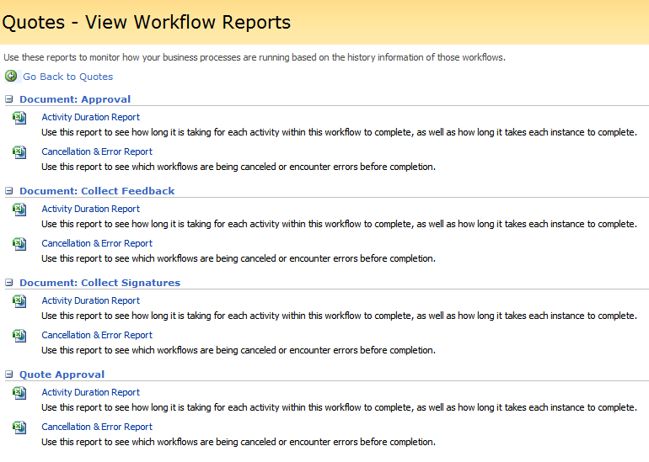

#### In the **Quote Approval** section, locate and click the **Activity Duration Report** link to generate an Excel report. The first page contains a pivot chart summarizing the raw data. Switch to the second page to see the raw data the pivot table is based on.

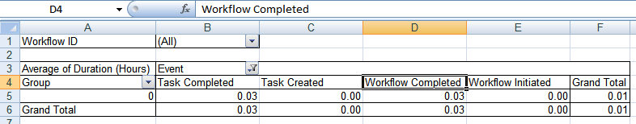

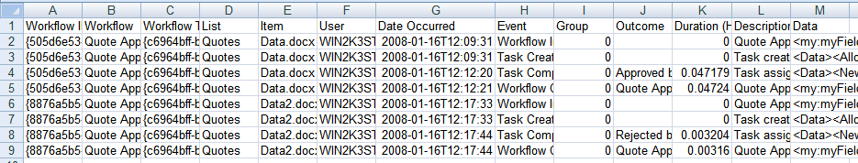

## Exercise 2: Starting the Workflow Manually

### Start the **Quote Approval** workflow manually.

#### Navigate to the **Quotes** document library.

#### Hover over the **Sample Quote** document name and click the **Workflows** option in the drop down.

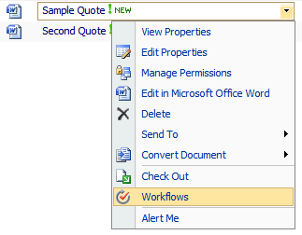

#### On the **Workflows** page click the **Quote Approval** workflow to start a new instance of it.

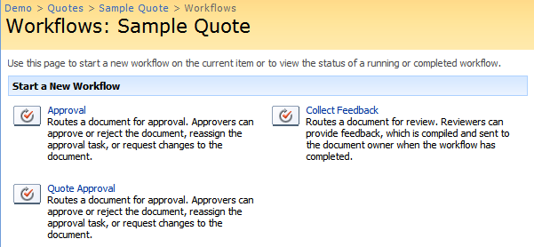

#### On the **Start Workflow** page, leave the approvers list the same, but change the message to something other than the default.

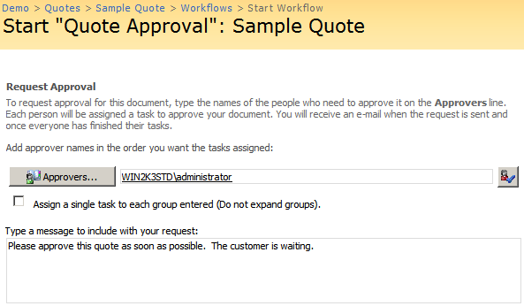

#### Click the **Start** button to start the workflow.

### Modify the running workflow instance.

#### Click the **In Progress** link on the **Sample Quote** document to view the workflow instance’s status.

#### In the **Workflow Information** section, click the **Update active tasks** list to update all current tasks for the workflow instance.

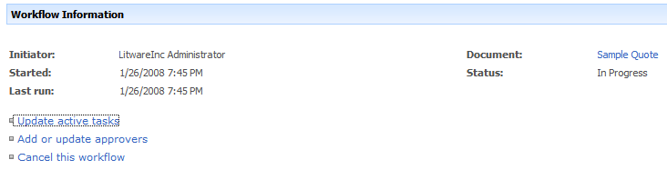

#### Change the due date of the tasks to today’s date and update the message to indicate the change.

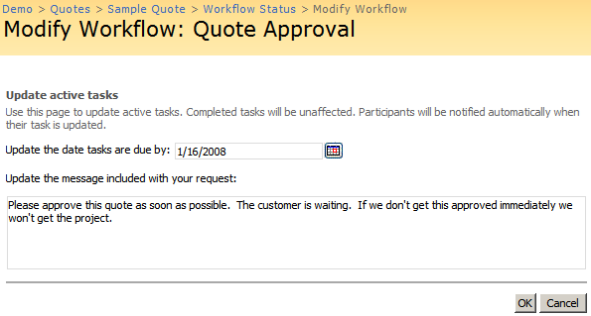

#### Click **OK** to commit the changes.

#### Verify the due date of the task has changed to today’s date.

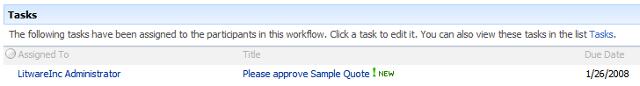

### Request a change to the workflow.

#### On the **Workflow Status** page In the **Tasks** section, click the title of the approval task.

#### On the tasks form, click the **Request** a change link at the bottom of the form.

#### On the new **Tasks** page that is loaded, leave the user to request the change from as the workflow’s owner.

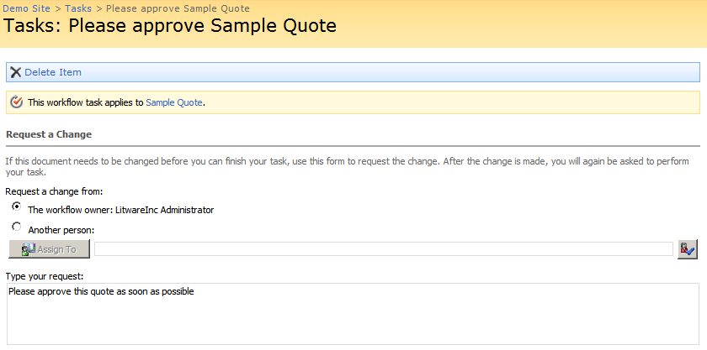

#### Set the due date to today’s date.



#### Click **Send** to submit the new task.

#### A new task will exist in the **Tasks** list requesting the change.

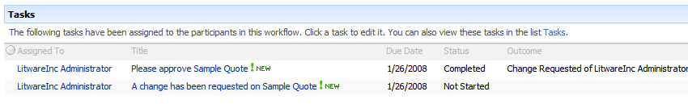

### Complete the request change task.

#### In the **Tasks** section, click the **Title** of new task.

#### Enter the response as if you’d made the changes and click **Send Response**.

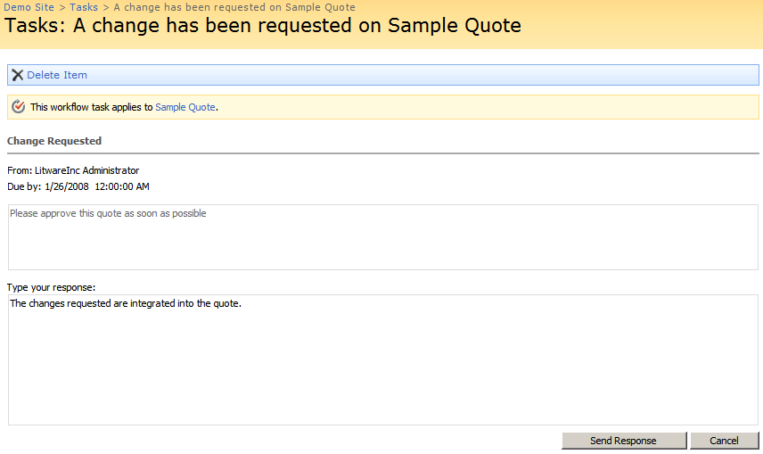

#### In the **Tasks** section, verify the request change task is completed and a new approval task exists.

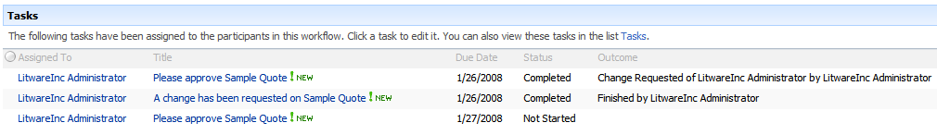

### Complete the approval task.

#### Complete the new approval task by approving the tasks, just like in the previous exercise.

#### The workflow’s status in the **Workflow Information** section should be **Approved** and the **Workflow History** section should show the entire process.

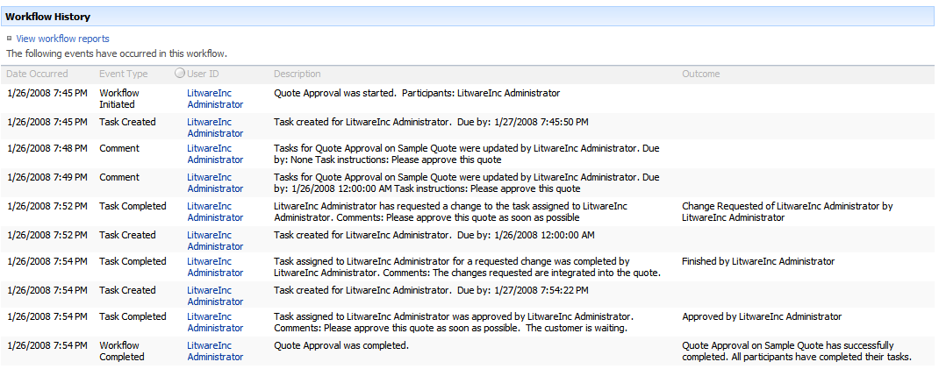

## Exercise 3: Executing Workflow using Office 2007

### Open an existing quote document

#### Navigate to the **Quotes** document library.

#### Hover over the **Sample Quote** document name and click the **Edit in Microsoft Office Word** option in the drop down.

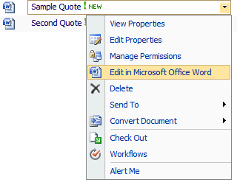

### Start the **Quote Approval** in Word 2007

#### Click the **Office Button** and select **Workflows** option from the menu.

#### In the **Workflows** window, click the **Start** button under the **Quote Approval** workflow.

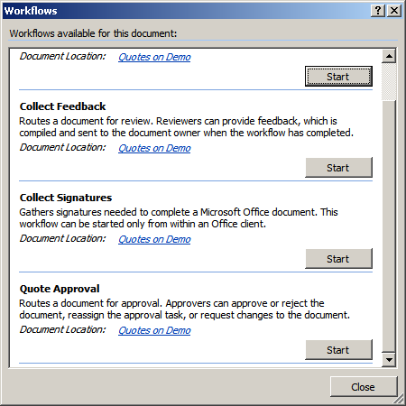

#### Update the comments to something other than the default and click **Start** to start the workflow.

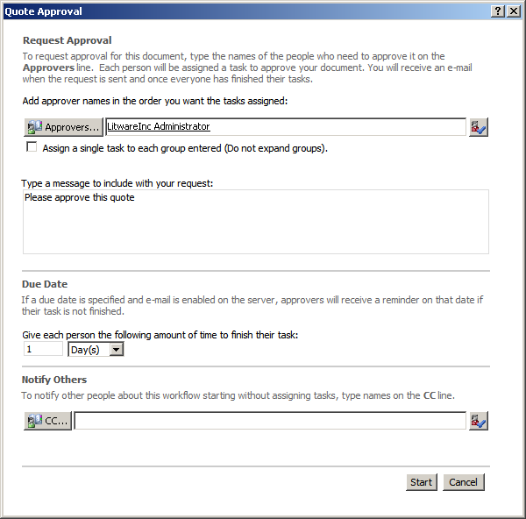

#### Notice the **Workflow Task** bar at the top of the document. This notifies the editor of the document that they have a task that relates to this document.



### Approving the task in Word 2007

#### Click the **Edit this task** button at the top of the document in Word 2007.

#### In the **Task** dialog, enter some comments and click the **Approve** button to approve the document.

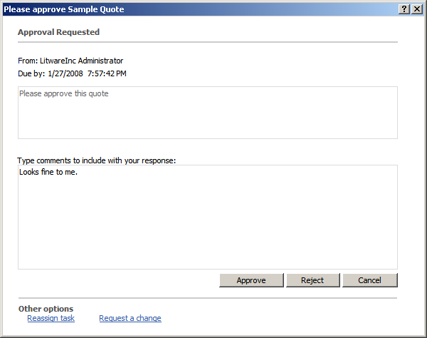

### Verify the results in **Internet Explorer**.

#### Navigate to the **Quotes** document library

#### Verify that the **Sample Quote’s Quote Approval** column contains **Approved**.

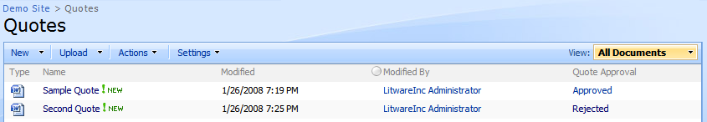

## Challenge: Quote Content Type

Often specific document types are grouped by content type and not by document library. Therefore, it is more realistic to create a **Quotes** content type and attach the workflow to the content type.

Attach the same quote approval workflow to a new **Quote** content type and add the content type to any document library. Now as long as the document is a quote content type the workflow will be available no matter which document library it is in.

Do not forget to remove the workflow association from the **Quotes** document library or you may see that workflow association instead of the content type association.