Lab 02: MOSS 2007 & Web Content Management Overview

**Lab Time:** 45 minutes

**Lab Overview:** This lab will help you get familiar with the Microsoft Office SharePoint Server (MOSS) 2007 Web Content Management (WCM) features and capabilities. In addition, you will also spend some time working within the Microsoft.SharePoint.Publishing namespace, where everything WCM can be found within the SharePoint object model. In this lab you will first create a new Web application and site collection based off the Publishing Portal site template and add a few content pages using the Web authoring tools. Then you will dive into the Microsoft.SharePoint.Publishing namespace to interrogate the Publishing site and some aspects within it.

Exercise 1: Creating a new Web application & provisioning a Publishing site collection

In this exercise you will create a new Web application that you will use throughout the remainder of the course.

1. If you haven't already, make sure you are logged in as **LITWAREINC\Administrator** (with a password of **pass@word1**).
2. Before you create a Web application, add a new DNS entry on the server for the new URL you will use. Select **Start » Administrative Tools » DNS**.
3. In the **dnsmgmt** utility, expand the tree on the left-hand side of the utility to **DNS » LITWARESERVER » Forward Lookup Zones » Litwareinc.com**. Right-click **Litwareinc.com** in the tree in the left-hand panel of the utility and select **New Host (A)...**. Enter the following information in the **New Host** dialog and click **Add Host** (when finished, your DNS settings should look like the following image):
   * **Name:** wcm
   * **IP Address:** 192.168.150.1

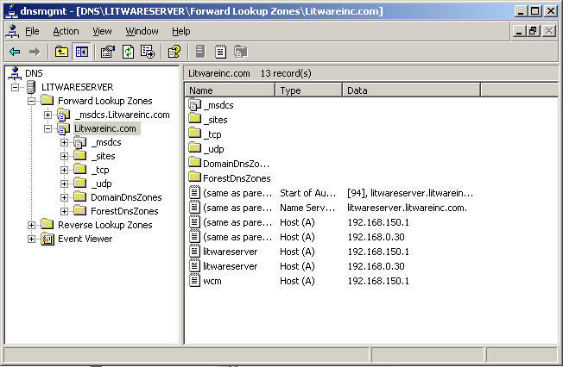

1. Launch Central Administration by selecting **Start » All Programs » Microsoft Office Server » SharePoint 3.0 Central Administration**.
2. From the **Central Administration** site, select the **Application Management** tab and then select **Create or extend Web application** under the **SharePoint Web Application Management** section.
3. On the **Create or Extend Web Application** page, select **Create a new Web application**.
4. On the **Create New Web Application** page, use the following information to create a new Web application and click **OK** (if not listed, leave default setting):
   * **IIS Web Site:** Create a new IIS web site
   * **Description:** (leave alone... this will automatically be changed as you sent the next two values)
   * **Port:** 80
   * **Host Header:** wcm.litwareinc.com
   * **Application Pool:** Use existing application pool & **SharePointDefaultAppPool (Litwareinc\SP_WorkerProcess)**
   * **Database Server:** LitwareServer
   * **Database Name:** WSS_WCM
   * **Database Authentication:** Windows authentication (recommended)
5. Upon the completion of creating the Web application, you are redirected to the **Application Created** page. Select the **Create Site Collection** link.
6. On the **Create Site Collection** page, complete the required information as follows and click **OK** to create a new site collection:
   * **Web Application:** http://wcm.litwareinc.com
   * **Title:** Litware Inc.
   * **Description:** Litware Inc. Publishing Site
   * **Web Site Address:** http://wcm.litwareinc.com/
   * **Template Selection:** Publishing Portal (found under the Publishing tab)
   * **Primary Site Collection Administrator:** LITWAREINC\administrator
   * Make sure to click the icon or press **[CTRL]+[K]** to validate the account... this may take a second or two to resolve. It should resolve to **Litware Admin Guy**.
7. When the site collection process is complete, you will be redirected to a page with a link to the new site collection. Click the link to open the site in a new window.

At this point you now have a new Web application containing a single site collection that's been created using the Publishing Portal site template. You will use this site throughout the remainder of the course.

Exercise 2: Create content pages

With a site created, this exercise will familiarize you with the process of creating some content pages.

1. If you haven't already, navigate to the Litware Inc. Publishing site at **http://wcm.litwareinc.com**.
2. Select **Press Releases** in the top horizontal navigation. This is where you will create your content pages.
3. To create a new content page, select **Site Actions » Create Page**.
4. On the **Create Page** page, specify the following information and click **Create**:
   * **Title:** Press Release 1
   * **Description:** Description of press release 1.
   * **URL Name:** should be automatically filled, but if not, enter PressRelease1
   * **Page Layout:** (Article Page) Article page with image on left
5. Use the field controls on the page to specify the **Page Image**, **Image Caption**, **Article Date**, **Byline**, and **Page Content**. Once you have entered the desired content, select **Submit for Approval** at the top of the page to start the page approval workflow.
6. On the **Start "Parallel Approval": PressRelease1** page, click **Start**.
7. The page will then load with the **Press Release 1** page you just created, but not in edit mode. Notice how the Page Editing Toolbar (PET) Quick Access buttons have changed (refer to the following image). This is because the buttons are aware of the different states of the page. To advance the page through the workflow, select the **Approve** button in the PET.

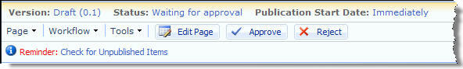

1. On the **Workflow Tasks: Please approve PressRelease1** page, optionally enter any comments and click the **Approve** button. The browser will refresh with the published page in display mode.
2. Repeat this process a few more times to create a total of three content pages. Each time, pick a different name, URL and enter different content. When selecting the page layout on the **Create Page** page, make sure you pick only page layouts that are associated with the **Article Page** content type, as indicated in the following image:

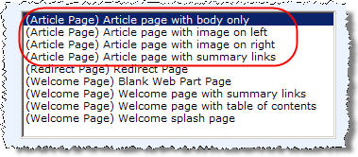

In the page layouts module we will explore this dialog further. For now, know that associated content type is the part in parentheses and the name of the page layout is to the right.

At this point, you have added some sample content to your Publishing site. Next you will access this site and content using the SharePoint object model.

Exercise 3: Working with the Microsoft.SharePoint.Publishing namespace

In this exercise you will create a console application that displays information about the Publishing site collection created in the last exercise.

1. Open **Visual Studio** and create a new **C# Console Application** project named **Lab2**. You should create the project within the following path so the project files will reside within the same directory structure as all the other lab exercises:

c:\Student\Labs\02_WcmArchitecture\Lab

1. In this lab you will be working with common SharePoint objects as well as objects specific to the Microsoft.SharePoint.Publishing namespace. In order to do this, you will need to add two assembly references to the project: **Windows SharePoint Services (Microsoft.SharePoint.dll)** which you will find under the **.NET** tab in the **Add Reference** dialog and **Microsoft.SharePoint.Publishing.dll** (no component name specified). To add the **Microsoft.SharePoint.Publishing.dll** reference you will need to pick the file from the following location on the file system using the **Browse** tab in the **Add Reference** dialog: **c:\Program Files\Common Files\Microsoft Shared\web server extensions\12\ISAPI**.
2. Make your life a little easier by adding the following using statements to the top of the **Program.cs** file:

using Microsoft.SharePoint;

using Microsoft.SharePoint.Publishing;

1. The first thing you will do is output some information about the Publishing site collection you created. Add the following code to the static **Main** method in **Program.cs**:

// get reference to the litware publishing site

SPSite siteCollection = new SPSite("http://wcm.litwareinc.com");

// get reference to the publishing site

PublishingSite publishingSiteCollection = new PublishingSite(siteCollection);

// write out some information about the publishing site

Console.Out.WriteLine("Publishing site collection properties:");

Console.Out.WriteLine(" Site collection URL: {0}", publishingSiteCollection.Site.Url);

Console.Out.WriteLine(" Total content types in the collection: {0}", publishingSiteCollection.ContentTypes.Count.ToString());

Console.Out.WriteLine(" Total page layouts in the Master Page Gallery: {0}", publishingSiteCollection.PageLayouts.Count.ToString());

Console.Out.WriteLine("");

Console.Out.WriteLine("Press any key to continue...");

Console.ReadLine();

Press **F5** to build and run the code... you should see something similar to the following image:

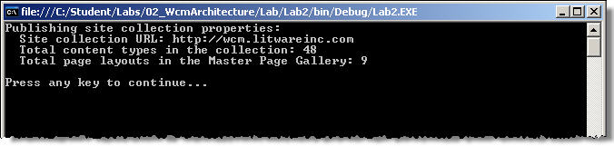

1. Now get a reference to the root web, first making sure it's a PublishingWeb, and output some information about the Pages list. Add the following code to **Program.cs** after **Console.Out.WriteLine("")** in the code added in the previous step:

// get reference to the publishing web..

SPWeb site = siteCollection.RootWeb;

if (PublishingWeb.IsPublishingWeb(site)) {

PublishingWeb publishingSite = PublishingWeb.GetPublishingWeb(site);

// write out some information about the publishing web

Console.Out.WriteLine("Publishing web properties:");

Console.Out.WriteLine(" Pages list name: {0}", publishingSite.PagesListName);

Console.Out.WriteLine(" Total pages in the list: {0}", publishingSite.PagesList.ItemCount.ToString());

Console.Out.WriteLine("");

}

Press **F5** to build and run the code... you should see something similar to the following image:

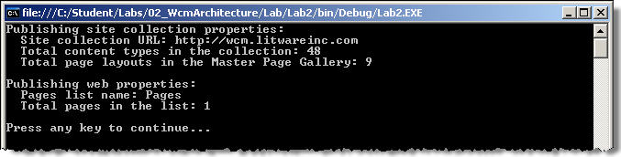

1. Finally, add some code just to the end of the **IF** statement added in the previous step to display all the pages in the Pages library:

// write out all pages

Console.Out.WriteLine("Publishing pages witin the root web's Pages library:");

foreach (PublishingPage page in publishingSite.GetPublishingPages()) {

Console.Out.WriteLine(" Page: {0}", page.Name);

Console.Out.WriteLine(" Page URL: {0}", page.Url);

Console.Out.WriteLine(" Underlying SPListItem ID: {0}", page.ListItem.ID.ToString());

}

Press **F5** to build and run the code... you should see something similar to the following image:

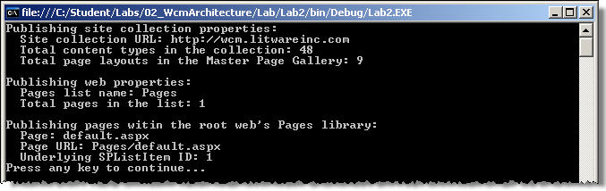

1. Now... see if you can modify the code to point to the Press Releases subsite where you created the pages in the previous exercise to output the same information displayed in steps 5 & 6 in this exercise. If you get stuck, refer to the solution of this lab.

*Tip: You only have to modify a single line of code!*