## **Creating External Content Types with the BCS**

**Lab Time**: 90 minutes

**Lab Folder**: C:\Student\Modules\BCS\Lab

**Lab Overview**: In this lab you work with several different service applications including the BCS and the User Profile Service.

### Exercise 1: Creating the SQL Server Database named WingtipCustomersDB

In this exercise you will create a SQL Server database with a table of customers and then you will create an external content type to surface those customers in a SharePoint site using an external list.

1. Create the SQL Server database named **WingtipCustomersDB**.
   1. Using the Windows Explorer, open the lab folder at **C:\Student\Modules\ServiceApplications\Lab**. You should see that there are two SQL scripts named **CreateCustomersDB.sql** and **CreateCustomersTable.sql**. There is also an executable file named **SqlDBGenerateCustomers.exe** and an associated configuration file named **SqlDBGenerateCustomers.exe.config.**

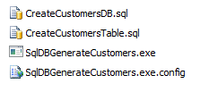

* 1. Right-click on **CreateCustomersDB.sql** and select **Open With >> SQL Server Management Studio** to open the SQL script in SQL Server Management Studio.  
     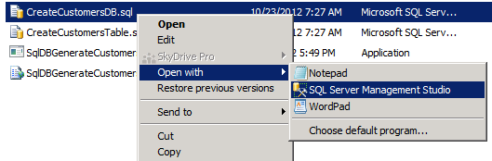
  2. If prompted to Connect to Database Engine be sure to select **Database Engine** as the Server Type, **WINGTIPSERVER** as the Server name, and use **Windows Authentication** for the Authentication type and click **Connect** as shown in the image below.  
     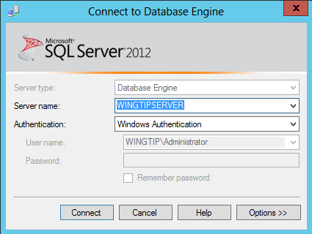
  3. Once the script named **CreateCustomersDB.sql** has opened in SQL Server Management Studio, execute this script by clicking the **Execute** button up in the ribbon.

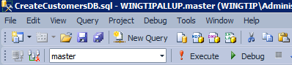

* 1. The **CreateCustomersDB.sql** script should execute successfully and show response message of **Command(s) complete successfully**.

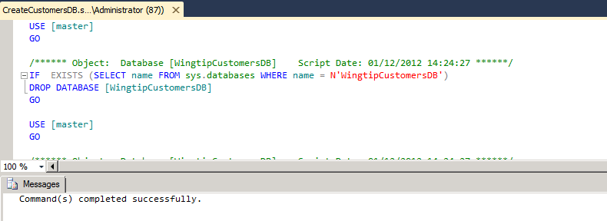

* 1. Within the SQL Server Management Studio, use the **Open >> File** command from the **File** menu to open the other script named **CreateCustomersTable.sql**. Once this script has opened, execute it by clicking the execute button just as you execute the other script.
  2. The **CreateCustomersTable.sql** script should execute successfully and show response message of **Command(s) complete successfully**.

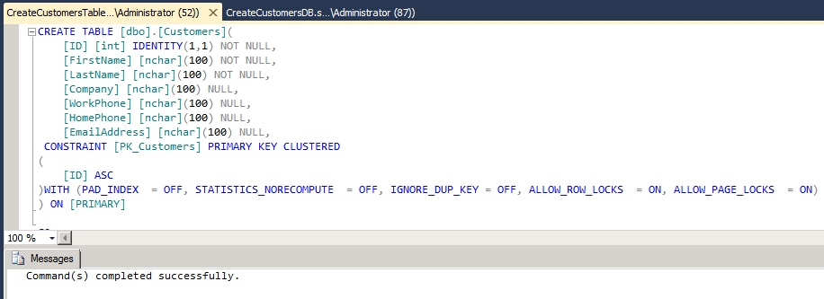

* 1. Use the tree view inside the Object Explorer to verify that a new database named **WingtipCustomersDB** has been created.

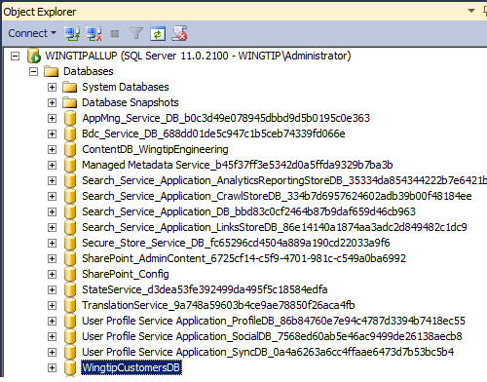

* 1. Expand the **WingtipCustomersDB** node and verify it contains a table named **Customers**.

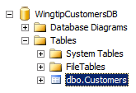

* 1. Return to the Windows Explorer and locate the file named **SqlDBGenerateCustomers.exe**. Double click this file to run a program which will connect to the database named **WingtipCustomersDB** and populate the **Customers** table with a few thousand sample records.
  2. Once the executable program **SqlDBGenerateCustomers.exe** has run, return to the SQL Server Management Studio and verify that the **Customer** table now contains sample data, You can do this by right-clicking the **Customers** table and selecting the command **Select Top 1000 Rows**.

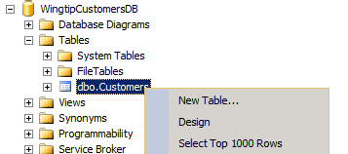

* 1. At this point, you should see that Customer table now contains records.

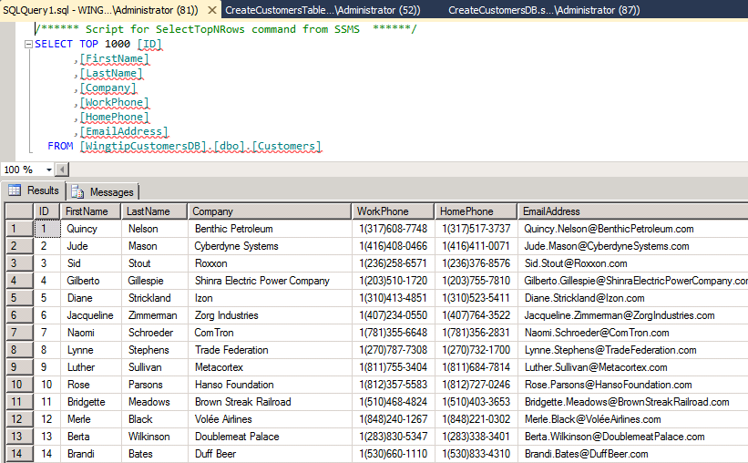

1. Configure access to the **WingtipCustomersDB** for the Active Directory group **Wingtip Sales Team**.
   1. In the SQL Server Management Studio, locate and expand the top-level **Security** node under the **Databases** node. Expand the **Logins** node inside the Security node to see the current set of logins.

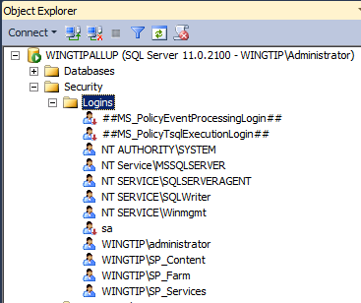

* 1. Right-click in the **Logins** node and select the **New Login** command to display the **Login - New** dialog. Add a Login name of **WINGTIP\WingtipSalesTeam**. Do not click the **OK** button until you are instructed to do so below.

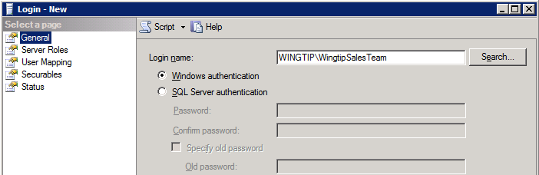

* 1. On the **Select a page** pane on the left, select the **User Mapping** page. On the right in the **Users mapped to this login** section, scroll down and check the option for **WingtipCustomersDB**. Below in the **Database role membership for: WingtipCustomersDB** section. Select the roles of **db_datareader** and **db_datawriter**. When you are done, click the **OK** button to create the new login.

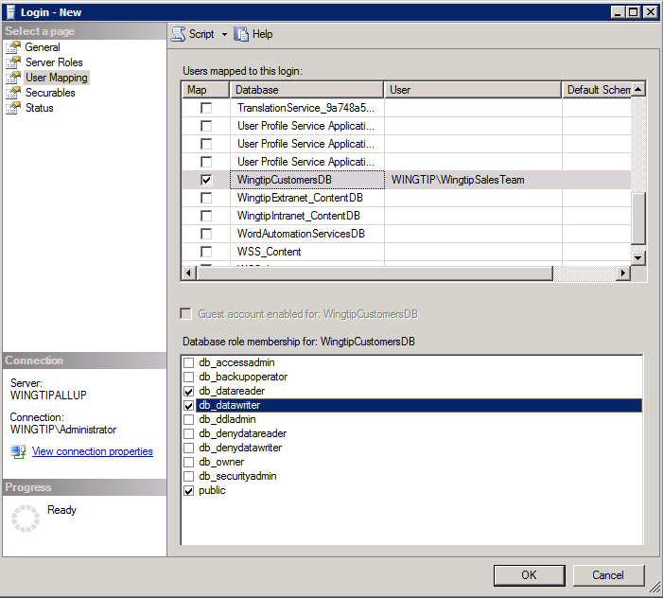

* 1. At this point, you can now close the SQL Server Management Studio.

In this exercise you created a SQL Server database with a **Customers** table that will be used in an exercise later in the lab when you create an external content type to access external data and make it available within a SharePoint site.

### Exercise 2: Creating A Secure Store Service Application

In this exercise you will configure the Secure Store Service by creating a new encryption key and creating a new Secure Store Service application. The Secure Store Service application you create in this exercise will be used in the following exercise to configure authentication when you create an external content type.

1. Navigate to **Central Administration**.
2. Click **Manage service applications** to navigate to the Service Applications Management page.
3. Select the **Secure Store Service** hyperlink (i.e. the first instance of the **Secure Store Service** click on the hyperlink **Secure Store Service**) to navigate to the main Management screen for the Secure Store Service. When the main administration screen for the Secure Store Service is displayed, you will see that there is only one button enabled with a caption of **Generate New Key** which makes it possible to create a new encryption key.

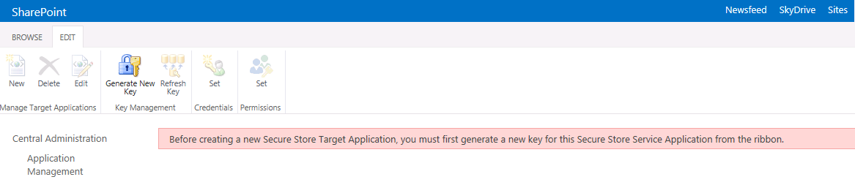

1. Create a new encryption key.
   1. Click the of **Generate New Key** button.
   2. Add a value of Password1 into the textboxes for **Pass Phrase** and **Confirm Pass Phrase** and click **OK**.
2. At this point, you should see the **New** button is now enabled on the main administrative page for the Secure Store Service.

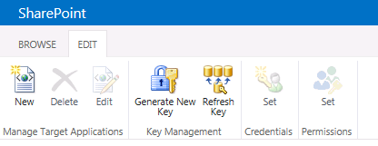

1. Create a new Secure Store application for the Wingtip Sales team.
   1. Click the **New** button which will start the **Create New Secure Store Target Application** wizard.
   2. On the first page of the **Create New Secure Store Target Application** wizard, enter the following property values and then click Next
      1. **Target Application ID**: WingtipSales
      2. **Display Name**: Wingtip Sales
      3. **Contact E-mail**: ac@wingtip.com
      4. **Target Application Type**: Individual
      5. **Target Application Page URL**: use default page

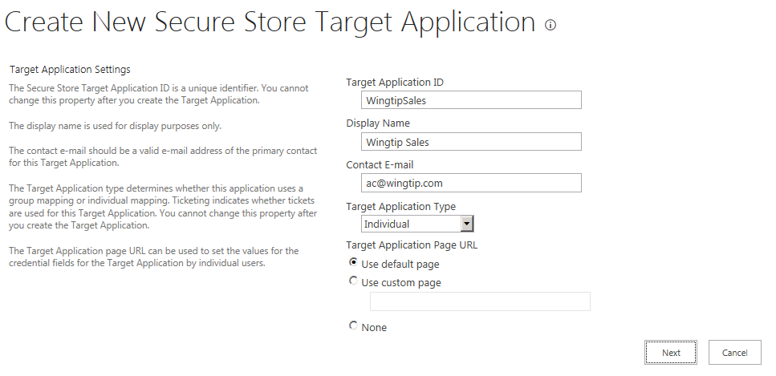

* 1. On the second page of the **Create New Secure Store Target Application** wizard, accept the default settings for the fields that have been added and click **Next**.
  2. On the third page of the **Create New Secure Store Target Application** wizard, enter the user **WINGTIP\Administrator** into the **Target Application Administrators** input control and click **OK** to create the new Secure Store application.
  3. You should be able to verify that the new Secure Store application has been created.

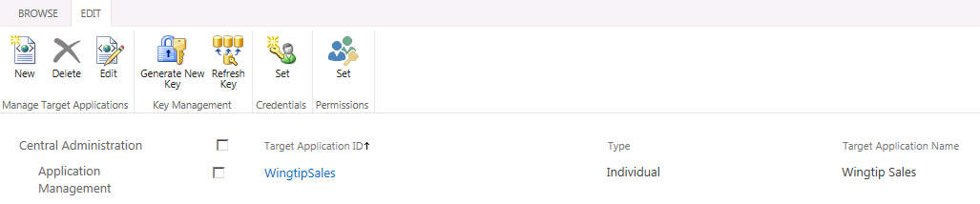

In this exercise you have created a Secure Store application that will be put to use in the next exercise when you create an external content type to access data in the SQL Server database named **WingtipCustomersDB**.

### Exercise 3: Create an External Content Type using SharePoint Designer 2013

In this lab, you will create an External content type and surface it in a SharePoint site suing an external list.

1. Open SharePoint Designer 2013
   1. **Press the Windows key to display the Windows Start page.**
   2. **Locate and click the tile for SharePoint Designer 2013 to start this application.**



1. Within SharePoint Designer 2013, open the site at **http://sales.wingtip.com**:
   1. Click the **Open Site** button.
   2. In the **Open Site** dialog, enter **http://sales.wingtip.com** in the **Site Name** box and click **Open**.
   3. If prompted to login, use the credentials for **WINGTIP\ administrator**.
2. Select **External Content Types** in the Navigation pane.
3. Click the **External Content Type** button in the **EXTERNAL CONTENT TYPES** group on the ribbon.
4. Use the following values to create the new external content type:
   1. **Name:** WingtipCustomers
   2. **Display Name:** Wingtip Customers
   3. **Office Item Type:** Contact

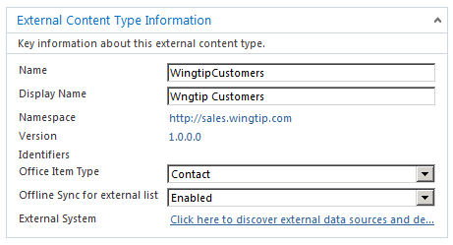

1. Using the ribbon, click the **Operations Design View** button in the **EXTERNAL CONTENT TYPES** group.
2. Click the **Add Connection** button.
   1. In the **External Data Source Type Selection** dialog, select **SQL Server** and click the **OK** button.
   2. In the **SQL Server Connection** dialog, use the following and click OK:
      1. **SQL Server:** WingtipServer
      2. **Database Name:** WingtipCustomersDB
      3. **Connect with Impersonated Windows Identity:** checked
      4. **Secure Store Application ID**: WingtipSales

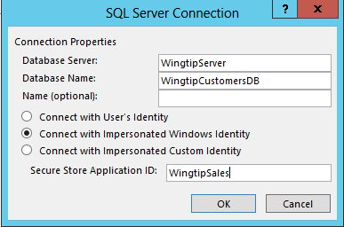

* 1. Click **OK** to close the **SQL Server Connection** dialog and save your changes.

1. Next, you will be prompted for security credentials. Login in as **WINGTIP\Administrator** using a password of **Password1**.
2. Once you have logged in you should see a node for **WingtipCustomersDB**. Expand the **WingtipCustomerDB** node and the **Tables** folder and locate the **Customers** table.

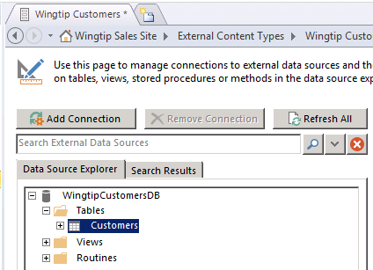

1. Right-click the **Customers** table, and select **Create All Operations** from the context menu:

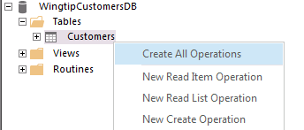

1. Use the **All Operations** wizard dialog to create the operations needed for this external content type:
   1. On the **Operations Properties** page, click **Next**.
   2. On the **Parameters Configuration** page, select the **FirstName** column and modify the following values in the **Properties** section to the right.
      1. **Display Name**: First Name
      2. **Required**: checked
      3. **Office Property**: First Name (FirstName)
      4. **Show In Picker**: checked.

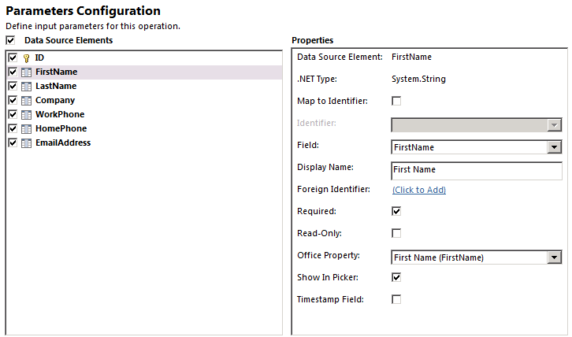

* 1. Remain on the **Parameters Configuration** page, select the **LastName** column and modify the following values in the **Properties** section to the right.
     1. **Display Name**: Last Name
     2. **Required**: checked
     3. **Office Property**: Last Name (LastName)
     4. **Show In Picker**: checked.

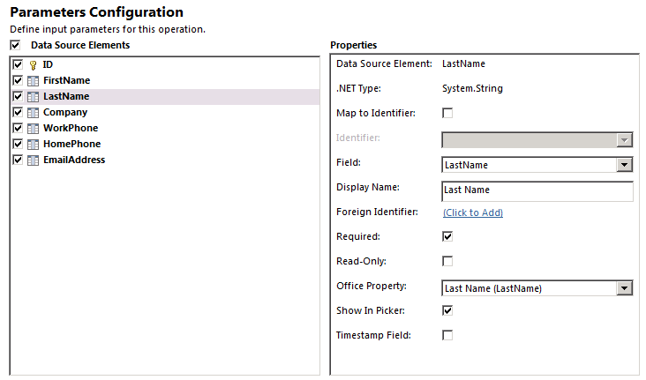

* 1. Once you have modified the **FirstName** column and the **LastName** column on the **Parameters Configuration** page, click **Next** move to the next page.
  2. On the **Filter Parameters Configuration** page, do the following to create a new limit filter
  3. Click the **Add Filter Parameter** button.
  4. In the **Properties** section (right hand side), click the **Click to Add** link next to **Filter**.
     1. In the **Filter Configuration** dialog, set **Filter Type** to **Limit** and click **OK**:
  5. In the **Properties** section, set the **Default Value** to **500** (Note: click into the **Default Value** drop-down text box and then type **500** and press **Enter**)
  6. Click **Finish**.

1. Save your changes to the new external content type by clicking the **File** tab in the ribbon and then **Save**.

Remember that an external content type after it has been created has no default permissions and is not accessible by any user including the user that created it. Therefore, you must set permissions on the external content type so that it can be used. This is done by editing the external content type in the Business Data Connectivity service application: This is separate from and in addition to having rights to access the underlying data. Users must also be granted access to use the external content type that exposes the data to SharePoint and the users.

1. Navigate to **Central Administration**.
   1. **Press the Windows key to display the Windows Start page.**
   2. **Locate and click the tile for SharePoint 2013 Central Administration to start this application.**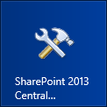
2. In Central Administration select the **Manage Service Applications** hyperlink (underneath the Application Management section).
3. In the list of service applications, click the **Business Data Connectivity Service** hyperlink (first instance in the list) to navigate to the main administration page for the BCS. You should see the external content type named **WingtipCustomers** that you just created using SharePoint Designer 2013.

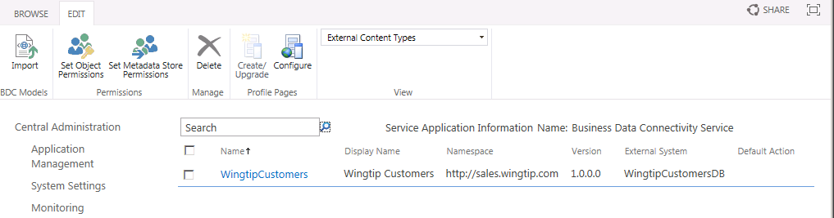

1. Using the drop-down arrow off of the **WingtipCustomers** external content type, select **Set Permissions**.

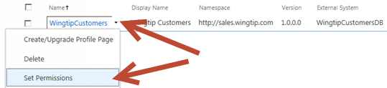

1. In the **Set Object Permissions** dialog, do the following:
   1. In the top-most box, type **WINGTIP\Administrator** and click the **Check Names** icon.  
      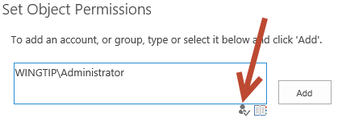
   2. After **WINGTIP\Administrator** is validated, click **Add**.
   3. Ensure the **WINGTIP\Administrator** is selected in the middle box.
   4. Check all four permissions for **WINGTIP\Administrator**.

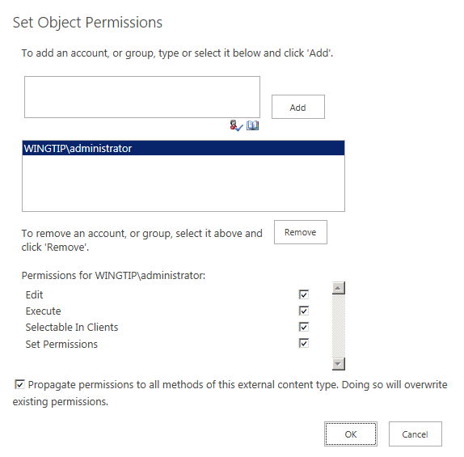

* 1. In the top-most box, type **WINGTIP\wingtipsalesteam** and click the **Check Names** icon.
  2. After **WINGTIP\wingtipsalesteam** is validated, click **Add**.
  3. Ensure the **WINGTIP\wingtipsalesteam** is selected in the middle box.
  4. Check the **Edit** and **Execute** permissions for **WINGTIP\wingtipsalesteam**.
  5. Click **OK** to save your changes and close the **Set Object Permissions** dialog.

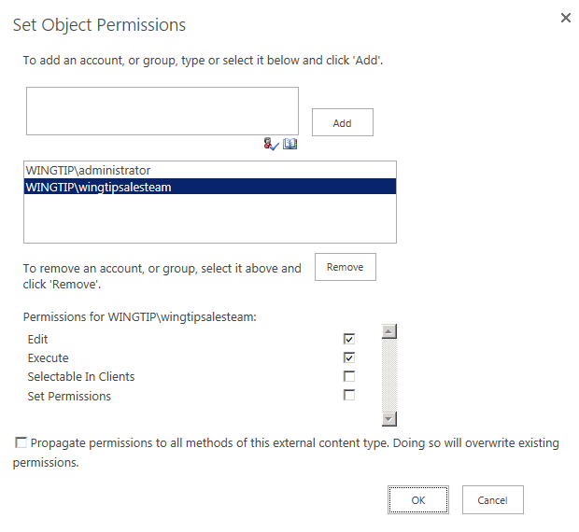

Now you have created an external content type that can be used by the user **WINGTIP\administrator** as well as by users within the group named **WingtipSalesTeam**.

### Exercise 4: Create an External List Based on the External Content Type

In this exercise you will create an external list within the site at http://sales.wingtip.com to surface the external content type you created in the previous exercise.

1. Using Internet Explorer, navigate to the site at **http://sales.wingtip.com**.
2. Create a new external list based on the **WingtipCustomers** external content type:
   1. Using the Quick Launch navigation, click the **Site Contents** link.  
      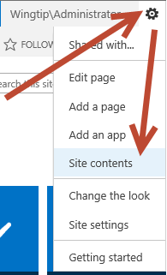
   2. On the **Site Contents** page, click the **add an app** link.
   3. Search for **External** by typing this into the **Find an app** search box near the top of the page and pressing **Enter**.
   4. Select **External List**.
   5. In the **Adding External List** dialog, use the following values to create the list and click Create:
      1. **Name:** Wingtip Customers
      2. **External Content Type:**
         1. Click the icon that has a database picture superimposed on a document.  
            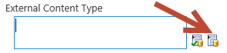
         2. In the **External Content Type Picker** dialog, select **WingtipCustomers** and click **OK**.

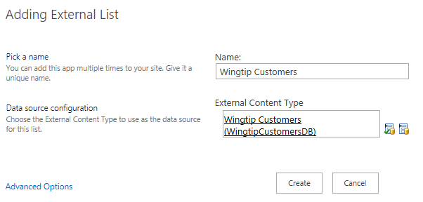

1. Once you have created the external list, you should see a **Wingtip Customers** link on the Quick Launch underneath the Lists section. Click this **Wingtip Customers** link to navigate to the page which displays the external list.
   1. The first time you attempt to access the external list, the BCS discovers that the current user does not yet have credentials stored within the Secure Store application. In this scenario the page for the external list displays a **Click here to authenticate** link which will allow the user to add credentials.

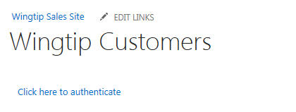

* 1. Click the **Click here to authenticate** link. This will redirect you to a page where you can enter security credentials for the current user.
  2. Note: as we are in a lab environment and do not have security certificates properly configured you may be prompted with a **Secure Store Service Security Warning**. Should this occur click on the **Continue to this Site** hyperlink to continue on to the Secure Store Service Set Credentials page.
  3. On the **Secure Store Service Set Credentials: WingtipSales** page, add a **Windows User Name** of **WINGTIP\Administrator** and a password of **Password1** for both the **Windows Password** and **Confirm Windows Password** text boxes. Click **OK** to store these credentials in the Secure Store application.

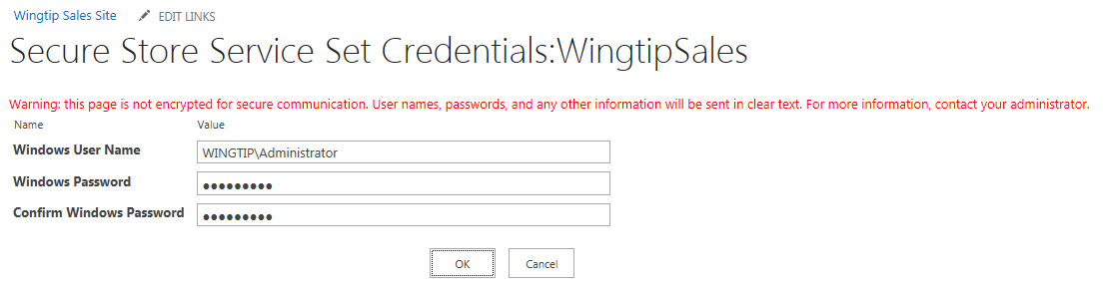

* 1. At this point the external list should now display customer information from the SQL Server database.

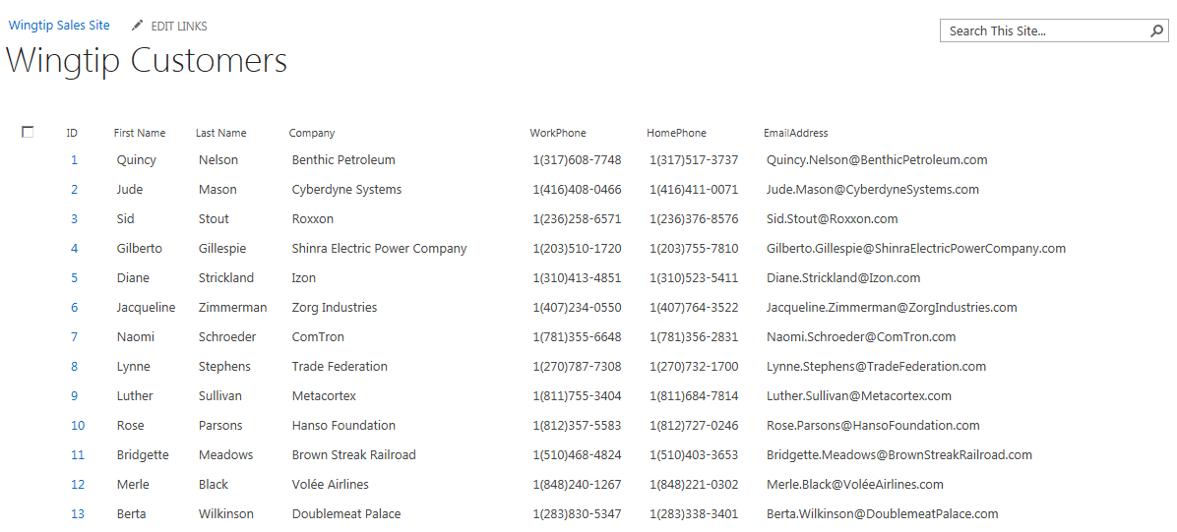

1. Experiment by adding, editing and deleting a few items. You should see that working with items in an external list provides a very similar user experience to working with items in a native SharePoint list.

In this exercise you created a new external list to surface an External Content Type in a SharePoint site to provide users with read/write access to a table in SQL Server.