## Getting Started with SharePoint Server 2013

**Lab Time**: 40 minutes

**Lab Folder**: C:\Student\Modules\GettingStarted\Lab

**Lab Overview**: In this lab, you will begin by copying the student lab files on the **WingtipServer** VM. You will also work with Windows PowerShell to get some experience executing execute cmdlets in the PowerShell console window and learning how to write and test PowerShell scripts. Having a comfort level with Windows PowerShell will be important as this is something you will see throughout the lectures and labs of this course. In the final exercise you will work with the ActiveDirectory PowerShell snap-in module to add user and group accounts into Active Directory using a PowerShell script.

### Exercise 1: Copy the Student files folder to the root drive of the WingtipServer VM

In this exercise, you will copy the student files for this course to the local **c:** drive of the **WingtipServer** VM. This will ensure that you have access to all the files that are references in the lab exercises throughout this course.

1. Locate the **Student.zip** file for this course. This zip file will either be located on the host Hyper-V computer or it will be provided to you by your instructor.
2. Copy the files into the **WingtipServer** VM and extract them to the **C:\** drive. When you are done, you should have created a root folder named **C:\Student** which contains a child folder for each of the labs in the course.

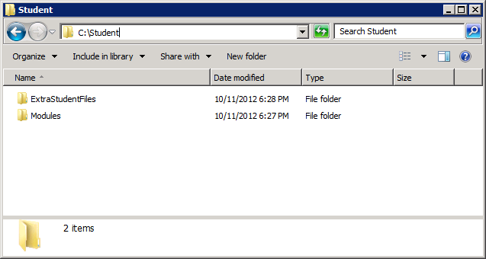

### Exercise 2: Working with the Windows PowerShell Console Window

In this exercise you will get some exposure to working with Windows PowerShell.

1. Ensure you are logged onto the VM named **WingtipServer**. If you are not, log on using the user account **WINGTIP\Administrator** and a password of **Password1**.
2. Launch the Windows PowerShell console.
   1. Click on the **Windows** key to display the **Windows Start** page.
   2. Locate and click the tile with the caption **Windows PowerShell** as shown in the following screenshot.

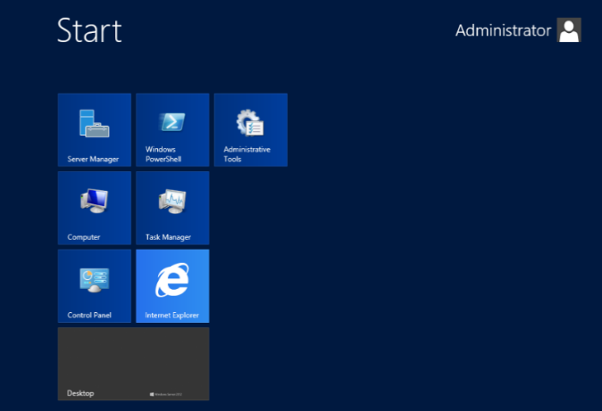

1. Once you have a command prompt in the Windows PowerShell console windows, type the following command using the Set-Location cmdlet and single parameter with a path on the local C:\ drive and press [Enter]. Now use the same cmdlet to set the location to the folder for this lab.

Set-Location “c:\Student\Modules\GettingStarted\Lab\”

1. The current folder of the Windows PowerShell console should now be located in a folder that has several Windows PowerShell scripts (*.ps1 files) that will be used in this lab. Type the following command which uses the Get-ChildItem cmdlet and passes no parameters and press [Enter] to see a listing of all the .ps1 files in this folder.

Get-ChildItem

1. Type in the following command to open Notepad and the script named Hello.ps1. Press [Enter] after typing the command to execute it.

Notepad .\Hello.ps1

1. After examining the Windows PowerShell code inside Hello.ps1, close Notepad and attempt to run it by typing .\Hello.ps1 and pressing [Enter]. If the Windows PowerShell scripting support on your VM still has the default execution policy of restricted, the script will not run at all. If the execution policy has been changed to unrestricted, the console will prompt you whether to run the script or not. When writing and testing Windows PowerShell scripts, it is easiest to change the execution policy to **Bypass** so that scripts can freely run without any user prompts. Type the following command and press [Enter] twice to enable scripting support.

Set-ExecutionPolicy Bypass

1. Now, try to run the script named Hello.ps1 a second time by attempt to run it by typing .\Hello.ps1 and pressing [Enter]. You should now see the script is able to run and output a simple message to the Windows PowerShell console.

-----------------------------------------------------

Hello Wonderful World of Windows PowerShell Scripting

Host name: WINGTIPSERVER

-----------------------------------------------------

In this exercise you ran your first Windows PowerShell cmdlets and scripts.

### Exercise 3: Writing and Debugging Windows PowerShell Scripts

In this exercise you will write and debug your first Windows PowerShell scripts.

1. Open the Windows PowerShell ISE.
   1. Click on the **Windows** key on the keyboard to bring up the Windows Server 2012 **Start page**.
   2. Go to the keyboard and type in **"powershell ise"**. Click on the **Apps** link on the right as shown in the following screenshot. Click on **Windows PowerShell ISE** to launch the ISE.

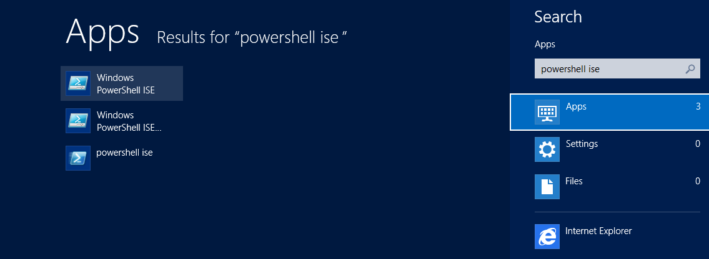

1. Open Hello.ps1 once again in the Windows PowerShell ISE. Drop down the Debug menu and you should see it gives you the ability to run and debug the code inside a Windows PowerShell script. Execute Hello.ps1 by pressing [F5] and examine the output.
2. Make a small change to the text message inside Hello.ps1 that is assigned to the variable named $HelloMessage and save your work.

# create a variable with a welcome message

$HelloMessage = "Hello Wonderful World of Windows PowerShell Scripting"

# write ouptu to Windows console window

Write-Host "-----------------------------------"

Write-Host $HelloMessage

Write-Host "Host name: "$(Get-Item env:\computerName).value

Write-Host "-----------------------------------"

1. Run Hello.ps1 one more time in the Windows PowerShell console. You should see your changes and also observe how easy it is to edit and run Windows PowerShell scripts.
2. Now, it's time to practice debugging and single stepping through a Windows PowerShell script. Set a breakpoint by right-clicking a line and selecting Toggle Breakpoint or by pressing [F9] in the first line in Hello.ps1. Now, press [F5] to begin execution. The execution should stop and the breakpoint you set. Now, press [F11] repeatedly to single step through the remaining lines of code inside the script.

### Exercise 4: Using the ActiveDirectory Module to Manage User Accounts and Groups

In this exercise, you will create new user accounts for Wingtip employees in the **wingtip.com** domain. These user accounts will be used in various exercises throughout the labs for this course. You will create these accounts by running a Windows PowerShell script.

1. In the Windows Explorer, navigate to the folder at C:\Student\Modules\GettingStarted\Lab. Inside this folder you should be able to locate several files including a Windows PowerShell script named CreateWingtipUsers.ps1.

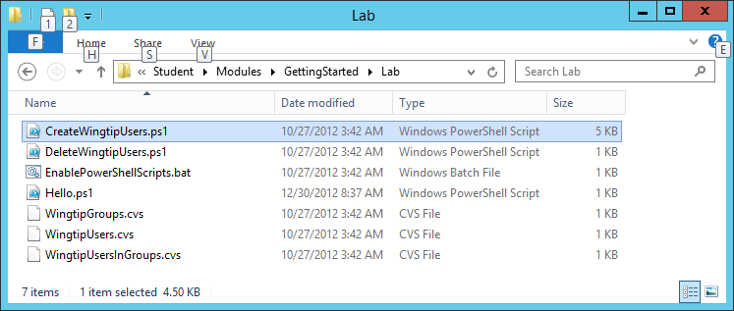

1. Open and examine the script named CreateWingtipUsers.ps1. Executing this script will also create a number of standard Active Directory accounts for normal users and add them to an Organizational Unit named Wingtip Users. Run CreateWingtipUsers.ps1 by right clicking it and clicking the menu command titled Run with PowerShell.

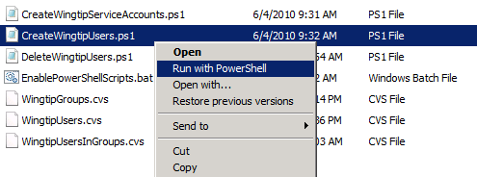

1. Running the script should produce the following output in the console window.

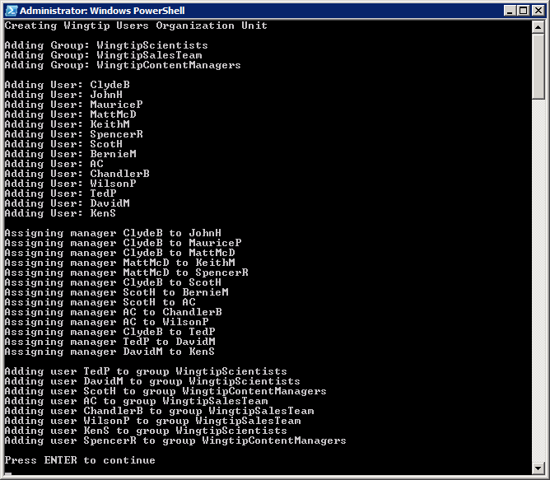

1. Upon the script’s completion, the Wingtip user accounts should have been created successfully. You can verify this by making sure you can see the accounts inside Active Directory.
   1. Click on the **Windows** key to display the **Windows Start** page.
   2. Locate and click the tile with the caption **Active Directory Users and Computers** as shown in the following screenshot.

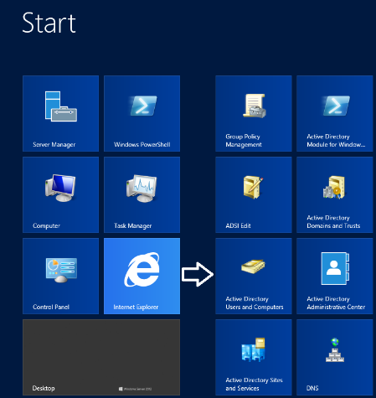

* 1. Once the Active Directory Users and Computers administrative tool has been started, select the **Wingtip Users** group which should allow you to see all the new Wingtip user accounts.

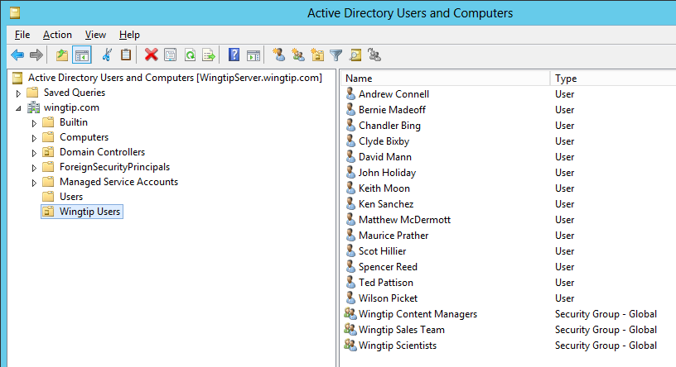

You have now completed all the exercises in the first lab. If you are new to PowerShell, this lab has given you some hands-on experience with writing and testing PowerShell scripts. This will be an essential skill to anyone who has administrative responsibilities within a SharePoint 2013 farm. You can be assured that you will be getting much more hands-on experience with Windows PowerShell in the upcoming lab exercises of this course.