## **Working with the Managed Metadata Service**

**Lab Time**: 60 minutes

**Lab Folder**: C:\Student\Modules\ManagedMetadata\Lab

**Lab Overview**: In this module you will gain hands on experience creating and using a term set with the Managed Metadata service.

### Exercise 1: Creating a Taxonomy with the Managed Metadata Term Store Tool

In this exercise you will create a new taxonomy using the Managed Metadata term store tool and use it within a site.

First we need to connect to and configure the Managed Metadata Service for the remainder of this lab:

1. Navigate to Central Administration.
2. Navigate to the Term Store Management Tool page.
   * 1. Click on the **Application Management** link.
     2. Click on the **Manage Service Applications** link to navigate to the **Manage Service Applications** page.
     3. Click on the **Managed Metadata Service** hyperlink.

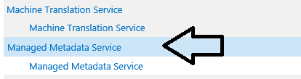

1. When the **Term Store Management Tool** page loads, enter **WINGTIP\Administrator** in the **Term Store Administrators** box and click the person with a check mark icon **“Check Names”** just below to the box to resolve the user.

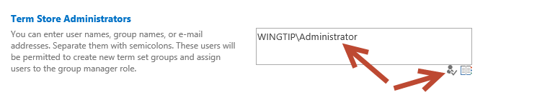

1. Click **Save** at the bottom of the page.

We needed to add our account to the Term Store Administrators in order to create groups and term sets in the term store database,. Simply having the permissions as a SharePoint farm administrator is not enough.

1. Within the **Term Store Management Tool**, select the **Managed Metadata Service** node drop down arrow in the left-hand part of the page and select **New Group**.

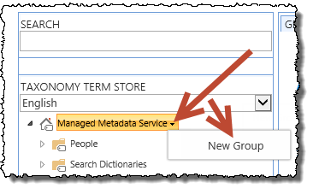

1. Set the name of the group to **Example Taxonomies**.
2. Select the **Example Taxonomies** group drop down arrow and select **New Term Set**.
3. Set the name of the term set to **Corporate Locations** and press **Enter**.
4. Select **Corporate Locations** term set drop down arrow and select **Create Term**. Use this technique to create a small taxonomy as shown in the following figure:

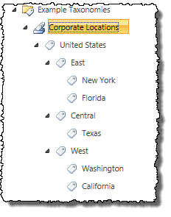

* 1. After creating **United States** and pressing **Enter**, select the drop down arrow off of **United States** and select **Create Term** to create the next level term **East** and press **Enter**. Type **Central** and press **Enter**. Type **West** and press **Enter  
     (**Note: you can continue to add additional terms at the same level by typing them in and pressing enter after each one)
  2. Select the drop down arrow off of **East** and select **New Term**. Type **New York** and press **Enter**. Type **Florida** and press **Enter**.
  3. Repeat this process for the sub terms of Central and West.

1. Now, we will change the taggable property for the United States, East, Central, and West terms as these term should not be available for tagging as they are only used to group terms.
   1. Select the tag for the **East** term to expose the properties for this on the right hand pane of this screen.   
      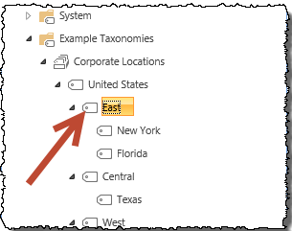
   2. In the right-hand pane you will find the detail for this term.
      1. Uncheck the **Available for Tagging** checkbox and click **Save**.

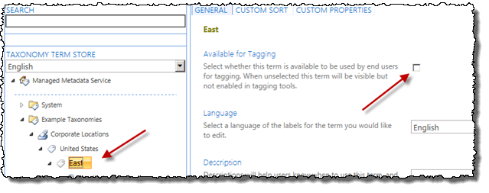

* 1. Repeat this process for the **Central** and **West** and **United States** terms
  2. You should note that Terms that are not available for tagging have a slightly different icon (tag facing up to the right at 45 degree angle) than Terms that are available (tag facing left and horizontal)  
     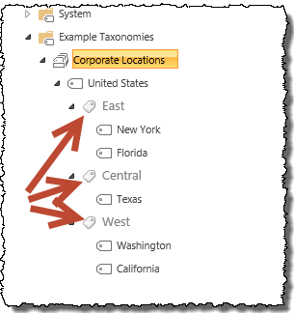

1. A new capability of the Term Store Management Tool is the ability to visually edit the custom properties on a term. Add a new property to signify the primary point of contact for a corporate region:
   1. Select the **Texas** term.
   2. In the right-hand pane, select the **Custom Properties** tab at the top.
   3. Under the **Shared Properties**, select **Add**.
   4. Name the property **PrimaryPOC** and give it a value of **Ken Sanchez** and click **Save**.

### Exercise 2: Use the Taxonomy in a SharePoint List

In this exercise you will use the taxonomy in a SharePoint list.

1. Navigate to the site at **http://sales.wingtip.com**.
2. Create a new **Announcements** list:
   1. In the **Quick Launch** navigation on the left-hand side of the page, click **Site Contents**.
   2. On the **Site Contents** page, under the **Lists, Libraries and Other Apps** section, click the **Add an App** link.
   3. On the **Site Contents > Your Apps** page, select **Announcements**.
   4. Set the name of the list to **Announcements** and click **Create**.
3. Modify the **Announcements** list to contain terms for the different company locations:
   1. In the **Quick Launch** navigation, select the **Announcements** list/app.
   2. When the **Announcements** list loads, using the ribbon (at the top of the page) select the **List** taband click the **List Settings** button.  
      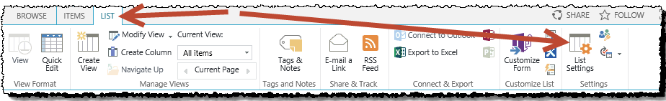
   3. Click the **Create column** link in the **Columns** section of the page.
   4. On the **Settings > Create Column** page, use the following to create a new column mapped to the taxonomy you created and click **OK**:
      1. **Column Name:** Relevant Offices
      2. **The type of information in this column is:** Managed Metadata
      3. **Allow multiple values**: checked
      4. **Term Set Settings**: Use a managed term set. Select the **United States** term set as shown in the following figure:

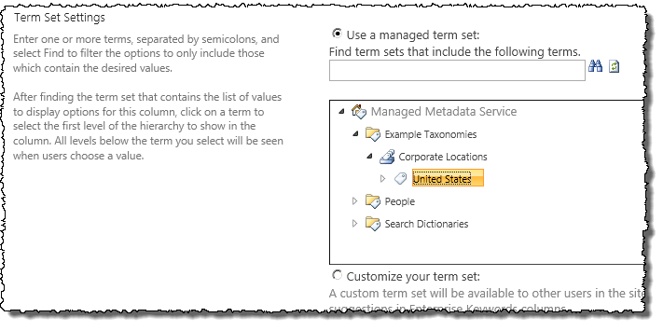

* + 1. Click **OK** to save your changes

1. Now add some data to your list:
   1. In the **Quick Launch** navigation, select the **Announcements** list/app.
   2. Add an announcement to the list. Set the:
      1. **Title**: “The Stars at night, are big and bright…”
      2. **Relevant** Offices: Texas
      3. Click **Save**
   3. Next, add multiple announcements, except this time use the **Quick Edit** view. Using the ribbon, click the **List** tab and the **Quick Edit** button in the **View Format** group. This was previously called the Datasheet View. It has been improved in SharePoint 2013 to support managed metadata!  
      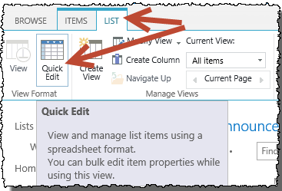
      1. Add the following announcements using the **Quick Edit** view and make sure each has the appropriate term(s) tagged to it. As shown below:.  
         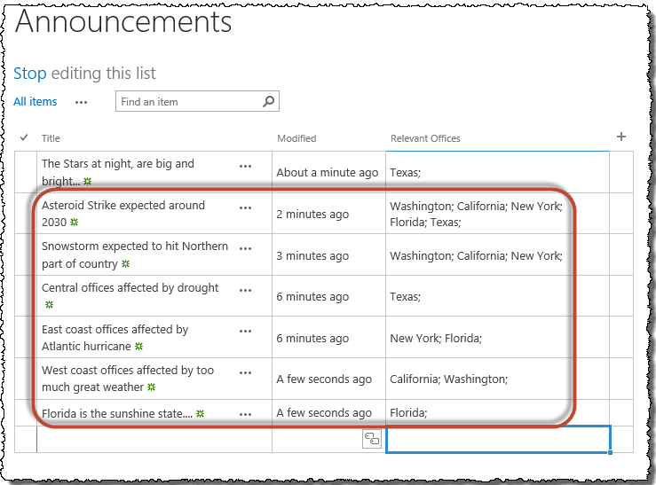
   4. When finished click **Stop** editing this list (Near the top left side of the screen under the **Announcements** title).
2. Last, to see how the managed navigation works, first, enable it on site:
   1. Using the **Site Actions** “gear” icon in the top-right corner of the browser, select **Site Settings**.  
      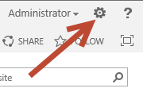
   2. In the **Site Actions** section, select **Manage Site Features**.
   3. Find the Site Feature **Metadata Navigation and Filtering** and click the **Activate** button.
3. Now enable it on the list:
   1. In the **Quick Launch** navigation, select the **Announcements** list/app.
   2. When the **Announcements** list loads, using the ribbon select the **List** taband click the **List Settings** button.
   3. Under the **General Settings** section, select **Metadata navigation settings**.
   4. In the **Configure Navigation Hierarchies**, add the **Relevant Offices** column from the **Available Hierarchy Fields** to the **Selected Hierarchy Fields** and remove Folders. Then click **OK**.
4. Next, go back to the **Announcements** list
5. Notice in the lower portion of the **Quick Launch** you have a new navigation option. Using this you can filter all the content in the list, regardless of any folders you may have.
   1. Try expanding **Relevant Offices** and select **Central**, then **West**, then **East**, then just **Florida**
   2. Notice how **East** and **Florida** produce slightly different results (as there was a snowstorm announcement that did not affect **Florida**, but did affect other **East** Coast locations).

In this exercise you created a term set using the browser interface and used it within a SharePoint list.