## **Backing Up and Restoring Content**

**Lab Time**: 45 minutes

**Lab Folder**: C:\Student\Modules\Recovery\Lab

**Lab Overview**: This lab will walk you through the process of backing up a site using PowerShell and give you experience with the unattached database recovery options available in SharePoint 2013. The Wingtip Company has hired staff to start a new Product Management team. You will begin by creating a new site collection for the team.

### Exercise 1: Create Some Content to Back Up

You will begin by creating a new site collection and adding some content. This will provide a source of content for backup and restore operations in later lab exercises.

1. Create the **Wingtip Product Management** Site Collection using Central Administration.
   1. Open SharePoint Central Administration.
   2. On the home page, click **Create Site Collections.**
   3. If the Web Application is not set to intranet, click the **Web Application**: dropdown and select **Change Web Application**.
      1. Select http://intranet.wingtip.com from the list.
   4. Enter for the Title **Wingtip Product Management**.
   5. For the URL, enter <http://intranet.wingtip.com/sites/Product>Management.
   6. Choose the **Team Site** as the template.
   7. Use WINGTIP\Administrator as the Primary Site Collection Administrator.
   8. Click **OK** to create the site collection.
2. When the Site Collection is created, click the URL http://intranet.wingtip.com/sites/ProductManagement to open the site.
   1. Log in as **WINGTIP\Administrator** if prompted.
3. Upload some Top Secret documents.
   1. In the Quick Launch bar, click **Documents** to navigate to the **Shared Documents** document library.
   2. Use the **new document** link to upload the following documents to the document library.
      1. C:\Student\Modules\Recovery\WingtipProductDetails.docx
      2. C:\Student\Modules\Recovery\WingtipProductIdeas.docx
      3. C:\Student\Modules\Recovery\WingtipProductTestResults.docx

### Exercise 2: Back up the Product Management Site with PowerShell and SQL

1. Create a backup directory.
   1. In **Windows Explorer**, navigate to the root of the C:\ drive.
   2. Make a new folder called SPBackups**.**
2. Use Windows PowerShell to back up the Product Management site.
   1. Open the **SharePoint 2013 Management Shell**.
      1. Press the **Windows key** to go to the **Start** menu and then click on the **SharePoint 2013 Management Shell** tile.
   2. Type the following and press [Enter].  
      (Note: this must be on one line or it will not work correctly)

Backup-SPSite http://intranet.wingtip.com/sites/ProductManagement   
-path "C:\SPBackups\ProductManagement.bak"

* 1. Open up C:\SPBackups to verify that the backup completed.

1. In **Central Administration** select **Manage content databases** underneath **Application Management** section
   1. In **Manage content databases** page set the Web Application to [**http://intranet.wingtip.com/**](http://intranet.wingtip.com/)
   2. Notice how there are two separate databases contained by this web application (ContentDB_WingtipEngineering and WingtipIntranet_ContentDB) also notice how there are multiple Site Collections underneath each.   
      Note: A hard lesson to learn about multiple databases on a web application is this; anytime there are multiple content databases, the way SharePoint decides which to use automatically is based on how much available space is left in each, not how many Site Collections are currently contained by each (e.g. given two DB’s A [containing 10 Site Collection with a Maximum of 5000] and B [containing 5 Site Collections with a Maximum of 4000], A will be automatically chosen until B has more available space in it (available space in a 4990 Site Collections, available space in B 3995 site collections). When both have an equal amount of available space left they are chosen in a round robin format. Therefore, if you wish to have a content DB with only one site collection in it, upon creation you should come to the Content Databases screen in Central Administration and reduce the Maximum Number of Databases in it to 1 to prevent any other Site Collections from using it.
2. Create a Database Snapshot in SQL. (Actually as we have 2 Content databases here, we need to do this 2x)
   1. Open SQL Server Management Studio
      1. Press the **Windows key** to go to the **Start** menu and then click on the **SQL Server Management Studio** tile.
   2. On the **Connect to Server** dialog box, click **Connect.**
   3. Expand the **Databases** tree.
   4. Scroll through the database list and find **WingtipIntranet_ContentDB**.
   5. Right-click on **WingtipIntranet_ContentDB** and select **New Query**.
   6. In the **Query** pane that opens, type the following script:

CREATE DATABASE WingtipIntranet_ContentDB_Snapshot   
ON (NAME = "WingtipIntranet_ContentDB",   
 Filename = 'C:\SPBackups\WingtipIntranet_Snapshot.ss')  
AS SNAPSHOT OF "WingtipIntranet_ContentDB";

* 1. In the toolbar above the Query window, click the **Execute** button 
  2. Underneath the Query window, you will receive a message that the **Command** completed successfully.

1. Repeat step 6 for **ContentDB_WingtipEngineering** using the following Query instead of step 6f.

CREATE DATABASE ContentDB_WingtipEngineering_Snapshot   
ON (NAME = "ContentDB_WingtipEngineering",   
 Filename = 'C:\SPBackups\WingtipEngineering_Snapshot.ss')  
AS SNAPSHOT OF "ContentDB_WingtipEngineering";

1. Verify that the 2 snapshot files exists.
   1. In the Object Explorer pane in SQL Server Management Studio, expand the Database Snapshots folder and verify that **WingtipIntranet_ContentDB** and **ContentDB_WingtipEngineering** exist there.  
      (Note: you may need to select the top WINGTIPSERVER node and refresh (Press F5) to see these)

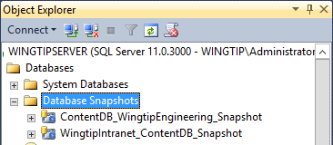

* 1. Open C:\SPBackups and verify that the WingtipIntranet_Snapshot.ss and **WingtipEngineering_Snapshot.ss** files exists.

1. In the browser, return to the site at <http://intranet.wingtip.com/sites/Product>Management.

### Exercise 3: Recover Deleted Information using Central Administration

Todd is being careless. While working in the Shared Documents folder, he accidentally deletes two of the product management documents. Then, while trying to recover the documents from the recycle bin, he ended up permanently deleting the documents. Todd is having a bad day.

1. Delete two documents.
   1. Click **Documents** in Quick launch to navigate to the document library.
   2. Hover over the WingtipProductDetails.docxdocument and **check the box** that appears to the left.
   3. Hover over the WingtipProductTestResults.docxdocument and **check the box** that appears to the left.
   4. Press the **Delete Key** on the keyboard.
   5. Click **OK** in at the prompt

Scot opens the library later and notices that the two documents are gone! He needs them quickly to finish up a Report for his manager and asks if there is anything you can do to recover them. Fortunately, you made a snapshot of the entire Wingtip Intranet content database just before Todd deleted the documents. You can recover the missing documents using that snapshot!

1. Use Central Administration to Browse the Database Snapshot.
   1. Open Central Administration.
   2. Click **Backup and Restore**.
   3. Under the **Granular Backup** header, click **Recover data from an unattached content database**.

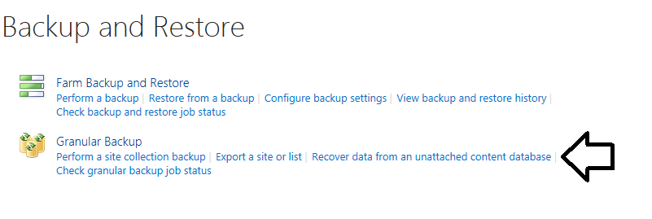

* 1. The **Database Server** should already be filled in with **WingtipServer.**
  2. For the **Database Name**, enter **WingtipIntranet_ContentDB_Snapshot**.
  3. In the **Choose Operation** section, keep **Browse Content** selected.

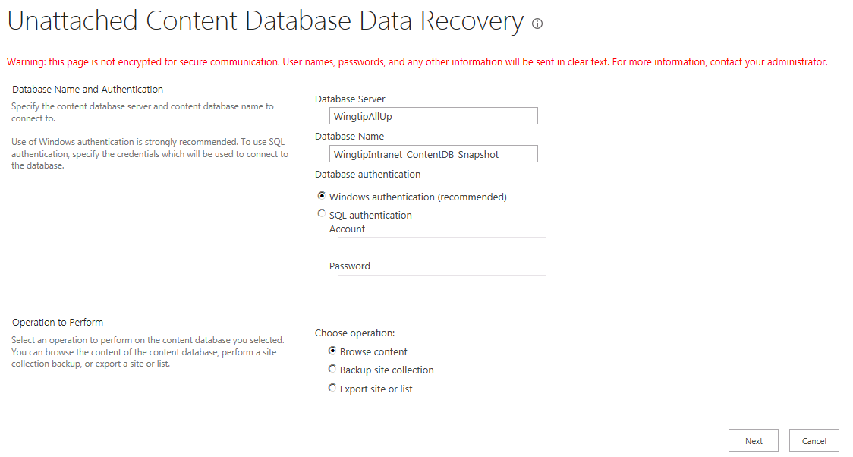

* 1. Click **Next**
  2. Click the dropdown next to **Site Collection**: and select **Change Site Collection**
  3. In the Select Site Collection window, select /sites/ProductManagementand click **OK.**
     1. Note: If you **do not see /sites/ProductManagement** click **Previous** and change **Database Name** to **ContentDB_WingtipEngineering_Snapshot** and click **Next** then repeat step **h** and **i** above.
  4. Click the **Site:** dropdown and select **Change site**
  5. Select /sites/ProductManagement (it’s the only site available to choose from) and click **OK**.
  6. Click the **List:** dropdown and select **Change list**
  7. Page through the available lists and select **Documents**, then click **OK.**
  8. Under Choose operation, select **Export site or list**.
  9. Click **Next.**

1. Export the list to a file.
   1. In the Filename field, type C:\SPBackups\ProductManagementSharedDocs.cmp.
   2. Click **Start Export**.
   3. The **Granular Backup Job Status** screen will appear and refresh every minute or so.
   4. When the **Status** under **Previous Job** in the **Content Export** section lists **Succeeded**, your export has finished.

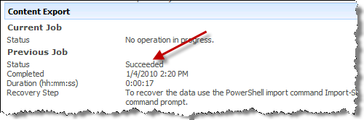

* 1. Notice also that this screen gives you a clue as to the next step in the recovery process

1. Import the list back into the **Wingtip Product Management** site for Scot.
   1. Switch to your SharePoint 2013 Management Shell window.
   2. Type the following cmdlet ad press [Enter].

Import-SPWeb

* 1. This cmdlet is prompting you for additional parameters. For **Identity**, type:

http://intranet.wingtip.com/sites/ProductManagement

* 1. For **Path**, type the following:

C:\SPBackups\ProductManagementSharedDocs.cmp

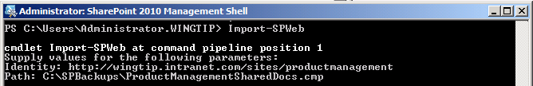

* 1. After a minute or so the backup will complete and will also let you know that a log file has been generated for the import.

1. Verify that the documents have been restored to the Shared Documents library.
   1. In the browser, navigate to http://intranet.wingtip.com/sites/ProductManagement.
   2. Click Shared Documents in the Quick Launch.
   3. Notice that all the documents have been restored to the library.