## **Configuring Search in SharePoint 2013**

**Lab Time**: 45 minutes

**Lab Folder**: C:\Student\Modules\Search\Lab

**Lab Overview**: In this exercise you will create a new instance of the SharePoint Search Service application and configure it to facilitate running searches in various types of SharePoint sites.

### Exercise 1: Creating the Search Service Application

In this lab you will create and configure an instance of the SharePoint Search service.

1. Ensure you are logged into the **WingtipServer** VM using the account **WINGTIP\Administrator | Password1**.
2. Create an instance of the **Search Service Application**. Note that if you created an instance of the **Search Service Application** when you ran the Farm Configuration Wizard in an early lab, you should skip this step and move to the next step.
   1. Navigate to the home page of **Central Administration**.
   2. Click the **Manage service applications** link to navigate to the **Manage Service Applications** page.
   3. Drop down the **New** menu in the ribbon and select **Search Service Application**.

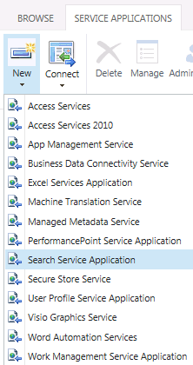

* 1. Fill out the form with data to create the Search Service Application.
     1. **Name**: Search Service Application
     2. **Search Service Account**: WINGTIP\SP_Services

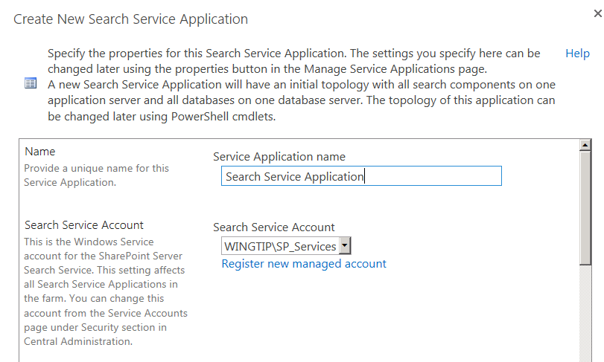

* + 1. **Application Pool for Search Admin Web Service**: Select **Use existing application pool** and select the **SharePoint Web Services Default** pool.

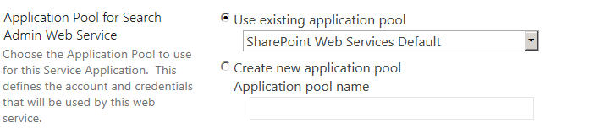

* + 1. **Application Pool for Search Query and Site Settings Web Service**: Select **Use existing application pool** and select the **SharePoint Web Services Default** pool.

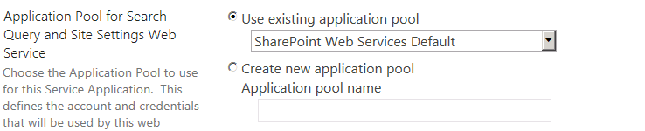

* + 1. Leave all other settings with the default value and click **OK** to create the new Search Service Application. Once the service application has been created, SharePoint will display a success message.

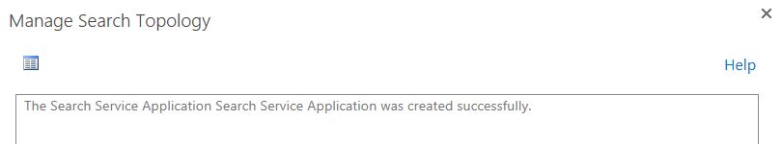

* + 1. Click **OK**

1. Once you return to the **Manage Service Applications** page, you should see the new instance of the **Search Service Application** listed along with the other service applications.

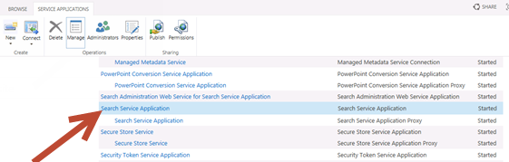

1. Click on the **Search Service Application** link to open the home page of the search administration site. Look at the **System** **Status** section at the top of the page and inspect the set of properties that are shown along with their initial values.

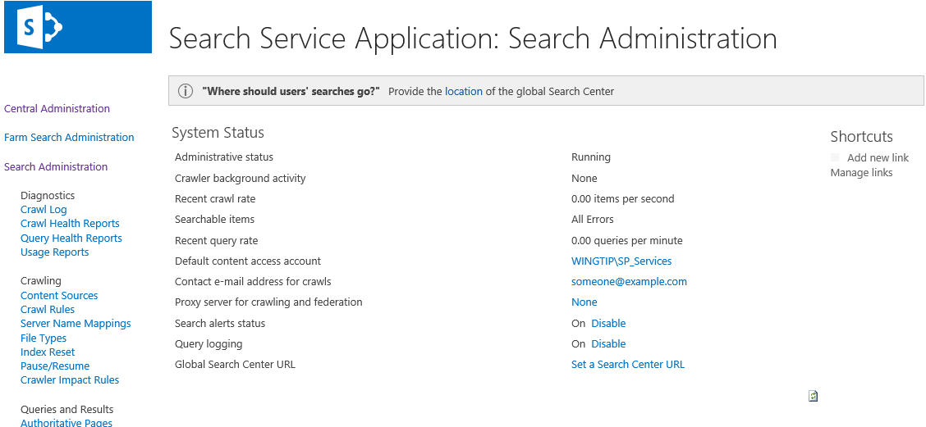

1. Scroll down and locate the **Search Application Topology** section. You should be able to verify that the **WingtipServer** server is currently assigned to each of the following roles in the SharePoint search infrastructure.  
   (Note: you may need to refresh this page to see this as it sometimes takes the Admin service a minute or two to start up upon creation)
   1. Admin
   2. Crawler
   3. Content Processing
   4. Analytics Processing
   5. Query Processing
   6. Index Partition

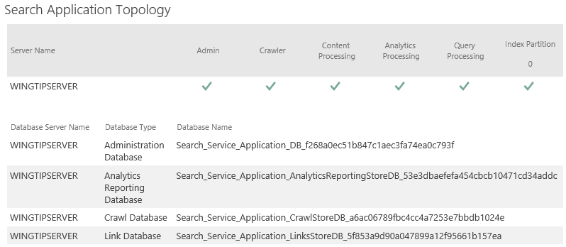

1. You should also be able to verify that the **SharePoint Application Topology** section shows that the **WingtipServer** server is running the following four databases associated with the Search Service Application.
   1. Administration Database
   2. Analytics Reporting Database
   3. Crawl Database
   4. Link Database

In this exercise you created an instance of the Search Service Application and now you will continue on to the next exercise to begin configuring it.

### Exercise 2: Configuring the Search Service Application

In this exercise you will add a few documents into a SharePoint site and into a Windows file share so you have some sample content to search. Then you will configure various aspects of the Search Service Application such as the identity of the crawler account as well as setting up search content sources.

1. Add sample content to your environment so that you have something to search.
   1. Using Windows Explorer, open the lab folder at **c:\Student\Modules\Search\Lab**. You should see that this folder contains twochild folders named **SharePointContent** and **WingtipFileShare**. Each of these folders contains a small collection of files that will be good examples of files you will want users to be able to find in search results.
   2. Upload content into the SharePoint team site at **http://intranet.wingtip.com**.
      1. Using the browser, navigate to the SharePoint team site at site at **http://intranet.wingtip.com**.
      2. Click the **Documents** link in the Quick launch to navigate to the **Documents** document library.
      3. Upload all documents in **c:\Student\Modules\Search\Lab\SharePointContent** to this document library.
         1. With both the **Intranet** Documents library and the .**SharePointContent** folder open on the same screen, select all files in the **SharePointContent** Folder and click and drag them over the **new document or drag files here** area of the screen  
            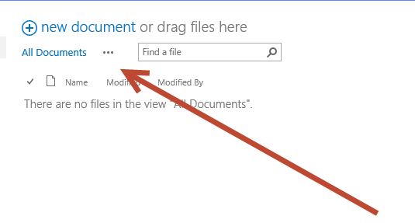
         2. When the screen changes to say **Drop here…** as shown in the image below, drop the files by removing your finger from the mouse button.  
            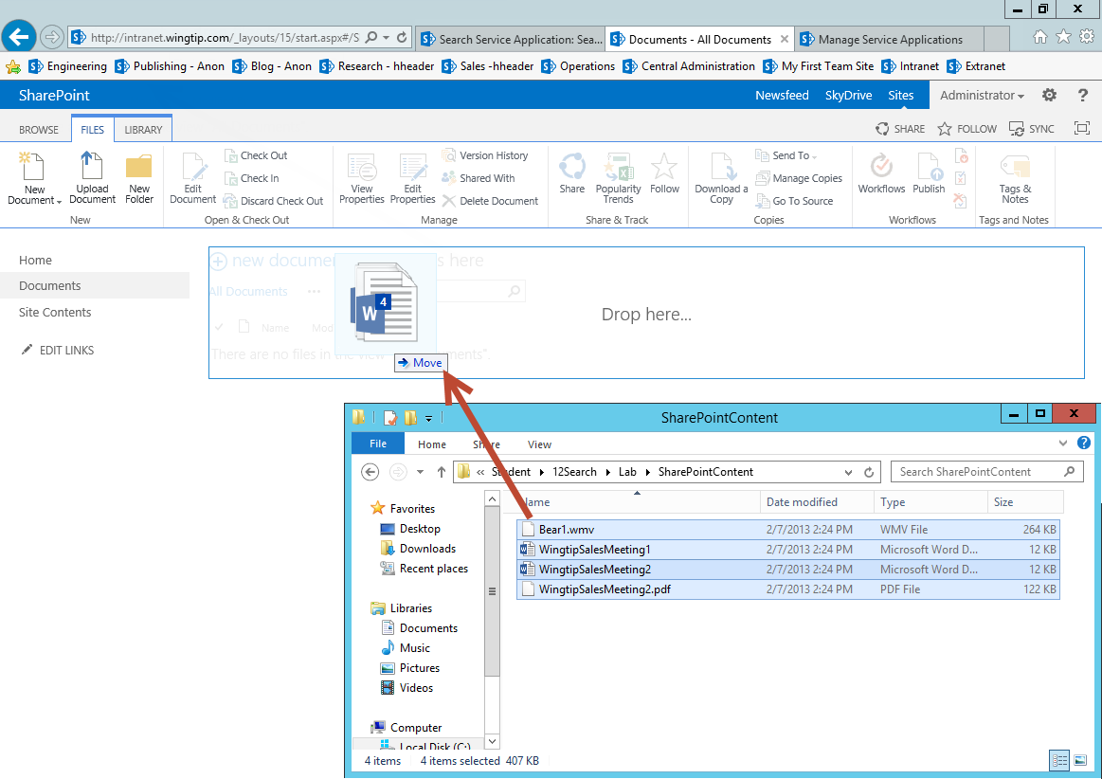
         3. You have just used another cool new feature of SharePoint 2013 (direct drag-drop of files into a Library), and your files should now be in the **Documents** library as shown here:  
            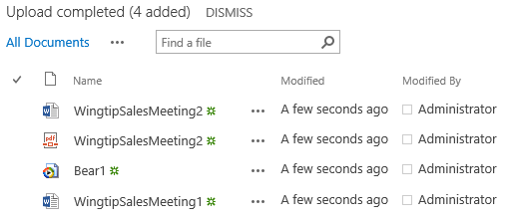
   3. Create a Windows file share to make content accessible on the network,
      1. Using Windows Explorer, navigate to **c:\Student\Modules\Search\Lab**.
      2. Right-click the **WingtipFileShare** folder and select **Properties**.
      3. Select the **Sharing** tab on the **WingtipFileShare Properties** dialog.
      4. In the **Network File and Folder** **Sharing** section, click the **Share** button.
      5. Select **Everyone** from the drop down list and select **Add**.
      6. Grant the **Everyone** account with **Read** access.

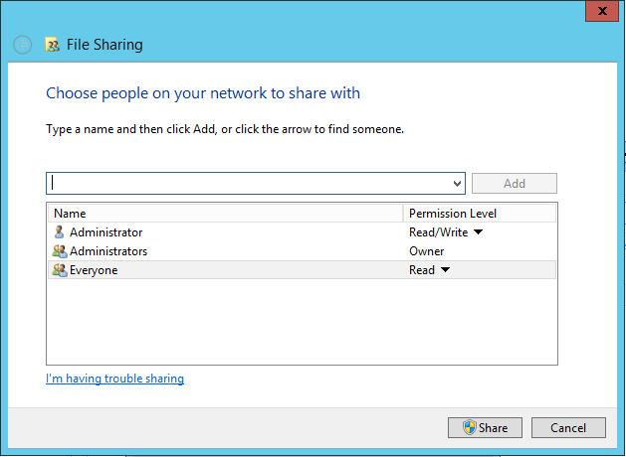

* + 1. Click the **Share** button to create the Windows file share.
    2. You should now have a file share accessible through the path **\\WINGTIPSERVER\WingtipFileShare**.

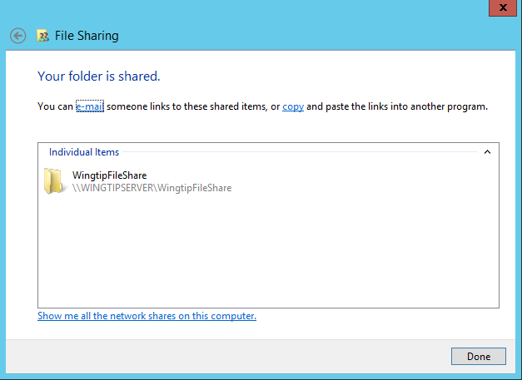

* + 1. Click **Done** and on the **WingtipFileShare Properties** dialog box click **OK**.

1. In addition to the **Read** permission (which the account we use to crawl the content will need, we also need to assign a specific permission **Manage auditing and security log** on all servers that contains the file shares to enable SharePoint to detect the security settings of the file share correctly. Normally we could accomplish this across all servers in our domain by generating a new Group Policy for the search account or we could accomplish this by editing the **Local Group Policy** on the server(s) that host the file share(s). In our case we have the unusual situation of being on a domain controller, therefore we will edit the **Default Domain Controllers Policy** We will examine setting this policy here:
   1. Open the Start Menu by pressing the **Windows Key** and then select **Administrative Tools**
   2. Next double click on **Group Policy Management**
   3. On the **Group Policy Management** Window expand **Forest: wingtip.com → Domains → wingtip.com → Domain Controllers** and right click on **Default Domain Controllers Policy** and select **Edit…**  
      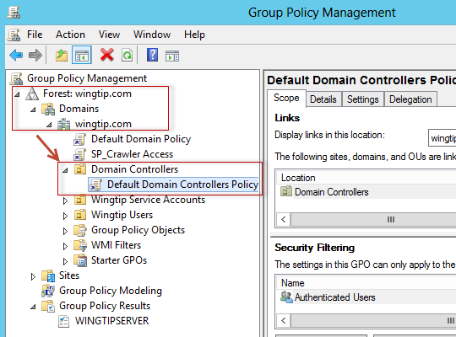
   4. Now on the **Group Policy Management Editor** expand **Computer Configuration → Policies → Windows Settings → Security Settings → Local Policies** and select **User Rights Assignment** then on the right hand side scroll to **Manage auditing and security log** and double click on this  
      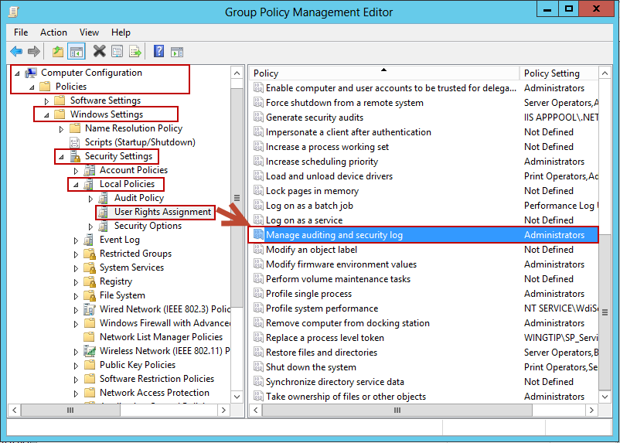
   5. On the **Manage auditing and security log Properties** dialog box, click on the **Add User or Group** button.
   6. Type the **WINGTIP\SP_Crawler** user name in the **User and group names** textbox and click **OK.** Click **Ok** again.
   7. You should now see that the **Manage auditing and security log** policy is applied to **WINGTIP\SP_Crawler** as shown below  
      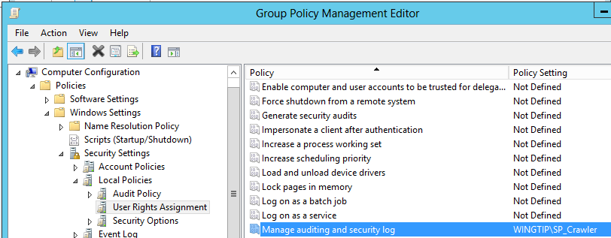
   8. Click the **X** in the top right corner to close the **Group Policy Management Editor**.
2. Next we need to apply this new policy to our local computer:  
   (Note: this would normally be applied automatically over time, however we need this new policy to be in force immediately).
   1. Press the **Windows Key** to bring up the **Start menu** and then type **cmd** and select the **Command Prompt** tile  
      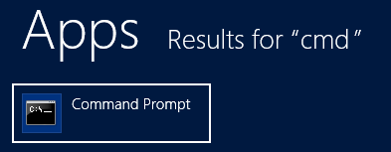
   2. In the Administrator: **Command Prompt** window type **Gpupdate /Force** and press **Enter**
   3. wait for the update success message and then **close** the Command Prompt window
3. Next we need to configure the identity of the Search Service Application Crawl Account
   1. In Central Administration Navigate to the main Search Administration page of the Search Service Application.
      1. **Central Administration → Manage service applications → Search Service Application** link
   2. Inspect the properties in the **System Status** section and locate the property named **Default content access account**.
   3. Currently, the **Default content access account** property should have a value of **WINGTIP\SP_Services**.
   4. Click on the link which shows the property value of **WINGTIP\SP_Services** to configure it to use a different account. A dialog will appear that allows you to add a new account and password. Add the **WINGTIP\SP_Crawler** account and a password / confirm password of **Password1** and then click **OK** to save your changes.

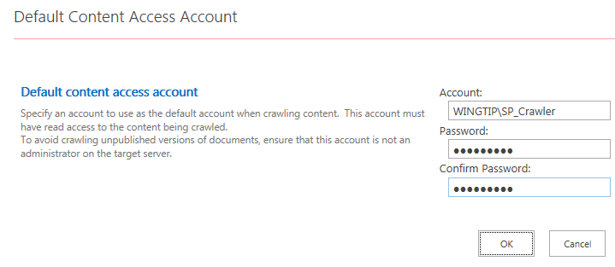

* 1. Return to the main Search Administration page of the Search Service Application.

When you configure a new identity for the crawler account by updating the **Default content access account** property, SharePoint will automatically add a user policy to each existing web application to provide the account will Full-Read access. Therefore, you do not need to worry about configuring permission for the crawler account to access SharePoint sites. However, SharePoint will not automatically configure permissions for the crawler account to properly access the User Profile Service Application. You will configure the permissions that are required in the following step.  
(Note: you would also need to provide access to any external content that you wish to crawl; we did this earlier by configuring the **WingtipFileShare** to allow the **Everyone** group **Read** **Access**. Additionally you would need to provide this account with the Group Policy **Manage auditing and security log** privilege which we also accomplished earlier in this lab)

1. Provide the **WINGTIP\SP_Crawler** account with access to the User Profile Service Application.
   1. Navigate to the **Manage service applications** page and select the **User Profile Service Application**
      1. **Central Administration → Manage service applications →** just select **User Profile Service Application** (but do not click the link (i.e. click anywhere on this line but the link itself to highlight/select this application))
   2. With the **User Profile Application Service** selected, click the **Administrators** button in the Ribbon.
   3. In the textbox in the **Administrators for User Profile Service Application** dialog, enter the account **WINGTIP\SP_Crawler** and then click **Add**.
   4. Configure the **WINGTIP\SP_Crawler** account with the **Retrieve People Data for Search Crawlers** permission.  
      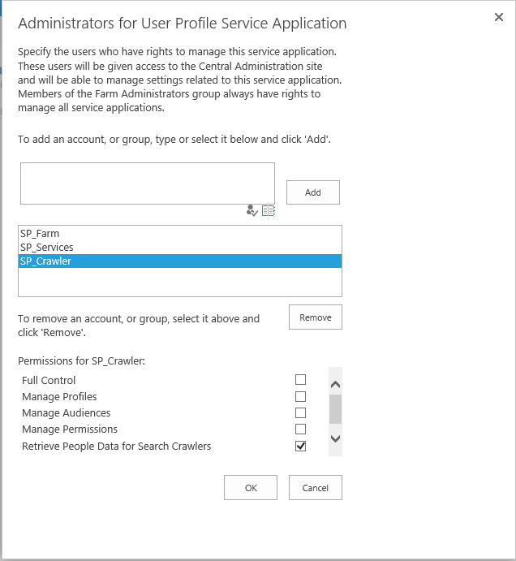
   5. Click **OK** to save your configuration changes.
   6. Return to the main Search Administration page of the Search Service Application
      1. Click on the **Search Service Application** link in the **Manage service applications** screen (i.e. the screen you are currently on).
2. On the main Search Administration page of the Search Service Application, locate and click the **Content Sources** link in the **Crawling** section of the Quick launch. This will redirect you to the **Manage Content Source** page where you should be able to see that there is a single content source named **Local SharePoint Sites**.

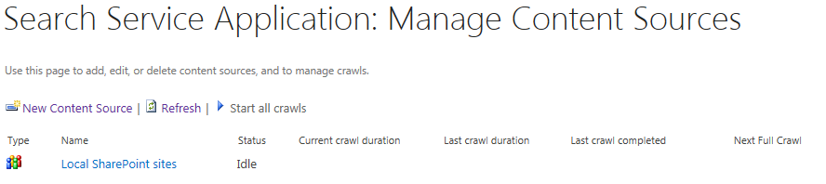

1. Run a full crawl on all SharePoint content.
   1. Use the drop down menu of the **Local SharePoint Sites** content source to run the Start Full Crawl command.

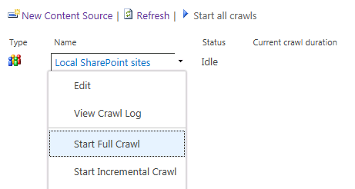

* 1. Note that you can continue with the next step while the full crawl is processing.

1. Create a new content source for a Windows file share.
   1. Click the **New Content Source** link on the **Manage Content Sources** page (i.e. just above the **Local SharePoint Sites** link you used previously).
   2. On the **Add Content Source** page, create the new content source using the following property values and then click **OK** to create the new content source.
      1. **Name**: Wingtip File Share
      2. **Content Source Type**: File Shares
      3. **Start Address**: \\WINGTIPSERVER\WingtipFileShare
      4. **Crawl Settings**: Crawl the folder and all subfolders of each start address

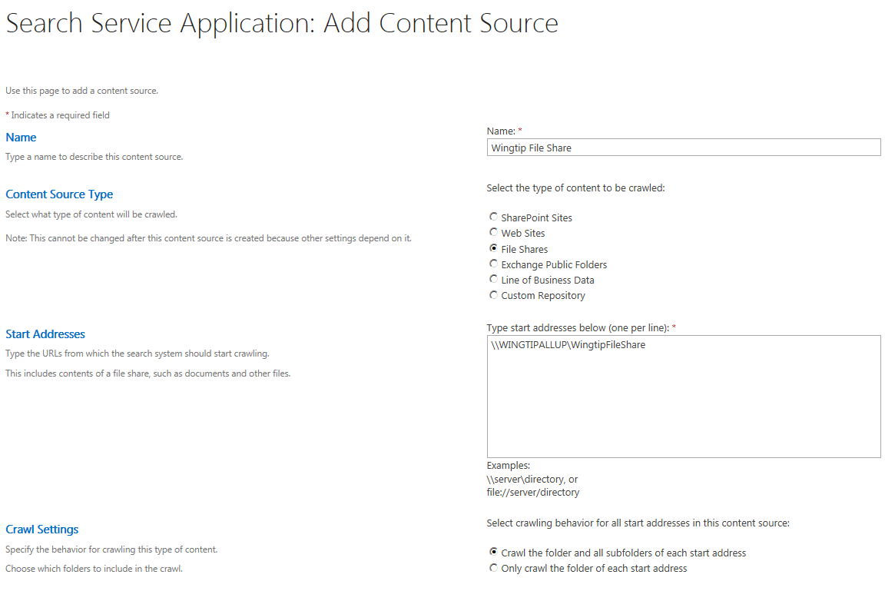

* 1. Once you have created the **Wingtip File Share** content source, initiate a **Full Crawl** on it just as you did for the **Local SharePoint Sites** content source.

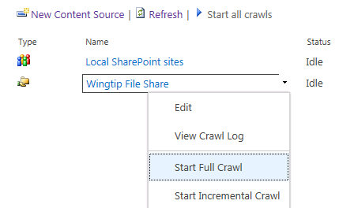

1. Wait until both full crawls have completed.
   1. At first you might see that one or both of the full crawls are still be processed.

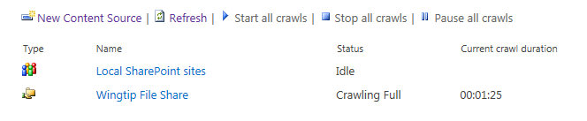

* 1. Click the refresh button every 30 seconds or so until you see that the **Status** of both content sources displays a value of **Idle**.

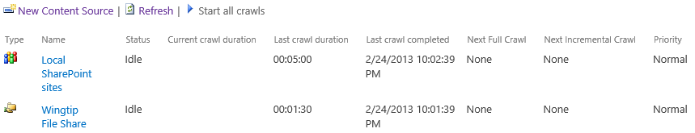

1. Click on the **Crawl Log** link in the **Diagnostics** section of the Quick launch. You should see top-level information about each full crawl job which shows a summary of successes, warnings and errors that were experienced during each crawl.

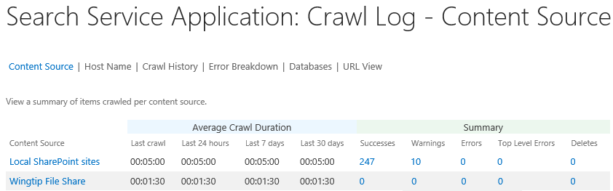

1. On the **Crawl Log – Content Sources** page, click on each of the following links to see what type of information can be seen.
   1. Host Name
   2. Crawl History
   3. Error Breakdown
   4. Databases
   5. URL View

### Exercise 3: Executing Search Queries

In this exercise you will create a **Search Center** site and run searches to see the search experience in SharePoint 2013.

1. Navigate to the home page of Central Administration and click the **Create Site Collections** link.
2. On the **Create Site Collection** page, fill in the details to create a new **Search Center** site using the following property values and then click **OK** to create the new site collection.
   1. **Web Application**: http//intranet.wingtip.com
   2. **Title**: Search Center
   3. **URL**: http://intranet.wingtip.com/sites/Search
   4. **Experience**: 2013
   5. **Select a template**: Enterprise Search Center
   6. **Primary Site Collection Administrator**: WINGTIP\Administrator

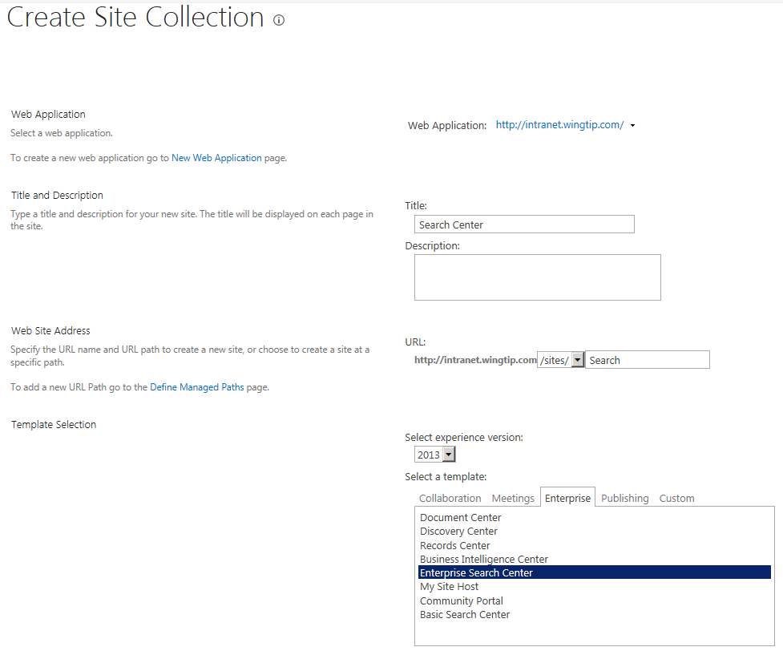

1. Once the Search Center site collection has been created, navigate to it. You should see a very simple site that has a home page with nothing more and a search box.
2. Run a search on the term "Administrator" and inspect the results.  
   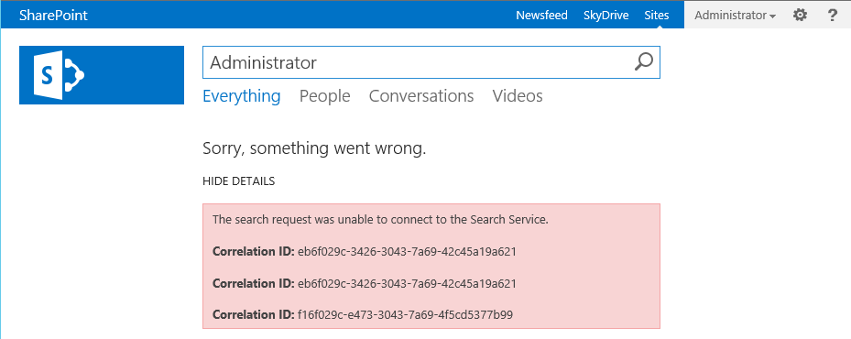
3. O…. K… What we have here… is a failure to communicate… We could look up the correlation ID’s in the log files and cross reference to see the error that occurred… However, you may recall that we have encountered a “similar” issue in the past… the clue is that this occurred in the Intranet… Let’s investigate:
   1. In **Central Administration** navigate **to Application Management → Configure service application associations**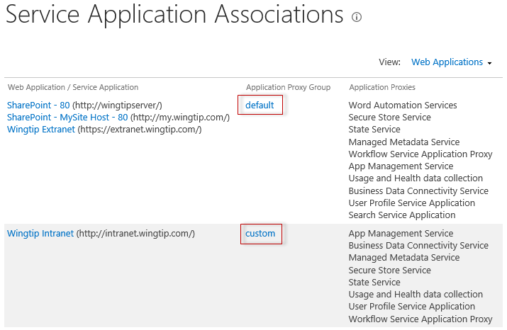
   2. Notice how everything EXCEPT **Wingtip Intranet** is using the **default Application Proxy Group**?
   3. Click on the **default** Application Proxy Grouplink and notice how everything is selected automatically.
   4. Click **Cancel** to return to the **Service Application Associations** screen and click on the **custom** Application Proxy Group
   5. Notice how this one is missing a couple of connections to service applications?
   6. The lesson to learn about custom Service Application Associations is that once these are configured, they will NOT by default automatically add any new service applications, to the custom group, that are subsequently added to a server (e.g. **Search Service Application**) (Note: whereas the default Application Proxy Group will by default, automatically add any new service application that is added to the server)
   7. Place a check in the **Search Service Application** and click **OK**
4. Navigate back to your search page (<http://intranet.wingtip.com/sites/search>) (Note: if you still had this open from before you must refresh the page or the errors tend to remain cached on the page). If necessary, run a search on the term "**Administrator**"
5. Inspect the search results
   1. Observe the different refinement panels.
   2. Hover over search results with the mouse and observe that the information at the top right changes to display addition information about the current search result.



1. Click the **People** link in the search navigation panel. Note that the search now only shows results that relate to user profiles.

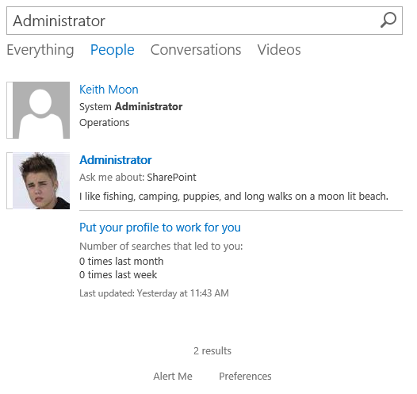

1. At this point, as time permits, you should experiment on our own running searches and seeing what you can find with search results.

In this exercise, you created a Search Center site and executed searches to witness the user experience of enterprise search in SharePoint 2013.