## **Configuring Service Applications**

**Lab Time**: 210 minutes

**Lab Folder**: C:\Student\Modules\ServiceApplications\Lab

**Lab Overview**: In this lab you work with several different service applications including the BCS, Managed Metadata Service and the User Profile Service.

### Exercise 1: Creating the SQL Server Database named WingtipCustomersDB

In this exercise you will create a SQL Server database with a table of customers and then you will create an external content type to surface those customers in a SharePoint site using an external list.

1. Create the SQL Server database named **WingtipCustomersDB**.
   1. Using the Windows Explorer, open the lab folder at **C:\Student\Modules\ServiceApplications\Lab**. You should see that there are two SQL scripts named **CreateCustomersDB.sql** and **CreateCustomersTable.sql**. There is also an executable file named **SqlDBGenerateCustomers.exe** and an associated configuration file named **SqlDBGenerateCustomers.exe.config.**

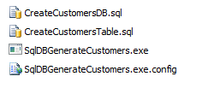

* 1. Right-click on **CreateCustomersDB.sql** and select **Open With >> SQL Server Management Studio** to open the SQL script in SQL Server Management Studio.

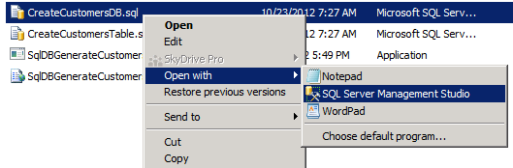

* 1. If prompted to Connect to Database Engine be sure to select **Database Engine** as the Server Type, **WINGTIPSERVER** as the Server name, and use **Windows Authentication** for the Authentication type and click **Connect** as shown in the image below.  
     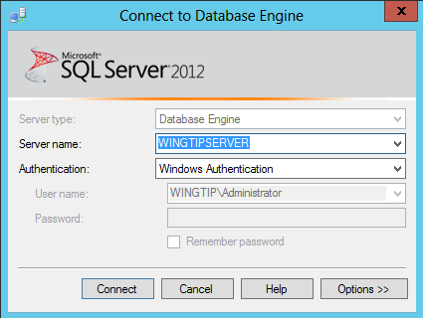
  2. Once the script named **CreateCustomersDB.sql** has opened in SQL Server Management Studio, execute this script by clicking the **Execute** button up in the ribbon.

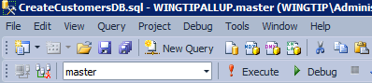

* 1. The **CreateCustomersDB.sql** script should execute successfully and show response message of **Command(s) complete successfully**.

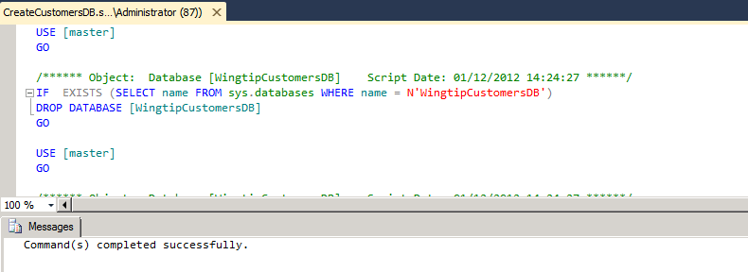

* 1. Within the SQL Server Management Studio, use the **Open >> File** command from the **File** menu to open the other script named **CreateCustomersTable.sql**. Once this script has opened, execute it by clicking the execute button just as you execute the other script.
  2. The **CreateCustomersTable.sql** script should execute successfully and show response message of **Command(s) complete successfully**.

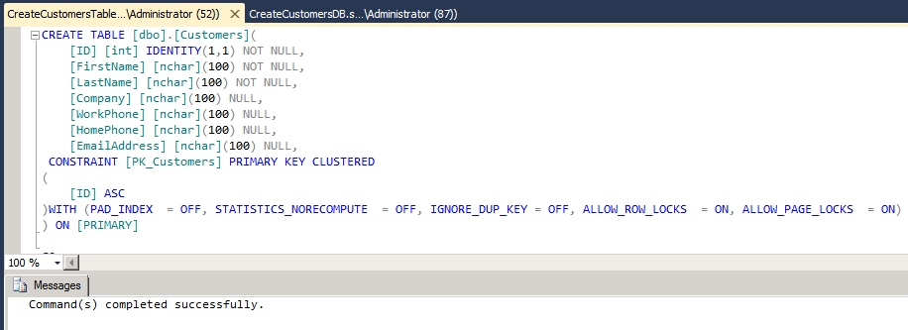

* 1. Use the tree view inside the Object Explorer to verify that a new database named **WingtipCustomersDB** has been created.

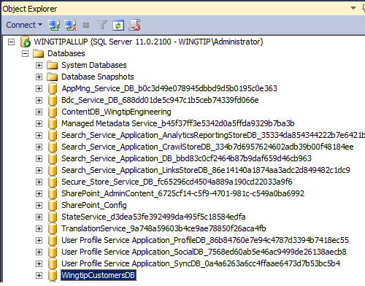

* 1. Expand the **WingtipCustomersDB** node and verify it contains a table named **Customers**.

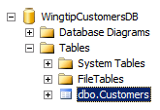

* 1. Return to the Windows Explorer and locate the file named **SqlDBGenerateCustomers.exe**. Double click this file to run a program which will connect to the database named **WingtipCustomersDB** and populate the **Customers** table with a few thousand sample records.
  2. Once the executable program **SqlDBGenerateCustomers.exe** has run, return to the SQL Server Management Studio and verify that the **Customer** table now contains sample data. You can do this by right-clicking the **Customers** table and selecting the command **Select Top 1000 Rows**.

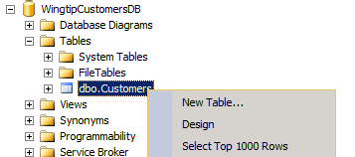

* 1. At this point, you should see that **Customer** table now contains records.

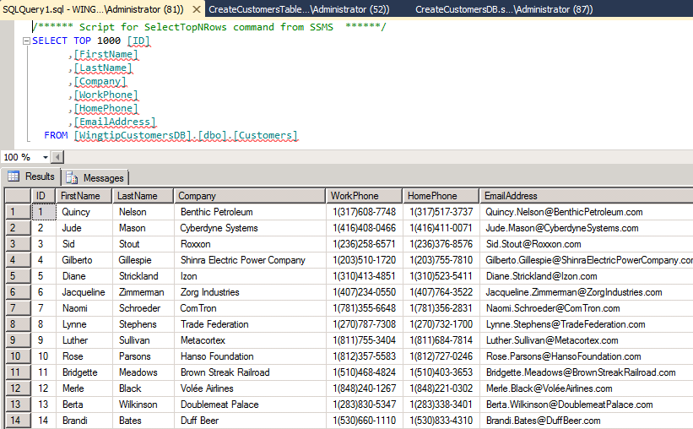

1. Configure access to the **WingtipCustomersDB** for the Active Directory group **Wingtip Sales Team**.
   1. In the SQL Server Management Studio, locate and expand the top-level **Security** node under the **Databases** node. Expand the **Logins** node inside the Security node to see the current set of logins.

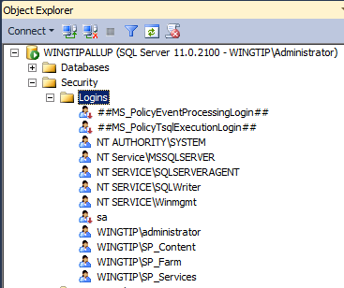

* 1. Right-click in the **Logins** node and select the **New Login** command to display the **Login - New** dialog. Add a Login name of **WINGTIP\WingtipSalesTeam**. Do not click the **OK** button until you are instructed to do so below.

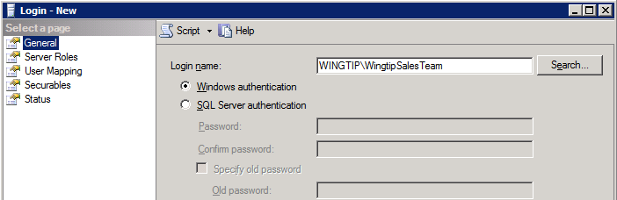

* 1. On the **Select a page** pane on the left, select the **User Mapping** page. On the right in the **Users mapped to this login** section, scroll down and check the option for **WingtipCustomersDB**. Below in the **Database role membership for: WingtipCustomersDB** section. Select the roles of **db_datareader** and **db_datawriter**. When you are done, click the **OK** button to create the new login.

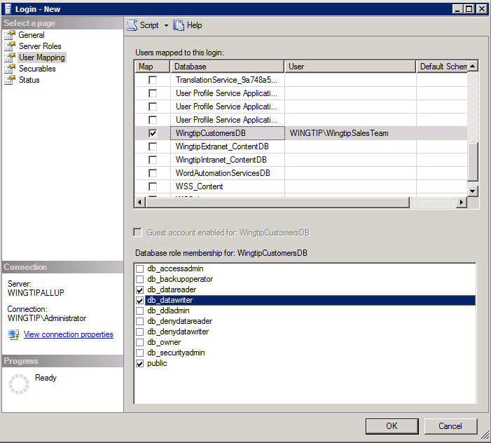

* 1. At this point, you can now close the SQL Server Management Studio.

In this exercise you created a SQL Server database with a **Customers** table that will be used in an exercise later in the lab when you create an external content type to access external data and make it available within a SharePoint site.

### Exercise 2: Creating a Secure Store Service Application

In this exercise you will configure the Secure Store Service by creating a new encryption key and creating a new Secure Store Service application. The Secure Store Service application you create in this exercise will be used in the following exercise to configure authentication when you create an external content type.

1. Navigate to **Central Administration**.
2. Click **Manage service applications** to navigate to the Service Applications Management page.
3. Select the **Secure Store Service** hyperlink (i.e. the first instance of the **Secure Store Service** click on the hyperlink **Secure Store Service**) to navigate to the main Management screen for the Secure Store Service. When the main administration screen for the Secure Store Service is displayed, you will see that there is only one button enabled with a caption of **Generate New Key** which makes it possible to create a new encryption key.

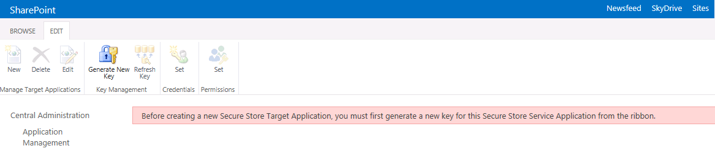

1. Create a new encryption key.
   1. Click the of **Generate New Key** button.
   2. Add a value of Password1 into the textboxes for **Pass Phrase** and **Confirm Pass Phrase** and click **OK**.
2. At this point, you should see the **New** button is now enabled on the main administrative page for the Secure Store Service.

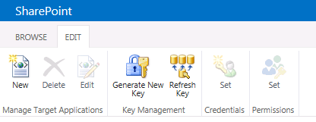

1. Create a new Secure Store application for the Wingtip Sales team.
   1. Click the **New** button which will start the **Create New Secure Store Target Application** wizard.
   2. On the first page of the **Create New Secure Store Target Application** wizard, enter the following property values and then click **Next**
      1. **Target Application ID**: WingtipSales
      2. **Display Name**: Wingtip Sales
      3. **Contact E-mail**: ac@wingtip.com
      4. **Target Application Type**: Individual
      5. **Target Application Page URL**: use default page

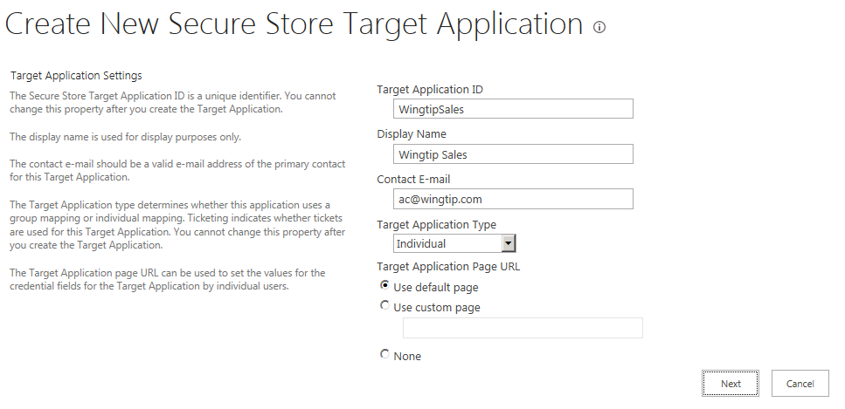

* 1. On the second page of the **Create New Secure Store Target Application** wizard, accept the default settings for the fields that have been added and click **Next**.
  2. On the third page of the **Create New Secure Store Target Application** wizard, enter the user **WINGTIP\Administrator** into the **Target Application Administrators** input control and click **OK** to create the new Secure Store application.
  3. You should be able to verify that the new Secure Store application has been created.

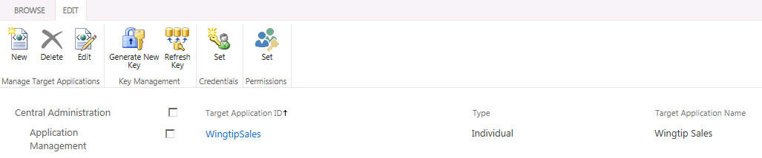

In this exercise you have created a Secure Store application that will be put to use in the next exercise when you create an external content type to access data in the SQL Server database named **WingtipCustomersDB**.

### Exercise 3: Create an External Content Type using SharePoint Designer 2013

In this lab, you will create an External content type and surface it in a SharePoint site using an external list.

1. Open SharePoint Designer 2013
   1. **Press the Windows key to display the Windows Start page.**
   2. **Locate and click the tile for SharePoint Designer 2013 to start this application.**



1. Within SharePoint Designer 2013, open the site at **http://sales.wingtip.com**:
   1. Click the **Open Site** button.
   2. In the **Open Site** dialog, enter **http://sales.wingtip.com** in the **Site Name** box and click **Open**.
   3. If prompted to login, use the credentials for **WINGTIP\Administrator**.
2. Select **External Content Types** in the Navigation pane.
3. Click the **External Content Type** button in the **EXTERNAL CONTENT TYPES** group on the ribbon.
4. Use the following values to create the new external content type:
   1. **Name:** WingtipCustomers
   2. **Display Name:** Wingtip Customers
   3. **Office Item Type:** Contact

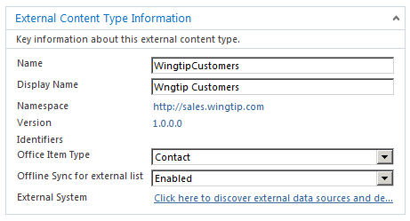

1. Using the ribbon, click the **Operations Design View** button in the **EXTERNAL CONTENT TYPES** group.
2. Click the **Add Connection** button.
   1. In the **External Data Source Type Selection** dialog, select **SQL Server** and click the **OK** button.
   2. In the **SQL Server Connection** dialog, use the following and click OK:
      1. **SQL Server:** WingtipServer
      2. **Database Name:** WingtipCustomersDB
      3. **Connect with Impersonated Windows Identity:** checked
      4. **Secure Store Application ID**: WingtipSales

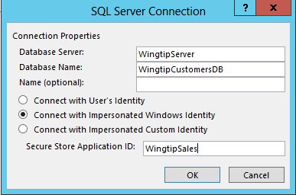

* 1. Click **OK** to close the **SQL Server Connection** dialog and save your changes.

1. Next, you will be prompted for security credentials. Login in as **WINGTIP\Administrator** using a password of **Password1**.
2. Once you have logged in you should see a node for **WingtipCustomersDB**. Expand the **WingtipCustomerDB** node and the **Tables** folder and locate the **Customers** table.

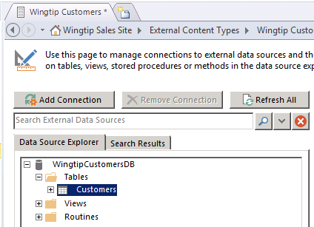

1. Right-click the **Customers** table, and select **Create All Operations** from the context menu:

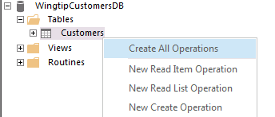

1. Use the **All Operations** wizard dialog to create the operations needed for this external content type:
   1. On the **Operations Properties** page, click **Next**.
   2. On the **Parameters Configuration** page, select the **FirstName** column and modify the following values in the **Properties** section to the right.
      1. **Display Name**: First Name
      2. **Required**: checked
      3. **Office Property**: First Name (FirstName)
      4. **Show In Picker**: checked.

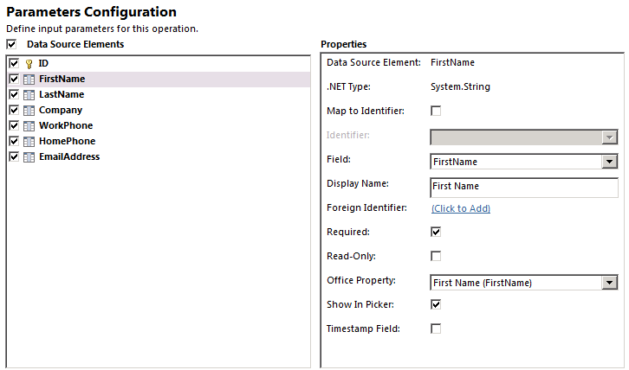

* 1. Remain on the **Parameters Configuration** page, select the **LastName** column and modify the following values in the **Properties** section to the right.
     1. **Display Name**: Last Name
     2. **Required**: checked
     3. **Office Property**: Last Name (LastName)
     4. **Show In Picker**: checked.

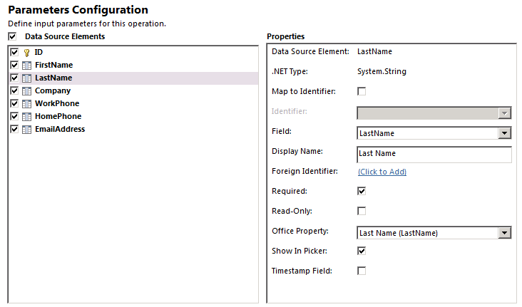

* 1. Once you have modified the **FirstName** column and the **LastName** column on the **Parameters Configuration** page, click **Next** move to the next page.
  2. On the **Filter Parameters Configuration** page, do the following to create a new limit filter
  3. Click the **Add Filter Parameter** button.
  4. In the **Properties** section (right hand side), click the **Click to Add** link next to **Filter**.
     1. In the **Filter Configuration** dialog, set **Filter Type** to **Limit** and click **OK**:
  5. In the **Properties** section, set the **Default Value** to **500** (Note: click into the **Default Value** drop-down text box and then type **500** and press **Enter**)
  6. Click **Finish**.

1. Save your changes to the new external content type by clicking the **File** tab in the ribbon and then **Save**.

Remember that an external content type after it has been created has no default permissions and is not accessible by any user including the user that created it. Therefore, you must set permissions on the external content type so that it can be used. This is done by editing the external content type in the Business Data Connectivity service application: This is separate from and in addition to having rights to access the underlying data. Users must also be granted access to use the external content type that exposes the data to SharePoint and the users.

1. Navigate to **Central Administration**.
   1. **Press the Windows key to display the Windows Start page.**
   2. **Locate and click the tile for SharePoint 2013 Central Administration to start this application.**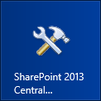
2. In Central Administration select the **Manage Service Applications** hyperlink (underneath the Application Management section).
3. In the list of service applications, click the **Business Data Connectivity Service** hyperlink (first instance in the list) to navigate to the main administration page for the BCS. You should see the external content type named **WingtipCustomers** that you just created using SharePoint Designer 2013.

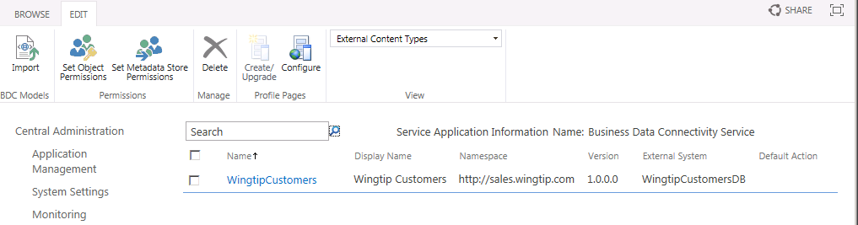

1. Using the drop-down arrow off of the **WingtipCustomers** external content type, select **Set Permissions**.

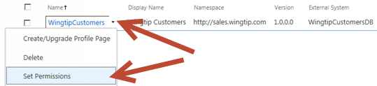

1. In the **Set Object Permissions** dialog, do the following:
   1. In the top-most box, type **WINGTIP\Administrator** and click the **Check Names** icon.  
      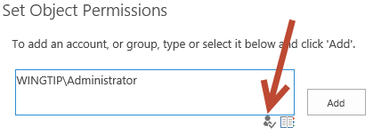
   2. After **WINGTIP\Administrator** is validated, click **Add**.
   3. Ensure the **WINGTIP\Administrator** is selected in the middle box.
   4. Check all four permissions for **WINGTIP\Administrator**.

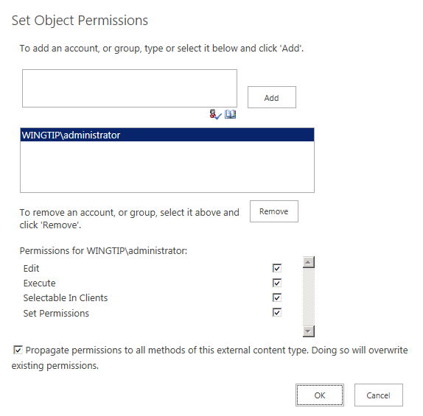

* 1. In the top-most box, type **WINGTIP\wingtipsalesteam** and click the **Check Names** icon.
  2. After **WINGTIP\wingtipsalesteam** is validated, click **Add**.
  3. Ensure the **WINGTIP\wingtipsalesteam** is selected in the middle box.
  4. Check the **Edit** and **Execute** permissions for **WINGTIP\wingtipsalesteam**.
  5. Click **OK** to save your changes and close the **Set Object Permissions** dialog.

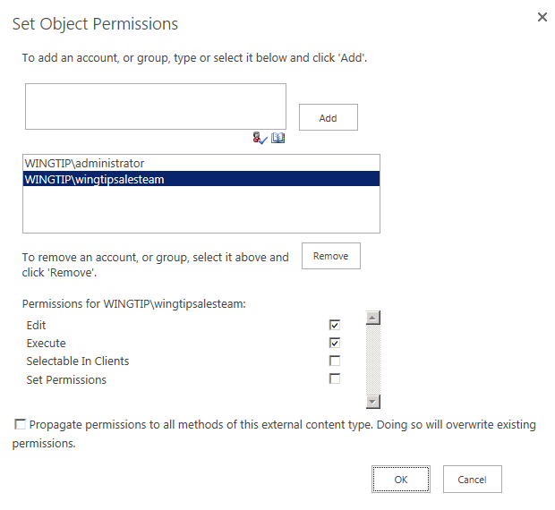

Now you have created an external content type that can be used by the user **WINGTIP\administrator** as well as by users within the group named **WingtipSalesTeam**.

### Exercise 4: Create an External List Based on the External Content Type

In this exercise you will create an external list within the site at http://sales.wingtip.com to surface the external content type you created in the previous exercise.

1. Using Internet Explorer, navigate to the site at **http://sales.wingtip.com**.
2. Create a new external list based on the **WingtipCustomers** external content type:
   1. Using the Quick Launch navigation, click the **Site Contents** link.  
      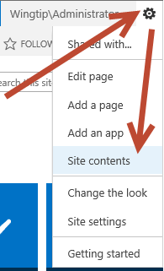
   2. On the **Site Contents** page, click the **add an app** link.
   3. Search for **External** by typing this into the **Find an app** search box near the top of the page and pressing **Enter**.
   4. Select **External List**.
   5. In the **Adding External List** dialog, use the following values to create the list and click **Create**:
      1. **Name:** Wingtip Customers
      2. **External Content Type:**
         1. Click the icon that has a database picture superimposed on a document.  
            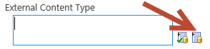
         2. In the **External Content Type Picker** dialog, select **Wingtip Customers** and click **OK**.

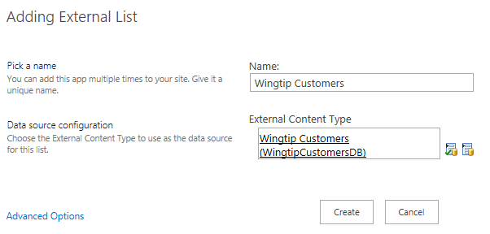

1. Once you have created the external list, you should see a **Wingtip Customers** link on the Quick Launch underneath the Lists section. Click this **Wingtip Customers** link to navigate to the page which displays the external list.
   1. The first time you attempt to access the external list, the BCS discovers that the current user does not yet have credentials stored within the Secure Store application. In this scenario the page for the external list displays a **Click here to authenticate** link which will allow the user to add credentials.

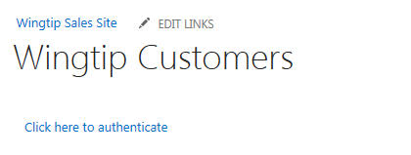

* 1. Click the **Click here to authenticate** link. This will redirect you to a page where you can enter security credentials for the current user.
  2. Note: as we are in a lab environment and do not have security certificates properly configured you may be prompted with a **Secure Store Service Security Warning**. Should this occur click on the **Continue to this Site** hyperlink to continue on to the Secure Store Service Set Credentials page.
  3. On the **Secure Store Service Set Credentials: WingtipSales** page, add a **Windows User Name** of **WINGTIP\Administrator** and a password of **Password1** for both the **Windows Password** and **Confirm Windows Password** text boxes. Click **OK** to store these credentials in the Secure Store application.

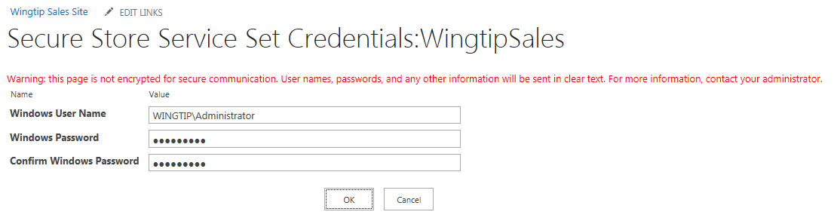

* 1. At this point the external list should now display customer information from the SQL Server database.

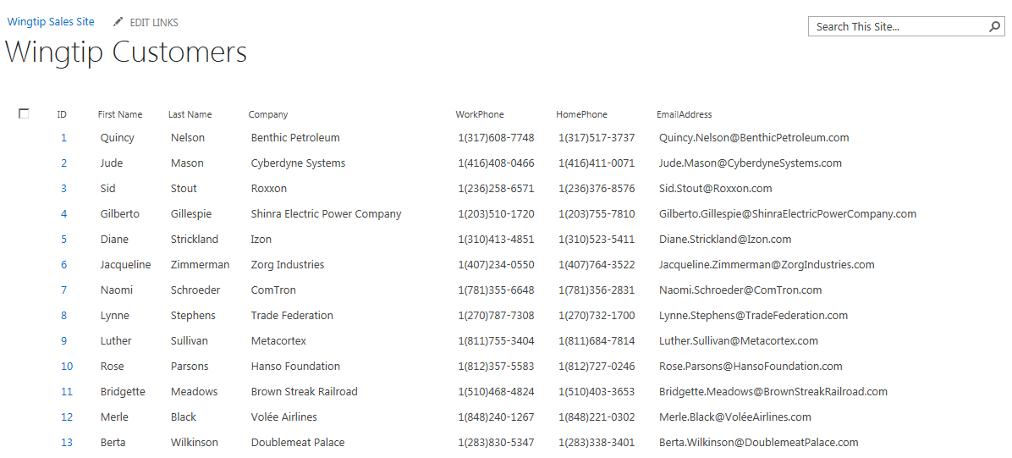

1. Experiment by adding, editing and deleting a few items. You should see that working with items in an external list provides a very similar user experience to working with items in a native SharePoint list.

In this exercise you created a new external list to surface an External Content Type in a SharePoint site to provide users with read/write access to a table in SQL Server.

### Exercise 5: Creating a Taxonomy with the Managed Metadata Term Store Tool

In this exercise you will create a new taxonomy using the Managed Metadata term store tool and use it within a site.

First we need to connect to and configure the Managed Metadata Service for the remainder of this lab:

1. Navigate to Central Administration.
2. Navigate to the Term Store Management Tool page.
   * 1. Click on the **Application Management** link.
     2. Click on the **Manage Service Applications** link to navigate to the **Manage Service Applications** page.
     3. Click on the **Managed Metadata Service** hyperlink.  
        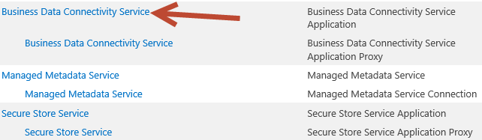
3. When the **Term Store Management Tool** page loads, enter **WINGTIP\Administrator** in the **Term Store Administrators** box and click the person with a check mark icon **“Check Names”** just below to the box to resolve the user.  
   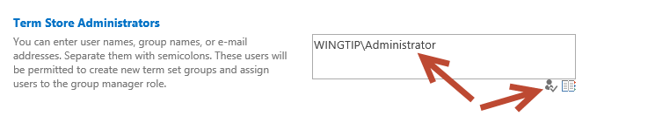
4. Click **Save** at the bottom of the page.

We needed to add our account to the Term Store Administrators in order to create groups and term sets in the term store database,. Simply having the permissions as a SharePoint farm administrator is not enough.

1. Within the **Term Store Management Tool**, select the **Managed Metadata Service** node drop down arrow in the left-hand part of the page and select **New Group**.

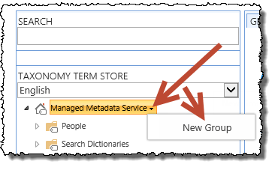

1. Set the name of the group to **Example Taxonomies**.
2. Select the **Example Taxonomies** group drop down arrow and select **New Term Set**.
3. Set the name of the term set to **Corporate Locations** and press **Enter**.
4. Select **Corporate Locations** term set drop down arrow and select **Create Term**. Use this technique to create a small taxonomy as shown in the following figure:

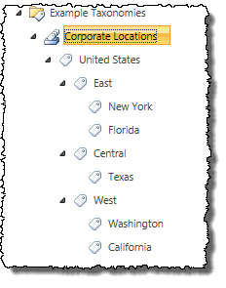

* 1. After creating **United States** and pressing **Enter**, select the drop down arrow off of **United States** and select **Create Term** to create the next level term **East** and press **Enter**. Type **Central** and press **Enter**. Type **West** and press **Enter  
     (**Note: you can continue to add additional terms at the same level by typing them in and pressing enter after each one)
  2. Select the drop down arrow off of **East** and select **New Term**. Type **New York** and press **Enter**. Type **Florida** and press **Enter**.
  3. Repeat this process for the sub terms of Central and West.

1. Now, we will change the taggable property for the United States, East, Central, and West terms as these term should not be available for tagging as they are only used to group terms.
   1. Select the tag for the **East** term to expose the properties for this on the right hand pane of this screen.   
      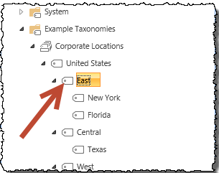
   2. In the right-hand pane you will find the detail for this term.
      1. Uncheck the **Available for Tagging** checkbox and click **Save**.

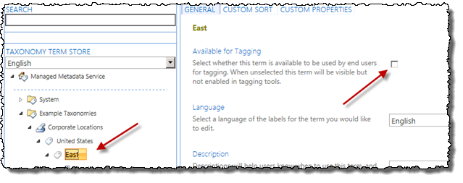

* 1. Repeat this process for the **Central** and **West** and **United States** terms
  2. You should note that Terms that are not available for tagging have a slightly different icon (tag facing up to the right at 45 degree angle) than Terms that are available (tag facing left and horizontal)  
     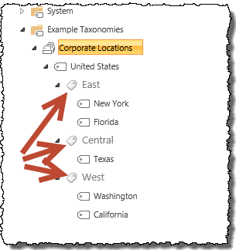

1. A new capability of the Term Store Management Tool is the ability to visually edit the custom properties on a term. Add a new property to signify the primary point of contact for a corporate region:
   1. Select the **Texas** term.
   2. In the right-hand pane, select the **Custom Properties** tab at the top.
   3. Under the **Shared Properties**, select **Add**.
   4. Name the property **PrimaryPOC** and give it a value of **Ken Sanchez** and click **Save**.

### Exercise 6: Use the Taxonomy in a SharePoint List

In this exercise you will use the taxonomy in a SharePoint list.

1. Navigate to the site at **http://sales.wingtip.com**.
2. Create a new **Announcements** list:
   1. In the **Quick Launch** navigation on the left-hand side of the page, click **Site Contents**.
   2. On the **Site Contents** page, under the **Lists, Libraries and Other Apps** section, click the **Add an App** link.
   3. On the **Site Contents > Your Apps** page, select **Announcements**.
   4. Set the name of the list to **Announcements** and click **Create**.
3. Modify the **Announcements** list to contain terms for the different company locations:
   1. In the **Quick Launch** navigation, select the **Announcements** list/app.
   2. When the **Announcements** list loads, using the ribbon (at the top of the page) select the **List** taband click the **List Settings** button.  
      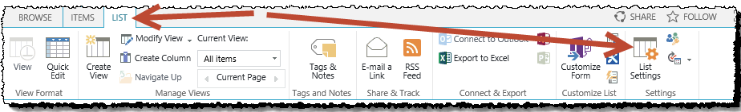
   3. Click the **Create column** link in the **Columns** section of the page.
   4. On the **Settings > Create Column** page, use the following to create a new column mapped to the taxonomy you created and click **OK**:
      1. **Column Name:** Relevant Offices
      2. **The type of information in this column is:** Managed Metadata
      3. **Allow multiple values**: checked
      4. **Term Set Settings**: Use a managed term set. Select the **United States** term set as shown in the following figure:

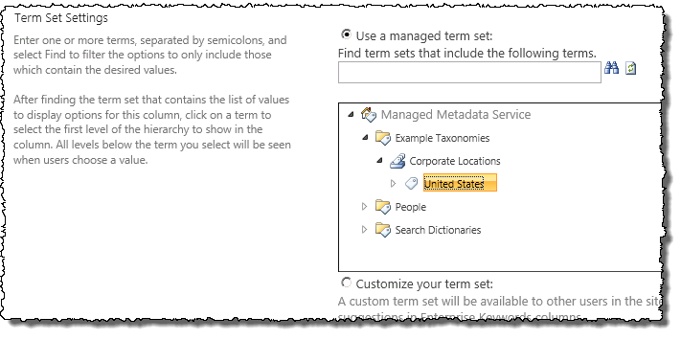

* + 1. Click **OK** to save your changes

1. Now add some data to your list:
   1. In the **Quick Launch** navigation, select the **Announcements** list/app.
   2. Add an announcement to the list. Set the:
      1. **Title**: “The Stars at night, are big and bright…”
      2. **Relevant** Offices: Texas
      3. Click **Save**
   3. Next, add multiple announcements, except this time use the **Quick Edit** view. Using the ribbon, click the **List** tab and the **Quick Edit** button in the **View Format** group. This was previously called the Datasheet View. It has been improved in SharePoint 2013 to support managed metadata!  
      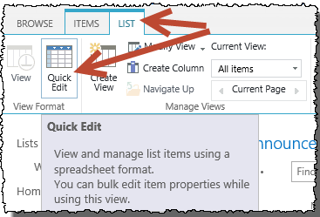
      1. Add the following announcements using the **Quick Edit** view and make sure each has the appropriate term(s) tagged to it. As shown below:.  
         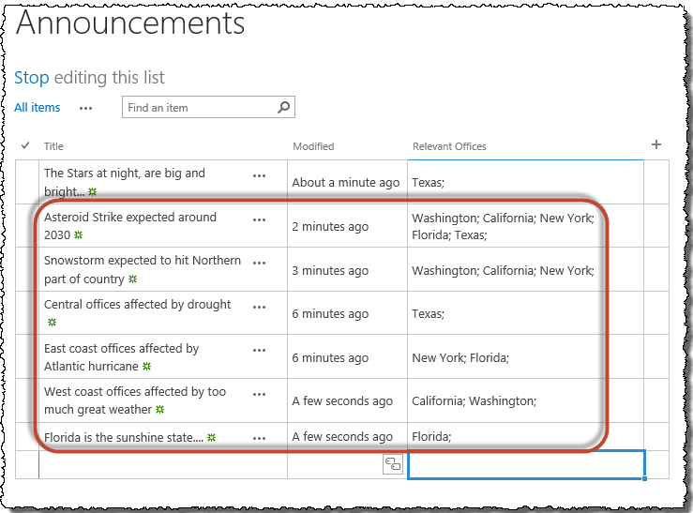
   4. When finished click **Stop** editing this list (Near the top left side of the screen under the **Announcements** title).
2. Last, to see how the managed navigation works, first, enable it on site:
   1. Using the **Site Actions** “gear” icon in the top-right corner of the browser, select **Site Settings**.  
      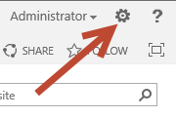
   2. In the **Site Actions** section, select **Manage Site Features**.
   3. Find the Site Feature **Metadata Navigation and Filtering** and click the **Activate** button.
3. Now enable it on the list:
   1. In the **Quick Launch** navigation, select the **Announcements** list/app.
   2. When the **Announcements** list loads, using the ribbon select the **List** taband click the **List Settings** button.
   3. Under the **General Settings** section, select **Metadata navigation settings**.
   4. In the **Configure Navigation Hierarchies**, add the **Relevant Offices** column from the **Available Hierarchy Fields** to the **Selected Hierarchy Fields** and remove Folders. Then click **OK**.
4. Next, go back to the **Announcements** list
5. Notice in the lower portion of the **Quick Launch** you have a new navigation option. Using this you can filter all the content in the list, regardless of any folders you may have.
   1. Try expanding **Relevant Offices** and select **Central**, then **West**, then **East**, then just **Florida**
   2. Notice how **East** and **Florida** produce slightly different results (as there was a snowstorm announcement that did not affect **Florida**, but did affect other **East** Coast locations).

In this exercise you created a term set using the browser interface and used it within a SharePoint list.

### Exercise 7: Creating the User Profile Service Application / My Sites host

In this exercise you will configure SharePoint to create and host My Sites. In order to host My Sites you will need a new Web Application that is configured for Self-Service Site Creation and has a My Site Host site collection.

1. Create a new Web Application to host the My Sites:
   1. Ensure you are logged into the **WingtipServer** VM using the account **WINGTIP\Administrator | Password1**.
   2. Open **Central Administration**:
      1. **Press the Windows key to display the Windows Start page.**
      2. **Locate and click the tile for SharePoint 2013 Central Administration to start this application.**
   3. Select **Manage Web Applications** underneath the **Application Management** section.
   4. Click the **New** button in the ribbon to display the **Create New Web Application** dialog.
   5. Locate the **IIS Web Site** section in the **Create New Web Application** dialog.
      1. Select the radio button option **Create a new IIS web site**.
      2. Configure the following properties for the new IIS Web Site.
         1. **Name**: SharePoint MySite Host – 80
         2. **Port**: 80
         3. **Host Header**: my.wingtip.com
   6. Scroll down to the Public URL section and edit the URL to remove the port number from the end so that the URL is **http://my.wingtip.com**.
   7. Scroll down to the **Application Pool** section in the **Create New Web Application** dialog.
      1. Select the radio button **Use existing application pool.**
      2. Select the application pool named **SharePoint - 80**.
   8. Scroll down to the **Database Name and Authentication** section in the **Create New Web Application** dialog.
      1. Configure the following properties for creating the content database for the new web application.
         1. **Database Server**: WingtipServer
         2. **Database Name:** WSS_Content_MySites.
   9. Leave all other settings with their default values and click OK to create the new web application.
   10. The process to create a web application will take a few moments. At the end of the process, SharePoint will display the **Application Created** dialog which will ask if you want to create a site collection. Click the **Create Site Collection** link provided to begin the process to create a new site collection and continue to the next step.
2. Create a My Site Host site collection:
   1. On the **Create Site Collection** page, use the following information to complete the form and click **OK**:
      1. **Title:** My Site Host
      2. **URL:** /
      3. **Template Selection:** My Site Host (*found in the* ***Enterprise*** *tab*)
      4. **Primary Site Collection Administrator:** WINGTIP\Administrator

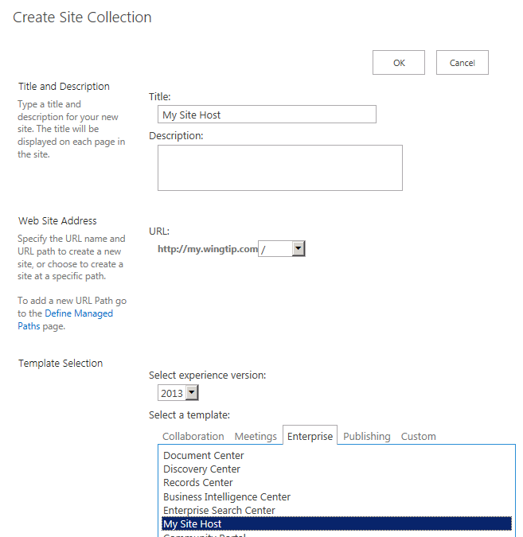

* 1. When the site has been created, SharePoint displays the **Top-level Site Successfully Created** dialog. There is a link to the new site collection but if you attempt to access it at this point it will produce an error. Click **OK** to close the dialog.

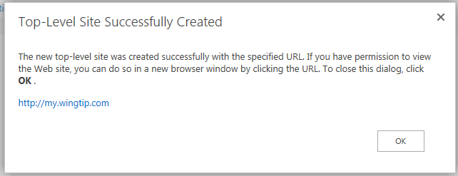

* 1. You should now see **SharePoint MySite Host – 80** in the list of web applications.

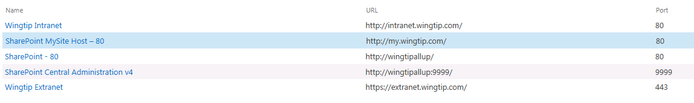

1. Update the Web Application to host my sites:
   1. On the Current Page (**Manage Web Applications**), select the **SharePoint MySite Host – 80** web application.  
      (Note: click anywhere on this line except the **SharePoint MySite Host – 80 link** as this will take you to the Manage Features screen automatically. That is, we just want to highlight this selection not click on the link for it).
   2. Click the **Managed Paths** button in the ribbon.
   3. Remove the **sites** managed path and add two new managed paths and click **OK**:
      1. **personal** – Wildcard inclusion
      2. **my** – Explicit inclusion

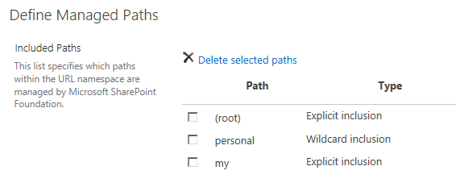

* 1. With the **SharePoint MySite Host – 80** web application still selected, click the **Self-Service Site Creation** button in the Ribbon Bar at the top of the screen.
     1. On the **Self-Service Site Creation Management** page, enable the option to create **Site Collections** by selecting the **On** option button, and then click the **OK** at the bottom of the page.

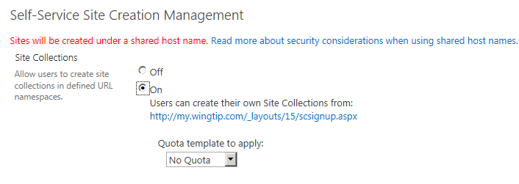

Next, you will create an instance of the User Profile Service Application and use the My Site host to configure it.

1. From the home page of Central Administration click the **Manage services on server** link (located under the **System Settings** area) to navigate to the page where you can start and stop services on the local server.
2. Find the service named **User Profile Service** and click the **Start** link to the right to start it up. After you click on the **Start** link, the service should show the status of **Started**.

Note: At this point in the lab you should not start the **User Profile Synchronization Service**. That is something you will do in later exercise in this lab after you have configured and tested the **User Profile Service** and the functionality of MySite.

1. From the home page of Central Administration click the **Manage service applications** link (located under the **Application Management** section) to navigate to the page where you can create a new service application instance.
2. In the **Service Applications** page select the drop-down menu beneath the **New** button and choose **User Profile Service Application**.

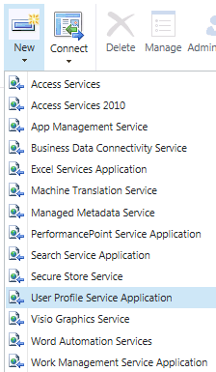

1. A dialog where you can create the new service application is displayed.
   1. Give it the name **User Profile Service Application**.
   2. Use the existing application pool **SharePoint Web Services Default**.

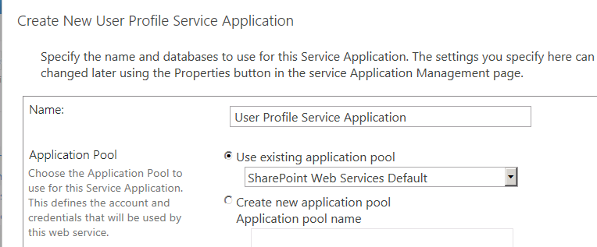

* 1. Scroll down to the **My Site Host URL** section add the URL of **http://my.wingtip.com**.

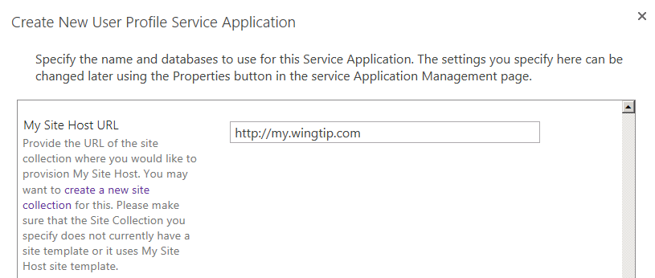

* 1. Leave all other settings with their default value and click **OK** to create the new service application.
  2. It will take several minutes to create the new service application. When it has been created, SharePoint displays a dialog with the message **Profile Service Application successfully created**. Click **OK** to close the dialog.
  3. At this point your SharePoint deployment is now configured to automatically create My Sites under **http://my.wingtip.com/Personal/UserName** when users first browse to them.
  4. Let’s test for the presence of the My Site links on some sites; Open <https://extranet.wingtip.com> and <http://intranet.wingtip.com> in Internet Explorer.
     1. Notice how the Title Bar at the top of the page is different; **Extranet** has three additional hyperlinks (**Newsfeed**, **SkyDrive**, and **Sites**) whereas **Intranet** is missing these. **Intranet** does not appear to be using the **User Profile Service**; let’s investigate why.  
        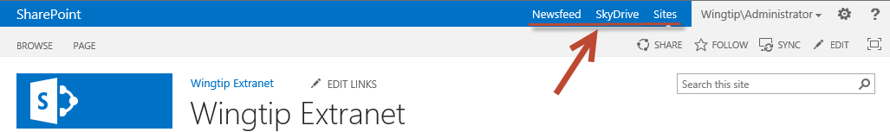

1. Configure the service application associations for the **Wingtip Intranet** web application to add the User Profile Service application.
   1. Using Central Administration navigate to **Application Management → Configure service application associations**
   2. Note how Wingtip Intranet is in a **custom** Application Proxy Group.
   3. Click on the Wingtip Intranet hyperlink on the Service Application Associations page  
      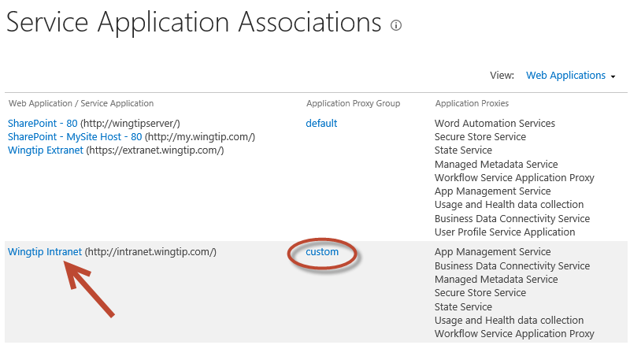
   4. In the **Configure Service Application Associations** dialog, check the **User Profile Service Application** and then click **OK** to save you changes.

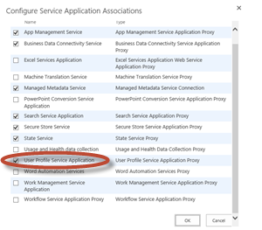

* 1. Refresh the [**http://intranet.wingtip.com**](http://intranet.wingtip.com) site in Internet Explorer. Notice how the three hyperlinks now appear in the Title Bar as shown below.  
     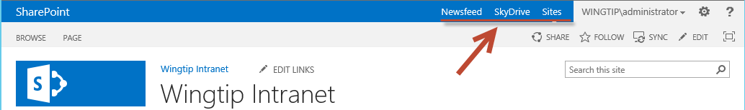
  2. At this point your SharePoint deployment is now configured to automatically create My Sites under **http://my.wingtip.com/Personal/UserName** when users first browse to them. The **Intranet** site is now configured to correctly use the User Profile Service

You have now created and properly configured the user profile service to manage user profiles and create MySites on demand.

### Exercise 8: Working with MySites

In this exercise you will create a MySite for the WINGTIP\Administrator account and navigate around the site to become more familiar with it.

1. Make sure you are logged on to the **WingtipServer** server as **WINGTIP\Administrator**.
2. In the browser, navigate to the team site at **http://intranet.wingtip.com**.
3. Once the page for the team site is displayed, look at the upper right portion of the page and locate the following links:
   1. Newsfeed
   2. SkyDrive
   3. Sites

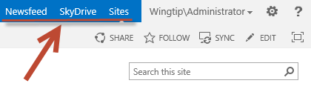

1. Click on the **Sites** link. The **Sites** link is designed to navigate users to their MySIte. However, in this case the MySite for the user **WINGTIP\Administrator** has not yet been created. SharePoint responds to this by creating the new MySite on demand. After a minute or two you should see the following screen. Click the **OK** button to continue.

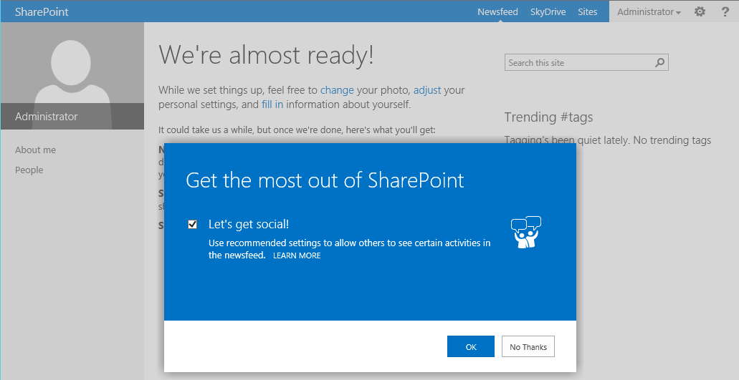

1. After the MySite has been fully provisioned you should see a page that looks like the following screenshot. 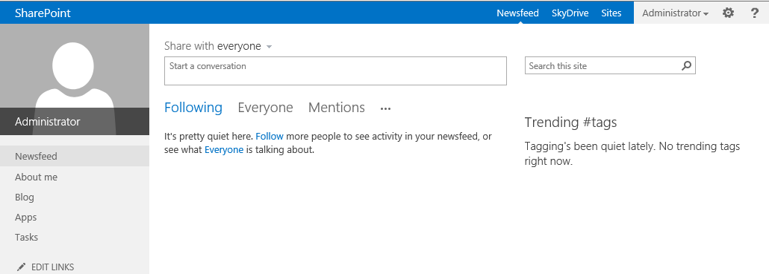
   1. Click the **About me** link in the Quick launch section of the page.
2. At this point you should be on About page for the current user. Click the **edit your profile** link.

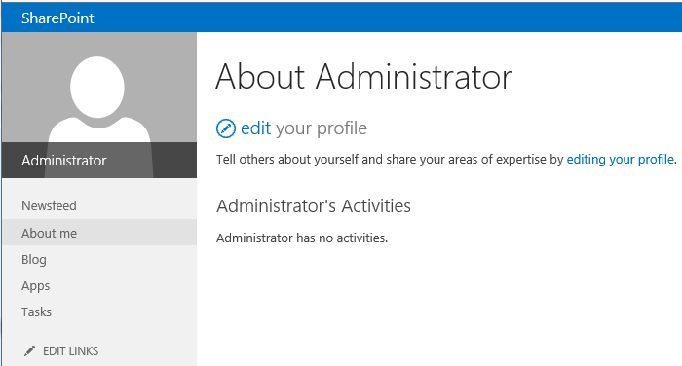

1. On the Edit Profile page, fill in the details with some creative information.  
   (Note: the folder for this lab has an image file named **Administrator.jpg** that you can use for a photo.)  
   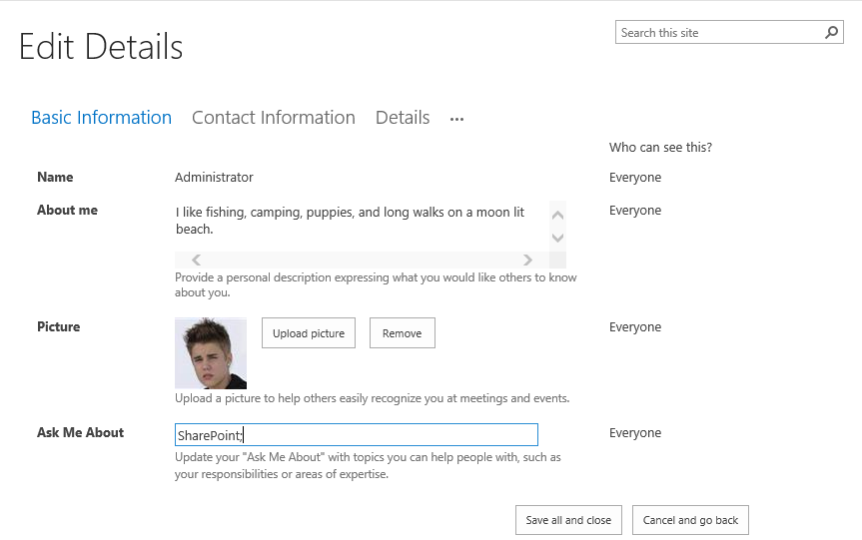
   1. When done editing the Administrator profile click the **Save all and close** button.
   2. Click the **OK** button on the **Profile Changes** dialog box notification that appears.  
      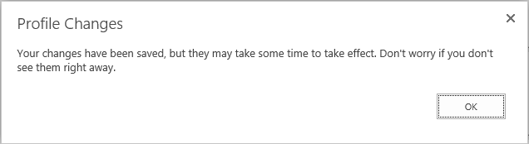
2. Feel free to take a little more time navigating around this MySite and getting to know what's there.

In this exercise you created a new MySIte and made a few customization changes to it.

### Exercise 9: Configuring the User Profile Syndication Service

In this exercise you will setup the user profile synchronization service to connect to Active Directory and synchronize user account information into user profiles in the User Profile Service Application. One strange aspect of this configuration is that you are required to add the SP_Farm account to the local Administrators group during the configuration. Once the configuration has been completed, you can and should remove the SP_Farm account from the local Administrators group because you should abide by the principles of least privilege.

1. Add the **WINGTIP\SP_Farm** account to the local **Administrators** group on the **WingtipServer** VM.
   1. From the Windows start page (press the Windows key on the keyboard), launch the **Active Directory Users and Computers** utility by click the following tile.

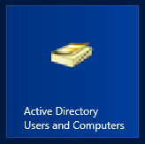

* 1. Under the **wingtip.com** node click on the **Builtin** folder.
  2. On the right hand side of the **Active Directory Users and Computers** dialog box, locate the group account for the **Administrators** and double click on it to display the **Administrator Properties** dialog.   
     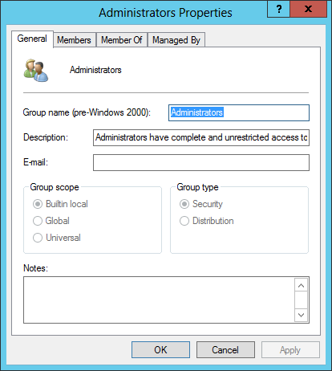
  3. Click on the **Members** tab at the top of the **Administrators Properties** dialog box.
  4. On the **Members** tab, click the **Add** button and add the account **WINGTIP\SP_Farm**. Click **OK** when you are done. The **Administartors Properties**, **Members** tab should now look like the screenshot below.  
     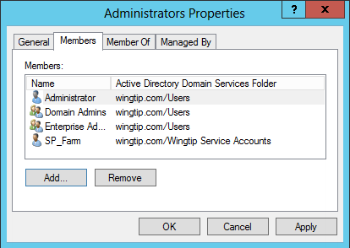
  5. Click **OK** on the **Administrators Properties** dialog box.

1. One additional task that we must accomplish is to configure the user account (WINGTIP\SP_Farm) to have **Replicating domain changes** permissions on the **wingtip.com** domain. This is a requirement because without this, you can’t import changes from SharePoint to Active Directory, or Active Directory to SharePoint.
   1. On the **Active Directory Users and Computers** screen Right Click on the **wingtip.com** domain and select **Delegate Control…** as shown below:  
      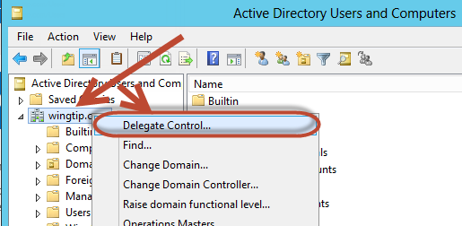
   2. In the **Delegation of Control Wizard** click **Next >** then click **Add...**
   3. On the **Select Users, Computers, or Groups** dialog box add the **WINGTIP\SP_Farm** account and click **OK** to return to the **Delegation of Control Wizard.** Then click **Next >**.
   4. On the **Tasks to Delegate** screen select **Create a custom task to delegate** and click **Next >**.  
      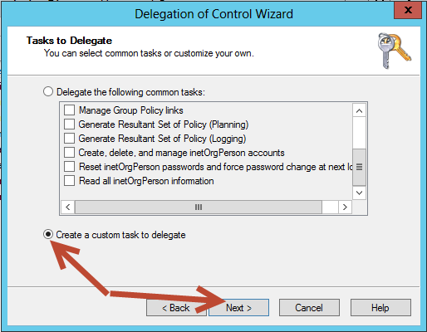
   5. On the **Active Directory Object Type** screen click **Next >.**
   6. On the **Permissions** screen select the **Replicating Directory Changes** Permission and Click **Next >** and then click **Finish**  
      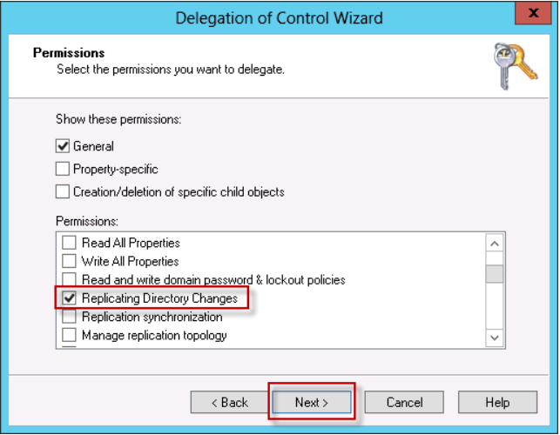
2. Now that we have configured the the **WINGTIP\SP_Farm** account, reboot the **WingtipServer** server and wait for the server to restart.
   * 1. To reboot the server press the **Windows Key + i** to bring up the Settings screen.  
        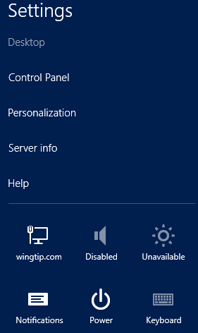
   1. On the **Settings** screen click on the **Power** option then select either **Update and restart** or **Restart** (depending on whether there are any pending updates on your system).
   2. Select **Other (Planned)** from the drop down box and click the **Continue** button.
   3. Once the server has rebooted, log back in as **WINGTIP\Administrator** with a password of **Password1**

Now that we have the User Profile Service turned on (from earlier in the labs), we need to configure the profile import from Active Directory.  
(Note: there are several ways to configure this: **Profile Synchronization** (Read/Write access to Active Directory), **Active Directory Import** (Read only access to Active Directory), or **External Identity Manager** (use some other service to provide user information). We will be using the Read/Write **Profile Synchronization** in this lab).

1. To configure the Active Directory Import:
   1. Using Central Administration navigate to **System Settings** **→ Manage services on server**
   2. Scroll down to the **User Profile Synchronization Service** and click on **Start**
   3. Using the **Wingtip\SP_Farm** account enter the **Password / Confirm Password:** Password1 and click **OK**(Note: the Synchronization Service will appear as **Starting** for 5-10 minutes, we don’t need to wait for this however)
   4. Using Central Administration navigate to **Application Management** **→ Manage service applications → User Profile Service Application (Click on this hyperlink as shown in the image below):**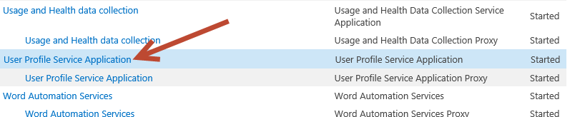
   5. On the Manage Profile Service page, select the **Configure Synchronization Connections** hyperlink and then click **Create New Connection** on the **Synchronization Connections** screen
   6. On the **Add new synchronization connection** screen, establish a connection to the Active Directory domain named **wingtip.com** by entering the followingvalues on this form and click **OK**:
   7. **Connection Name**: Wingtip AD Users
   8. **Type**: Active Directory
   9. **Connection Settings**:
      1. **Fully Qualified Domain Name**: wingtip.com
      2. **Authentication Provider Type**: Windows Authentication
      3. **Account Name**: WINGTIP\Administrator
      4. **Password** (and **Confirm Password**): Password1

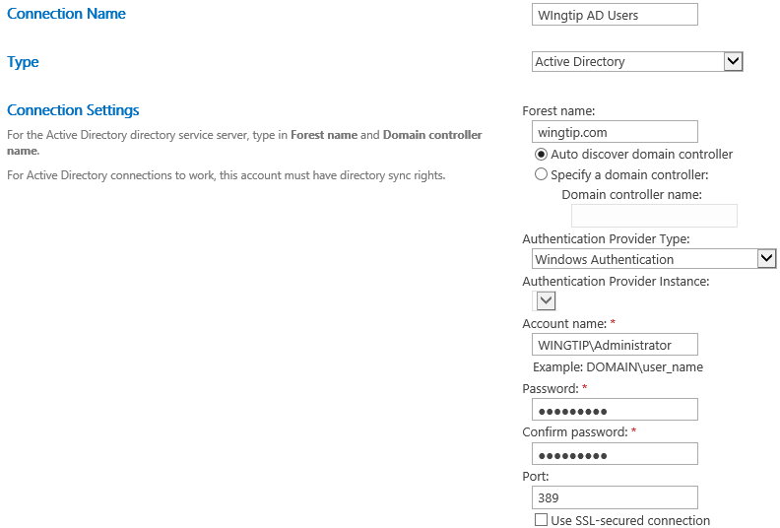

* 1. **Containers**:
     1. Click **Populate Containers**.
     2. After it loads, expand the **WINGTIP** node and select the Organizational Unit named **Wingtip Users**.  
        (Note: place a check in the **Wingtip Users** checkbox as shown below)

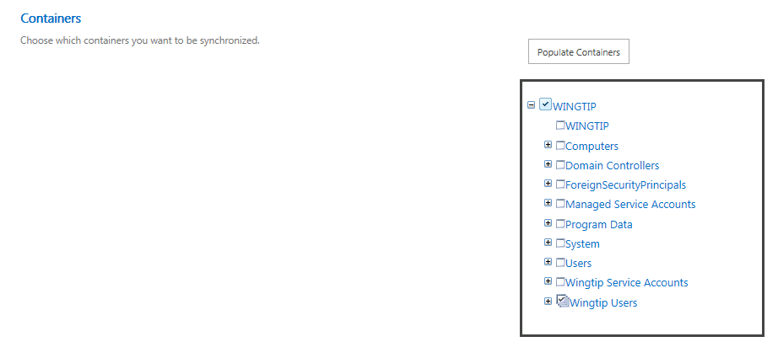

* 1. Click **OK** to save the connection. You should see the connection has been successfully created.

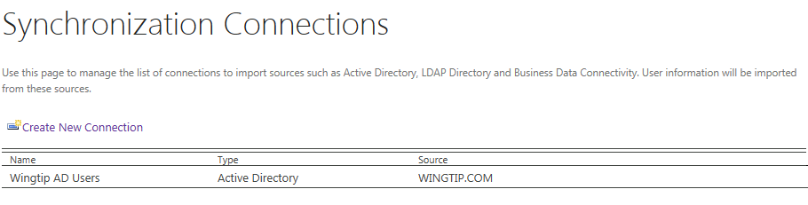

1. Now that we have the User Profile Service configured to use Active Directory, we need to start the synchronization:
   1. Navigate back to the **Manage Profile Service: User Profile Service Application** page (**Central Administration → Application Management → Manage Service Applications** → **User Profile Service Application**)
   2. , select **Start Profile Synchronization** (located under the **Synchronization** section)
   3. On the **Start Profile Synchronization** page select **Start Full Synchronization** and click the **OK** button.  
      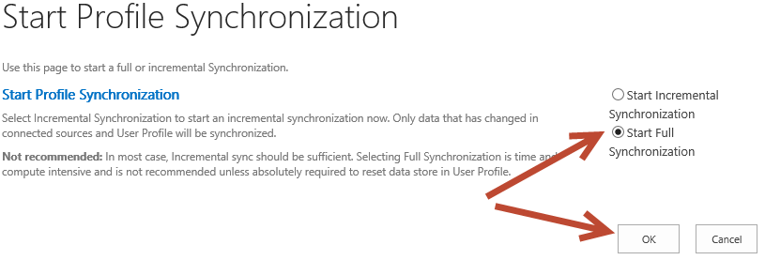
   4. You will be taken back to the UPA management page. Notice in the top-right corner there is a status block that reports how many profiles are in the UPA database. Refresh the page to see it increase to a handful of profiles as the import process runs.  
      (Note: there should be 15 User Profiles total).  
      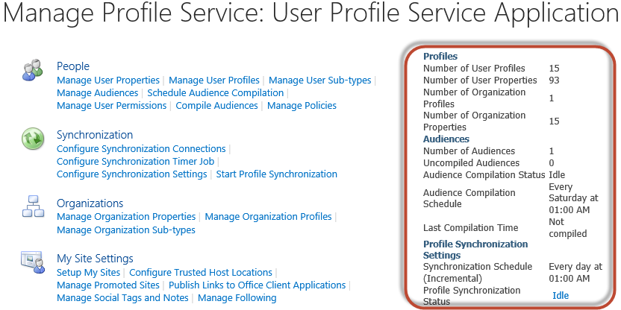
2. Following the principle of Least Privilege we can now remove the **WINGTIP\SP_Farm** account from the local **Administrators** group on the **WingtipServer** VM.
   1. From the Windows start page (press the Windows key on the keyboard), launch the **Active Directory Users and Computers** utility by click the following tile.



* 1. Under the **wingtip.com** node click on the **Builtin** folder.
  2. On the right hand side of the **Active Directory Users and Computers** dialog box, locate the group account for the **Administrators** and double click on it to display the **Administrator Properties** dialog.   
     
  3. Click on the **Members** tab at the top of the **Administrators Properties** dialog box.
  4. On the **Members** tab, select the **WINGTIP\SP_Farm** account and click the **Remove** button to remove the account. Click **Yes** in the **Active Directory Domain Services** dialog box. Click **OK** on the **Administrator Properties** dialog box when you are done. The **Administrators Properties**, **Members** tab should now look like the screenshot below.  
     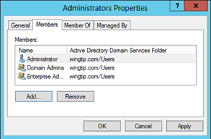
  5. After removing the **WINGTIP\SP_Farm** account to the local **Administrators** group, reboot the **WingtipServer** server and wait for the server to restart.
     1. To reboot the server press the **Windows Key + i** to bring up the Settings screen.  
        
  6. On the **Settings** screen click on the **Power** option then select either **Update and restart** or **Restart** (depending on whether there are any pending updates on your system).
  7. Select **Other (Planned)** from the drop down box and click the **Continue** button.
  8. Once the server has rebooted, log back in as **WINGTIP\Administrator** with a password of **Password1**

At this point you have successfully configured the UPA to import profiles from the local AD.

(Note: After you start the User Profile synchronization service, for day to day operations, the farm account is not required to be a member of the Administrators group on the computer that is running the synchronization service. To improve the security of your SharePoint Server installation we removed the farm account from the Administrators group on the computer that is running the synchronization service. However, when you perform a backup of the User Profile application, the synchronization service provisions the User Profile application again. During the course of provisioning the User Profile application, the farm account must stop and start the synchronization service. To do this, the farm account must be a member of the Administrators group on the computer that is running the synchronization service. So, before you perform a backup, add the farm account to the Administrators group on the computer that is running the synchronization service. After the backup has finished running, you can remove the farm account from the Administrators group.)