## **Upgrading Content from SharePoint 2010 to SharePoint 2013**

**Lab Time**: 45 minutes

**Lab Folder**: C:\Student\Modules\Upgrade\Labs

**Lab Overview**: This lab focuses on migrating site content from a SharePoint 2010 farm to a SharePoint 2013 farm. In this lab exercise you will perform a database attach upgrade. With this approach you will upgrade only the content of your environment and not the configuration settings. Using a database attach upgrade is useful when you are changing hardware or want to reconfigure your server farm topology as part of the upgrade process.

### Exercise 1: Preparing SharePoint 2010 Content Databases for Upgrade

In this first exercise you just read to understand we are providing you with a backup file for a SharePoint 2010 content database. This content database was prepared and backed up in a SharePoint 2010 farm and it is now ready to migrate to your SharePoint 2013 farm using the database attach migration strategy. This first exercise will simply walk you through the steps of what was done to prepare the content database backup in the SharePoint 2010 environment.

1. There are a number of steps you must perform in the SharePoint 2010 environment before you upgrade the content database. These are the high level steps that were used to prepare the backup file used in the next exercise. ***Don’t do these steps … this is an overview of what you would have done do a SharePoint 2010 environment.***
   1. Set the SharePoint 2010 content database(s) to be upgraded to read-only.
   2. Back up the SharePoint 2010 content databases by using SQL Server tools.
   3. Copy the backup file for the 2010 content database to the database server in your SharePoint 2013 farm.

### Exercise 2: Restoring the SharePoint 2010 Content Database in a SharePoint 2013 Farm

In this step you will use the SQL Server database management tools to restore a SharePoint 2010 content database so you can begin the database attach upgrade process.

1. Log on to the **WingtipServer** as **WINGTIP\Administrator** with **Password1**.
2. Using the Windows Explorer, navigate to **C:\Student\Modules\Upgrade\Lab**.
3. Verify that you can locate the following two files:
   1. WingtipOperations_ContentDB.bak
   2. CopyBackup.bat
4. Double click on the batch file named CopyBackup.bat. This will copy the Wingtip Sales content database backup file to the default location used by SQL Server 2012.

C:\Program Files\Microsoft SQL Server\MSSQL11.MSSQLSERVER\MSSQL\Backup

1. Open the SQL Server Management Studio
   1. **Start menu (Windows Keyboard Key)**
   2. Click on the **SQL Server Management Studio tile.**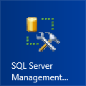
2. Once you have launched SQL Server Management Studio, connect to the **Database Engine** on **WINGTIPSERVER**.
3. Expand the **Databases** node to see the existing databases. Right-click on the **Databases** node and select the **Restore Database…** command.

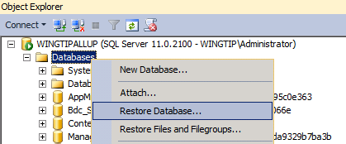

1. In the **Restore Database** dialog, locate the section titled **Source** and select the **Device** option. Click the button to the right with the ellipse (…) to add a new device using the **Specify Backup** dialog. Click the **Add** on the **Specify Backup** dialog to bring up the **Locate Backup File** dialog. In the **Locate Backup File** dialog, select the backup file named WingtipOperations_ContentDB.bak. Click **OK** to close the **Locate Backup File** dialog and then click **OK** to close the **Specify Backup** dialog. At this point, you should be back at the **Restore Database** dialog.

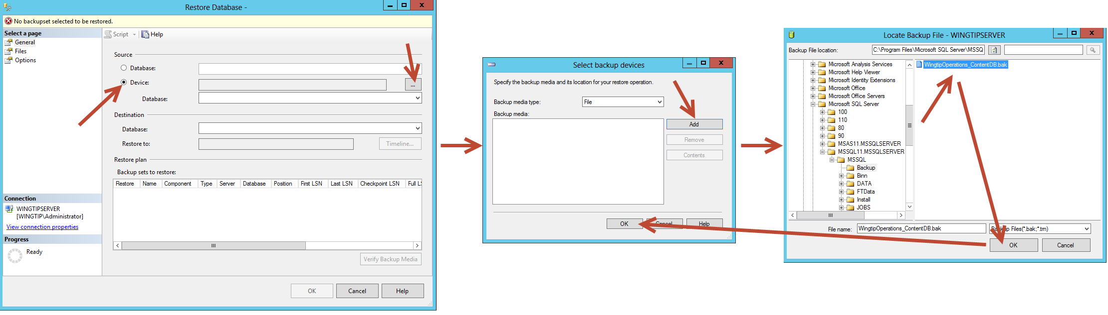

1. On the **Restore Database** dialog, locate dropdown control with the caption **Database** in the **Destination** section. Ensure that the database is set to WingtipOperations_ContentDB. Also ensure that the check is in the checkbox for the **Backup sets to restore** section in the **Restore** column as shown in the screenshot below. Now that you have the provided entries for the **Source** option and **Destination** option, click the **OK** button in the **Restore Database** dialog to begin the database restore operation.

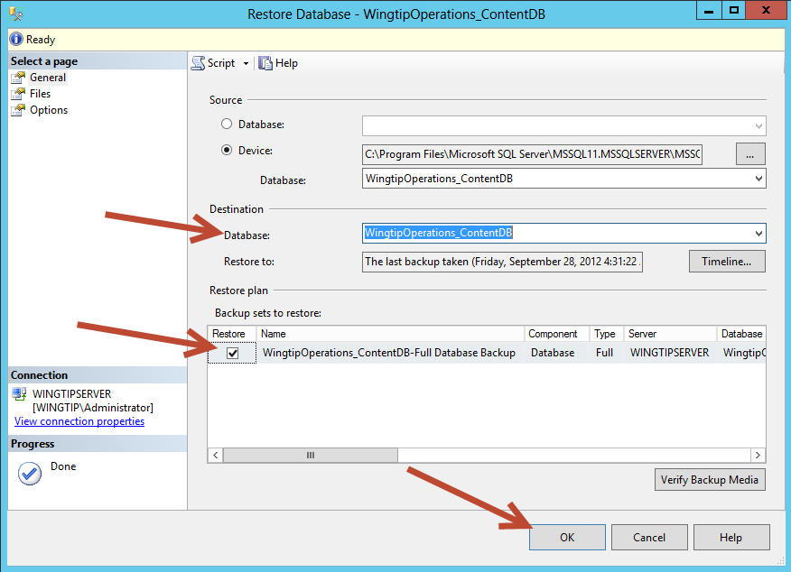

1. Once the **WingtipOperations_ContentDB** database has been restored, click **OK** to the success message dialog. You can now close the SQL Server Management Studio.

### Exercise 3: Mounting the Restored Content Database

In this exercise you will create a new Web application at [**http://operations.wingtip.com**](http://sales.wingtip.com) and you then you will attach **WingtipOperations_ContentDB** by mounting the restored database in order to upgrade SharePoint 2010 content to SharePoint 2013.

1. Open the **SharePoint 2013 Central Administration**.
2. Click **Application Management**.
3. Click the **Manage web applications** hyperlink in the Web Applications section.
4. Click the **New** button on the ribbon to create a new web application with the following properties:
   1. **Name**: Wingtip Operations
   2. **Port**: 80
   3. **Host Header**: operations.wingtip.com
   4. **Public URL:** <http://operations.wingtip.com>  
      (Note: be sure to remove the :80 from the end of the URL above)
   5. Use existing application pool: SharePoint - 80
   6. **Database name**: WingtipOperations_ContentDB_Temp.

One thing to watch out for here is prevent database name conflicts. For example do not name the database **WingtipOperations_ContentDB** because that is the name of the database that you restored earlier in this lab exercise. Also note that the database you are creating here will not always be used and might be discarded after the upgraded database is attached.

* 1. Click the **OK** button to start the creation of the web application.
  2. After the Web application has been created, you are prompted with the Create Site Collection dialog. **Do NOT create a new site collection at root of the Web application**. This would cause problems because the SharePoint 2010 content database we are going to upgrade already has a site collection at the root URL.

1. Before you attach the content database to upgrade, you can test it to verify if it can be upgraded without problem. There is a PowerShell cmdlet that can do this for you:
   1. Start by bringing up the SharePoint PowerShell console window.
      1. Start » All Programs » Microsoft SharePoint 2013 Products » SharePoint 2013 Management Shell.
   2. Type in the following cmdlet (On one line) and press [Enter] to execute it.   
      (Note: make sure to enter this command on one line, it is only split across three lines here for readability. It MUST be typed on one line or it will not work.)

Test-SPContentDatabase -Name "WingtipOperations_ContentDB"   
 -WebApplication "[http://operations.wingtip.com](http://sales.wingtip.com)"  
 -Verbose

(Note: we use the **–Verbose** switch in the statement above so that you might see what this statement does. If you run this without –Verbose the cmdlet will typically run silently and return you to the command prompt if everything is in order).

* 1. This should execute successfully.

If you have more than one content database to attach, make sure that you first attach the content database containing the root site collection of the web application. After you attach the database that contains the root site, you can attach the other content databases for the Web application in any order. You do not have to create any site collections to store the content before you attach the database; this process creates the site collections for you. Make sure that you do not add any new site collections until you have restored all the content databases.

1. Now it is time to attach the content database to the SharePoint 2013 web application.
   1. Use the Mount-SPContentDatabase cmdlet to attach the content database. The value of –updateuserexperience is set to false to be able to perform the visual upgrade afterwards.  
      (Note: make sure to enter this command on one line, it is only split across three lines here for readability. It MUST be typed on one line or it will not work.)

Mount-SPContentDatabase –Name "WingtipOperations_ContentDB"

–WebApplication "[http://operations.wingtip.com](http://sales.wingtip.com)"

1. Wait for this to reach 100% completion. When it finishes you should receive a small report with ID, Name, WebApplication, Server, and CurrentSiteCount. There should be 3 sites in the CurrentSiteCount.
2. When the first content database is upgraded, you can verify that the upgrade was successful from **SharePoint 2013 Central Administration**
   1. In **SharePoint Central Administration** select **Upgrade and Migration**. There are two links that you can use to view information about the upgrade which are **Review database status** and **Check upgrade status**.
      1. Click on the **Review database status** link
         1. In Review database status locate the WINGTIPSERVERWingtipOperations_ContentDB and click on it
         2. On the **Manage Content Database Settings** screen look in the **Database Versioning and Upgrade** area. You should note that the **Database Schema Versions**  Current and Maximum match which indicates that the database has been upgraded.
         3. Navigate back to the **Upgrade and Migration** screen in Central Administration.
      2. Click on the **Check upgrade status** link
         1. You should see that the update **Succeeded** and you can find all the details of the update below on the same screen.  
            (Note: if there were multiple upgrades that had been completed, you could view the status details of each one by clicking on the hyperlink located in the **Status** column on each row of data)
3. Open Internet Explorer and navigate to the site located at [http://operations.wingtip.com](http://sales.wingtip.com). You will likely find that the site will not display yet. (i.e. you will receive an **Error: Access Denied** message).
4. There is a problem in that these sites at http://operations.wingtip.com are coming from another Active Directory domain which is not recognized in the wingtip.com domain. We need to gain access to this to add all needed accounts. We will add ourselves to the User Policy for this web application to gain access to all underlying sites at one time.
5. To begin fixing this:
   1. Open the **SharePoint 2013 Central Administration**.
   2. Click **Application Management**.
   3. Click the **Manage web applications** under the **Web Applications** section.
   4. Select the **Wingtip Operations** web application (Click on this line anywhere EXCEPT on the hyperlink found in the Name column. We want to highlight this not navigate to another screen.
   5. In the Ribbon Bar click on **User Policy**.
   6. On the **Policy for Web Application** dialog click on the **Add Users** link
   7. On the **Add Users** dialog select **All Zones** and click **Next >**
   8. In the **Users** textbox type **WINGTIP\Administrator** and press enter (this should cause your selection to be validated and if there is an exact match you will now see it underlined in the Users textbox)
   9. Under **Permissions** place a check in the **Full Control** checkbox and click **Finish**
   10. Navigate back to the site at http://operations.wingtip.com and verify that you can now display the site. You should see that the site is displaying using the SharePoint 2010 user experience.

(Note: although we gained access to these sites using the User Policy, the Site Collection Administrators for the site might also need to be changed to reflect the new domain [this can be accomplished using **Central Administration >> Application Management >> Change site collection administrators**])