## **Configuring the User Profile Service**

**Lab Time**: 60 minutes

**Lab Folder**: C:\Student\Modules\UserProfiles\Lab

**Lab Overview**: In this lab you will configure the User Profile Service and work with a My Site. You will also work through all the steps required to set up the User Profile Synchronization Service so that you can import and synchronize user profile data from Active Directory user accounts.

### Exercise 1: Creating the User Profile Service Application / My Sites host

In this exercise you will configure SharePoint to create and host My Sites. In order to host My Sites you will need a new Web Application that is configured for Self-Service Site Creation and has a My Site Host site collection.

1. Create a new Web Application to host the My Sites:
   1. Ensure you are logged into the **WingtipServer** VM using the account **WINGTIP\Administrator | Password1**.
   2. Open **Central Administration**:
      1. **Press the Windows key to display the Windows Start page.**
      2. **Locate and click the tile for SharePoint 2013 Central Administration to start this application.**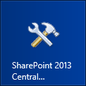
   3. Select **Manage Web Applications** underneath the **Application Management** section.
   4. Click the **New** button in the ribbon to display the **Create New Web Application** dialog.
   5. Locate the **IIS Web Site** section in the **Create New Web Application** dialog.
      1. Select the radio button option **Create a new IIS web site**.
      2. Configure the following properties for the new IIS Web Site.
         1. **Name**: SharePoint MySite Host – 80
         2. **Port**: 80
         3. **Host Header**: my.wingtip.com
   6. Scroll down to the Public URL section and edit the URL to remove the port number from the end so that the URL is **http://my.wingtip.com**.
   7. Scroll down to the **Application Pool** section in the **Create New Web Application** dialog.
      1. Select the radio button **Use existing application pool.**
      2. Select the application pool named **SharePoint - 80**.
   8. Scroll down to the **Database Name and Authentication** section in the **Create New Web Application** dialog.
      1. Configure the following properties for creating the content database for the new web application.
         1. **Database Server**: WingtipServer
         2. **Database Name:** WSS_Content_MySites.
   9. Leave all other settings with their default values and click OK to create the new web application.
   10. The process to create a web application will take a few moments. At the end of the process, SharePoint will display the **Application Created** dialog which will ask if you want to create a site collection. Click the **Create Site Collection** link provided to begin the process to create a new site collection and continue to the next step.
2. Create a My Site Host site collection:
   1. On the **Create Site Collection** page, use the following information to complete the form and click **OK**:
      1. **Title:** My Site Host
      2. **URL:** /
      3. **Template Selection:** My Site Host (*found in the* ***Enterprise*** *tab*)
      4. **Primary Site Collection Administrator:** WINGTIP\Administrator

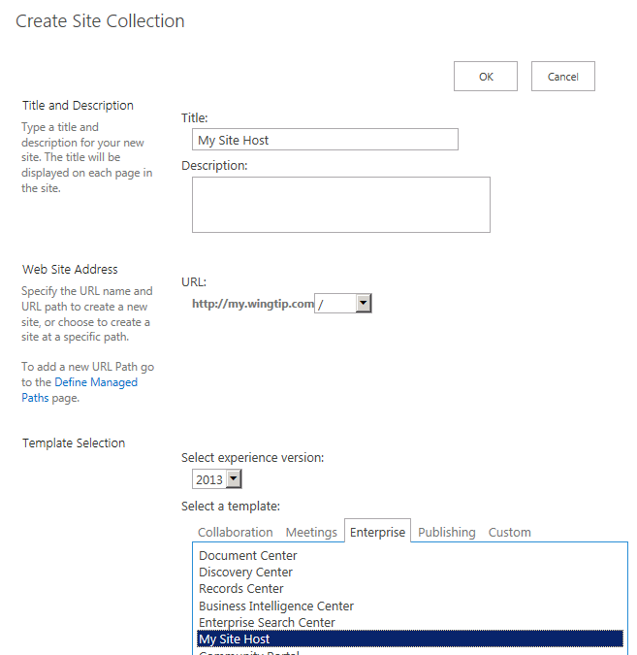

* 1. When the site has been created, SharePoint displays the **Top-level Site Successfully Created** dialog. There is a link to the new site collection but if you attempt to access it at this point it will produce an error. Click **OK** to close the dialog.

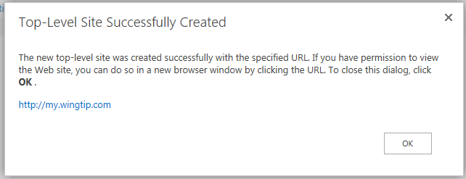

* 1. You should now see **SharePoint MySite Host – 80** in the list of web applications.

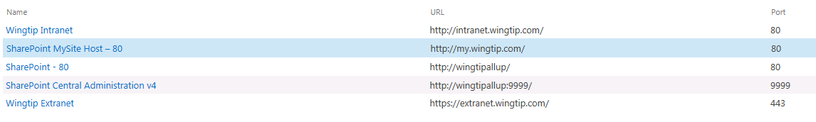

1. Update the Web Application to host my sites:
   1. On the Current Page (**Manage Web Applications**), select the **SharePoint MySite Host – 80** web application.  
      (Note: click anywhere on this line except the **SharePoint MySite Host – 80 link** as this will take you to the Manage Features screen automatically. That is, we just want to highlight this selection not click on the link for it).
   2. Click the **Managed Paths** button in the ribbon.
   3. Remove the **sites** managed path and add two new managed paths and click **OK**:
      1. **personal** – Wildcard inclusion
      2. **my** – Explicit inclusion

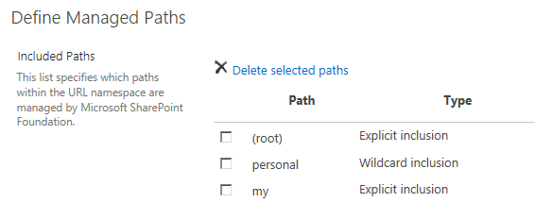

* 1. With the **SharePoint MySite Host – 80** web application still selected, click the **Self-Service Site Creation** button in the Ribbon Bar at the top of the screen.
     1. On the **Self-Service Site Creation Management** page, enable the option to create **Site Collections** by selecting the **On** option button, and then click the **OK** at the bottom of the page.

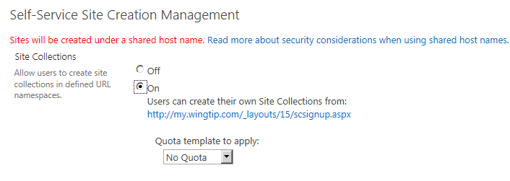

Next, you will create an instance of the User Profile Service Application and use the My Site host to configure it.

1. From the home page of Central Administration click the **Manage services on server** link (located under the **System Settings** area) to navigate to the page where you can start and stop services on the local server.
2. Find the service named **User Profile Service** and click the **Start** link to the right to start it up. After you click on the **Start** link, the service should show the status of **Started**.

Note: At this point in the lab you should not start the **User Profile Synchronization Service**. That is something you will do in later exercise in this lab after you have configured and tested the **User Profile Service** and the functionality of MySite.

1. From the home page of Central Administration click the **Manage service applications** link (located under the **Application Management** section) to navigate to the page where you can create a new service application instance.
2. In the **Service Applications** page select the drop-down menu beneath the **New** button and choose **User Profile Service Application**.

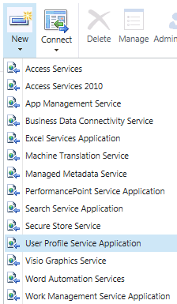

1. A dialog where you can create the new service application is displayed.
   1. Give it the name **User Profile Service Application**.
   2. Use the existing application pool **SharePoint Web Services Default**.

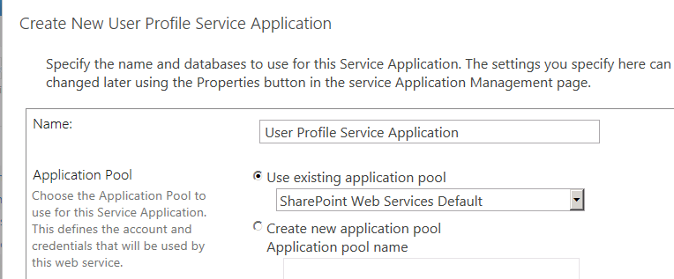

* 1. Scroll down to the **My Site Host URL** section add the URL of **http://my.wingtip.com**.

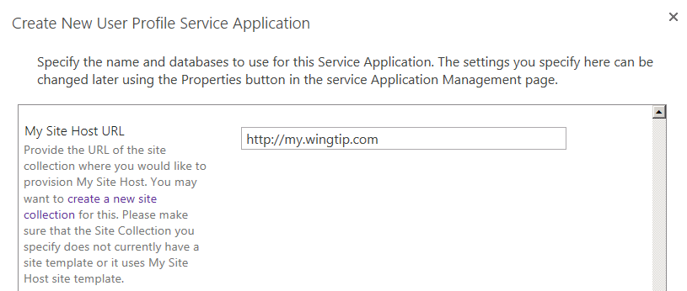

* 1. Leave all other settings with their default value and click **Create** to create the new service application.
  2. It will take several minutes to create the new service application. When it has been created, SharePoint displays a dialog with the message **Profile Service Application successfully created**. Click **OK** to close the dialog.
  3. At this point your SharePoint deployment is now configured to automatically create My Sites under **http://my.wingtip.com/Personal/UserName** when users first browse to them.
  4. Let’s test for the presence of the My Site links on some sites; Open <https://extranet.wingtip.com> and <http://intranet.wingtip.com> in Internet Explorer.
     1. Notice how the Title Bar at the top of the page is different; **Extranet** has three additional hyperlinks (**Newsfeed**, **SkyDrive**, and **Sites**) whereas **Intranet** is missing these. **Intranet** does not appear to be using the **User Profile Service**; let’s investigate why.  
        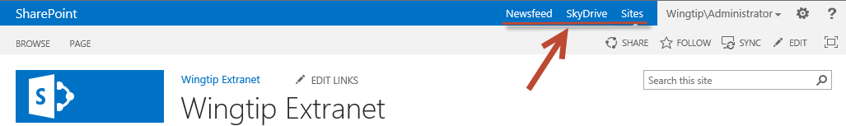

1. Configure the service application associations for the **Wingtip Intranet** web application to add the User Profile Service application.
   1. Using Central Administration navigate to **Application Management → Configure service application associations**
   2. Note how Wingtip Intranet is in a **custom** Application Proxy Group.
   3. Click on the Wingtip Intranet hyperlink on the Service Application Associations page  
      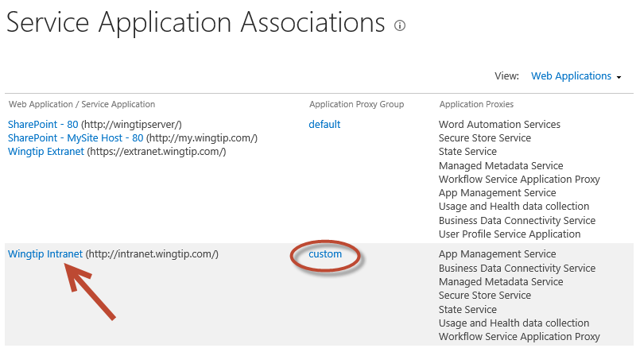
   4. In the **Configure Service Application Associations** dialog, check the **User Profile Service Application** and then click **OK** to save you changes.

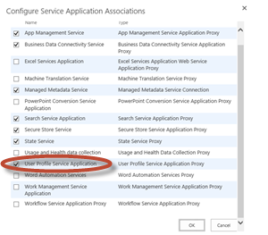

* 1. Refresh the [**http://intranet.wingtip.com**](http://intranet.wingtip.com) site in Internet Explorer. Notice how the three hyperlinks now appear in the Title Bar as shown below.  
     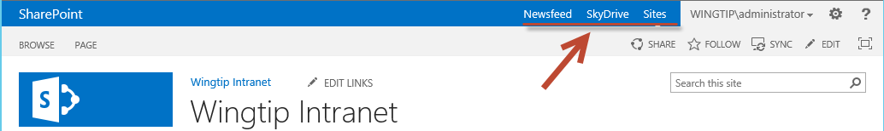
  2. At this point your SharePoint deployment is now configured to automatically create My Sites under **http://my.wingtip.com/Personal/UserName** when users first browse to them. The **Intranet** site is now configured to correctly use the User Profile Service

You have now created and properly configured the user profile service to manage user profiles and create MySites on demand.

### Exercise 2: Working with MySites

In this exercise you will create a MySite for the WINGTIP\Administrator account and navigate around the site to become more familiar with it.

1. Make sure you are logged on to the **WingtipServer** server as **WINGTIP\Administrator**.
2. In the browser, navigate to the team site at **http://intranet.wingtip.com**.
3. Once the page for the team site is displayed, look at the upper right portion of the page and locate the following links:
   1. Newsfeed
   2. SkyDrive
   3. Sites

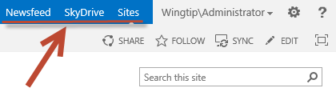

1. Click on the **Sites** link. The **Sites** link is designed to navigate users to their MySIte. However, in this case the MySite for the user **WINGTIP\Administrator** has not yet been created. SharePoint responds to this by creating the new MySite on demand. After a minute or two you should see the following screen. Click the **OK** button to continue.

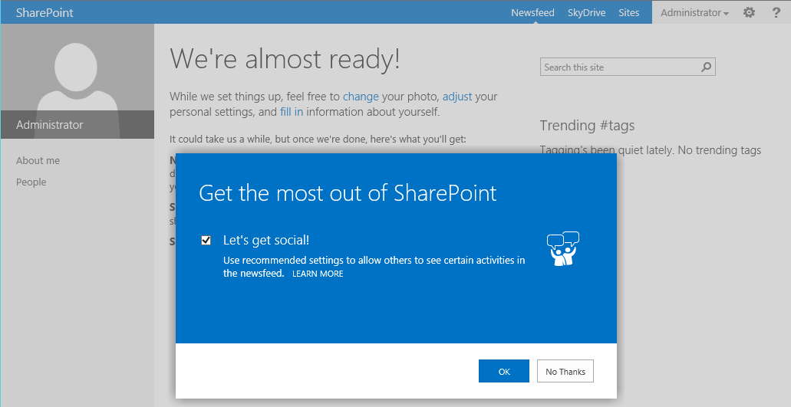

1. After the MySite has been fully provisioned you should see a page that looks like the following screenshot. 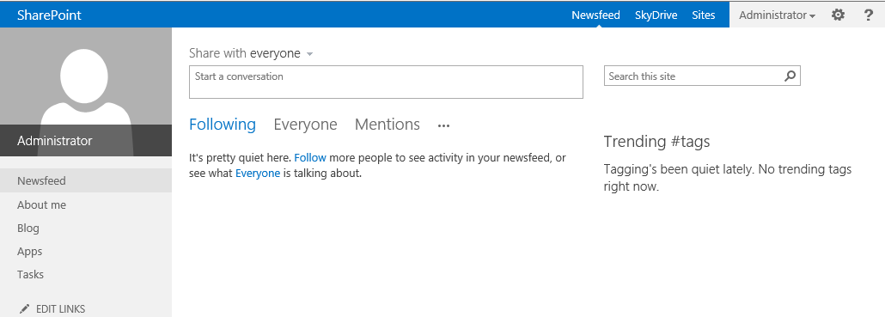
   1. Click the **About me** link in the Quick launch section of the page.
2. At this point you should be on About page for the current user. Click the **edit your profile** link.

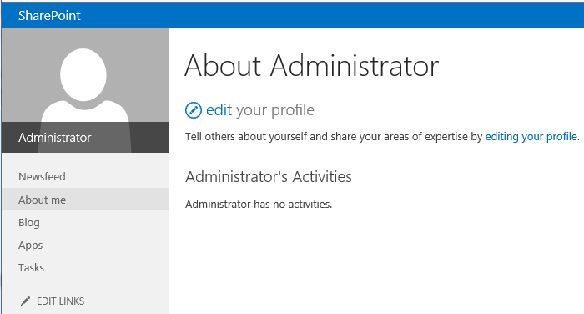

1. On the Edit Profile page, fill in the details with some creative information.  
   (Note: the folder for this lab has an image file named **Administrator.jpg** that you can use for a photo.)  
   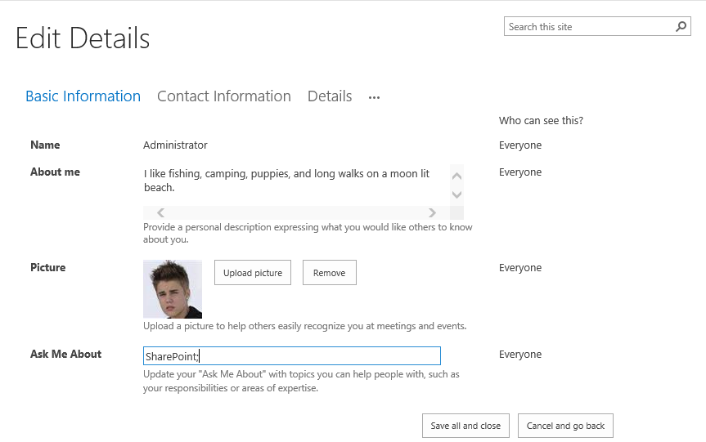
   1. When done editing the Administrator profile click the **Save all and close** button.
   2. Click the **OK** button on the **Profile Changes** dialog box notification that appears.  
      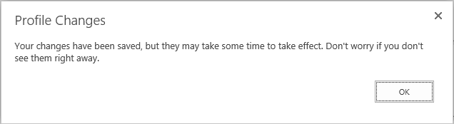
2. Feel free to take a little more time navigating around this MySite and getting to know what's there.

In this exercise you created a new MySIte and made a few customization changes to it.

### Exercise 3: Configuring the User Profile Synchronization Service

In this exercise you will setup the user profile synchronization service to connect to Active Directory and synchronize user account information into user profiles in the User Profile Service Application. One strange aspect of this configuration is that you are required to add the SP_Farm account to the local Administrators group during the configuration. Once the configuration has been completed, you can and should remove the SP_Farm account from the local Administrators group because you should abide by the principles of least privilege.

1. Add the **WINGTIP\SP_Farm** account to the local **Administrators** group on the **WingtipServer** VM.
   1. From the Windows start page (press the Windows key on the keyboard), launch the **Active Directory Users and Computers** utility by click the following tile.

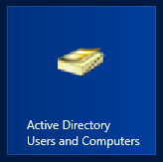

* 1. Under the **wingtip.com** node click on the **Builtin** folder.
  2. On the right hand side of the **Active Directory Users and Computers** dialog box, locate the group account for the **Administrators** and double click on it to display the **Administrator Properties** dialog.   
     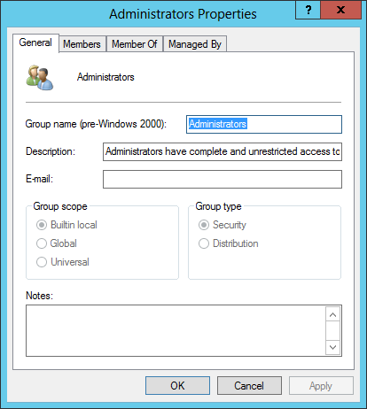
  3. Click on the **Members** tab at the top of the **Administrators Properties** dialog box.
  4. On the **Members** tab, click the **Add** button and add the account **WINGTIP\SP_Farm**. Click **OK** when you are done. The **Administartors Properties**, **Members** tab should now look like the screenshot below.  
     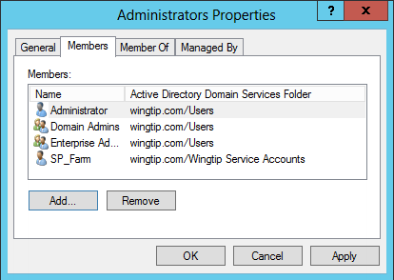
  5. Click **OK** on the **Administrators Properties** dialog box.

1. One additional task that we must accomplish is to configure the user account (WINGTIP\SP_UPS) to have **Replicating domain changes** permissions on the **wingtip.com** domain. This is a requirement because without this, you can’t import changes from SharePoint to Active Directory, or Active Directory to SharePoint.
   1. On the **Active Directory Users and Computers** screen Right Click on the **wingtip.com** domain and select **Delegate Control…** as shown below:  
      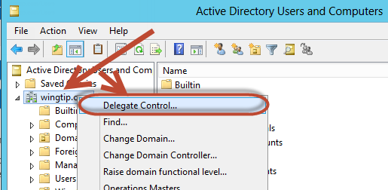
   2. In the **Delegation of Control Wizard** click **Next >** then click **Add...**
   3. On the **Select Users, Computers, or Groups** dialog box add the **WINGTIP\SP_UPS** account and click **OK** to return to the **Delegation of Control Wizard.** Then click **Next >**.
   4. On the **Tasks to Delegate** screen select **Create a custom task to delegate** and click **Next >**.  
      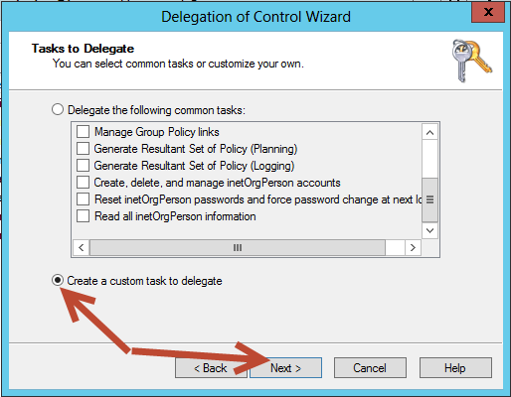
   5. On the **Active Directory Object Type** screen click **Next >.**
   6. On the **Permissions** screen select the **Replicating Directory Changes** Permission and Click **Next >** and then click **Finish**  
      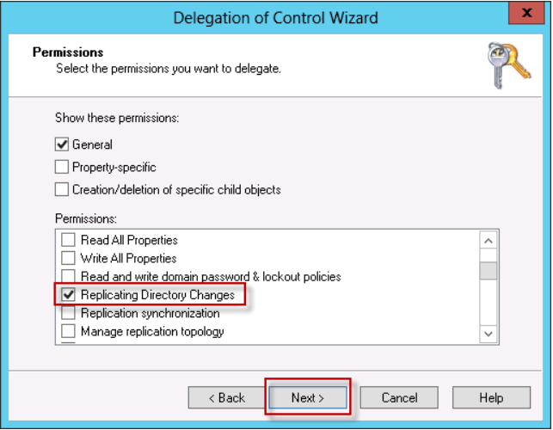
2. Now that we have configured the **WINGTIP\SP_Farm and WINGTIP\SP_UPS** accounts, reboot the **WingtipServer** server and wait for the server to restart.
   * 1. To reboot the server press the **Windows Key + i** to bring up the Settings screen.  
        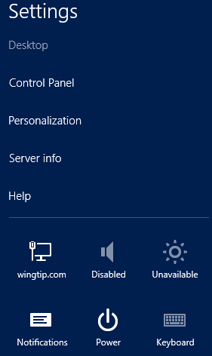
   1. On the **Settings** screen click on the **Power** option then select either **Update and restart** or **Restart** (depending on whether there are any pending updates on your system).
   2. Select **Other (Planned)** from the drop down box and click the **Continue** button.
   3. Once the server has rebooted, log back in as **WINGTIP\Administrator** with a password of **Password1**

Now that we have the User Profile Service turned on (from earlier in the labs), we need to configure the profile import from Active Directory.  
(Note: there are several ways to configure this: **Profile Synchronization** (Read/Write access to Active Directory), **Active Directory Import** (Read only access to Active Directory), or **External Identity Manager** (use some other service to provide user information). We will be using the Read/Write **Profile Synchronization** in this lab).

1. To configure the Active Directory Import:
   1. Using Central Administration navigate to **System Settings** **→ Manage services on server**
   2. Scroll down to the **User Profile Synchronization Service** and click on **Start**
   3. Using the **Wingtip\SP_Farm** account enter the **Password / Confirm Password:** Password1 and click **OK**(Note: the Synchronization Service will appear as **Starting** for 5-10 minutes, we don’t need to wait for this however)
   4. Using Central Administration navigate to **Application Management** **→ Manage service applications → User Profile Service Application (Click on this hyperlink as shown in the image below):**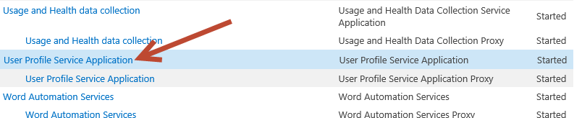
   5. On the Manage Profile Service page, select the **Configure Synchronization Connections** hyperlink and then click **Create New Connection** on the **Synchronization Connections** screen
   6. On the **Add new synchronization connection** screen, establish a connection to the Active Directory domain named **wingtip.com** by entering the followingvalues on this form and click **OK**:
   7. **Connection Name**: Wingtip AD Users
   8. **Type**: Active Directory
   9. **Connection Settings**:
      1. **Forest Name**: wingtip.com
      2. **Authentication Provider Type**: Windows Authentication
      3. **Account Name**: WINGTIP\SP_UPS
      4. **Password** (and **Confirm Password**): Password1

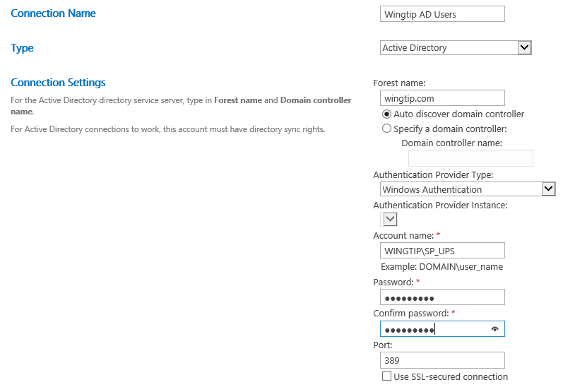

* 1. **Containers**:
     1. Click **Populate Containers**.
     2. After it loads, expand the **WINGTIP** node and select the Organizational Unit named **Wingtip Users**.  
        (Note: place a check in the **Wingtip Users** checkbox as shown below)

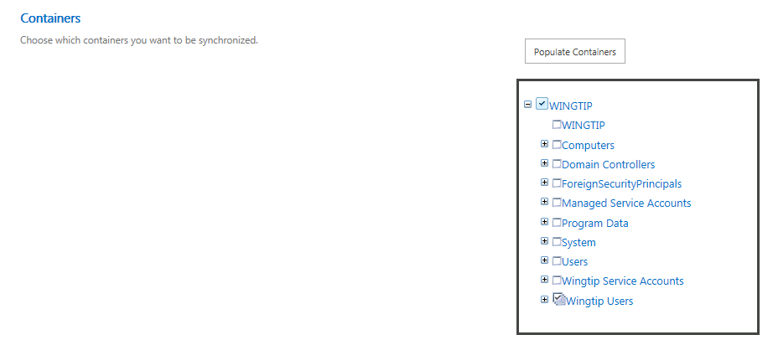

* 1. Click **OK** to save the connection. You should see the connection has been successfully created.

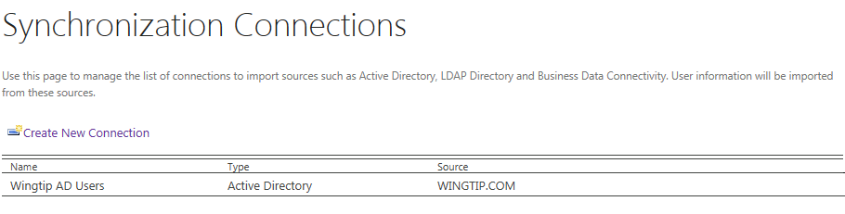

1. Now that we have the User Profile Service configured to use Active Directory, we need to start the synchronization:
   1. Navigate back to the **Manage Profile Service: User Profile Service Application** page (**Central Administration → Application Management → Manage Service Applications** → **User Profile Service Application**)
   2. Select **Start Profile Synchronization** (located under the **Synchronization** section)
   3. On the **Start Profile Synchronization** page select **Start Full Synchronization** and click the **OK** button.  
      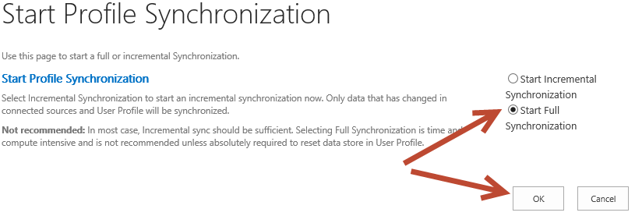
   4. You will be taken back to the UPA management page. Notice in the top-right corner there is a status block that reports how many profiles are in the UPA database. Refresh the page to see it increase to a handful of profiles as the import process runs.  
      (Note: there should be 15 User Profiles total).  
      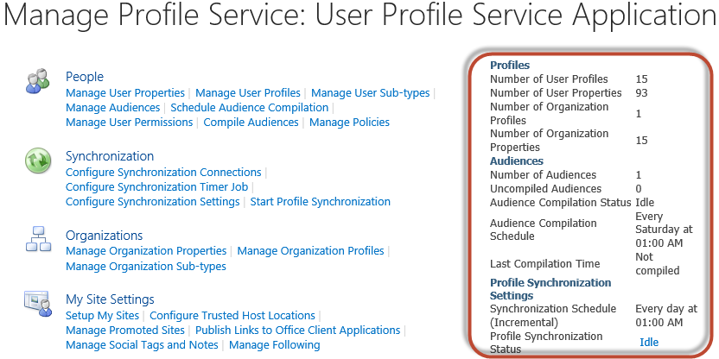
2. Following the principle of Least Privilege we can now remove the **WINGTIP\SP_Farm** account from the local **Administrators** group on the **WingtipServer** VM.
   1. From the Windows start page (press the Windows key on the keyboard), launch the **Active Directory Users and Computers** utility by click the following tile.



* 1. Under the **wingtip.com** node click on the **Builtin** folder.
  2. On the right hand side of the **Active Directory Users and Computers** dialog box, locate the group account for the **Administrators** and double click on it to display the **Administrator Properties** dialog.   
     
  3. Click on the **Members** tab at the top of the **Administrators Properties** dialog box.
  4. On the **Members** tab, select the **WINGTIP\SP_Farm** account and click the **Remove** button to remove the account. Click **Yes** in the **Active Directory Domain Services** dialog box. Click **OK** on the **Administrator Properties** dialog box when you are done. The **Administrators Properties**, **Members** tab should now look like the screenshot below.  
     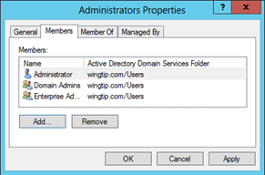
  5. After removing the **WINGTIP\SP_Farm** account to the local **Administrators** group, reboot the **WingtipServer** server and wait for the server to restart.
     1. To reboot the server press the **Windows Key + i** to bring up the Settings screen.  
        
  6. On the **Settings** screen click on the **Power** option then select either **Update and restart** or **Restart** (depending on whether there are any pending updates on your system).
  7. Select **Other (Planned)** from the drop down box and click the **Continue** button.
  8. Once the server has rebooted, log back in as **WINGTIP\Administrator** with a password of **Password1**

At this point you have successfully configured the UPA to import profiles from the local AD.

(Note: After you start the User Profile synchronization service, for day to day operations, the farm account is not required to be a member of the Administrators group on the computer that is running the synchronization service. To improve the security of your SharePoint Server installation we removed the farm account from the Administrators group on the computer that is running the synchronization service. However, when you perform a backup of the User Profile application, the synchronization service provisions the User Profile application again. During the course of provisioning the User Profile application, the farm account must stop and start the synchronization service. To do this, the farm account must be a member of the Administrators group on the computer that is running the synchronization service. So, before you perform a backup, add the farm account to the Administrators group on the computer that is running the synchronization service. After the backup has finished running, you can remove the farm account from the Administrators group.)