## Configuring Web Applications

**Lab Time**: 45 minutes

**Lab Folder**: C:\Student\Modules\WebApplications\Lab

**Lab Overview**: In this lab you begin by configuring a few commonly-used web application settings. Next, you will create a new site collection in a path-based web application using Central Administration. After you will create several more site collections as host header site collections with top-level domain names such as **sales.wingtip.com** and **blog.wingtip.com.** Along the way you will be required to modify DNS settings and to create a wildcard SSL certificate for testing purposes to get all the site collections up and running.

### Exercise 1: Configuring General Web Application Settings

In this exercise you will configure commonly-used settings for a web application. This will give you a chance to work with common web application configuration options such as list throttling, managed paths and service connections,

1. Ensure you are logged onto the **WingtipServer** server as **WINGTIP\Administrator**.
2. Navigate to **Central Administration**.
3. Once you get to the home page of Central Administration, click on the **Manage Web Applications** link to navigate to the administration page which shows the list of web applications in the local farm. You should see that the farm currently contains four web applications.

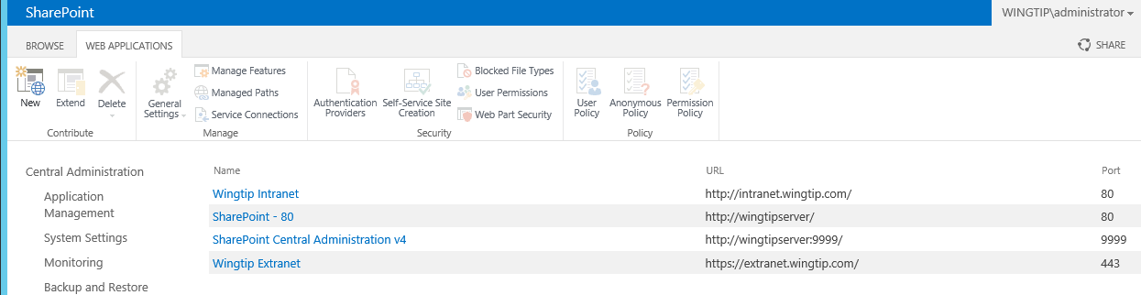

1. Select the web application with the name **SharePoint - 80** which has an URL of **http://WingtipServer**. Drop down the **General Settings** menu and select the first menu command titled **General Settings**.

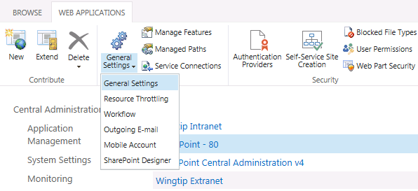

1. In the **Web Application General Settings** dialog, assign a time zone of **Eastern Time** or choose a different value for the time zone in which you are located. After you have set the time zone, scroll down to the bottom to see what other web application settings are available in this dialog. When you are done, click the **OK** button to save your change to the **Default Time Zone** setting and return to the **Web Application Management** page.

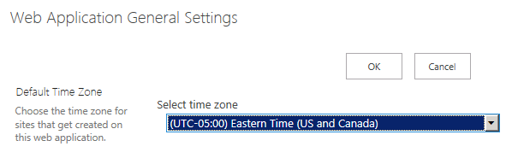

1. With the **Wingtip Intranet** web application selected on the **Web Application Management** page, drop down the **General Settings** menu and select the menu item titled **Resource Throttling**.

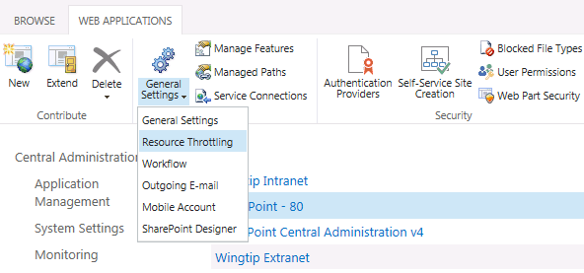

1. When the **Resource Throttling** dialog appears, change the setting for the **List View Threshold** from the default value of **5000** to a new value of **7500**. Once you have changed this setting, scroll down to the bottom to see what other configuration options are available in this dialog. When you are done, click the **OK** button to save your configuration change and return the Web Application Management page.
2. With the **Wingtip Intranet** web application selected on the Web Application Management page, click on the **Service Connections** button in the ribbon to display the **Configure Service Application Associations** dialog.

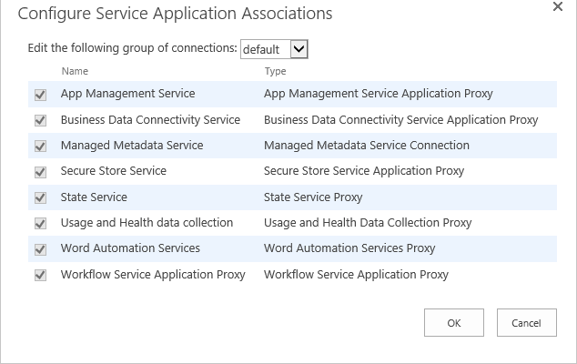

1. Use the drop down menu to change the group from **default** to **[custom]**. This change makes it possible to select the service application associations for this web application on an individual basis. Select the service application associations for this web application based on what is shown in the following screenshot. Once you have select the service application associations, click the **OK** button to save your changes and return to the **Web Application Management** page.

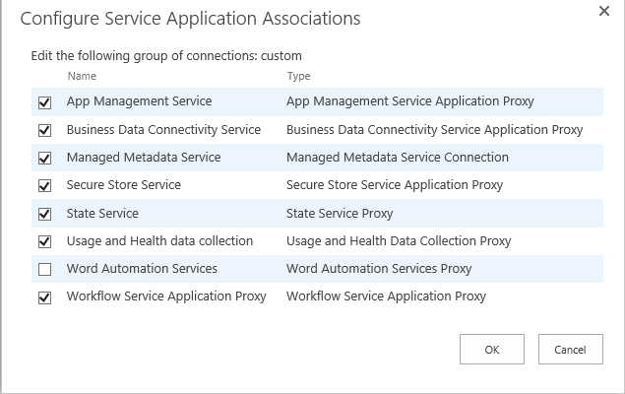

With the **SharePoint - 80** web application selected on the Web Application Management page, click on the **Managed Paths** button in the ribbon to display the **Define Managed Paths** dialog. Note that the web application should have two managed paths. You should observe that there is a managed path which is an **Explicit inclusion** at the **(root)** level and there is a second which is a **Wildcard inclusion** based on a path of **sites**. 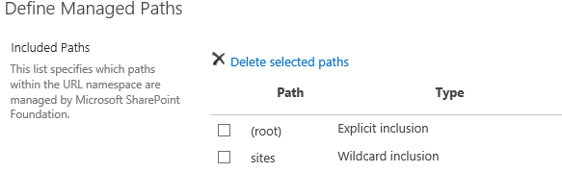

1. Add a new **Explicit inclusion** managed path based on a path of **search**. Do this by typing **search** into the **Path** textbox, selecting **Explicit Inclusion** from the **Type** drop-down menu, and clicking the **Add Path** button.

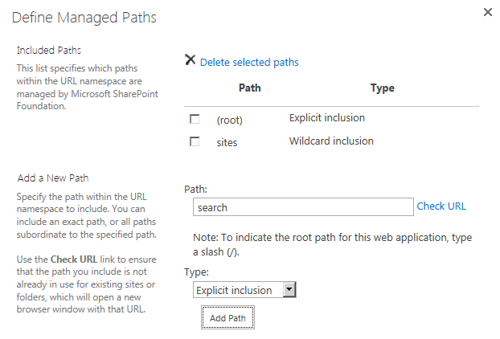

1. After you have added the new managed path, you should be able to see it listed as shown in the following screenshot. Note that you will not be using the search managed path in this lab. Instead, you will use it in a later lab which focuses on the search capabilities of SharePoint 2013.

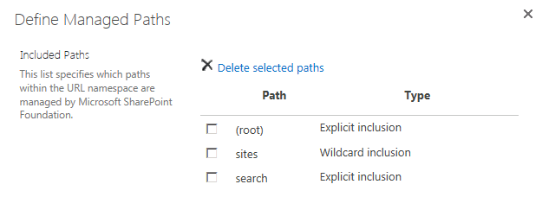

1. When you are done, click the **OK** button to return to the **Web Application Management** page.

In this lab you configured several web application settings and created a managed path that will be used in a later lab.

### Exercise 2: Creating a Site Collection using Central Administration

Now it's time to create a new site collection. In this exercise you will create the first site collection using Central Administration. In the following exercise you will create several additional host header site collections which cannot be created using Central Administration but instead must be created using PowerShell.

1. Navigate to **Central Administration**.
2. Click the **Create site collections** link.
3. On the **Create Site Collection** page, make sure that the **Web Application** drop down menu shows the web application at the URL of **http://intranet.wingtip.com**. Select this web application if it is not already selected.

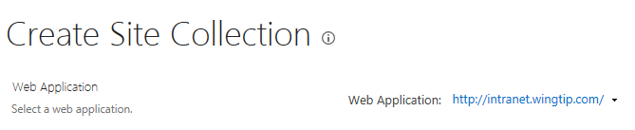

1. Fill in the form to create a new site collection.

Add a title of **Wingtip Operations**.

Add an **URL** using the **sites** managed path with an URL of **http://intranet.wingtip.com/sites/operations**.

Select an **experience version** of 2013.

Select **Team Site** as the **template** that will be used to create the top-level site.

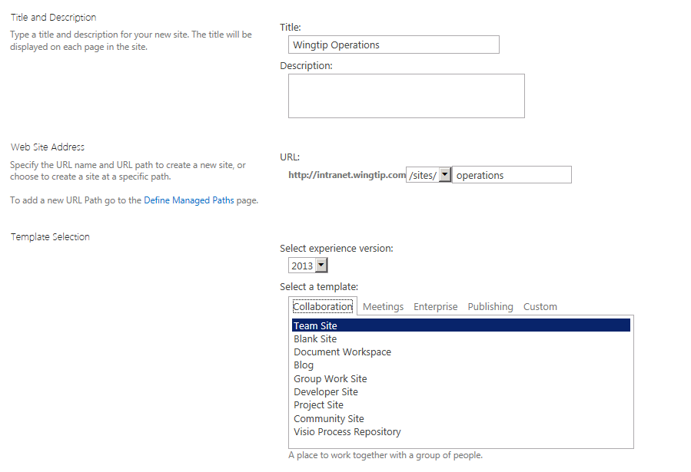

Assign the user **John Holiday (WINGTIP\JohnH)** as the **Primary Site Collection Administrator**.

Assign the user **WINGTIP\Administrator** as the **Secondary Site Collection Administrator**.

Leave the **Quota Template** setting with its default value of **No Quota**.

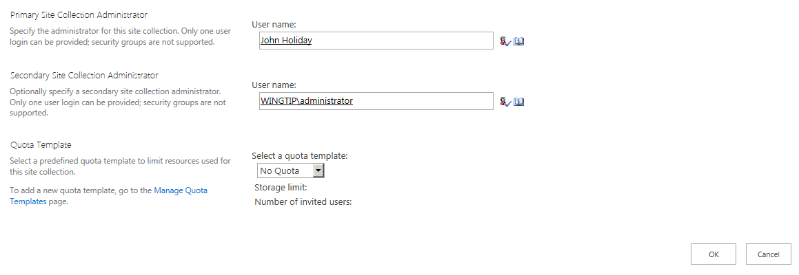

Click the **OK** button to begin the process of creating the new site collection.

1. It will probably take the SharePoint host environment a few minutes to create the site collection. Once the SharePoint host environment has been created the site collection it will display a page that confirms it has successfully created a top-level site. This page will display a link that will make it possible for you to navigate to the new site collection.

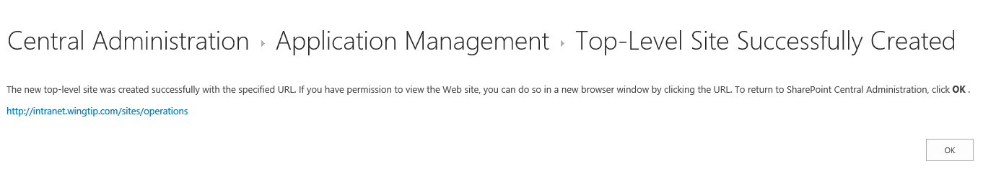

1. Click the link to navigate to the new top-level site at **http://intranet.wingtip.com/sites/operations**.
2. Once the site has been initialized, it should display a page that looks like the following screenshot.

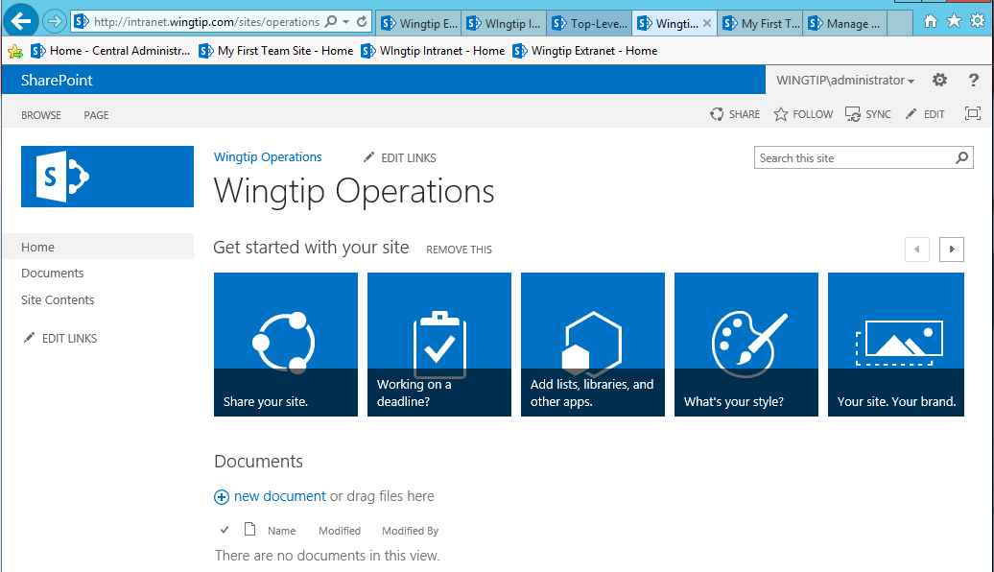

1. You have now completed this exercise.

In this exercise you create a new site collection within a path-based site collection.

### Exercise 3: Creating Host Named Site Collections

In this exercise you will create two new host named site collections. The first one you will create will be at **sales.wingtip.com**. Next, you will create a second host named site collection at **blog.wingtip.com**.

1. Create a new DNS A record based on the wildcard path of **\*.wingtip.com**.
   1. Start **DNS Manager** by press the **Windows** key to display the windows **Start** page and then clicking the **DNS** tile.
   2. In the DNS Manager, navigate down the hierarchy of node to **DNS » WingtipServer » Forward Lookup Zones » wingtip.com**.

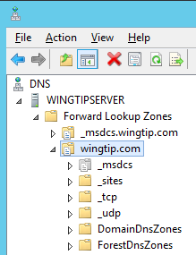

* 1. Right-click on the **wingtip.com** node and click the **New Host (A or AAAA)** menu command.
  2. In the New Host dialog enter a **Name** of **\*** and an **IP address** of **192.168.150.1**. When you are done, click the **Add Host** button to create the new A Record.

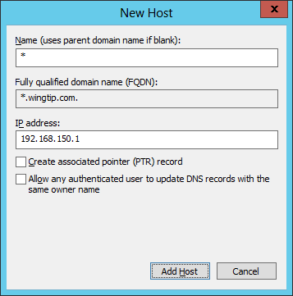

* 1. You should be able to verify that there is a new DNS A record for **\***.

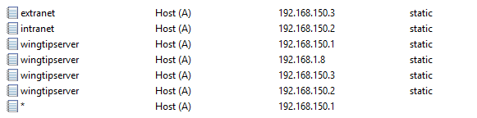

* 1. Now it is time to test your work. Bring up a standard DOS command prompt. Run the **ipconfig** command and pass the **/flushdns** parameter to get rid of any cached DNS entries.

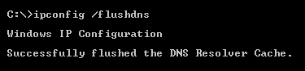

Ensure you can successfully ping the domain **sales.wingtip.com** and see a reply from **192.168.150.1**.

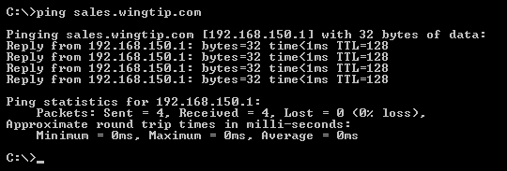

* 1. Ensure you can successfully ping the domain **blog.wingtip.com** and see a reply from **192.168.150.1**.

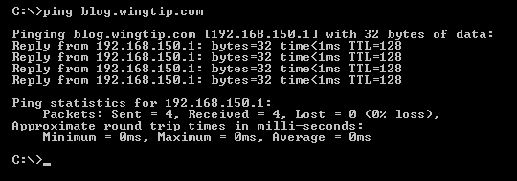

* 1. You have now successfully configured DNS.

Now that you have created the required DNS entry, you can now create host header site collections that use it.

Note that you will not create the site at **http://blog.wingtip.com** until the next lab. In this lab you will create a site at **http://sales.wingtip.com**.

1. Create a host header site collection at **http://sales.wingtip.com**.
   1. Create a PowerShell script named **CreateWingtipSalesSite.ps1**.
   2. Save this new script in the folder for this lab at **C:\Student\Modules\WebApplications\Lab**.
   3. Add code to **CreateWingtipSalesSite.ps1** to load the SharePoint PowerShell snap-in

Add-PSSnapin Microsoft.SharePoint.PowerShell

Next, create a variable named **$webapp** and initialize it by calling **Get-SPWebApplication** and obtaining a reference to the web application at a base URL of **http://WingtipServer**.

$webapp = Get-SPWebApplication -Identity "http://WingtipServer"

Create a set of variables to hold the data required to create a new site collection using the following code listing. Note that the site collection administrator should be assigned with the Active Directory user named **Andrew Connell** which has a login name of **WINGTIP\AC**. Also assign the **WINGTIP\Administrator** account as the secondary site collection administrator. Also use a site template of **STS#0** which is used to create a new Team Site

$siteUrl = "http://sales.wingtip.com/"

$siteTitle = "Wingtip Sales Site"

$siteAdmin1 = "Wingtip\AC"

$siteAdmin2 = "Wingtip\Administrator"

$siteTemplate = "STS#0"

Add the PowerShell cmdlet named **New-SPSite** to create the new host header site collection. Make sure you use the parameter named **–HostHeaderWebApplication** and pass the web application referenced by the **$webapp** variable as shown in the following listing. Also keep in mind that the following listing uses line breaks in the parameter list passed to **New-SPSite** to make the code readable. However, you cannot use line breaks when you add parameters to a cmdlet such as **New-SPSite** in an actual PowerShell script.

$site = New-SPSite -HostHeaderWebApplication $webapp -Url $siteUrl -Name $siteTitle  
 -OwnerAlias $siteAdmin1 -SecondaryOwnerAlias $siteAdmin2 -Template $siteTemplate

Once you have created the PowerShell script, save it,

Execute the script named **CreateWingtipSalesSite.ps1** to create the new site collection at **http://sales.wingtip.com**.

* 1. Once the site collection has been created, test your work by navigating to the site at **http://sales.wingtip.com** in the browser and making sure that the SharePoint host environment is able to properly display the home page of the new site.

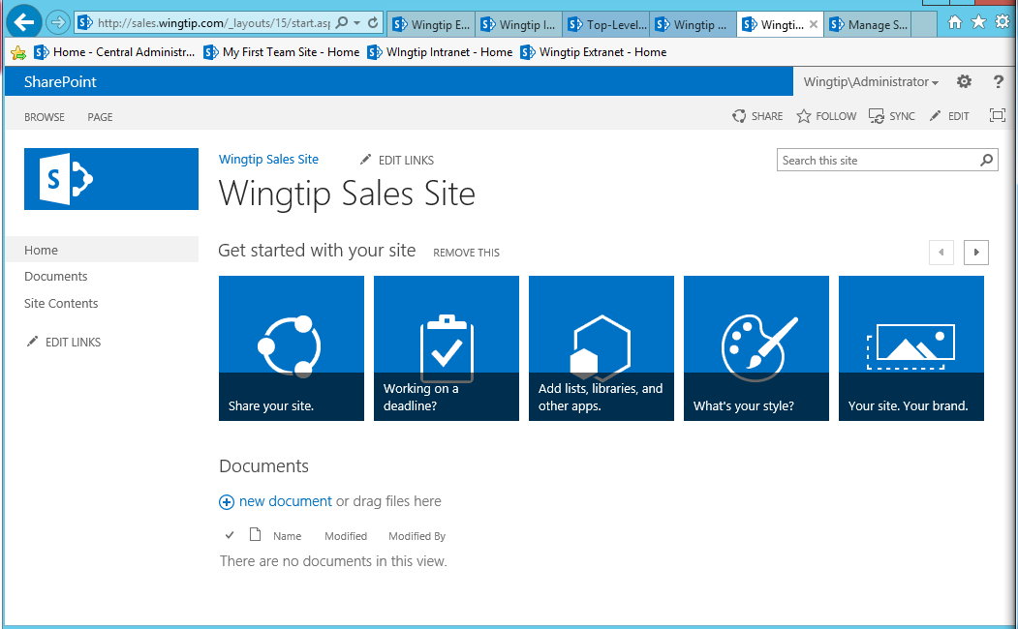

* 1. You have now created your first host header site collection.

In this exercise, you created a host header site collection using the top-level domain name of sales.wingtip.com.

### Exercise 4: Creating Host Named Site Collections using a Wildcard SSL Certificate

In this exercise you will create and install a test SSL certificate based on the wildcard path of **\*.wingtip.com**. You will then bind this SSL certificate to the IIS Web site associated with the **SharePoint – 80** web application. This will make it possible to create several site collections with top-level DNS names within this web application that are accessible through SSL.

1. Create a test SSL certificate based on the wildcard path of **\*.wingtip.com**.
   1. Launch the **IIS Manager** by pressing the **Windows** key to display the Widows **Start** page and clicking the tile with the caption **Internet Information services (IIS)**.



* 1. In the IIS Manager, select the top node for the computer named **WINGTIPSERVER**. Once you have selected the **WINGTIPSERVER** node, look in the middle of the screen and find and double click on the **Server Certificates** icon.

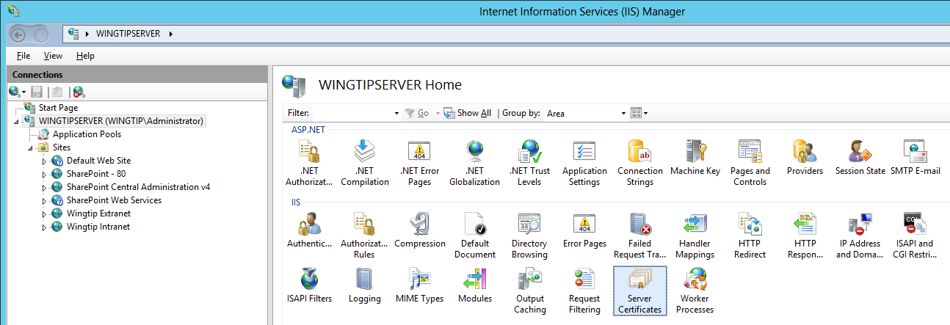

* 1. Currently, there should be a certificate issued to **extranet.wingtip.com** that you installed in an earlier lab exercise.

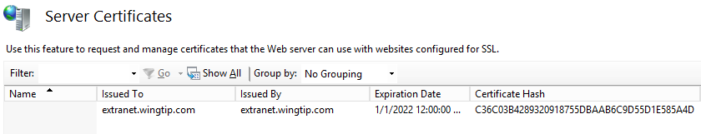

* 1. Using the Windows Explorer, locate the student lab folder at **c:\Student\Modules\WebApplications\Lab**. You should see inside this folder that there is a Windows PowerShell script named **CreateWildcardSSLCert.ps1**. Open up this script and examine the PowerShell code inside.
  2. Execute the PowerShell script named **CreateWildcardSSLCert.ps1**. When you execute the script, you should see the following output.

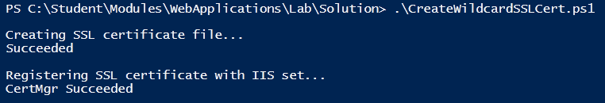

* 1. Return to the IIS Manager and refresh the page which shows the SSL certificates. You should be able to verify that the test SSL certificate for extranet.wingtip.com has been added.

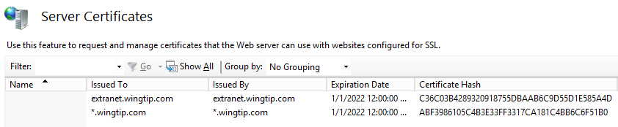

You have now installed the wildcard SSL test certificate and installed it into IIS.

1. Configure the IIS Web site bindings for the **SharePoint – 80** web application.
   1. Go to the IIS Manager and select the IIS Web site named **SharePoint - 80**.
   2. On the right hand side of the screen in the **Actions** section, select the **Bindings** link to view the bindings for this IIS Web site. There should be one existing binding which is currently configured to accept incoming requests from any IP address.
   3. Add a second binding for SSL. Click the **New** button on the **Site Bindings** dialog to add a second binding. When the **Add Site Binding** dialog appears, fill in the information as shown in the following screenshot and then click **OK**.

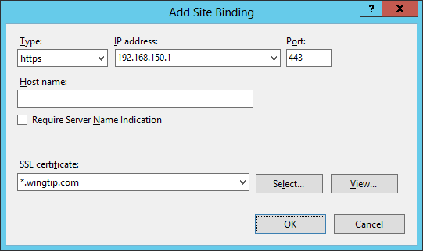

* 1. After you have added the second binding, the **Site Bindings** dialog should appear as it does in the following screenshot.

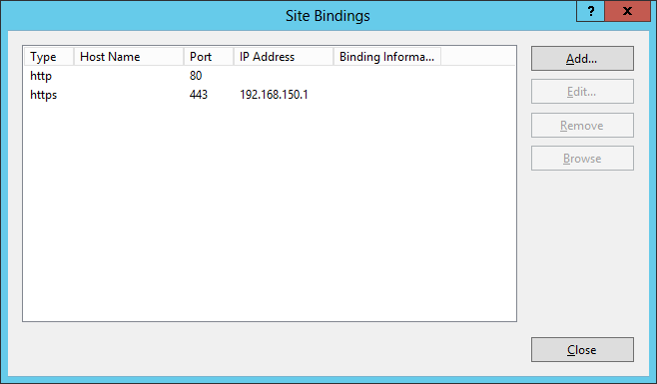

* 1. You have now finished configuring the bindings for the **SharePoint – 80** web application.

Now that you have configured the proper SSL settings, you can now create host header site collections that use SSL.

1. Using **Windows PowerShell ISE** create a host header site collection at **https://research.wingtip.com**.
   1. Create a PowerShell script named **CreateWingtipResearchSite.ps1**.
   2. Save this new script in the folder for this lab at **C:\Student\Modules\WebApplications\Lab**.
   3. Add code to **CreateWingtipResearchSite.ps1** to load the SharePoint PowerShell snap-in

Add-PSSnapin Microsoft.SharePoint.PowerShell

* 1. Next, create a variable named **$webapp** and initialize it by calling **Get-SPWebApplication** and obtaining a reference to the web application at a base URL of **http://WingtipServer**.

$webapp = Get-SPWebApplication -Identity "http://WingtipServer"

* 1. Create a set of variables to hold the data required to create a new site collection using the following code listing. Note that the site collection administrator should be assigned with the Active Directory user named **David Mann** which has a login name of **WINGTIP\DavidM**. Assign the **WINGTIP\Administrator** account as the secondary site collection administrator. Also use a site template of **STS#1** which is used to create a new **Blank Site**.

$siteUrl = "https://research.wingtip.com/"

$siteTitle = "Wingtip Researh and Development"

$siteAdmin1 = "Wingtip\DavidM"

$siteAdmin2 = "Wingtip\Administrator"

$siteTemplate = "STS#1"

* 1. Add the PowerShell cmdlet named **New-SPSite** to create the new host header site collection. Make sure you use the parameter named **–HostHeaderWebApplication** and pass the web application referenced by the **$webapp** variable as shown in the following listing. Also keep in mind that the following listing uses line breaks in the parameter list passed to **New-SPSite** to make the code readable. However, you cannot use line breaks when you add parameters to a cmdlet such as **New-SPSite** in an actual PowerShell script.

$site = New-SPSite -HostHeaderWebApplication $webapp -Url $siteUrl -Name $siteTitle  
 -OwnerAlias $siteAdmin1 -SecondaryOwnerAlias $siteAdmin2 -Template $siteTemplate

* 1. Once you have created the PowerShell script, save it,
  2. Execute the script named **CreateWingtipReseachSite.ps1** to create the new site collection at **https://research.wingtip.com**.

When you execute the script, you will get the following warning: " WARNING: The port specified for the new host header site does not match any known bindings in the specified Web Application. The new site will not be accessible if the Web Application is not extended to an IIS Web Site serving this port." This is a warning that you can ignore in this scenario.

* 1. Once the site collection has been created, test your work by navigating to the site at **https://research.wingtip.com** in the browser and making sure that the SharePoint host environment is able to properly display the home page of the new site.

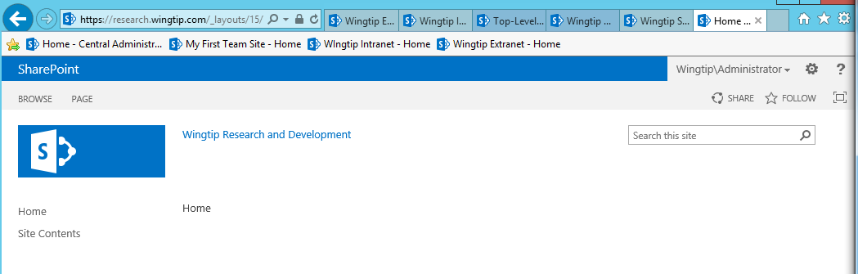

* 1. You have now created a host named site collection which used SSL.

You have now completed this lab in which you created several new host named site collections including one that uses SSL.