## **Configuring Workflow in SharePoint 2013**

**Lab Time**: 45 minutes

**Lab Folder**: C:\Student\Modules\Workflow\Lab

**Lab Overview**: In this lab you begin install and configure Workflow Manager 1.0 in order to configure the new workflow environment for SharePoint 2013. At the end you will use the SharePoint Designer 2013 to ensure that your work configuration has been set up correctly.

### Exercise 1: Install & Configure Workflow Manager 1.0

1. Ensure you are logged into the **WingtipServer** VM using the account **wingtip\administrator | Password1**.
2. Verify that SQL Server 2012 TCP/IP has the TCP/IP connection protocol enabled to support Workflow Manager 1.0.
   1. Press the **Windows key** on the keyboard.
   2. Open the **SQL Server Configuration Manager**.

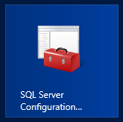

* 1. Expand the hierarchy on the left-hand side. Navigate from **SQL Server Connection Manager (local)** to **SQL Server Network Configuration** to **Protocols for MSSQLSERVER**.

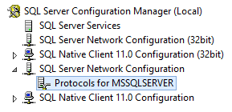

* 1. In the main window, if **TCP/IP** is **Disabled**, right-click **TCP/IP** and select **Enable**.

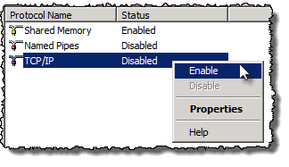

* 1. When prompted with a warning, click **OK**.
  2. Close **SQL Server Configuration Manager**

1. If you just **Enabled** the **TCP/IP** Protocol, then SQL Server must be restarted in order to reflect this change; if not skip to step 4
   1. In the hierarchy on the left-hand side of the window, select **SQL Server Services**.
   2. Right-click **SQL Server (MSSQLSERVER)** and select **Restart**.

At this point SQL Server is now configured with the TCP/IP protocol enabled, a requirement when configuring Service Bus. The next step is to configure the Workflow Service Account (SP_Workflow) with the necessary rights

1. Grant the **WINGTIP\SP_Workflow** account **securityadmin** & **dbcreator** permissions in SQL Server:
   1. Launch **SQL Server Management Studio**
      1. Press the **Windows** keyboard **key**.
      2. Open the **SQL Server Management Studio**.
   2. When SQL Server Management Studio launches, within the **Connect to Server** dialog, login using the default settings and click **Connect**.
   3. In the **Object Explorer** tool window, expand the **WINGTIPSERVER** server hierarchy to the **Security 🡪 Logins** node.

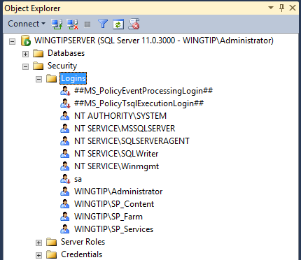

* 1. At this point, you should see that the account **WINGTIP\SP_Workflow** account has not been added as a login.
  2. Right-click on the **Logins** node and select the **New Login…** command.

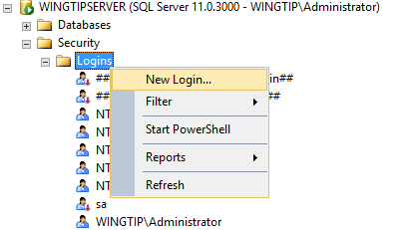

* 1. On the **General** page of the **Login -New** dialog, enter an account name of **WINGTIP\SP_Workflow**.

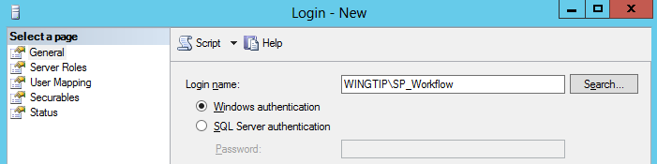

* 1. On the left hand side of the screen in the **Select a page** pane and select **Server Roles**. Check **securityadmin** & **dbcreator.**

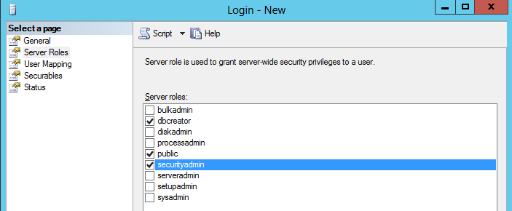

* 1. Click **OK**: to close the **Login - New** save your changes to the SQL Server new login.

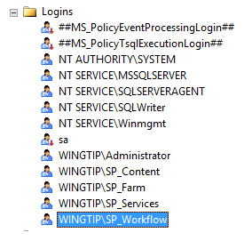

* 1. Close **SQL Server Management Studio**.

1. Add the **WINGTIP\SP_Workflow** account service account to the local Administrators group
   1. Open the **Active Directory Users and Computers** administrative tool from the Windows **Start** page (i.e. press the **Windows** **Key** then select the **Active Directory Users and Computers** tile):
   2. Expand the tree view to **Active Directory Users and Computers** 🡪 **wingtip.com** 🡪 **Builtin.** Locate and select the **Administrators** group.

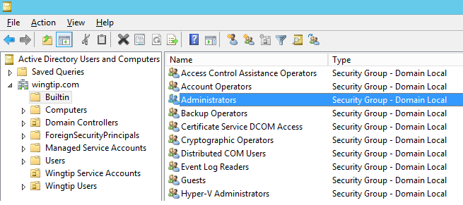

* 1. Right-click **Administrators** group and select **Properties**.
  2. In the **Administrators Properties** dialog, select the **Members** tab and click **Add…**.
  3. In the **Enter the object names to select** box, enter **WINGTIP\SP_Workflow** and click the **Check Names** button.

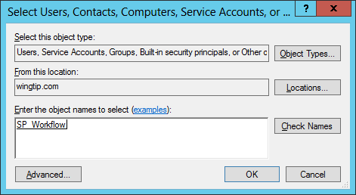

* 1. Click **OK** to dismiss the dialog and verify that the **SP_Workflow** account has been added to the **Administrators** group.

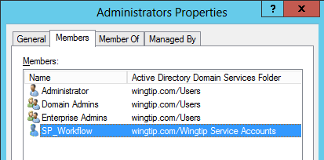

* 1. Click **OK** to close the **Administrators Properties** dialog.
  2. Close the **Active Directory Users and Computers** window.

At this point, you have configured the service account that will host Workflow Manager. Now it is time to download and install the Workflow Manager and Service Bus. One thing that is a bit strange is that you must log off of the WingtipServer VM and then log back using the WINGTIP\SP_Workflow account before you begin the installation and initial configuration of the Workflow Manager using the Web Platform Installer. Note that the **WingtipServer** VM must have an active Internet connection to complete this exercise.

1. Log off the VM and log back on using the account **WINGTIP\SP_Workflow** and a password of **Password1**.
   1. Press the **Windows Key** to go to the Start menu
   2. Click on your **login name** (in the upper right corner [Administrator] to surface the Sign out option
   3. Click on **Sign out**
   4. Log back on as SP_Workflow
2. Open the Windows Explorer and navigate to the folder for the lab at **C:\Student\Modules\Workflow\Lab**. You should be able to see a file named **wpilauncher.exe**.
3. Right-click on **wpilauncher.exe** and select the command Run as administrator to launch the **Platform Installer**.

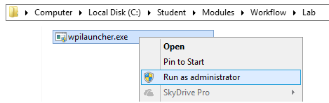

1. If you are prompted with a **User Access Control** dialog, click **Yes** to continue.
2. At this point, the Web Platform Installer should be initializing.

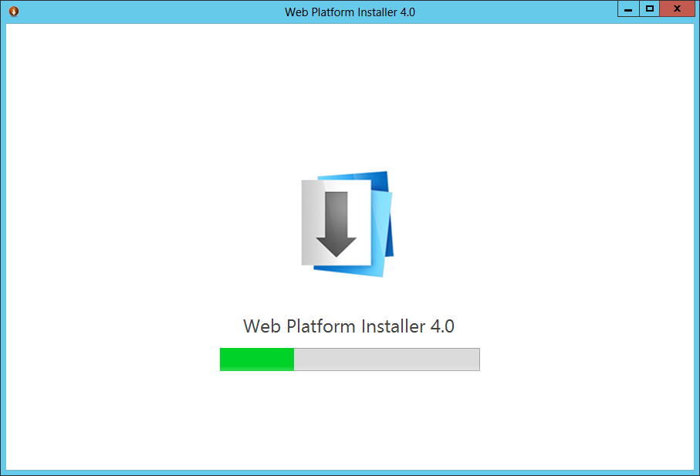

1. After the **Web Platform Installer** loads, locate the search box at the top right of the dialog box. Execute a search by typing "workflow" into the search box and then pressing the ENTER key.

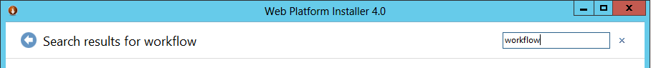

1. After running the search, you should be able to see **Workflow Manger 1.0. Select Workflow Manger 1.0** and click **Add**.

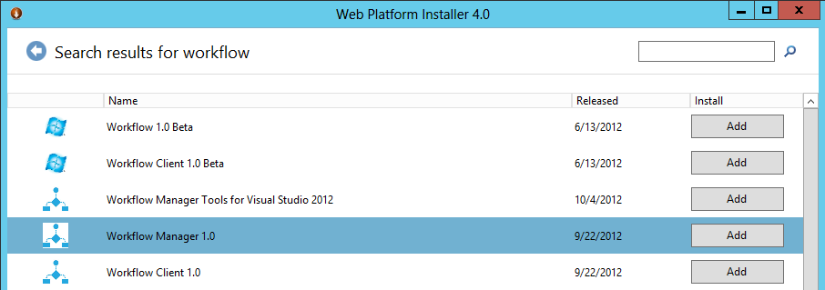

1. Click the **Install** button at the bottom of the **Web Platform Installer 4.0** window.
2. On the **Prerequisites** page, click **I Accept**.

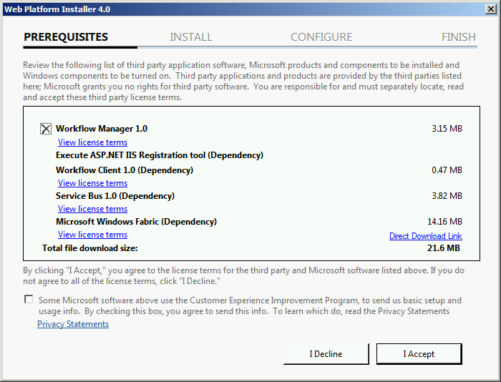

**Note:** The **Web Platform Installer 4.0** may prompt you to keep certain products updated using Microsoft Update. If it does, select **Use Microsoft Update when I check for updates (recommended)** and click **Continue**.

1. When the installer completes, the following dialog will appear. Click **Continue** to start the configuration process:

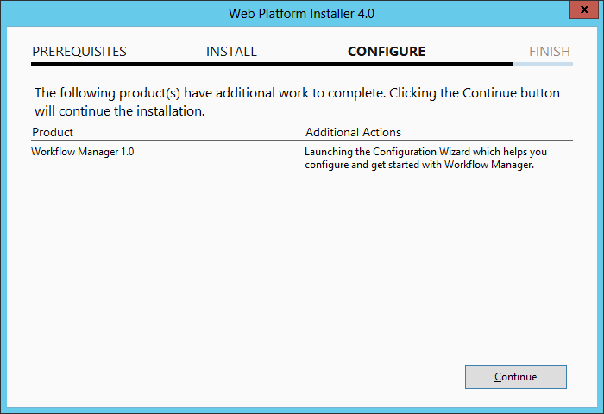

1. On the **Welcome** page, click **Configure Workflow Manager with Default Settings (Recommended)**.

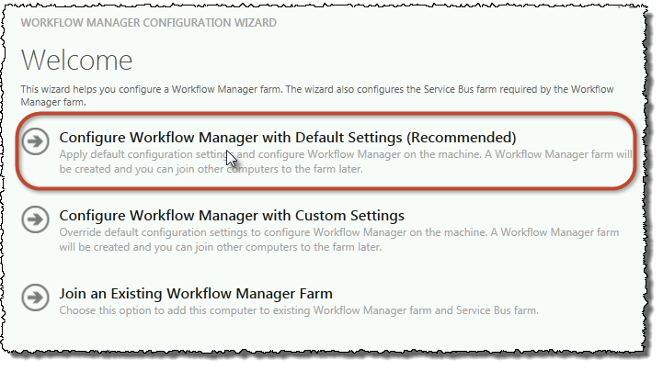

1. On the **New Farm Configuration** page, do the following:
   1. In the section **Configure Service Account**, set the credentials to:
      1. **User ID**: sp_workflow@wingtip.com
      2. **Password:** Password1
   2. Check the **Allow Workflow management over HTTP on this computer** checkbox.

Ensure the username is entered in the fully qualified UPN format, not as the default shows in the installer (sp_workflow@wingtip) or the domain\username format. In particular**, the installer does not add the .com to the end of the account name so you must add it yourself.**

In a production environment you should be doing everything over SSL.

* 1. Make certain your USER ID is SP_Workflow@WINGTIP.com
  2. Click the **Test Connection** button to verify the connection credentials before proceeding:

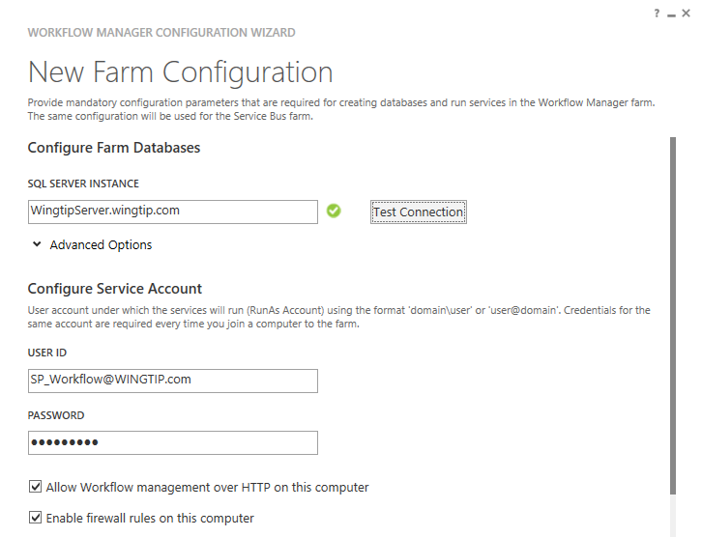

* 1. In the **Certificate Generation Key** and **Confirm Certificate Generation Key**, enter **Password1** into both fields.

1. Click the right arrow in the bottom right corner to proceed to the **Summary** page.
2. On the **Summary** page review your settings and click the button with the circled check mark at the bottom right of the window to start the configuration process.

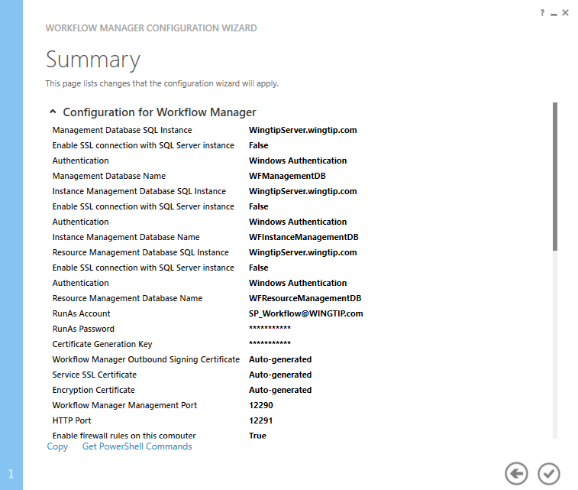

1. After a few minutes the **Configuration Progress** screen will show that everything has been configured correctly:

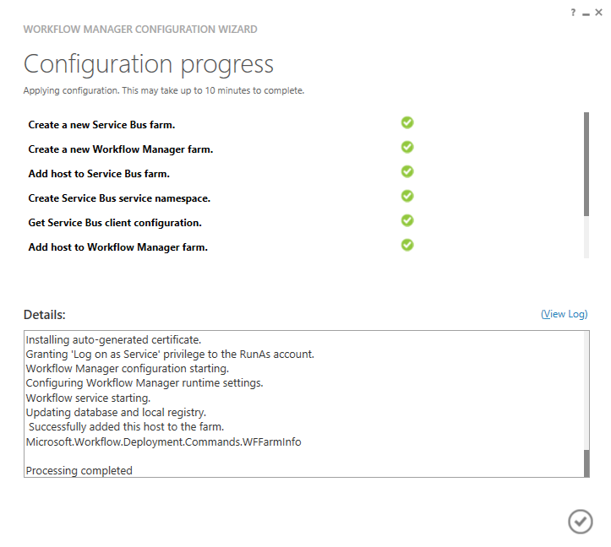

1. Click the **check** in the bottom right corner.

At this point Workflow Manager & Service Bus has been installed and a new Workflow Manager farm has been created. The next step is to connect the SharePoint 2013 farm to the Workflow Manager farm.

1. You are now done with the configuration work which must be done using the **WINGTIP\SP_Workflow** account. Log off the **WingtipServer** VM and then log back in as **WINGTIP\administrator**.
2. Get the Workflow Manager endpoint:
   1. Press the **Windows** key to display the **Windows Start** page.
   2. Type "**workflow**" and then click **Workflow Manager PowerShell** to start the command prompt which is used to configure the Workflow Manager.

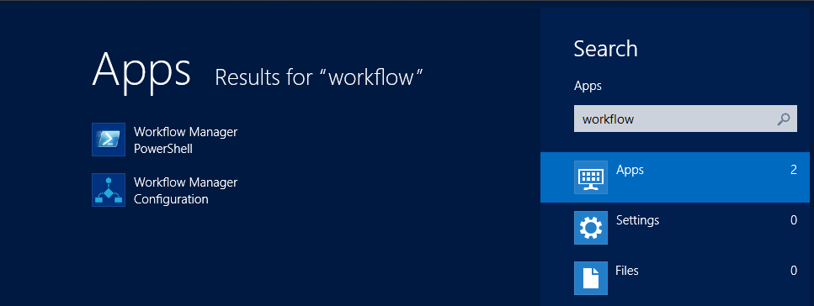

* 1. Execute the Windows PowerShell following cmdlet: (Note: the symbol between Get-WFFarm and ft is the pipe symbol [**Shift + \** keyboard key to add it])

Get-WFFarm | ft HttpPort

* 1. Take note of this port (usually 12291). This port number is what you will use to connect the SharePoint 2013 farm to the Workflow Manager 1.0 farm.

In production you should connect to the HTTPS port listed in the **HttpsPort** property (typically 12290) when you run **Get-WFFarm**.

* 1. Close the Workflow PowerShell window.

1. Connect the SharePoint 2013 farm to Workflow Manager:
   1. Open **SharePoint 2013 Management Shell** from the Windows Start page.
   2. Execute the following Windows PowerShell script in the **SharePoint 2013 Management Shell**:  
      (Note: this command **MUST be entered as one line** (it is only spread over 3 lines here to make it more readable)

Register-SPWorkflowService –SPSite "http://intranet.wingtip.com"   
 –WorkflowHostUri "http://wingtipserver:12291"

–AllowOAuthHttp

This PowerShell command which calls the Register-SPWorkflowService cmdlet is configuring the endpoint the local SharePoint farm will use to communicate with Workflow Manager as well as the SharePoint site collection that the Workflow manager should use when calling into SharePoint using CSOM. It is also configuring all communication over HTTP rather than HTTPS for performance reasons. In production you should always use HTTPS.

**This step will take a moment with no feedback during the process. Be patient.**

* 1. Close the SharePoint 2013 Management Shell.

At this point the SharePoint 2013 farm is connected to the Workflow Manager 1.0 farm.

### Exercise 2: Creating SharePoint 2013 Workflows with SharePoint Designer

In this lab you will create and test a simple workflow with SharePoint Designer 2013. The purpose of completing this lab is to verify that the SharePoint 2013 workflow environment has been setup correctly.

1. Open the SharePoint Designer 2013.
2. In SharePoint Designer, **Open** the site at **http://intranet.wingtip.com**.
3. Click on the Workflows node. You should see that there are currently no workflows in this site.
   1. On the left hand side of the screen under the **Site Objects** section click on **Workflows**

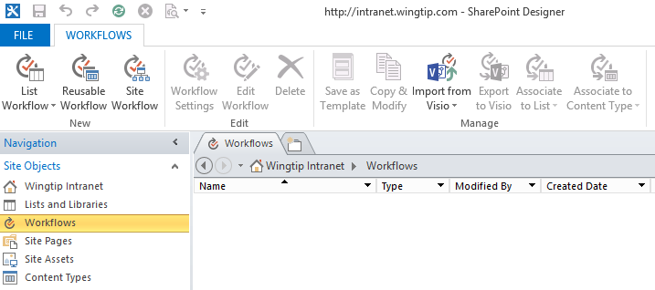

1. With the **Workflows** node selected, create a new workflow by dropping down the List Workflows button in the ribbon and selecting the document library with the title of **Documents**.

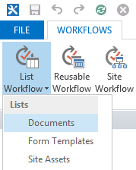

1. Name the workflow **My First Workflow** and ensure that **SharePoint 2013 Workflow** is selected as the **Platform Type**  and Click **OK**.

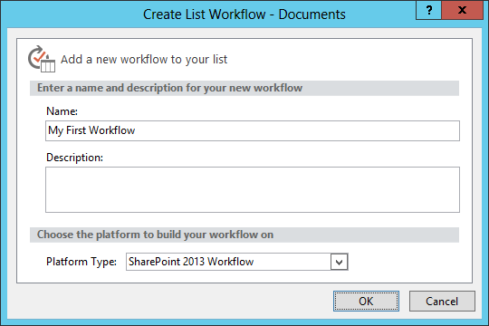

If **SharePoint 2013 Workflow** is not an available options for the **Platform Type**, it means that the configured workflow connection between the local SharePoint farm and the Workflow Manager has not been set up correctly.

At this point you can continue and play with the Workflow Designer. You have just verified that the workflow configuration has been set up correctly.