## Using Power View in Excel 2013

**Lab Time**: 60 minutes

**Lab Folder**: C:\Student\Modules\ExcelPowerView\Lab

**Lab Overview**: In this module you will with Power View and continue to work with Excel 2013 and along with the Excel workbook and data model you created in the previous lab.

### Exercise 1: Create Sales Revenue by Product Report

In this exercise you will launch Power View and begin to work with the different features for creating powerful charts and visualizations.

#### Log in to Student Environment

1. Login to the Student VM using the login **WINGTIP\Administrator** and the appropriate password.
   1. If you’re using a local VM provided by the hosting training company, the password will be **Password1**.
   2. If your student VM is hosted by CloudShare, the password for the **WINGTIP\Administrator** account is going to be unique for each student, system-generated by CloudShare. Also note that the CloudShare VM configuration usually logs you into the VM automatically so you do not have to enter the user name and password.

#### Open Existing Workbook

1. Open the Excel workbook titled **WingtipSalesModel.xlsx** that you completed in the Module 3 lab on Time Intelligence and KPIs.
   1. Navigate to the directory located in your student folder at **C:\Student\Models\**

This lab assumes that you have completed the previous Time Intelligence and KPIs lab in which you continued working on an Excel workbook named **WingtipSalesModel.xlsx**. If you would like to begin work on this lab without first completing the Time Intelligence and KPIs lab, use the Windows Explorer to copy the lab solution file at **C:\Student\Modules\TimeIntelligenceAndKPIs \Lab\Solution\WingtipSalesModel.xlsx** into the folder at **C:\Student\Models**.

* 1. Double-click on the Excel workbook file named **WingtipSalesModel.xlsx** to open it in Excel 2013.
  2. Once the file is open you may get prompted with a security warning. If prompted, click on the **Enable Content** button to enable External Data Connections.



* 1. Once the file is open it should look similar to the image below.

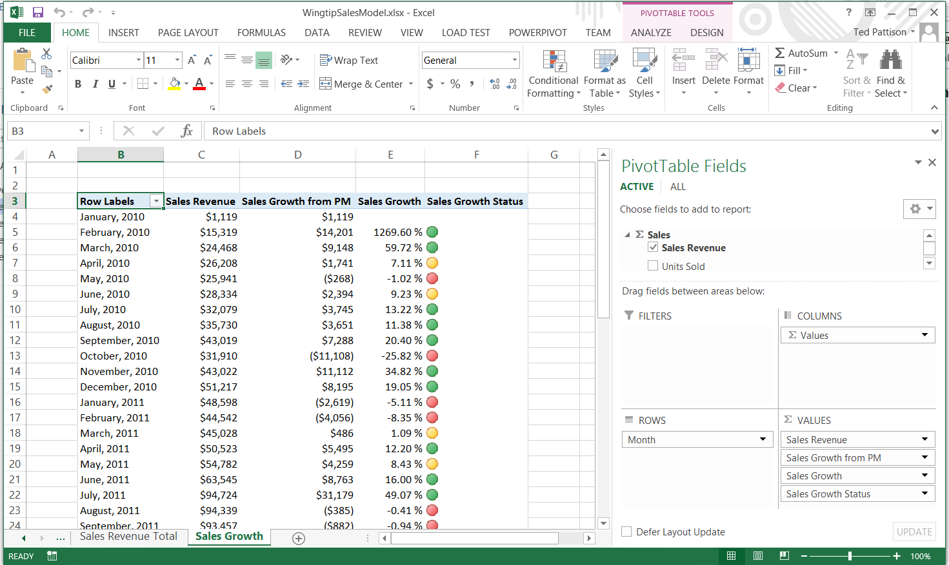

#### Create Sales Revenue by Product Report

1. Launch Power View.
   1. From the **INSERT** tab in the **Reports** group, click on the **Power View** button.

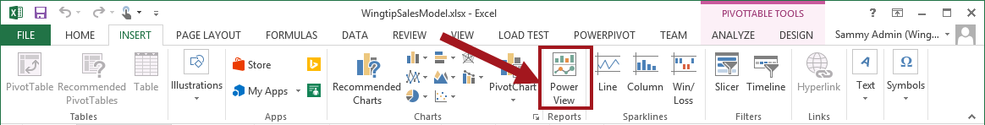

* 1. A Power View sheet is now created named Power View1 and the POWER VIEW tab is active.
  2. Rename the sheet from **Power View1** to **Sales Revenue by Product**.

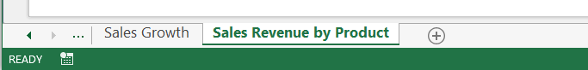

1. Add a report title.
   1. Click on **Click here to add title** and type **Sales Revenue by Product**.

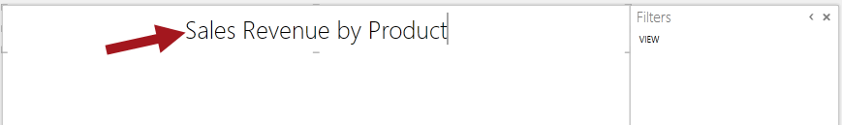

1. Save the **WingtipSalesModel.xls** file.

#### Make Changes to PowerPivot Diagram View

Before you can use images in your report, you must first make some modifications to the Data Model so images can be pulled into the chart being created. Follow the steps below to make the necessary changes for the images.

1. Navigate to PowerPivot Data Model.
   1. From the **POWERPIVOT** tab in the **Data Model** group, click on **Manage**.

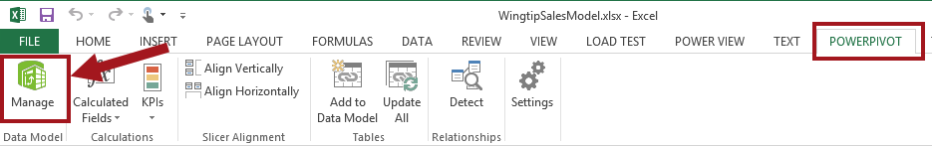

* 1. The PowerPivot window should now be open.

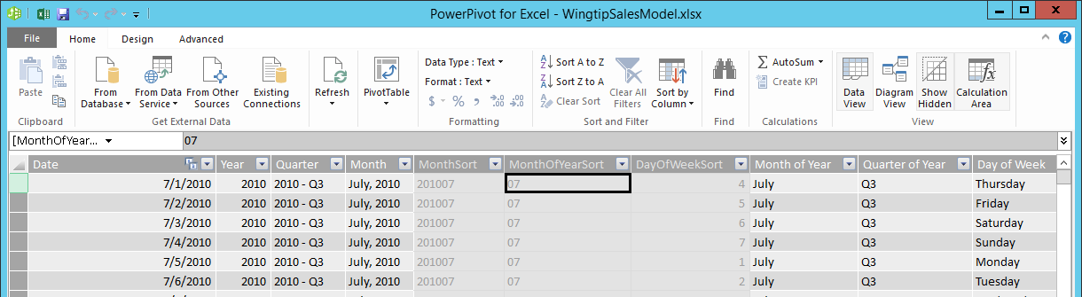

1. Make sure that the **Product Images** column in the **Products** table is not hidden from client tools.
   1. From the **HOME** tab in the **View** group, click on **Diagram View**.

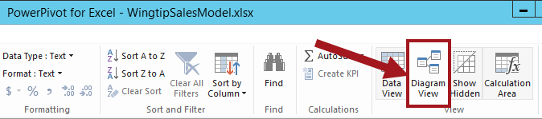

In order to use product images in the report, the **Product Images** column not be hidden from the Client Tools in Diagram View.

* 1. In Diagram View, right-click on the **Product Image** column. If the **Product Image** column is currently hidden, right-click it and select the **Unhide from Client Tools**.

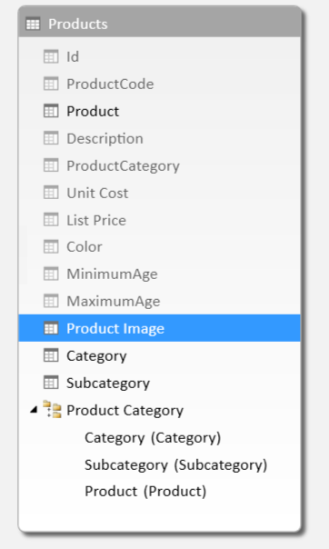

#### Change the Default Table Behavior

1. Ensure that the **Advanced** tab is visible in the PowerPivot window.
   1. Determine whether the **Advanced** tab is visible.

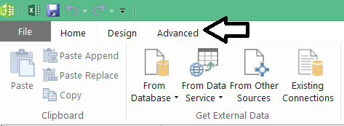

* 1. If the Advanced tab is not visible, drop down the **File** menu and select the **Switch to Advanced Mode** command to add the **Advanced** tab to the ribbon.

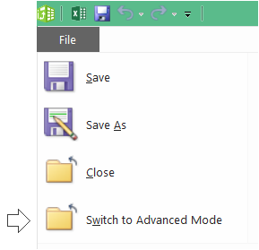

1. Change the table behavior of the **Products** table.
   1. Navigate to the **ADVANCED** tab. Inside the **Reporting** **Properties** group,
   2. Make sure that the Products table is currently select table in **Diagram** view
   3. Click on **Table** **Behavior**.

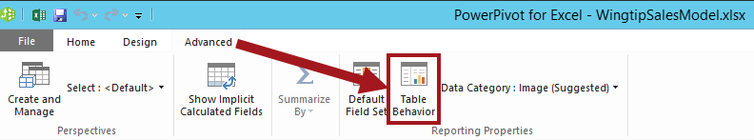

1. In the Table Behavior Dialog update the following:
   1. In the **Row Identifier** drop-down list, choose **Id**.
   2. In the **Default** **Label** drop-down list, choose **Product**.
   3. In the **Default** **Image** drop-down list, choose **ProductImage**.

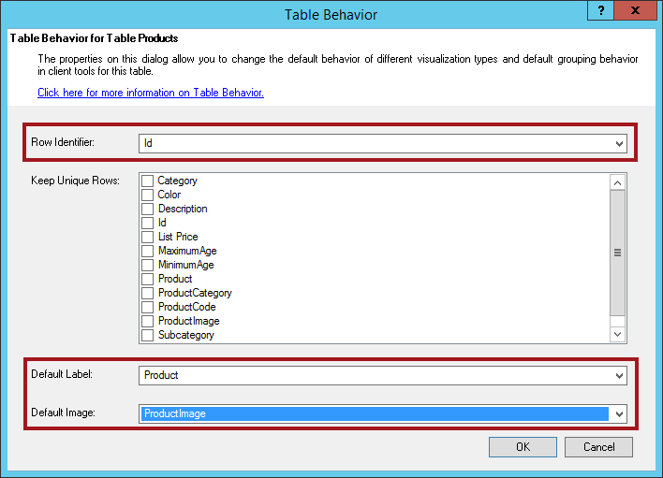

* 1. Click **OK**.

1. Click on the **Switch to Workbook** icon located next to the Save icon to switch back to the workbook.

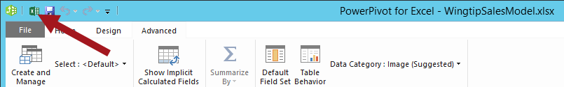

1. When the Data Model has changed dialog appears, click **OK** to apply the changes to Power View. Once the changes have been made, Power View will refresh and the Power View Fields will be updated according to the changes made.

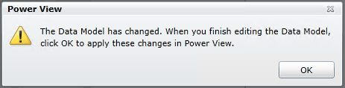

1. From the **Power View Fields** panel, expand **Products** and expand **Product Category**. Notice the **Product** and **Product Image** columns now display an icon next to the field. This icon represents an image.

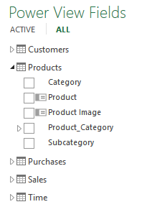

#### Add Fields to Report

1. Add Product, Product Image, and Sales by Revenue fields to the table visualization.
   1. Ensure the table visualization below the report title is selected.
   2. In the Power View Fields list under the **Products** table, select the **ProductImage** check box and then select the **Product** check box.

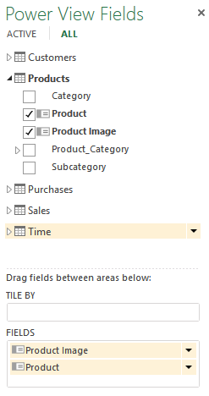

* 1. Your report should look similar to the image below.

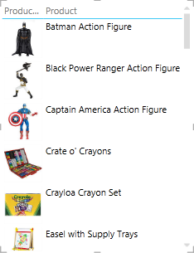

* 1. Under the Sales table, select the **Sales** **Revenue** check box. Now your report should look similar to the image below.

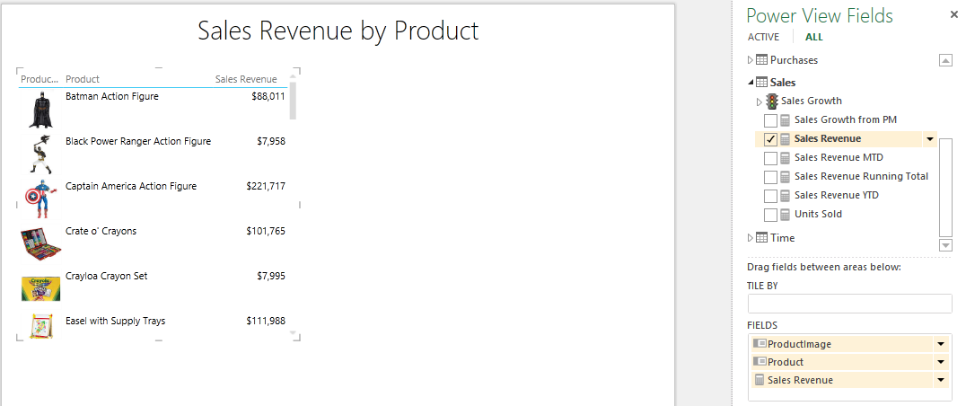

1. Change the Table Visualization to Card:
   1. From the **DESIGN** tab in the Switch Visualization group, click on the down arrow for **Table** and then click on **Card**.

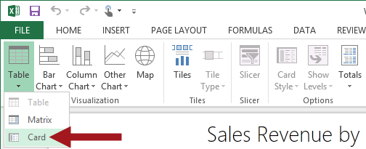

1. The report should now look similar to the image below.

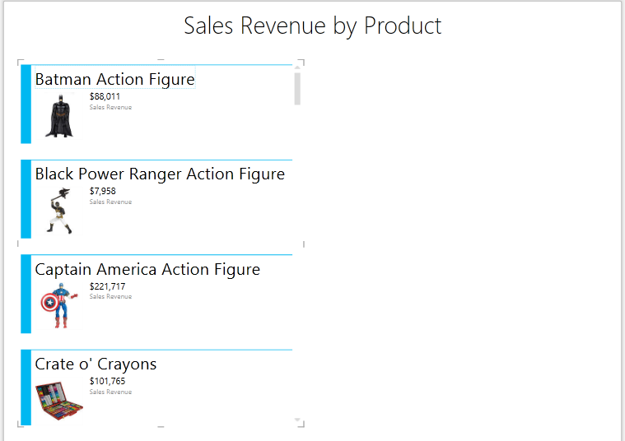

1. Save the **WingtipSalesModel.xls** file.

### Exercise 2: Create Sales by Zip Code Report

In this exercise you will continue with the WingtipSalesModel.xls file and work with the filters for the Power View report as well as add a Map visualization to the report.

#### Create Sales by Zip Code Report

1. Launch Power View.
   1. From the **INSERT** tab in the **Reports** group, click on the **Power View** button.



* 1. A Power View sheet is now created named Power View2 and the POWER VIEW tab is active.

1. Rename the sheet from **Power View2** to **Sales by Zip Code**.

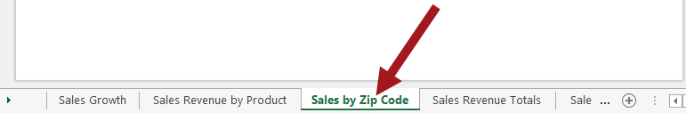

1. Create a report title.
   1. Click on **Click here to add title** and type **Sales by Zip Code**.

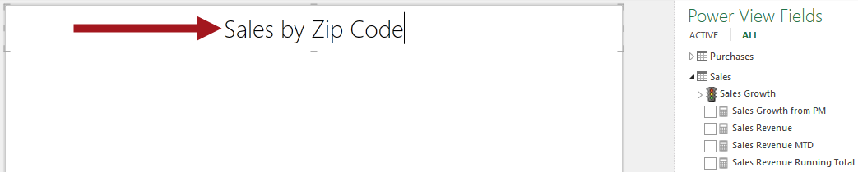

1. Add Zip Code and Sales Revenue fields to the table visualization.
   1. Ensure the table visualization below the report title is selected.
   2. In the Power View Fields list under the **Customers** table, expand **Customer_Geography** and select the **Zip_Code** check box.

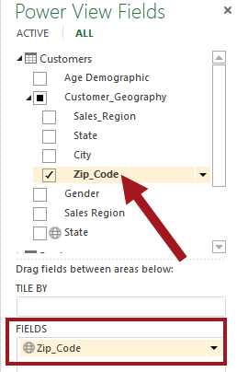

* 1. Under the **Sales** table, select the **Sales** **Revenue** check box.

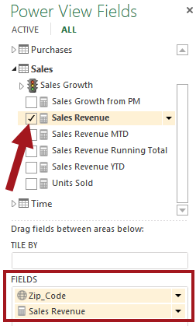

1. The report should now look similar to the image below.

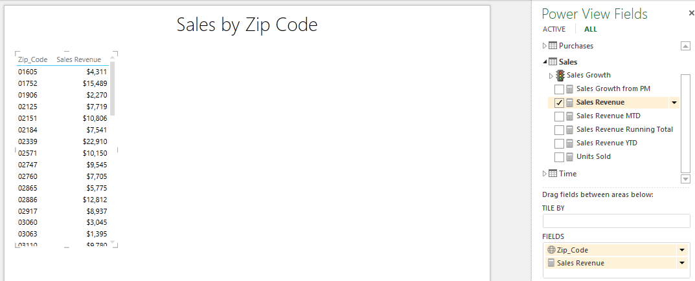

1. Save the **WingtipSalesModel.xls** file.

#### Switch Visualization to Map

1. Now change the Table Visualization to a Map.
   1. From the **DESIGN** tab in the **Switch Visualization** group, click on the **Map** button.

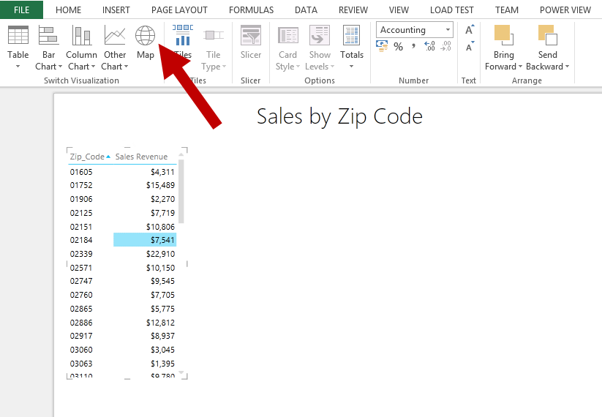

* 1. Once the file is open you may get prompted with a security warning. If prompted, click on the **Enable Content** button to enable data to be sent to Bing for geocoding.



* 1. The report should now look similar to the image below.

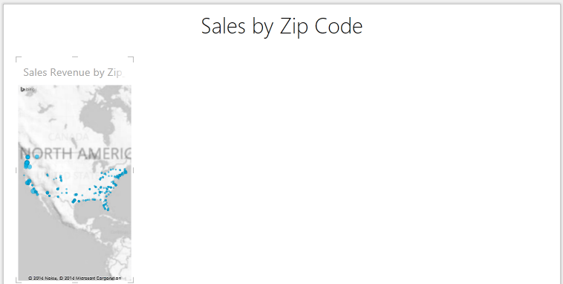

1. Resize the map.
   1. Place your mouse cursor over a corner of the map until the resizing double arrow activates.
   2. Hold down the left mouse button and drag your map to resize and stop once you achieve the desired size.
2. The map should now look similar to the image below.

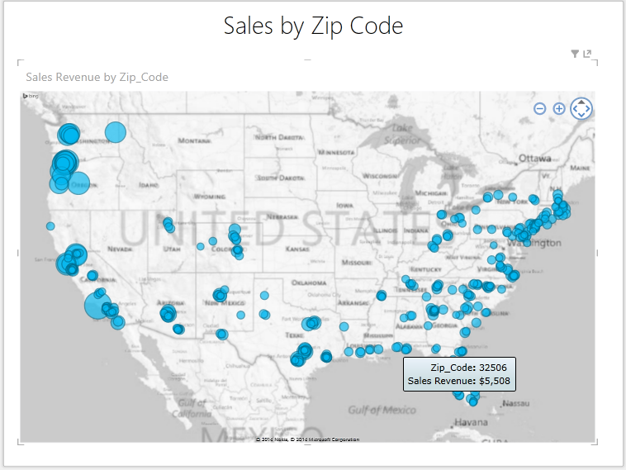

1. Add **State** field to the map visualization.
   1. Ensure the map visualization in the report is selected.
   2. In the Power View Fields list under the **Customers** table, expand **Customer_Geography** and select the **State** check box.

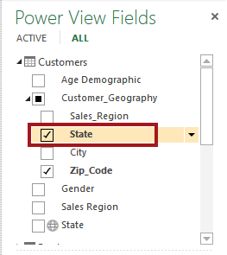

1. The map should now look similar to the image below.

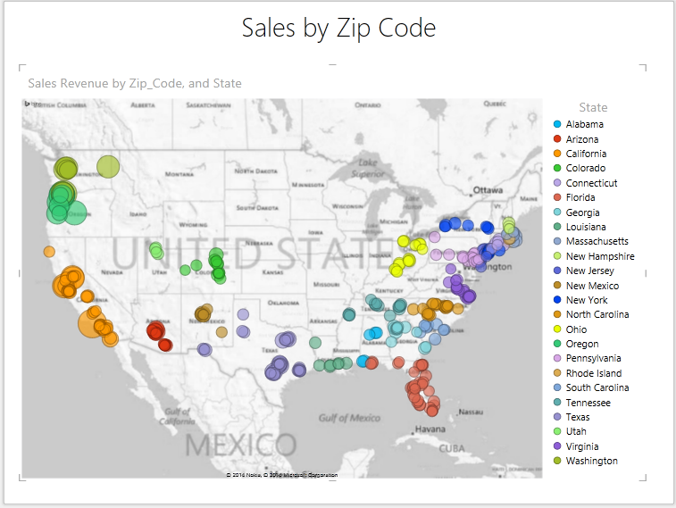

1. Save the **WingtipSalesModel.xls** file.

#### Add a Filter for Purchase Year

1. Activate the Filters Area. If the Filters Area is not displayed to the right of the Power View canvas enable by doing the following:
   1. From the **POWERVIEW** tab in the View group, click on the **Filters Area** button.

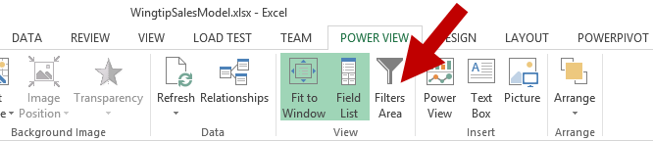

* 1. In the Filters Area should now be visible to the right of the canvas.
  2. Click on the Map and then in the Filters Area click on the word **MAP**. *Sales Revenue*, *State*, and *Zip_Code* should be visible.

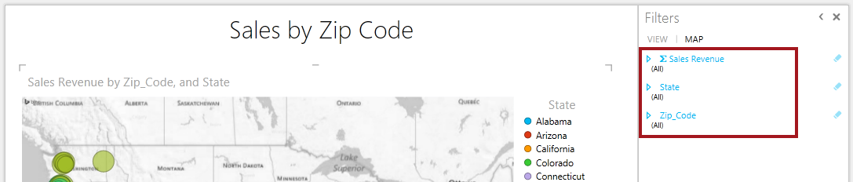

1. Add a filter for Purchase Year.
   1. In the Power View Fields List, click on ALL to view all fields.
   2. Expand the **Purchases** table. Click on the **Purchase Year** arrow and select **Add to Locations**.

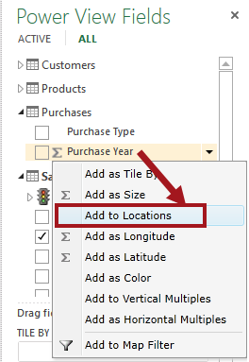

* 1. Notice **Purchase Year** is now added to the Filters Area for Locations.

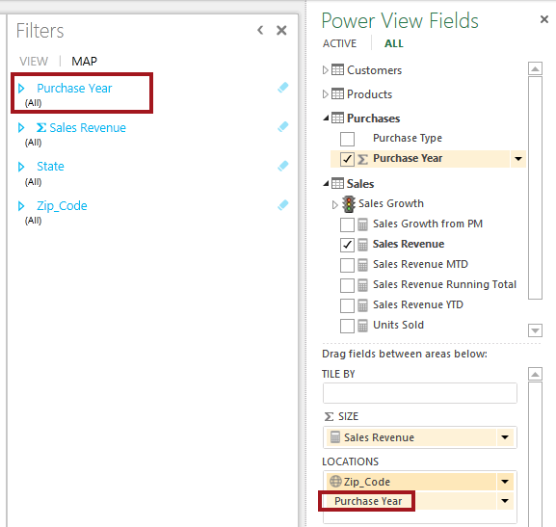

1. Set the Purchase Year filter value.
   1. Set the **Purchase Year** value to **2010**. Notice the circles on the map updates.

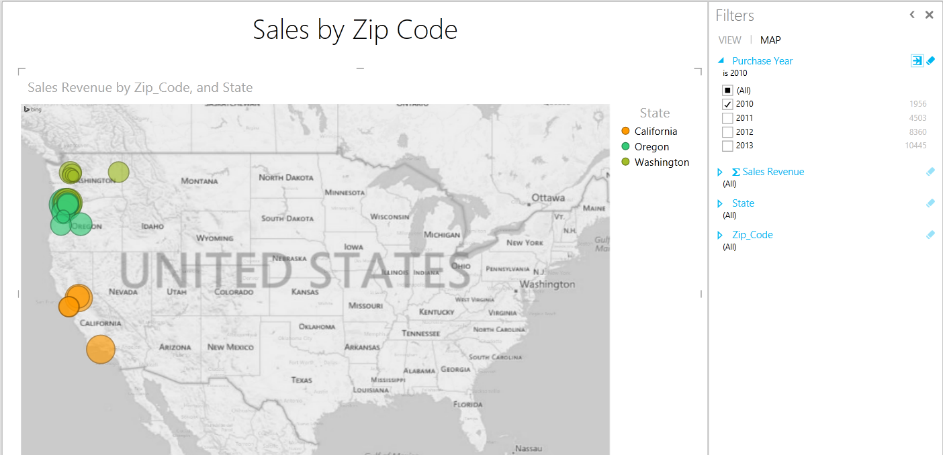

1. Save the **WingtipSalesModel.xls** file.

#### Zooming and Panning

1. To navigate around the map:
   1. Hover over the map to display the zoom and pan controls.

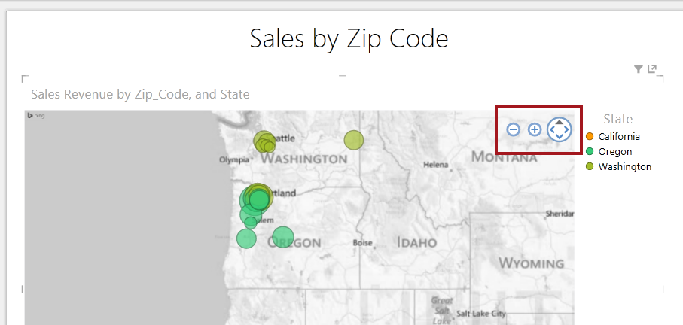

* 1. You pan the map by clicking the arrows on the pan control located next to the zoom controls or hold your mouse down and drag the map to the desired location.

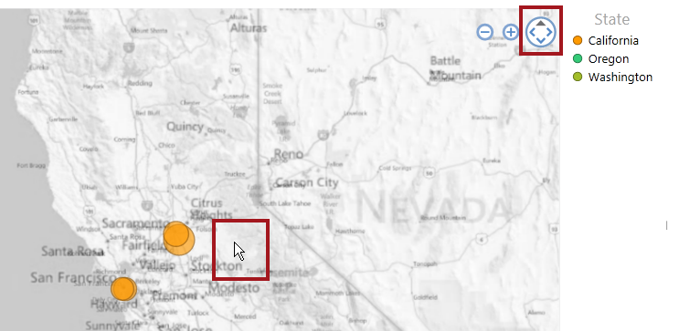

1. Save the **WingtipSalesModel.xls** file.

### Exercise 3: Create Sales by Age Demographics Report

In this exercise you will launch Power View and begin to work with the different features for creating powerful charts and visualizations.

#### Create Sales Revenue by Age Demographic Table Visualization

1. Launch Power View.
   1. From the **INSERT** tab in the **Reports** group, click on the **Power View** button.



* 1. A Power View sheet is now created with a name such as **Power View3** and the POWER VIEW tab is active.
  2. Rename the sheet from **Power View3** to **Sales** **Revenue Age Demographic**.



1. Create a report title.
   1. Click on **Click here to add title** and type **Sales** **Revenue by Age Demographic**.



1. Add **Age Demographic** field to the table visualization.
   1. Ensure the table visualization below the report title is selected.
   2. In the Power View Fields list under the **Customers** table, select the **Age** **Demographic** check box.
   3. Under the Sales table, select the **Sales** **Revenue** check box.
   4. The report should look similar to the image below.

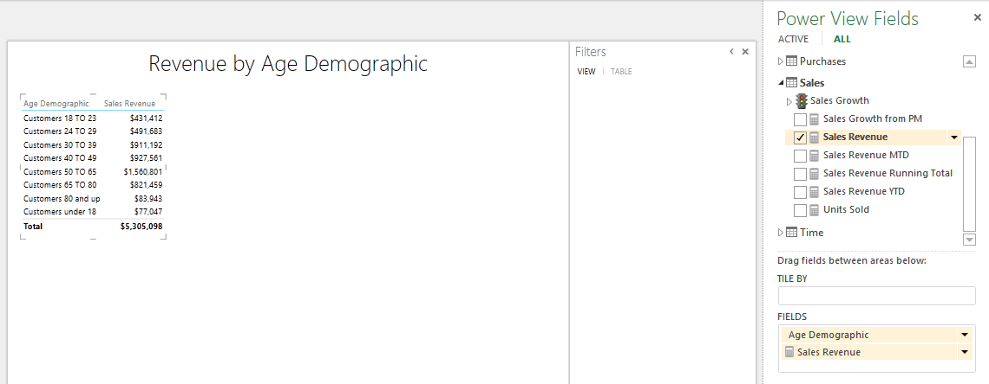

1. Save the **WingtipSalesModel.xls** file.

#### Adding Filters to Visualization

1. Activate the Filters Area. If the Filters Area is not displayed to the right of the Power View canvas enable by doing the following:
   1. From the **POWERVIEW** tab in the View group, click on the **Filters Area** button.

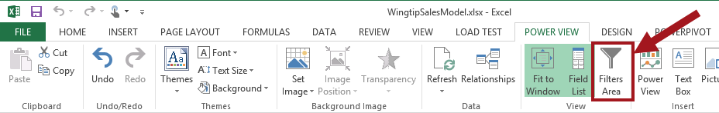

1. In the Filters Area, click on the word **TABLE**.

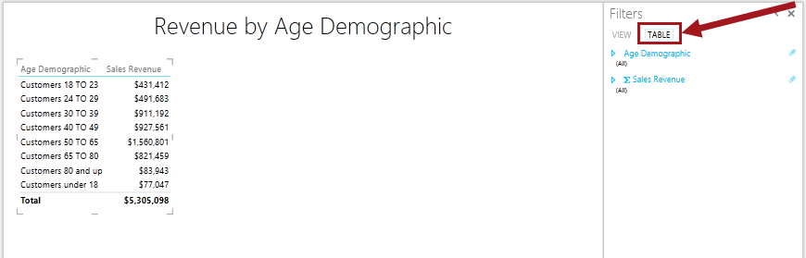

The Filters area shows each of the fields and measures in the visualization. You can expand the fields and measures and select different values you want to filter on and also add additional fields to the Filters Area.

1. Add the Purchase Type filed to the Filters Area.
   1. In the Power View Fields list, expand the **Purchases** table. Click on the **Purchase Type** arrow and select **Add to Table Filter**.

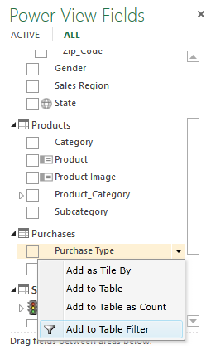

* 1. Notice the Purchase Type field is now added to the Filters Area.

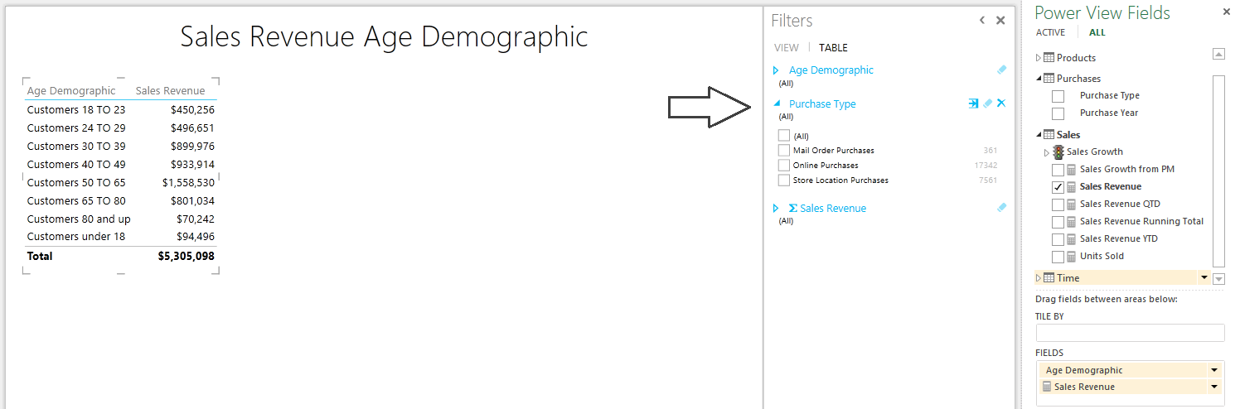

1. Test the **Purchase Type** filter.
   1. In the **Filters Area** with the **Purchase** **Type** expanded, click the checkbox for **Online**. Notice the data in the table visualizations changes.
   2. Select another option and notice the values change.
2. Add the **Sales Region** field to the **Filters** Area.
   1. In the Power View Fields List, expand the **Customers** table. Click on the **Sales Region** dropdown list and select **Add to Table Filter**.

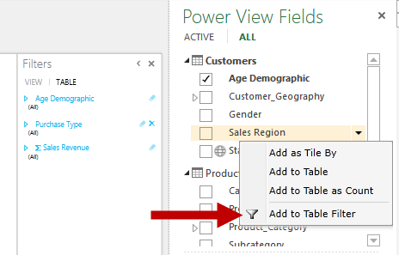

* 1. Notice the Sales Region field has now been added to the Filters Area.

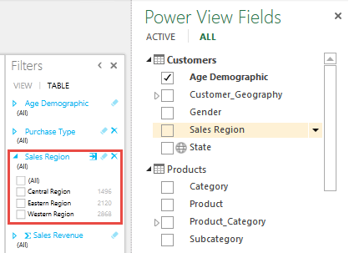

#### Using Tiles

1. Add Sales Region to the Tile By.
   1. In the Power View Fields List under the **Customers** table, click on the **Sales Region** dropdown list and select **Add as Tile By**.

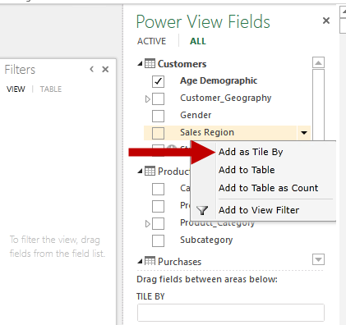

* 1. Notice the **Sales Region** tiles are added to the top of the data in the table visualization.

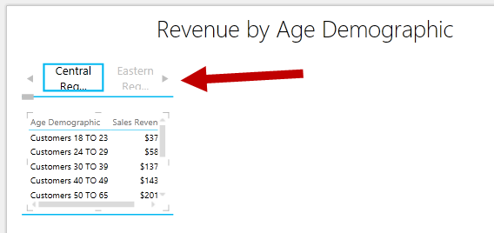

1. Resize the visualization.
   1. Hover the mouse pointer over the small gray line in the middle of the table’s right edge. The mouse pointer will change to a double-headed arrow as shown in the image below.

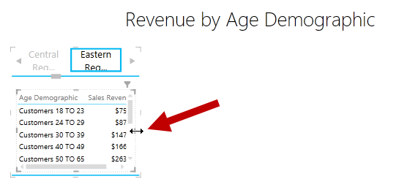

* 1. Drag the table wider to the desired size.
  2. Repeat the steps to manually resize the bottom of the table to the desired size. Your table should look similar to the image below.

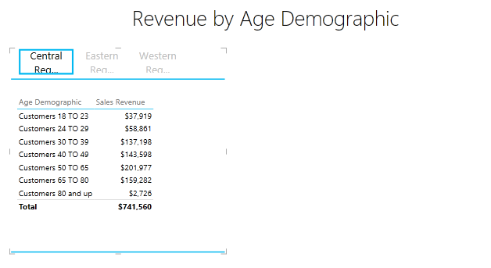

1. Add State as Tile By.
   1. In the Power View Fields List under the **Customers** table, click on the **State** dropdown list and select **Add as Tile By**.
   2. Notice the State tiles are now at the top of the data in the table visualization.

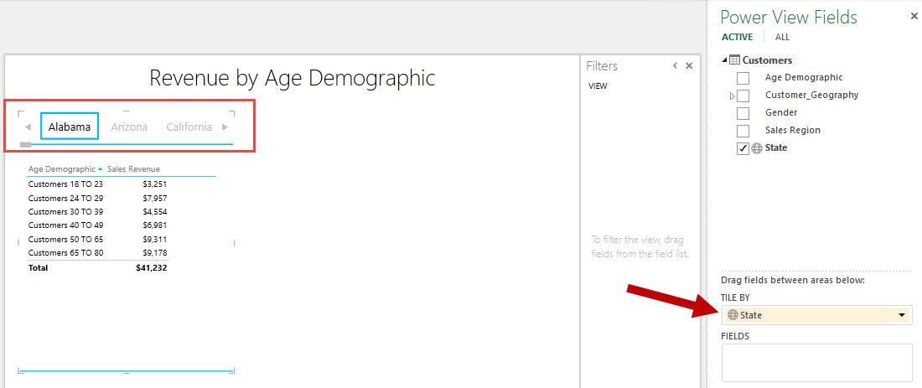

* 1. Click on the different states to see the data in the table visualization change based on the state you selected.

You can easily remove the Tile By by selecting the field in the TILE BY dropdown list and select Remove Field. Or you can uncheck the check box for the field used for the TILE BY in the Power View Fields list.

1. Save the **WingtipSalesModel.xls** file.

### Exercise 4: Create Sales Revenue Pie Chart Report

In this exercise you will continue with the WingtipSalesModel.xls file and create a report using a Pie Chart along with other visualizations for filtering.

#### Create Sales Revenue Pie Chart Report

1. Launch Power View.
   1. From the **INSERT** tab in the **Reports** group, click on the **Power View** button.



* 1. A Power View sheet is now created named Power View2 and the POWER VIEW tab is active.

1. Rename the sheet from **Power View4** to **Sales Revenue Pie Chart**.

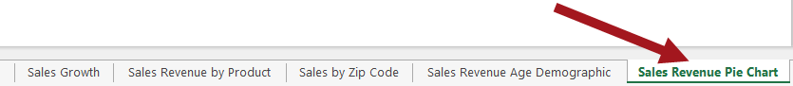

1. Remove the Report title to free up canvas space.
   1. Select the report title area to make it active then on the keyboard hit the **Delete** key.



* 1. The Report title should now be deleted similar to what is shown in the image below.



#### Create Pie Chart

Before a Pie Chart can be created a table visualization must be created first.

1. Add table visualization to Power View report by using the Power View Fields list:
   1. Under the **Purchases** table, select the **Purchase** **Type** check box.
   2. Under the **Sales** table, select the **Sales** **Revenue** check box.
2. The table visualization should now look similar to the image below.

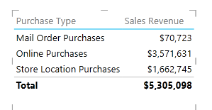

1. Convert Table visualization to Pie Chart.
   1. Ensure the table visualization in the report is active.
   2. From the **DESIGN** tab in the Switch Visualization group, click on the down arrow for **Other Chart** and then click on **Pie**.

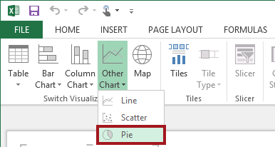

* 1. The visualization has now been converted from a Table to a Pie Chart similar to the image below.

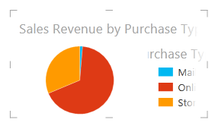

1. Resize the Pie Chart so the entire chart is viewable on the report.

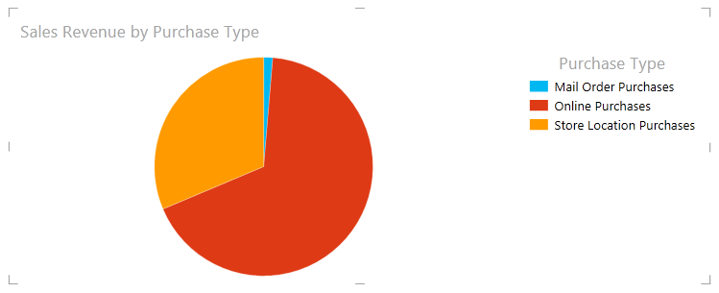

#### Add Additional Visualizations

1. Add **Units Sold** to canvas.
   1. Place mouse on canvas area outside of the Pie Chart visualization and then click to deactivate the Pie Chart.
   2. In the Power View Fields panel under the **Customers** table, drag **Gender** to the canvas and then release the mouse button. Do not select the check box for the field. Just drag the field to the canvas.
   3. Now add **Sales Revenue** next to the **Gender** column by expanding the **Sales** table and click on the **Sales Revenue** check box.
   4. Your report should now look similar to the image below.

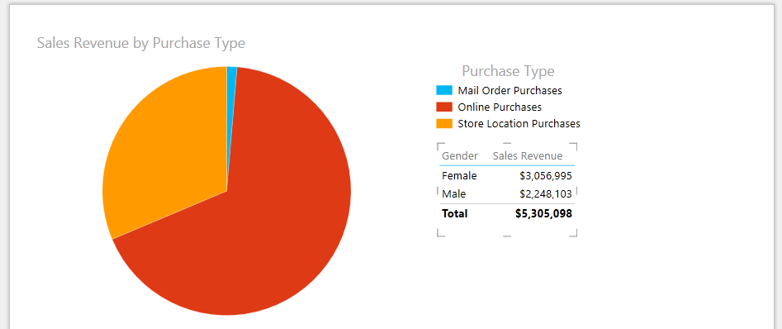

1. Add **Sales Region** to canvas.
   1. Select any area of the canvas that is blank so none of the visualizations are selected.
   2. In the Power View Fields panel under the **Customer** table, drag **Sales Region** to the canvas and then release the mouse button. Do not select the check box for the field. Just drag the field to the canvas.
   3. Now add **Sales Revenue** next to the **Sales Region** column by expanding the **Sales** table and click on the **Sales Revenue** check box.
   4. Drag the **Sales Region/Sales Revenue** table visualization below the **Gender/Sales Revenue** table visualization so it looks similar as shown in the image below.

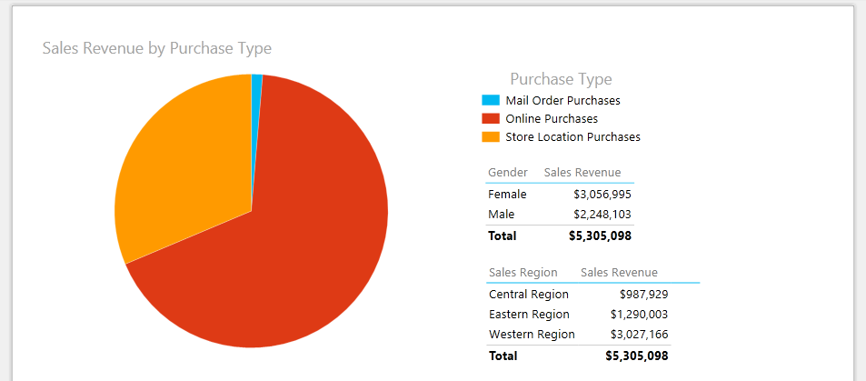

1. Test the Report.
   1. Click on the **Mail Order Purchases** label in the legend and notice the rest of the data on the report updates accordingly. Continue to click on another **Purchase Type** label values including **Online Purchases** and **Store Location Purchases** and notice the report continues to update based on what was selected.

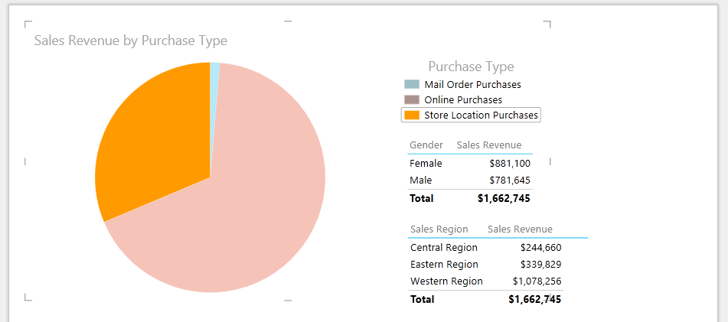

1. Save the **WingtipSalesModel.xls** file.

You have now completed all the steps to this lab.