## Working with Excel Services 2013

**Lab Time**: 60 minutes

**Lab Folder**: C:\Student\Modules\ExcelServices\Lab

**Lab Overview**: In this module you will work with Excel Services to publish workbooks and to expose a data table as an OData source.

### Exercise 1: Publish Credit Card Payoff Calculator Workbook

In this exercise you will create a Credit Card Loan Calculator used for customers who have taken out a loan for toy purchases. You will add parameters to the workbook and then publish the workbook to SharePoint.

#### Log in to Student Environment

1. Login to the Student VM using the login **WINGTIP\Administrator** and the appropriate password.
   1. If you’re using a local VM provided by the hosting training company, the password will be **Password1**.
   2. If your student VM is hosted by CloudShare, the password for the **WINGTIP\Administrator** account is going to be unique for each student, system-generated by CloudShare. Also note that the CloudShare VM configuration usually logs you into the VM automatically so you do not have to enter the user name and password.

#### Navigate to Existing BI Center Site

1. Open the browser and navigate to [**http://intranet.wingtip.com/sites/bicenter**](http://intranet.wingtip.com/sites/bicenter)
2. Your site should look like this.

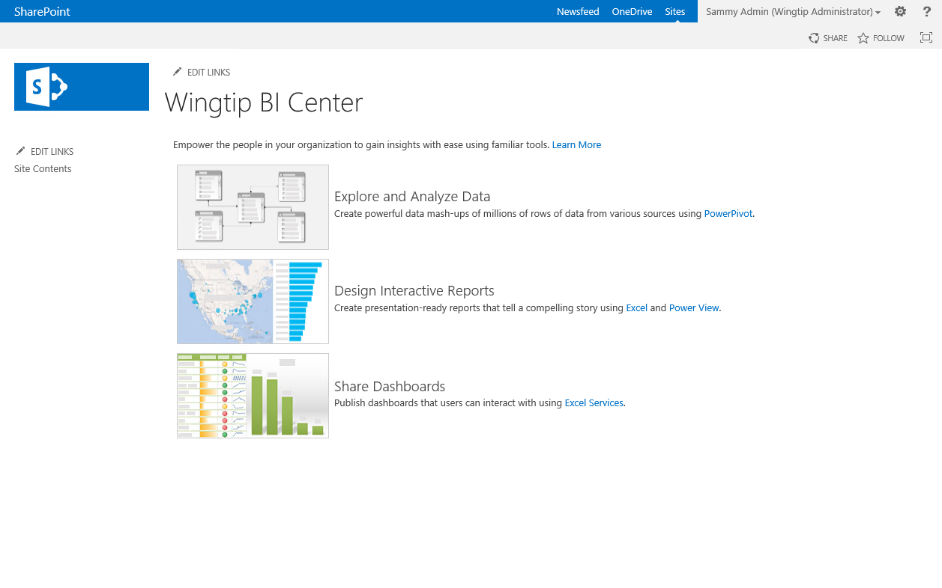

#### Update Credit Card Payoff Calculator Workbook

1. Locate the **Credit Card Loan Calculator** workbook in your student folder at the following path.

C:\Student\Modules\ExcelServices\Lab\Credit Card Payoff Calculator.xlsx

1. Open the file in Excel and examine what's inside. The file should look similar to the image below.

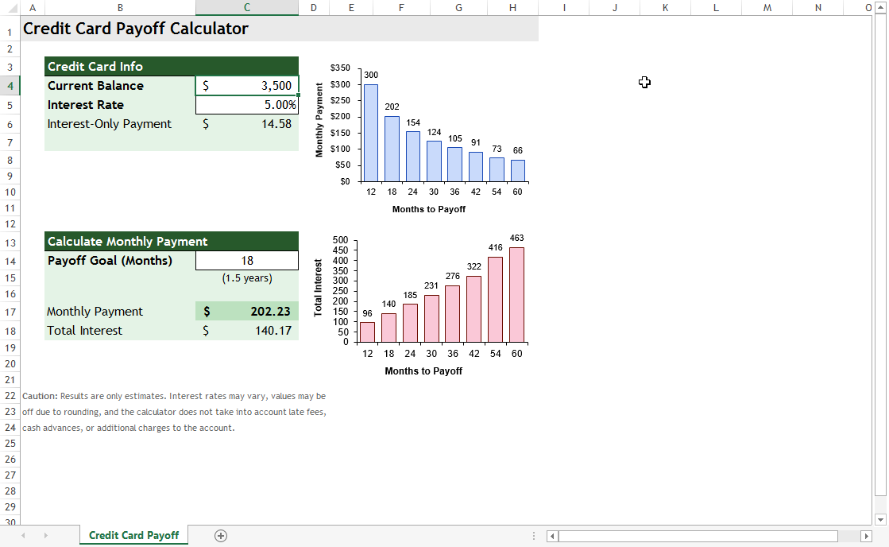

#### Define Names Used for Browser Parameters

Before we upload the file to SharePoint, we want the user to be able to input parameters for the Current Balance, Interest Rate, and Payoff Goal (Months). In order to add parameters, names for the desired cells must be defined in the workbook. Continue to the next steps to define the names.

1. Define Name for **Current Balance**:
   1. Click on cell **C4** which is the cell for the Current Balance value.
   2. From the **FORMULAS** tab in the **Defined** **Names** group, click on **Name Manager**.

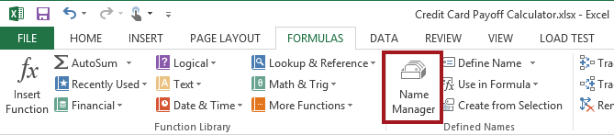

* 1. From the Name Manager dialog, click **New**.

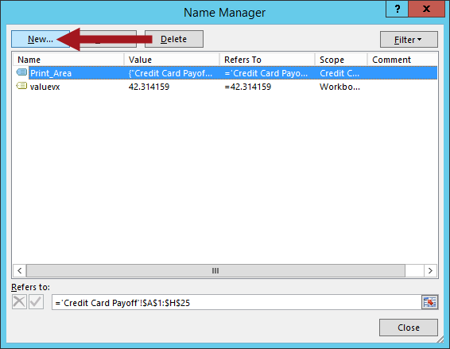

1. Define Name for **Current Balance**:
   1. Set the **Name** to **Current_Balance**.
   2. Set **Scope** to **Workbook**.
   3. Click the range selector icon next to the **Refers** **To** text box.
   4. Click on cell **C4** so the Edit Name – Refers to: updates similar to the image below.

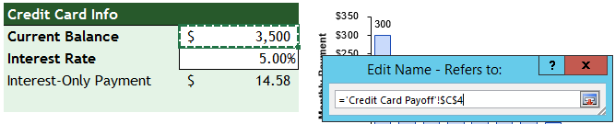

* 1. Click the exit cell range selector icon again to return to the New Name dialog.
  2. Click **OK**.

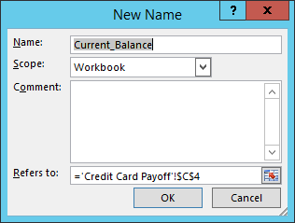

1. Define Name for **Interest Rate**:
   1. Repeat the steps as defined above except set **Name** to **Interest_Rate** and select cell **C5** for the Refers to value.

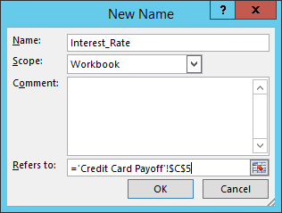

1. Define Name for **Payoff Goal (Months)**:
   1. Repeat the steps as defined above except set **Name** to **Payoff_Months** and select cell **C14** for the Refers to value.

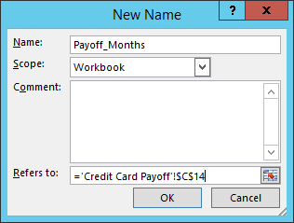

#### Add Browser Parameters to Workbook

1. Add browser parameters:
   1. Click on the **FILE** tab. From the Info panel, click on the **Browser View Options** button.

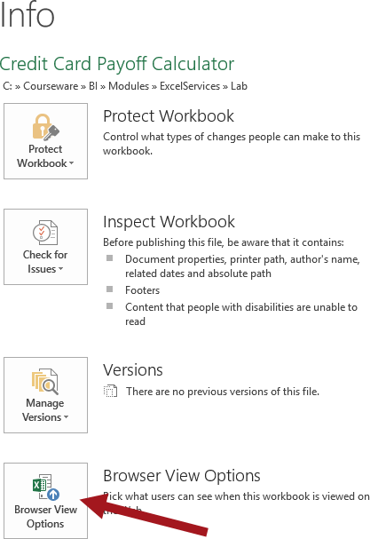

* 1. From the **Parameters** tab, click the **Add** button.

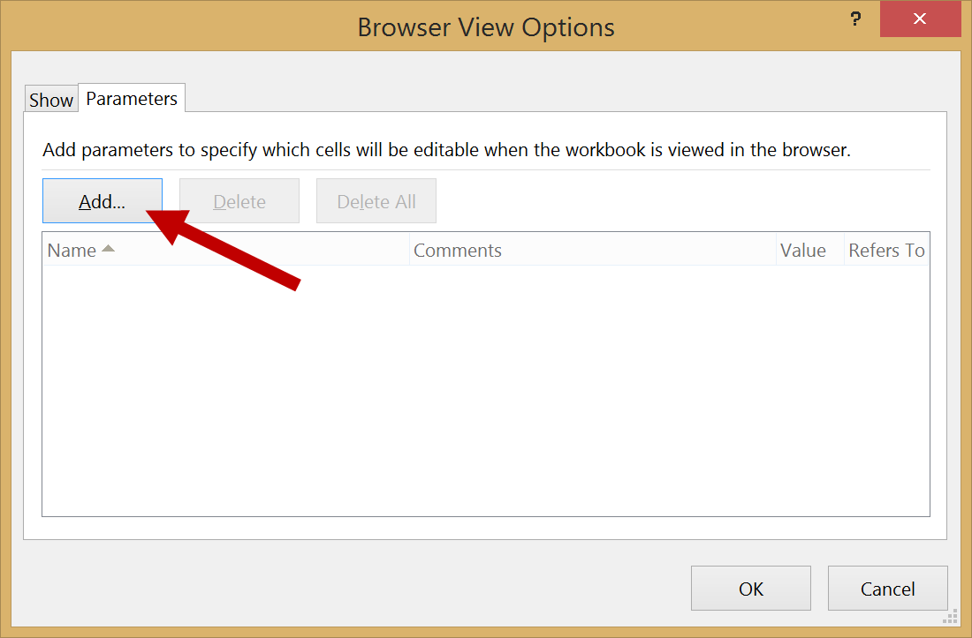

* 1. Select all of the available field parameters and then click **OK**.

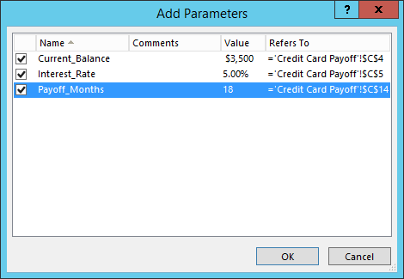

* 1. Click **OK** to close Browser View Options dialog.

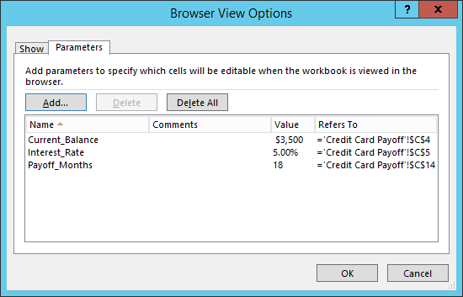

1. **Save** the file.
2. Now navigate to your Business Intelligence site [**http://intranet.wingtip.com/sites/bicenter**](http://intranet.wingtip.com/sites/bicenter)
3. Click on **Site Contents** in the left navigation and then click on the **Documents** tile.

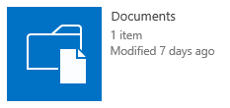

1. Upload the **Credit Card Payoff Calculator.xlsx** file to the Document library:
   1. From the **Documents** library, click **+New Document** to open the **Add a Document** dialog.
   2. **Browse** to the location of the file and then click **Open**.
   3. Click **OK**.

#### Interact with Credit Card Payoff Calculator Workbook

1. Click on the **Credit Card Payoff Calculator** link to open the file in the browser.
2. The file should now be opened through the browser in Excel Services.

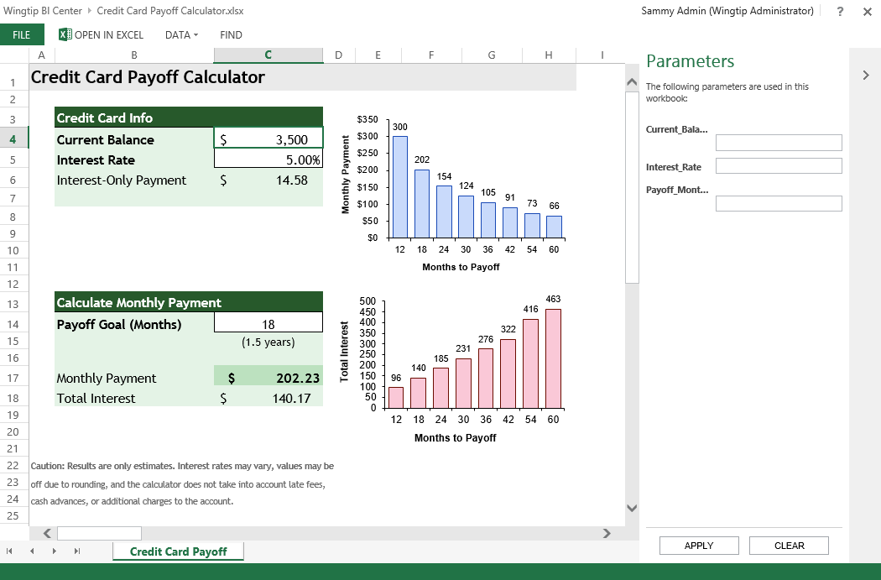

1. Fill in all the input parameters as shown in the following screenshot and then click **Apply**. Notice the data updates in the workbook.

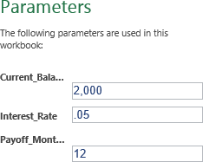

1. Notice the values in the Credit Card Payoff Calculator worksheet update based on the values you inputted for the Parameters.

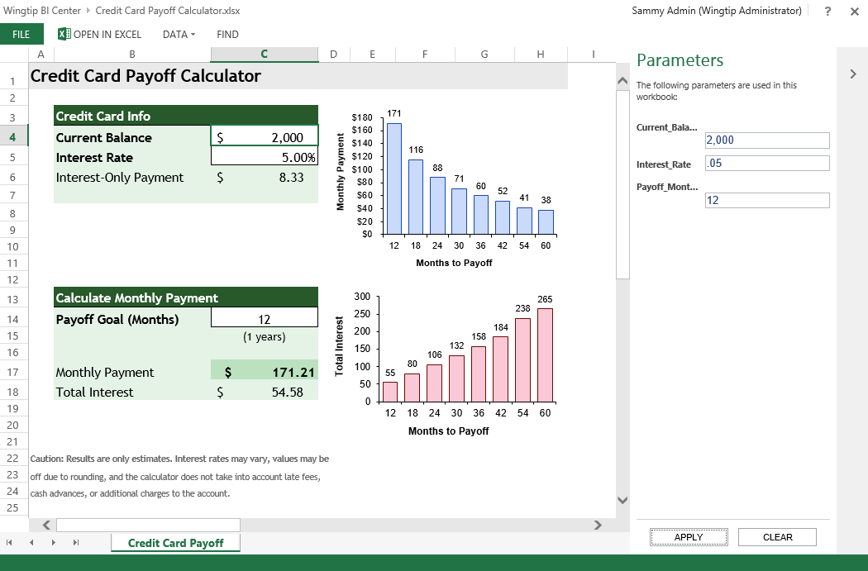

1. Update the parameters again to new values and then click **APPLY** and notice the data updates again in the worksheet.
2. To navigate back to the Documents library, click on the **Wingtip BI Center** link located in the breadcrumb at the top.
3. This exercise is now complete.

### Exercise 2: Publish WingtipSalesModel Workbook using Excel Services

All exercises in this lab assume you will work in an existing BI Center site collection, http://intranet.wingtip.com/sites/bicenter. In this exercise you will create a PowerPivot Gallery library, upload the existing file used in the previous module, and create a Power View report through the browser.

#### Create PowerPivot Gallery

1. Navigate to **Site Contents**.
2. Look at the set of existing List and Libraries and determine whether there is already a library named **PowerPivot Gallery**. If the **PowerPivot Gallery** already exists, skip ahead to the next section title **Upload Existing Workbook to PowerPivot Gallery**. If **PowerPivot Gallery** does not exists, continue with the following steps to create it.
3. From the left navigation pane, click **Site Contents** then click on **Add an app**.



1. Click on the **PowerPivot Gallery** tile.

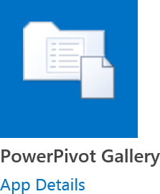

1. Type **PowerPivot** and then click **Create**. The PowerPivot Gallery is now created.



1. Click on the PowerPivot tile to navigate to the new library. The library will not contain any documents and should display similar to the image below.

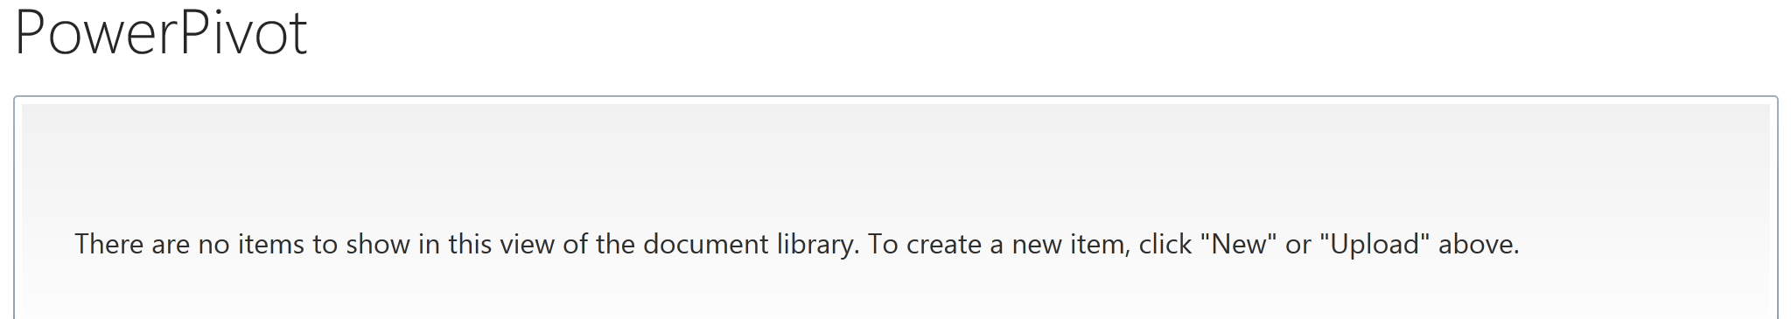

#### Upload Existing Workbook to PowerPivot Gallery

1. Upload the existing **WingtipSalesModel.xlsx** file you have been working on for this class to the newly created PowerPivot library:

This lab assumes that you have completed the lab titled **Using Power View in Excel 2013** in which you modified the existing Excel workbook named **WingtipSalesModel.xlsx** that was initially created in the **Getting Started** lab. If you would like to begin work on this lab without first completing prior labs, use the Windows Explorer to copy the lab solution file at **C:\Student\Modules\ExcelPowerView\Lab\Solution\WingtipSalesModel.xlsx** into the folder at **C:\Student\Models**.

* 1. From the **PowerPivot** library, click on the **FILE** tab and click on **Upload** **Document**.

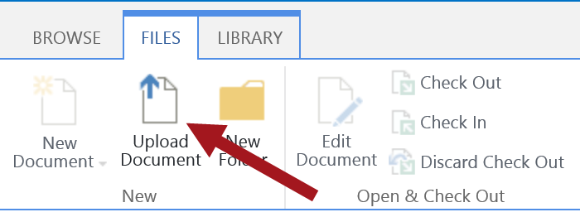

* 1. **Browse** to the location of the file (**C:/Student/Models/WingtipSalesModel.xlsx**) and then click **Open** and then click **OK**.

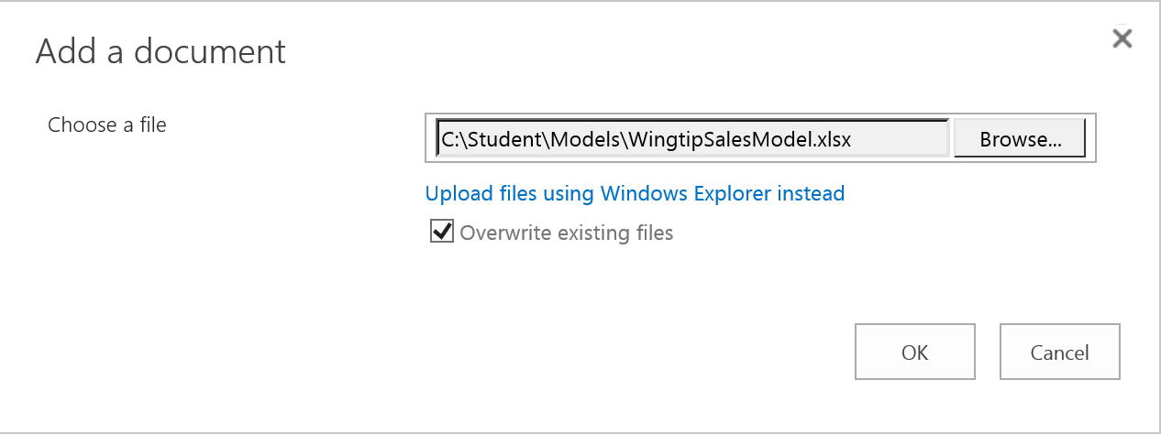

* 1. The file is now uploaded to the PowerPivot library and should now look similar to the image below.

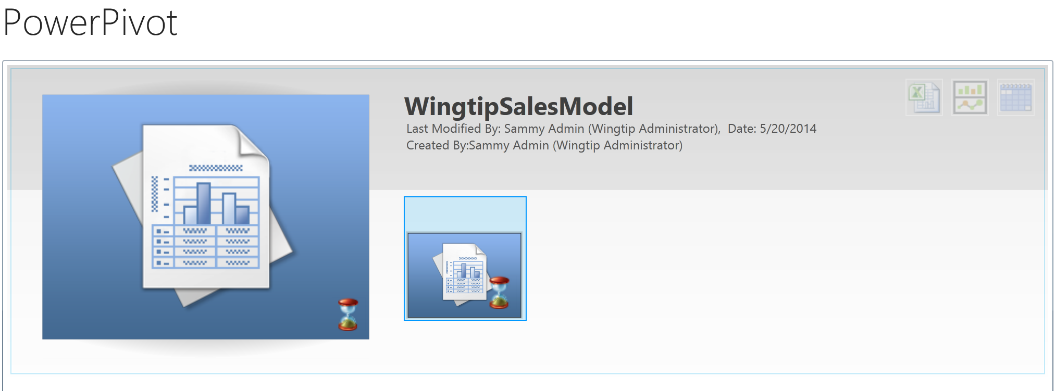

#### Interact with WingtipSalesModel Workbook

1. Click on the **WingtipSalesModel** document image to open the file in the browser.

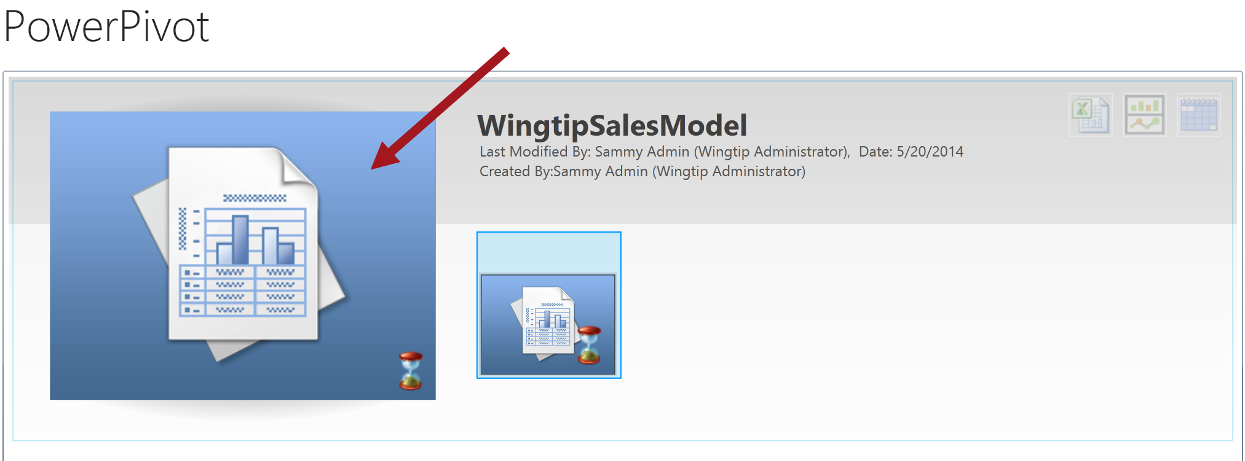

1. The file should now be opened through the browser in Excel Services.

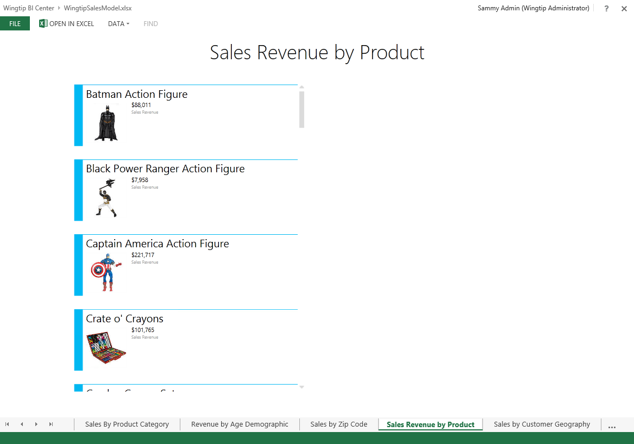

1. Click on the **Sales by Product Category** sheet. Notice the sheet loads with the PivotTable.

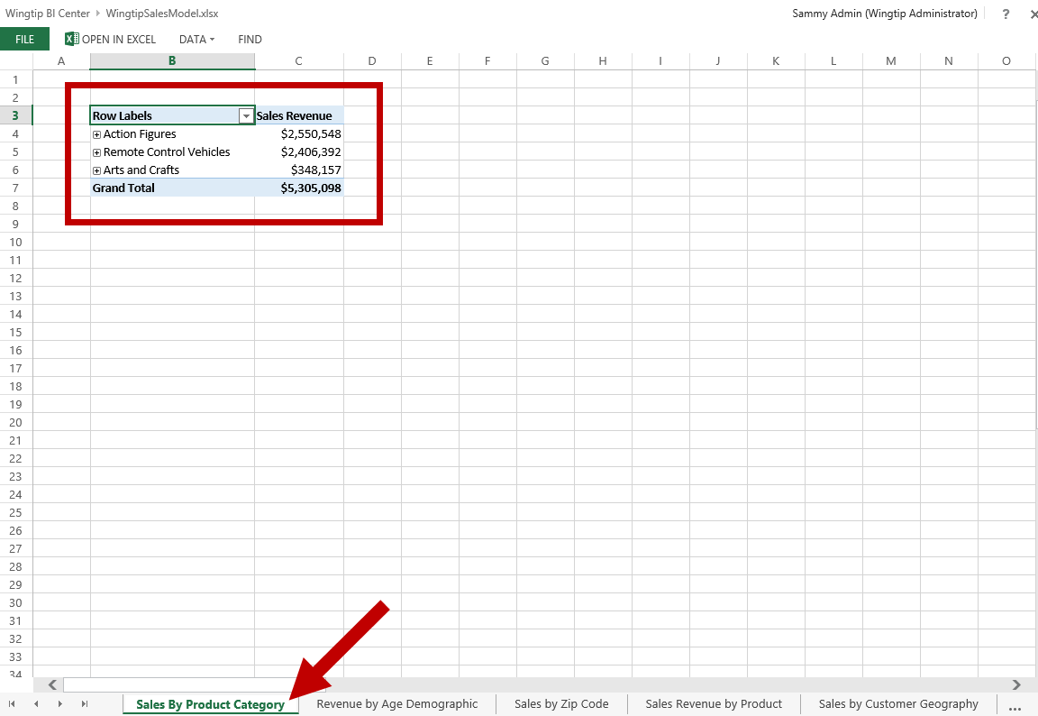

1. Expand the different values in the PivotTable to drill down the data.

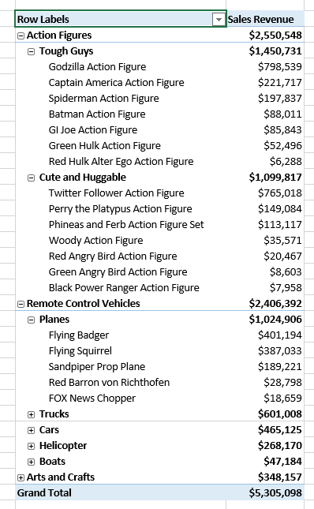

1. Now enable the Field List panel.
   1. Right-click anywhere on the PivotTable and click on Show Field List.

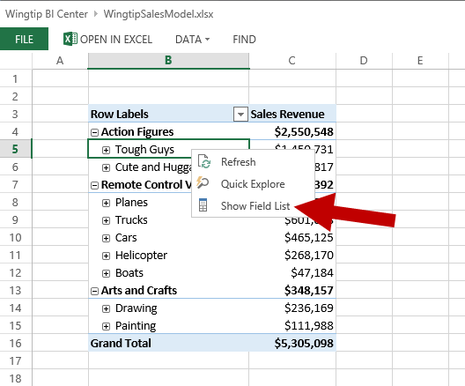

* 1. The PivotTable Fields panel should now be active and displayed on the right-hand of the workbook.

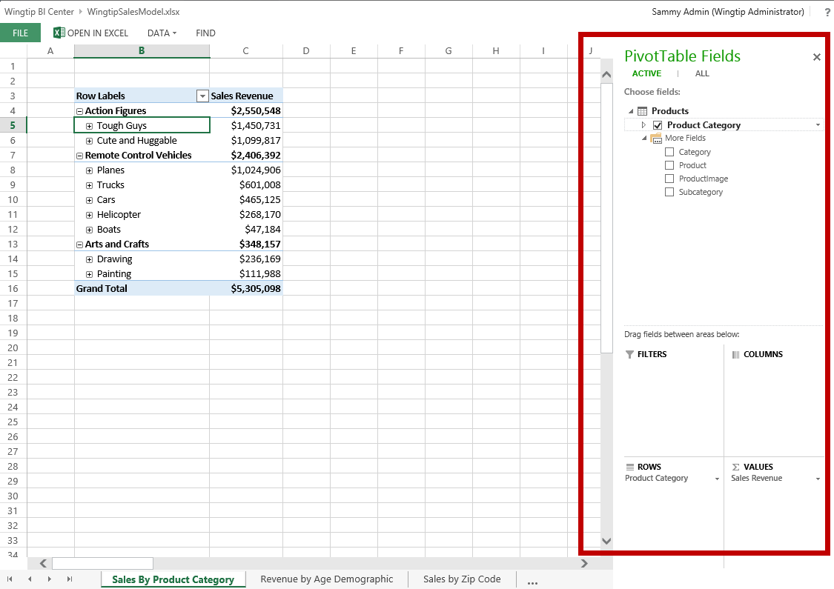

1. Now drill down by Action Figures.
   1. Double-click on Tough Guys. Notice the data changes and filter icons show up next to the columns in the PivotTable Fields panel.

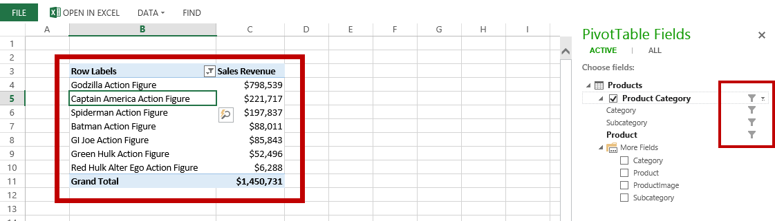

1. Now clear the filter.
   1. In the **Rows Label** column, click on the **Filter** icon. Expand **Product** and then click on **Clear Filter from ‘Product’**.

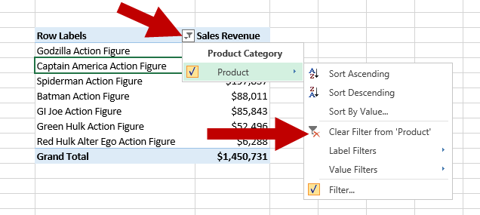

* 1. Notice the PivotTable has updated.

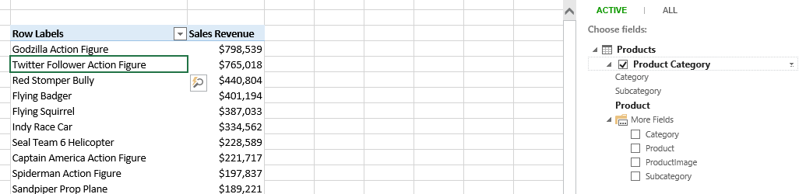

* 1. Now in the **PivotTable Fields** panel under **Products**, uncheck **Product Category**. Notice the PivotTable now only shows Sales Revenue.

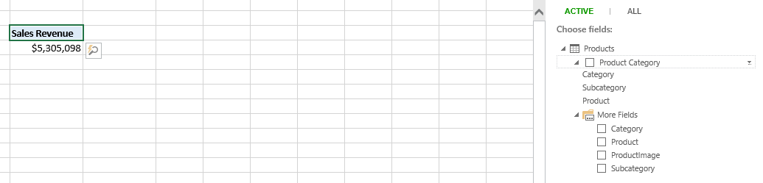

* 1. To add back Product Category, check the **Product Category** box. Notice the PivotTable has been updated.

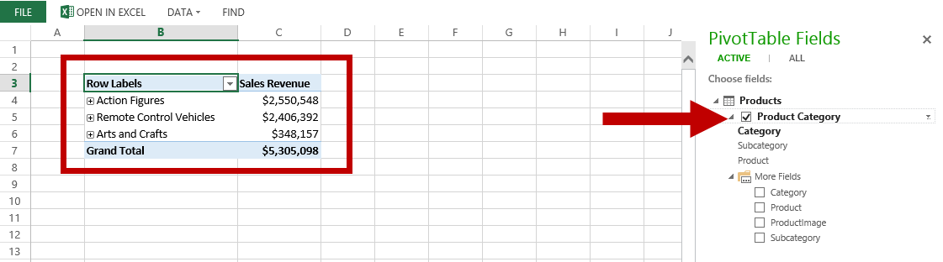

1. Now close the PivotTable Fields panel.
   1. Click on the **X** in the **PivotTable Fields** panel or right-click on the PivotTable and click on **Hide Field List**.

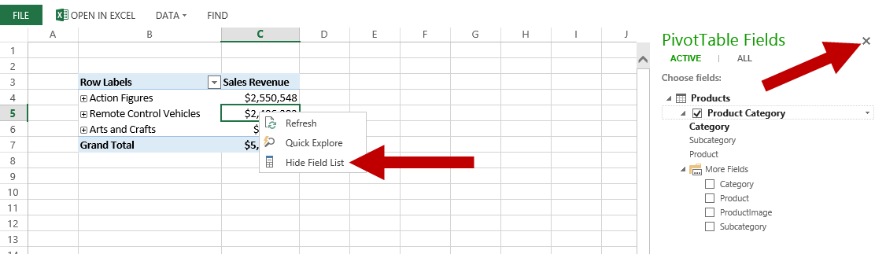

1. Now click on another sheet such as **Sales by Zip Code** and interact with the data in the workbook. Continue to do this with the remaining sheets to explore the data in each sheet.

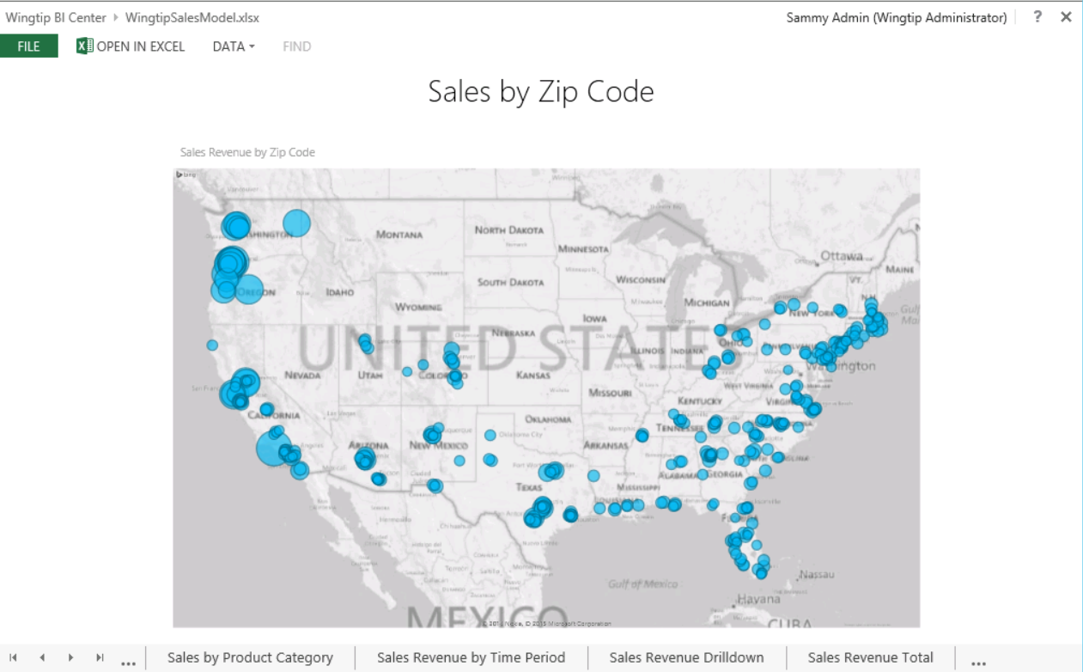

1. Once you are done exploring the data you have completed this exercise. To navigate back to the Documents library, click on the **Wingtip BI Center** link located in the breadcrumb at the top.

### Exercise 3: Create Power View Report from Power Pivot Gallery

In this exercise you will create a Power View report through the browser.

#### Create Power View Report

1. To create a Power View report click on the **Create Power View Report** icon for WingtipSalesModel.

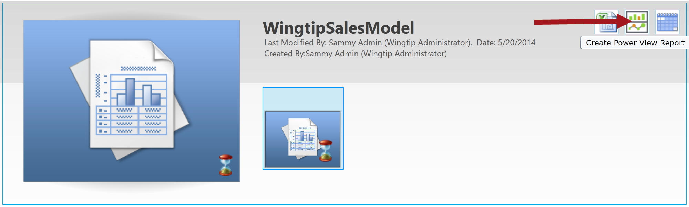

1. Start designing your Power View report and once you are complete click the **Save** icon.

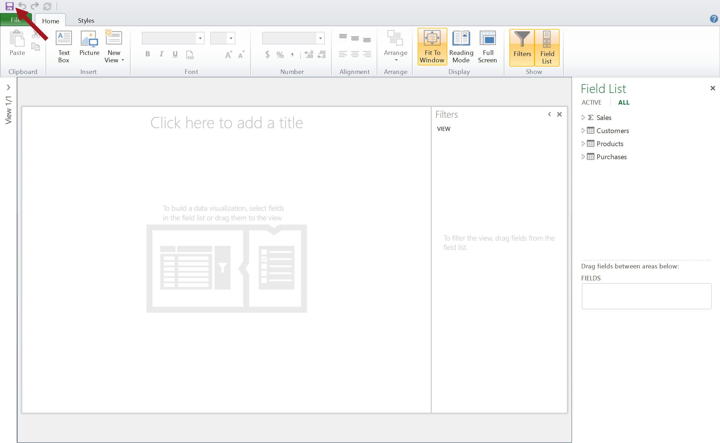

1. Name your report file and then click **Save**. The new Power View report is now saved.

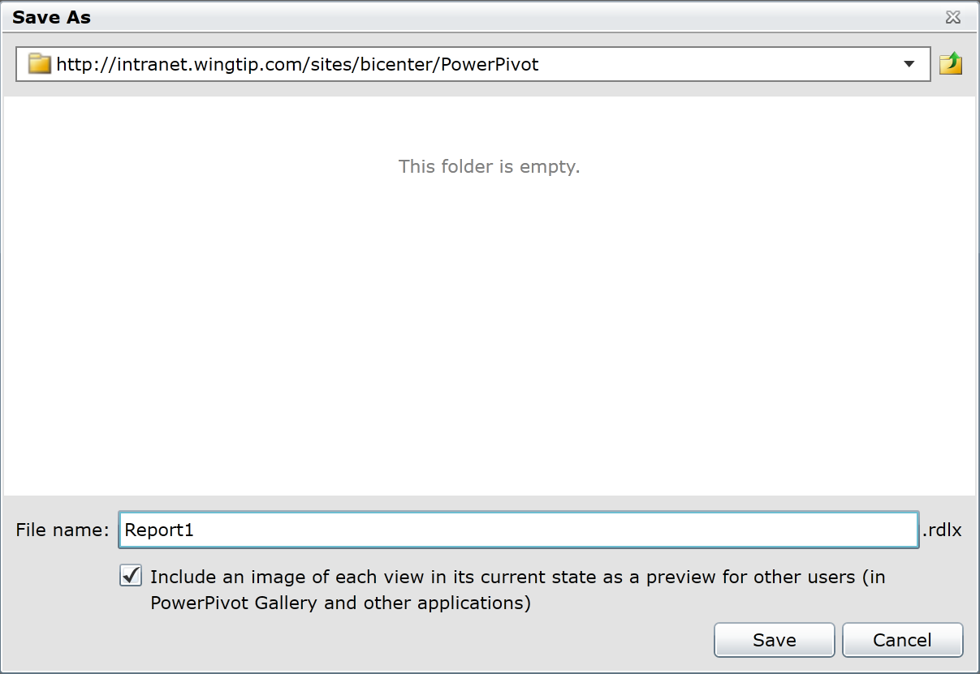

### Exercise 3: Working with BI Semantic Model Connections

In this exercise you will learn how to create a BI Semantic Model Connection in SharePoint 2013.

#### Update the Trusted File Location

1. From the left navigation pane, click **Site Contents** then click on the **Data Connections** tile.



1. Copy the URL from the browser address bar: <http://intranet.wingtip.com/sites/bicenter/Data%20Connections>



The Data Connections library location must be added to the Excel Services Trusted Data Connection Libraries. The location you just copied will be pasted into the location for the setting in Central Administration.

1. From the browser, open **Central Administration**.
2. Under Application Management click **Manage service applications**.

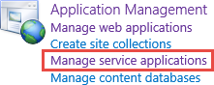

1. Click on the **Excel Services Application** link.



1. Click on the **Trusted Data Connection Libraries** link.



1. Click on **Add Trusted Data Connection Library**.

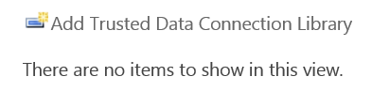

1. Paste the URL of the Data Connection library in the **Address** text box and then click **OK**.

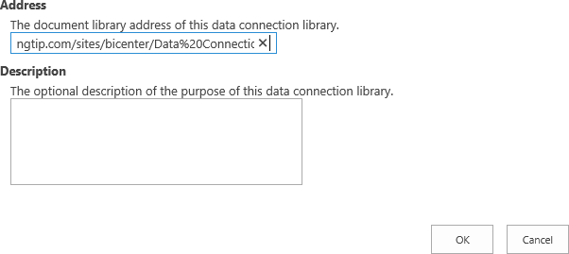

#### Enable Feature and Add Content Type

Before you can create a BISM connection, you must first enable the PowerPivot Feature Integration for Site Collections feature to use the BI Semantic Model Connection File content type.

1. Navigate back to the home page of the BI Center site.
2. Enable the **PowerPivot Feature Integration for Site Collections** site collection feature.
   1. Go to the **Site Settings** page for the BI Center site.
   2. Under the **Site Collection Administration** group, click on the **Site collection features** link.

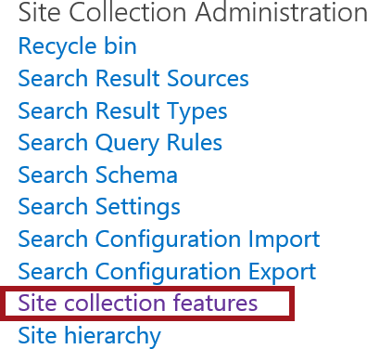

* 1. Find **PowerPivot Feature Integration for Site Collections** and then click **Activate**.



1. Now navigate to the **Data Connections** library.
   1. From the **Quick Launch**, click on **Site Contents**.
   2. Click on the **Data Connections** library tile.



* 1. From the **LIBRARY** tab click on **Library Settings**.
  2. Under the **Content Types** section click on the **Add from existing site content types** link.

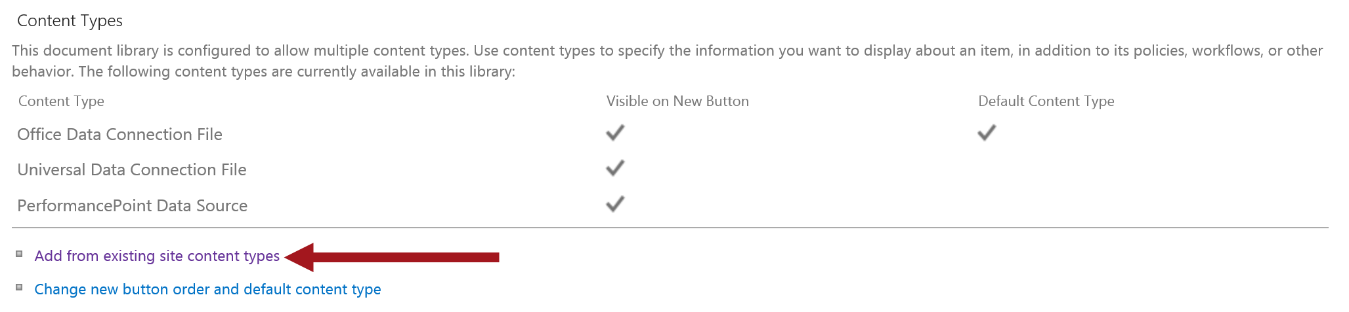

* 1. From the **Select site content types from** drop-down, select **BI Semantic Model Connection** click **Add** and then click **OK**.

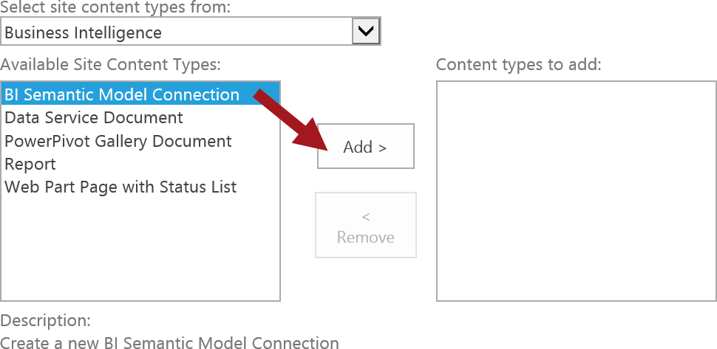

* 1. The **BI Semantic Model Connection** should now be listed under **Content Types**.

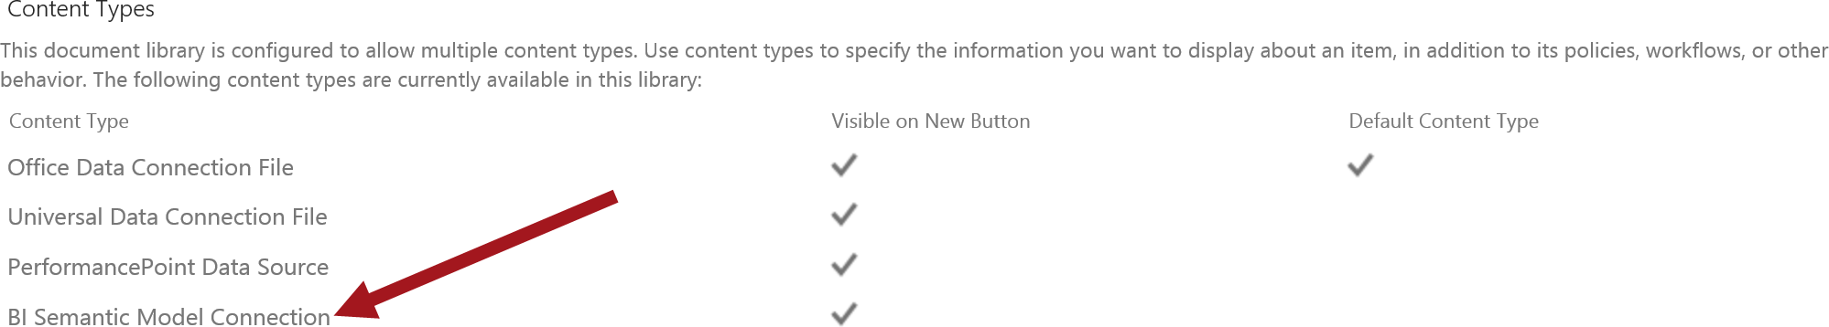

* 1. Navigate back to the Data Connections library by clicking on **Data Connections** in the breadcrumb.

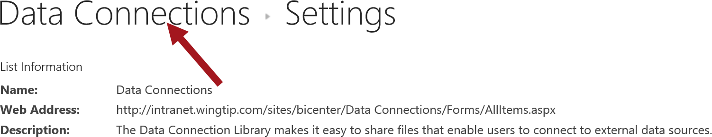

* 1. From the **FILES** tab click on the drop-down menu for **New Document** and click on **BI Semantic Model Connection**.

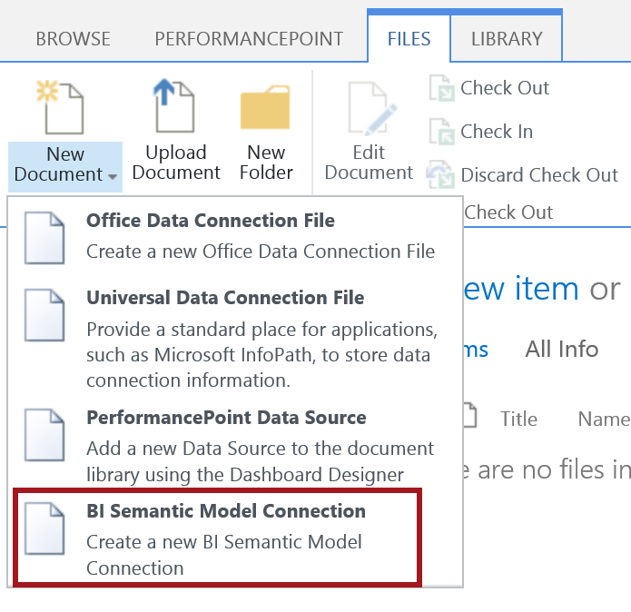

#### Create BI Semantic Model Connection

1. Type **WingtipSalesExcelModel** in the **File Name**. Input the URL to the WingtipSalesModel.xlsx workbook file located in the Documents library and then click **OK**.

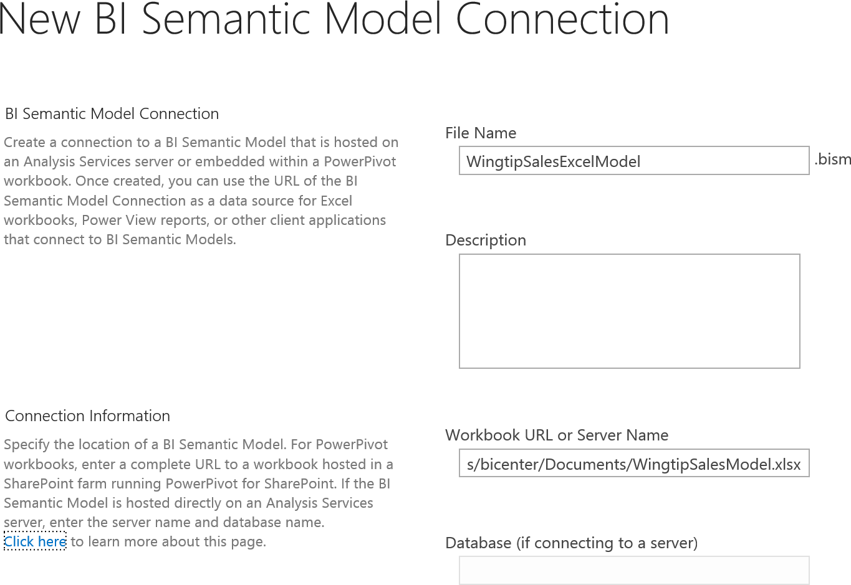

1. Return to the home page of the BI Center.
2. Click **Site Actions | Edit Page**.
3. Delete the Untitled Web Part from the home page.
   1. Click on the arrow for the web part and choose **Delete** from the drop-down menu.

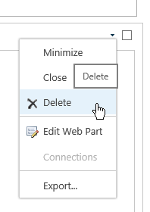

1. In the **Main** web part zone, click **Add a Web Part**
2. Choose the **Business Data** category and the **Excel Web Access** Web part.

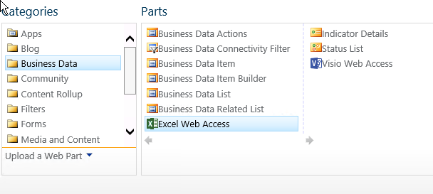

1. Click **Add**.
2. Select a workbook for the web part to access by clicking the text **Click here to open the tool pane**.
3. In the **Workbook Tool pane** click the **ellipsis** button next to the Workbook text box.
4. Browse into the **Documents** library and chose the **WingtipSalesModel.xlsx** file.
5. Click **Insert**.
6. Scroll to the bottom of the tool pane and click OK.
7. In the ribbon, click **Stop Editing**.
8. You should now see the entire Workbook displayed in the web part.

### Exercise 4: Use REST API to Display Chart in Web Part

In this exercise you use the Excel Services REST API to pull a chart through an Image Web Part and display it on a SharePoint page.

#### Add Bar Chart to PivotTable

1. Open the existing WingtipSalesModel workbook.
   1. **Browse** to the location of the file (**C:/Student/Models/WingtipSalesModel.xlsx**) and then click **Open** and then click **OK**.
2. Create Bar Chart to Sales by Customer Age sheet in workbook:
   1. Select the **Sales by Customer Age** sheet and then click on **Row Labels** which is cell B4.

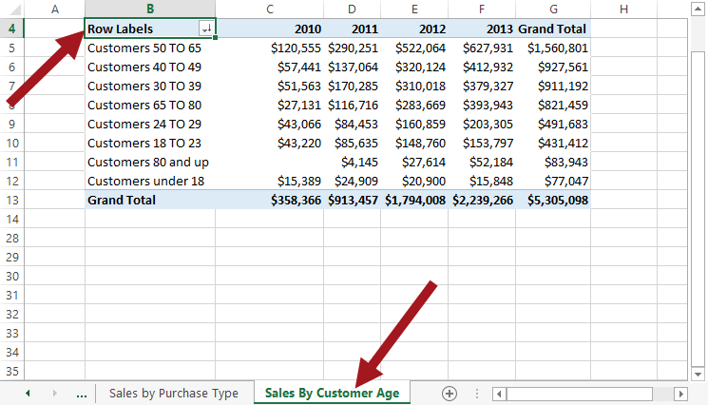

* 1. From the **INSERT** tab in the **Charts** group, select the **Insert Column Type** drop-down and then click on **Clustered Column**.

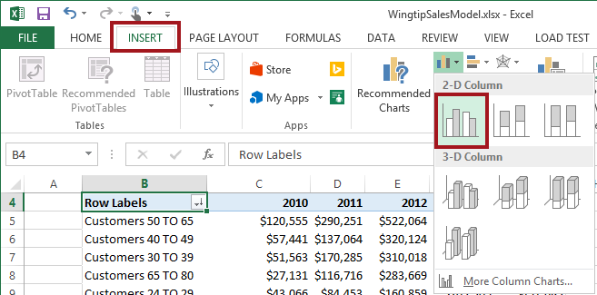

* 1. Reposition the chart and resize if desired, similar to the image below.

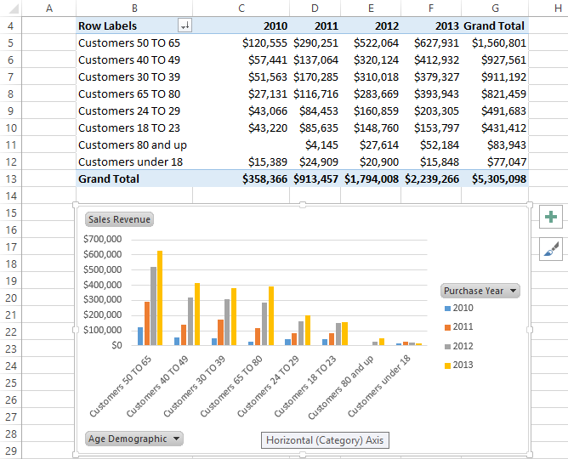

* 1. Notice the Chart Name is **Chart 1**. This name will be used for building the REST API later in this exercise.



1. Add Title to Chart 1:
   1. With the chart still selected click on the **DESIGN** tab then select the first option from the **Quick Layout**.

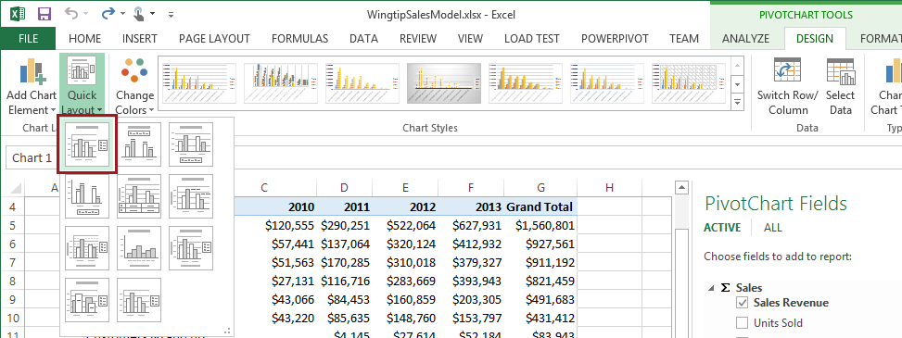

* 1. Select Chart Title from the chart and then rename to **Sales Revenue by Customer Age**.

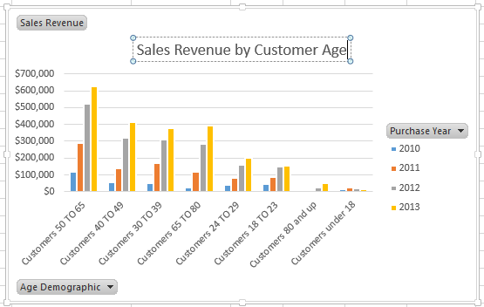

1. **Save** the file.

#### Upload Workbook to Documents Library

1. Now navigate to your Business Intelligence site [**http://intranet.wingtip.com/sites/bicenter**](http://intranet.wingtip.com/sites/bicenter)
2. Click on **Site Contents** in the left navigation and then click on the **Documents** tile.



1. Upload the **WingtipSalesModel.xlsx** file to the Document library:
   1. From the **Documents** library, click **+New Document** to open the **Add a Document** dialog.
   2. **Browse** to the location of the file and then click **Open**.
   3. Click **OK**.
2. Navigate to the BI Center site homepage: [**http://intranet.wingtip.com/sites/bicenter**](http://intranet.wingtip.com/sites/bicenter)
3. Your site should look like this.



#### Add Image View Web Part to Page

1. Click **Site Actions** | **Edit Page**.
2. When prompted to check out the page click **OK**.

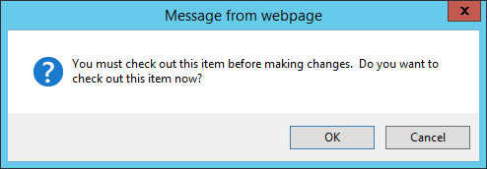

1. Delete the Excel Web Access Web Part from the home page.
   1. Click on the arrow for the web part and choose **Delete** from the drop-down menu.
2. In the **Main** web part zone, click **Add a Web Part**
3. Click the **Media and Content** category and chose the **Image Viewer Web Part** then click **Add**.

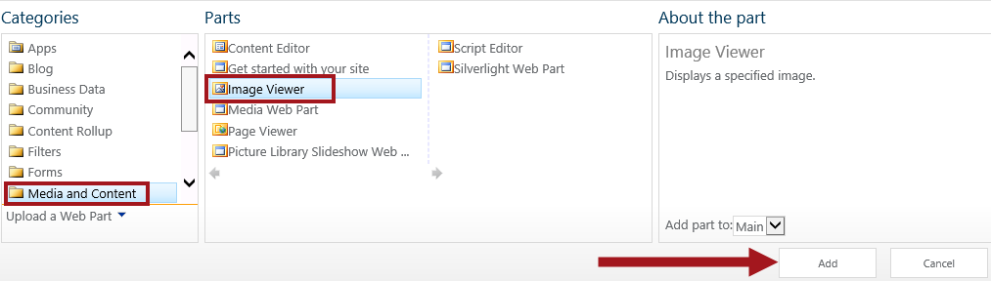

1. Click the text **Open the tool pane** to access the web part properties.



#### Build REST API URL for Chart

1. In the browser type the following to open the RSS feed for the WingtipSalesModel.xslx file**: http://intranet.wingtip.com/sites/bicenter/_vti_bin/ExcelRest.aspx/Documents/WingtipSalesModel.xlsx/model**
2. Click on **Charts**.

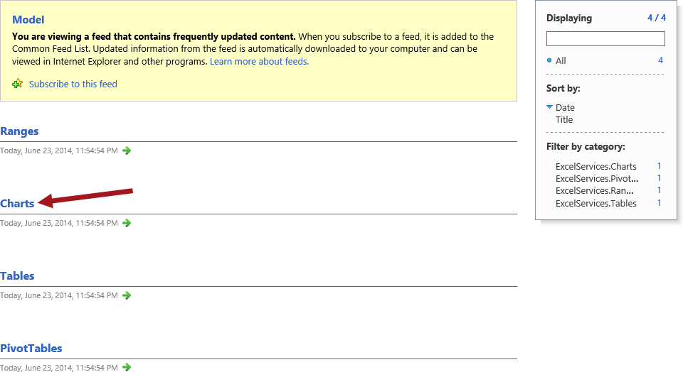

1. Now click on **Chart 1**.

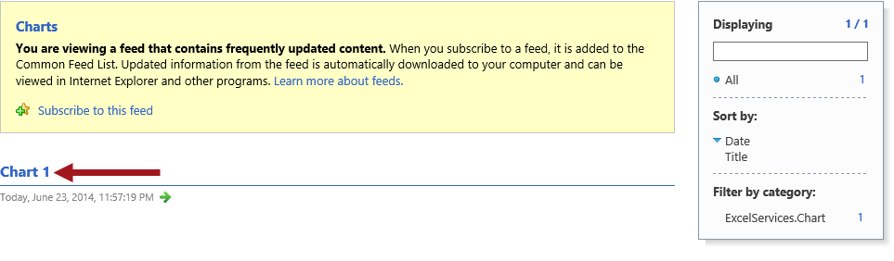

1. Ensure the chart image renders and then copy the relative URL.

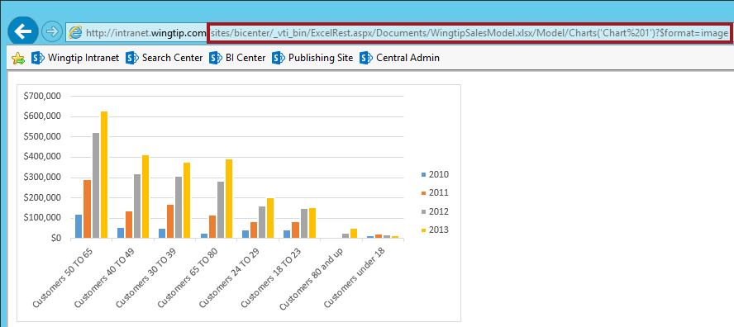

1. In the Image Link text box paste the copied relative URL:

**/sites/bicenter/_vti_bin/ExcelRest.aspx/Documents/WingtipSalesModel.xlsx/Model/Charts('Chart%201')?$format=image**

This isn’t as scary as it looks…

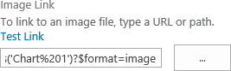

1. Update the remaining Web Part properties:
   1. Change **Image Vertical Alignment** to **Top**
   2. Change **Image Horizontal Alignment** to **Left**.

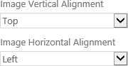

* 1. Set Chrome Type to None.
  2. Click **OK**.

1. In the Ribbon, choose **Stop Editing**.
2. The Chart should now be rendering successfully on the page as shown in the image below.

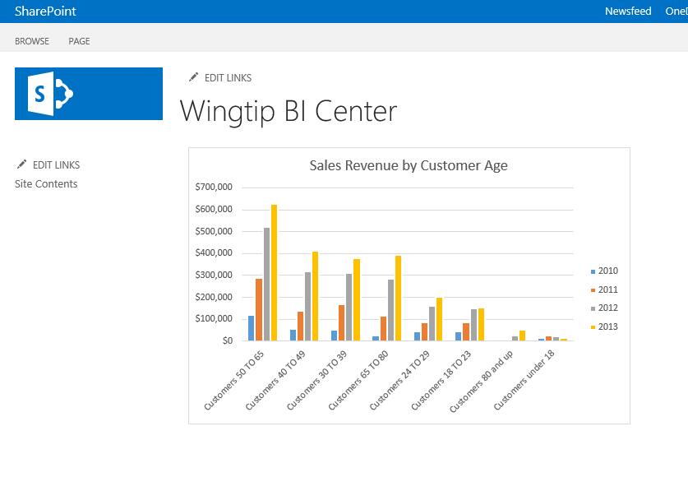

You have now learned two methods to add Excel charts to a SharePoint page.