## Getting Started with the Excel Data Model

**Lab Time**: 60 minutes

**Lab Folder**: C:\Student\Modules\GettingStarted\Lab\

**Lab Overview**: In the lab exercises throughout this course you will work with product sales data from Wingtip Toys, a fictitious retail sales company. Wingtip Toys first began selling their products in January of 2010 with several stores on the West coast of the United States. In their first year of business the overwhelming majority of product sales revenue came from in-person customer purchasing although there was also a minor amount of sales revenue generated by mail-order customers.

In June of 2011, Wingtip Toys added support to their public website which allows customers to make online purchases which has had very positive effect sales. In January of 2012, Wingtip Toys began to execute on an aggressive plan to expand to the East coast by investing in targeting advertising and by opening new stores in retail malls.

In the following lab, you will begin the work to create a data model which will allow you to analyze product sales data from 2010 through the end of 2013. More specifically, you will work with Excel 2013 and PowerPivot to create a new Excel data model using existing product sales data in a Microsoft Access database. You will also learn how to import additional data from a secondary source to create a custom dimension table for analyzing sales revenues by geographical region.

### Exercise 1: Activating Excel 2013 Add-ins for PowerPivot and Power View

Before you can begin to work with the Wingtip product sales data, you must make sure Microsoft Excel has been properly configured so that the Excel Add-ins have been enabled for PowerPivot and for Power View.

#### Log in to Student Environment

1. Login to the Student VM using the login **WINGTIP\Administrator** and the appropriate password.
   1. If you’re using a local VM provided by the hosting training company, the password will be **Password1**.
   2. If your student VM is hosted by CloudShare, the password for the **WINGTIP\Administrator** account is going to be unique for each student, system-generated by CloudShare. Also note that the CloudShare VM configuration usually logs you into the VM automatically so you do not have to enter the user name and password.

#### Enable Excel Add-Ins

1. Launch Microsoft Excel 2013.
   1. Press the **Windows** key to navigate to the Windows Start page.
   2. Launch Microsoft Excel 2013.



* 1. Once Excel has started, the program displays the **New** page as shown in the following screenshot.
     1. Create a new workbook by clicking the **Blank workbook** tile.

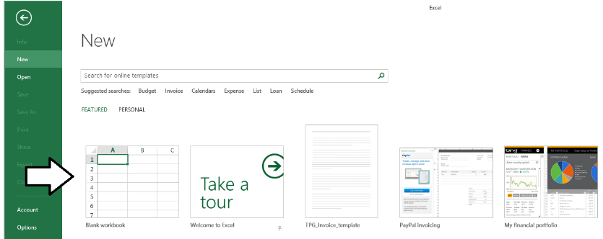

* 1. Once the new workbook has been created, inspect the tabs in the ribbon. At this point, there should not be a ribbon tab for PowerPivot.

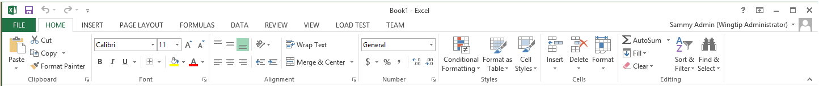

If you do see the POWERPIVOT tab in the ribbon, it means that the PowerPivot add-in for Excel has already been activated. If this is the case, you can now skip past this exercise to the beginning of the next exercise.

1. Activate the Excel Add-ins for PowerPivot and Power View.
   1. In the Excel ribbon, click on the **File** menu and then click on the **Options** link as shown in the following screenshot to display the Excel Options dialog.

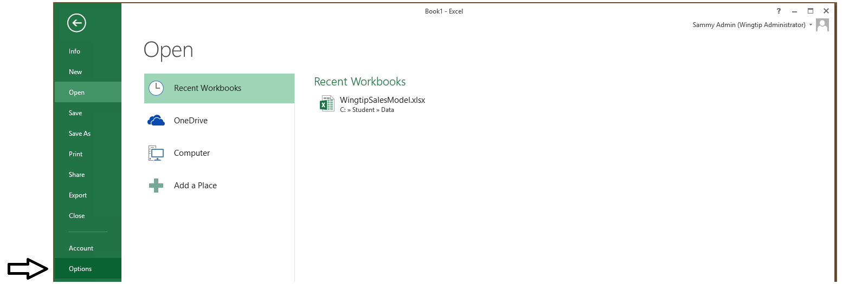

* 1. In the Excel Options dialog…
     1. Click on the **Add-Ins** tab on the left-hand side.
     2. Select **COM Add-ins** in the **Manage** dropdown box and then click the **Go…** button to display the **COM Add-ins** dialog.

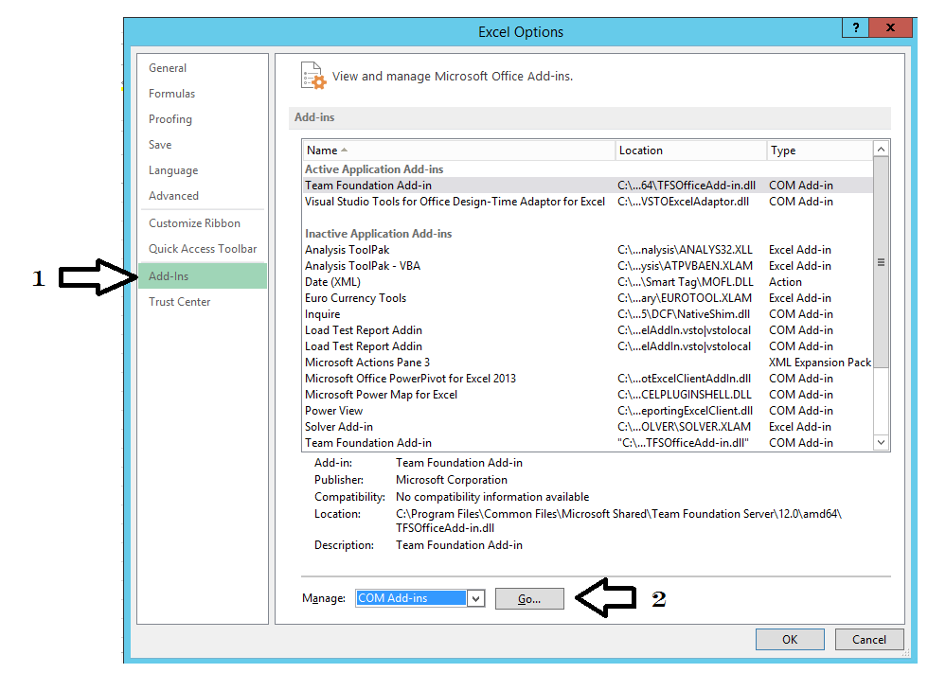

* 1. In the **COM Add-Ins** dialog, select the following Add-Ins.
     1. Microsoft Office PowerPivot for Excel 2013
     2. Microsoft Power Map for Excel
     3. Power View

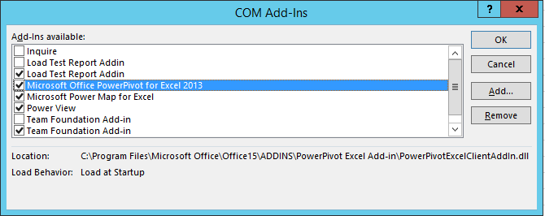

* 1. Click **OK** to close the **COM Add-Ins** dialog.

1. Once the PowerPivot Add-In is enabled, you should be able to see a new **POWERPIVOT** tab on the ribbon.

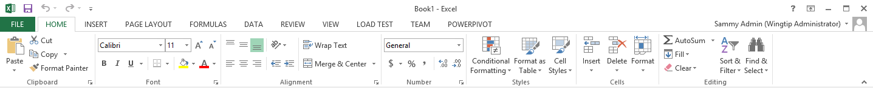

1. Click on the **POWERPIVOT** tab in the ribbon and inspects it contents.
   1. In the **Data Model** ribbon group, there is a **Manage** button you can use to launch the PowerPivot user interface.
   2. In the **Calculations** ribbon group, there are controls to create new Calculated Fields and KPIs.
   3. The **Slicer Alignment** ribbon group, there is an **Align Vertically** button and an **Align Horizontally** button.
   4. In the **Tables** ribbon group, there is an **Add to Data Model** button and an **Update All** button.
   5. In the **Relationships** ribbon group, there is a **Detect** button.
   6. On the far right, there is a **Setting** button you can use to display the **PowerPivot Options and Diagnostics** dialog.

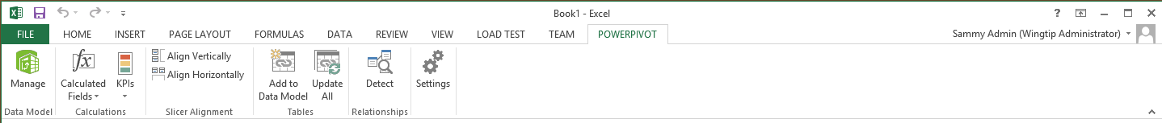

1. Leave Excel open but close any and all open workbooks and then move on to the next lab.

Now that you have configured Excel by enabling the PowerPivot Add-In, you can began designing and building the Excel data model which you will use to analyze product sales data.

### Exercise 2: Create New Data Model using Data from the Wingtip Sales Database

In this exercise you will create a new Excel workbook and import data from a Microsoft Access database to create an Excel data model for Wingtip sales data.

1. Review the table schema of the Wingtip Sales database.
   1. Inspect the following diagram which shows the schema for the four tables in the Wingtip Sales database.

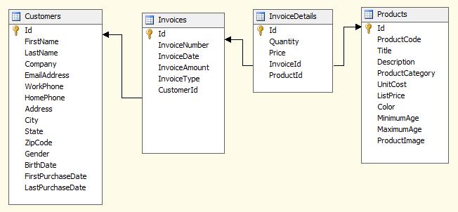

1. Let's make a few important observations about the schema of the Wingtip Sales database.
   1. The **InvoiceDetails** table will serve as the primary fact table for sales with aggregate measures on **Price** and **Quantity**.
   2. The **Customers** table will serve as a dimensions table for customer geography, customer age and customer gender.
   3. The **Customers** table has several columns that will not be used as dimensions such as **FirstName**, **LastName** and **Address**.
   4. The **Invoices** table will serve as a dimensions table for purchase type and purchase date.
   5. The **Products** table will serve as a dimensions table for product and product category.

Now that you have a basic understanding of the table schema of the Wingtip Sales database, it's time for you to import the Wingtip sales data into the data model of a new Excel workbook.

#### Create Excel Workbook

1. Create a new Excel workbook.
   1. If Microsoft Excel 2013 is not already running, launch it now.
   2. Click on **File >> New**.
   3. Create a new workbook by clicking the **Blank workbook** tile.
   4. Once the Excel workbook has been created, save the workbook to the local hard drive using the following path.

c:\Student\Models\WingtipSalesModel.xlsx.

1. Open the PowerPivot window for the current Excel workbook.
   1. Navigate to the **POWERPIVOT** tab in the Excel ribbon.
   2. Click the **Manage** button in the **Data Model** ribbon group to open the PowerPivot window.



* 1. When the PowerPivot window appears, you should be able to see the name of the workbook file **WingtipSalesModel.xlsx**. However, this PowerPivot window does not display anything below the ribbon. That's because a new Excel workbook like this is always created with an empty data model.

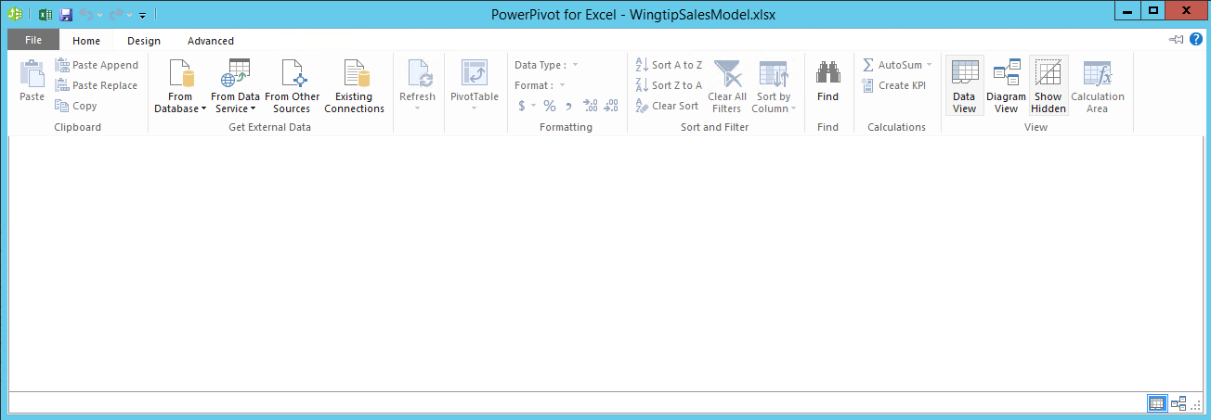

#### Import Data into Workbook

1. Use the Table Import Wizard to import the four tables from the Wingtip Sales database.
   1. Navigate to the **Home** tab in the ribbon of the PowerPivot window.
   2. Locate the **From Database** dropdown menu in the **Get External Data** ribbon group.
   3. Drop down the **From Database** dropdown menu and select the option **From Access** to start up the **Table Import Wizard**.

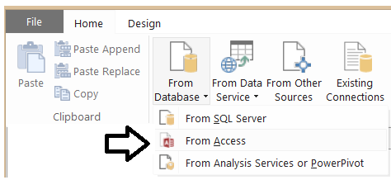

* 1. The first page of the **Table Import Wizard** prompts you to **Connect to a Microsoft Access Database**. Fill out the data for this page using the following values and then click **Next**.
     1. Friendly connection name: **Wingtip Sales Database**
     2. Database name: **C;\Student\Data\WingtipSales.accdb**
     3. User name: *leave blank*
     4. Password: *leave blank*

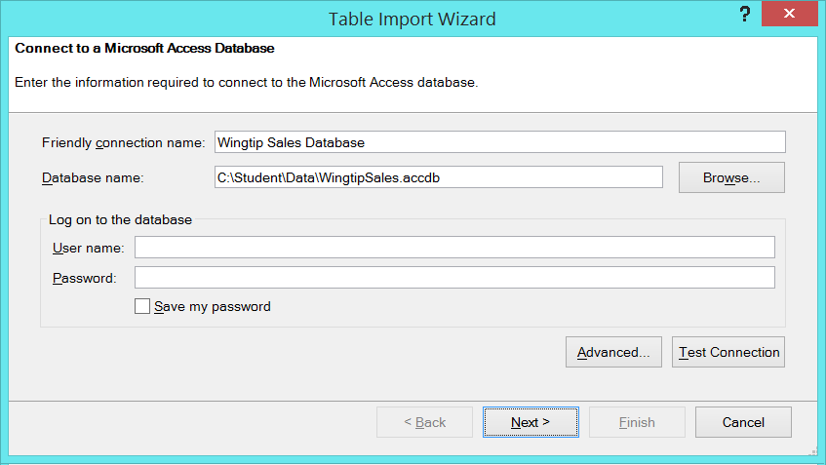

* 1. On the **Choose How to Import the Data** page of the **Table Import Wizard**, keep the default option of **Select from a list of tables and views to choose the data to import** and then click **Next**.

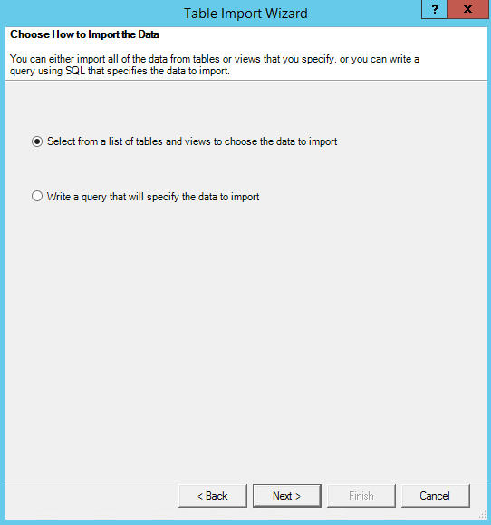

* 1. On the **Select Tables and Views** page of the **Table Import Wizard**…
     1. Make sure you do *NOT* click the **Finish** button prematurely - wait until you finish all the steps outlined here.
     2. Select each of the four tables including **Customers**, **InvoiceDetails,** **Invoices** and **Products**.

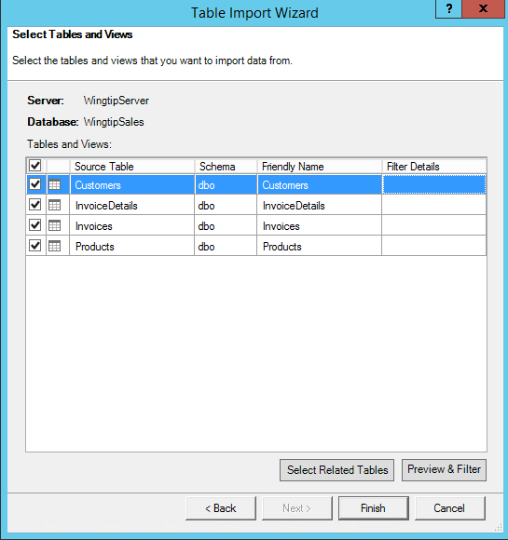

* 1. Update the **Friendly Name** of the **InvoiceDetails** table to **Sales**.

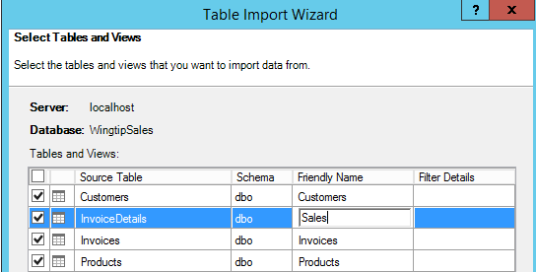

* 1. Update the **Friendly Name** of the **Invoices** table to **Purchases**.

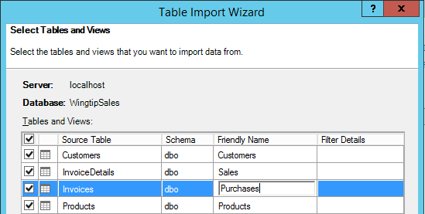

* 1. Select the row with the **Customers** table and then click the **Preview & Filter** button.

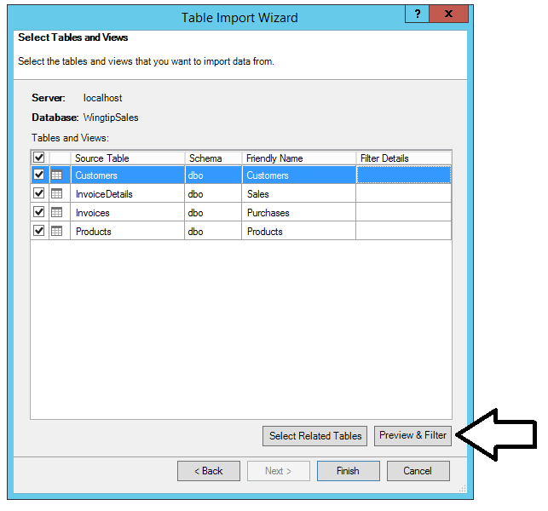

* 1. In the **Preview Selected Table** page of the **Table Import Wizard**, you should see all the columns from the **Customers** table along with a few rows of data. Note that you can remove unwanted columns such as **FirstName** and **LastName** from the import process by unchecking the checkboxes for those columns.

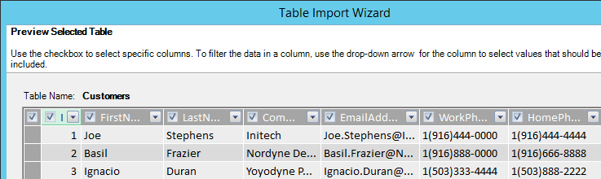

* 1. Uncheck the checkbox for the following unneeded columns to remove them from the table import process.
     1. FirstName
     2. LastName
     3. Company
     4. EmailAddress
     5. WorkPhone
     6. HomePhone
     7. Address
  2. Once you have unchecked the unwanted columns on the **Preview Select Table** page for the **Customers** table, click the **OK** button to return to the **Select Tables and Views** page.

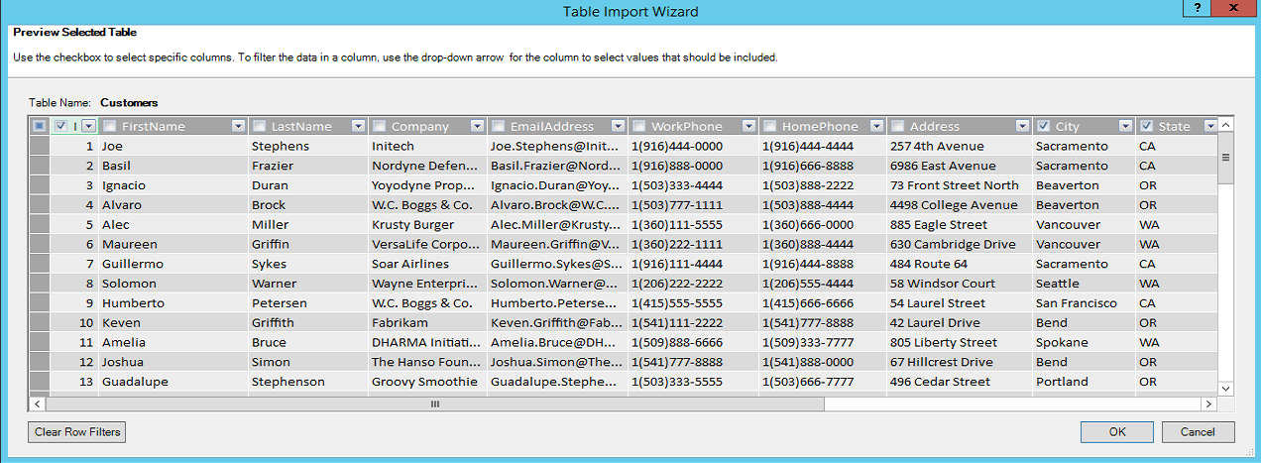

* 1. On the **Select Tables and Views** page of the **Table Import Wizard**, click the **Finish** button to begin the import process.
  2. Once the data import process has completed you should see a confirmation of success that looks like the following screenshot which reports on the number of rows that have been imported into each new table in the data model.

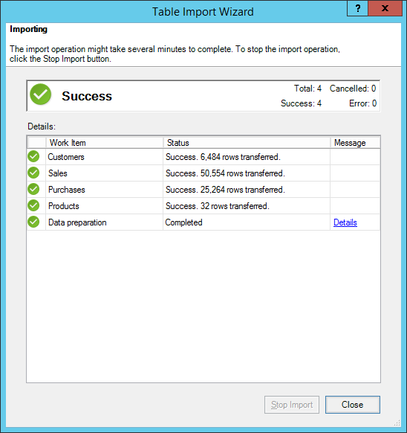

* 1. If you click on the **Details** link in the **Message** column, you will see the following dialog with a somewhat cryptic message that tells you that PowerPivot was able to create three table relationships on the imported tables because table relationships were defined between the tables in the Wingtip Sales database.

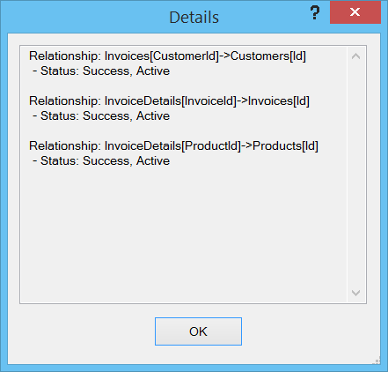

Keep in mind that you were not explicitly required to create the relationships between the tables imported from the Wingtip Sales database. That's because the **Table Import Wizard** was able to recognize the relationships that exist between the tables in the SQL Server database and to add the relationships into the Excel data model as part of the import process.

* 1. 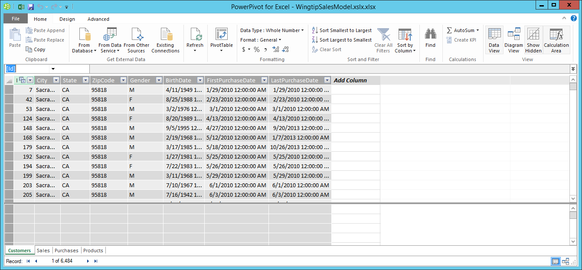Click the **Close** button to close the **Table Import Wizard**. You should now see the four tables available for viewing in the main PowerPivot window.

1. Take a minute to inspect the four tables that have been imported using the tabs at the bottom of the PowerPivot window.

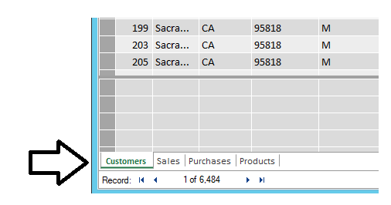

1. Inspect the relationships between the four imported tables.
   1. Switch the PowerPivot window from *Data View* to *Diagram View* by clicking the **Diagram View** button in the ribbon.

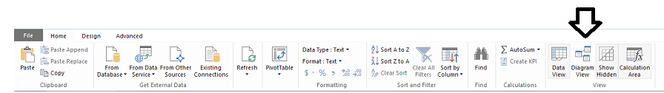

* 1. When you move to **Diagram View,** you should see the four imported tables you just imported. You should also be able to see three lines connected tables which represent relationships. However, the initial layout of the tables in **Design View** needs to be cleaned up.
  2. Using the mouse in **Diagram View**, rearrange the fours tables as shown below to make things more visually appealing.

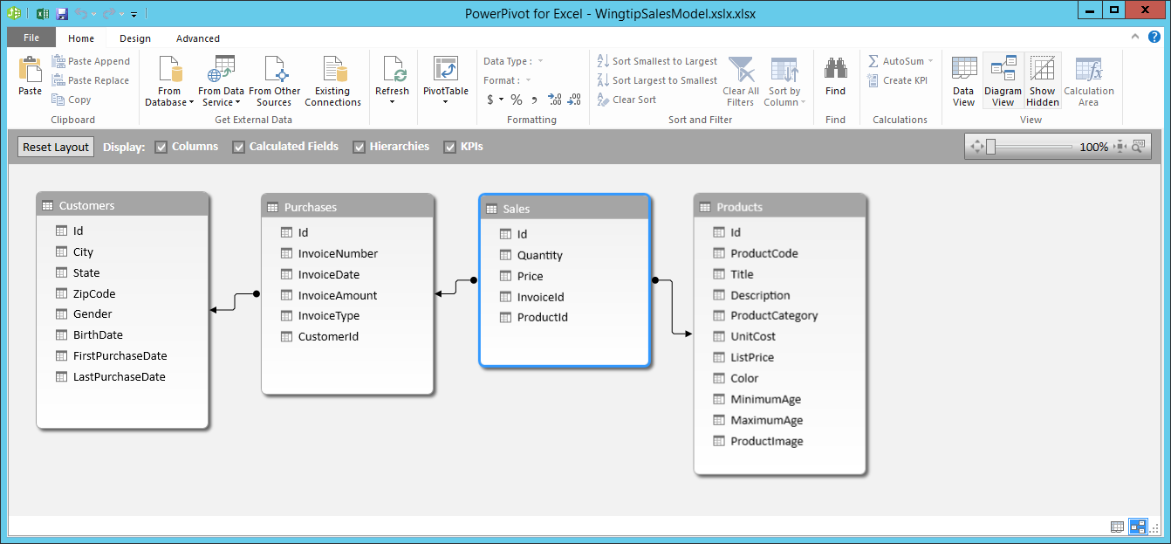

One handy aspect of using **Design View** is that it makes it simple to change the name of a table or a table column. In this scenario, there is a column in the **Sales** table named **Price** that contains that sales amount. In order to make the data model easier to understand, you will now change the name of the **Price** column to **Sales Amount**.

1. Change the name of the **Price** column to **Sales Amount**.
   1. In **Design View**, right-click on the **Price** column in the **Sales** table and click the **Rename** command.

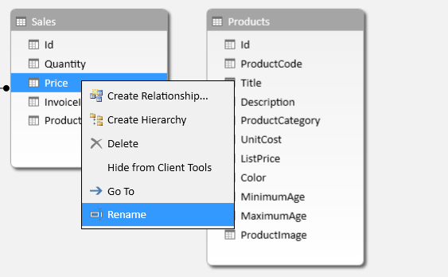

* 1. Rename the column **Sales Amount**.

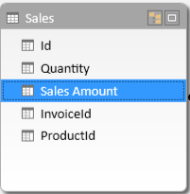

1. Click on the **Data View** button in the ribbon to move the PowerPivot window back to Data View.

Now that you have imported data in the data model, you will move on to the next exercise where you will create a simple PivotTable using this data model which displays sales revenue by state.

### Exercise 3: Creating a PivotTable from an Excel Data Model

In this exercise you will create a simple PivotTable using the Wingtip sales data you imported in the previous exercise.

#### Create PivotTable

1. If you are not already there, navigate to the PowerPivot window for the workbook **WingtipSalesModel.xlsx**.
2. Create a new PivotTable to show sales revenue by state.
   1. From the **Home** tab in the ribbon, drop down the **PivotTable** menu control and click **PivotTable**.

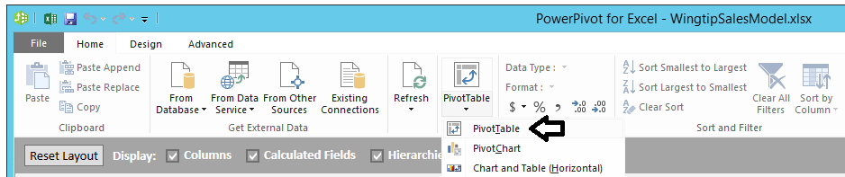

* 1. When the **Create PivotTable** dialog appears, select **Existing Worksheet** and click the **OK** button.

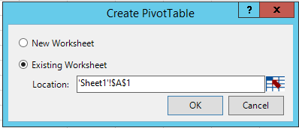

* 1. Once the PivotTable has been added to the worksheet, you should see the PivotTable work area on the left-hand side and a PivotTable Fields section on the right-hand side in the task pane.

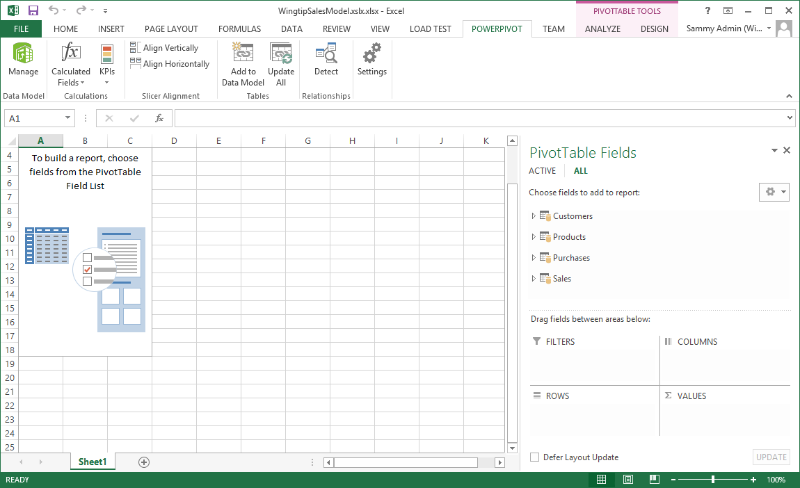

#### Customize PivotTable

1. Customize the PivotTable to show sales revenue by state.
   1. On the right-hand side of the workbook, expand the **Sales** table in the **PivotTable Fields** task pane.
   2. Select the **Sales Amount** column from the **Sales** table. When you do this, you should see the column show up in the **VALUES** section down below with a default name of **Sum of Sales Amount**.

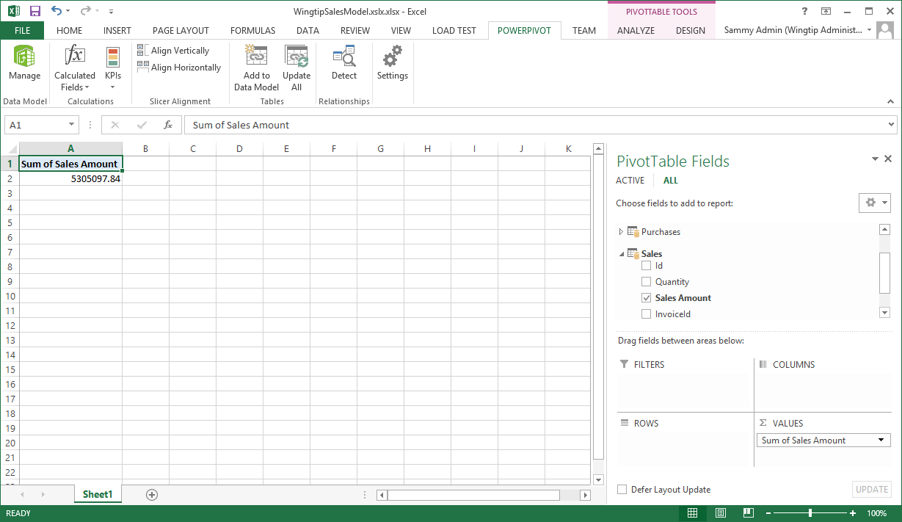

* 1. In the **VALUES** section in the bottom right of the PowerPivot window, click on **Sum of Sales Amount** to drop down the menu control and click the **Value Field Settings…** command to display the **Field Value Settings** dialog.

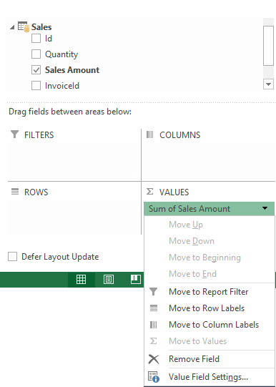

* 1. In the **Value Field Settings** dialog, change the **Custom Name** property from **Sum of Sales Amount** to **Total Sales Amount**.

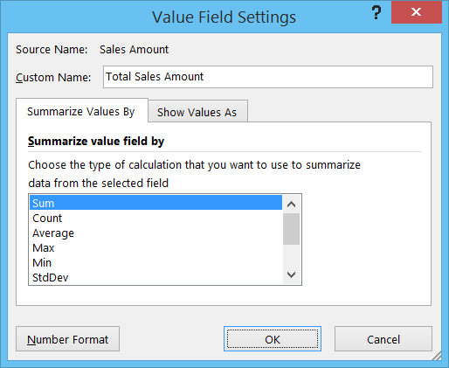

* 1. In the **Value Field Settings** dialog, click to **Number Format** button to display the **Format Cells** dialog.
  2. In the **Format Cells** dialog, set the **Category** to **Currency** and assign a value of **0** for the number of **Decimal places**.

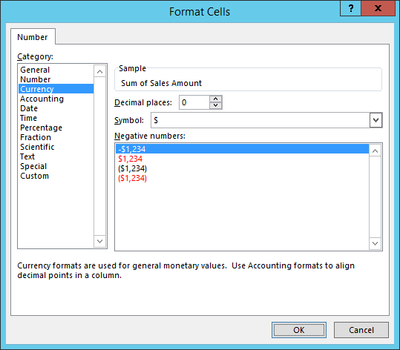

* 1. Click **OK** to close the **Format Cells** dialog.
  2. Click **OK** to close the **Value Field Settings** dialog.
  3. You should now see the result in the PivotTable has been renamed to **Total Sales Amount** and is formatted as currency.

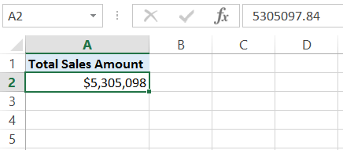

1. Add the **State** column from the **Customers** table to view sales revenue by that dimension.
   1. In the list of **PivotTable Fields**, expand the columns of the **Customers** table.
   2. Select the column named **State** which should expand the PivotTable to show sales revenue on a state-by-state basis.

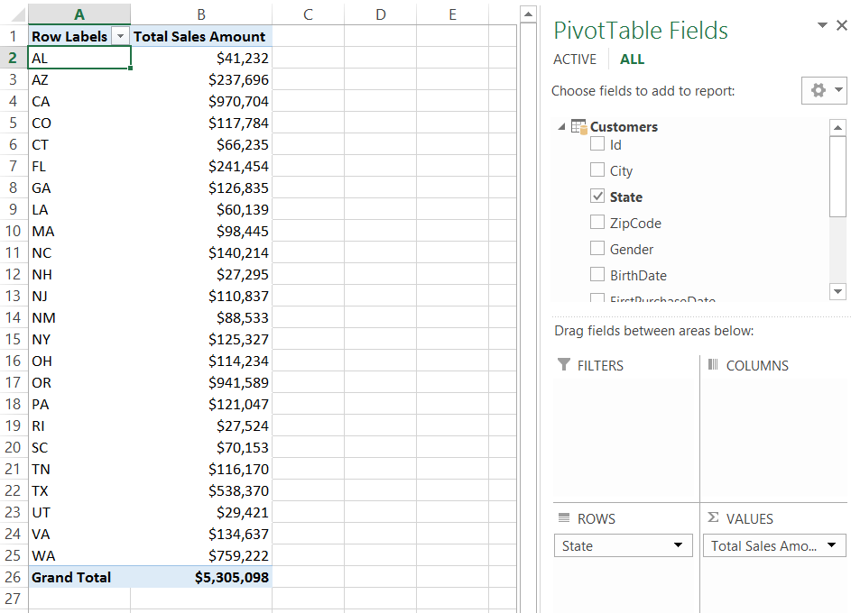

* 1. The next task is to sort the list of states so that the states with the higher sales revenue are displayed at the top. You can accomplish this by right-clicking on any cell in the **Total** **Sales Amount** column and selecting the menu command the **Sort >> Sort Largest to Smallest**.

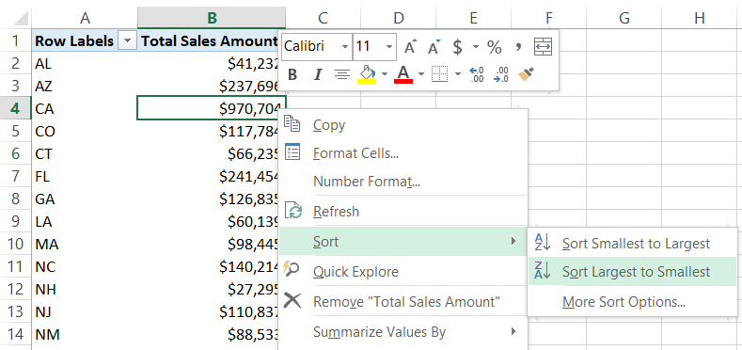

* 1. You should now see the states have been reordered by sales revenue in a descending fashion with **CA** at the top.

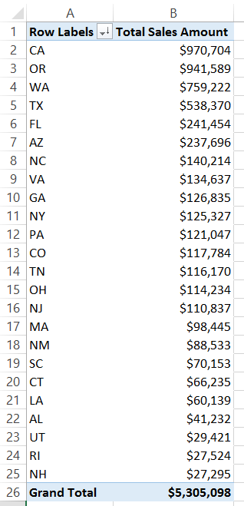

1. Rename the current worksheet from **Sheet1** to **Sales by State**.

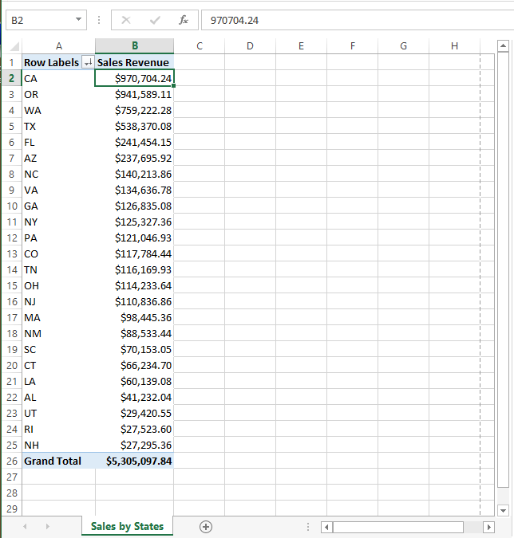

You have now created a simple PivotTable from the Excel data model in **WingtipSalesModel.xlsx**.

### Exercise 4: Adding a New Dimensions Table for Sales Region

In this exercise you will add a new dimension table which assigns a geographic sales region to each state. It will also include the full name for each state so that reports can display state names such as California, Texas and Florida instead of state abbreviations such as CA, TX and FL.

#### Import Data

1. Import the data for the Sales Region table from an existing Excel workbook.
   1. The student lab files for this course include an Excel workbook named **SalesRegions.xlsx** which contains the following table which contains a row for each of the 50 states along with the state full name and an assigned sales region. As you can see, the 50 states have been divided into three sales regions which are **Western Region**, **Central Region** and **Eastern Region**.

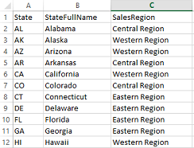

* 1. Navigate to the PowerPivot window for **WingtipSalesModel.xlsx**.
  2. In the Get External Data ribbon group, click the **From Other Sources** button to start the **Table Import Wizard**.

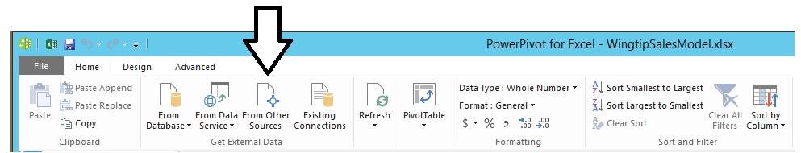

* 1. In the **Connect to a Data Source** page of the **Table Import Wizard**, scroll down the list of available sources, select **Excel file** and then click the **Next** button to move to the next page.

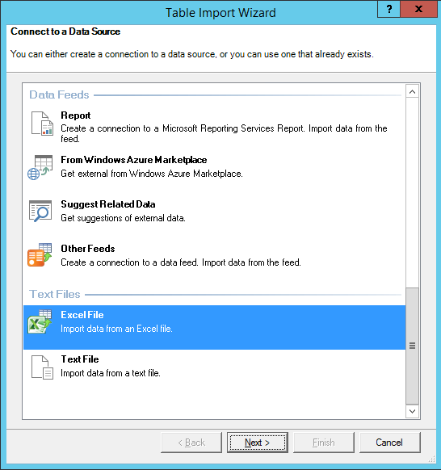

* 1. On the **Connect to a Microsoft Excel File** page, enter the following information:
     1. **Friendly connection name**: Sales Regions from WingtipSalesRegions.xlsx
     2. **Excel File Path**: C:\Student\Data\WingtipSalesRegions.xslx
     3. **Use first row as column headers**: Checked

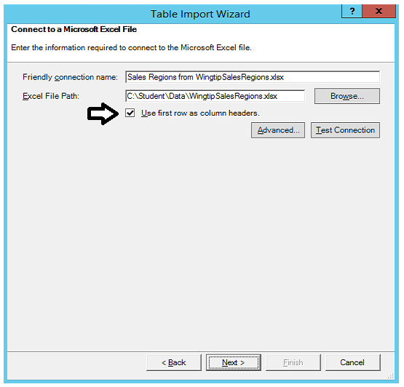

* 1. Click the **Next** button on the **Connect to a Microsoft Excel File** page to move to the **Select Tables and Views** page.
  2. On the **Select Tables and Views** page, accept the default settings and click the **Finish** button to begin the import process.

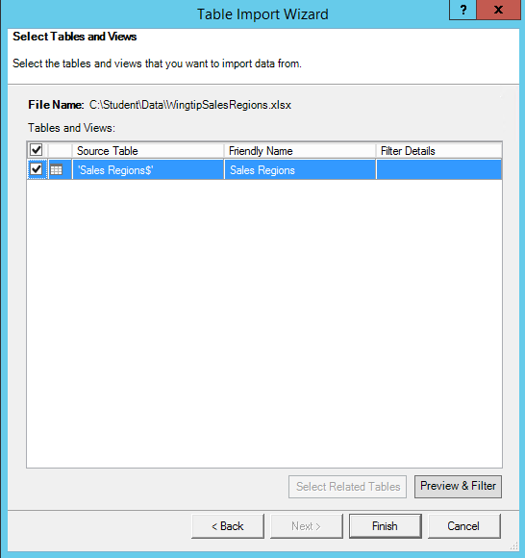

* 1. Once the import process completes, you should see a success confirmation which tells you that 50 rows have been imported.

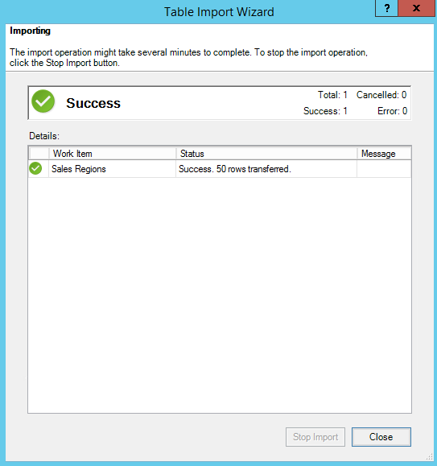

* 1. Click the **Close** button to close the **Table Import Wizard** and inspect the newly imported **Sales Regions** table.

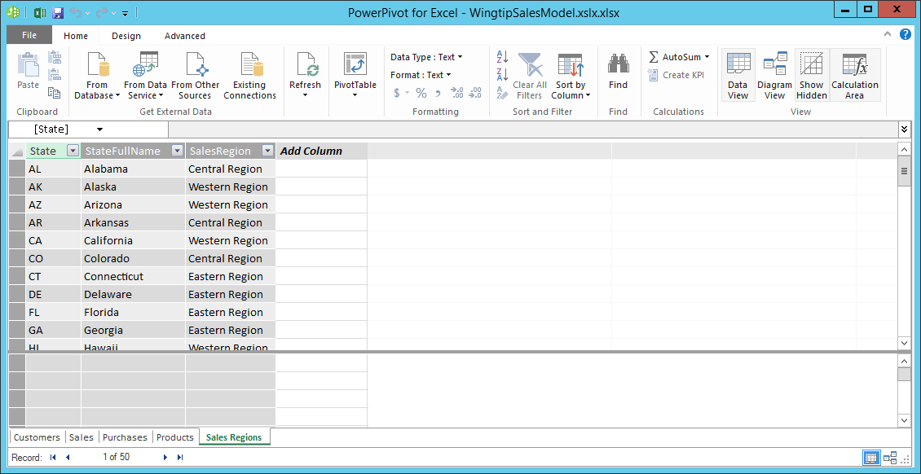

#### Define Relationships

1. Define a relationship between the **Customers** table and the **Sales Regions** table.
   1. Switch the PowerPivot window over to Diagram View by clicking the **Diagram View** button in the ribbon.
   2. You should be able to see **Sales Regions** table in Diagram View but this table has been created without any relationships.
   3. Using your mouse in Diagram View, drag the **Sales Regions** table to the left of the **Customers** table.

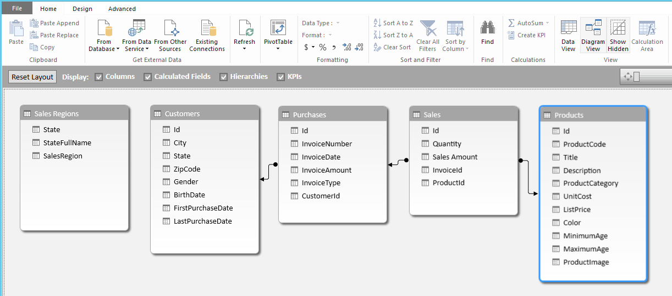

* 1. Using your mouse, drag-and-drop the **State** column from the **Customers** table on top of the **State** column of the **Sales Regions** table to create a relationship between the two.

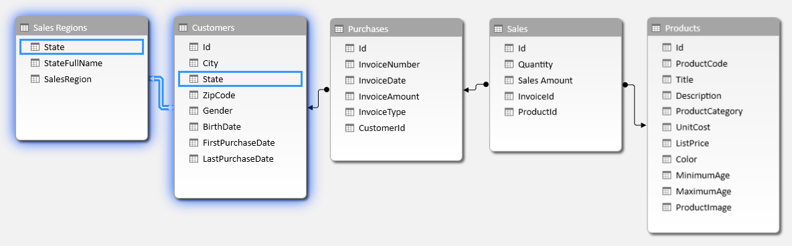

You have just created a table relationship that allows you to integrate the Sales Regions table with the other tables in the data model. You will now demonstrate this by creating a second PivotTable that breaks down sales revenue by sales category and then by state.

#### Modify the PivotTable

1. Navigate back to the Excel application window and the **Sales By State** worksheet you created with the PivotTable.
2. Select one of the cells in the PivotTable so that Excel shows the **PivotTable Fields** sections. You should see that **Sales Regions** is now displayed with the other four tables.

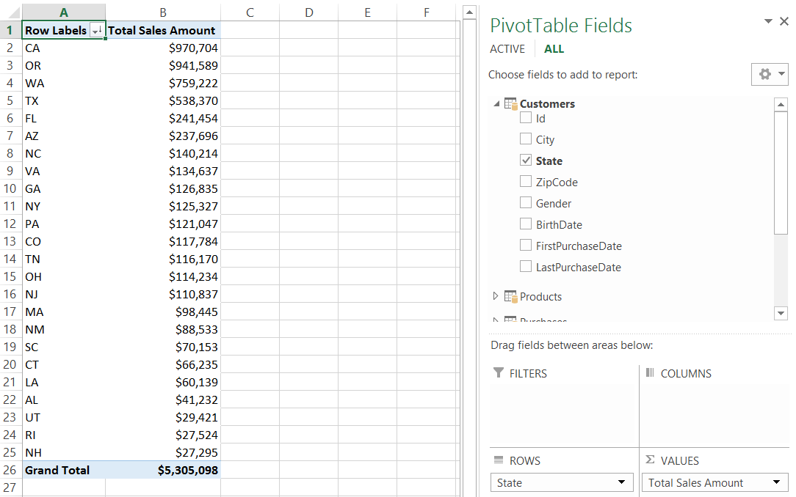

1. Remove the row label for the State column in the Customers table.
   1. Expand the Customers table. You should see that the State column is checked.

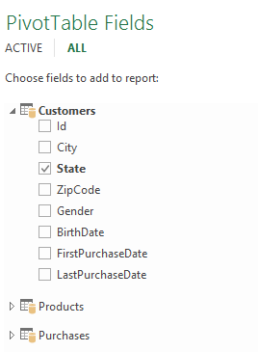

* 1. Uncheck the **State** column.

1. Add the **SalesRegion** column from the **Sales Regions** table to view sales revenue by that dimension.
   1. In the list of **PivotTable Fields**, expand the columns of the **Sales Regions** table.
   2. Select the **SalesRegion** column which should expand the PivotTable to show sales revenue split out by sales region.

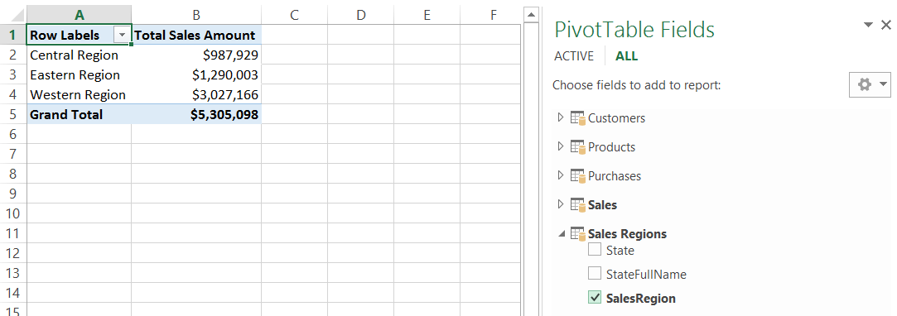

* 1. Right-click on one of the cells in the **Total** **Sales Amount** column and select **Sort >> Sort Largest to Smallest**. This should sort the regions by sales revenue in a descending order.

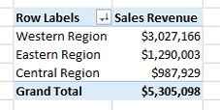

1. Add a secondary row label to show sales revenue by state.
   1. Select the **StateFullName** column which should expand the PivotTable to show sales revenue by state using the full state name in addition to region. After you have completed this step you should be able to see the **StateFullName** column directly under the **SalesRegion** column in the **ROWS** section in the bottom of the task pane.

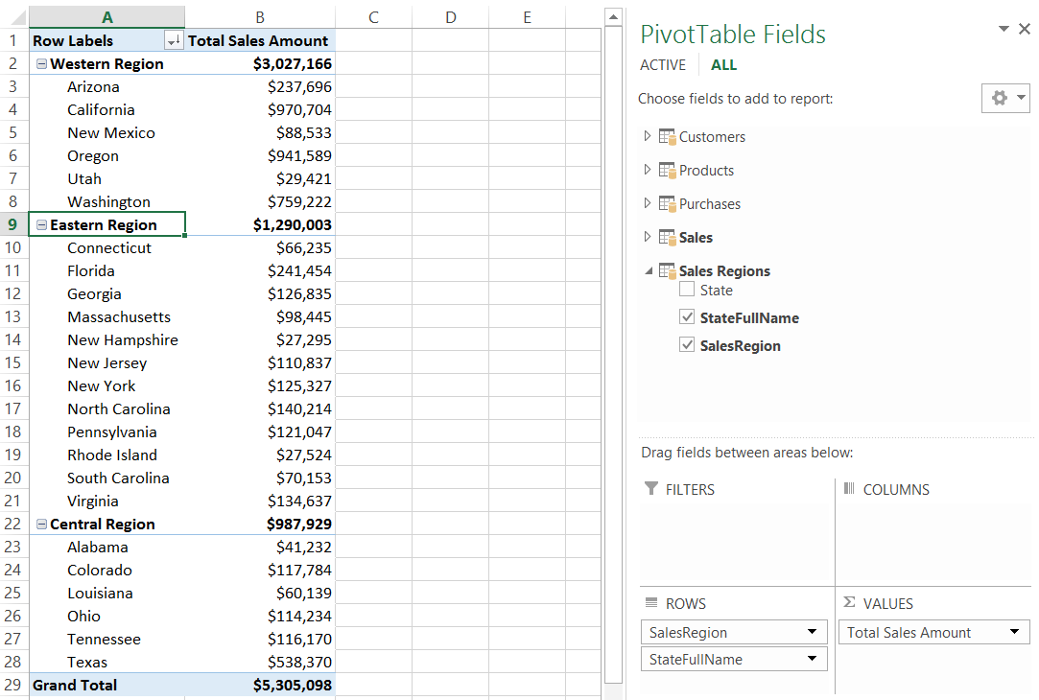

* 1. Right-click on one of the cells in the **Total Sales Amount** column for any state and select **Sort >> Sort Largest to Smallest**. This should sort the states within all regions by sales revenue in a descending order.

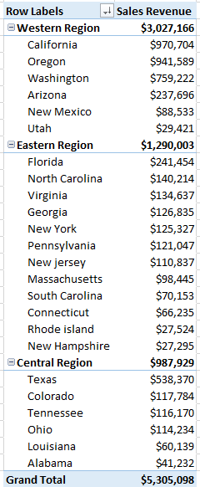

1. Save all changes to the Excel workbook named **WingtipSalesModel.xlsx**.
2. Close the workbook named **WingtipSalesModel.xlsx**.

You have now completed all the steps to this lab.