## Creating Dashboards with PerformancePoint Services

**Lab Time**: 60 minutes

**Lab Folder**: C:\Student\Modules\PerformancePoint\Lab

**Lab Overview**: In this module you will work with a PerformancePoint Services and the Dashboard Designer within a BI center site to create a dashboard based on the Wingtip Sales Cube that you created in the previous lab.

### Exercise 1: Install ADO.NET MD version 10

In this exercise you will install ADO.NET MD on the SharePoint Server which is a prerequisite to running the Dashboard Designer.

1. Look in the folder at **C:\Student\Modules\PerformancePoint\Lab** and locate the installation file named **SQLSERVER2008_ASADOMD10.msi**. Right-click this file and click **Install** to begin the installation process.

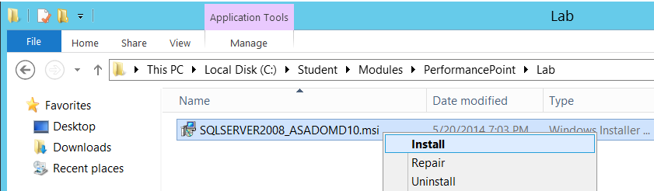

1. Step through the installation process and take all the default installation options along the way.
2. When the installation is done, reboot the student VM.
3. When the student VM has restarted, log in again.

### Exercise 2: Configure the Performance Point Service Application

In this exercise you will make an important configuration to the PerformancePoint Service application service in Central Administration.

1. Launch the browser and navigate to **Central Administration**.
2. In the **Application Management** section, click **Manage service applications**.
3. You should now be at the **Manage Service Applications** page as shown in the following screenshot. Look down the list of managed service applications and click on the one titled **PerformancePoint Service Application** to navigate to the main configuration page for **PerformancePoint Service Application**.

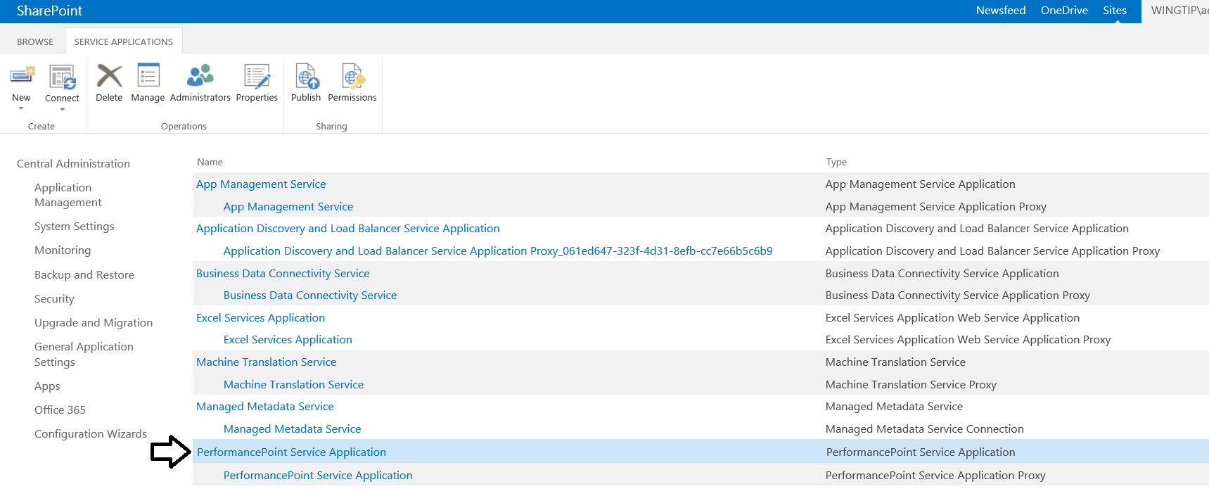

1. You should now be at the main configuration page for PerformancePoint Service Application. Click on the link titled PerformancePoint Service Application Settings.

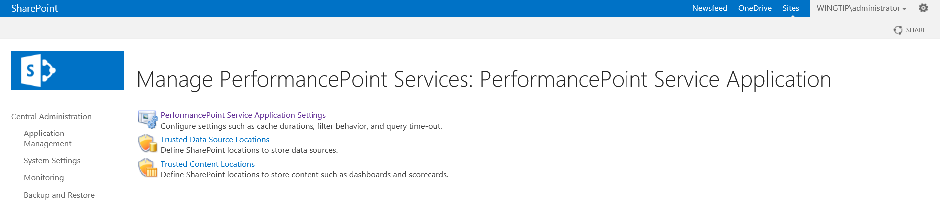

1. You should now be at the **PerformancePoint Service Application Settings** page as shown in the following screenshot. Look down the page to get an idea of the types of settings that are tracked by PerformancePoint Services. Click the **Change User** button.

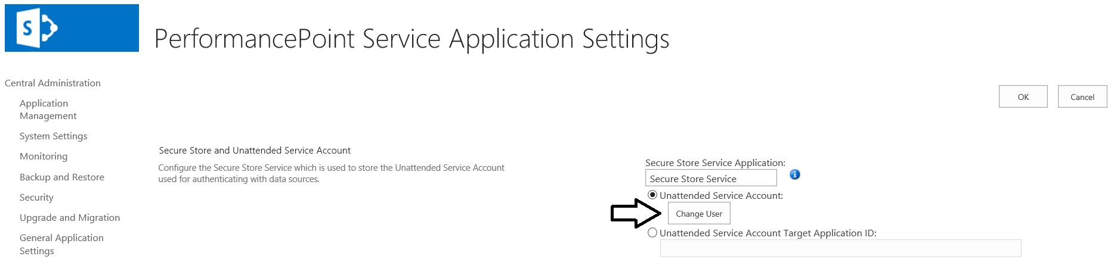

1. Add a User Name of **WINGTIP\SP_Services** and a password of **Password1**.

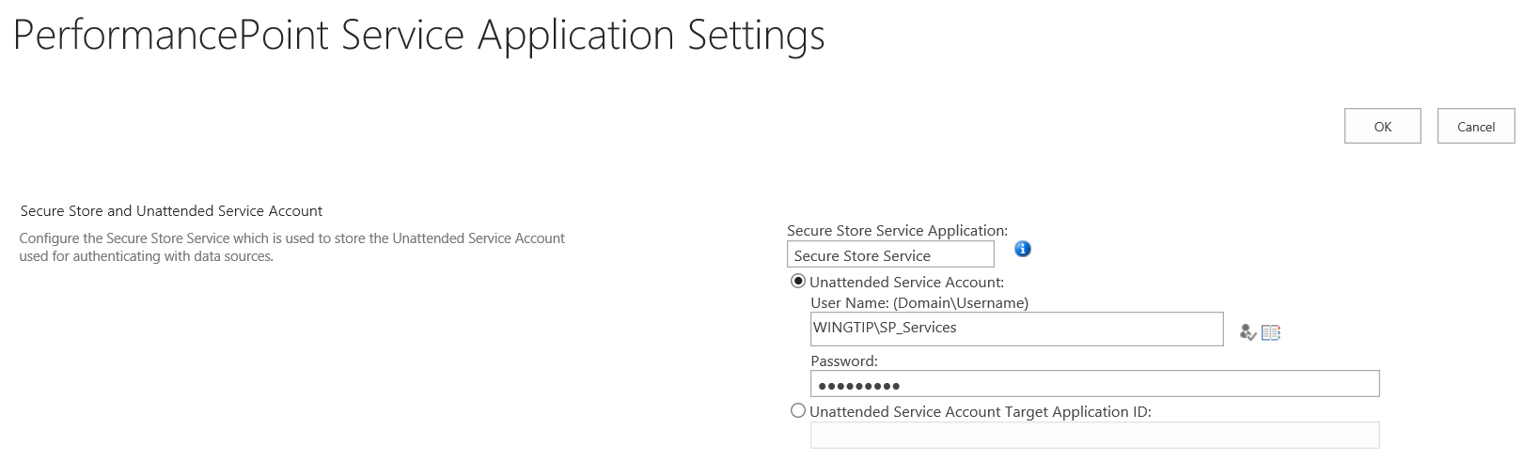

1. Click the **OK** button on the **PerformancePoint Service Application Settings** page to save changes.

Now the configuration is complete and you can begin working with the Dashboard Designer.

### Exercise 3: Use the Dashboard Designer to Create an Analytic Chart

In this exercise you will launch the PerformancePoint Dashboard Designer from a BI Center site and create an analytic report and a dashboard page.

1. Using the browser, navigate to the BI Center site at <http://intranet.wingtip.com/sites/bicenter>.

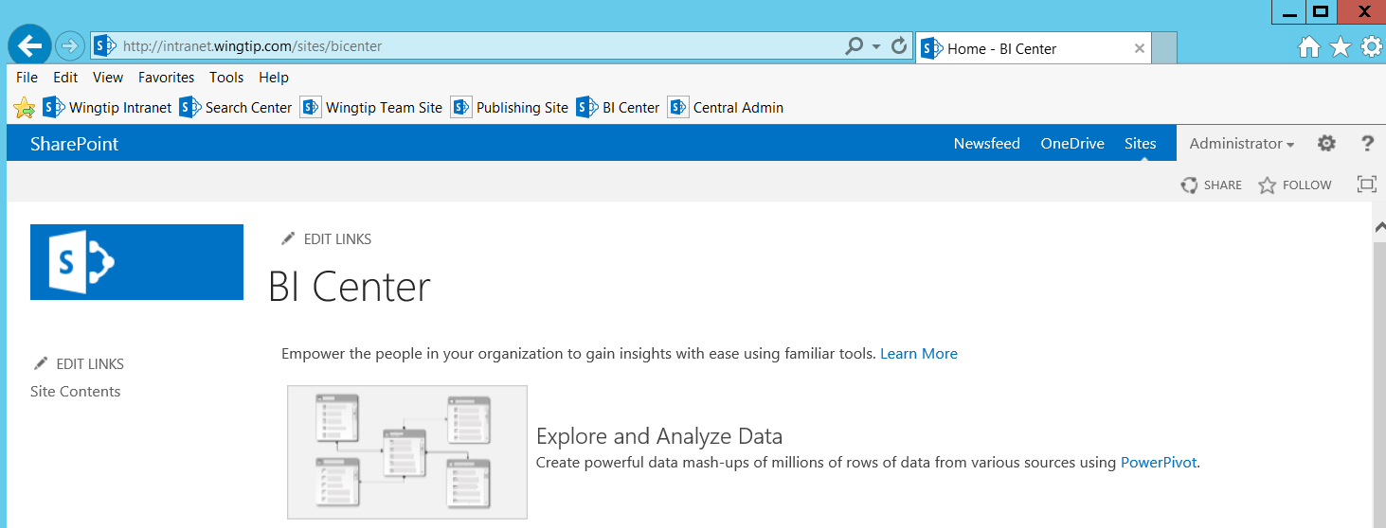

1. Using the Quick Launch, navigate to the Site Content page. Locate and click the **PerformancePoint Content** tile to navigate to the default view of the **PerformancePoint Content** list.

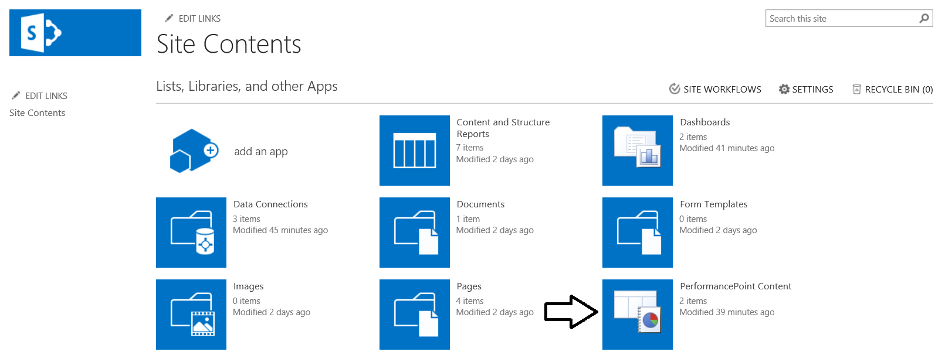

1. On the default view of the **PerformancePoint Content** list, click the **new item** link to launch the Dashboard Designer.

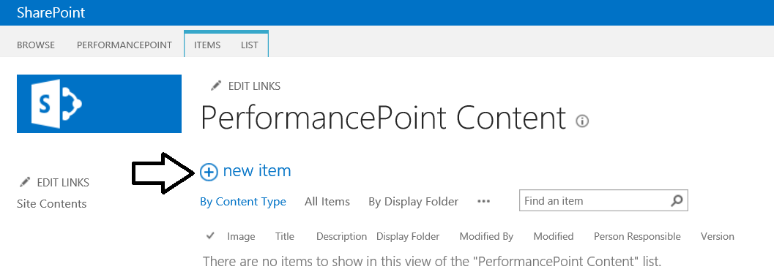

1. The Dashboard Designer should start up and appear as it does in the following screenshot.

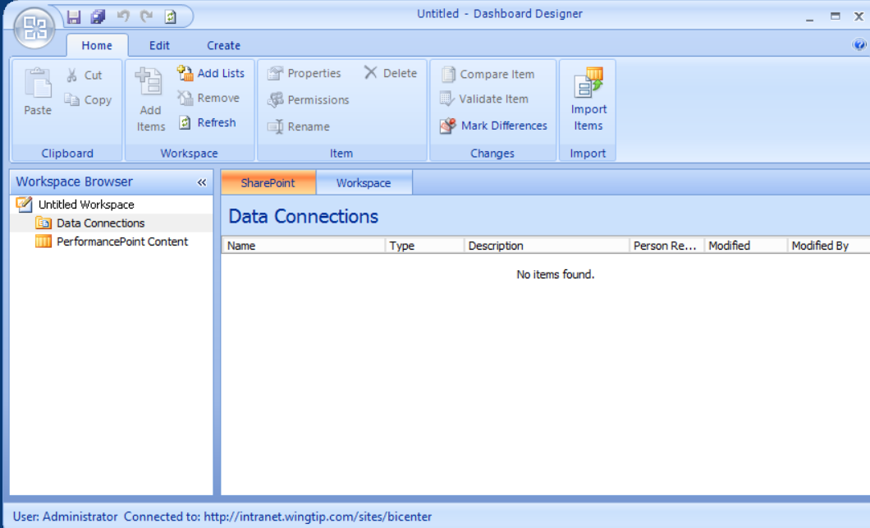

1. Right-click on **Data Connections** folder and then click the **New Data Source** menu command.

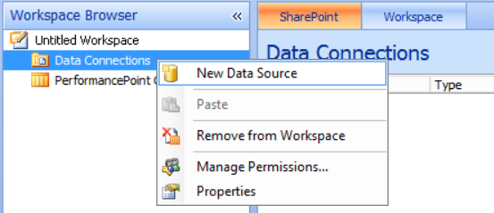

1. When you are prompted with the **Select a Data Source Template** dialog, select Analysis Services and click **OK**.

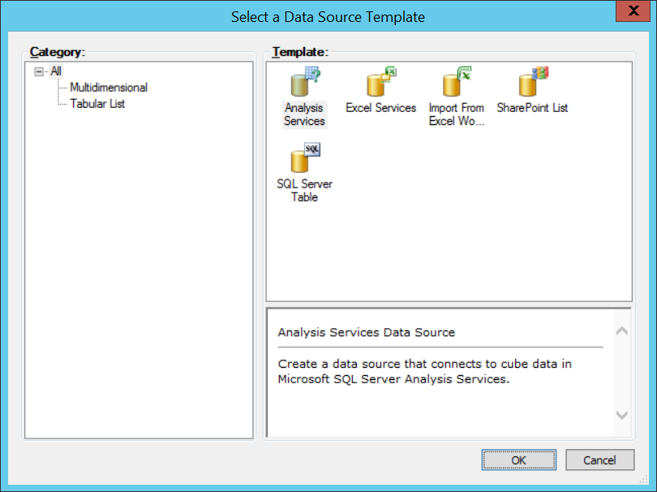

1. In the **Editor** tab of the **New Data Source** form, type in a **Server** setting of **WingtipServer**. Next drop down the control for the **Database** and select **WingtipSalesModelMD**. Finally, drop down the control for the **Cube** and select **Wingtip Sales Cube**.

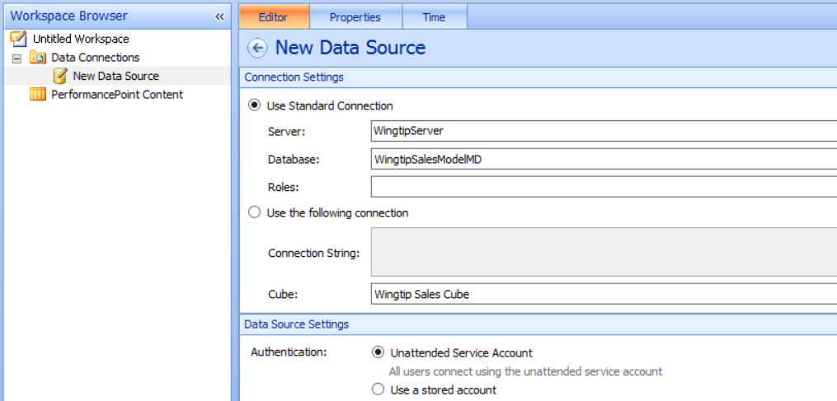

1. Navigate to the **Properties** tab and change the name to **Wingtip Sales Cube**. Save your changes.

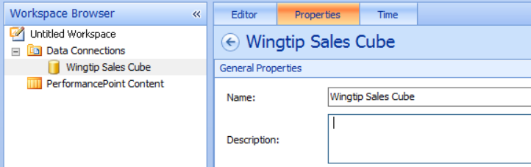

1. Navigate to the **Time** tab and fill in the form using the settings you see in the following screenshot.

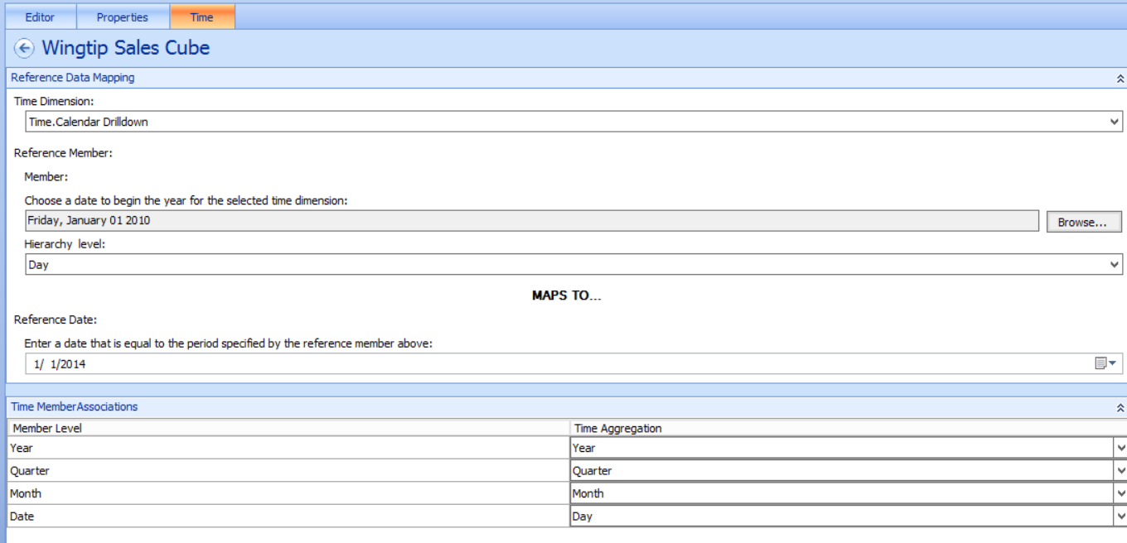

1. Back in the **Workspace Browser**, right-click on the **PerformancePoint Content** folder and select **New > Report**.

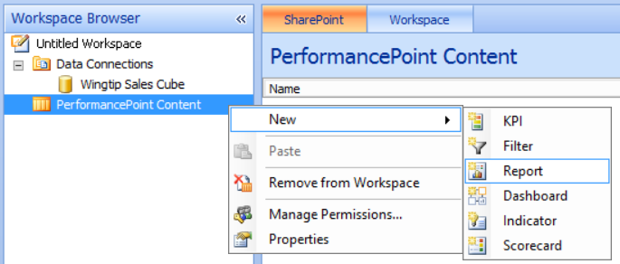

1. In the **Select a Report Template** dialog, select **Analytic Chart** and click **OK**.

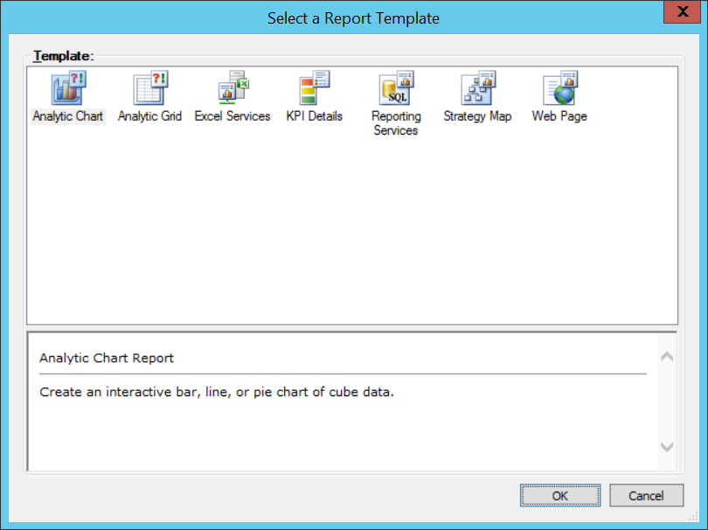

1. In the **Create an Analytic Chart Report** dialog, select the data connection named **Wingtip Sales Cube**.

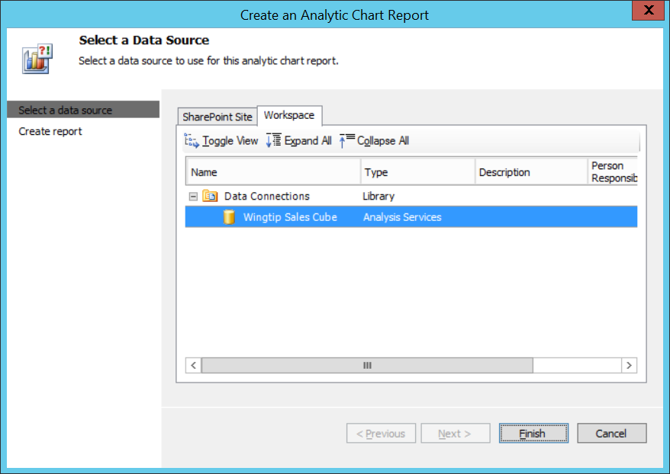

1. Once the chart has been created, rename it to **Product Sales by Region**.

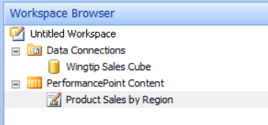

1. Create the chart by adding the measure named **Sales Revenue** to the **Bottom Axis** section and the **Customer Region** attribute of the **Customer** dimension to the **Series** section.

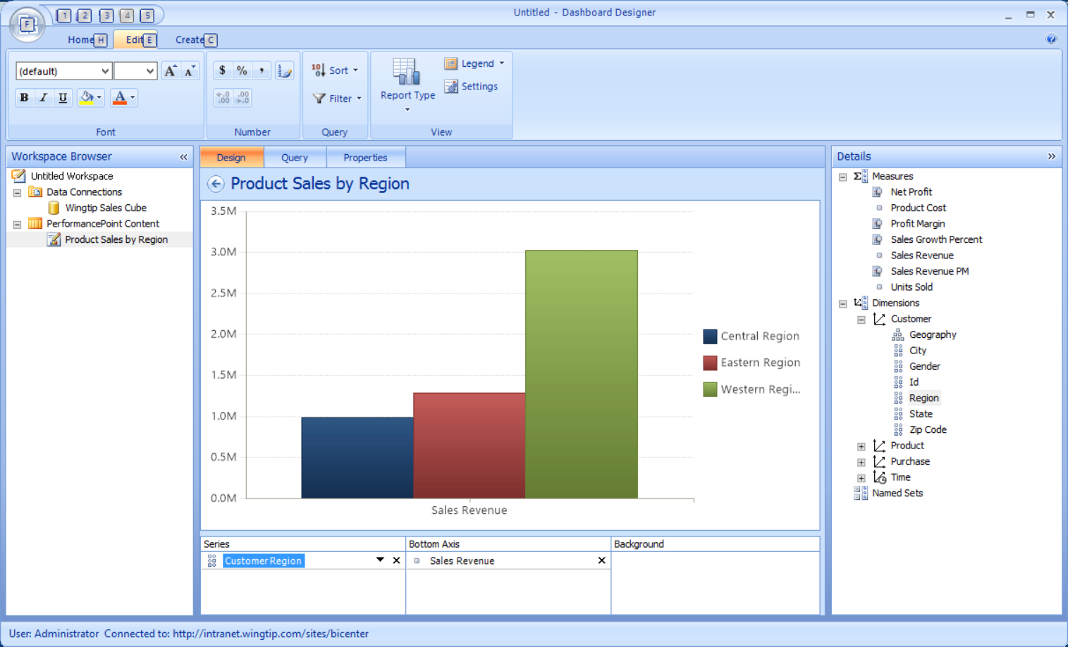

1. In the ribbon, navigate to the **Edit** tab. Drop down the **Report Type** menu button and change the chart type to **Pie Chart**.

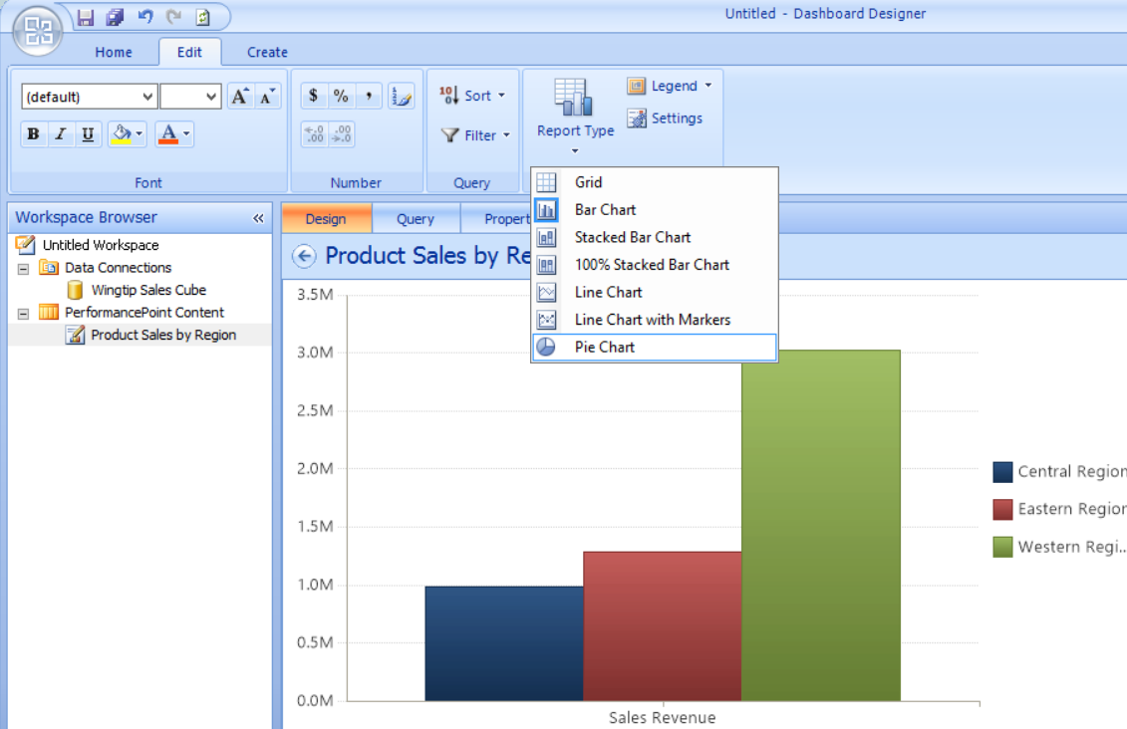

1. At this point, you should be able to see the pie chart on the Dashboard Designer.

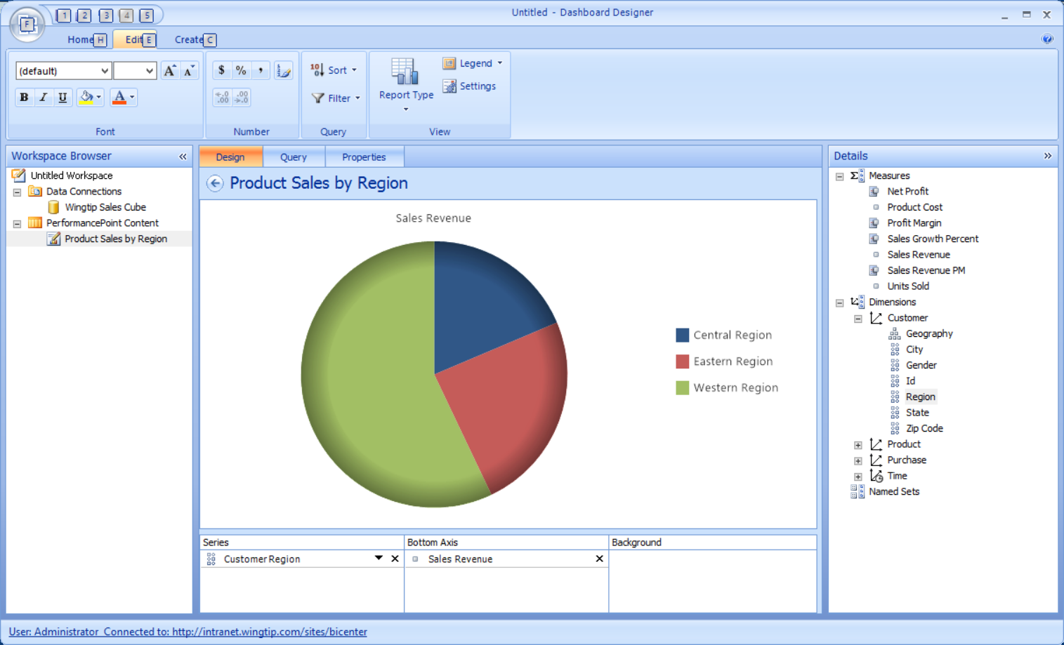

### Exercise 4: Create and Deploy a Dashboard to a SharePoint Site

In the final exercise you will deploy the PerformancePoint Dashboard to a SharePoint site.

1. Right-click on the PerformancePoint Content folder in the **Workspace Browser** section and then click **New > Dashboard** to create a new dashboard.

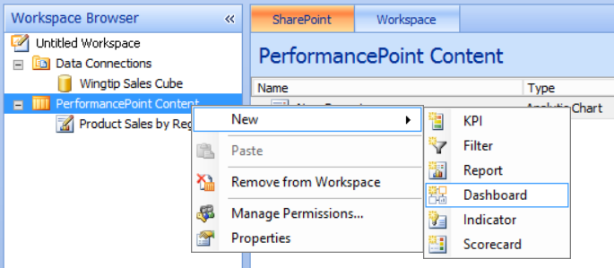

1. In the **Select a Dashboard Page Template** dialog, select the **1 Zone** template and then click **OK**.

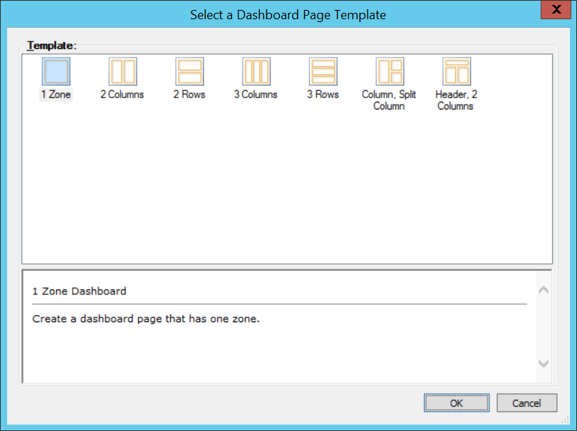

1. The new dashboard is created with a named of **New Dashboard** and a single dashboard page named **Page 1**.

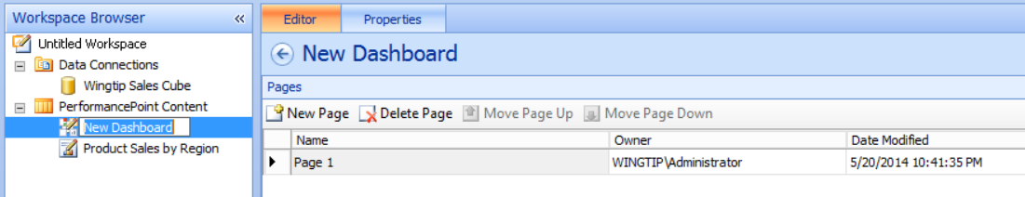

1. Rename the dashboard to **Wingtip Sales Dashboard** and rename the page to **Product Sales by Region**.

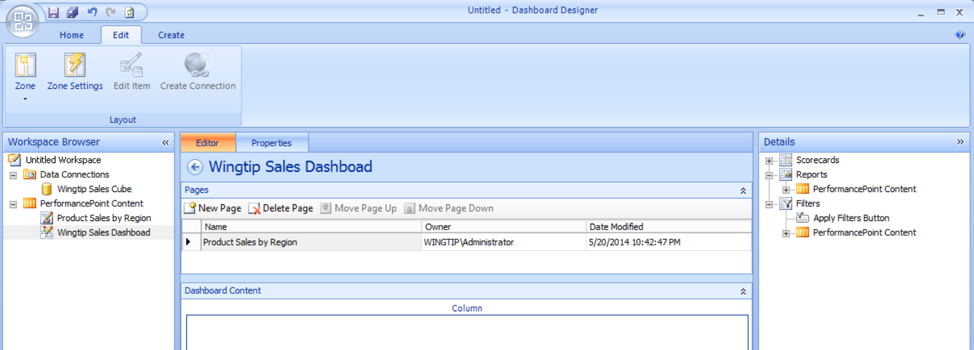

1. In the **Details** section on the right-hand side of the Dashboard Designer, expand **Reports > PerformancePoint Content** so you can see the report named **Product Sales by Region**. Drag and drop the report named **Product Sales by Region** into the **Dashboard Content** section in the bottom of the middle section. Save all your changes.

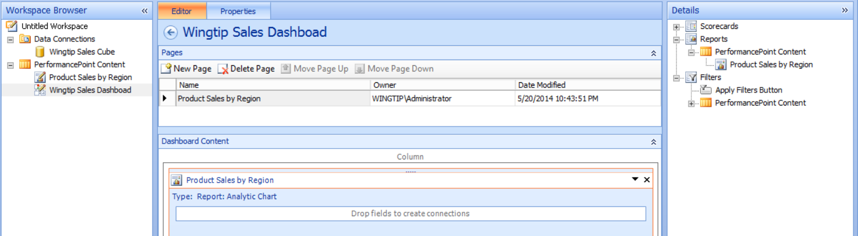

1. In the **Workspace Browser** section, right-click on the dashboard named **Wingtip Sales Dashboard** and then click the **Deploy to SharePoint** menu command.

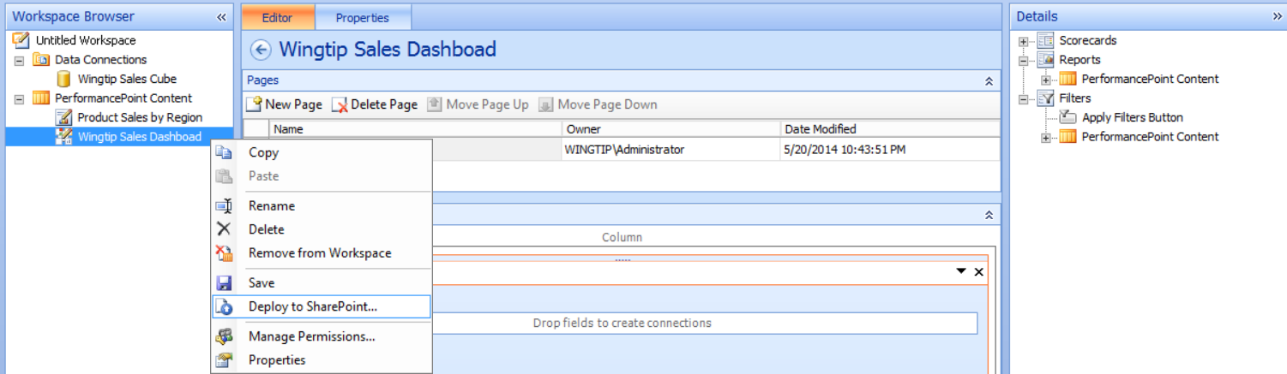

1. When you are prompted with the **Deploy To** dialog, check the **Include page list for navigation** checkbox and click **OK**.

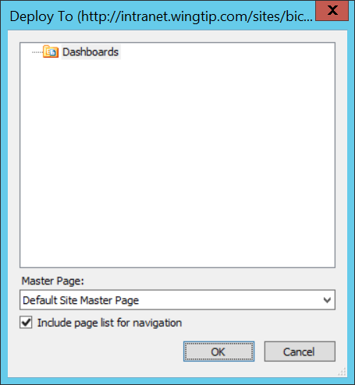

1. The deploy process should complete and you will be redirected to the new Dashboard page.

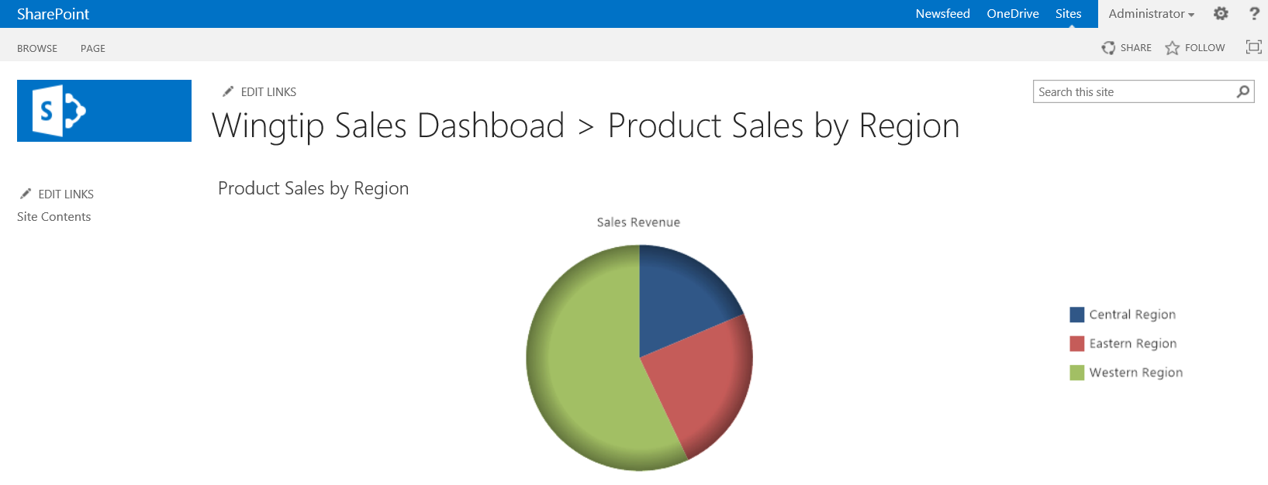

1. Right click on the **Eastern Region** section of the pie chart to display the menu options available. Click the **Decomposition Tree** menu command.

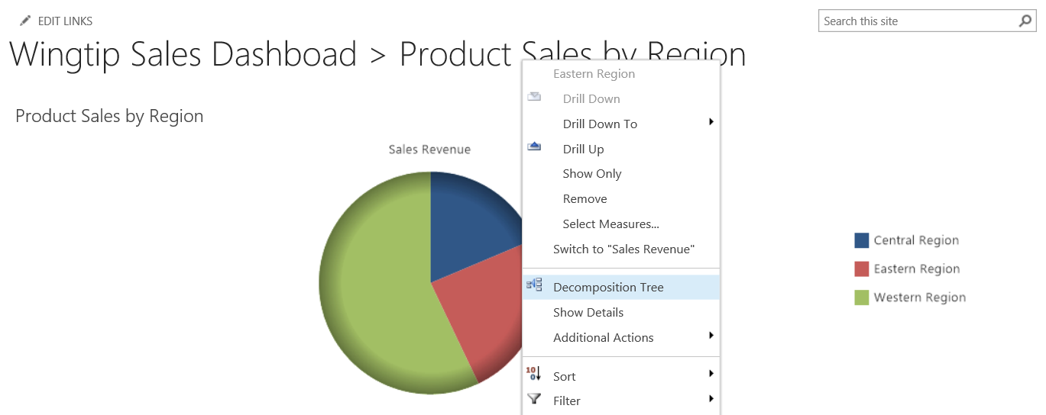

1. Experiment by navigating around inside the Decomposition Tree to see what types of data you can see from the cube.

