## Working with Document Libraries in SharePoint 2013

**Lab Time**: 45 minutes

**Lab Folder**: C:\Student\Modules\Documents

**Lab Overview:** In this lab you will create a new document library, work with the document library features, manage files within the library, customize the library, and save the library as a template.

### Exercise 1: Working with Document Libraries

In this exercise you will create a Document Library to hold employee forms. You will work with document library features, as well as create folders, navigate between the folders, create a new file, check out/check in, and set the properties of the file.

#### Log in to SharePoint Site

1. Make sure you have the login information for the SharePoint environment where you will work on your lab exercises. You should have received this log in information from the hosting training company or from your instructor.
2. Make sure you have the URL to the **Team Site** that has been created for you to do your lab work. This URL will be in a form that looks something like this.

https://cpt.atrackspace.com/sites/TeamSite_Student01

1. Launch the Internet Explorer and navigate to the URL of the Team Site mention in the previous step. Note that you should be logged in with a user account that has full control and access to the site collection, and therefore will be permitted access and be able to create lists.
   1. When prompted to login, enter the user name and password that has been supplied to you and then click **OK**.

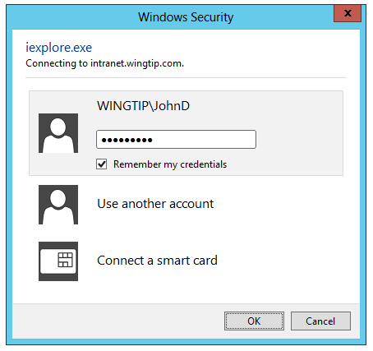

* 1. You should be able to confirm that you are logged into the SharePoint site. For example, if you were logged in as a student named **John Doe**, your name would appear in the SharePoint Welcome menu as shown in the following screenshot.

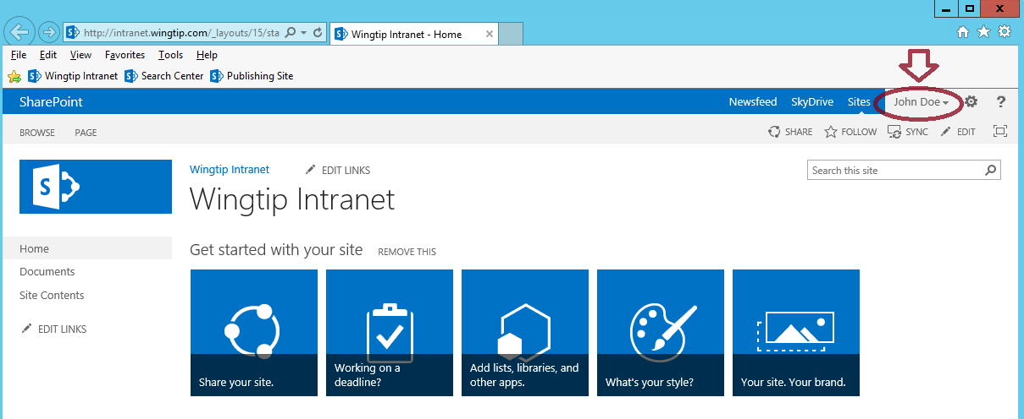

#### Create a Word Document Library

In this part of the exercise you will create a Document Library to hold word documents.

1. Navigate to **Add an app** to create a new Document library.
   1. Click on the **Settings** icon.
   2. Click **Add an app** or click **Site contents >> add an app**.

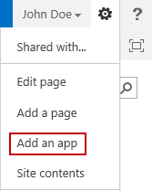

* 1. Click on the **Document Library** tile.

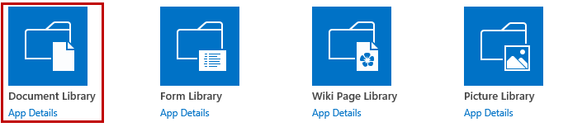

1. From the dialog, click the **Advanced Options** link.

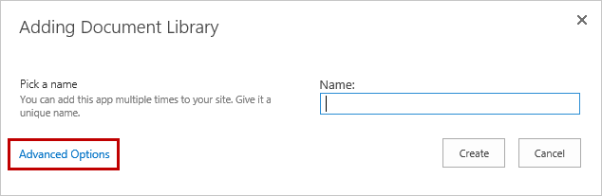

1. From the Advanced Options create page:
   1. In the **Name** text box from the popup dialog, type **Word Documents** and type something for the **Description** (optional).

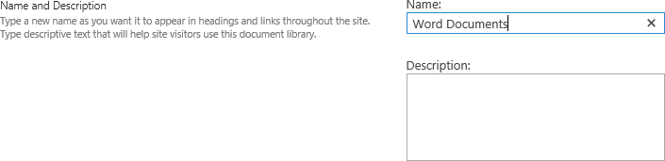

* 1. Leave **Document Version History**, **Create a version each time you edit a file in this document library** set to **No**.



* 1. In the **Document Template** drop-down list, ensure **Microsoft Word document** is selected.



* 1. Click **Create**.

1. The **Word Documents** library will now display with the default **All Documents** view.

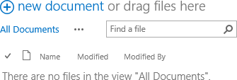

#### Create an Excel Document Library

1. Navigate to **Add an app** to create a new Document library.
   1. Click on the **Settings** icon.
   2. Click **Add an app** or click **Site contents >> add an app**.
   3. Click on the **Document Library** tile.
2. From the dialog, click the **Advanced Options** link.
3. From the Advanced Options create page:
   1. In the **Name** text box from the popup dialog, type **Excel Documents** and type something for the **Description** (optional).

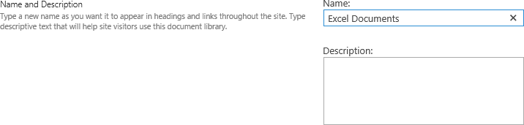

* 1. Leave **Document Version History** setting **Create a version each time you edit a file in this document library** set to **No**.



* 1. In the **Document Template** drop-down list, ensure **Microsoft Excel document** is selected.



* 1. Click **Create**.

1. The **Excel Documents** library will now display with the default **All Documents** view.



#### Create Folders and Navigate Between Them

1. Navigate back to the **Word Documents** library.
2. From the **Files** tab of the **Word Documents** library, click **New Folder** to create a folder for this library.

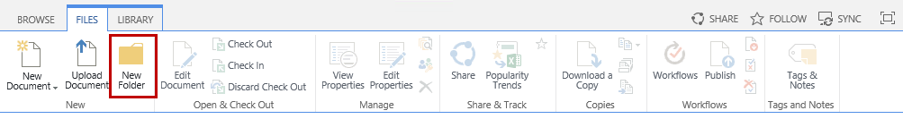

1. Type **Time Off Requests** and then click **Save**.

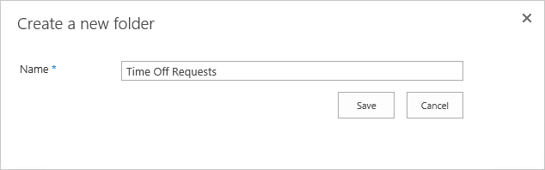

1. Repeat the same steps to create additional folders. Create two additional folders named **Expenses** and **Time** **Sheets**.

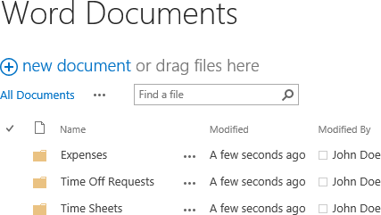

1. Click on the **Time Off Requests** folder to open the location.
2. To navigate up, from the **Library** tab click on the **Navigate Up** button located in the **Manage Views** group in the ribbon.

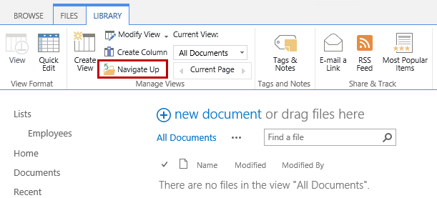

#### Create New Document

1. Navigate to the **Word Documents** library.
2. From the **Files** tab of the **Word Documents** library, expand the **New Document** **drop-down list and** click **New Document**.

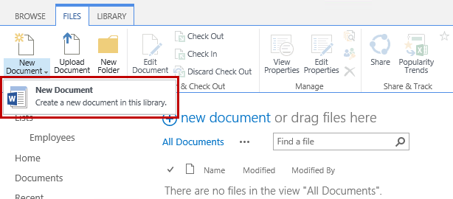

**Note:** The **Word Documents document** library is using a blank Word file as the default template. This is the default template that is used for document libraries. However, it can be modified and you will do so later in this lab.

1. In Word, select **Title** in the styles group in the **Home** tab and then type **Time Off Request**.
2. Hit **Enter** to create a new line.
3. Type **=lorem()** and then hit Enter to generate Lorem ipsum text.
4. Click the **Save** icon above the ribbon.
5. From the **Save As** panel, click **Word Documents** under **Current** **Folder**.

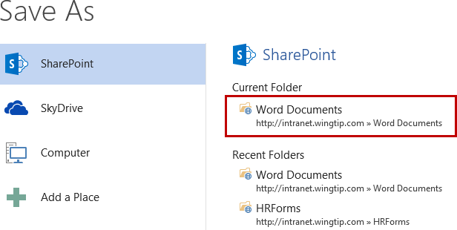

1. From the **Save As** dialog, verify the **File name** is **Time Off Request.docx**.
2. Double click on the **Time Off Requests** folder, or single click on the Time Off Requests folder and click Open.

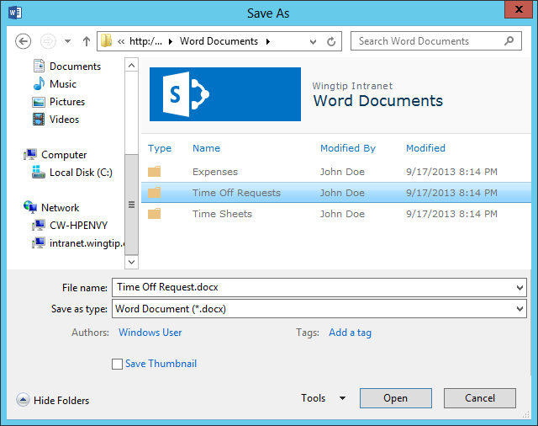E

1. Click **Save** and then close **Word**.

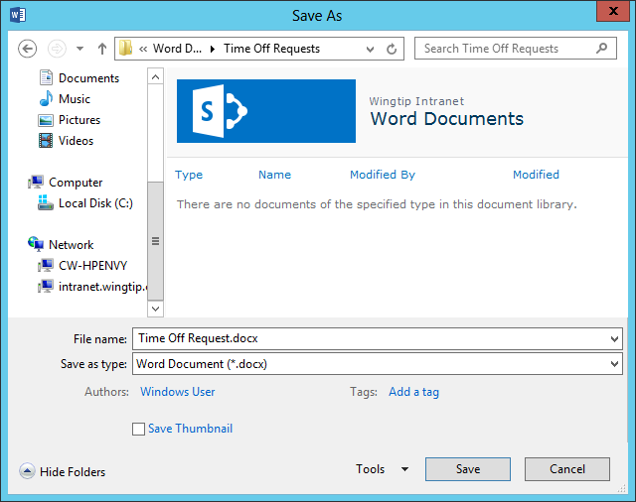

1. Using the browser, return to the Team Site you are working on in this lab.
2. Navigate back to your **Word Documents** library in SharePoint.
3. Click on the **Time Off Requests** folder.

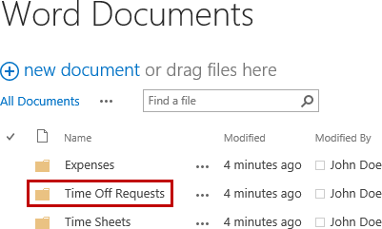

1. Verify the **Time Off Request** file has been saved.

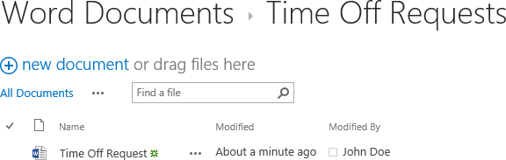

#### Check out, Edit, Save, Check in Files

Checking documents in and out allows you to obtain exclusive write access to a document, which eliminates the need to merge changes from multiple authors. When you check out a document, you are the only one who can save the changes to the document until you check the file back in. Follow the steps below to check out, make changes, save, and then check in a document.

1. Click on the **ellipsis (…)** for the **Time Off Request** document.
2. From the dialog for the file, click on the **ellipsis (…)** which is next to FOLLOW and then select **Check Out**.

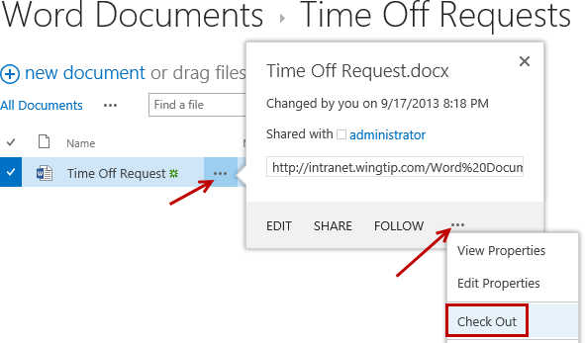

1. Notice the document icon now has an arrow. This arrow indicates the file is checked out.

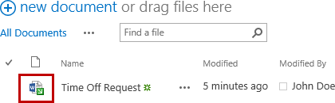

1. Click on the name **Time Off Request** to open the file.
2. If the **READ-ONLY** message appears, click **Edit** **Document**.

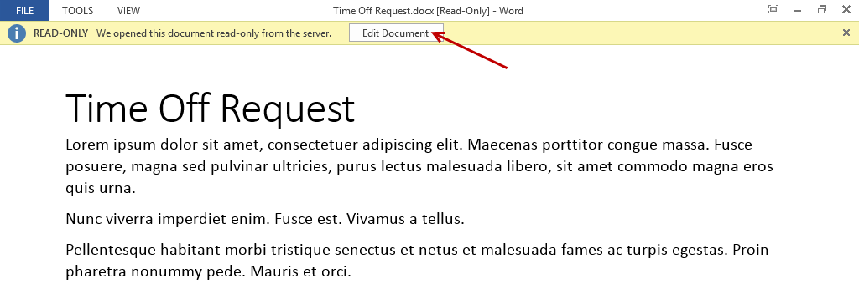

1. Make some changes to the file then click the **Save** icon.

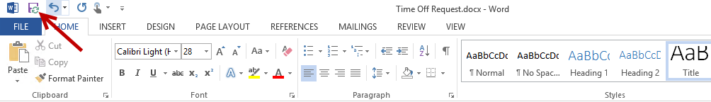

1. Once the file is saved you have two different ways you can check in the file.
2. To check-in the file from Word 2013 follow the steps below:
   1. Click on the **FILE** tab.

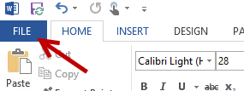

* 1. From the Info panel, click on the **Check In** button.

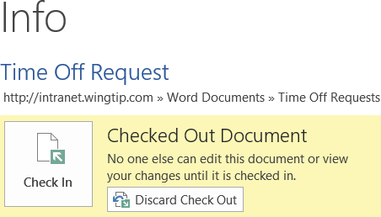

* 1. Type in desired **Version Comments** (optional) and then click **OK**.

**Note:** In some cases you may want to leave the file checked out while you continue to make updates the next day. You can save the file and keep it checked out and then check in the file when you are ready to publish the changes. If you close the file you will be prompted with a dialog confirming if you want to check in the file. If you click No your changes will still be saved but the file will remain checked out. All users will only have read access to the file while it is still checked out and they will only see the latest published version.

1. To check-in the file from the browser follow the steps below:
   1. Close the file. When prompted to check in click on **No**.

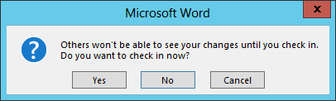

* 1. Navigate back to the **Time Off Request.docx** file in the Employee Documents library.
  2. Click on the **ellipsis (…)** for the **Time Off Request** document.
  3. From the dialog for the file, click on the **ellipsis (…)** next to **FOLLOW** and then select **Check In**.

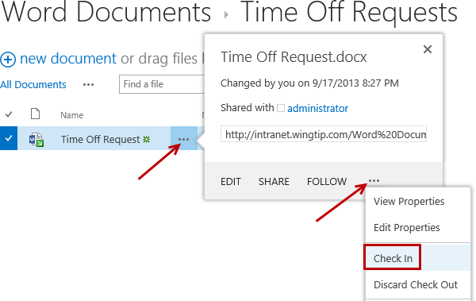

* 1. From the **Check in** dialog, enter any desired **Comments** (optional) and then click **OK**.

**Note:** If you want to retain your checkout but publish the latest changes so the users can see the updates, set **Retain your check out after checking in** to **Yes**.

1. Notice the document icon no longer shows an arrow, indicating that the file is no longer checked out.

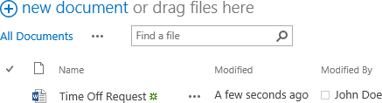

#### Set Properties of Files

Users who have the appropriate permissions to edit can update the properties of documents anytime the file is not checked out. The properties are determined based on the columns that have been added to the library. The pre-defined columns for a document library include Name and Title. The Name field is set automatically as the name of the file. The Title property is not set by default, but can be updated by modifying the properties of a file. The Title property is good to use to set a friendly title for the file. For example, you may want the file name to not have any spaces but want the title to contain spaces.

To update the properties follow the steps below:

1. Click on the **ellipsis (…)** for the **Time Off Request** document.
2. From the **Time Off Request.docx** dialog, click on the **ellipsis (…)** next to **FOLLOW** and then select **Edit Properties**.

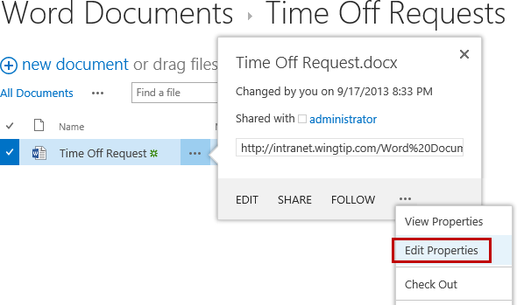

1. Change the **Name** to **TimeOffRequest**.
2. In the **Title** text box, type **Time Off Request Form** then click **Save**.

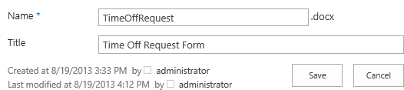

1. Notice the **Name** of the file has been updated.

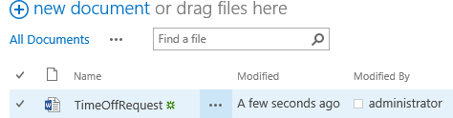

1. To view the properties, click on the **ellipsis (…)** for the **Time Off Request** document.
2. From the dialog for the file, click on the **ellipsis (…)** next to **FOLLOW** and then select **View Properties**.
3. You will now see the **Name** and **Title** properties. Click **Close**.

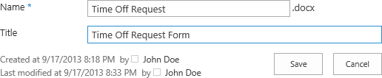

### Exercise 2: Managing Files in Document Libraries

In this exercise you will upload files into the Word Documents library, delete documents and folders, open the library in Explorer View, and move files between SharePoint folders and document libraries.

#### Upload Files to Document Library

1. Navigate to the **Word** **Documents** library.
2. Add the student lab **Expense Report.xlsx** (Student Lab file) file to the **Expenses** folder:
   1. Click on the **Expenses** folder.
   2. Click the **+ new document** link which is next to **or drag files here**.

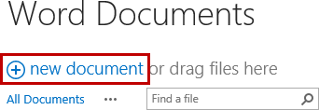

* 1. Click **Browse…**

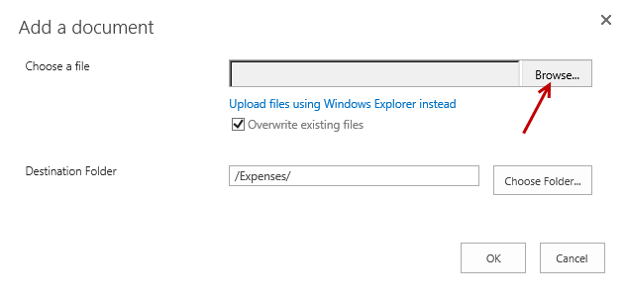

* 1. Navigate to **C:\Student\Modules\Documents\Lab**, select **Expense** **Report.xlsx** and then click **Open**.

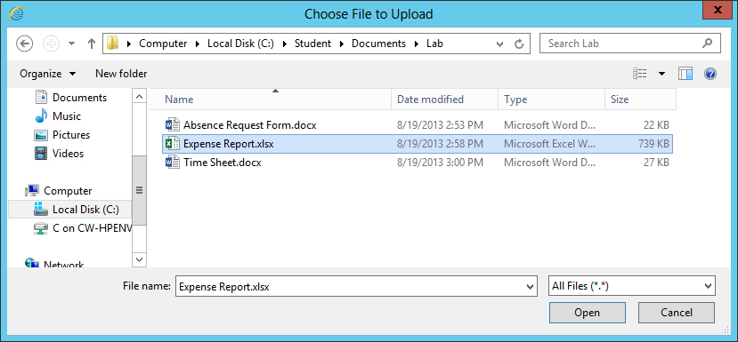

* 1. Verify the **Destination Folder** is pointing to **/Expenses/** and then click **OK**.

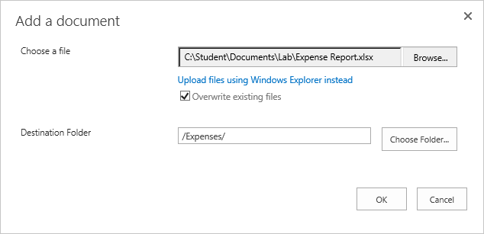

1. Navigate back up by clicking on the **LIBRARY** tab and then click on the **Navigate** **Up** ribbon button.
2. Add the **Absence Request Form.docx** file (Student Lab file) to the **Time Off Requests** folder:
   1. Click on the **Time Off Requests** folder.
   2. Click the **+ new document** link which is next to **or drag files here**.

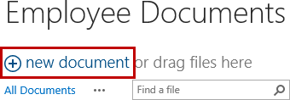

* 1. Click Browse…
  2. Navigate to **C:\Student\Documents\Lab**, select **Absence Request Form.docx** and then click **Open**.

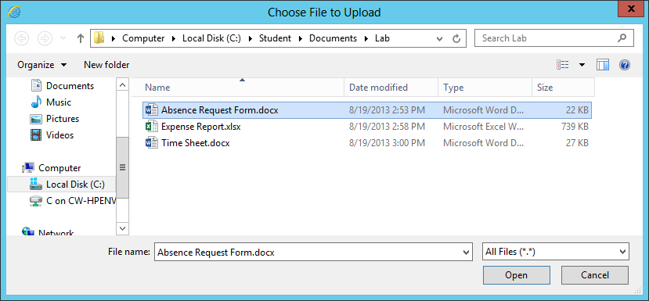

* 1. Verify the **Destination Folder** is pointing to **/Time Off Requests/** and then click **OK**.

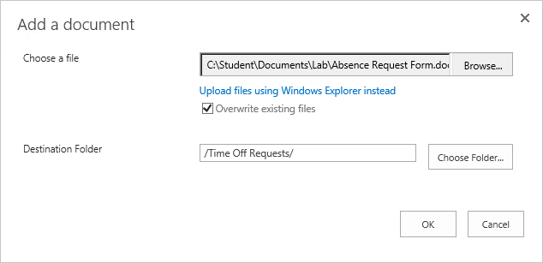

1. Navigate back up by clicking on the **LIBRARY** tab and then click on the **Navigate** **Up** ribbon button.
2. Add the **Time Sheet.docx** file (Student Lab file) to the **Time Sheets** folder:
   1. Click on the **Time Sheets** folder.
   2. Click the **+ new document** link which is next to **or drag files here**.



* 1. Click Browse…
  2. Navigate to **C:\Student\Documents\Lab**, select **Time Sheet.docx** and then click **Open**.

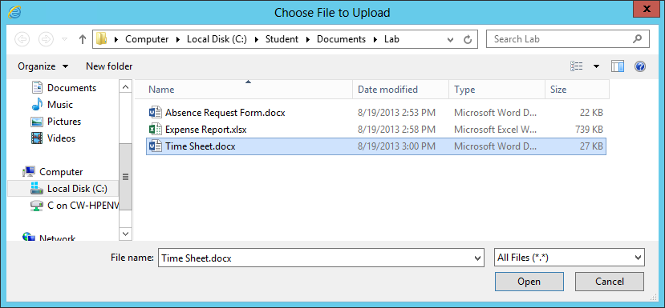

* 1. Verify the **Destination Folder** is pointing to **/Time Sheets/** and then click **OK**.

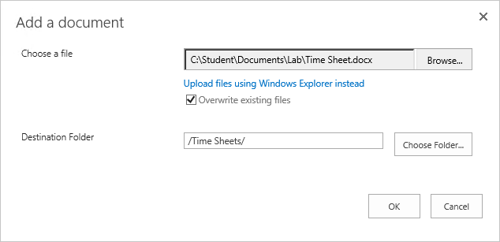

1. Navigate back up by clicking on the **LIBRARY** tab and then click on the **Navigate** **Up** ribbon button.

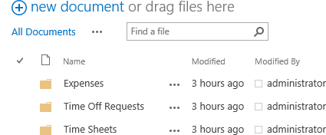

1. Navigate back and forth between the folders to see the newly uploaded files.

#### Create New Folder and Move Document to Folder

1. Make sure you are in the root of the **Word Documents** library.
2. From the **FILES** tab, click the **New** **Folder** ribbon button.

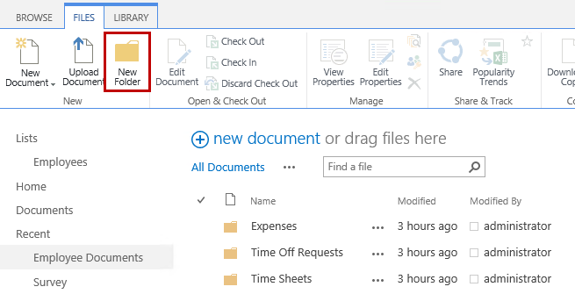

1. In the **Name** text box, type **Archived** and then click **Save**.
2. The easiest way to move files in a document library is by using Explorer View. To open the library in Explorer View:
   1. Click on the **LIBRARY** tab, and then click the **Open with Explorer** icon located in the **Connect & Export** group.

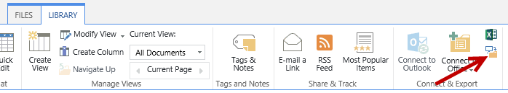

* 1. If prompted for credentials enter the credentials used for this lab and then click **OK**.
  2. The **Word Documents** library will open in **Explorer** **View** in Windows.

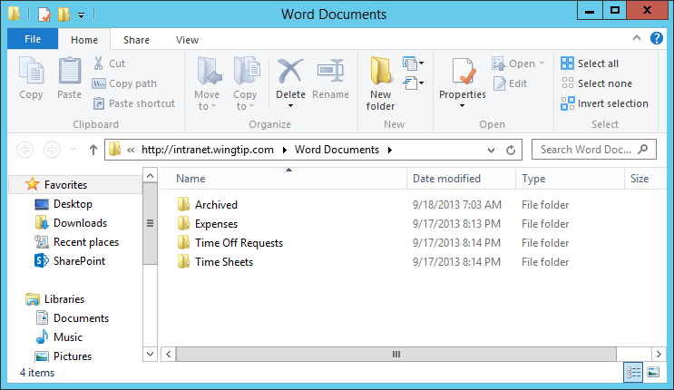

1. From **Explorer View**, double-click the **Time Off Requests** folder.
2. Right-click on **TimeOffRequest.docx** and select **Cut**.

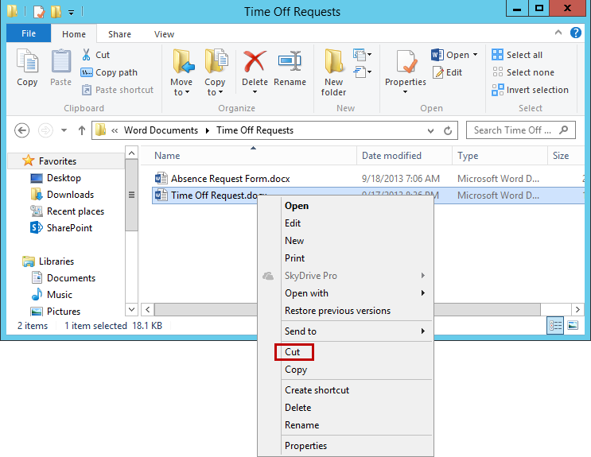

1. In the File address bar, click on **Word Documents** to navigate up.

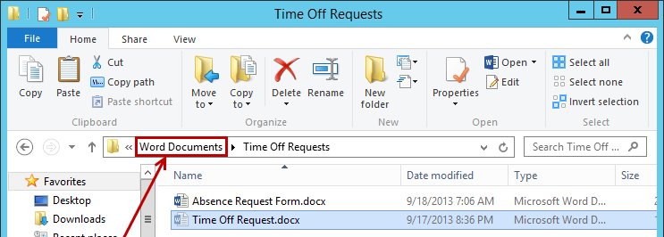

1. Double-click on the **Archived** folder then **right-click** and select **Paste**.

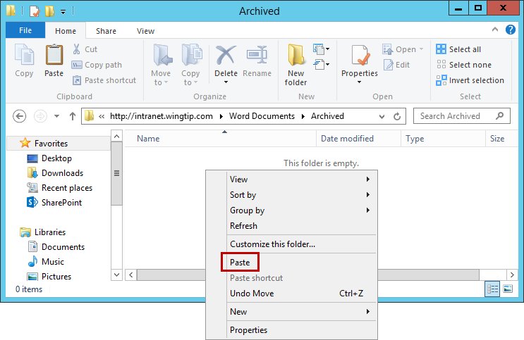

1. The **TimeOffRequest.docx** is now in the **Archived** folder.

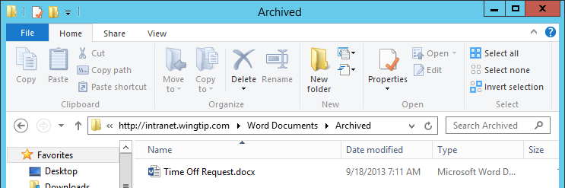

1. **Close** Windows **Explorer** **View**.
2. Go back to the site from the browser and navigate to the **Word Documents** library.
3. Open the **Archived** folder and verify the **TimeOffRequest** document is in the folder.

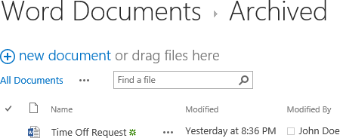

#### Delete Files and Folders

Deleting files and folders in SharePoint is easy to do. In this step you will delete the TimeOffRequest.docx file and then delete the Archived folder.

1. To delete the **TimeOffRequest.docx** file:
   1. Click the white space in the check mark column for the **TimeOffRequest** file.

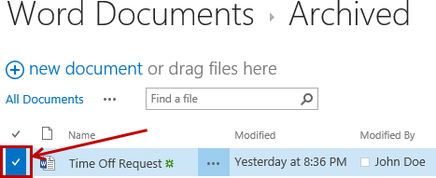

* 1. From the **FILES** tab, click the **Delete Document** button located in the Manage group.

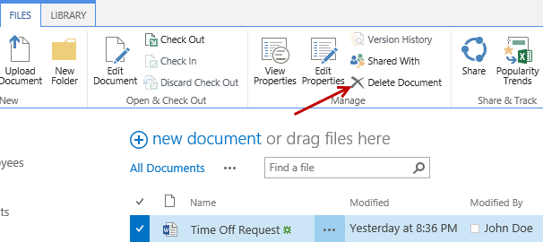

* 1. From the **send the item(s) to the site Recycle Bin** dialog, click **OK**.

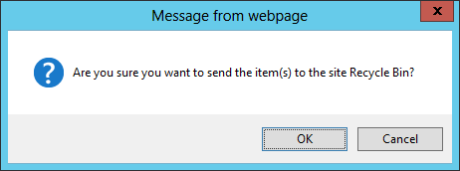

* 1. Notice the **TimeOffRequest** file has been deleted.

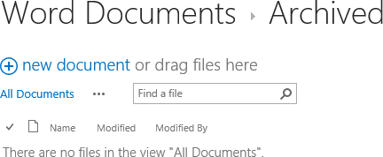

1. To delete the **Archived** folder:
   1. From the **LIBRARY** tab, click the **Navigate** **Up** icon.
   2. Select the **check** **mark** for the **Archived** folder.
   3. From the **FILES** tab, click the **Delete Document** button located in the Manage group.
   4. From the **send the item(s) to the site Recycle Bin** dialog, click **OK**.
   5. Notice the **Archived** folder has been deleted.

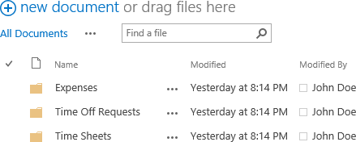

### Exercise 3: Customize Document Library

In the previous exercises you created a Word Documents library with folders. Navigating through folders in SharePoint document library provides the same experience as using a file share. Instead of using folders, it is recommended to use columns and custom views to provide a better experience for the user.

In this exercise you will customize the document library by adding a **Category** choice column, set the category for each document, move the documents into the root folder, delete the folders, and then create custom views to display the documents for the different categories.

#### Create Column

In this step you will create a choice column called **Category** with **Expenses**, **Time** **Off** **Requests**, and **Time** **Sheets** as the available options.

1. Navigate to the **Word Documents** library.
2. From the **LIBRARY** tab, click **Library** **Settings** ribbon button located in the **Settings** group.
3. In the **Columns** section, click the **Create** **column** link.

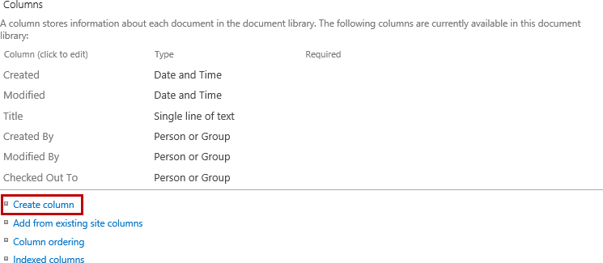

1. In the **Column** **name** text box, type **Category** then select the **Choice (menu to choose from)** radio button.

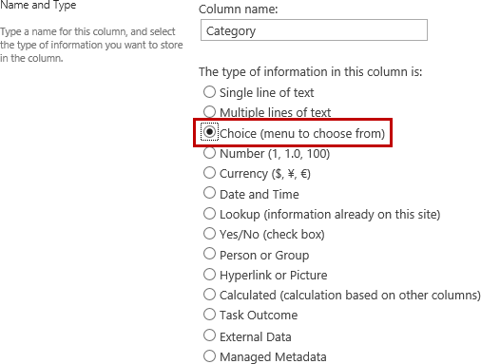

1. In the **Type each choice on a separate line** multi-line text box, type **Expenses** (then hit enter), type **Time Off Requests** (then hit enter), and type **Time Sheets** (then hit enter).

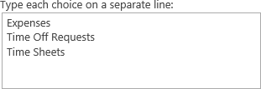

1. Ensure the **Drop-Down Menu** radio button is selected and **Allow ‘Fill-in’ choices** is set to **No**.

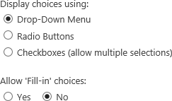

1. In the **Default** **value** with the **Choice** option selected, delete **Expenses** from the text box. Ensure **Add to default view** is selected and then click **OK**.

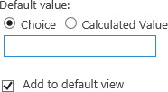

#### Move Files to Root

Before setting the category for each of the documents, the files will first be moved from each of the folders into the root. To move the files, you will use Explorer View and cut/paste to the appropriate location.

1. From the **Document Library Settings** page, click the **Word Documents** link in the breadcrumb at the top.

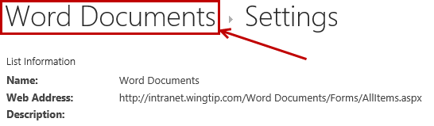

1. Click on the **LIBRARY** tab, and then click the **Open with Explorer** icon located in the **Connect & Export** group.



1. If prompted for credentials enter the credentials used for this lab and then click **OK**.
2. From **Explorer View**:
   1. Navigate to the **Expenses** folder, right-click on the **Expense Report.xlsx** file and select **Cut**.
   2. In the File address bar, click on **Word Documents** to navigate up.
   3. Right-click in the white area below the list of files and select **Paste**.

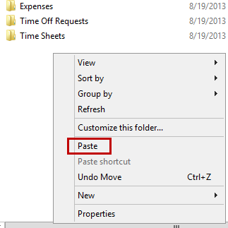

1. To delete the **Expenses** folder from **Explore** **View**:
   1. Right-click on the **Expenses** folder and click on **Delete**.

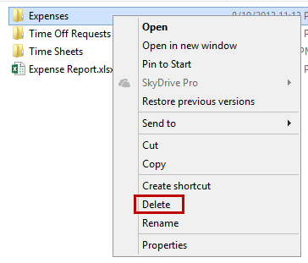

* 1. From the **Delete** **Folder** dialog prompt, click **Yes**.

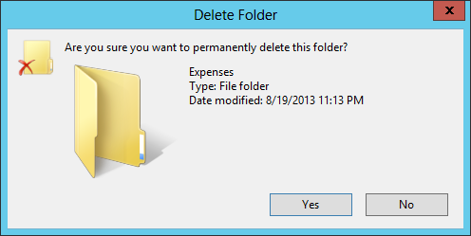

1. Repeat the steps for the remaining files and folders.
2. One complete it should now have all the files in the root of the Word Documents library and all folders have been deleted.

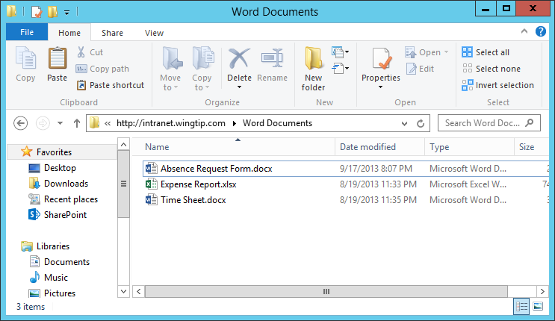

1. **Close** Windows **Explorer View**.
2. From the browser, navigate back to the **Word** **Documents** library and notice the files are in the root and all folders are gone.

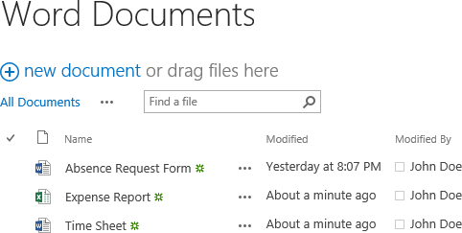

#### Assign Category to each File

1. To assign a category for the **Absence Request Form** using **Edit Properties**.
   1. Click the **ellipsis (…)** for the **Absence Request Form**.
   2. From the **Absence Request Form.docx** dialog, click the **ellipsis (…)** and then select **Edit Properties**.

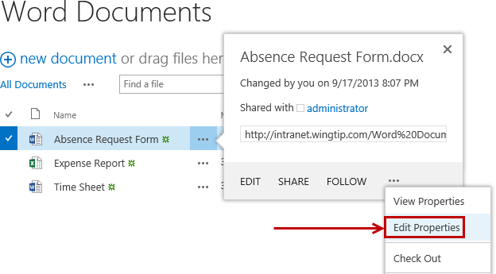

* 1. From the **Category** drop-down list, select **Time Off Requests** and then click **Save**.

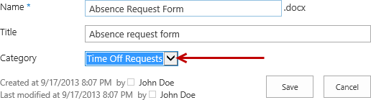

**Note:** To update the category for each file a quicker method is to use Quick Edit mode.

1. To update the Category in **Quick Edit** mode:
   1. From the **LIBRARY** tab in the **View Format** group, click the **Quick Edit** ribbon button.

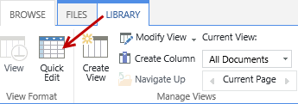

* 1. In the **Category** column, select **Expenses** from the drop-down list for **Expense** **Report**.

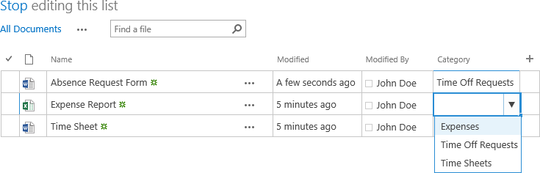

* 1. Select **Time** **Sheets** from the **Category** drop-down list for **Time** **Sheet**.

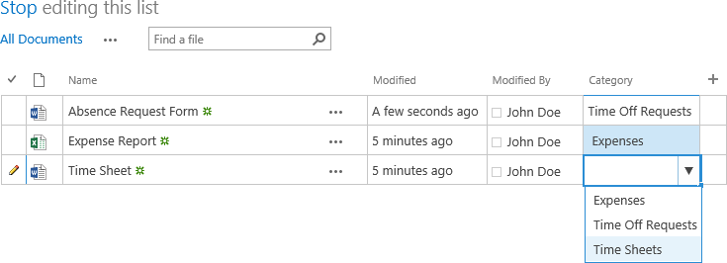

* 1. Once complete, click the **Stop** link next to the **editing** **this** **list** text.

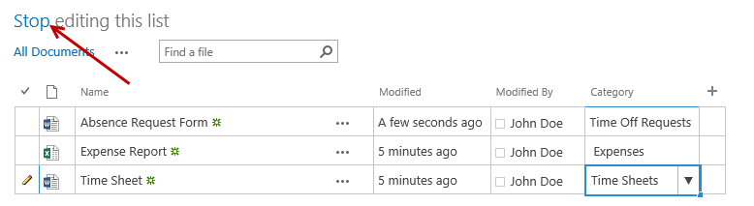

* 1. Notice the files all have the Category property set.

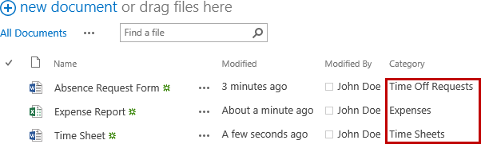

#### Modify and Create Views

Now that the files have a category assigned to them, you can now modify the default view and group them by the Category column.

1. From the **LIBRARY** tab in the **Manage** **Views** group, click on **Modify** **View**.

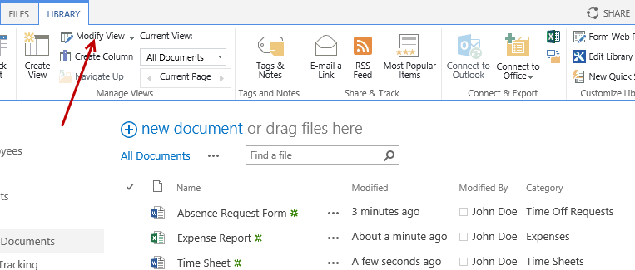

1. In the **Columns** section, uncheck the box for **Category**.

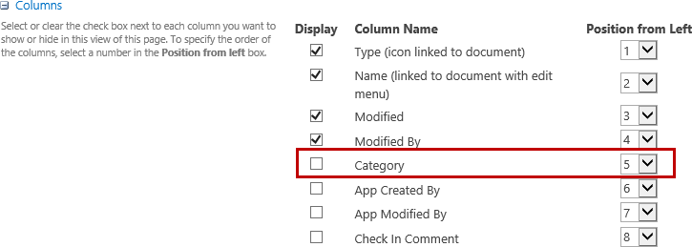

1. Scroll down and click on the **+** symbol next the **Group By** section.

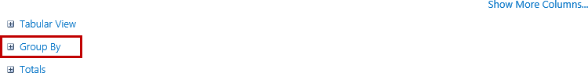

1. From the **First group by the column** drop-down list, select **Category**.

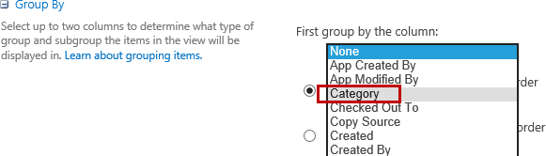

1. Ensure the **Show groups in ascending order** is selected.

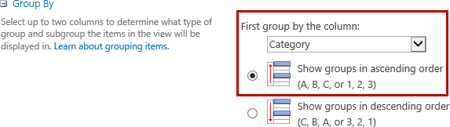

1. Leave **Then group by the column** set to **None**.
2. In the **By default, show groupings** property ensure **Collapsed** is selected.
3. For collapsed, set the **Number of groups to display per page** to a desired value or leave it set to **30**.
4. Scroll to the top or bottom of the page and then click **OK**.

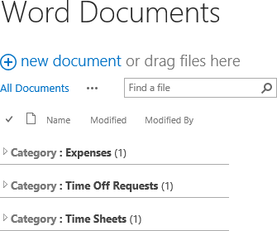

1. To change the default view Group By from Collapsed to Expanded:
   1. From the **LIBRARY** tab in the **Manage** **Views** group, click on **Modify** **View**.
   2. Scroll down and click on the **+** symbol next the **Group By** section.
   3. In the **By default, show groupings** property, select **Expanded**.



* 1. Scroll to the top or bottom of the page and then click **OK**.

1. Notice the groups are now expanded in the default view.

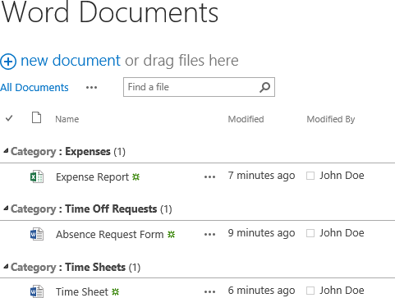

### Exercise 4: Configure Versioning for Co-Authoring

SharePoint versioning helps protect documents and prevent data loss by allowing authors to roll back to a previous document version when the current version contains unwanted changes.

Do not enable minor versioning in document libraries that contain OneNote notebooks. Minor versioning can result in synchronization errors that prevent edits from being saved.

When multiple authors work on the same document, edits are retained on the server as document versions. To limit server storage usage, you can limit the number of retained versions. If you enable major versioning in a document library that contains OneNote notebooks, we recommend that you specify the maximum number of versions so you can use disk space more efficiently.

#### Enable Versioning

1. Browse to the **Word Documents** library or to the document library you want to configure.
2. From the **LIBRARY** tab, in the Settings group click on the **Library** **Settings** ribbon button.
3. In **General Settings**, click on **Versioning settings**.

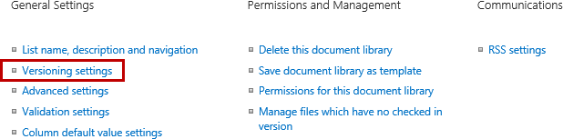

1. In **Document Version History**, select **Create major versions**.

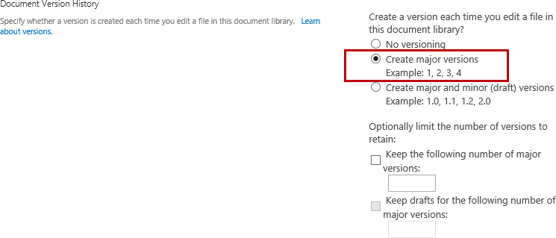

1. Optional: To specify a version retention limit, select **Keep the following number of major versions** and in the text box type the desired number of versions.

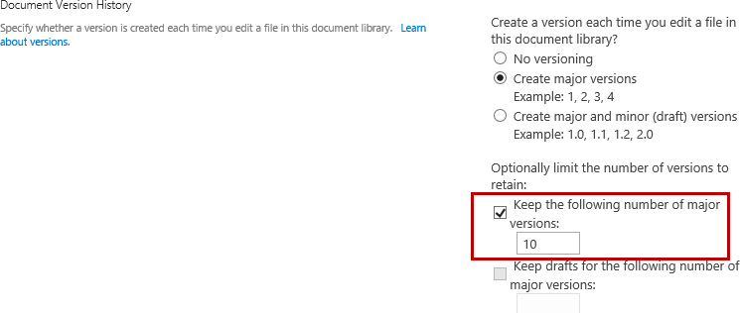

#### Configure Require Check Out

When a document is checked out of a document library, the document is locked. This makes it unavailable for co-authoring. Therefore, the Require Check Out setting should not be enabled in document libraries that are used for co-authoring. By default, for SharePoint 2013 document libraries, this setting is not enabled.

1. To enable Require Check Out
   1. Browse to the **Word Documents** library or to the document library you want to configure.
   2. From the **LIBRARY** tab, in the Settings group click on the **Library** **Settings** ribbon button.
   3. In **General Settings**, click on **Versioning settings**.
   4. In **Require Check Out**, select **Yes**.

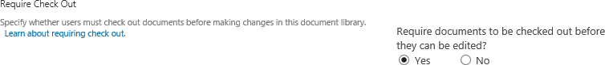

1. To disable Require Check Out
   1. Browse to the **Word Documents** library or to the document library you want to configure.
   2. From the **LIBRARY** tab, in the Settings group click on the **Library** **Settings** ribbon button.
   3. In **General Settings**, click on **Versioning settings**.
   4. In **Require Check Out**, select **No**.

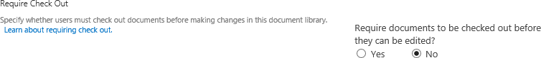

### Exercise 5: Update Document Library Templates

In this exercise you will change the document library template for the document library you created in exercise 1. You will create a new document library that will default to Excel and change the default template for the library.

#### Update the Word Document Library Template

1. Navigate to the **Word Documents** library.
2. From the **LIBRARY** tab, click **Library** **Settings** ribbon button located in the **Settings** group.
3. Under the **General** **Settings** section, click on the **Advanced** **settings** link.

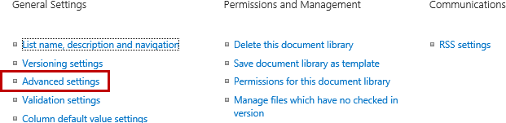

1. In the **Document** **Template** section under the **Template** **URL** property, click on **(Edit Template)**.

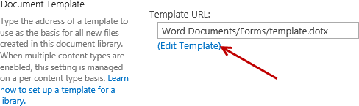

1. From the client computer, open **Windows Explorer** and navigate to **C:/Student/Documents/Lab**.
2. Double-click on the **Time Sheet.docx** file to open the file in **Word**.

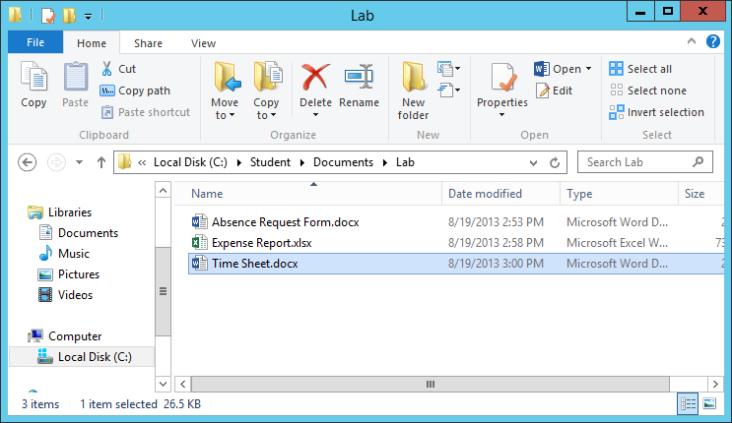

1. Copy content from the **Time Sheet.dotx** file and paste into the **template.dotx** file:
   1. Select all content (**Ctrl +A**).
   2. Copy the content (**Ctrl + C**).
   3. Close the **Time Sheet.docx** file.
   4. Now paste (**Ctrl + V**) the content into the template.dotx file that is open in Word.
2. Save the **template.dotx** file and then close Word.
3. From the browser, navigate back to the root of the **Word Documents** library.
4. From the **Files** tab of the **Word Documents** library, expand the **New Document** **drop-down list and** click **New Document**.



1. Word will open using the updated template.dotx file and the Document Properties panel should display on top which includes the Title and Category fields.

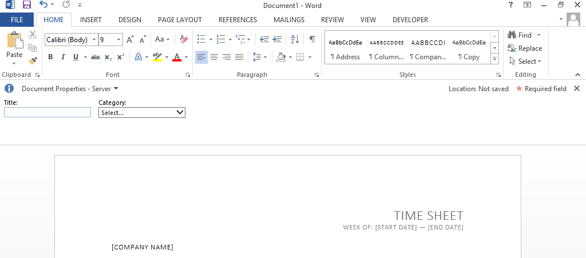

1. From the **Document Properties** panel, set the **Title** and **Category** to a desired value.
2. Update the contents of the Time Sheet file and once complete hit **save**.
3. From the **Save As** panel, click on **Word Documents** located under the **Current Folder** section.

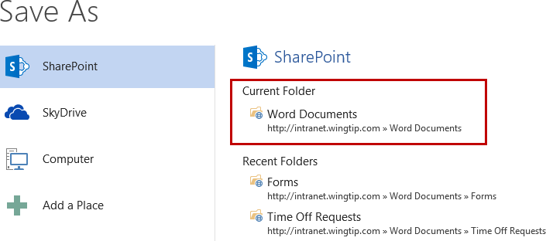

1. Update the **File name** and then click **Save**.

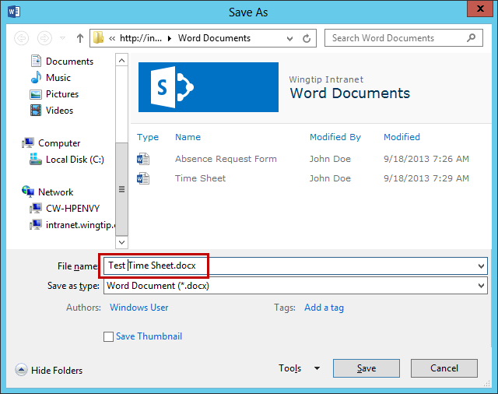

1. Close Word.
2. From the browser, navigate back to the **Word Documents** library and notice your new file has been saved.

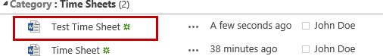

#### Update the Excel Documents Library Template

1. Navigate to the **Excel Documents** library.
2. From the **LIBRARY** tab, click **Library** **Settings** ribbon button located in the **Settings** group.
3. Under the **General** **Settings** section, click on the **Advanced** **settings** link.



1. In the **Document** **Template** section under the **Template** **URL** property, click on **(Edit Template)**.

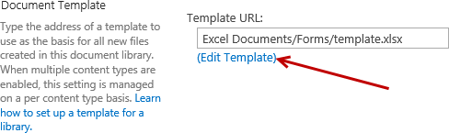

1. From the client computer, open **Windows Explorer** and navigate to **C:/Student/Documents/Lab**.
2. Double-click on the **Expense Report.xlsx** file to open the file in **Excel**.

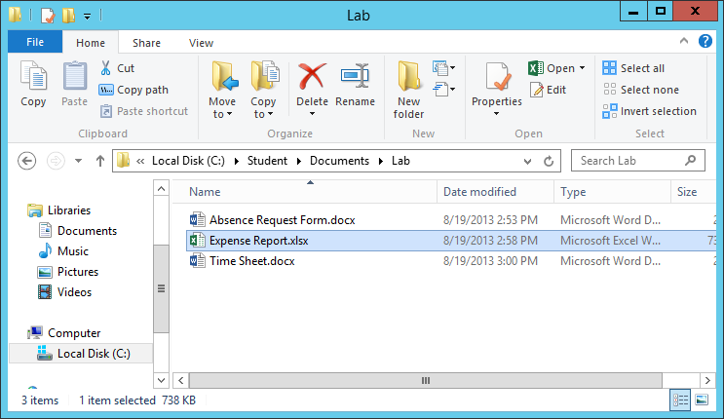

1. Copy content from the **Expense Report.xlsx** file and paste into the **template.xlsx** file:
   1. Right-click on the **Expense Report sheet tab** in the **Expense Report.xlsx** file and select **Move or Copy…**

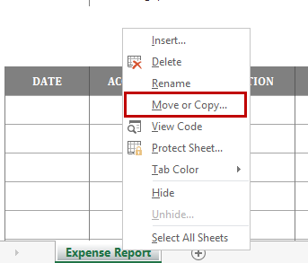

* 1. From the **Move or Copy** dialog, select **template.xlsx** in the **To book** drop-down list.
  2. Select the check box for **Create a copy** and click **OK**.

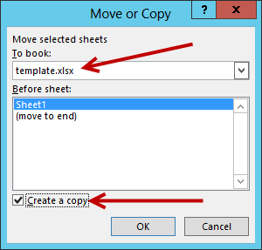

1. In the **template.xlsx** file, right-click on the **Sheet1** tab and select **Delete**.

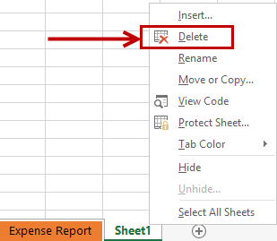

1. Save the **template.xlsx** file and then close the file.
2. Close the **Expense Report.xlsx** file and close **Excel**. Do not save changes to the Expense Report.xlsx file.
3. From the browser, navigate back to the root of the **Excel Documents** library.
4. From the **Files** tab of the **Excel Documents** library, expand the **New Document** **drop-down list and** click **New Document**.

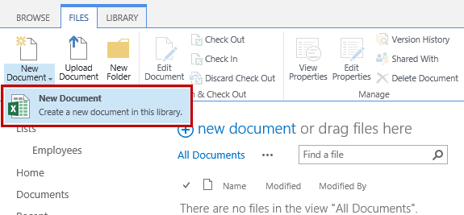

1. Excel will open using the updated template.xlsx file.

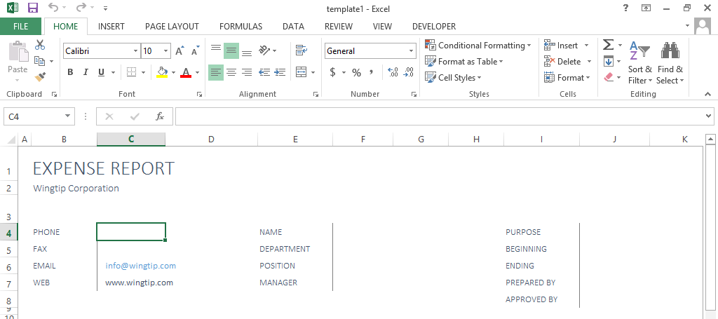

1. Update the contents of the file and once complete hit the **Save** icon at the top of Excel.
2. From the **Save As** panel, click on **Excel Documents** located under the **Current Folder** section.

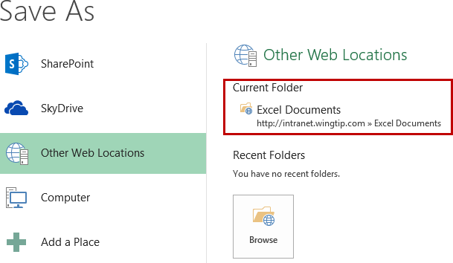

1. Update the **File name** and then click **Save**.

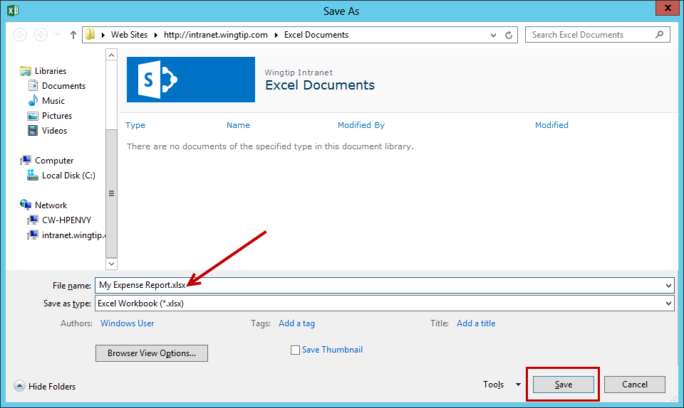

1. Close **Excel**.
2. From the browser, navigate back to the **Excel Documents** library and notice your new file has been saved.

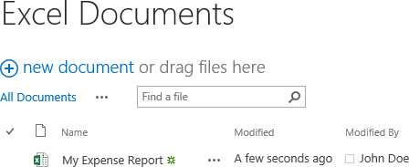

You have now completed this lab exercise.