## Getting Started in SharePoint 2013

**Lab Time**: 30 minutes

**Lab Folder**: C:\Student\Modules\GettingStarted

**Lab Overview:** In this lab you will log into SharePoint, navigate throughout the site and libraries, and work with SharePoint Apps.

### Exercise 1: Log in to SharePoint

In this exercise you will learn how to log into a SharePoint 2013 site as well as use some of the site features.

#### Log in to SharePoint Site

1. Make sure you have the login information for the SharePoint environment where you will work on your lab exercises. You should have received this log in information from the hosting training company or from your instructor.
2. Make sure you have the URL to the **Team Site** that has been created for you to do your lab work. This URL will be in a form that looks something like this.

https://cpt.atrackspace.com/sites/TeamSite_Student01

1. Launch the Internet Explorer and navigate to the URL of the Team Site mention in the previous step. Note that you should be logged in with a user account that has full control and access to the site collection, and therefore will be permitted access and be able to create lists.
   1. When prompted to login, enter the user name and password that has been supplied to you and then click **OK**.

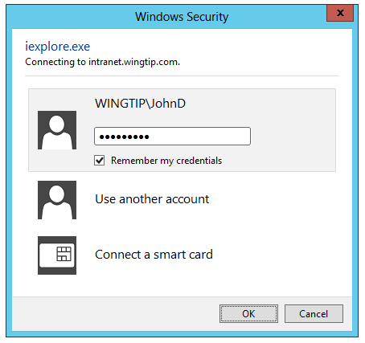

* 1. You should be able to confirm that you are logged into the SharePoint site. For example, if you were logged in as a student named **John Doe**, your name would appear in the SharePoint Welcome menu as shown in the following screenshot.

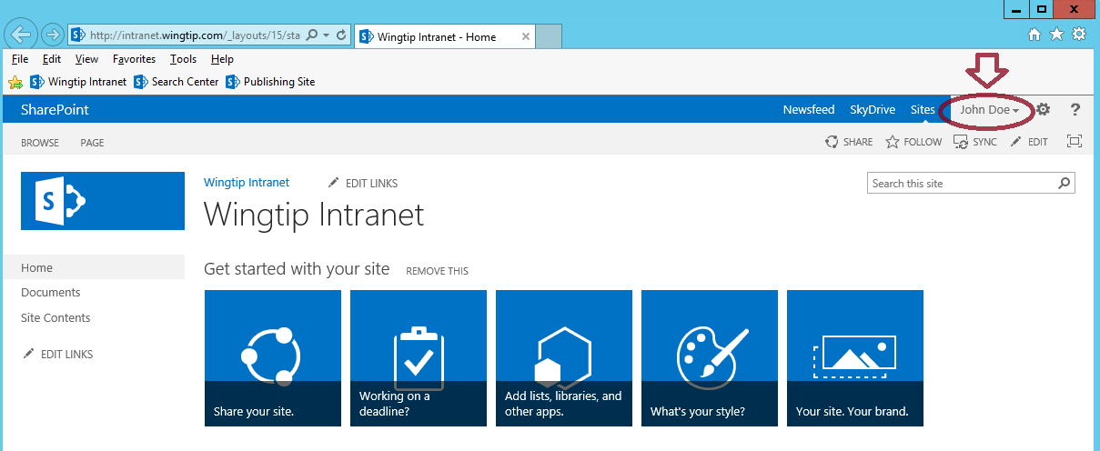

#### Navigate to Site Contents from Quick Launch

1. From the site’s home page in the left navigation, click on the **Site Contents** link.

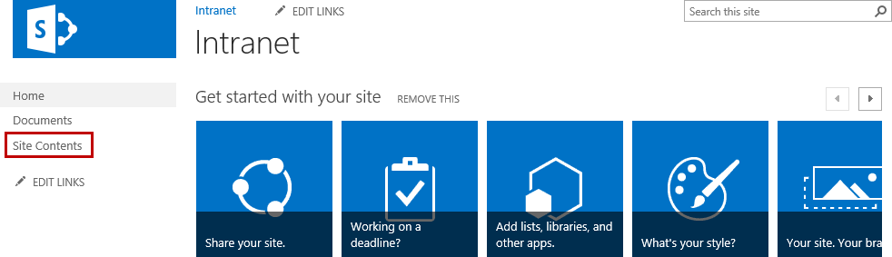

1. From the **Site Contents** page, notice all the different list and library tiles.

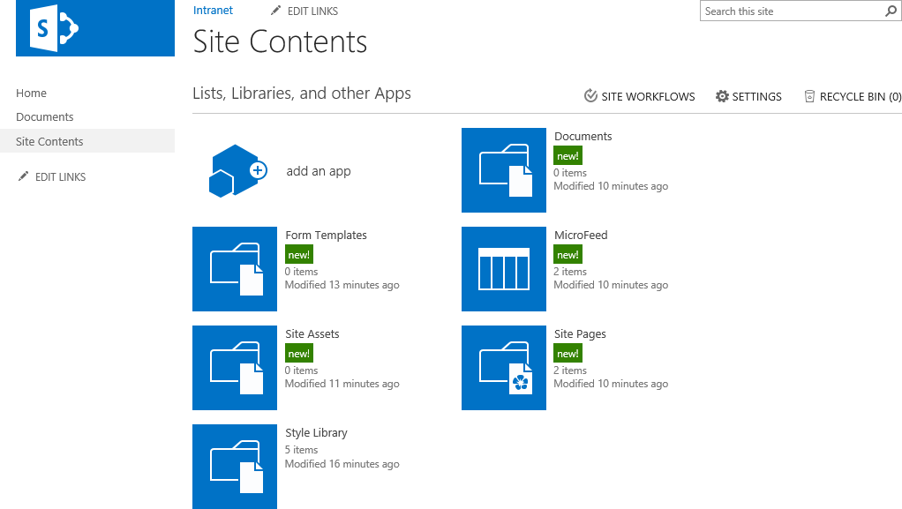

1. From the left navigation, click on the **Home** link to go back to the site’s home page.

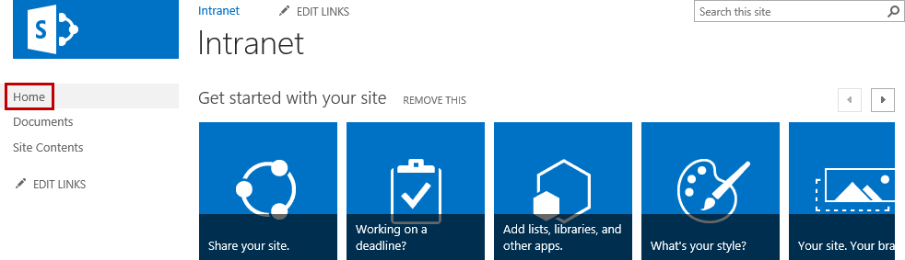

1. You will now be back on the home page.

#### Navigate to Site Contents from Settings

1. From the top of the page on the right-hand side, click the **Settings** icon and then click on **Site Contents**.

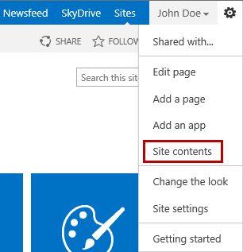

1. Now click on the **Documents** tile to open the Documents library.

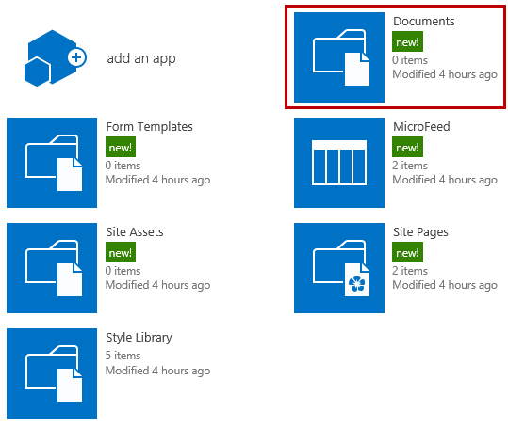

1. You are now viewing the Documents library **All Items** (allitems.aspx)page. Notice the Documents link in the left navigation is highlighted a light gray. This indicates which page you are viewing.

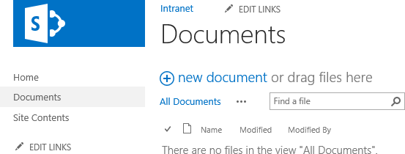

#### Use the Ribbon

1. From the **Documents library All Items** page, click on the **FILES** tab.

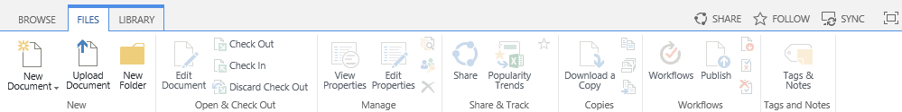

The FILES tab is used for managing content in the Documents library. Because there are no documents in the library and nothing is selected, only the ribbon buttons for creating a new document, uploading a new document, and creating a new folder is active. Once you have content in the library and select an item, more ribbon buttons will become active.

1. Now click on the **LIBRARY** tab. Notice the different ribbon button groups and ribbon buttons available.

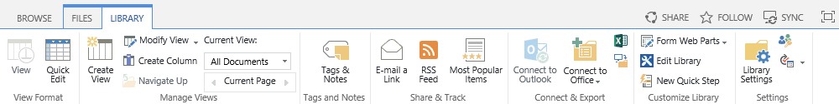

The LIBRARY tab is used for managing the settings of the entire library. This includes managing formatting, connecting to Outlook, viewing items in Windows Explorer, and getting to the Library Settings page.

1. From **LIBRARY** tab, click on the **Library Settings** ribbon button located in the **Settings** group.

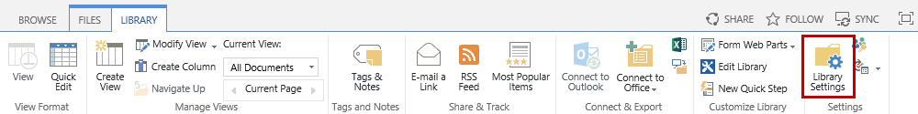

1. This will take you to the **Documents Settings** page.

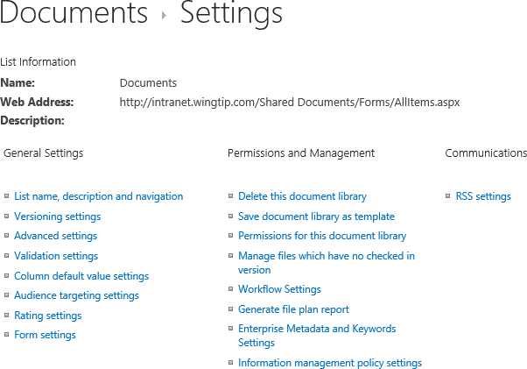

The first section contains information about the library which includes Name, Web Address, and Description. Notice the different links under General Settings, Permissions and Management, and Communications.

1. Now observe the **Columns** section.

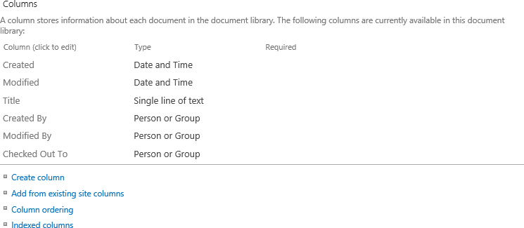

The Columns section provides all the links for managing columns at the list/library level. From here you can create a column, add from existing site columns, change the column ordering, and index columns.

1. Now observe the **Views** section.

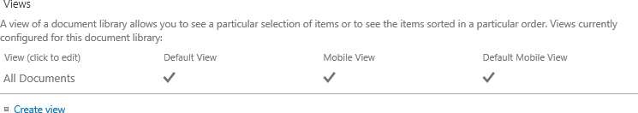

The Views section is used for creating views and managing existing views. Views are used to display the content on the All Items page. By default, the All Documents view displays the Type, Name (linked to document with edit menu), Modified, and Modified By columns. More about views will be covered in the Documents module.

### Exercise 2: Navigating through a SharePoint Site

In this exercise you will learn how to navigate through a SharePoint site using the top navigation, left navigation, and breadcrumbs.

#### Modifying the Top Link Bar

1. From the **Documents Settings** page, click on the **Wingtip Intranet** link located in the top navigation bar to navigate back to the home page of the site.

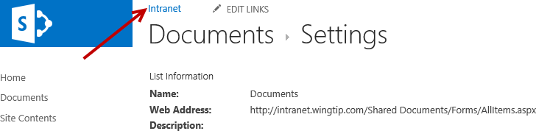

1. Now click on **EDIT LINKS** to activate edit mode for adding/removing links in the **Top Link Bar**.

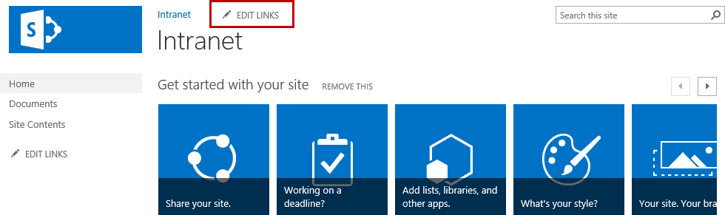

1. Click on **+ link** to add a new link.



1. In the **Add a link** dialog, type **Bing** for the **Text to display**. Type **http://www.bing.com** for the **Address** and then click **OK**.

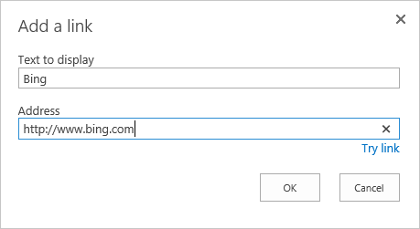

1. From the top navigation bar, click **Save** to commit the changes.



1. Notice that the Bing link is now added.



1. To make changes to the link go back into Edit mode by clicking on **EDIT LINKS**.
2. From edit mode, click on the **Bing** link to make changes to the existing link.

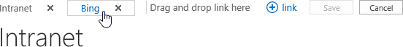

1. To change the name of the link, simply type the new value in the text box or click on the globe link icon located to the right of the text box for the link.



1. Clicking on the **globe link icon** will bring up the **Edit link** dialog. From here you can update both the **Text to display** and the **Address**.

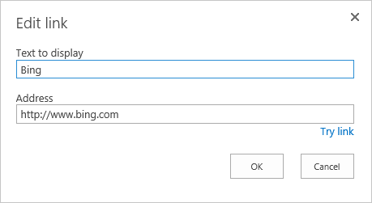

1. To change the order of the links, simply drag a link to the location you want it to be. For example, to move the **Bing** link before the **Intranet** link, **click and hold** on the **Bing** link and **drag the link** to the left of the **Intranet** link.

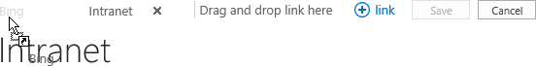

1. Once the link is in the new position, let go of the mouse and then click **Save** to commit the changes.

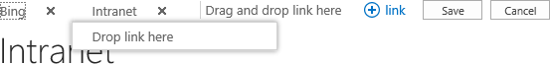

1. The **Bing** link is now before the **Intranet** link.



1. You can repeat the steps to make changes to the links or change the order. Or you can modify the links through **Site Settings** by following these steps:
   1. Click on the **Settings** icon and then select **Site settings**.

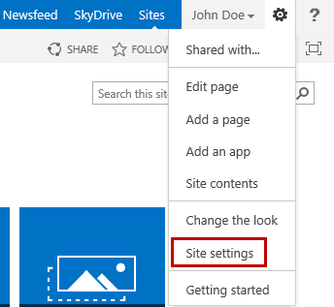

* 1. In the **Look and Feel** group, click on **Top link bar**.

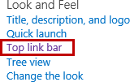

* 1. To change the order, click on **Change Order**.

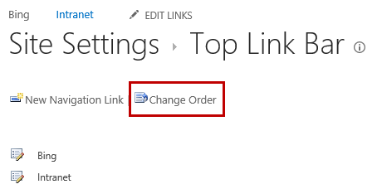

* 1. From the **Top Link Bar Change Order** page, change the **Link Order** drop-down values to reorder. When complete, click **OK**.

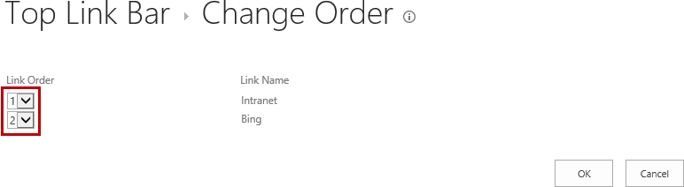

* 1. To add a new link, click on **New Navigation Link.**

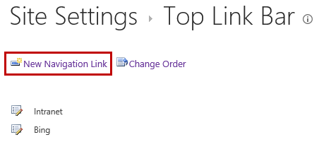

* 1. Enter values for **Type a Web address** and **Type the description**. When complete click **OK** or click **Cancel** to cancel.

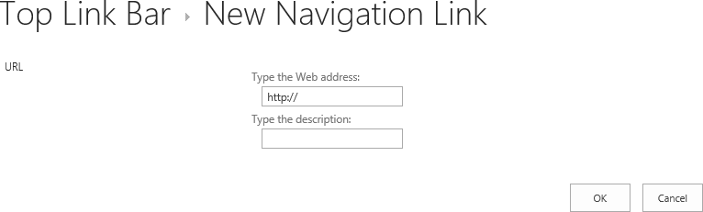

* 1. To edit an existing link, click on the **edit** **icon** next to the link you want to modify.

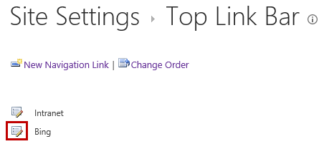

* 1. From the **Site Settings Edit Navigation Link** page, make the desired changes and then click **OK**. Or click the **Delete** button to delete the link or **Cancel** to cancel making changes.

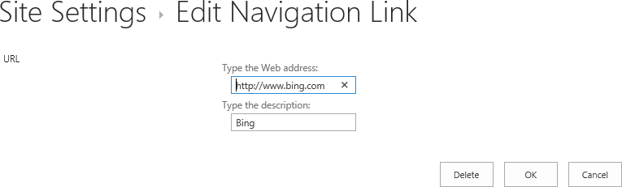

#### Modifying the Left Navigation Bar

You can modify links for the left navigation bar (Quick Launch) the same way you edit link in the Top Link Bar using both the EDIT LINKS link or through the Site Settings.

1. In the left navigation bar, click on the Home link to navigate back to the site’s home page.

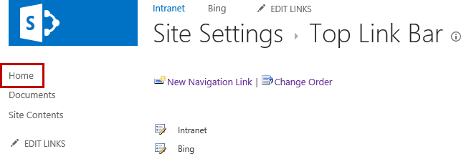

1. From the left navigation bar, click on **EDIT LINKS** to activate edit mode for adding/removing links to the Quick Launch.

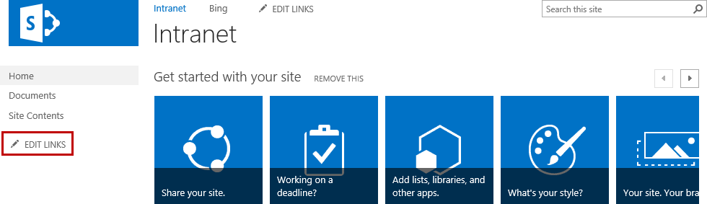

1. Click on **+ link** to add a new link.

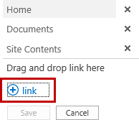

1. From the **Add a link** dialog, type **Microsoft** for the **Text to display**. Type **http://www.microsoft.com** for the **Address** and then click **OK**.

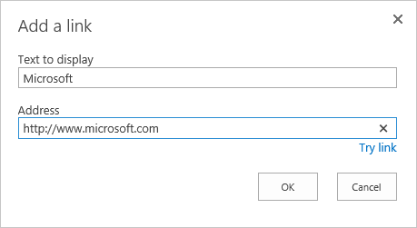

1. From the left navigation bar, click **Save** to commit the changes.

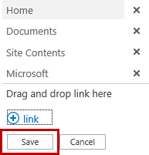

1. Notice that the **Microsoft** link is now added.

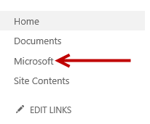

1. To make changes to the link go back into Edit mode by clicking on **EDIT LINKS**.
2. From edit mode, click on the **Microsoft** link to make changes to the existing link.

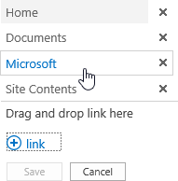

1. To change the name of the link, simply type the new value in the text box or click on the **globe link icon** located to the right of the text box for the link.

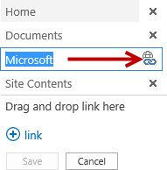

1. Clicking on the **globe link icon** will bring up the **Edit link** dialog. From here you can update both the **Text to display** and the **Address**.



1. To change the order of the links, simply drag the link to the location you want it to be. For example, to move the **Microsoft** link before the **Documents** link **click and hold** on the **Microsoft** link and **drag the link** to the left of the **Documents** link.

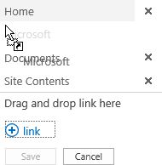

1. Once the link is in the new position, let go of the mouse and then click **Save** to commit the changes.

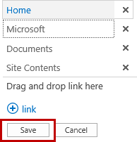

1. The **Microsoft** link is now before the **Documents** link.

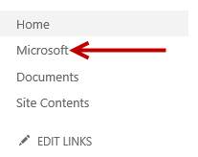

1. You can repeat the steps to make changes to the links or change the order. Or you can modify the links through **Site Settings** by following these steps:
   1. Click on the **Settings** icon and then select **Site settings**.



* 1. In the **Look and Feel** group, click on **Quick launch**.

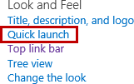

* 1. To change the order, click on **Change Order**.

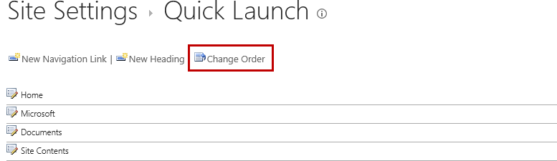

* 1. From the **Quick Launch Change Order** page, change the drop-down values to reorder to desired values to reorder the links. When complete, click **OK**.

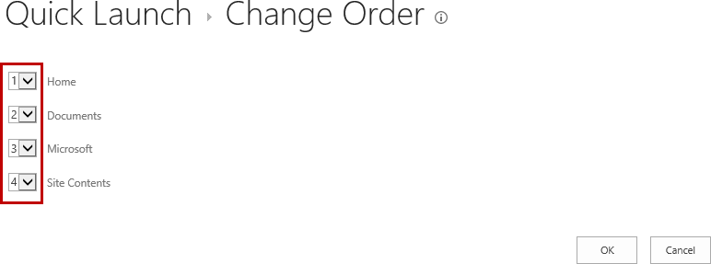

* 1. To add a new link, click on **New Navigation Link.**

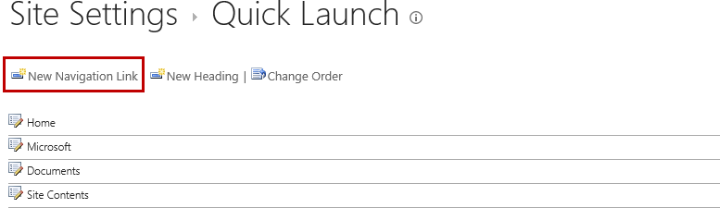

* 1. Enter values for **Type a Web address** and **Type the description**. In the **Heading** drop-down list, select the desired heading or leave it set to Home to make it a main link. When complete click **OK** or click **Cancel** to cancel.

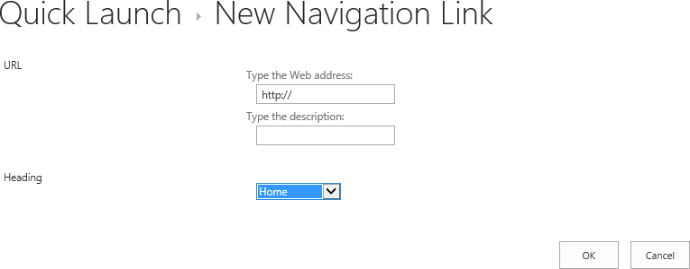

* 1. To edit an existing link, click on the **edit** **icon** next to the link you want to modify.

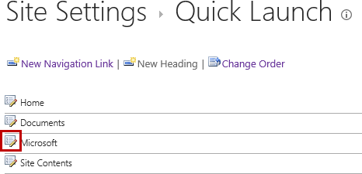

* 1. From the **Site Settings Edit Navigation Link** page, make the desired changes and then click **OK**. Or click the **Delete** button to delete the link or click **Cancel** to cancel making changes.

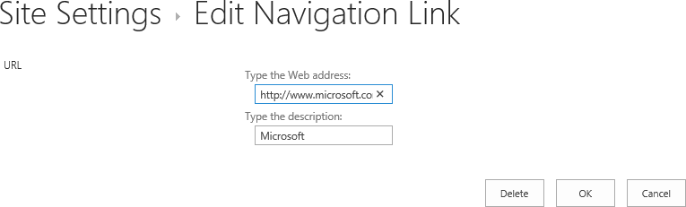

1. To add a Heading, click on the **New Heading** link.

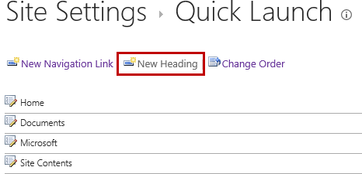

1. From the **Quick Launch New Heading** page, enter the desired values for the **Type a Web address** and **Type the description** and then click **OK**.

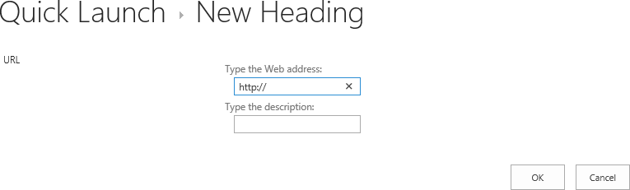

### Exercise 3: Navigate to Lists/Libraries

In this exercise you will learn how to navigate to lists and libraries, as well as learn how to view properties and other navigation features of lists and libraries.

#### View All Lists and Libraries

1. To view all existing lists and libraries navigate to the **Site Contents** page:
   1. From the **left navigation bar**, click on the **Site Contents** link.

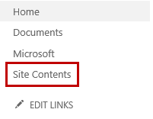

* 1. Or from the **Settings** icon and then click on **Site contents**.

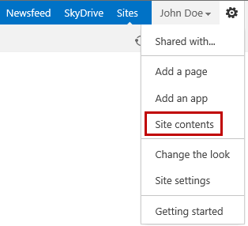

* 1. You are now on the **Site Contents** page which displays all existing lists and libraries.

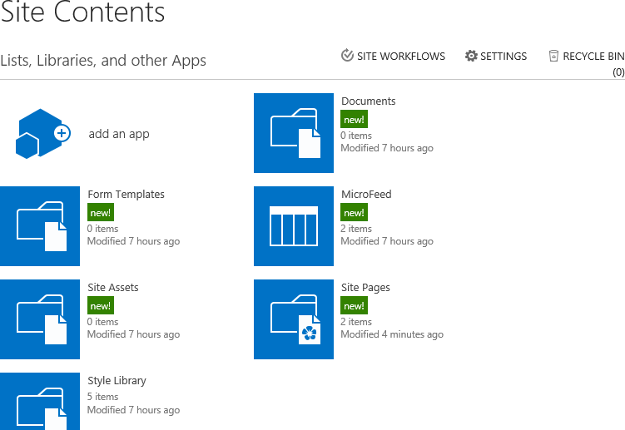

#### Use Direct Links in the Left Navigation Bar

1. From the left navigation bar, click on the link to the desired list or library.

If the link to the list or library is not there you can add the link using the EDIT LINKS or update the General Settings of the list or library to add the link to the Quick Launch.

1. To add an existing list or library to the **Quick Launch** through the **General Settings** follow these steps:
   1. From the **left navigation bar**, click on **Site Contents**.
   2. Hover over the **Site Pages** tile and click on the **ellipse (…)**.

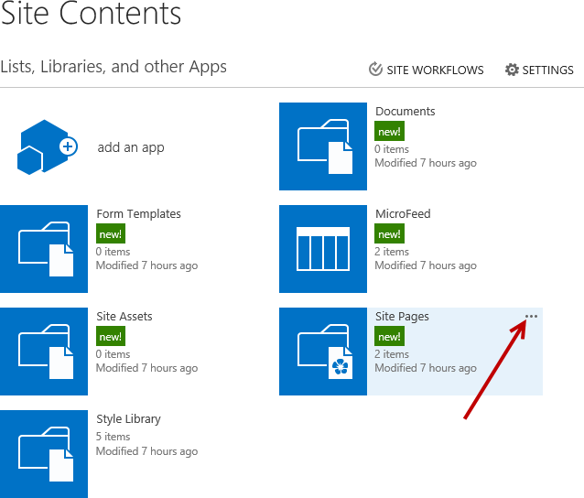

* 1. From the **Site Pages** dialog, click on **SETTINGS**.

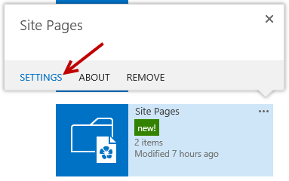

* 1. In the **Site Pages Settings** page under the **General Settings** group, click on **List name, description and navigation**.

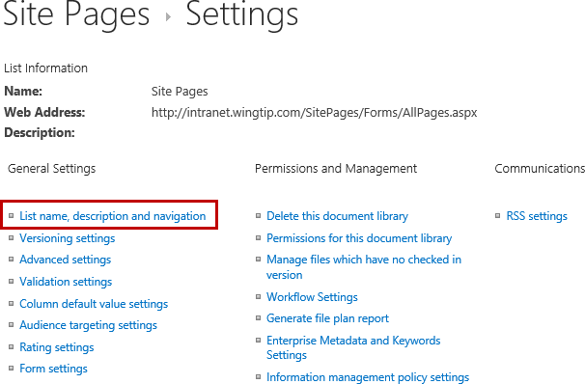

* 1. From the **General Settings** page in the **Navigation** property, change **Display this document library on the Quick Launch** from **No** to **Yes**.

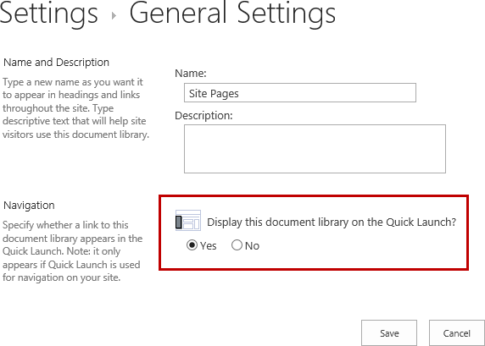

* 1. Click **Save**. The link to the **Site Pages** is now on the left navigation bar.

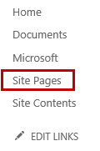

You have now completed this lab exercise.