## Working with Lists in SharePoint 2013

**Lab Time**: 45 minutes

**Lab Folder**: C:\Student\Modules\Lists

**Lab Overview:** In this lab you will create new lists from existing list templates, customize the columns of a list, add validation rules to lists, and import content into a SharePoint list.

### Exercise 1: Working with List Items

In this exercise you will become familiar with the different list template options that can be used to create lists.

#### Log in to SharePoint Site

1. Make sure you have the login information for the SharePoint environment where you will work on your lab exercises. You should have received this log in information from the hosting training company or from your instructor.
2. Make sure you have the URL to the **Team Site** that has been created for you to do your lab work. This URL will be in a form that looks something like this.

https://cpt.atrackspace.com/sites/TeamSite_Student01

1. Launch the Internet Explorer and navigate to the URL of the Team Site mention in the previous step. Note that you should be logged in with a user account that has full control and access to the site collection, and therefore will be permitted access and be able to create lists.
   1. When prompted to login, enter the user name and password that has been supplied to you and then click **OK**.

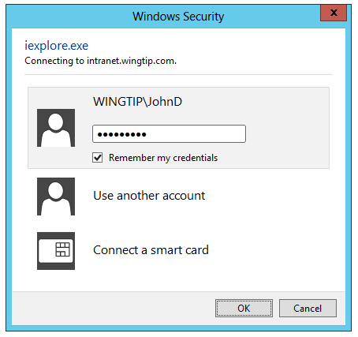

* 1. You should be able to confirm that you are logged into the SharePoint site. For example, if you were logged in as a student named **John Doe**, your name would appear in the SharePoint Welcome menu as shown in the following screenshot.

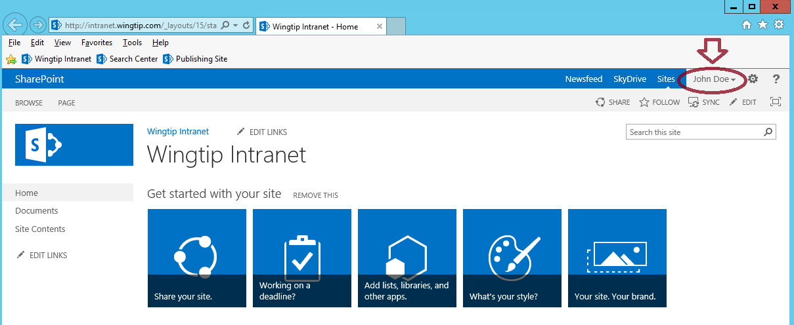

#### ****Navigate to the Out-of-the-Box (OOTB) List Templates****

1. Navigate to the Site Contents from the quick launch menu or from the Settings gear icon.
2. From the quick launch menu:
   1. Click **Site Contents** from the left navigation quick launch menu.

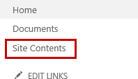

1. From the Settings gear icon:
   1. Click on the **Settings** gear icon.
   2. Click **Site contents**.

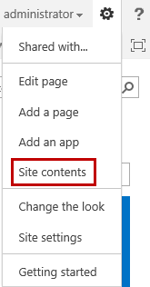

1. **In the Site Contents Page, click add an app.**

**Note:** From the **Site Contents > Your Apps** page, you will notice two different sections which include **Noteworthy** and **Apps you can add**. Noteworthy apps contain Document Library, Custom List, and Tasks.

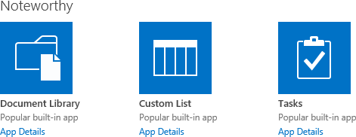

1. To sort alphabetically, click on **Name** link next to **Apps you can add**.

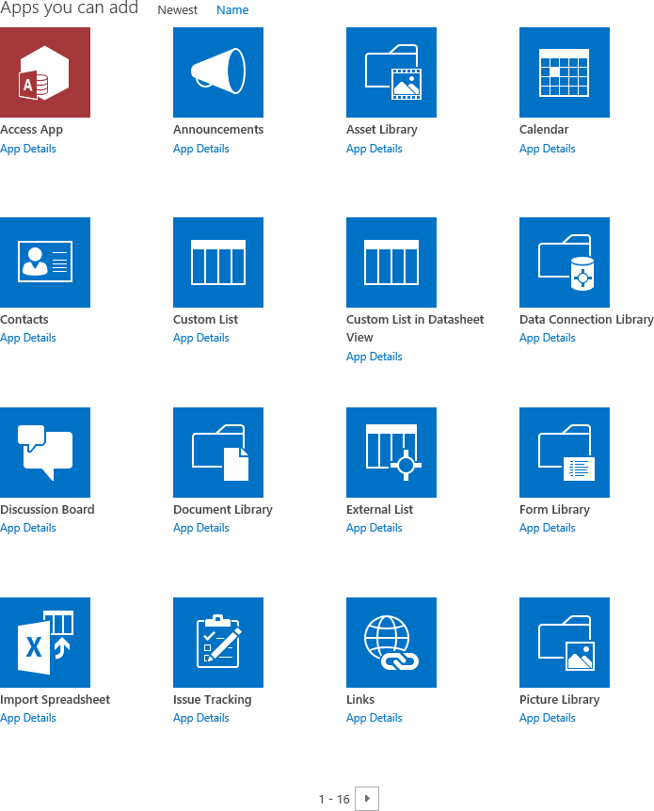

1. Click on the **right arrow** (pagination control) below the tiles to navigate to the remainder of the available apps.

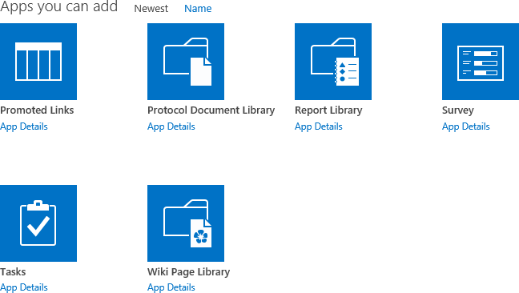

### Exercise 2: Creating a New List

In this exercise you will create an Announcements list, Tasks list, Calendar, as well as edit items and delete items.

#### Create an Announcements List

To create a new Announcements list, follow the steps below:

1. Navigate to **Add an app** to create a new Announcements list.
   1. Click on the **Settings** icon.
   2. Click **Add an app** or click **Site contents >> add an app**.

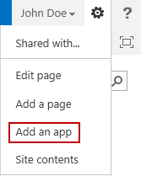

* 1. Click on the **Announcements** tile.

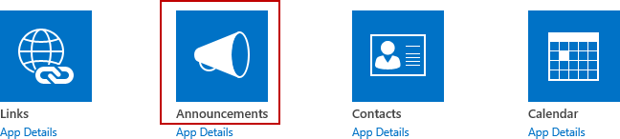

1. In the **Name** text box from the popup dialog, type **Announcements** and click **Create**.

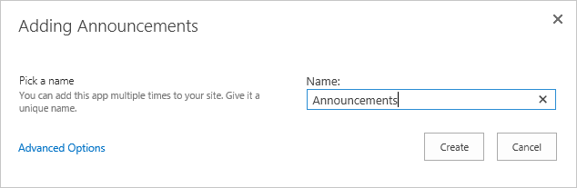

1. Click on the new **Announcements** list tile to view the list.

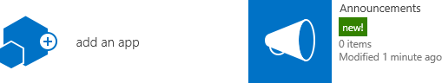

1. Click **new announcement** to open the New Form to create a new announcement.

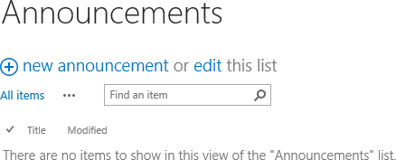

#### Create a Task List

To create a new Task list, follow the steps below:

1. Navigate to **Add an app** to create a new Task list.
   1. Click on the **Settings** icon.
   2. Click **Add an app** or click **Site contents >> add an app**.

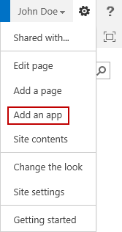

* 1. Click on the **Tasks** tile.

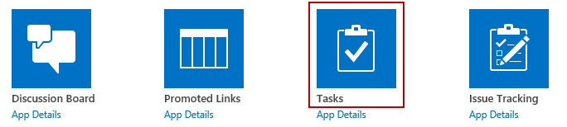

1. In the **Name** text box from the popup dialog, type **Tasks** and click **Create**.

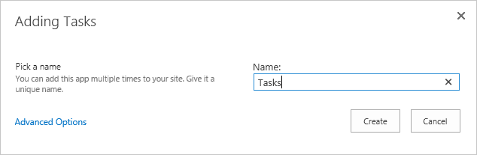

1. Click on the new **Tasks** list tile to view the list.

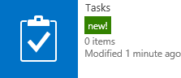

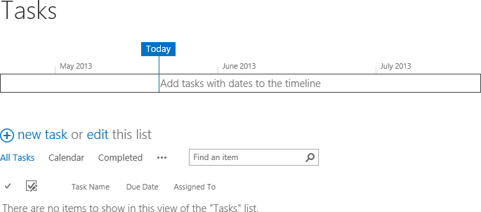

1. Click **new task** to open the New Form to create a new task.
2. Fill in the desired fields and then click **Save**.

#### Create a Calendar

To create a new Calendar, follow the steps below:

1. Navigate to **Add an app** to create a new Calendar.
   1. Click on the **Settings** icon.
   2. Click **Add an app** or click **Site contents >> add an app**.



* 1. Click on the **Calendar** tile.

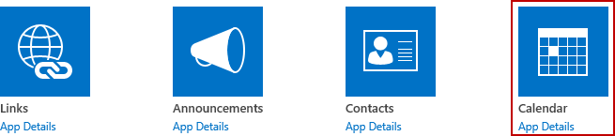

1. In the **Name** text box from the popup dialog, type **Calendar** and click **Create**.

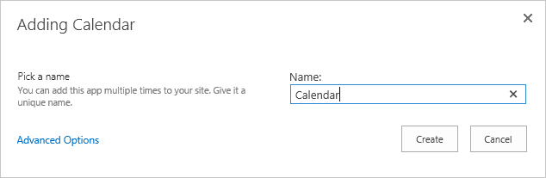

1. Click on the new **Calendar** list tile to view the list.

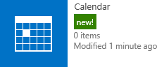

1. Notice the calendar is displayed in a visual view.

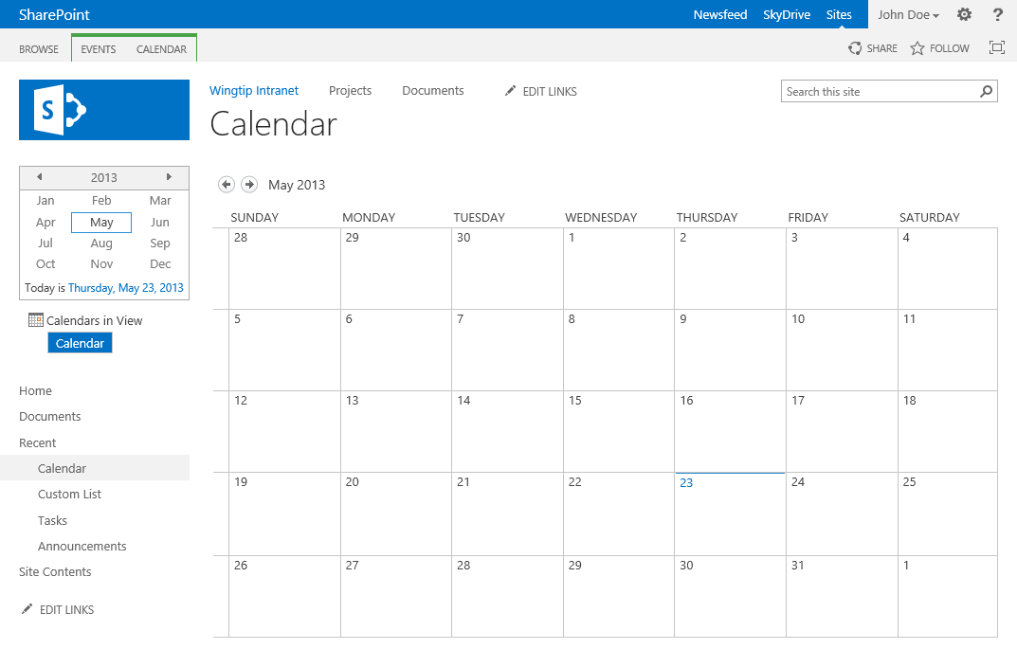

1. Click on date in the calendar to open the day view.

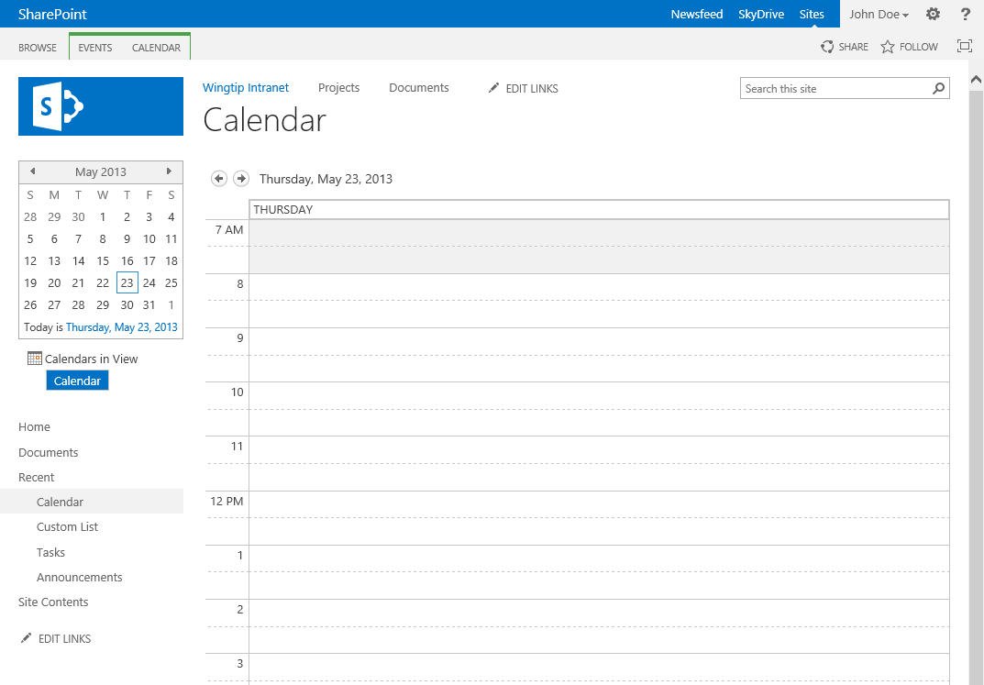

1. To add an item from the day view, double-click on a desired time to open the New Item dialog.

**Note:** You can also add items from the Calendar view by double-clicking in the white area inside the cell of the day you want to add or single-click in the cell and click on **+Add**.

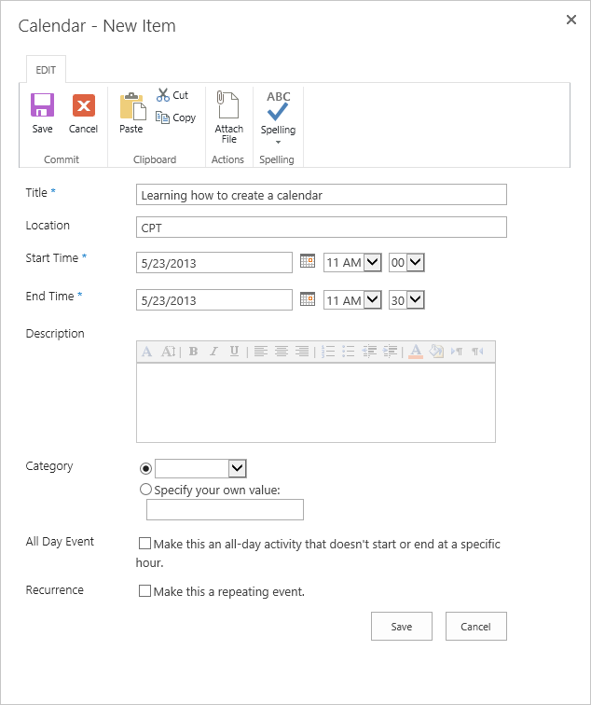

1. Input the desired fields and then click **Save**.
2. Click on the **BROWSE tab** and then click on the **Calendar** title to go back to the default Calendar view.

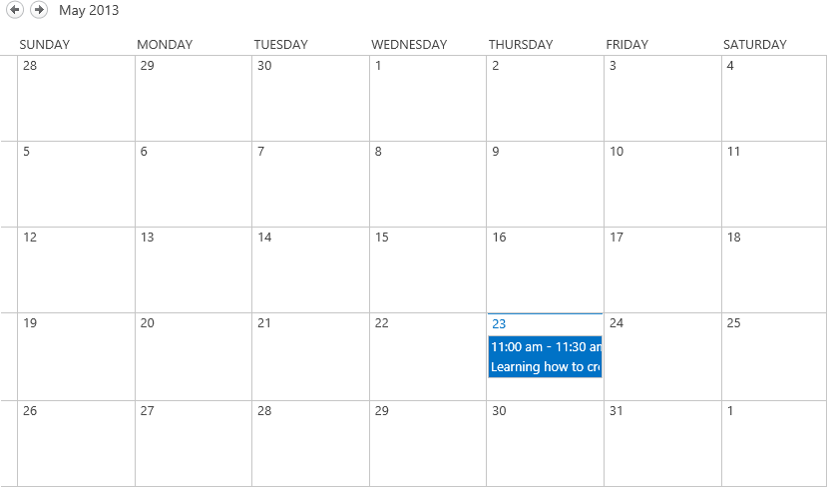

### Exercise 3: Manipulating SharePoint 2013 List Items

In this exercise you will populate an existing list with items then manage those items by editing them and eventually deleting them.

#### Add Items to Announcements List

1. Navigate to the newly created Announcements list.
   1. Click on the **Settings** icon.
   2. Click **Site contents**.
   3. **Click on the Announcements tile.**
2. Fill out the required fields and then click **Save**.

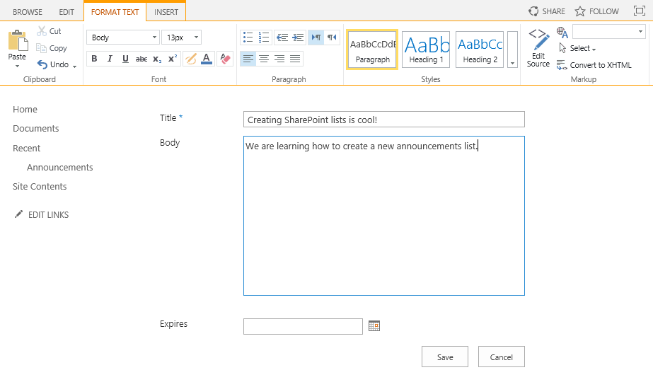

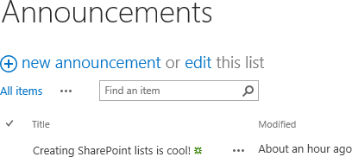

#### Edit a List Item

To edit a list item follow the steps below:

1. Navigate to the list you want to modify items for.
2. Find the list item you want to modify, click the **ellipsis (…)** and click **Edit Item**.



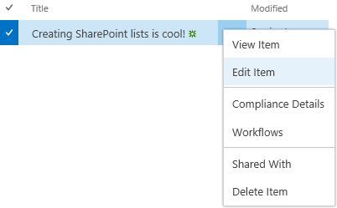

1. Make any desired changes and then click **Save**.

#### Delete a List Item

To delete a list item follow the steps below:

1. Navigate to the list you want to modify the items for.
2. Find the list item you want to modify, click the **ellipsis (…)** and click **Delete Item**.

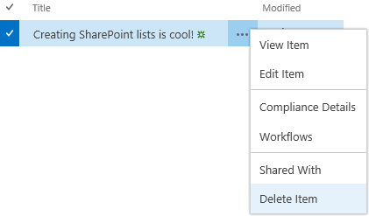

1. From the delete confirmation dialog, click **OK**.

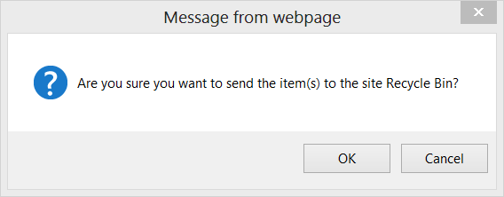

### Exercise 4: Customizing Columns of a SharePoint 2013 List

In this exercise you will create a custom list to store a list of students and customize the set of columns behind it for storing additional student information such as phone number and email address.

#### Create a Custom List

To create a new custom list, follow the steps below:

1. **Navigate to Add an app to create a new custom list.**
   1. **Click on the Settings icon.**
   2. **Click Add an app or click Site contents > add an app.**



* 1. **Click on the Custom List tile.**

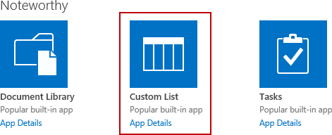

1. **In the Name text box from the popup dialog, type Students and click Create.**

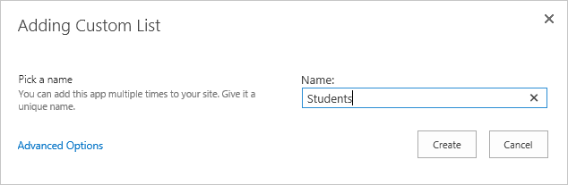

1. Click on the new **Students** tile to view the list.

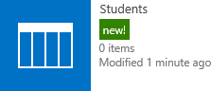

1. The list will display as shown in the figure below.

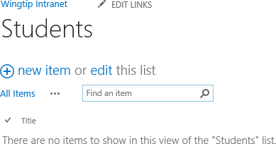

#### Customize List Columns

To edit a list item follow the steps below:

1. Click on the **LIST tab** in the ribbon and then click on **List Settings**.

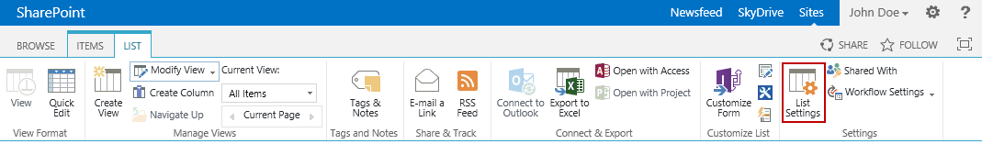

1. From the List Settings page, observe the **Columns** section.

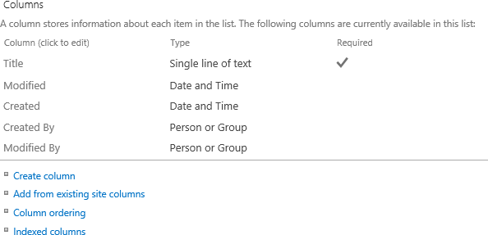

**Note:** The default columns for a Custom list include **Title**, **Modified**, **Created**, **Created** **By**, and **Modified** **By**. The **Columns** section provides the links to create a new list column, add an existing site column, adjust the column ordering, and set the indexed columns. The default **Title** column is a required field which cannot be deleted; however, you can change the **Display Name** of the **Title** column to something else if desired.

1. Click on the **Title** column to access the properties.
2. Change the **Column name** from **Title** to **Student Name** and then click **OK**.

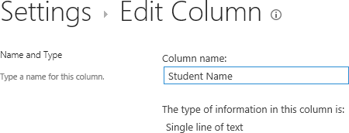

Now, create a column to store the student’s phone number:

1. Click **Create Column**.
2. Type **Phone** for the **Column name** and then click **OK**.

Now, create a column to store the student’s email address:

1. Click **Create Column**.
2. Type **Email** for the **Column name** and then click **OK**. You will now have the following columns as displayed in the figure below.

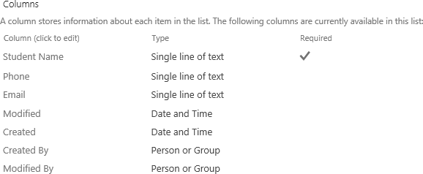

#### Save as List Template

It is common to create custom lists and then save them as list templates so that the template can become the basis of a new list on a site. To save a list as a list template, follow the steps below:

1. From the list settings page under the Permissions and Management section, click **Save list as template**.

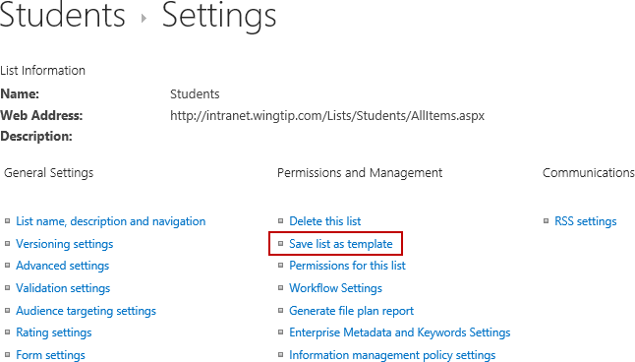

1. In the **File Name** text box, type **Students**.
2. In the **Template** name text box, type **Students** **List** **Template**.

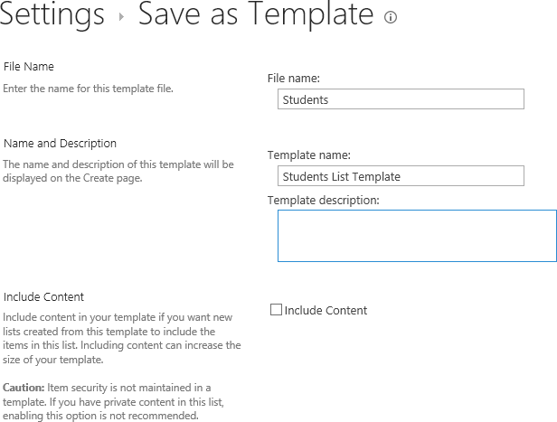

1. Click **OK**.
2. The list template gallery success message will display. Click on the **list template gallery** link.

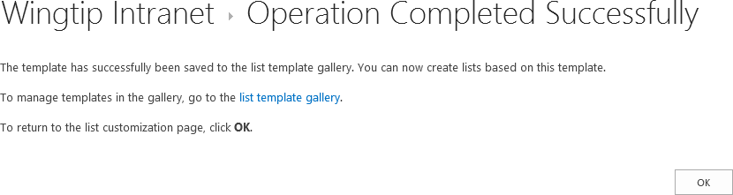

1. The newly created **Students** list template will be displayed in the **List** **Template Gallery**.

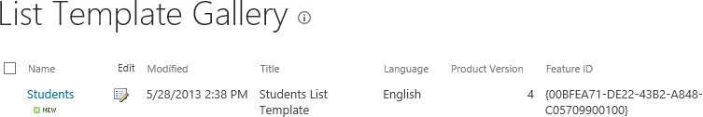

1. From the left navigation pane, click **Site** **Contents**.
2. Click **Add an app**.
3. Click the right arrow at the bottom pagination control to go to the next page of templates.
4. Notice the Students List Template is now available.

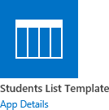

### Exercise 5: Adding Validation Rules

In this exercise you will learn how to customize a list by adding column-level and item-level validation rules.

#### Date Column Validation Rule

In this section, you will add column validation to validate an email address for the Email column.

1. Navigate back to the Students list.
   1. Click on the **Settings** icon.
   2. Click **Site** **contents**.
   3. Click on the **Students** tile**.**
2. Click on the **LIST tab** in the ribbon and then click on **List Settings**.
3. Click on **Create Column.**
4. Type **Birth Date** for the **Column name.**
5. Change the data type to **Date and Time** and click **OK**.
6. From the List Settings page, in the **Columns** section, click on the **Birth Date** column link.
7. Expand the **Column Validation** section.

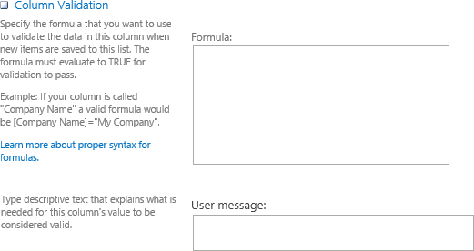

**Note:** The **Formula** property is used to input the column validation formula and the **User message** property is used for inputting the message you want to display to the user.

1. Type the following in the **Formula** input box:

=[Birth Date] < DATE(2000,1,1)

1. In the **User message** property, type **Birth Date must be before January 1, 2000.**

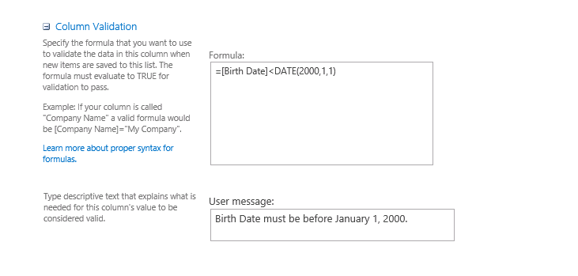

1. Click **OK**.
2. Navigate back to the **Students** list and add a new item. Input a **Birth Date** after January 1, 2000 and click **Save** to test the validation.

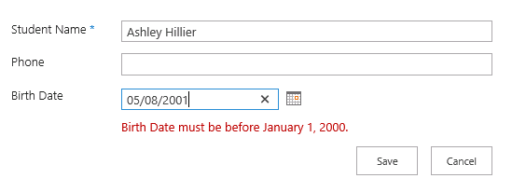

### Exercise 6: Importing Content into a SharePoint list

In this exercise you will learn how to import content from external sources such as an Excel spreadsheet.

1. Navigate to **Add an app** to import content from an Excel Spreadsheet.
   1. Click on the **Settings** icon.
   2. Click **Add an app** or click **Site contents >> add an app**.



* 1. **Click on the Import Spreadsheet tile.**

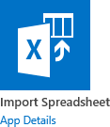

1. From the Import Spreadsheet page, type in a value for the **Name**.
2. In the **File location** property, click **Browse** and browse to your custom Spreadsheet you want to import.

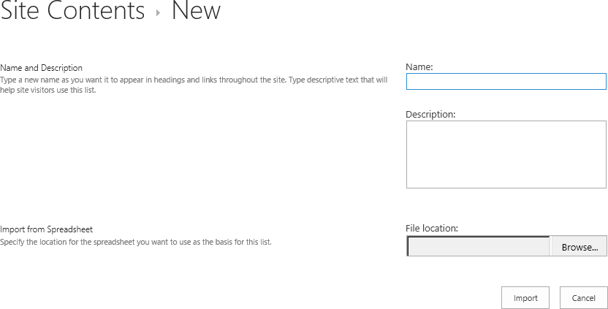

You have now completed this lab exercise.