## SharePoint 2013 Search

**Lab Time**: 45 minutes

**Lab Folder**: C:\Student\Modules\Search

**Lab Overview:** In this lab you explore the Search Center using Keyword Query Language, create result sources, and leverage managed properties for various tasks.

### Exercise 1: Exploring the Search Center

In this exercise you will execute queries, use refiners, and edit items using the search center.

#### Log in to Search Center

1. Make sure you have the login information for the SharePoint environment where you will work on your lab exercises. You should have received this log in information from the hosting training company or from your instructor.
2. Make sure you have the URL to the **Search Center** that has been created for you to do your lab work. Note that this site is different than the team site you use in other labs. This URL will be in a form that looks like this:

https://cpt.atrackspace.com/sites/SearchCenter_Student01

1. Launch the Internet Explorer and navigate to the URL of the Search Center mentioned in the previous step. Note that you should be logged in with a user account that has full control and access to the site collection, and therefore will be permitted access and be able to configure search settings.
   1. When prompted to login, enter the user name and password that has been supplied to you and then click **OK**.

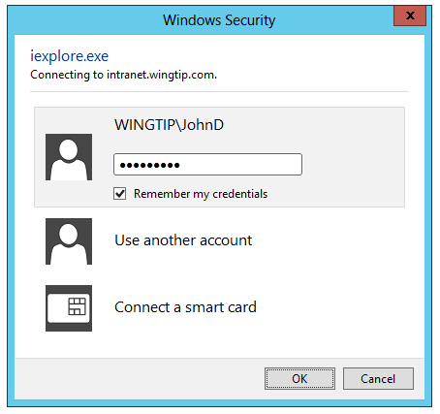

* 1. You should be able to confirm that you are logged into the Team Site.

#### Using the Search Center

1. On the Home page of the Search Center, you will see a large search box in the middle of the page.

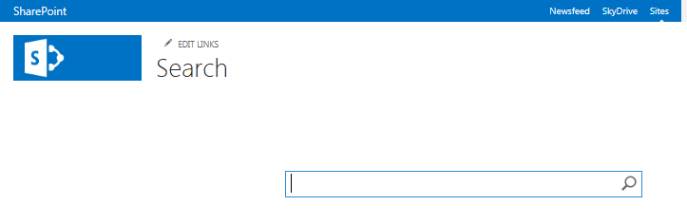

1. Type “Batman” in the search box.
2. Either hit the **Enter** key, or click the magnifying glass in the search box to run your search.

Note that typing into this search box will bring you to the default Search Results Page of the Search Center.

1. View the results of your search and familiarize yourself with the layout of the search page.

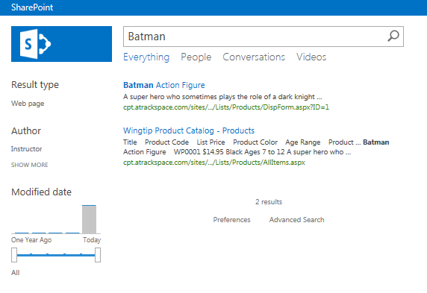

1. To the left of the search results you will see the refinement panel. Under **Result Type**, click **Web Page.** This will refine the search results to show you only the items which are web pages. To view all the search results again, click **All**.



1. In the refinement panel, under **Author**, click **SHOW MORE**.

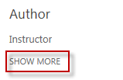

1. A text box will appear where you can enter the name of an author of items. If there were many more authors of items in the site available, you would be able to see some of their names as choices in this refiner.

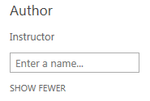

1. To close the text box and see fewer results, click **SHOW FEWER**.
2. In the Refinement Panel, look at the **Modified Date** refiner. This refiner is different than the others because it works with the range of dates in which items in the search results have been changed.

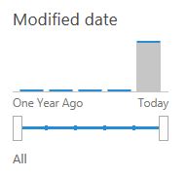

1. Hover over any of the bars in the bar graph in the refiner. Note that they change color and are clickable.
2. Click one of the bars and note that not only do the search results become refined, but also that the range of dates below the graph in the refiner changes.

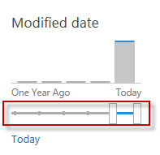

1. Conversely, you can expand the range of dates in the refiner and change the selection in the bar graph above while changing the search results.

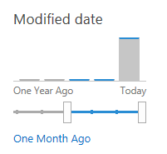

1. From the search results, place your cursor over one of the items. Do not click the item, simply hover over it. You will see the preview pane appear for that particular item.

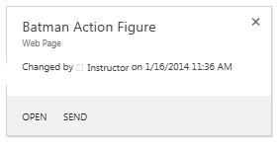

The preview pane shows basic information about the item it refers to. Important information such as Title, last modified date, etc. show up to help you decide whether this item is the one you were looking for, before you click on it.

1. In the Search Results, click on the title of any item to navigate directly to that item.

Note that, because you only have Read permissions to the site that contains these products, you cannot edit or delete the items.

### Exercise 2: Create a New Search Source

In this exercise you will create a new search scope using result sources, query rules, and the search navigation links.

#### Create a New Result Source for Tasks

1. Navigate to your Search Center site, at an address similar to **https://cpt.atrackspace.com/sites/SearchCenter_Student01**
2. Click **Settings🡪 Site Settings**
3. In the Site Settings page, under the **Search** header, locate and click **Result Sources**

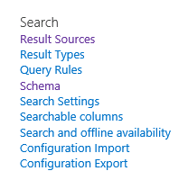

1. Click **New Result Source**



1. In the **Name** section, type **Tasks**
2. In the **Description** section, type a quick description (optional)
3. In the Query Transform section, locate and click the button for **Launch Query Builder**

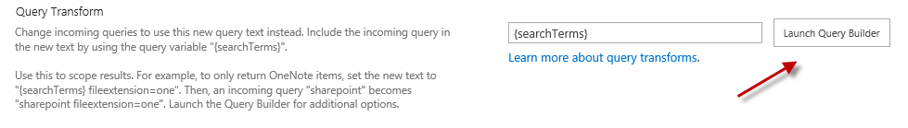

1. In the **Property Filter** portion of the query builder, select the value **contentclass**.

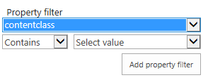

1. Underneath this, leave the drop down with **Contains** as-is; set the next drop down to **Manual value.**
2. A text box will appear. In this box, type **STS_listitem_tasks.**

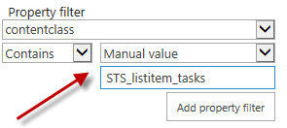

Note: This structure, **contentclass:STS_listitem_tasks** is very powerful in SharePoint. **Contentclass** is a managed property which allows the user to identify types of items across the farm, such as task list items, site collections, sites, etc.

1. Click the button **Add property filter.**
2. Your Query text should appear like the following:

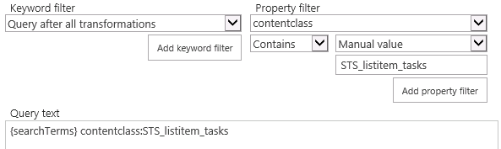

1. Click the button **Test query**. Task list items should appear in the preview pane to the right.

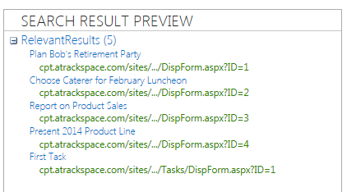

1. Click **OK**
2. In the **Add Result Source** Page,Click **Save**

#### Create a New Search Results Page for Tasks

1. Navigate to your Search Center site, at an address similar to **https://cpt.atrackspace.com/sites/SearchCenter_Student01**
2. Navigate to Site Contents
   1. Either click **Settings**🡪 **Site Contents**, or
   2. Click the **Site Contents** link in Quick Launch on the left.
3. In the Site Contents page, locate the library called **Pages** and click it.

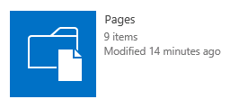

1. In the ribbon, click **Files**

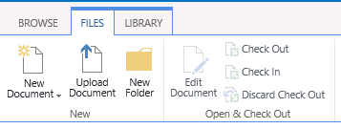

1. Click **New Document**
2. Fill out the Create Page form with the following values:
   1. Title: **taskresults**
   2. Description: **This page displays results of item type task**
   3. URL Name: **taskresults**
3. Click **Create**
4. In the Pages library, locate the new **taskresults page**. Click the **ellipsis (…)** next to the page name.



1. In the dialogue that opens, click the **ellipsis (…)** for more options.
2. Select **Check In**

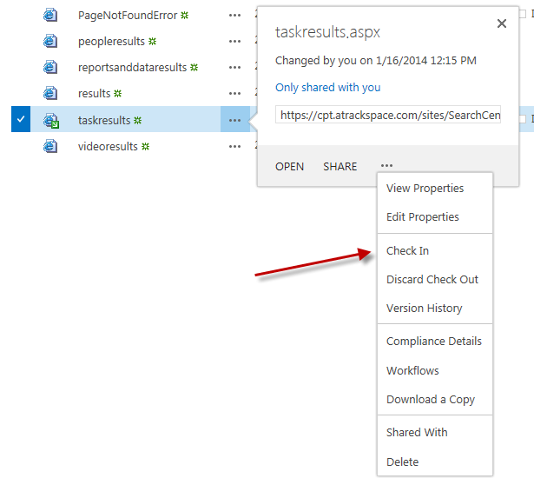

1. In the dialogue that appears, select the option **Major version (publish)** and click **OK**.

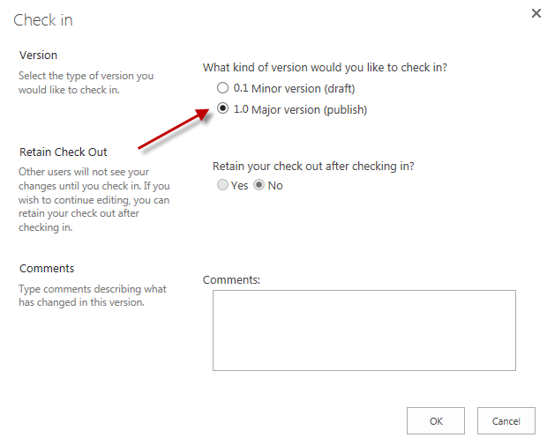

#### Add a link to Search Navigation

1. Navigate to your Search Center site, at an address similar to **https://cpt.atrackspace.com/sites/SearchCenter_Student01**
2. Click **Settings🡪Site Settings**
3. Under the Search heading, click **Search Settings**

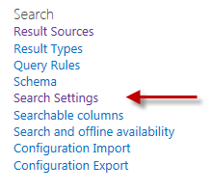

1. In Search Settings, in the **Configure Search Navigation** section, click the button **Add Link…**

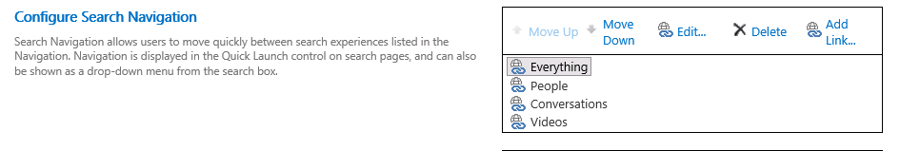

1. Fill out the Navigation Link form with the following values:
   1. Title: **Tasks**
   2. URL: browse for the tasks results page:
      1. On the left, click the **Pages** folder

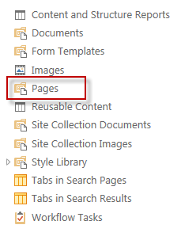

* + 1. To the right, click **taskresults.aspx**
    2. The page will get added to the end of the URL at the bottom:

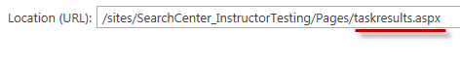

1. Click **Insert**
2. In the **Navigation Link** dialogue, click **OK**
3. In the **Search Settings** page, click **OK**

Note: If this does not work correctly and SharePoint gives you an error, go back to the Pages library and make sure the taskresults.aspx page is checked in. Then repeat steps 27-34.

#### Associate Result Source with Search Results Page

1. Navigate to the task results page in your Search Center at a path similar to the following:

**https://cpt.atrackspace.com/sites/SearchCenter_Student01/Pages/taskresults.aspx**

Note that you can also get to this page by running a search in the Search Center, and clicking the new **Tasks** link you added in the steps above.

1. Click **Settings🡪 Edit page**
2. Locate the **Search Results** web part.
3. Hover next to the title of the web part until a small arrow appears. Click the arrow to show the edit control box for this web part.

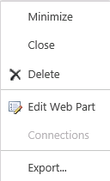

1. Click **Edit Web Part**
2. In the web part configuration panel, click the **Change query** button

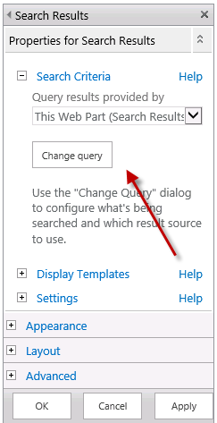

1. In the **Select a query** section, drop the list down and select **Tasks**, which is the result source created earlier.



1. Click **OK** in the change query dialogue.
2. Click **OK** in the web part configuration.
3. In the ribbon, click the **Publish** tab.
4. Click the **Publish** button

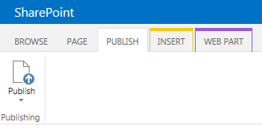

1. In the dialogue that appears, click **Continue**.

### Exercise 3: Configuring the Refinement Panel

In this exercise you will leverage site collection managed properties to configure the refinement panel in the search center.

#### Change a Refiner Display Name

1. Navigate to your Search Center site, at an address similar to **https://cpt.atrackspace.com/sites/SearchCenter_Student01**
2. Run a search for “Action Figure”.
3. Notice the three default refiners in the refinement panel to the left: Result Type, Author, and Modified Date.

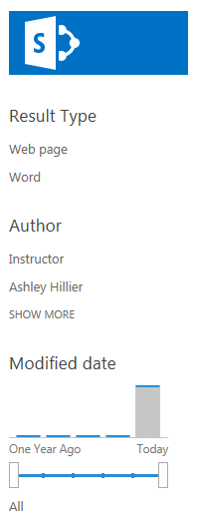

1. Place the page in edit mode by clicking **Settings🡪Edit page**
2. Click on the arrow next to the Refinement web part title and select **Edit Web Part**
3. In the configuration for the web part, click the button for **Choose Refiners…**

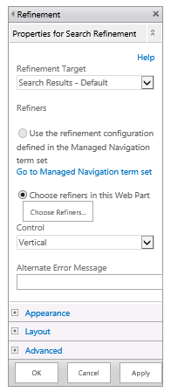

1. In the dialogue that appears, inspect the list of **Available Refiners** and **Selected Refiners**.

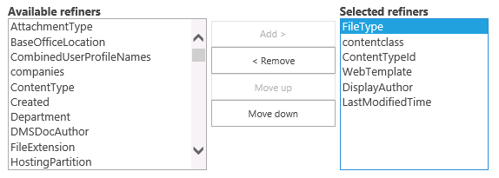

1. Select **FileType** from the **Selected Refiners** group. In the bottom panel, look at the properties that can be configured for this refiner.

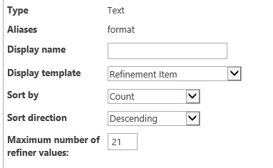

1. Set **Display Name** to **Type.**
2. Click the button **Preview Refiners…** and note that the refiner that used to be called **Result Type** now has a display name of **Type.**
3. Click **OK** to exit the preview.
4. Click **OK** in the configuration dialogue.
5. Click **OK** in the web part configuration to save the changes.
6. In the Ribbon, click the **Publish** tab, then click the **Publish** button, and click **Continue.**
7. Re-run the search for “Action Figure”. Note that the change made to the refiner display name is visible in the refinement panel.

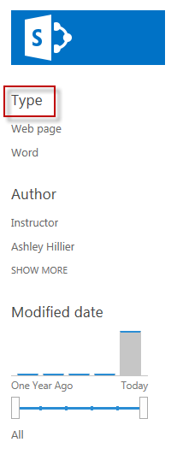

#### Add a Refiner to the Refinement Panel

1. Navigate to your Search Center site, at an address similar to **https://cpt.atrackspace.com/sites/SearchCenter_Student01**
2. Run a search for “Action Figure”
3. Place the page in edit mode by clicking **Settings🡪Edit page**
4. Click on the arrow next to the Refinement web part title and select **Edit Web Part**
5. In the configuration for the web part, click the button for **Choose Refiners…**
6. In the dialogue that appears, inspect the list of **Available Refiners** and **Selected Refiners**.
7. From the list of **Available Refiners,** select **FileExtension** and click **Add**.

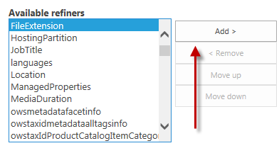

1. With **FileExtension** selected, click the button **Move up** until **FileExtension** is the second refiner from the top.

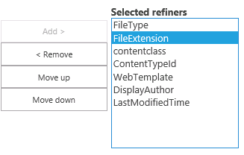

1. In the panel below, note the properties that can be configured for the new refiner.
2. Set the **Display Name** as **File Type**
3. Set the **Sort By** section to **Name**
4. Set the **Sort Direction** section to **Ascending**.

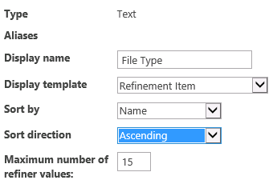

1. Click **OK** in the configuration dialogue.
2. Click **OK** in the web part configuration to save the changes.
3. In the Ribbon, click the **Publish** tab, then click the **Publish** button, and click **Continue.**



1. Re-run the search for “Action Figure”. Note that the change made to add a refiner is visible in the refinement panel.

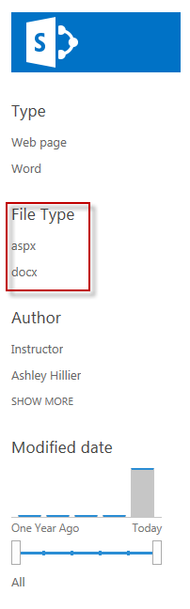

### Exercise 4: Using Keyword Query Language

In this exercise you will use keyword query language (KQL) to manipulate search results.

#### Free Text Searches, Property Restrictions, and Boolean Operators

1. Navigate to your Search Center site, at an address similar to **https://cpt.atrackspace.com/sites/SearchCenter_Student01**
2. In the search box, type **Bob**.
3. Inspect the search results. Notice that they include a variety of items, including word documents, a calendar, some tasks, and web pages.

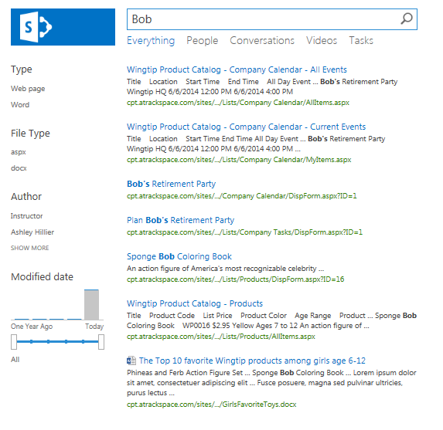

1. In the search box, run a search for **Title:Bob**. This is a keyword query search for items in which the title contains the word **Bob**.
2. Inspect the search results. Notice that they have been narrowed down, and now include an entry in the product catalog, a task, and a calendar event.

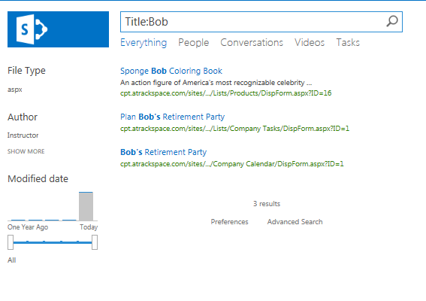

1. In the search box, run a search for **Title:Favorite**. Here we have a new set of items returned.
2. In the search box, run a search for **Title:Favorite AND FileExtension=docx.** This keyword query searches for items in which the title contains **Favorite**, but also that are Microsoft Word documents. Notice that the only item types in the results are Word documents. The refiners also reflect this.

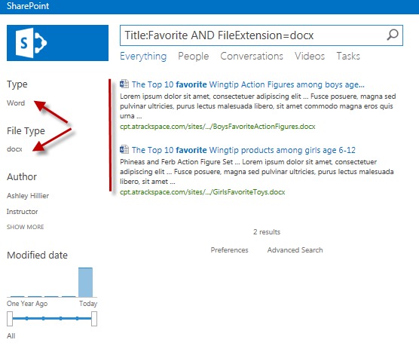

1. Inspect the search results with the addition of AND, a Boolean operator.
2. In the search box, run a search for **Title:Favorite OR Title:Bob**
3. Inspect the search results. This search yields a larger number of results because it will include anything in which the title contains either **Favorite** or **Bob**. If you try running this search with **AND** instead of **OR**, search will not return any results to you.

#### Property-Based KQL

1. In the search center, run a search for the word **Instructor.**
2. Utilizing the search result source created in an earlier exercise, click on the link **Tasks** in the search navigation.
3. Note the list of tasks which appear in the search results.

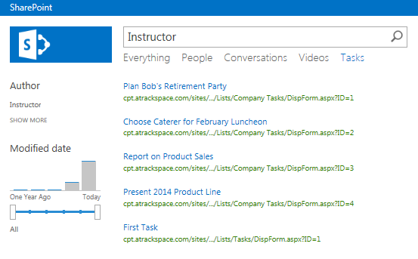

1. Click on the title of one of the tasks. Note that the search result takes the user to the task item itself, where it can be read without first navigating to the task list.
2. Click the back button in the browser to return to the search results.
3. Click on the link **Everything** in the search navigation.
4. In the search box, type **ContentClass:STS_listitem_task**
5. Inspect the search results. Note that these results are items only of type **task**, even though the user is currently viewing the **Everything** result source in search. Using the property **ContentClass** allows the user to specify types of files and items to view in search.

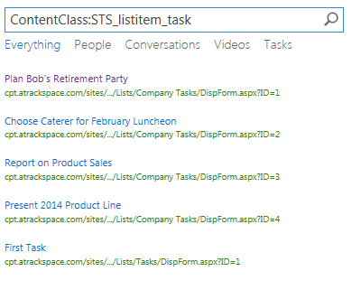

Note: **contentclass:STS_listitem_tasks** was the query used to create the result source **Tasks**, which was added to the search navigation.

1. In the search box, type **ContentClass:STS_listitem_event**

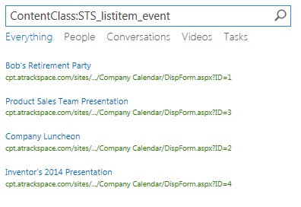

1. Inspect the search results. Note that these results are items only of type **event**, in the **Everything** result source in search.

### Exercise 5: KQL Hyperlink Solutions

In this exercise you will use property-based KQL as the basis for hyperlink solutions, putting links to the search center on important sites.

1. Navigate to your Search Center site, at an address similar to **https://cpt.atrackspace.com/sites/SearchCenter_Student01**
2. In the search center, run a search for **ContentClass:STS_listitem_task.**
3. In the browser, take a look at the URL for the search results page. It will look similar to the following:

https://cpt.atrackspace.com/sites/SearchCenter_Student01/Pages/results.aspx?k=ContentClass%3ASTS_listitem_task

1. Note that the first half of the URL stands for the default search results page the user is looking at.
2. Note the second half of the URL, the portion which looks similar to this:

**k=ContentClass%3ASTS_listitem_task**

1. The **k=** stands for the keyword query being run which brings back the specific search results visible in the page.

Note that the query run in the search box—although encoded—is recognizable inside the URL.

1. Click inside the address bar of the browser.
2. Highlight the text and copy the URL.
3. In a new window, navigate to the your Wingtip Team Site at an address similar to the following:

**https://cpt.atrackspace.com/sites/TeamSite_Student01**

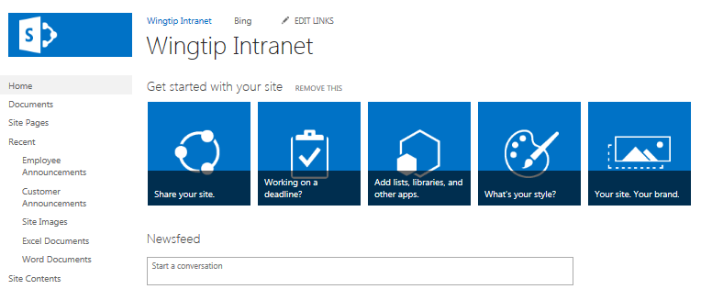

1. If prompted to log in again, enter your credentials and click **OK**



1. On the Home Page of **Wingtip Intranet,** put the page in Edit mode by clicking **Settings🡪 Edit page**.
2. Click inside the page, placing the cursor on its own line.
3. In the Ribbon, Click the **Insert** tab.
4. Click the **Link** button and select **From Address**

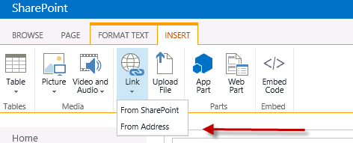

1. In the dialogue that appears, set **Text to display** as **All Tasks**

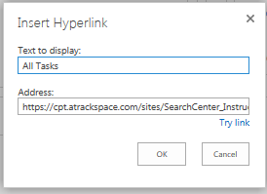

1. Paste the URL of the search center which was copied in step 8 into the **Address** box.
2. Click **OK**.
3. In the Ribbon, click the **Page** tab
4. Click the **Save button**
5. You should now see a link called **All Tasks** on this page. Click the link, and note that it takes the user directly to the search center results for all tasks.

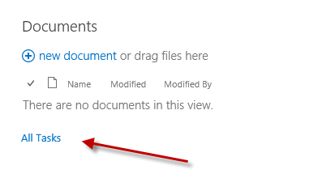

Note: Because search is security trimmed, search results are tailored to only what the current user is permitted to see. This way, a link to the search center such as this one can be placed on the home page, and each user will see results specific to him or her.

You have now completed this lab exercise.